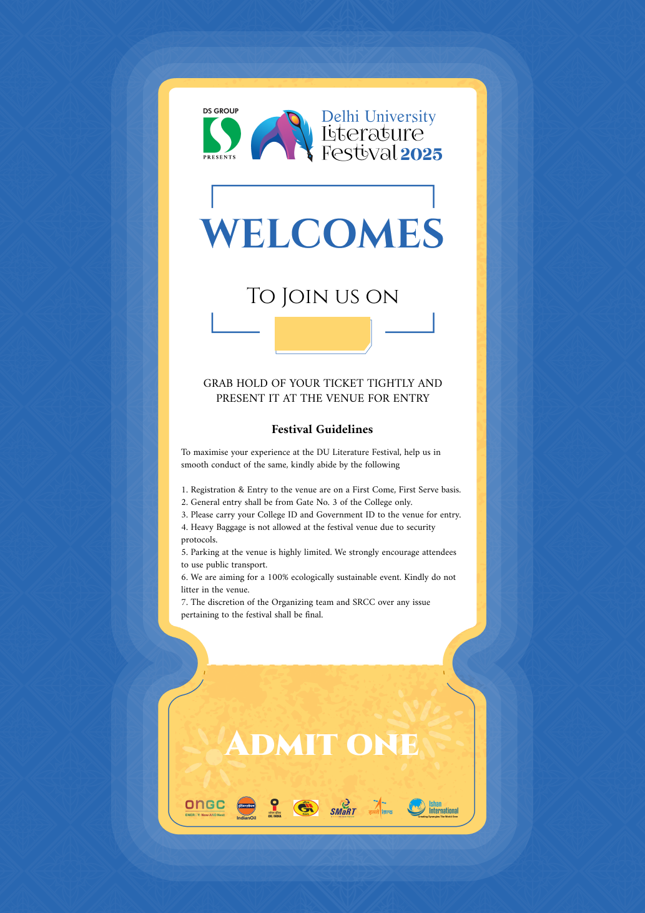

{{ DayNumber }}

{{ FirstName }}