PROJECT REPORT

Electric Vehicle Market
Performance & Insights
Exploratory EV Specification Analysis Using Tableau

Student | Gulla Navya Sree
Project Tool | Tableau Desktop / Tableau Public
Project Repository | https://github.com/nav-sree/EV-Market-Analysis
Demonstration Video | https://drive.google.com/file/d/1Wb9KBb0moQ1wSFsZKk6NIUwWjbIyS8TG/view
PUBLISHED DASHBOARD
https://public.tableau.com/app/profile/gulla.navya.sree/viz/EV_Market_Analysis1/Dashboard1

1. INTRODUCTION

1.1 Project Overview
Electric Vehicle Market Performance & Insights is an exploratory data-analysis project developed in Tableau. It examines electric-vehicle specification records through visualizations of manufacturer representation, listed driving range, battery capacity, and vehicle categories. The dashboard brings multiple views together so users can compare attributes in the available dataset.

1.2 Purpose
The purpose is to make EV specification data easier to inspect than raw tabular records. The visualizations help users explore differences and patterns across the records. The project is descriptive and exploratory; record counts should not be interpreted as real-world sales, registrations, or market share.

1.3 Abstract
This project uses Tableau to create a multi-view dashboard for exploring electric-vehicle specifications. The dashboard includes manufacturer comparison, driving-range distribution, battery capacity versus range, category counts, and average battery capacity by manufacturer. This report documents the problem, design approach, workflow, tests, results, limitations, and supporting links. Exact quantitative findings should be reported only after checking the final workbook and source data.

2. IDEATION PHASE

2.1 Problem Statement
EV specification datasets can contain many attributes, making it difficult to compare models or identify patterns by scanning raw tables. A consolidated visual dashboard organizes selected fields—manufacturer, listed driving range, battery capacity, and vehicle category—into charts that are easier to inspect.

2.2 Empathy Map Canvas
Target user: a student, researcher, or prospective EV buyer who wants to explore listed EV specifications.
- Says: “I want to compare EV specifications without manually reading a large table.”
- Thinks: “How do manufacturer representation, driving range, and battery capacity vary across the available records?”
- Does: Opens the dashboard and compares the available charts.
- Needs: Readable visualizations, clear labels, and transparent information about data limitations.
This empathy map represents a proposed user perspective and can be adjusted if a team-created canvas is available.

2.3 Brainstorming
- Use a bar chart to compare the most represented EV manufacturers.
- Create a driving-range distribution chart to inspect the spread of listed range values.
- Use a scatter plot to explore battery capacity versus driving range.
- Compare vehicle records across categories available in the dataset.
- Combine the charts in one Tableau dashboard for convenient exploration.

3. REQUIREMENT ANALYSIS

3.1 Customer Journey Map
A user opens the dashboard, reads chart titles, reviews visualizations, compares values across groups, and uses visible patterns to understand the dataset. Where available, the user can interact with dashboard controls. The dashboard supports exploration and does not provide a purchase recommendation.

3.2 Solution Requirement
- Input: EV CSV file(s) used by the Tableau workbook, identified in the report as ev_market_train.csv and ev_market_test.csv.
- Analysis fields: manufacturer, model name, vehicle ID, driving range, battery capacity, and vehicle category where present.
- Visual outputs: manufacturer comparison, range distribution, battery capacity versus range, category comparison, and average battery capacity by manufacturer.
- Deliverables: Tableau workbook/dashboard, project report, repository, and demonstration link.

3.3 Data Flow Diagram
EV CSV FILES → IMPORT INTO TABLEAU → INSPECT FIELDS → CREATE WORKSHEETS → ASSEMBLE DASHBOARD → EXPLORE VISUAL PATTERNS
Figure: High-level data flow for the project.

3.4 Technology Stack
Technology | Purpose in this project
Tableau Desktop / Tableau Public | Data exploration, worksheet creation, dashboard assembly, and publishing.
CSV files | Input format for the EV records.
GitHub | Repository link supplied for project files and documentation; confirm final contents before submission.
Google Drive | Hosting/sharing the demonstration video.

3.5 Dataset Description
The project report identifies ev_market_train.csv and ev_market_test.csv as the CSV files used in Tableau. Described fields include Manufacturer, Model Name, Vehicle Id, driving range, and battery capacity, with category information where available. The original public dataset source URL and exact row count have not been established in the supplied report; add these only after verification.

4. PROJECT DESIGN

4.1 Problem Solution Fit
The dashboard addresses the difficulty of comparing several EV specification attributes in a raw table by presenting multiple charts in a consolidated view. Its usefulness depends on correct field selection and aggregation, readable labels, and whether the visuals answer the intended exploratory questions.

4.2 Proposed Solution
The proposed solution is a Tableau dashboard containing views for manufacturer representation, driving-range distribution, battery capacity versus range, vehicle category counts, and average battery capacity by manufacturer. Only controls and interactions present in the submitted workbook should be described as implemented.

4.3 Solution Architecture
Data layer | EV CSV input files.
Analysis layer | Tableau data source, field selection, and worksheet aggregations.
Presentation layer | Individual worksheets combined into the Tableau dashboard.
Delivery layer | Published Tableau dashboard, project repository, demo video, and report.

5. PROJECT PLANNING & SCHEDULING
The workflow is organized into the stages below. Exact project dates were not included in the supplied material, so they are left for the student to enter rather than being estimated.
Phase | Activity | Actual date / duration
1. Dataset review | Select and inspect the EV CSV files. | Oct 2026
2. Field selection | Review fields and choose analysis attributes. | Oct 2026
3. Worksheet development | Create manufacturer, range, battery, and category charts. | Oct 2026
4. Dashboard assembly | Arrange worksheets and review layout. | Oct 2026
5. Publishing and evidence | Save/publish workbook and capture screenshots. | Oct 2026
6. Documentation | Prepare report and organize project links/files. | Oct 2026

6. FUNCTIONAL AND PERFORMANCE TESTING

6.1 Performance Testing
Functional testing was conducted to check data loading, chart displays, dashboard layout, and project links. The results are summarized in the table below.
Test | What to verify | Status
Data loading | The intended CSV source opens and fields are available. | pass
Brand chart | Selected manufacturers and count aggregation display correctly. | pass
Range distribution | Range bins and counts appear as expected. | pass
Battery vs. range | Axes and marks use the intended fields. | pass
Category chart | Category field and record counts are correct. | pass
Dashboard layout | Titles, charts, and labels are readable without clipping. | pass
Project links | Repository, demo video, and dashboard open for the evaluator. | pass

7. RESULTS

7.1 Output Screenshots
The supplied report contains a screenshot of the completed dashboard. Add separate worksheet screenshots where available so the evaluator can inspect each visualization.
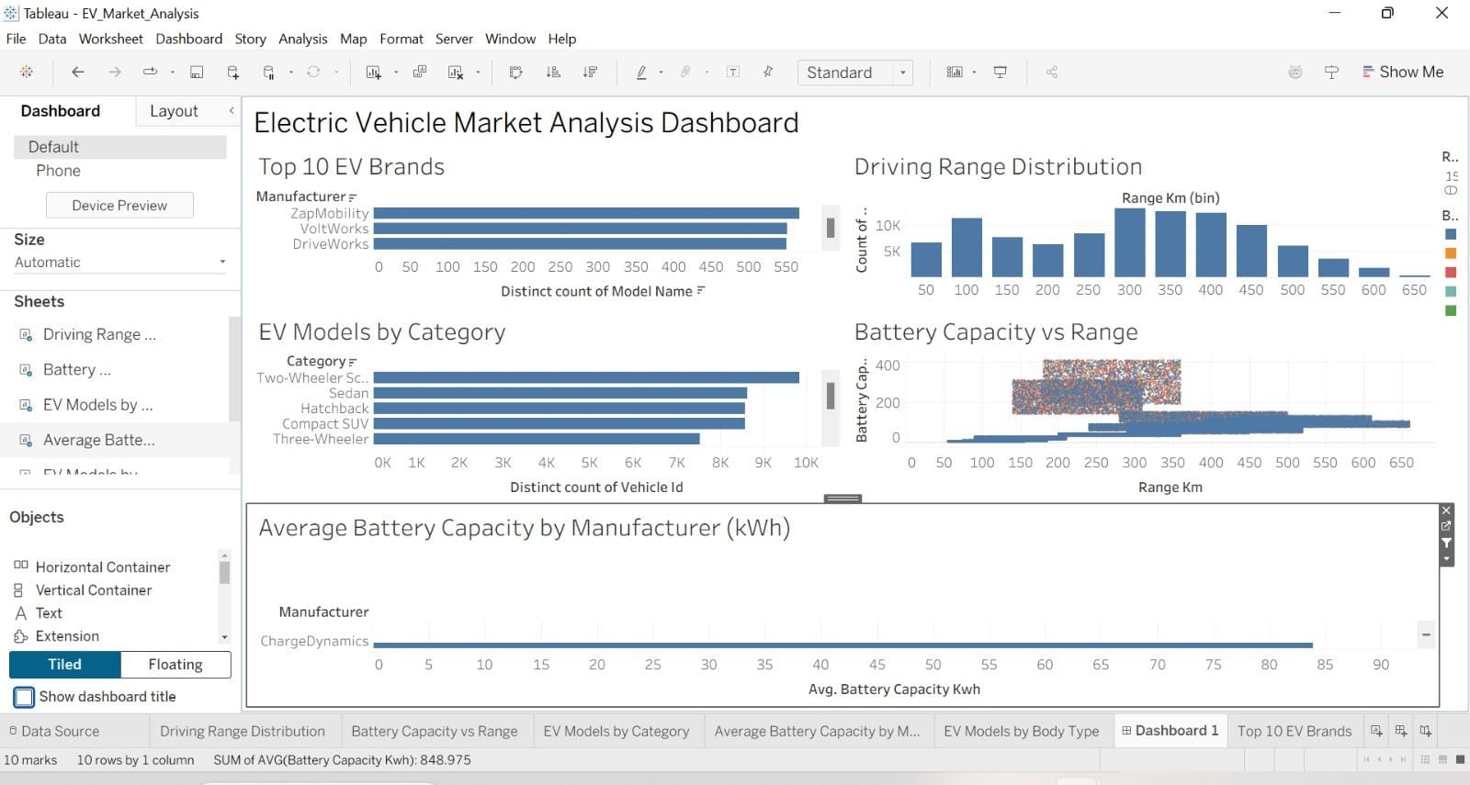
Figure 1. Electric Vehicle Market Analysis Dashboard.
- Figure 2. Top 10 EV Brands worksheet
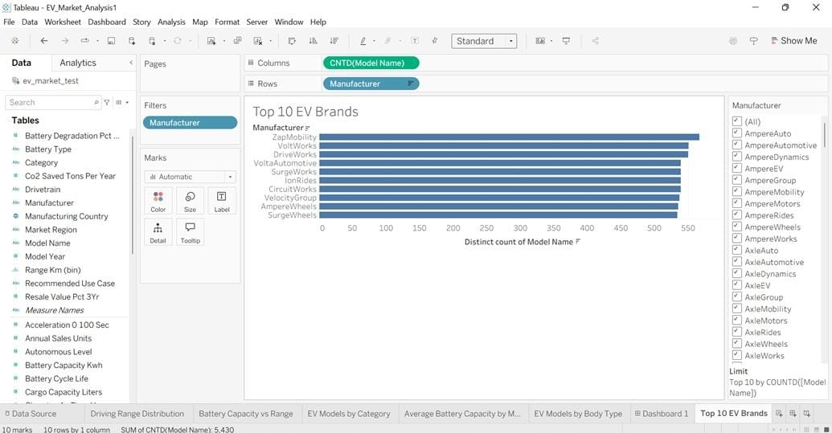
- Figure 3. Driving Range Distribution worksheet
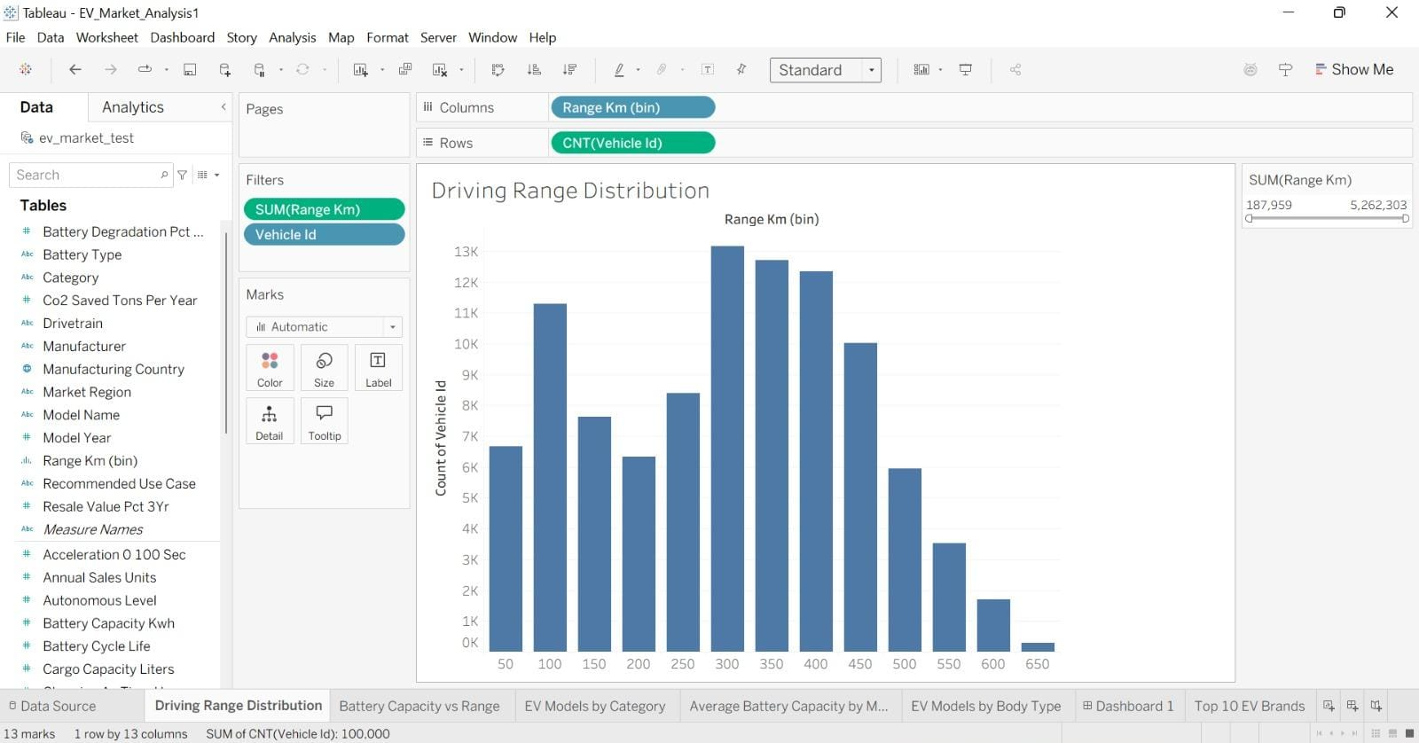
- Figure 4. Battery Capacity vs Range worksheet
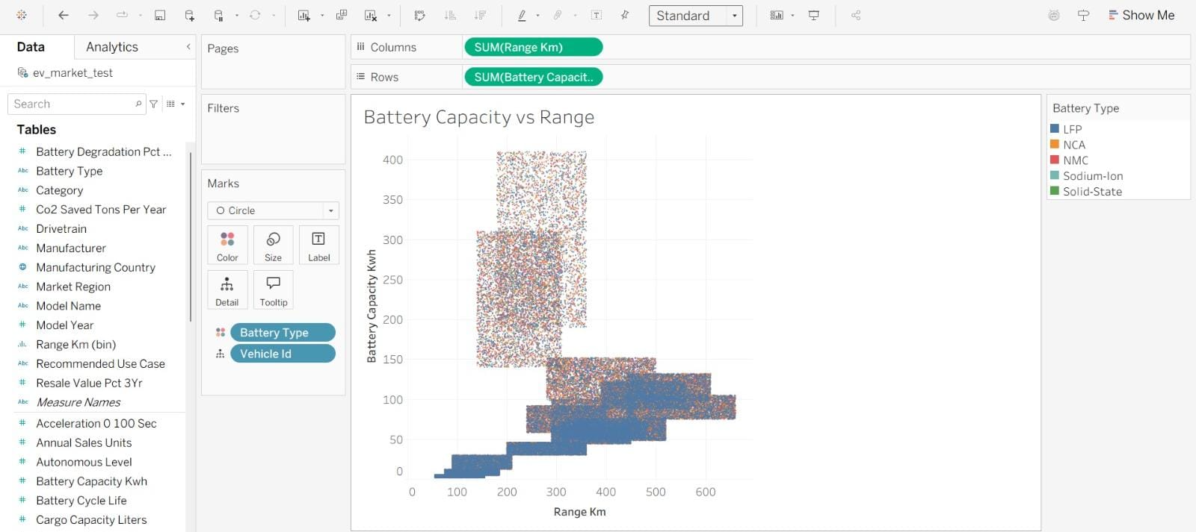
- Figure 5. EV Models by Category worksheet
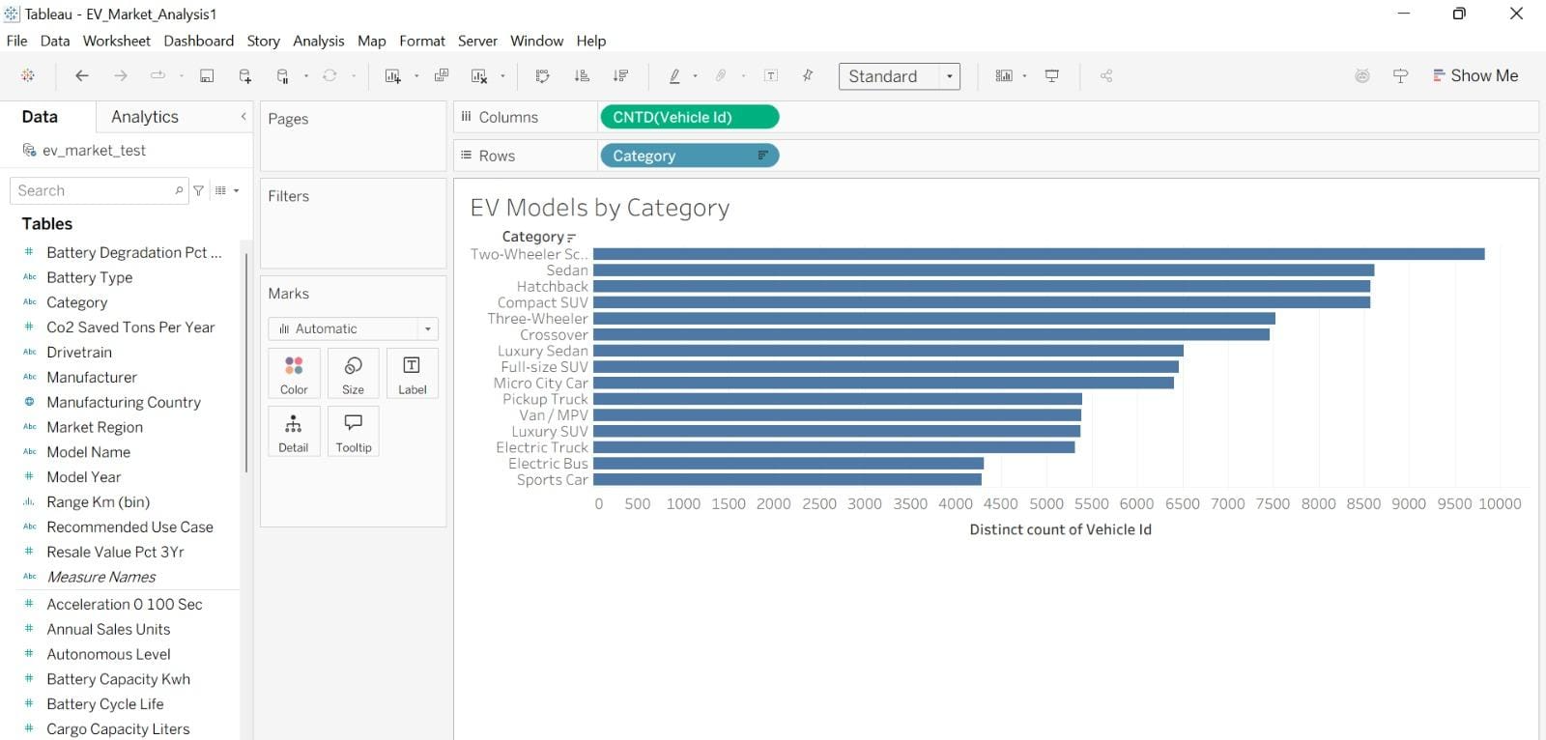
- Figure 6. Average Battery Capacity by Manufacturer worksheet
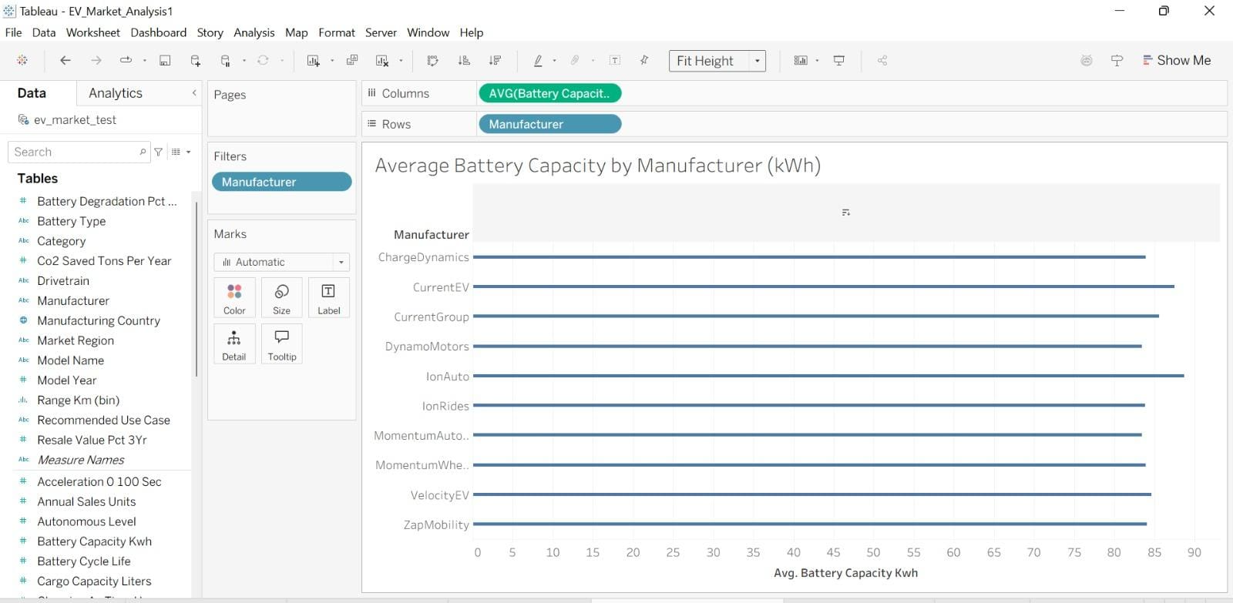

7.2 Results Summary
The dashboard brings together views that allow users to compare manufacturer representation, inspect listed driving-range distribution, explore the association between battery capacity and range, and compare records across available vehicle categories. Exact numerical findings should be taken from the final dashboard and dataset. The report does not claim sales, registration, or market-share results.

8. ADVANTAGES & DISADVANTAGES

Advantages
- Presents several EV specification views in one dashboard.
- Makes visual comparison easier than scanning raw data rows.
- Supports exploration of manufacturer, range, battery capacity, and category fields.

Disadvantages
- Findings depend on the quality and coverage of the input dataset.
- Listed specifications may differ from real-world conditions.
- Overlapping marks or limited chart space may reduce readability.
- Record counts do not establish sales, registrations, or market share.

9. CONCLUSION
This project demonstrates how Tableau can be used to explore EV specification records through a multi-view dashboard. The visualizations bring together manufacturer representation, driving-range distribution, battery capacity versus range, vehicle category counts, and average battery capacity by manufacturer. The dashboard supports exploratory comparison, while conclusions remain limited to the fields and records available in the input data.

10. FUTURE SCOPE
- Improve chart spacing, labels, and dashboard layout based on reviewer feedback.
- Add the verified original dataset source and document dataset size and relevant fields.
- Add additional filters or key indicators only where supported by the data and implemented in the workbook.
- Compare EV specifications with reliable price, sales, or registration data if those datasets become available.
- Create a Tableau Story or additional views if required and within project scope.

11. APPENDIX

11.1 Source Code / Supporting Files
This project primarily uses Tableau rather than a custom software codebase. Include the Tableau workbook and supporting files if they are part of the submitted repository. Do not state that files are present in GitHub unless the repository has been checked.

11.2 Dataset Link
Dataset files identified in the project report: ev_market_train.csv and ev_market_test.csv. Original dataset download/source URL: not provided in the supplied report; add the verified source URL before final submission.

11.3 GitHub and Project Demo Links
GitHub repository: https://github.com/nav-sree/EV-Market-Analysis
Demo video: https://drive.google.com/file/d/1Wb9KBb0moQ1wSFsZKk6NIUwWjbIyS8TG/view?usp=sharing
Tableau Public dashboard: https://public.tableau.com/app/profile/gulla.navya.sree/viz/EV_Market_Analysis1/Dashboard1

11.4 Final Submission Checklist
- Enter actual project dates/duration in Section 5.
- Verify each test and update its status in Section 6.
- Add screenshots for individual worksheets in Figures 2–6, if available.
- Verify the original dataset source URL and dataset row count.
- Open all three project links in a private browser session before submission.
- Confirm the repository contains the files described in the report.

