PyKV: A Scalable In-Memory Key–Value Store with Persistence

1. Abstract
PyKV is a high-performance, in-memory key-value store designed to mimic core behaviors of modern databases like Redis. It supports asynchronous client communication using FastAPI, memory-efficient operations using an LRU cache, durable persistence through an append-only log, and fault tolerance via crash recovery. The project also includes replication, allowing a secondary server to mirror data from the primary for high availability. This project demonstrates real-world backend concepts such as concurrency, caching, durability, and distributed system fundamentals.

2. Introduction
Modern applications require fast access to data, often with sub-millisecond latency. Traditional disk-based databases cannot meet these requirements. In-memory key-value stores solve this by storing data in RAM, providing extremely fast reads and writes. PyKV is built to expose students to the internal workings of such systems, including memory management, persistence mechanisms, and distributed replication.

3. Objectives
• Build a fast, in-memory key-value data store.
• Support GET, SET, DELETE operations.
• Ensure non-blocking performance using async I/O.
• Implement an LRU eviction policy.
• Provide durable storage via append-only logging.
• Enable crash recovery by replaying logs.
• Implement server replication for high availability.
• Develop a client application for remote interaction.

4. System Requirements

Software:
- Python 3.10+: Required for typing and FastAPI features.
- FastAPI: Framework to build async servers.
- Uvicorn: server to run FastAPI.
- Pydantic: Used for request validation.
- Requests: Used by the client to send commands.

5. Architecture Overview
PyKV uses a client–server architecture with the following components:
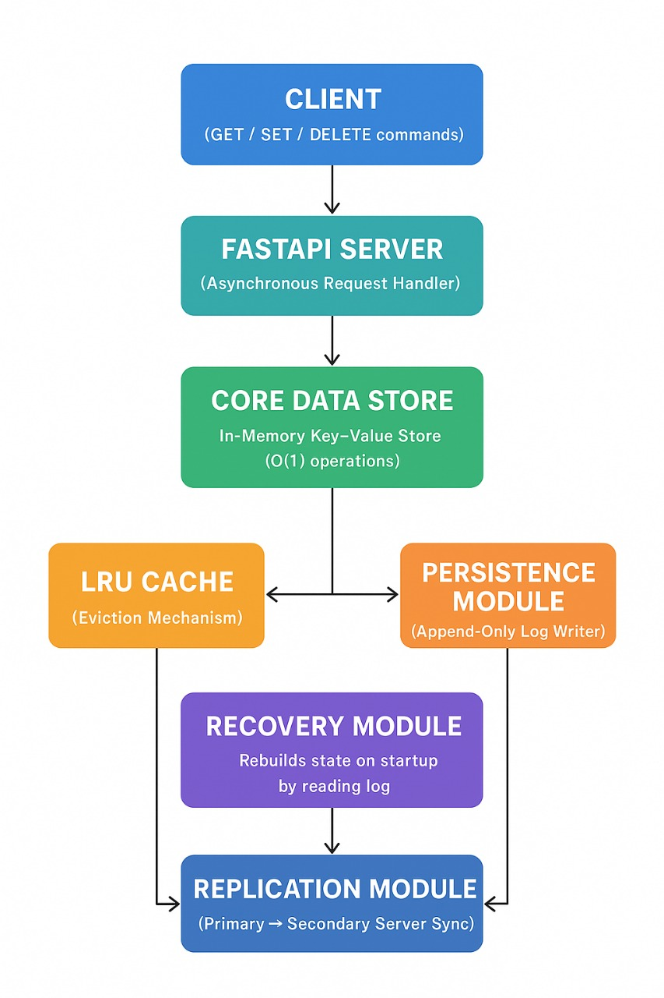

• Client: Sends commands via HTTP.

• FastAPI Server: Handles async requests.

• Core Data Store: Manages key-value pairs.

• LRU Cache: Manages memory eviction.

• Persistence Module: Writes logs for durability.

• Recovery Module: Restores state after a crash.

• Replication Module: Sends logs to a secondary server.

6. Module Descriptions
- Data Store Module:
Handles GET, SET, DELETE operations using a Python dictionary for O(1) lookup.

- LRU Cache:
Uses an OrderedDict or custom doubly linked list + hashmap to evict least recently used keys.

- FastAPI Server:
Provides async routes for client interaction and ensures high concurrency.

- Persistence Module:
Writes all write operations (SET, DELETE) to an append-only log file.

- Compaction Module:
Removes outdated log entries to reduce file size.

- Recovery Module:
Replays logs on startup to rebuild the in-memory state.

- Replication Module:
Primary server streams log updates to a secondary server.

- Client Module:
Command-line client using requests library to test operations.

7. Terminologies Explained
• In-Memory Store: Data stored in RAM for speed.
• Concurrency: Handling multiple clients at once.
• Asynchronous I/O: Non-blocking communication via async/await.
• LRU Cache: Removes least-used items.
• Append-Only Log: File that grows only by appending new entries.
• Log Compaction: Cleanup of old log data.
• Crash Recovery: Rebuilding from logs.
• Replication: Keeping secondary server in sync.

8. Algorithms:
1.LRU Cache Algorithm:
• Use hashmap + doubly linked list for O(1) get/set.
2.Append-Only Logging Algorithm:
• On every SET/DEL, append an entry to log.
3.Recovery Algorithm:
• On startup, read log line by line and rebuild state.
4.Replication Algorithm:
• Primary streams log updates to secondary.
9.Applications of PyKV :
1. High-Performance Caching
- Speeds up application performance
- Reduces load on main databases
- Stores frequently accessed user data, API responses, product pages, etc.
2. Real-Time Data Processing
- Suitable for dashboards and monitoring tools
- Handles live data like IoT sensor streams
- Supports fast reads/writes for stock, gaming, or analytics platforms
3. Session & Token Management
- Stores login sessions
- Manages authentication tokens
- Used in web applications for maintaining user state

10. Conclusion
PyKV demonstrates how high-performance data stores are built internally. The project covers critical real-world systems engineering topics such as concurrency, caching, durability, async networking, and replication. This hands-on implementation designing understanding of distributed systems and backend architecture.

