I have used second option of webmin to backup and restore. As per my analysis, backup/restore in 1st otption does not work.

1. Backup process.

a) Click on Webmin Configuration option ans select Webmin Modules as shown below.

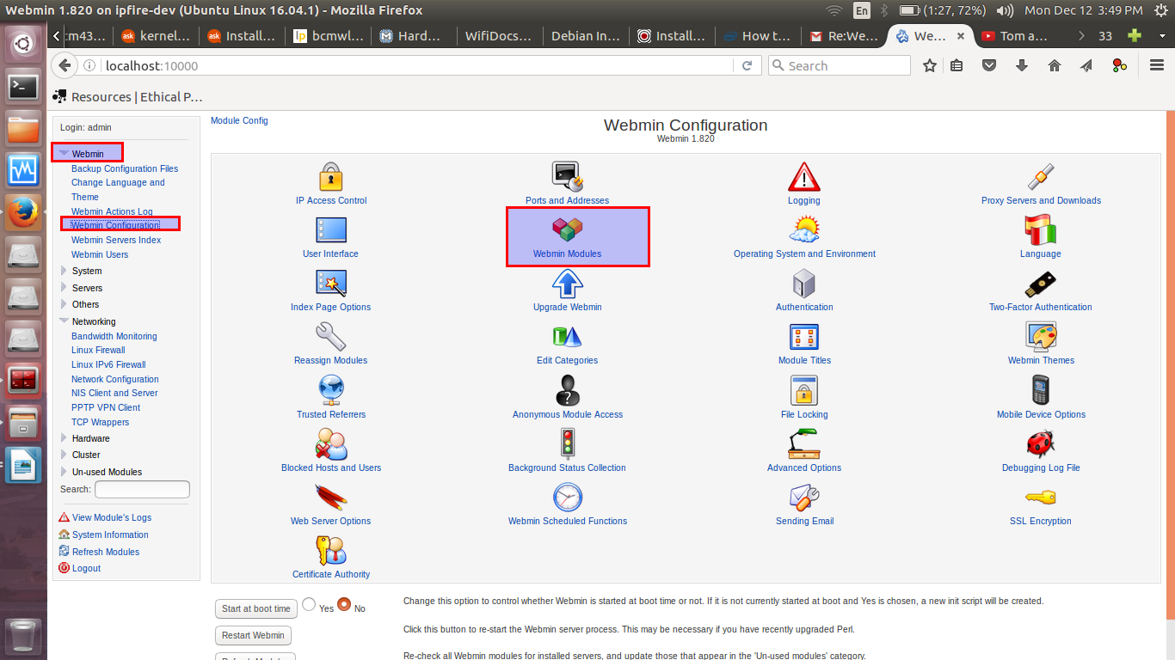

b). After click on Webmin Module, following window appears. Go to Export option, select “Network Configuration (which is net module)” and click on “Export selected Mdoules”.

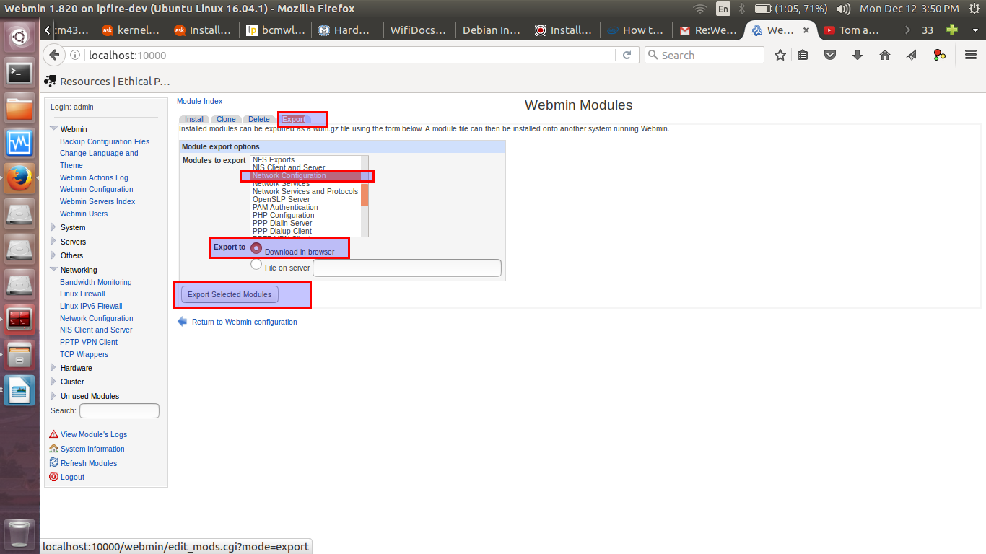
After clicking on “export selected modules”, another window appear to save it on the laptop/PC.

NOTE: both original and custom net module are exported and will be shared with you via FTP/Google Drive.

2. Restore process.

a) Click on Webmin Configuration option ans select Webmin Modules as shown below.

b) click on Webmin Modules options and give path to backup network module (net) as shown below. Please click on yes for Ignore dependencies option.

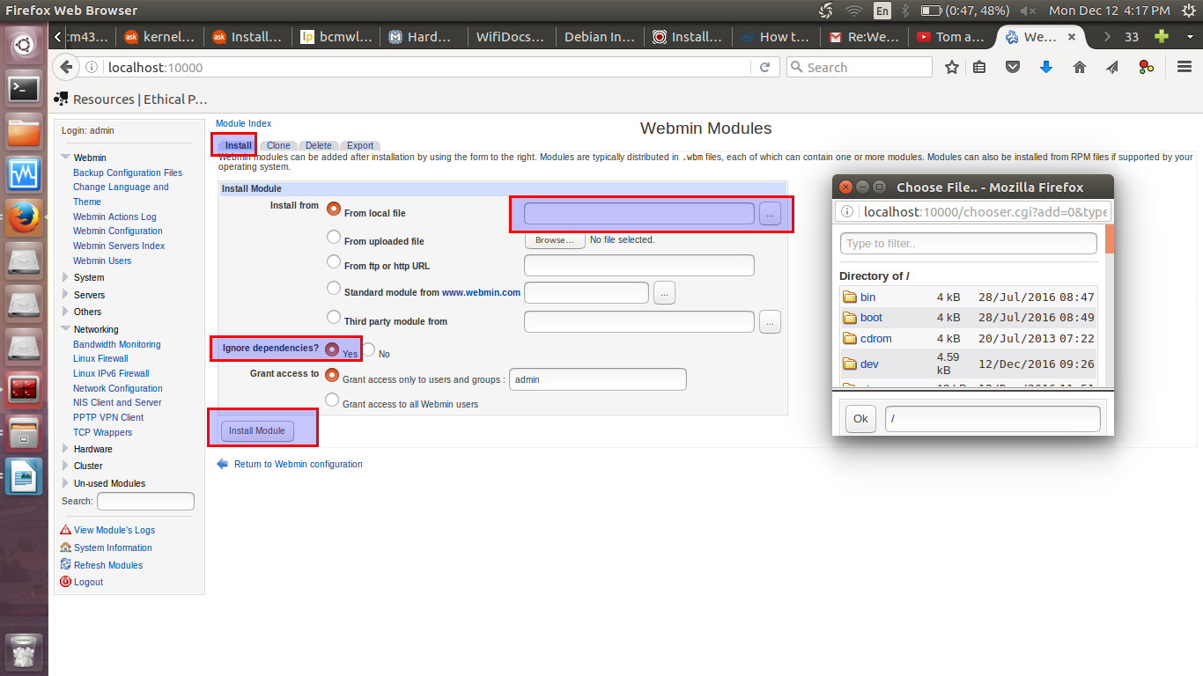

Custom network module path is shown in “from local file” option
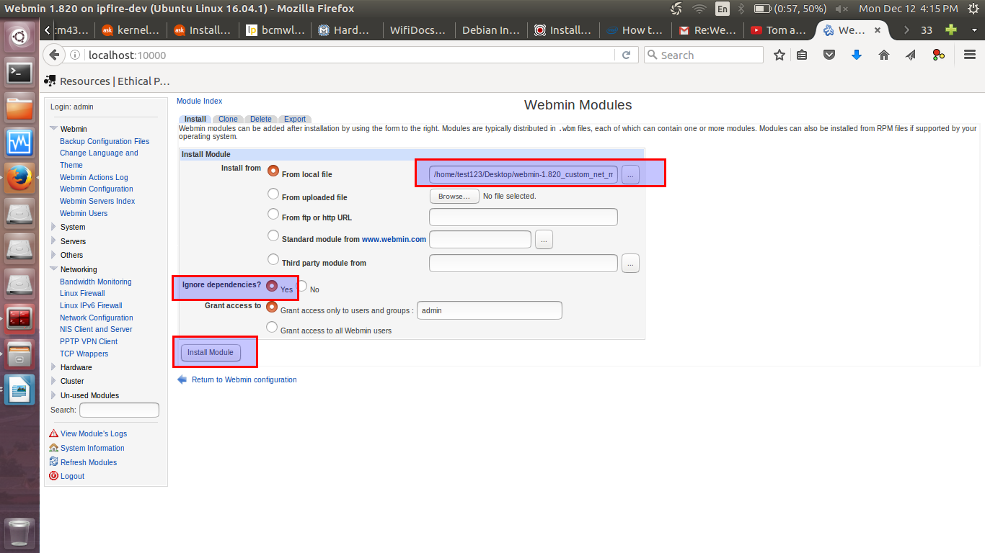

Following window will appear which shows the successful installation of custom netowkr module

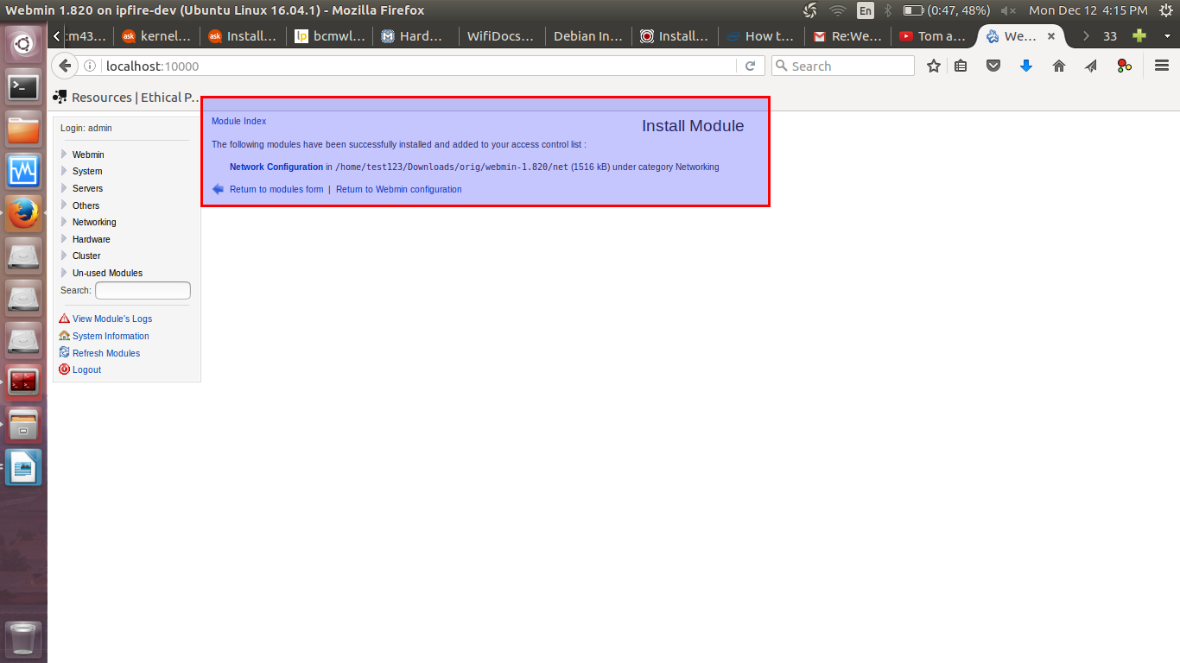

Now, go to Networking tab and see the changed or custom network module.

