Navneet

Security headers

**Table of Contents**

X-XSS-Protection (read here) 2

Payload 2

Code (/WEB-INF/result/X-XSS-Protection.jsp) 2

Experiment 2

Observation #1 2

Access-Control-Allow-Origin (read here) 3

Code: /WEB-INF/result/cors.jsp 3

Experiment 3

Observation #1 3

Cache-Control (read here) 4

Code (/WEB-INF/test/Cache-Control.jsp) 4

Experiment 4

Observation #1 4

Observation #2 5

Referrer-Policy (Read Here) 6

Code (/WEB-INF/test/referrer-policy.jsp) 6

Experiment 6

Observation #1 6

Observation #2 8

X-Frame-Options (read here) 9

Code(/WEB-INF/test/Bank.jsp) 9

Experiment 9

Observation #1 9

Observation #2 9

Content Security Policy (read here) 11

Code(/WEB-INF/test/Content-Security-Policy.jsp) 11

Experiment 11

Observation #1 11

# X-XSS-Protection ([read here](https://developer.mozilla.org/en-US/docs/Web/HTTP/Headers/X-XSS-Protection))

## Payload

* <script>alert(‘XSS’)</alert>

## Code (/WEB-INF/result/X-XSS-Protection.jsp)

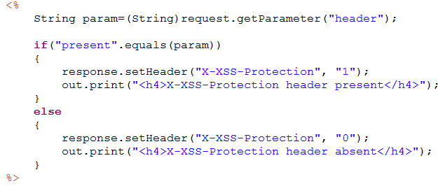

## Experiment

Play around with the following values to observe browser response.

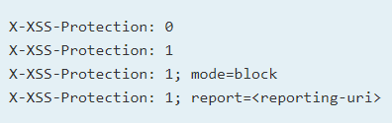

## Observation #1

* X-XSS-Protection: 1

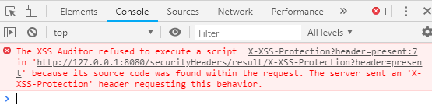

# Access-Control-Allow-Origin ([read here](https://developer.mozilla.org/en-US/docs/Web/HTTP/CORS))

## Code: /WEB-INF/result/cors.jsp

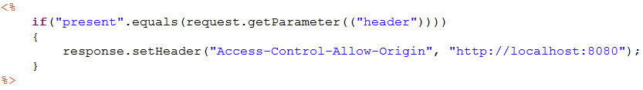

## Experiment

There are various other headers, which you can experiment with -

* Access-Control-Allow-Methods
* Access-Control-Allow-Credentials
* Access-Control-Max-Age
* Access-Control-Expose-Headers

## Observation #1

* Access-Control-Allow-Origin: http://localhost:8080

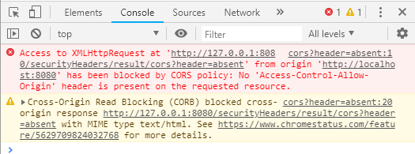

# Cache-Control ([read here](https://developer.mozilla.org/en-US/docs/Web/HTTP/Headers/Cache-Control))

## Code (/WEB-INF/test/Cache-Control.jsp)

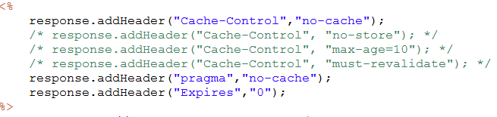

## Experiment

Play around with different cache-control directive to see how it affects browser’s caching behavior.

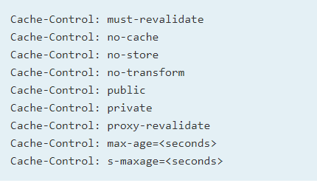

## Observation #1

* Cache-Control: no-cache

Browser actually caches the web page.

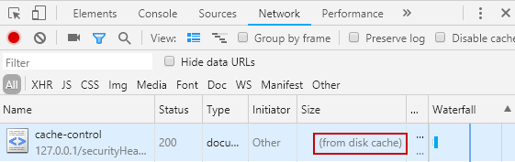

## Observation #2

* Cache-Control: no-store

Browser does not cache web page. Every time it fetches page from server.

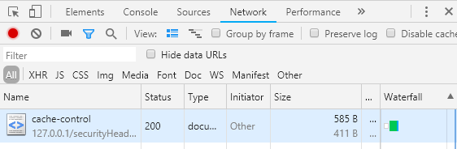

# Referrer-Policy ([Read Here](https://developer.mozilla.org/en-US/docs/Web/HTTP/Headers/Cache-Control))

## Code (/WEB-INF/test/referrer-policy.jsp)



## Experiment

Play around with various directives to see how the browsers behaves.

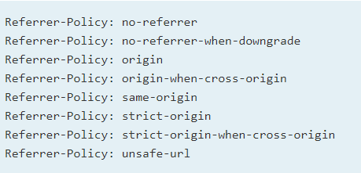

## Observation #1

* referrer-policy: no-referrer

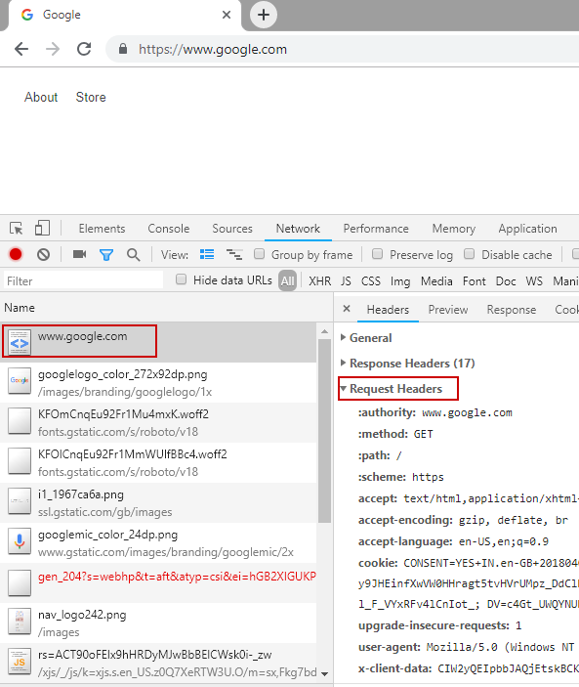

## Observation #2

* referrer-policy:origin-when-cross-origin

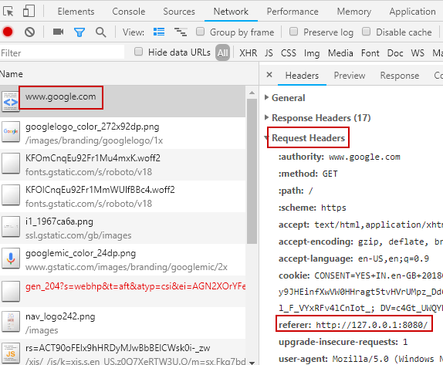

# X-Frame-Options ([read here](https://developer.mozilla.org/en-US/docs/Web/HTTP/Headers/X-Frame-Options))

## Code(/WEB-INF/test/Bank.jsp)



## Experiment

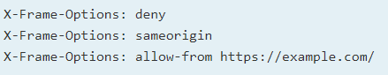

## Observation #1

* X-Frame-Options: sameorigin

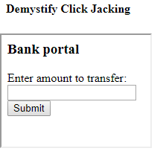

## Observation #2

* X-Frame-Options: deny

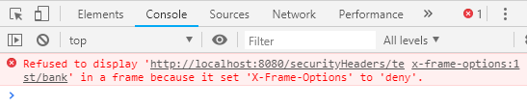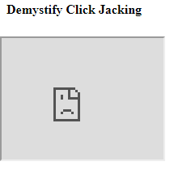

# Content Security Policy ([read here](https://developer.mozilla.org/en-US/docs/Web/HTTP/CSP))

## Code(/WEB-INF/test/Content-Security-Policy.jsp)



## Experiment

There are various options available to experiment with

* report-uri
* unsafe-inline

## Observation #1

