A multi-agent skill pipeline finds no tumor-selective heart-failure ligand–receptor axis across 30 tumor types under rank-based source criteria
Nicolas Avelar^{a,b}, Ruidong Zhang^{b}, Yi Pan^{b}
ª North Oconee High School, Bogart, GA, USA
^{b} School of Computing, University of Georgia, 200 D.W. Brooks Drive, Athens, GA 30602, USA
Corresponding author: Nicolas Avelar, School of Computing, University of Georgia, 200 D.W. Brooks Drive, Athens, GA 30602, USA. E-mail: navelar773@gmail.com

Highlights
- Multi-agent pipeline screened heart-failure ligands against 30 tumor types
- No cardiac-specific ligand had a tumor-enriched receptor under rank-based criteria
- NPR1 is depleted in tumor versus adjacent normal in all 15 testable types
- An expression floor was load-bearing: random sets otherwise reproduced the rank
- Pre-set kill criteria withdrew all seven recovered pleiotrophin axes

Abstract
Background. Heart failure may accelerate tumor growth through circulating factors. Testing this across tumor types is an integration problem increasingly delegated to autonomous agents, whose errors leave no trace in their output.
Methods. A multi-agent system (23 sub-agents in five waves) executed the screen using six reusable skills whose methodological requirements are assertions that halt execution rather than advice. A heart-failure signature from two RNA-seq cohorts (n=64; n=360), re-tested in three microarray cohorts, was intersected with the secretome and a ligand-receptor database and scored against receptor expression in 9,538 TCGA tumors of 30 types.
Results. Under rank-based source criteria, no axis had both a cardiac-distinctive ligand and a tumor-enriched receptor; the negative is definition-dependent: requiring only that the heart exceed the cross-tissue median returns 29 axes. NPR1, the only curated receptor for NPPA and NPPB, was depleted against matched adjacent normal in all 15 testable types (median log2FC -1.91), as were NPR2 and NPR3. Two guardrails proved load-bearing, each written after the pipeline made the error it prevents: without an expression floor, matched random receptor sets reproduced the ranking (rho=0.363 versus 0.107 with it). Failure-induction re-scoring recovered seven pleiotrophin axes, all withdrawn by pre-specified kill criteria.
Conclusions. The negative applies to ligands induced in the failing human ventricle, not to secreted mediators generally; circulating elevation and receiver-cell identity were not measured. A requirement written as an assertion in a reusable skill cannot be silently omitted by the next study.

Keywords
Cardio-oncology; heart failure; ligand-receptor signaling; multi-agent systems; computational reproducibility; pan-cancer transcriptomics

Abbreviations
HF — Heart failure
DCM / ICM / HCM — Dilated / ischemic / hypertrophic cardiomyopathy
TCGA — The Cancer Genome Atlas
GTEx — Genotype-Tissue Expression project
CPTAC — Clinical Proteomic Tumor Analysis Consortium
PDC — Proteomic Data Commons
TMT — Tandem mass tag (quantitative proteomics)
HPA — Human Protein Atlas
GEO — Gene Expression Omnibus
DepMap — Cancer Dependency Map
RSEM — RNA-Seq by Expectation-Maximization (transcript quantification)
RPKM / TPM / CPM — Reads/Transcripts/Counts per kilobase million
FDR — False discovery rate (Benjamini-Hochberg)
logFC — Log fold change
LR — Ligand-receptor
NPPA / NPPB — Natriuretic peptide A- / B-type
NPR1 / NPR2 / NPR3 — Natriuretic peptide receptor 1 / 2 / 3
PTN — Pleiotrophin
AGT / AGTR1 — Angiotensinogen / angiotensin II receptor type 1
CCN2 / CTGF — Cellular communication network factor 2 / connective tissue growth factor
MAGNet — Myocardial Applied Genomics Network
IPF — Idiopathic pulmonary fibrosis
NAFLD / NASH — Non-alcoholic fatty liver disease / steatohepatitis
CI — Confidence interval
ρ — Spearman rank correlation coefficient

1. Introduction
Cardio-oncology has largely studied how cancer treatment damages the heart. The converse direction, whether established heart disease influences the course of cancer, has received attention more recently, and the experimental evidence for it is specific. Transplanting a failing heart into tumor-bearing mice accelerated tumor growth even though the recipient’s own circulation was otherwise unchanged, which points to a factor carried in the blood rather than to altered perfusion or oxygen delivery (Meijers 2018¹). Myocardial infarction accelerates breast cancer growth in mice through changes in the output of bone-marrow-derived myeloid cells (Koelwyn 2020²; Avraham 2020³).
Human evidence is weaker and openly conflicting. Several cohorts report excess cancer incidence following a heart-failure diagnosis (Hasin 2013⁴; Banke 2016⁵; Roderburg 2021⁶). The largest study with adjudicated cancer outcomes and a 19.9-year median follow-up found no association (adjusted HR 1.05, 95% CI 0.86–1.29; Selvaraj 2018⁷). In a national cohort, allowing a two-year lag between diagnoses, which removes cancers likely to have been present but undetected when heart failure was diagnosed, attenuated the hazard ratio from 1.64 to 1.09 (Kwak 2021⁸). Conventional cardiovascular risk factors predict incident cancer about as well as they predict incident heart failure (van den Berg 2026⁹), and clonal hematopoiesis of indeterminate potential, in which an expanded blood-cell clone carries a somatic mutation without overt disease, is a shared substrate for both (Jaiswal 2017¹⁰; Fuster 2017¹¹). Even the direction of effect is unsettled: tumor-bearing mice subjected to pressure overload developed less cardiac hypertrophy and fibrosis than tumor-free controls (Awwad 2023¹²). Of 107 verified records assembled for this work, 21 report findings inconsistent with a causal link from heart failure to cancer.
We do not attempt to settle causality, because no available dataset links heart-failure status to cancer incidence with molecular resolution. We address a narrower question that follows from the mouse experiments and can be tested with existing human data. If the failing heart releases signaling proteins, a tumor can respond to them only if it expresses the corresponding receptors. Two conditions must therefore hold simultaneously for any specific heart-to-tumor signal: the ligand must be released distinctively by the heart rather than by tissues generally, and its receptor must be present in tumor tissue, ideally at higher levels than in the matched normal tissue from which the tumor arose.
Treating the problem as receptor compatibility rather than causation makes it falsifiable, because it can fail in three separable ways. The ligand may not be cardiac-specific, in which case the heart is not a distinctive source. The receptor may not be transcribed in tumor tissue at all, in which case no signal can be received. Or the receptor may be present but no more abundant than in normal tissue, in which case there is no reason to expect a tumor-selective effect. We tested all three across 30 solid tumor types and report where each candidate axis failed.
There is a second reason to report this screen. It was executed by an autonomous agent, and the work involved is the kind now routinely delegated: five public resources in three unit systems, a join at every boundary, and a methodological choice at each join that determines the answer while leaving no trace in the output when it goes wrong. Two of those choices went wrong here, in ways that produced confident and entirely spurious rankings. Both were caught, and the question this paper takes seriously is what to do with a correction once it has been made. Recorded as a sentence in a methods section, it binds nobody, and the next study inherits the text rather than the constraint. We instead packaged the analysis as six reusable skills in which each correction is an assertion that halts execution, and we report both what that changed and what it cost.

2. Material and methods
All analysis is transcript-level and uses public data. Parameter values given here are the values used, not library defaults.
Each step is implemented as a skill: a directory holding a documentation file and a Python module. The documentation is addressed to an agent deciding whether the procedure fits the task in front of it and carries a structured header naming what the module does and when to invoke it. The module is what executes, and is where the methodological requirements live as assertions. Six were written for this analysis, and each subsection below names the one that performs its step. The unit is deliberately larger than a function and smaller than a pipeline, corresponding to the amount of work that recurs across studies of similar shape. Section 2.10 gives the measured properties of the whole set.

2.1 Data sources
Retrieval is the geo-bulk-de and tcga-pancan skills. Heart-failure transcriptomes were GSE116250 (discovery; left-ventricular RNA-seq, submitter-supplied RPKM¹³; 37 dilated cardiomyopathy, 13 ischemic cardiomyopathy, 14 non-failing donors, with the primary contrast pooling the 50 failing hearts against the 14 non-failing) and GSE141910 (validation; MAGNet left ventricle, per-sample log-scale normalized values¹⁴; 166 dilated cardiomyopathy, 28 hypertrophic cardiomyopathy and 166 non-failing donors, with 6 peripartum cardiomyopathy samples excluded, giving 194 versus 166). Group labels were parsed from the series-matrix characteristics fields rather than hardcoded, since hardcoding is the mechanism by which a mislabeled cohort becomes a silent result.
Cross-platform replication (Section 3.10) used three further cohorts, all Affymetrix microarray and none used elsewhere: GSE5406 (194 failing, 16 non-failing; GPL96), GSE57345 (177 failing, 136 non-failing; GPL11532) and GSE1869 (31 failing, 6 non-failing; GPL96).^{15,16} Probe-level values were collapsed to genes by maximum mean intensity with a deterministic tie-break. Probes annotated to several genes were dropped rather than assigned to the first listed gene, and log scale was detected from the values rather than assumed.
Protein abundance (Section 3.12) came from eight CPTAC tandem-mass-tag proteome studies in the Proteomic Data Commons^{17–19}: ccRCC (PDC000127), ovarian (PDC000110), breast (PDC000120), pancreatic (PDC000270), endometrial (PDC000125), lung adenocarcinoma (PDC000153), head and neck (PDC000221) and glioblastoma (PDC000204). Log ratios were taken against the within-plex reference, with aliquots labeled tumor or adjacent normal from the study biospecimen records and assigned to TMT plexes from the experimental design. The GPL9052 sub-series of GSE57345 is a stub carrying no value rows and 6 samples, and was not analyzed.
Tumor transcriptomes came from the GDC PanCanAtlas EBPlusPlusAdjustPANCAN gene-expression matrix. Values are RSEM normalized_count, batch-corrected and upper-quartile scaled; they are neither TPM nor FPKM^{20–23} a distinction that becomes consequential in Section 3.3. Aliquot barcodes were parsed to sample type and study, and analysis retained primary solid tumors only (sample-type code 01), excluding LAML, DLBC and THYM, giving 9,538 tumors across 30 types. Adjacent normal tissue (sample-type code 11) was streamed from the same matrix: 710 samples mapped to a tumor type, of which 680 fall in the 15 types retaining at least 10 normals.
Supporting resources were the Human Protein Atlas protein-class and secretome annotations^{24,25} (search_download.php, columns g,eg,pc,secl,scml,rnats,blconcms); CellChatDB human (CellChatDB.human.rda)²⁶; GTEx v8 median TPM per tissue across 52 tissues²⁷; the Thorsson immune-landscape feature tables, leukocyte fraction, ABSOLUTE purity and TCGA-CDR²⁸ clinical endpoints from GDC²⁹; and DepMap 24Q4 Public (figshare article 27993248). Because depmap.org serves a bot-verification interstitial^{30–32} the DepMap release is resolved through the figshare API and the payload is asserted not to be HTML, since storing an error page as data yields plausible but meaningless output. Non-cardiac fibrosis cohorts for Section 3.9 were GSE150910 and GSE134692 (lung, idiopathic pulmonary fibrosis), GSE126848 and GSE130970 (liver, NASH/NAFLD) and GSE142025 (kidney, diabetic nephropathy).^{33–36} Human heart single-nucleus atlases (Reichart dilated and arrhythmogenic cardiomyopathy; Kuppe myocardial infarction) were obtained via CELLxGENE Census.^{37–39}

2.2 Differential expression and cross-cohort replication
This section is the geo-bulk-de skill. Each cohort was analyzed separately, on its own scale, with an empirical-Bayes moderated t-test equivalent to limma-trend implemented directly in NumPy and SciPy.^{40–42} Genes were retained when expression exceeded 1.0 (RPKM or CPM as appropriate) in at least 20% of the smaller group’s samples, and 65 genes carrying a sentinel value of 999999999.0 were detected and dropped from GSE116250. The prior degrees of freedom fitted to 3.04 in discovery and 4.82 in validation, and the variance trend used a 0.4 lowess fraction. Multiplicity was controlled by Benjamini–Hochberg FDR at 0.05.⁴³ Ensembl identifiers were version-stripped before intersecting the cohorts, yielding 18,061 shared genes.
A gene entered the replicated signature when it reached FDR<0.05 in both cohorts with the same direction of effect. Replication was quantified by directional concordance, log fold-change Spearman correlation, and a hypergeometric overlap test. The overlap test is near-saturated here, since 44.6% and 66.2% of shared genes are significant in the two cohorts, so concordance and effect-size correlation are the informative metrics and the hypergeometric p is reported alongside its fold enrichment. As a negative control, the discovery group labels were permuted (seed 42) and the identical pipeline re-run against the real validation result.
The implementation was validated against canonical limma 3.66.0 with the criterion fixed beforehand: a log fold-change Pearson correlation of at least 0.99 and at least 95% overlap of the FDR<0.05 gene sets, in both cohorts. Agreement is exact to floating-point precision. Pearson and Spearman correlations on log fold change are 1.000000 in both cohorts, with maximum absolute differences of 4×10⁻¹⁴ and 8×10⁻¹⁴, and the FDR<0.05 sets agree at Jaccard 0.9991 and 0.9998. The empirical-Bayes hyperparameters were estimated independently and match (prior degrees of freedom 3.041 against 3.037, and 4.818 against 4.825). Applying the replication rule to the limma output recovers 5,036 genes sharing 5,033 with the signature reported here. Full comparison tables, the least-agreeing variant and the one comparison that could not be made are given in the supplement, and agreement is shown in Supplementary Figure S2.

2.3 Secretome annotation and ligand–receptor mapping
These steps are the hpa-secretome and cellchat-lr skills. Up-replicated genes were annotated against HPA protein classes and tiered as core (predicted secreted and plasma-detectable), extended (secreted only) or none. A rule-based regex flag excluded structural extracellular-matrix families, which are secreted but are not plausible long-range endocrine signals: collagens, laminins, fibrillins, fibulins, elastin and microfibril proteins, fibronectin, nidogens, tenascins, structural proteoglycans and cartilage matrix. Exclusions were logged individually rather than aggregated into a count. The HPA response was required to parse as TSV with more than 10,000 rows, which guards against storing an error page as data.
Surviving ligands were mapped to CellChatDB, with analysis restricted to the Secreted Signaling annotation class. Heteromeric receptors were expanded to their constituent subunits, so that a receptor complex is scored on its obligate parts rather than on a single representative gene.

2.4 Two-factor compatibility score
This section and Sections 2.5 to 2.8 are the crosstalk-score skill, where the methodological risk concentrates and where 13 of the 141 guardrail checks sit. For each ligand–receptor interaction and each tumor type:
Receptor capacity. Subunit expression is aggregated per interaction using a minimum rule, which encodes obligate-subunit semantics: a complex cannot signal above the level of its scarcest component. A geometric-mean rule was run as a sensitivity analysis.
Expression floor (mandatory). Aggregated capacity must exceed an absolute floor set at 0.005 × the median GAPDH level across per-tumor-type medians. Expressing the floor relative to a housekeeping gene makes it unit-agnostic and therefore portable across platforms. In this matrix the median GAPDH value is 69,134.5, giving a floor of 345.7 RSEM normalized_count. The validator raises by default and names the offending receptor; interactions failing it in every tumor type are dropped before scoring rather than down-weighted.
Standardisation and weighting. Floor-passing capacities are z-standardized per receptor across tumor types, then averaged across interactions weighted by ligand availability, defined as the mean replicated log fold change of the ligand across the two heart cohorts.
Uncertainty and stability. Bootstrap 95% confidence intervals over 400 resamples (seed 20260727); leave-one-ligand-out and leave-one-pathway-out re-ranking; the geometric-mean complex rule; an unweighted variant; and a double-centered variant removing both row and column means.

2.5 Specificity null
The load-bearing validator asks whether a ranking is receptor-specific or merely tracks a global per-tumor expression axis. Each real receptor subunit is replaced by a random gene matched on mean-expression decile, the score is recomputed, and the null ranking is correlated against the observed one, over 300 iterations at seed 20260727. The background pool comprises 200 genes drawn 20 per decile from equal-count deciles of transcriptome-wide median expression across the 9,538 retained tumors, excluding the target panel and its legacy aliases. Four configurations were run: with the floor (primary), without it, from a uniform rather than decile-matched pool, and double-centered. A per-tumor-type empirical p is the fraction of null draws whose score equals or exceeds the observed one.

2.6 Ligand and receptor specificity criteria
Ligand (source) criterion. A ligand is cardiac-distinctive if the heart ranks first among the 52 GTEx tissues by median TPM and reaches an abundance plausible for a circulating signal.
Receptor (receiver) criterion. Because TCGA RSEM and GTEx TPM cannot be placed on a common scale, two independent strategies were used and required to agree. The first is a background-corrected percentile-rank comparison, in which each gene is converted to a within-dataset percentile among the same 1,379 genes shared by both matrices, separately per tumor type and per GTEx tissue, and the percentile delta is placed against the distribution of the same delta for all 1,379 background genes in that pair; enriched means top decile and positive, depleted bottom decile and negative. The second is a genuinely unit-matched log fold change against TCGA adjacent normal from the same source matrix, with BH-FDR within tumor type. No absolute value was subtracted, divided or plotted across the two platforms, and cross-dataset direction claims are ordinal only.
An axis survives only if the ligand criterion and the receptor criterion both hold.

2.7 Induction-based source criteria
Because the criterion in Section 2.6 scores the healthy heart, it is structurally unable to detect a ligand induced only in failure, which is a material limitation for a hypothesis about failing myocardium. A corrected definition was pre-specified before any computation, with three criteria, each computed within a single dataset so that no cross-platform absolute comparison is implied. A1 requires replicated induction of at least 1.0 log unit at FDR<0.05 in both heart cohorts. A2 requires abundance of at least 0.005 of GAPDH inside each heart cohort, the same housekeeping-relative device used for the tumor floor. A3 requires the heart to rank in the upper half of the 52 GTEx tissues rather than first. The receptor side was left unchanged. A pass required at least one surviving axis, with a guard declaring the criterion uninformative above twenty.

2.8 Adversarial tests of recovered axes
Kill criteria were fixed before any computation, with the receptor base rate measured before thresholds were chosen so that they could not be set to flatter the result. Retention required all three tracks to survive.
T1, receiver discrimination. The ligand-free base rate at which the 81 floor-passing receptors satisfy the receiver criterion in at least one tumor type, declared uninformative at 60% or above; a matched-random null substituting the candidate receptor set with expression-decile-matched sets of equal size, 1,000 permutations at seed 20260729, requiring the observed count to exceed the null’s 95th percentile; and pairwise co-expression among the candidate receptors, where a mean Spearman ρ of 0.7 or above would indicate that one observation was being reported several times.
T2, tissue generality. The same moderated-t pipeline applied to five non-cardiac fibrosis and organ-failure cohorts, each cohort’s normalization kept separate and COL1A1 required as a positive control. The criterion fails if the ligand is significantly induced in at least two cohorts at a median of at least 50% of the cardiac effect. Cell of origin was resolved in two single-nucleus atlases by per-cell-type expression share and by donor-level pseudobulk tests within the dominant cell type.
T3, literature. A PubMed search for circulating measurements of the ligand in heart failure. Published evidence contradicting a cardiac plasma source is a kill criterion.
Conjunction rule. Where a hypothesis generated three predictions (Section 3.10), all three were required to hold in the pre-specified direction. A single significant result with the others opposing is recorded as a failure, and any secondary read conditional on the conjunction was not performed when the conjunction failed. Survival analysis used Cox models⁴⁴ with the receptor z-scored within tumor type and stratified by type, and copy-number loss was tested against 1,000 loci matched on chromosome arm and overlapping-segment length.

2.9 Dependency screen
This section is the depmap-lineage skill. Per-lineage CRISPR gene effect was averaged across cell lines within each DepMap OncotreeLineage, then correlated (Spearman, BH-FDR) against the compatibility score of the TCGA types to which that lineage maps. The mapping was passed explicitly rather than inferred, and at least 5 screened lines per lineage were required, retaining 22 of 31 lineages. A gene effect below −0.5 was treated as a dependency, and essential and non-essential genes were carried as parsing controls.

2.10 The six skills, measured
Table 1. The six analytical skills, their function, and their load-bearing guardrails. Line, function, and guardrail counts are totals across all six modules as measured by static scan (Section 2.10); the distribution across modules is given in the text.
Skill (module) | Function | Representative guardrails
geo-bulk-de | GEO retrieval; empirical-Bayes moderated-t differential expression (limma-trend equivalent) | Detects and drops sentinel-value placeholders; detects log scale rather than assuming it; parses group labels from series-matrix fields rather than hardcoding them
hpa-secretome | HPA protein-class annotation and secretion tiering (core / extended / none) | Rejects a response that is not a >10,000-row TSV (guards against silently storing an HTML error page as data)
cellchat-lr | Ligand-receptor mapping via CellChatDB; receptor-complex subunit expansion | Restricts mapping to the Secreted Signaling annotation class; scores obligate complexes on their scarcest subunit
tcga-pancan | Memory-bounded streaming of the PanCanAtlas expression matrix; sample-type parsing | Excludes non-solid-tumor types (LAML, DLBC, THYM); separates primary tumor from adjacent-normal by aliquot barcode
crosstalk-score | Two-factor (availability × capacity) compatibility scoring | Mandatory expression floor (0.005×GAPDH) before any receptor is scored; expression-matched null construction (not a naive random pool); conjunction rule that raises rather than records a partial pass. Carries 13 of the 141 total guardrail checks.
depmap-lineage | CRISPR dependency screen via DepMap, aggregated per lineage | Resolves the DepMap release via the figshare API and asserts the payload is not HTML; requires an explicit (not inferred) lineage-to-tumor-type mapping and a minimum of 5 screened lines per lineage
The six modules total 4,858 lines of Python containing 114 functions, with 1,522 lines of accompanying documentation. Their third-party dependencies are NumPy, pandas, SciPy, statsmodels and requests^{45,46} with rdata required for one optional file reader; everything else is standard library. They contain no language-model call, no API key and no platform function, and a scan of all six executable modules for those returns zero in every category. That property is what makes the rest of this paper checkable, since every figure and table below is the output of code no model participated in executing, and the modules return the same numbers whichever agent invoked them or whether one did at all. The claim covers the module rather than the whole skill, since the documentation is addressed to an agent and is not executable, and no result here depends on how an agent reads it.
Across the six there are 141 executable guardrail checks: 78 assertions and 63 explicit raises. The distribution is informative rather than uniform. The scoring module, where the methodological risk concentrates, carries 13; the retrieval module, which handles heterogeneous public data and must reject malformed input in many ways, carries 47. Three are load-bearing for the results below and are named where they act. The expression floor refuses to score a receptor whose abundance falls below an absolute threshold, and raises an error naming the gene (Section 3.3). The null constructor refuses to draw a background set not matched on expression level (Section 3.3). The conjunction rule refuses to record a partial conjunction as a pass, so an axis satisfying two of three criteria cannot be counted as surviving (Section 3.9).
The distinction this draws is between a check a reader must choose to honor and a check a caller cannot avoid. A reader of a methods section can omit the floor without producing anything that looks wrong. A caller of this module cannot, because omitting it produces an exception rather than a number.
Random seeds were fixed as follows: 20260727 for the specificity permutation and the bootstrap, 42 for the differential-expression label permutation, 20260728 for the induction-criteria phase, and 20260729 for the adversarial receptor null. All computation used double precision.

2.11 The multi-agent system that ran the analysis
The analysis was executed by a hierarchical multi-agent system rather than by a single agent working serially. Because the call for reliability evidence in this area is specific, we report the topology and its failures as measured quantities rather than as description.
One orchestrating agent held the research question and the artifact store, and independent sub-agents were dispatched to tracks that could proceed without each other’s intermediate state. Twenty-three sub-agent frames ran in five waves over 91.4 hours of wall-clock time (Fig. 1). Wave 1 split the four data-acquisition tracks that share no inputs (heart-failure signature, secretome and ligand–receptor mapping, tumor expression axis, literature corpus) together with the dependency screen and normal-tissue comparison. Wave 2 ran five follow-up tests of the negative. Wave 3 ran the two orthogonal-molecule tracks, proteome and platform replication. Wave 4 ran six verification tracks, including two independent audits of the manuscript’s own claims. Wave 5 ran the implementation validation, the sensitivity sweeps and the citation expansion.
Each sub-agent received a task statement and a context summary rather than the orchestrator’s conversation, and returned results as artifacts plus a structured output object. This isolation is the principal justification for partitioning the work, since a sub-agent cannot inherit an assumption the orchestrator formed earlier, and two of the wave-4 audit tracks were dispatched specifically to check claims the orchestrator had already written down.
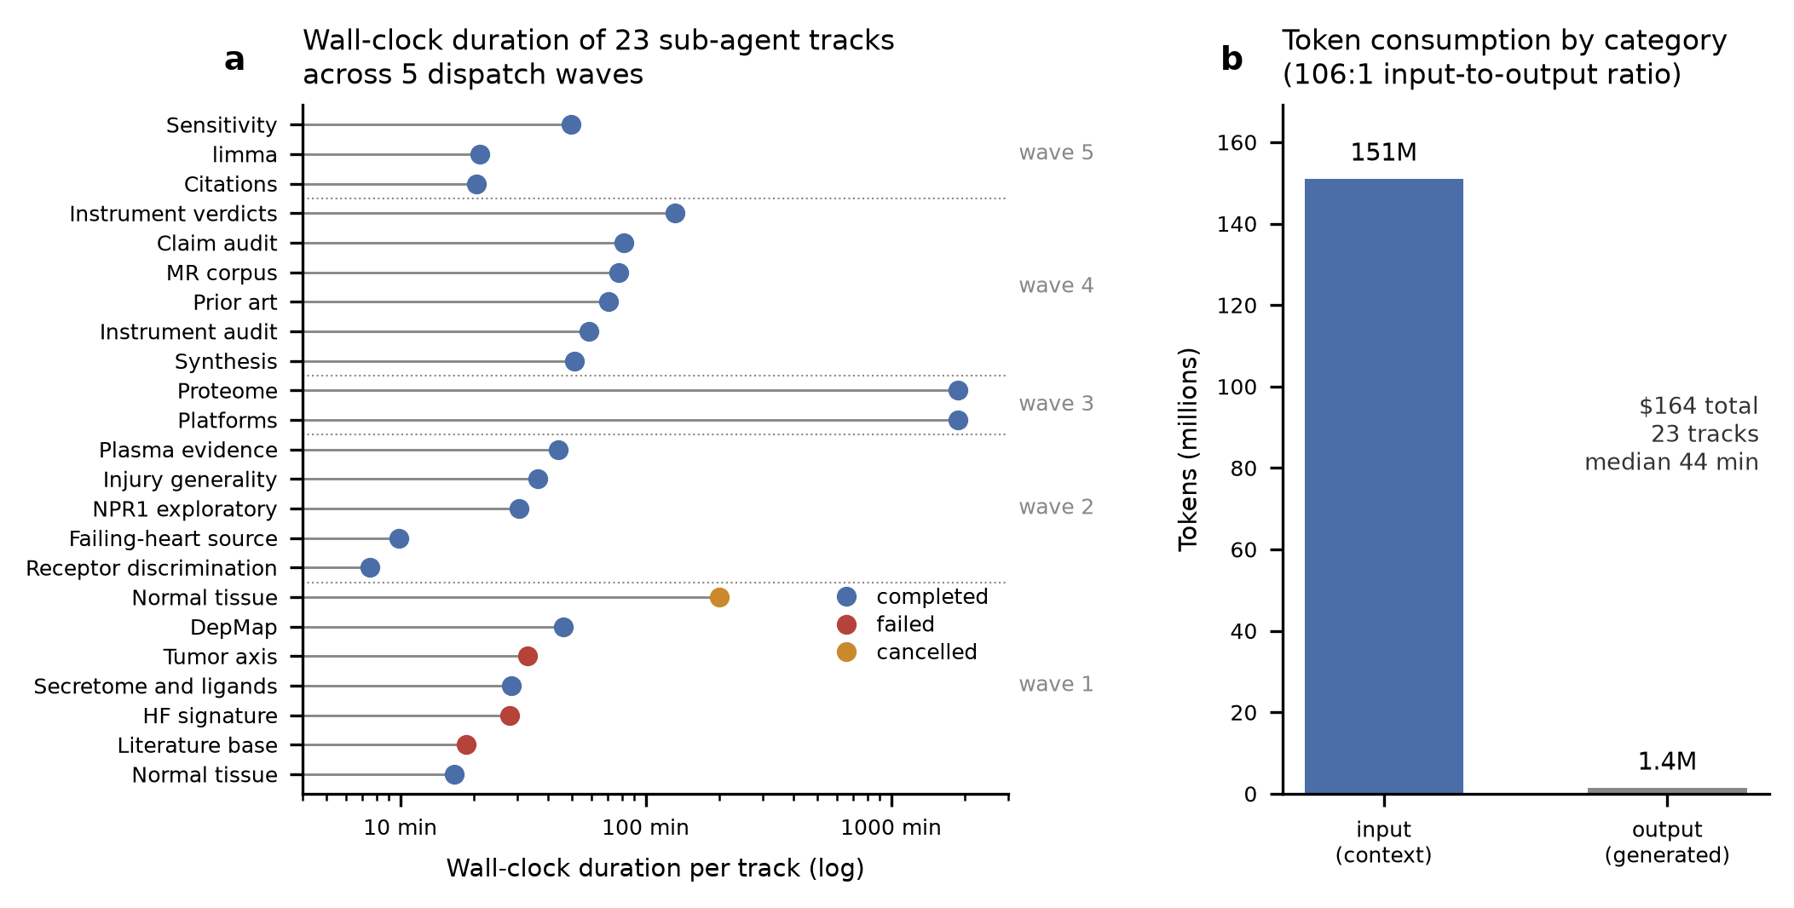
Figure 1. The multi-agent system that executed the analysis. (a) Wall-clock duration of each of the 23 sub-agent tracks, grouped into the five dispatch waves and colored by terminal status. The two longest tracks (Proteome, Platforms) include time parked on user approvals for network access. All four non-completing tracks had already written their results to the artifact store, and every one of those artifacts is cited in this paper. (b) Token consumption across the fleet. Cost is context rather than generation, which is why re-running the analysis from the six skills requires no model at all. Per-track figures are given in delegation_record.csv.
Nineteen of twenty-three tracks reached completion normally. Three terminated in a failed state and one was cancelled after 199 minutes when it exceeded its memory budget on an 8 GiB machine, and was re-dispatched with a streaming implementation. The instructive part is what happened to the work. All four non-completing tracks had already written their results to the artifact store, and every one of those artifacts is cited in this paper. Failure occurred at the reporting boundary rather than in the analysis, because results were persisted as artifacts as they were produced rather than returned only in a final message. A system that returns work only on successful completion would have lost four tracks and roughly 27 hours of compute.
The sub-agent fleet consumed $164 at 2026 API prices, with an input:output token ratio of 106:1, so essentially all of the cost is context rather than generation. Median track duration was 44 minutes. This is the figure that makes the division of Section 4.7 practical rather than rhetorical, since the deterministic modules those agents called cost nothing per invocation, and re-running the entire computational analysis from the six skills requires no model at all.

3. Results

3.1 A replicated human heart-failure signature
Differential expression in GSE116250 (50 failing hearts, of which 37 dilated and 13 ischemic cardiomyopathy, against 14 non-failing) recovered the expected cardiac stress programme: NPPA logFC +3.91 and NPPB +3.97, with MYH6 (−0.61) and ATP2A2 (−0.44) down, as expected in failing myocardium. GSE116250 distributes RPKM rather than counts, so a limma-trend-equivalent moderated t on log(RPKM+1) was used, and 65 genes carrying a sentinel value of 999999999 were detected and removed before analysis.
Validation in the larger MAGNet cohort (GSE141910; 194 cardiomyopathy against 166 non-failing donors) replicated the signature. Of 18,061 shared genes, 5,717 were significant in both cohorts and 5,036 shared direction, a directional concordance of 0.881 that rises monotonically with discovery effect size, from 85% at |logFC|<0.5 to 95% above 1.0. Effect sizes correlated at Spearman ρ=0.541 across all shared genes and ρ=0.759 among those significant in both.
Two cautions matter. The hypergeometric overlap test returns p=2.1×10⁻³ but only 1.07× enrichment: with 8,052 and 11,949 significant genes respectively, the test is near-saturated and is not evidence of replication despite the p-value, so directional concordance and effect-size correlation are the informative metrics. Separately, a label-permutation control run through the identical pipeline returned 0 significant genes and ρ=−0.134 against the real validation result, confirming that the pipeline does not manufacture concordance (Fig. 2).
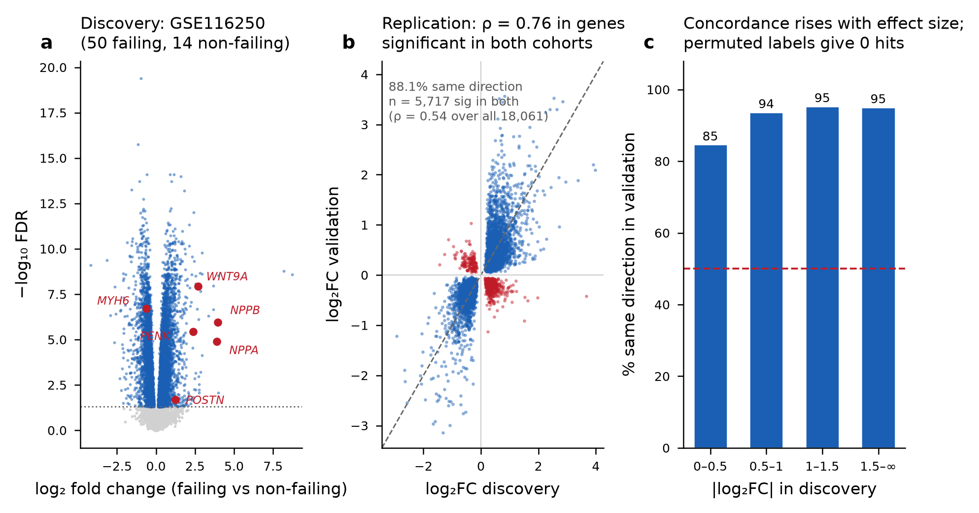
Figure 2. Replication of the heart-failure expression signature. (a) Discovery volcano, GSE116250 (50 failing, 14 non-failing left ventricle); empirical-Bayes moderated t, Benjamini-Hochberg FDR. (b) Cross-cohort effect-size concordance among the 5,717 genes significant in both cohorts (Spearman rho=0.759; rho=0.541 across all 18,061 shared genes); red points disagree in direction. (c) Directional concordance rises with discovery effect size, from 85% below |log2FC| 0.5 to 95% above 1.0. Validation cohort GSE141910 (194 cardiomyopathy, 166 non-failing). Label permutation returned 0 significant genes.
Pooling cardiomyopathy etiologies does not mask a secreted signal. Re-deriving differential expression within each etiology separately against the same controls, 12 of the 42 upregulated secreted ligands are induced in one etiology and not the other (POSTN, INHBA, HBEGF, CCL3, NTF3, LGALS9, CCL5, CCL4, BMP4, WNT10B, CX3CL1 and MSTN), but none is cardiac-enriched at GTEx rank 1 and only five are abundant, so none would have passed the criteria NPPA and NPPB passed. Label-permutation controls returned no significant genes in all four stratified contrasts. The ischemic and hypertrophic strata are small, at 13 and 28 samples, so a null there is weak evidence of absence rather than evidence of a null.

3.2 From signature to candidate crosstalk network
Of 3,084 replicated HF-upregulated genes, 295 are annotated as secreted by the Human Protein Atlas and 70 are CellChatDB ligands of any annotation class, 50 of them within Secreted Signaling. Restricting to Secreted Signaling, the only annotation class mechanistically plausible at a distance, gave 188 interactions from 51 ligands across 38 pathways, with receptor complexes expanded to 103 constituent subunits. Ligand availability was computed as the mean replicated effect size scaled by secretion tier; the highest were NPPA (3.05), NPPB (3.03), PENK (2.85) and WNT9A (2.32).

3.3 The absolute expression floor as a determinant of the result
TCGA PanCanAtlas values are RSEM normalized counts rather than TPM. The median GAPDH value across the 30 per-tumor-type medians is 69,134, so any floor expressed in transcript-per-million terms is meaningless in this matrix, and a familiar TPM threshold imported from elsewhere would return a number that carried no information. The floor was therefore defined relative to a housekeeping gene: 0.005×GAPDH = 345.7 in these units.
Twenty-eight of 188 interactions fall below it in every one of the 30 tumor types. These include all four proenkephalin-to-opioid-receptor axes (OPRD1, OPRK1, OPRL1, OPRM1), where OPRD1 reaches at most 4×10⁻⁴ of GAPDH, OPRM1 5×10⁻⁴ and OPRK1 1.4×10⁻³. PENK is the third most available HF ligand, so an unfiltered analysis would have nominated the opioid axis prominently, whereas the entire pathway is non-viable on receptor-expression grounds.
The floor is not hygiene; it is what makes the score interpretable. Under an expression-matched random receptor null (300 permutations, seed 20260727), the mean ρ against the observed ranking and the fraction of draws exceeding ρ=0.5 were as follows.
No floor applied: ρ = 0.363, with 21.5% of draws exceeding 0.5.
Floor applied (primary): ρ = 0.107, with 1.7%.
Floor applied, double-centered: ρ = 0.034, with 1.0%.
Unmatched (naive) random pool: ρ = 0.323, with 17.0%.
The global expression-axis confound affecting co-expression rankings is therefore attributable in large part to the scoring of untranscribed receptors; their removal renders the ranking receptor-specific. The null pool must additionally be expression-matched, since an unmatched pool yields ρ=0.323 and would incorrectly reject a receptor-specific score (Fig. 3).
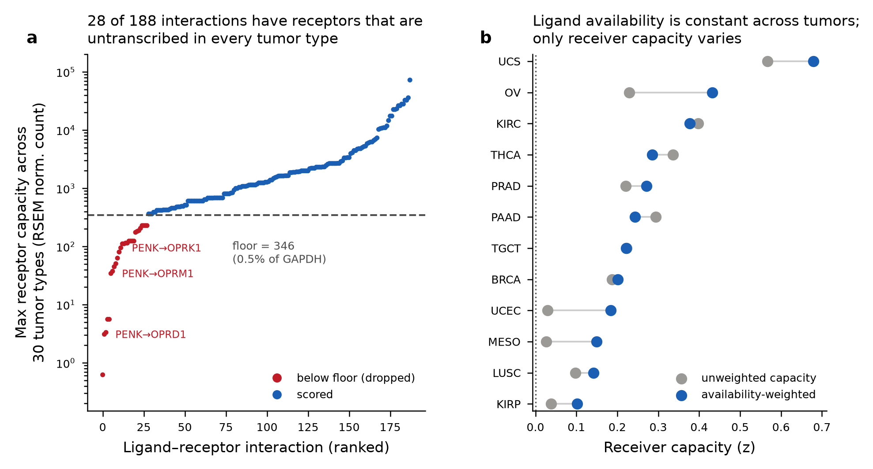
Figure 3. The expression floor and the two-factor decomposition. (a) Floor audit across all 188 candidate interactions; 28 (red) never clear the floor of 0.005xGAPDH (345.67 RSEM normalized counts) in any of the 30 tumor types, including all four PENK-opioid axes at 4x10-5 to 3x10-3 of GAPDH. (b) Two-factor decomposition of the compatibility score into ligand availability and receiver capacity. Availability is a property of the source and is constant across receivers, so only capacity can explain differences between tumor types.
The floor value is not tuned, but neither does it sit on a broad plateau. A pre-registered plateau test asked whether, across a fourfold window from 0.0025 to 0.01 of GAPDH, the null correlation stayed below 0.20, the count of types beating the null stayed within one of four, and pass-set membership changed by at most one member. It fails two of the three. The pass set is identical at 0.0025 and 0.005 (UCS, BRCA, KIRC, PAAD), so the published value is not perched on a knife edge. However, the null correlation falls monotonically across the whole sweep with no flat region (ρ = 0.295, 0.201, 0.113, −0.021, −0.161 and −0.184 at fractions 0.001, 0.0025, 0.005, 0.01, 0.025 and 0.05), and a twofold move to 0.01 changes the pass set to BRCA, KIRC, OV, THCA and UCS, gaining two types and losing one. The defensible reading is that a floor is necessary and any value in this range makes the score receptor-specific, while the identity of the four passing types is sensitive to the exact fraction. Combined with the background-pool result below, the count is better reported as four of 30 with a range of three to seven across defensible choices.
Three hundred permutations resolve the reported p-values. Because the smallest reported value, 0.003, is 1/300 and therefore at the resolution limit, the principal null was re-run at 1,000, 5,000 and 20,000 draws. The set passing p<0.05 is exactly UCS, BRCA, KIRC and PAAD at every depth, and no type crosses the threshold as depth increases. At 20,000 draws UCS sits at 0.0022 with room below it, so the published value is a real quantity rather than a floor artifact, and ovarian carcinoma reaches 0.055 without ever passing. Monte Carlo standard error for UCS falls from 0.0047 to 0.00033 over that range, so deeper permutation would not change any conclusion.
The decile-matched null is insensitive to bin width and sensitive to pool composition. Varying the matching from 2 to 40 bins moves the null correlation only between 0.113 and 0.143, always far below the 0.30 threshold at which the score would be judged non-specific, and the passing count stays within one of four. At 40 bins the correlation begins to rise as bins become too thin to draw from, which places the sound operating range at 10 to 20 deciles. Pool composition matters more than width: a stratified background pool gives seven passing types rather than four, which is the upper end of the range quoted above.

3.4 Pan-cancer compatibility ranking and its statistical resolution
Scoring the 160 floor-passing interactions ranked uterine carcinosarcoma first (0.679, bootstrap 95% CI 0.400–0.914, rank SD 0.55 over 400 resamples), followed by ovarian serous cystadenocarcinoma (0.432), clear-cell renal carcinoma (0.377), thyroid (0.285), prostate (0.272) and pancreatic adenocarcinoma (0.244). Only 4 of 30 types beat the matched-random null at p<0.05: UCS (p=0.003), KIRC (p=0.013), BRCA (p=0.010) and PAAD (p=0.033). Ovarian carcinoma, ranked second by score, is not among them (p=0.060). Rank order and receptor-specificity are therefore not the same thing, and a high score alone is insufficient grounds to nominate a tumor type.
Stability controls pass. Leave-one-ligand-out preserves the ranking at minimum ρ=0.907 (worst case WNT9A) and leave-one-pathway-out at ρ=0.842 (WNT, the largest single contributor at 40 of the 160 floor-passing interactions, or 80 rows once receptor complexes are expanded to subunits). Switching the receptor-complex rule from minimum-of-subunits to geometric mean gives ρ=0.908, and removing availability weighting altogether gives ρ=0.922, so no single ligand, pathway or parameter choice drives the result.
One control does not pass. Double-centering, which removes additive row and column effects, reorders the ranking substantially, at ρ=0.318 against the primary, promoting adrenocortical carcinoma to first and demoting UCS to sixth. Ovarian carcinoma is the only type in the top two under both variants. The ranking is correction-sensitive, and mid-table positions should not be interpreted (Fig. 4).
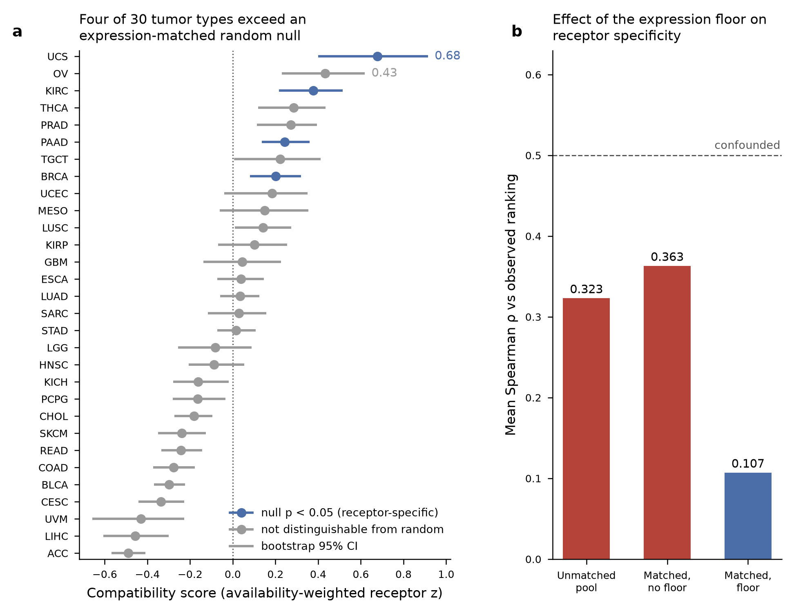
Figure 4. Pan-cancer compatibility ranking against an expression-matched null. (a) Compatibility score for each of 30 tumor types with 95% bootstrap confidence intervals (400 resamples, seed 20260727); the 4 types shown in blue exceed the expression-decile-matched random null at p<0.05 (UCS 0.003, BRCA 0.010, KIRC 0.013, PAAD 0.033). Ovarian carcinoma ranks second by score but does not pass (p=0.060). Individual positions are not interpretable: the ranking reorders substantially under double-centring (ρ=0.318 against the primary ranking). (b) Mean null correlation under three background constructions, showing that the absolute expression floor rather than the expression matching is what renders the score receptor-specific.

3.5 The exploitation component of the hypothesis is unsupported
Our hypothesis held that susceptibility depends on the ability to receive and then exploit cardiac signals. Availability is constant across tumor types by construction, so only receiver capacity can explain differences. Testing capacity against 29 Thorsson immune-landscape features, substituting for TIMER2, which was unreachable, only one survives FDR correction: B-cell receptor score (ρ=0.571, FDR=0.028). Leukocyte fraction, stromal fraction, TGF-β score, proliferation and wound-healing signatures are all null. Receptor compatibility and microenvironment state are therefore largely independent axes, and we found no evidence for the exploitation component as formulated.

3.6 Absence of correspondence between receptor expression and lineage dependency
Using DepMap 24Q4 Public (1,178 cell lines, resolved via figshare article 27993248 because depmap.org serves a bot interstitial), we correlated per-lineage CRISPR gene effect against compatibility for 81 floor-passing receptors across 22 mapped lineages. Positive controls confirm correct parsing: as pan-cell-line means, RPL3 −2.53, PLK1 −2.69, POLR2B −2.42 and EEF2 −2.35, with non-essential MYT1 −0.02 and HBB +0.16. Aggregated per lineage instead, the same genes give −2.55, −2.67, −2.40 and −2.37. The two aggregations are reported separately because only the per-lineage values enter the correlation below.
No receptor is significant after FDR correction (0 of 81, 3 nominal; minimum FDR 0.784). Furthermore, the receptors on the highest-ranked axes are not dependencies in any lineage. NPR1 has a pan-lineage mean gene effect of −0.163, and every WNT9A receptor subunit lies between LRP5 (−0.163) and FZD6 (+0.146), with no lineage cell crossing −0.5. The eight receptors that are dependencies (NCL, ITGAV, EGFR, ITGB5, ITGB1, ERBB2, FGFR1, IGF1R) are pan-essential or canonical adhesion and RTK genes whose essentiality is lineage-driven and unrelated to HF ligand availability.
This is a meaningful distinction rather than a disappointment. Receptor expression licenses a cell to receive a signal, but its loss need not impair proliferation in vitro. The nominated axes are candidate signaling conduits rather than drug targets, and should be tested by ligand stimulation with a pathway reporter rather than by viability knockout (Fig. 5).
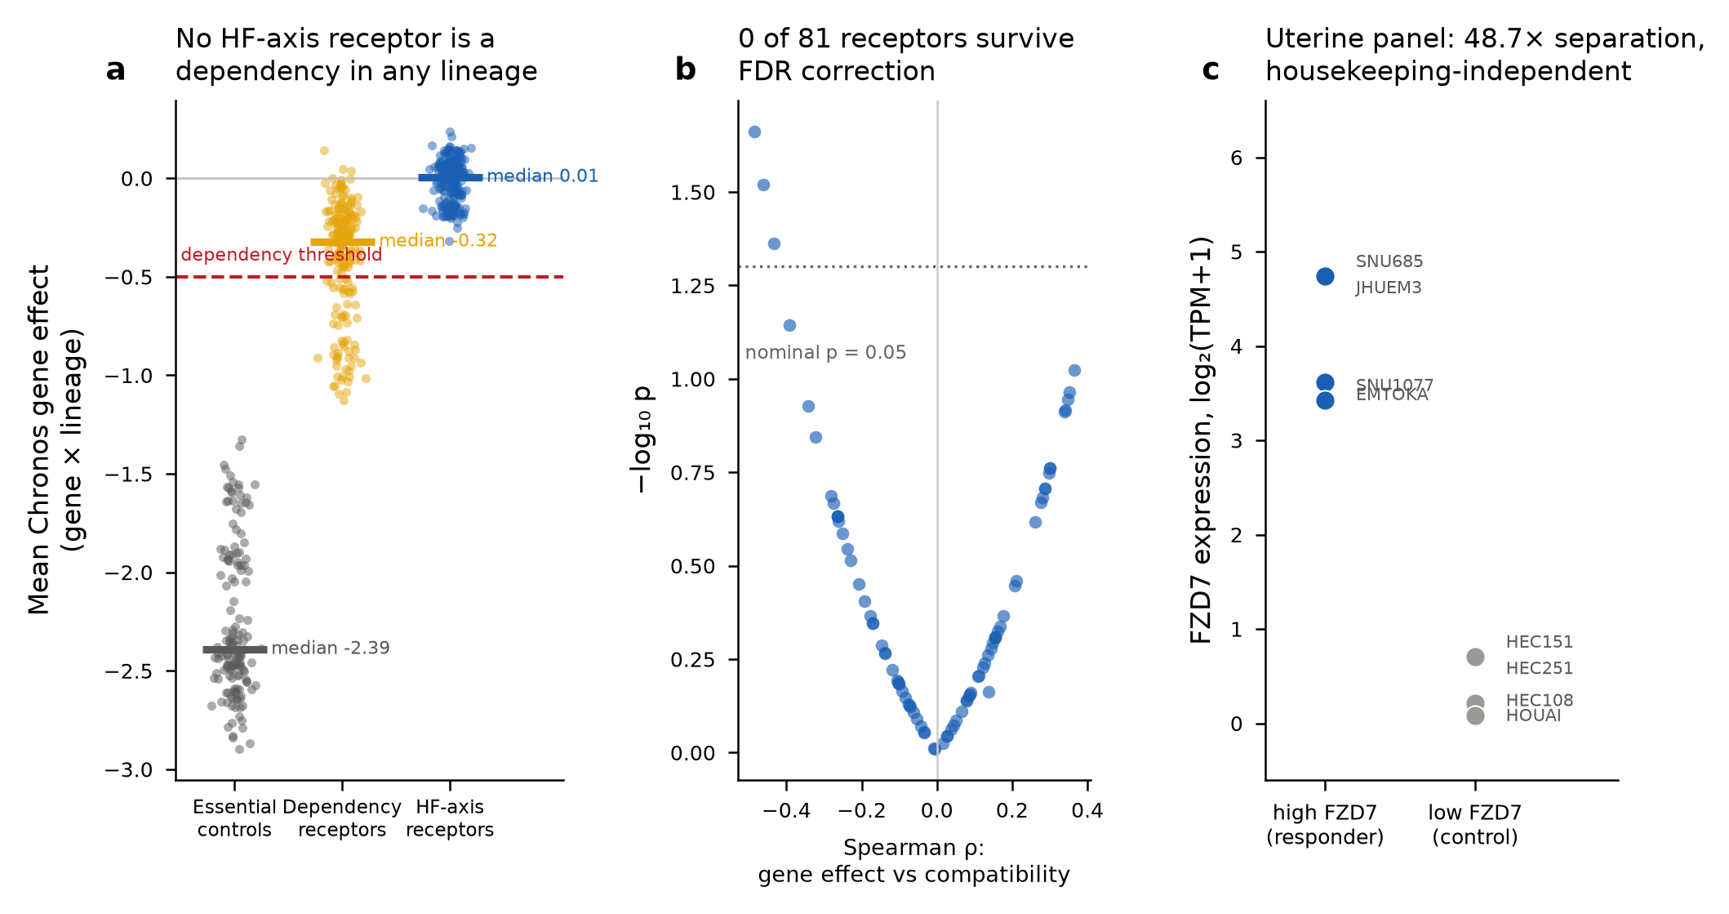
Figure 5. Receptor expression does not correspond to CRISPR dependency. (a) Mean Chronos gene effect for the 81 floor-passing HF-axis receptors against essential and non-essential controls across 22 DepMap 24Q4 lineages; HF-axis receptors cluster at zero while essential controls sit near -2.4 (RPL3 -2.53, PLK1 -2.69). (b) Correlation between per-lineage gene effect and compatibility score; no receptor survives Benjamini-Hochberg correction (0 of 81, 3 nominal, minimum FDR 0.784). (c) Proposed uterine cell-line panel for a WNT9A-FZD7 test, with 48.7-fold FZD7 separation between the high and low arms.

3.7 Specificity checks under a healthy-heart ligand filter
Two questions determine whether any axis is meaningful: whether the ligand is distinctively cardiac, and whether the receptor is tumor-enriched.
Across 52 GTEx tissues, only 2 of 42 floor-passing HF-upregulated secreted ligands are both cardiac-enriched and abundant: NPPA (heart rank 1, 35.8 TPM in left ventricle) and NPPB (rank 1, 26.8 TPM). GDF6 is relatively cardiac-enriched but at 0.18 TPM is too scarce to be a credible circulating signal. The other 39 peak elsewhere, with GDF15 in kidney cortex, CCL5 in whole blood, WNT9A in sigmoid colon (rank 29 of 52) and MDK in ovary. The failing heart is a distinctive source only for the natriuretic peptides.
The negative depends on the specificity metric rather than on the rank depth. Because heart ranking first is one of several defensible definitions, the criterion was re-scored under six of them, with GTEx v8 medians re-fetched and the 52-tissue set reproduced exactly. The three rank-based definitions are interchangeable: heart rank 1, top 3 and top 5 all give NPPA and NPPB as the only ligands that are both specific and abundant, and all give zero surviving axes. A fold-enrichment criterion is not interchangeable with them. At a fivefold threshold AGT joins as a third specific and abundant ligand (heart median 138.2 TPM against an all-tissue median 19.1, fold 7.2), though it fails every rank cutoff at best rank 11, and the axis count stays at zero because the AGT receptor AGTR1 is enriched in no tumor type. The two permissive definitions break the result: requiring only that heart sit above the tissue median admits 19 further ligands, 14 of them abundant, and returns 29 axes with a tumor-enriched receptor, while a twofold criterion returns 14. The negative is therefore a claim about strictly cardiac-restricted ligands. Under a cardiac-expressed-above-the-tissue-median reading the screen returns candidates, and which reading is correct is a question about what an endocrine source must look like rather than a question the data settle.
For receptors, comparison used two independent strategies, because TCGA (RSEM normalized counts) and GTEx (TPM) cannot be placed on a common scale: a background-corrected percentile-rank comparison against GTEx, and a genuinely unit-matched log fold change against TCGA adjacent-normal samples streamed from the same source matrix. Of those, 710 mapped to a tumor type, of which 680 fall in the 15 types retaining at least 10 normals and were analyzed. The two agree at ρ=0.545 (p=8.9×10⁻⁹⁴, n=1,200 pairs), validating the rank proxy without equating units. Of 78 receptors compared, 11 are enriched under both methods, 25 are comparable to normal tissue, and 15 are depleted.
The decisive result concerns NPR1. The receptor for the only two genuinely cardiac-enriched ligands is significantly depleted in tumor relative to adjacent normal in all 15 unit-matched tumor types (median background-corrected logFC −1.91, all FDR<0.05), and independently fails the expression floor in 24 of 30 types, passing only in KIRC, KIRP, MESO, OV, PCPG and SARC. Applying both criteria strictly, requiring the ligand to be cardiac-enriched and abundant and the receptor to be tumor-enriched and floor-passing in a top-6 tumor type, zero of the 146 ligand–receptor-subunit axes derived from the 160 floor-passing interactions survive.
The pattern is therefore inverted at both ends. The axis with a distinctive cardiac source has the least tumor-enriched receptor, and the axes with tumor-enriched receptors are driven by ligands the heart does not distinctively secrete (Fig. 6).
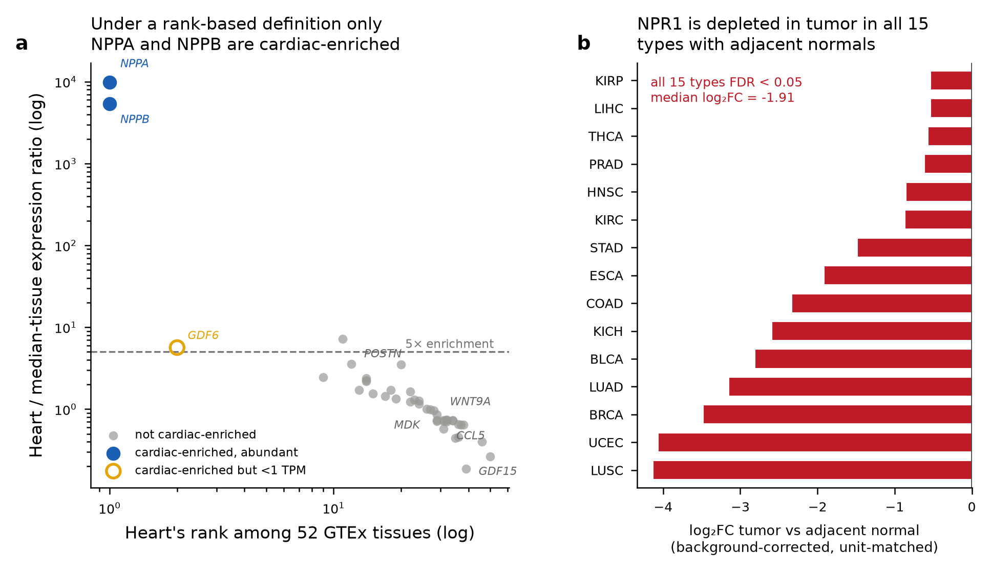
Figure 6. Ligand cardiac specificity and receptor tumor enrichment. (a) Under a rank-based definition (heart rank 1 of 52 GTEx tissues with left-ventricle median at least 5 TPM) only NPPA and NPPB are cardiac-enriched among the 42 HF-upregulated secreted ligands; the criterion is definition-dependent, and a fold-enrichment definition additionally admits AGT (Section 3.7). (b) NPR1, the sole floor-passing receptor for those two ligands, is depleted in tumor relative to unit-matched adjacent normal in all 15 types with at least 10 adjacent normals (median log2FC -1.91, all FDR<0.05, 680 normal samples).

3.8 A falsifiable experimental test derived from the negative result
A negative screen should still nominate something testable. The most tractable axis in the data is WNT9A to FZD7, since WNT is the largest pathway contributor and FZD7 has the widest dynamic range of any WNT9A receptor in DepMap Uterus. A 4-versus-4 cell-line panel with 48.7-fold mean separation in FZD7 is specified in the reproduction package, together with the controls that make it interpretable: receptor level is not a library-size artifact (ρ=0.131, p=0.447 against housekeeping mean across all 36 screened lines), and FZD7 knockout does not kill the lines, so a knockdown arm reads as a signaling-competence manipulation rather than a viability effect. WNT9A is not cardiac-enriched, so this tests whether the compatibility score predicts receptor-mediated signaling competence at all. It does not test a heart-specific mechanism, and it is offered as a check on the scoring skill rather than as a rescue of the hypothesis.

3.9 Correction of the specificity filter and adversarial testing of the recovered axes
Both the corrected specificity criteria and the three kill criteria applied to the recovered axes were fixed before any computation in this phase, with the receptor base rate measured before thresholds were chosen so that they could not be set to flatter the result (Sections 2.7 and 2.8).
Section 3.7 reported zero surviving axes under a ligand filter that scored cardiac distinctiveness in GTEx left ventricle, which is non-failing myocardium. That filter is wrong for a hypothesis about the failing heart, and correcting it changes the count: re-scoring cardiac source by failure induction, with the receptor criteria unchanged, leaves 7 of 146 axes surviving instead of 0, all with pleiotrophin (PTN) as ligand.
That is a methodological finding about the filter rather than a biological finding about PTN, and the distinction is the substance of this section. PTN entered only because criterion A3 was relaxed from heart ranking first of 52 GTEx tissues to heart ranking in the upper half, and PTN sits at rank 23. A hit that appears when a criterion is loosened is precisely what loosening a criterion produces, so three kill criteria were fixed before any of the tests below ran, with PTN retained only if it survived all three. It failed all three.
Table 2. Summary of the three pre-specified kill criteria applied to the seven pleiotrophin (PTN) axes recovered after correcting the ligand-specificity filter (Section 2.8, 3.9). All three criteria, and the receptor base rate against which Track 1 was judged, were fixed before any of the tests below were run. Retention required all three to survive.
Track | Test | Pre-specified threshold | Observed result | Verdict
T1 – Receiver discrimination | Ligand-free base rate at which candidate receptors satisfy the receiver criterion; matched-random null (1,000 permutations); pairwise receptor co-expression | Base rate ≥60% declared uninformative; observed count must exceed the null’s 95th percentile | 74.1% of all floor-passing receptors pass with no ligand involved (45-77% across aggregation rules); the 7 PTN receptors sit at the 31st percentile of a matched-random null (one-sided p = 0.688) | Fail
T2 – Tissue generality | Moderated-t differential expression in 5 non-cardiac fibrosis/organ-failure cohorts; cell-of-origin in 2 single-nucleus cardiac atlases | Fails if significantly induced in ≥2 cohorts at a median ≥50% of the cardiac effect | Significant in 2 of 5 cohorts at 50.5% of the cardiac effect (triggers by 1.0%); direction reverses in the largest lung cohort; PTN is 62-71% fibroblast-derived with no significant per-cell induction in either atlas | Fail
T3 – Literature | PubMed and full-text search for circulating PTN measured in a heart-failure cohort against controls | Published evidence against a cardiac plasma source is a kill criterion | No heart-failure cohort measurement exists in 609 verified records; the one study designed to detect cardiac PTN release (coronary-sinus sampling) explicitly rejected it as non-specific to myocardial injury | Fail
Conjunction rule | All three tracks required to pass | — | 0 of 3 tracks pass | All 7 axes withdrawn

Track 1: receiver discrimination
Before asking whether the PTN receptors are special, we asked how special any receptor is. Of the 81 floor-passing receptors, 60 (74.1%) are enriched versus matched adjacent normal in at least one tumor type with no ligand involved. That figure is rule-dependent: scoring receptor complexes whole rather than per subunit gives 46 of 103 (44.7%) under the obligate-subunit rule and 79 of 103 (76.7%) under a geometric mean, so the base rate should be read as 45 to 77%. The conclusion it was raised to support, that most receptors pass with no ligand involved and that a six or seven axis count is therefore uninformative on its own, holds under every rule and is strongest under the geometric mean. The pre-specified threshold for declaring an axis count uninformative was 60%.
Seven receptors pass in more tumor types than any PTN receptor does: PLXNA3 in 13, PLXNA1 in 11, TNFRSF12A in 10, ERBB3 in 9, and ITGA6, F2R and ITGB4 in 8 each. The PTN receptors average 3.86 types against an all-receptor average of 2.52, placing them above the mean but at the 76th percentile of a distribution most members of which already pass. Exceeding the average within a population in which nearly every member passes is not evidence of specificity.
The formal test is worse than merely unremarkable. Substituting the seven PTN receptors with expression-decile-matched random receptor sets of the same size (1,000 permutations, seed 20260729) gives a null median of 30 enriched pairs against 27 observed. The PTN set sits at the 31st percentile of the null, with empirical one-sided p = 0.688, and three null configurations agree. The PTN receptor set performs slightly worse than random receptor sets matched for expression level.
One check passed. The seven receptors are not a single co-expressed family counted seven times, with mean pairwise Spearman ρ of −0.091 across the 30 tumor types and a maximum of 0.692. The axes are genuinely seven independent receptors, and random draws beat them.

Track 2: tissue generality
PTN was tested in five non-cardiac organ-failure and fibrosis cohorts, each processed with the same moderated-t pipeline and each cohort’s normalization kept separate. COL1A1 rose in all five (logFC 1.17–2.52), confirming that every cohort captured a fibrotic signal. PTN was significantly induced in two: lung IPF (GSE134692, +0.646, FDR 4.6×10⁻³) and diabetic nephropathy (GSE142025, +0.871, FDR 2.5×10⁻⁵). The median of 0.7589 is 50.5% of the cardiac effect (1.5023) against a kill threshold of 50%. The criterion triggers by 1.0%, and is reported as triggered without adjustment, since revising a pre-specified threshold after observing which side of it a value falls would defeat the purpose of pre-specifying it.
The marginality does not rescue PTN, because the direction is inconsistent in a way the threshold does not capture. In the largest cohort tested, lung IPF with 103 cases and 103 controls (GSE150910), PTN is significantly down⁴⁷ (−0.556, FDR 2.5×10⁻⁵). The two lung cohorts disagree in sign. A ligand whose fibrosis response reverses between two cohorts of the same disease is not a robust injury signal in either direction, let alone a cardiac-specific one.
Cell of origin is more decisive than the induction test. In two independent human heart single-nucleus atlases, PTN is fibroblast-derived: 70.7% of PTN counts fall in fibroblasts in the Reichart DCM/ACM atlas and 61.6% in the Kuppe myocardial-infarction atlas, against 6.2% and 16.2% in cardiomyocytes, with fibroblast-to-cardiomyocyte mean expression ratios of 35.3× and 13.5×. The PTN of the failing heart is a wound-healing transcript from its stroma rather than a cardiomyocyte product.
The induction also does not survive the change of resolution. Per-fibroblast PTN does not rise in disease in either atlas (DCM +0.028, FDR 0.87; ACM −0.311, FDR 0.54; MI −0.430, FDR 0.30), nor does tissue-level pseudobulk (DCM +0.041, p = 0.72; MI −0.010, p = 0.68). The same MI fibroblast comparison detects POSTN at +1.77 and COL1A1 at +1.03, so the test had power. The bulk cardiac induction of logFC 1.50 that admitted PTN in the first place does not reproduce as a per-cell induction in either single-nucleus dataset. That discrepancy is unresolved. It may reflect aetiology or compositional differences between the bulk and single-nucleus cohorts, and it undermines the premise independently of any kill criterion.

Track 3: literature evidence for a circulating source
Across 52 PubMed queries over a 991-record pleiotrophin corpus, together with a full-text scan of 478 cardiac plasma-proteomics papers, 609 records were retrieved and verified, and none measures circulating PTN in a heart-failure cohort against controls. Four measure circulating PTN in some human cardiac context, and two of those four point away from the premise. In the first (Circ Heart Fail 2024⁴⁸), plasma PTN measured by SomaScan is lower in hypertrophic cardiomyopathy than in three comparator cardiomyopathies, in both training and test sets, and after adjustment for 19 clinical parameters. In the second (Nat Biotechnol 2011⁴⁹), coronary-sinus sampling during planned myocardial infarction detected PTN release, and the authors explicitly eliminated it as not specific to myocardial injury, because catheterisation alone moved it.
The two supporting records fall outside heart failure: anthracycline cardiomyopathy in childhood cancer survivors⁵⁰ in which only 8 of 28 cases had heart failure, in a population where serum PTN is independently raised by cancer, and coronary collateral grade.⁵¹
The secreted role of PTN in cancer is by contrast well established. The half of the axis that is supported is the tumor half. The cardiac-plasma half is unmeasured, and where adjacent measurements exist they run in the opposite direction. The one study designed to detect cardiac PTN release into blood found a signal and rejected it as an artifact of the procedure.

Verdict
The seven PTN axes are withdrawn as a positive finding. All three pre-specified tracks failed. The receptor test is passed by three-quarters of candidate receptors and the PTN set underperforms matched-random draws; PTN is a fibroblast injury transcript induced in lung and kidney fibrosis at half the cardiac effect, with no per-cell cardiac induction; and the plasma measurement on which the endocrine premise depends has never been made, with the nearest published evidence contradicting it.
The conclusion of the paper is therefore unchanged from Section 3.7, but it is now a stronger claim than it was. The original negative could have been an artifact of scoring cardiac specificity in healthy tissue. That objection has been tested directly: correcting the filter does recover axes, and the recovered axes do not survive. A negative that has been attacked on its most obvious weakness and held is worth more than one that has not (Fig. 7).
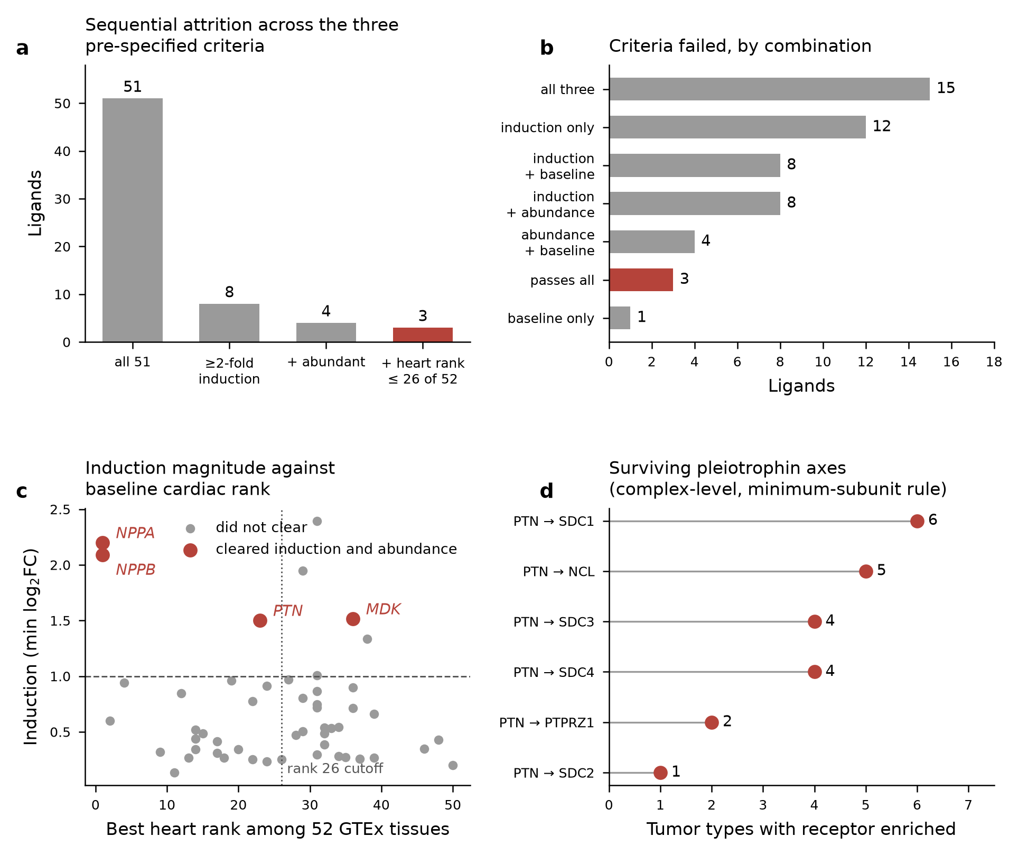
Figure 7. Cardiac specificity re-scored against failure induction. (a) Sequential attrition across the three pre-specified criteria; 3 of 51 ligands clear all three. The third criterion is A3, requiring the heart to rank in the upper half of the 52 GTEx tissues. (b) Combinations of criteria failed across the same 51 ligands; the 3 ligands failing none are NPPA, NPPB and PTN. (c) Induction magnitude, taken as the minimum log2 fold change across the two cohorts, against baseline cardiac rank; the four ligands clearing both induction and abundance are shown in red, of which MDK is excluded at rank 36 while PTN is retained at rank 23. (d) The surviving pleiotrophin axes scored at complex level under the minimum-subunit rule, by number of tumor types in which the receptor is enriched relative to matched adjacent normal. Ligand criteria are computed within single datasets only; the receptor side is unchanged from Section 3.7. n = 51 ligands, 146 axes.

3.10 Cross-platform replication of the signature
The discovery and validation cohorts of Section 3.1 both ran on GPL16791, so the replication reported there lies within a single sequencing technology. To test whether the signature is platform-independent, it was re-derived in three cohorts not used previously, all Affymetrix microarray: GSE5406 (194 failing, 16 non-failing, GPL96), GSE57345 (177 failing, 136 non-failing, GPL11532) and GSE1869 (31 failing, 6 non-failing, GPL96). Thresholds were fixed before these analyses ran: directional concordance of at least 0.75 and log fold-change Spearman ρ of at least 0.40 among genes significant in both, with NPPA and NPPB required to rise in at least two of the three cohorts. Label permutation returned 0 significant genes in all 6 contrasts.
The two adequately powered cohorts replicate the signature. GSE5406 gives directional concordance 0.846 and ρ=0.713 among genes significant in both, and GSE57345 gives 0.819 and ρ=0.774. Correlation across all shared genes is lower in both (0.347 and 0.479), as expected, and is reported separately throughout because the two quantities are not interchangeable. GSE1869 falls below both thresholds (0.602, ρ=0.187), which with 6 control samples is uninformative rather than contradictory. One cohort below threshold does not reach the pre-specified kill criterion of two.
Two aspects of the cross-platform comparison qualify the replication reported in Section 3.1. The shared sequencing platform inflated the apparent agreement: across all 10 cohort pairs, the 4 same-technology pairs have median concordance 0.918 and median ρ=0.722 among genes significant in both, against 0.745 and 0.545 for the 6 cross-technology pairs. The original pair sat at 0.881 and 0.759, inside the same-technology range. The concordance figure quoted in Section 3.1 is therefore about 0.17 units optimistic as an estimate of platform-independent agreement, and should be read as a within-technology number.
Second, and specific to this hypothesis, NPPB does not reproduce on either array platform, at −0.142 (FDR 0.90) in GSE5406 and +0.303 (FDR 0.27) in GSE57345, against +3.97 in RNA-seq discovery. This is not a probe-collapsing artifact, because NPPB is measured by a single probe on each platform (206801_at on GPL96, 7912520 on GPL11532), so no collapsing choice arises for it. Cross-platform support for the cardiac-ligand arm therefore rests mainly on NPPA, which behaves correctly in both (+1.856 and +1.733, FDR<10⁻⁸), as do MYH6 (−1.579 in GSE57345) and ATP2A2. Because the pre-specified criterion required both natriuretic peptides to rise in at least two of three cohorts and NPPB rises significantly in none, the criterion is not met, and the verdict on platform-independence is inconclusive rather than passed (Fig. 8).
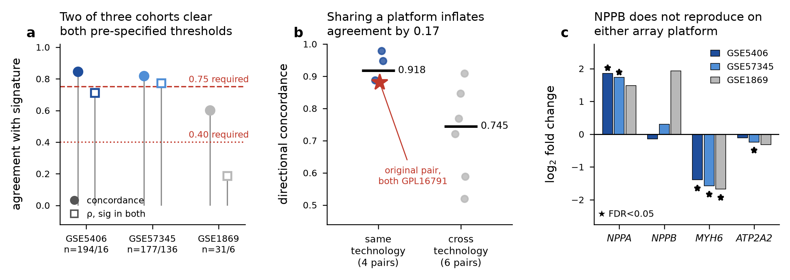
Figure 8. Cross-platform replication of the heart-failure signature. (a) Agreement between each microarray cohort and the RNA-seq signature, against thresholds fixed before the analysis ran (dashed 0.75 for directional concordance, dotted 0.40 for log fold-change Spearman ρ among genes significant in both). GSE5406 and GSE57345 clear both; GSE1869, with 6 control samples, clears neither. One cohort below threshold does not reach the pre-specified kill criterion of two. (b) Directional concordance for all 10 pairwise cohort comparisons, split by whether the pair shares a sequencing technology. Bars are group medians. The original discovery/validation pair (star) sits inside the same-technology group because both cohorts ran on GPL16791. (c) The four canonical heart-failure markers in each cohort; stars mark FDR<0.05. NPPB is not significant on either array platform despite +3.97 in RNA-seq discovery, and is measured by a single probe on each platform, so this is not a probe-collapsing artifact. n = 194/16 (GSE5406), 177/136 (GSE57345), 31/6 (GSE1869) failing versus non-failing. Unit of replication is the donor heart.
The consequence for the argument is limited but should be stated. NPPB was one of the two ligands carrying the cardiac-specific arm of the hypothesis, and one of them is not measurable as induced on array platforms. This does not rescue the hypothesis, because the axis failed on the receptor side, where NPR1 is depleted in tumor in all 15 testable types, and NPPA, which shares that receptor, does replicate. It does mean that the ligand evidence rests on one peptide rather than two when platform is varied, and that a plasma measurement would be the way to settle whether NPPB is induced at all.

3.11 The natriuretic peptide receptor family
Claiming NPR1 as the sole floor-passing receptor for NPPA and NPPB invites the question of what the other two natriuretic peptide receptors do, so all three were tested. The answer has two parts, one about the database and one about the data.
The database part is a scope limitation. CellChatDB pairs NPR2 with NPPC only and NPR3 with OSTN only, and neither NPPC nor OSTN is among the ligands induced in the failing ventricle. Within the curated interaction set, therefore, NPR1 is the only receptor reachable from NPPA or NPPB, and the claim is true as stated. It is true of the database rather than of receptor pharmacology: NPR3 binds ANP and BNP as a clearance receptor in vivo, and that binding is not recorded in CellChatDB. A curation gap of this kind cannot be detected from within the screen, which is a general limitation of interaction-database methods rather than a property of this dataset.
The data part removes the objection independently of the curation. Streaming NPR1, NPR2 and NPR3 from the PanCanAtlas matrix across 6,888 primary tumors and 698 adjacent normals in the 15 unit-matched types gives tumor-median expression of 125, 148 and 29 RSEM respectively, against a floor of 346; NPR1 and NPR2 clear the floor in 2 types each and NPR3 in 1. All three run in the depleted direction: median log2 fold change against matched adjacent normal is -1.91 for NPR1, -0.60 for NPR2 and -1.27 for NPR3, with significant depletion (Mann-Whitney, BH-FDR < 0.05) in 15, 8 and 13 of 15 types. Across 45 receptor-by-type comparisons exactly one is significantly enriched, NPR2 in papillary renal cell carcinoma (log2FC +0.48, FDR = 0.001), whose only annotated ligand NPPC is not induced in the failing heart. Extending the receptor arm to the full family therefore does not recover a candidate axis, and the re-streamed NPR1 value reproduces the -1.91 reported in Section 3.7 from an independent extraction.

3.12 Protein-level test of the receptor result
Every measurement above is transcript abundance, so the central negative was tested in a different molecule. CPTAC tandem-mass-tag proteomics provides tumor and adjacent-normal protein abundance for eight of the tumor types ranked here. Criteria were fixed before any type other than ccRCC was examined: a gene is testable in a study only if it appears in that study’s quantified gene index and at least 10 aliquots per arm and 60% of each arm carry a value; the primary test is a paired comparison within TMT plex; NPR1 protein enriched in tumor in at least 3 of the 7 previously unexamined types would refute the negative, depletion in at least 5 would replicate it, and fewer than 4 testable types would abandon the test as underpowered. ccRCC was examined during the design of these controls and is reported as unblinded throughout.
Batch structure was checked in every study rather than assumed, and one study fails outright. In the breast cohort all 18 adjacent normals sit in two normal-only plexes, giving 0 mixed-arm plexes of 17 and 0 within-plex pairs (χ²=143.0, p=1.9×10⁻²²), so arm is perfectly confounded with batch, no batch-free contrast exists, and the study is untestable regardless of coverage. The glioblastoma cohort has only 10 normals, none paired within plex. Six studies have balanced designs, ccRCC among them (21 of 23 plexes mixed, χ²=15.7, p=0.83).
The test could not be run. NPR1 is testable in only 3 of the 8 studies, and in 2 of the 7 blind types, against a pre-specified minimum of 4. It is absent from the breast and glioblastoma gene indices entirely, and falls below the coverage floor in pancreatic (38%/33% of aliquots), lung (47%/50%) and head-and-neck (29%/39%). Absence of detection in a mass-spectrometry matrix is not absence of protein, so these are recorded as untestable rather than as null results. By the pre-specified rule, Track A is abandoned as underpowered, and no verdict on protein-level NPR1 is issued.
What the three testable types show is consistent with the transcript result but cannot carry it. NPR1 protein is lower in tumor in all three: ovarian −0.697 (13 pairs, FDR 0.017), endometrial −0.929 (20 pairs, FDR 0.0014) and ccRCC −0.114 (68 pairs, unblinded). All four pre-specified sensitivity analyses agree in direction, and none restores power. The mandatory base-rate check clears: across studies, 35.7% of quantified proteins are depleted in tumor, below the 40% bar above which the result would have been uninformative, and NPR1 sits at the 6.9th percentile of the genome-wide effect distribution in ovarian and the 7.0th in endometrial cancer. Three types agreeing is suggestive. It is not the five the criteria required, and reporting it as replication would be exactly the after-the-fact reasoning the pre-specification exists to prevent.
The pleiotrophin receptor panel was tested on the same footing and is withdrawn at protein level. Its count of receptors enriched in tumor fails to exceed the 95th percentile of an abundance-matched random null in all 6 studies where the null is defined; the closest is endometrial cancer at 4 observed against a null 95th percentile of 4 (empirical p=0.12), and in two studies the observed count falls below the null mean. Coverage again dominates, since 29 of 72 panel cells are untestable, 23 of them because the gene is absent from that study’s matrix. Pleiotrophin itself is quantified in all eight matrices and is mostly lower in tumor, which is the opposite of what the recovered axes required.
The conclusion is therefore unchanged but its scope is now explicit. The transcript-level negative stands, the protein-level test that could have overturned it is not answerable with current public proteomics at the coverage NPR1 achieves, and the measurement that would decide the question remains a plasma one.

3.13 Directional discordance of a mediator nominated in the review literature
A 2024 review of this field by Seuthe et al.⁵⁵ nominates SerpinA3 as the principal secreted mediator linking heart failure to tumor growth, on the basis of the mouse study that established the phenomenon. SERPINA3 is a strong test case for the screen because it is annotated as secreted to blood at core tier, so it should have been available to the pipeline. It is in the replicated signature, but with the opposite sign to the one the hypothesis requires: logFC −2.64 in the discovery cohort (FDR 1.2×10⁻⁸) and −2.12 in validation (FDR 7.4×10⁻²¹), a replicated decrease in failing human left ventricle. The upregulation filter therefore excluded it, and it is also absent from CellChatDB as a ligand, so it would not have produced an interaction even had the direction agreed.
The discrepancy is most likely a species difference rather than a contradiction of the mouse work, since the induction was demonstrated in murine myocardium and in mouse plasma, whereas these are human explanted ventricles from patients with established end-stage disease, many on mechanical support. It nonetheless bears directly on the scope of the screen. The one mediator the review literature names most confidently is one this design could not have recovered, for two independent reasons, and this is stated explicitly rather than left to inference.
The same review⁵⁵ states that angiotensin II acting through AT1R promotes breast cancer proliferation. That axis is present in this screen and is informative about the specificity question in Section 3.7. AGT is upregulated in both cohorts, though weakly (logFC +0.22 and +0.13, FDR 0.042 and 0.047), and it is the third ligand admitted when cardiac specificity is defined by fold enrichment rather than rank. Its receptor is the reason the axis does not survive: AGTR1 is enriched in no tumor type against matched adjacent normal, and in the validation cohort it is itself strongly reduced in failing myocardium (logFC −1.16, FDR 4.7×10⁻²¹). A mechanism can be real in a treated mouse xenograft and still fail a compatibility screen built on human tumor transcript abundance, because the two tests ask different questions. This is the same distinction on which the negative result rests, visible here in a case the literature considers settled.

3.14 Comparison with the closest human study
A 2025 conference abstract by Caller et al.⁵⁶ is the closest human work to this screen and reaches a partially different answer, so its nominated ligands were run through the gates used here rather than discussed in prose. Because that report is a meeting abstract rather than a full paper, its methods are available only in summary, and the comparison below is with the ligands it nominates rather than with its analysis. It used single-cell data from ischemic and failing human hearts with NicheNet, implicated cardiac mesenchymal stromal cells as the source, nominated POSTN, NGF and PDGF-family ligands, and reported increased lung-cancer-cell proliferation in response to conditioned medium.
Those four ligand families fail at three different points, and none of the failures is a disagreement about the underlying measurement. NGF is in the replicated signature but runs the wrong way for the hypothesis, falling in failing ventricle in both cohorts (log2FC −0.73 and −0.57, FDR 2.9×10⁻⁶ and 1.6×10⁻¹³), so it cannot be a heart-failure- induced secreted signal in bulk myocardium whatever its behavior in a stromal subpopulation. PDGFA, PDGFB and PDGFC are not in the replicated signature at all. POSTN and PDGFD are replicated and induced (POSTN +1.25 and +0.84; PDGFD +0.58 and +0.34), pass the receptor expression floor, and were scored — POSTN through ITGAV_ITGB3 and ITGAV_ITGB5, PDGFD through PDGFRB — but both fail cardiac specificity: heart ranks 12th and 14th of 52 GTEx tissues, with aorta the top tissue for each, and POSTN's heart abundance is below the cross-tissue median (ratio 0.43). By comparison NPPA and NPPB rank first with ratios of 12 and 88.
The disagreement is therefore about cell resolution and about what the source criterion requires, not about whether these transcripts change. A single-cell design can attribute a ligand to a stromal subpopulation that bulk ventricle averages away, which is a real advantage and the same one exploited here for pleiotrophin (Section 3.9). What that design does not do is ask whether the heart is a distinctive source: a fibroblast- derived ligand that many organs' fibroblasts also make is not an endocrine cardiac signal, and aorta out-expressing heart for both surviving candidates is exactly that situation. Their conditioned-medium experiment is functional evidence this screen has no counterpart to, and it establishes that failing-heart stromal secretions can affect tumor-cell proliferation. It does not establish that the responsible ligand is cardiac-specific or that it reaches a tumor through the circulation. The two results are compatible: a paracrine, non-tissue-specific mechanism can be real while no transcriptomically supported cardiac-endocrine axis exists.

4. Discussion

4.1 Location of the failure within the two-factor model
The two-factor framing was chosen because it can fail in identifiable places rather than merely returning a null. It failed in two of them, and the location matters more than the verdict. The receiver side is not the constraint: receptor transcripts for HF-upregulated ligands are present, often abundantly, across tumor types, and a compatibility ranking built on them is stable under resampling and under leaving out any single ligand or pathway. The constraint is specificity at both ends of the axis. Only the natriuretic peptides are distinctively and abundantly cardiac among the candidate ligands, and their sole receptor is the one receptor in the panel that is consistently depleted in tumor relative to matched adjacent normal. An axis needs both ends, and no axis has both.
That the stability of the score coexists with the failure of the axes is the substantive point. A compatibility ranking can be internally robust and still carry no specific signal, which is why the ranking is reported with its specificity null rather than on its own.

4.2 Generalizable methodological requirements and their implementation
Three findings from Sections 3.3 and 3.9 are not about the heart. Each is a property of compatibility scoring in general, and each is now an assertion rather than a recommendation.
The first is that any score standardizing expression before checking that the gene is expressed at all inherits an artifact. The confound usually attributed to a global expression axis is substantially produced by scoring untranscribed receptors, since standardizing a gene sitting at instrument noise still yields large values, and those values are what a random draw reproduces.
The second is that the null used to detect this must itself be matched on expression. The naive pool and the floor address different failures, and neither substitutes for the other.
The third is a base rate. A screen that relaxes any criterion should report the rate at which the criterion it did not relax is passed, because without that number an axis count cannot be read as evidence about a particular ligand.
The sequence in Section 3.9, comprising a negative result, a filter identified as capable of having caused it, a correction that recovers hits, and a base-rate check that withdraws them, is generic enough that others will repeat it. This is the rationale for encoding the three requirements at the point of enforcement. Stated as prose here, they would be inherited by the next study as text, and a study that omits the floor would produce a result indistinguishable in form from one that honors it. Stated as assertions in the scoring skill, omitting the floor produces an exception naming the offending gene.
The claim is not that assertions are better than prose. Prose can express nuance that code cannot, and an assertion encodes a threshold rather than the reasoning that justified it, which may be wrong for another data type. The claim is that the two fail differently, and that for requirements of this kind, where the wrong answer resembles a right answer, the failure mode of the assertion is the one to prefer. An untranscribed receptor scored as though it were expressed does not announce itself; a missing exception does.

4.3 Bulk expression as a source measure
Two independent observations undercut bulk differential expression as a proxy for tissue output. The recovered ligand localises overwhelmingly to fibroblasts rather than cardiomyocytes, and its cardiac induction does not reproduce per-cell in either single-nucleus atlas, while established fibrotic markers do rise in the same comparison. Bulk differential expression in a tissue whose cellular composition changes with disease can reflect proportion shifts rather than regulation. The ligand-availability term of this screen is computed from bulk for every ligand and inherits that ambiguity generally, not only for the ligand that happened to be examined at single-cell resolution.

4.4 Measurements required to resolve the question
The measurement the endocrine premise requires has never been made for the recovered ligand: circulating concentration in a heart-failure cohort against controls. The nearest published measurements run against it, including one study that detected the ligand during a planned myocardial infarction and rejected it as not specific to myocardial injury because catheterisation alone moved it. No reanalysis of expression data can substitute. Converting tissue mRNA into a circulating contribution requires translation efficiency, secretion rate, clearance and volume of distribution, none of which are available for these ligands, and that calculation was excluded rather than attempted with fabricated parameters.
The decisive experiments are therefore measurement rather than analysis: plasma proteomics across a heart-failure cohort with cancer-free controls, and, for any axis surviving such a screen, ligand stimulation with a pathway reporter rather than viability knockout. Receptor expression licenses a cell to receive a signal, and its loss need not impair proliferation in culture, which is why the dependency screen was negative for reasons unrelated to the hypothesis.

4.5 Limitations
Transcript-only. Every measurement is mRNA. An endocrine mechanism requires circulating protein, and cardiac transcript induction need not produce elevated plasma ligand. Cell-specific knockout of CCN2 showed that a secreted cardiac factor can act autocrine on neighbouring fibroblasts rather than distally.⁵²
Platform dependence of the signature. The discovery and validation cohorts both ran on GPL16791. Same-technology cohort pairs agree substantially better than cross-technology pairs (median concordance 0.918 against 0.745), so the 0.881 reported in Section 3.1 is a within-technology figure. The signature does reproduce on two independent array platforms, but NPPB does not, so the cardiac-ligand arm rests on NPPA alone once platform is varied (Section 3.10).
Protein-level coverage. The proteomic test of NPR1 was abandoned as underpowered rather than passed or failed (Section 3.12). NPR1 is absent from two of eight CPTAC gene indices and below a 60% per-arm coverage floor in three more, and absence of detection in a mass-spectrometry matrix is not evidence of absent protein. The breast study is untestable for a different reason: all its adjacent normals sit in normal-only plexes, so batch is perfectly confounded with the comparison.
Ambiguous probe mappings. On the array platforms, 1,223 of 22,283 probes on GPL96 (5.5%) and 2,354 of 33,297 on GPL11532 (7.1%) map to more than one gene symbol. These were excluded rather than assigned to their first listed gene, which loses a small fraction of measurable genes (2.6% of signature symbols on GPL96, 4.9% on GPL11532) but avoids attributing the signal of a probe to an arbitrary one of its targets. No canonical marker is affected.
Bulk tissue on both sides. TCGA and GTEx values mix malignant, stromal and immune compartments, so receptor signal cannot be assigned to tumor cells. Compartment markers were extracted but a deconvolution was not performed.
Method heterogeneity across cohorts. GSE116250 provides RPKM and GSE141910 log-scale normalized counts, so cross-cohort effect sizes are not strictly comparable, and we rely on rank concordance rather than pooled magnitudes. The empirical-Bayes moderated t is our own implementation of a limma-trend equivalent rather than a call into limma.⁴²
GTEx heart is non-failing. Tissue specificity in healthy myocardium bounds baseline distinctiveness rather than HF inducibility. A ligand could be non-cardiac-enriched at baseline yet become a major cardiac output in failure. That possibility is no longer hypothetical, since Section 3.9 tests it directly and recovers PTN, which then fails on independent grounds.
Unit mismatch. TCGA RSEM and GTEx TPM were never placed on a common scale, and cross-dataset direction claims are ordinal only. The unit-matched adjacent-normal comparison is the stronger evidence and covers 15 of 30 types.
Mapping judgment calls. The DepMap-lineage to TCGA and TCGA to GTEx mappings are disclosed with per-row confidence (Tables 15, 20). UCS is the top-ranked type yet has a poor normal-tissue counterpart, only 57 tumors, and shares a single DepMap lineage with UCEC, so its specificity result is the weakest in the table. Adrenocortical carcinoma, first under double-centering, has one screened DepMap line and is untestable there.
TIMER2 not used. The Thorsson immune-landscape table substituted for TIMER2. To be precise about why, compbio.cn is reachable, but TIMER2 is served as an interactive Shiny application with no bulk-download endpoint we could locate (/timer2/data/ and /timer2/estimation.php both return 404), so its deconvolution estimates are not retrievable programmatically at pan-cancer scale. Thorsson is the published source for the same immune and stromal quantities over the same TCGA samples, but it is not an identical computation, and we did not cross-validate the two.
Induction as distinct from systemic release. The corrected specificity criterion in Section 3.9 admits ligands on induction magnitude without establishing that the failing heart dominates the circulating pool. Converting tissue mRNA into a circulating contribution requires parameters unavailable for these ligands, so that analysis was pre-emptively excluded rather than attempted with fabricated values.
Base-rate guard for relaxed criteria. The seven-axis result was recovered by relaxing one criterion and withdrawn by measuring the base rate of the criterion it was recovered against. Any screen that loosens a filter to recover hits should report the rate at which the unmodified half of the test passes; ours was 74%.
Bulk versus per-cell induction. Cardiac PTN induction (logFC 1.50, replicated across two cohorts) does not reproduce as per-cell induction in two single-nucleus atlases. Bulk differential expression in a tissue whose composition changes with disease can reflect cell-proportion shifts rather than per-cell regulation, and the ligand-availability term of this screen is computed from bulk for every ligand, not only PTN. The receptor side carries the same exposure: tumor purity varies by several-fold across the types scored here and was not adjusted for, so a receptor's apparent depletion or enrichment against adjacent normal is compatible with a shift in malignant-cell fraction as well as with regulation, and purity remains an untested alternative explanation for the receptor result.
Power. Dependency correlations use 22 lineage-level aggregates, so only a large effect would be detectable. The null result bounds effect size rather than excluding a small one.

4.6 Reuse beyond this question
The same six skills apply wherever the secreted output of a source tissue is scored against receiver contexts, including any organ-crosstalk screen, any secretome-to-receptor ranking, and any compatibility score across many tissues or cell lines. Nothing in the scoring module depends on the source being heart or the receivers being tumors, since it consumes a feature matrix and a vector of source-derived weights.
What does not transfer automatically is the threshold. The floor is calibrated as a fraction of GAPDH in RSEM units, and a study on a different platform must recalibrate it rather than inherit the number, since the assertion enforces that a floor exists and was applied rather than that 0.005×GAPDH is correct everywhere. The limit of the mechanism is therefore that it renders a requirement unavoidable without making its parameterisation universal.

4.7 Effects and costs of the multi-agent execution model
Three effects of partitioning the work were observed, the third of which altered a reported result. These are observations from a single execution rather than a controlled comparison: no single-agent baseline, no scripted-workflow baseline and no context-isolation ablation were run, so what follows describes what this configuration did and not what an alternative would have failed to do.
Where the work sits determines how much of it depends on the language model. None of the 4,858 lines contains a call to a language model, an API key or a platform function, so given the same inputs they return the same numbers whichever agent invoked them, and every figure and table here is output of that layer. The model contributed orchestration and judgment: choosing ligand distinctiveness and receptor abundance as the two factors, recognizing that an unfloored score was measuring the expression axis, and deciding that a recovered axis had to be tested against a ligand-free base rate. Those choices are reported so they can be disputed, and a different model making different ones would produce a different paper from the same modules.
The first effect was increased throughput on independent tracks. The four wave-1 acquisition tracks share no inputs and ran concurrently; serially they would have consumed the sum of their durations rather than the maximum.
The second is context isolation as a correctness property rather than an efficiency one. Each sub-agent received a task statement and a summary, never the conversation of the orchestrator, so it could not inherit an assumption formed earlier. This is what made the wave-4 audits usable, since tracks were dispatched specifically to re-derive claims the orchestrator had already written into the manuscript, working from the result tables rather than from its prose, and they found errors. The adjacent-normal sample count was reported as 710 where the table sums to 680, because 710 counts samples before the minimum-normals filter. The number of tumor types in which NPR1 fails the expression floor was reported as 26 of 30 where the column gives 24. One survival claim mixed units, stating zero of 160 when the table holds 146 subunit-level axes and 160 is the complex-level count. A review track separately found a pre-specification justifying its matched-null requirement by citing the expression-floor contrast (ρ=0.363 against 0.107) rather than the matching contrast (ρ=0.323), which is a reasoning error rather than a typographical one. None of these alters a conclusion, which is the relevant observation: they represent the class of error that survives self-review, because an agent auditing its own prose in its own context has already been persuaded by it.
The third is that isolation is what allowed the kill criteria to bite. The adversarial phase of Section 3.9 was dispatched with its criteria in the task statement and no access to the reasoning that had produced the seven candidate axes, and it withdrew all seven. We do not claim that a single-context agent could not have done this, but the design removes the mechanism by which it would most plausibly have failed to.
The architecture claim this paper can support is therefore narrow. The audits found errors and the pre-specified criteria withdrew a positive result, which shows the guardrails did work; it does not show that 23 agents were required to produce it, and a comparative evaluation against a single-agent or scripted pipeline on the same task is the obvious next experiment. The costs are real. The fleet consumed $164, essentially all of it context rather than generation at an input:output ratio of 106:1, which is the characteristic cost profile of this architecture, since every sub-agent pays to be told what it needs to know. Four of 23 tracks did not complete normally, and one of those consumed 199 minutes before exceeding its memory budget. Handoff is the fragile boundary, because the work of a track survives a failure only if it was persisted as it went, which is a design requirement rather than a platform guarantee. Isolation also cuts both ways, since a sub-agent lacking context can make a locally sensible choice that is wrong for the study, which is why the output of every track was checked against the artifact it claimed to produce rather than accepted from its summary.

5. Conclusions
Across 30 solid tumor types, no ligand–receptor axis has both a distinctively cardiac source and a receptor enriched in tumor tissue, where enrichment is measured against unit-matched adjacent normal in the 15 types that have it. Enrichment is a specificity criterion: a tumor could respond through a receptor expressed adequately but not enriched, so this is evidence against a tumor-selective cardiac axis rather than against receptor-mediated response in general. The conclusion survives correction of the design choice most capable of having produced it. Scoring cardiac specificity in healthy myocardium cannot detect a ligand induced only in disease, and re-scoring by failure induction recovered seven candidate axes, all involving pleiotrophin. Criteria fixed in advance withdrew all seven, because the receptor criterion was satisfied by 60 of 81 candidate receptors with no ligand involved.
Two further tests were pre-specified and run after the negative was reached. The signature reproduces on independent microarray platforms, but NPPB does not, so the cardiac-ligand arm rests on NPPA alone once platform is varied. A protein-level test of the receptor result was attempted in CPTAC proteomics and abandoned under its own kill criterion, because NPR1 reaches the required coverage in too few tumor types. The three types where it is testable all show lower NPR1 protein in tumor, which is directional agreement with the transcript result but not independent confirmation of it: three types cannot validate a conclusion drawn across 15, and the analysis was abandoned precisely because it is underpowered. The pleiotrophin panel is withdrawn at protein level as it was at transcript level.
The hypothesis is not refuted in general. It remains tenable in the weaker form that heart failure raises circulating concentrations of factors secreted by many tissues, which would require neither a cardiac-specific ligand nor a tumor-specific receptor. Distinguishing that from the specific form tested here requires plasma measurements in heart-failure patients, and for pleiotrophin, the strongest candidate this screen produced, such measurements do not exist. Tumor proteomics does not substitute, since it measures the receiver rather than the circulating signal. The screen also cannot recover a mediator that acts without a curated cognate receptor, is regulated in the opposite direction in human end-stage disease than in the mouse model, or acts through protease activity rather than receptor binding, which is the case of SerpinA3 (Section 3.13). The negative applies to receptor-mediated signaling by ligands induced in the failing human ventricle rather than to secreted mediators in general.
The transferable output of this study is the instrument rather than the negative result itself. The three requirements of Section 4.2 were each discovered as an error this pipeline made, and each now exists as an assertion inside a skill rather than as a paragraph here. The distinction is as follows: a study built on the scoring module cannot omit the expression floor or substitute an unmatched null without raising an error that names the offending gene, whereas a study inheriting the same three findings as prose can omit all of them and produce output that looks correct.
The untested premise is reuse. We can demonstrate the mechanism within one study, since the kill criteria that withdrew the only positive result of this study were themselves evaluated against a floored, expression-matched background because the module enforced it. Demonstrating that the constraint binds a different group would require a second analysis built on the same skills, and that has not happened yet. Section 6 sets out where that second analysis should be built: an imaging task with a known ground truth, where the two guardrails that proved load-bearing here have direct analogues in a signal floor and an acquisition-matched null, and where a segmentation or detection benchmark would permit the controlled comparison of agent configurations that this study could not run.

6. Future directions

6.1 What would make this a clinical tool
The screen reported here answers a question about tissue transcripts, and a clinical instrument would have to answer a question about patients. Three measurements separate the two, and each is obtainable with existing technology rather than new biology.
A circulating measurement, not a tissue one. The endocrine premise requires the concentration a tumor is exposed to, which is a plasma quantity. For the recovered ligand that measurement has never been made in a heart-failure cohort against controls (Section 4.4), and no reanalysis of expression data substitutes for it: converting tissue mRNA into a circulating contribution requires translation efficiency, secretion rate, clearance and volume of distribution, none of which this design observes. A single targeted immunoassay in banked plasma from an existing heart-failure cohort would settle whether the ligand arm of the hypothesis has a basis, and would cost less than any of the analyses reported here.
A continuous exposure, not a diagnostic label. Cases here were failing versus non-failing explanted ventricles, which collapses a continuum onto a binary. If a ligand's release scales with fibrotic burden or wall stress rather than with a diagnostic category, that contrast is the wrong estimator and attenuates a real signal toward the null. The natriuretic peptides make this concrete: NPPA and NPPB are clinically graded biomarkers whose plasma concentration tracks filling pressure across orders of magnitude, so scoring them as present-or-absent in tissue discards the axis on which they carry information. Cardiac MRI indices of fibrosis, NYHA class, ejection fraction and natriuretic-peptide concentration are all recorded routinely in cardiology cohorts and any of them would serve as a graded exposure.
Receiver-cell identity, not bulk tissue. The receptor arm used bulk expression that mixes malignant, stromal, immune and endothelial compartments. A receptor enriched in bulk tissue but confined to stroma does not support a tumor-cell-intrinsic claim. Single-cell or spatial data on the receiver side would test directly what this design can only infer, and TCGA carries diagnostic whole-slide images for most of the tumors scored here.
Until those three exist, a compatibility score of this kind is a hypothesis-generating filter and not a clinical decision aid, and it should be described as one. Its immediate clinical value is negative and still useful: it says which axes are not worth taking into a validation cohort. Screens are cheap to run and cheap to believe, and in a translational chain the alternative to an early withdrawal is expensive, since a target that survives to an animal model or a trial before its base rate is computed consumes resources that a pre-specified criterion would have saved.

6.2 Heart failure as a heterogeneous exposure
This screen treated heart failure as one exposure. Each limitation of that choice is answerable with existing cohort designs, and each is a stratification the compatibility score accepts without modification, because the scoring module consumes a feature matrix and a vector of source-derived weights and is indifferent to how the source group was defined. The guardrails travel with it: a severity-stratified or etiology-stratified rerun inherits the expression floor and the matched null whether or not whoever runs it has read this paper.
Etiology. Stratifying the 42 upregulated secreted ligands by cardiomyopathy subtype found 12 with etiology-specific induction in at least one cohort, none cardiac-enriched at rank 1, and two clearing the abundance bar set by NPPA and NPPB, so pooling did not conceal a candidate axis (Section 3.1). That test covers dilated, ischemic and hypertrophic cardiomyopathy with strata of 37, 13 and 28 patients, and a null in the two small strata is low power rather than demonstrated absence. Pressure overload from aortic stenosis, volume overload from mitral regurgitation and inflammatory myocarditis impose mechanically and immunologically distinct stresses, and there is no reason to assume their secreted programs are the union of what dilated and ischemic disease produce. Myocarditis is the pointed case: the one mediator this screen was structurally unable to recover, SerpinA3, an acute-phase protease inhibitor (Section 3.13), is exactly the class of molecule an inflammatory etiology would elevate.
Disease stage. Explanted ventricles come from transplant recipients, so every case is end-stage disease under maximal therapy. Early-stage heart failure, where the epidemiological association with cancer incidence would have to originate if the relationship is causal, is not represented in any tissue cohort and cannot be, since those patients are not undergoing cardiectomy. Endomyocardial biopsy series and circulating markers are the only accessible windows onto that stage. This is a structural limit on the tissue-transcriptomic approach to this question rather than a gap in the present study.
Pharmacological treatment. Patients supplying these ventricles were on guideline-directed therapy, and the major drug classes alter the transcripts this screen scores: neurohormonal blockade changes natriuretic-peptide signaling, and mechanical unloading by a left ventricular assist device produces partial reverse remodeling with measurable transcriptional recovery. What is measured here is the treated failing ventricle, not the failing ventricle. Whether the secreted program of interest is a property of the disease or of the disease under therapy is answerable, since paired pre- and post-LVAD samples exist, and it should be answered before a circulating-ligand hypothesis is tested prospectively in a treated population.

6.3 Evaluation of delegated analysis
Section 4.7 reports what the split across 23 sub-agents did in this study and states what it did not test. That gap is a well-posed research direction: a task with a known ground truth is a better testbed for comparing a single-agent pipeline, a scripted workflow and an isolated multi-agent fleet than a screen whose answer is a negative, because it permits measuring not only accuracy but the rate at which each configuration commits and then propagates a methodological error. The delegation record released here (delegation_record.csv) is offered as a starting schema for reporting that: tracks, waves, terminal status, duration and token cost, including the four tracks that did not complete.

7. Data and code availability
All data are public: GSE116250 and GSE141910 (Gene Expression Omnibus)^{53,54} TCGA PanCanAtlas expression and the Thorsson immune landscape, GTEx v8 median tissue expression, Human Protein Atlas protein-class annotations, CellChatDB, and DepMap 24Q4. Accession numbers, endpoints and retrieval dates are given in Section 2.1.
Analysis code is available at https://github.com/nav92061/hf-crosstalk and is archived at Zenodo (doi:10.5281/zenodo.21968364), which resolves to the most recent release. It is released as the six skills itemized in Table 1, each comprising a documentation file plus a Python module. The expression floor, the matched-random null and the conjunction rule are assertions that halt execution on violation rather than documented recommendations.
The skills carry no dependency on the environment used here: no language-model call, no API key, no platform function. They can be driven by another agent framework, or by a plain Python script with no agent at all, and the guardrails hold in every case because they are assertions in the code rather than instructions in a prompt. Continuous integration fails the build if a platform call appears in any module. The repository additionally carries the result tables, figures, pre-specifications, control log, and build_manuscript.py, which regenerates the typeset manuscript from source. Every figure is regenerated from the released tables by figures/build_figures.py, which writes vector PDF with embedded fonts alongside raster PNG and requires neither network access nor a language-model call.
What is not released is the agent layer itself. The orchestrator and the 23 sub-agents were runtime configurations of a general-purpose agent on a hosted platform rather than software we wrote, and they cannot be packaged. What is reproducible is the delegation record, comprising the tracks, their waves, their status, duration and token cost, in delegation_record.csv, together with the skills the agents called, which is where the guardrails live. A reader wanting to reproduce the analysis runs the skills directly; a reader wanting to reproduce the system would need to reconstruct the delegation from that record on whatever agent framework they use. We state this explicitly because a paper about agents that ships no agent should say so.
Sixty-eight numbered result tables, 8 figures, the pre-specifications for all three analysis phases, and a log of 264 controls and verdicts, including those that failed, accompany the code.

Author contributions
Nicolas Avelar: Conceptualization, Methodology, Software, Formal analysis, Investigation, Data curation, Visualization, Writing – original draft, Writing – review & editing, Project administration, Funding acquisition. Ruidong Zhang: Methodology, Software (original pipeline on which the present analysis was developed), Writing – review & editing. Yi Pan: Conceptualization, Methodology, Writing – review & editing.
The analysis was executed by a hierarchical multi-agent system (one orchestrating agent and 23 sub-agent instances dispatched across five waves) operating on six deterministic, model-free analytical modules, under human design and audit (Sections 2.11 and 4.7). N.A. specified the guardrails, audited every reported quantity against its source table, and is responsible for the final content. All authors reviewed the completed manuscript and take responsibility for the integrity of the analysis, including the portion executed by the agent pipeline described in Section 2.11.

Funding
This research received no external funding. All compute and API costs, including the $164 consumed by the sub-agent fleet at 2026 pricing (Section 2.11), were funded by the first author.

Conflicts of interest
The authors declare no conflicts of interest. No employment, consultancy, stock ownership, honoraria, paid expert testimony, patent application, grant or other funding relates to this work, and no author holds an editorial or advisory role with this journal.

Ethics statement
This study exclusively re-analyzed de-identified, publicly available human genomic, transcriptomic, and proteomic datasets (Gene Expression Omnibus, TCGA PanCanAtlas, CPTAC/Proteomic Data Commons, GTEx, DepMap, CELLxGENE Census; Section 2.1). No new human subjects data were collected and no additional ethics approval was sought beyond that obtained by the original data-generating studies, consistent with their terms of use.

Acknowledgments
The authors thank the patients and donor families whose tissue made the primary datasets possible, and the consortia that curate and release them: the Gene Expression Omnibus, TCGA and the PanCanAtlas, GTEx, CPTAC and the Proteomic Data Commons, DepMap, the Human Protein Atlas, and the maintainers of CellChatDB. This work is entirely a reanalysis of their data.

Declaration of generative AI and AI-assisted technologies in the manuscript preparation process
During the preparation of this work, the authors used Claude (Anthropic) for drafting and revising the manuscript text. The authors reviewed and edited the output as needed and take full responsibility for the content of the published article.
The same system also executed the computational analysis. That use is part of the research process rather than of manuscript preparation, and it is therefore reported as a method of the study in Sections 2.11 and 4.8, which give the delegation record, per-track costs and failure modes. Every numerical claim in the manuscript was verified against its source table and every correction was logged in validation_summary.csv (Section 7). No figure or image was generated or altered by generative AI; all figures are renderings of the analysis outputs produced by the analysis code.

References
1. Meijers WC, Maglione M, Bakker SJL, et al. Heart Failure Stimulates Tumor Growth by Circulating Factors. Circulation 2018;138(7):678-691. doi:10.1161/CIRCULATIONAHA.117.030816.
2. Koelwyn GJ, Newman AAC, Afonso MS, et al. Myocardial infarction accelerates breast cancer via innate immune reprogramming. Nat Med 2020;26(9):1452-1458. doi:10.1038/s41591-020-0964-7.
3. Avraham S, Abu-Sharki S, Shofti R, et al. Early Cardiac Remodeling Promotes Tumor Growth and Metastasis. Circulation 2020;142(7):670-683. doi:10.1161/CIRCULATIONAHA.120.046471.
4. Hasin T, Gerber Y, McNallan SM, et al. Patients with heart failure have an increased risk of incident cancer. J Am Coll Cardiol 2013;62(10):881-6. doi:10.1016/j.jacc.2013.04.088.
5. Banke A, Schou M, Videbaek L, et al. Incidence of cancer in patients with chronic heart failure: a long-term follow-up study. Eur J Heart Fail 2016;18(3):260-6. doi:10.1002/ejhf.472.
6. Roderburg C, Loosen SH, Jahn JK, et al. Heart failure is associated with an increased incidence of cancer diagnoses. ESC Heart Fail 2021;8(5):3628-3633. doi:10.1002/ehf2.13421.
7. Selvaraj S, Bhatt DL, Claggett B, et al. Lack of Association Between Heart Failure and Incident Cancer. J Am Coll Cardiol 2018;71(14):1501-1510. doi:10.1016/j.jacc.2018.01.069.
8. Kwak S, Kwon S, Lee SY, et al. Differential risk of incident cancer in patients with heart failure: A nationwide population-based cohort study. J Cardiol 2021;77(3):231-238. doi:10.1016/j.jjcc.2020.07.026.
9. van den Berg PF, Yousif LI, Koop Y, et al. Framingham risk score associates with incident cancer and heart failure. Eur J Prev Cardiol 2026;33(4):490-497. doi:10.1093/eurjpc/zwaf618. Published online 27 September 2025.
10. Jaiswal S, Natarajan P, Silver AJ, et al. Clonal Hematopoiesis and Risk of Atherosclerotic Cardiovascular Disease. N Engl J Med 2017;377(2):111-121. doi:10.1056/NEJMoa1701719.
11. Fuster JJ, MacLauchlan S, Zuriaga MA, et al. Clonal hematopoiesis associated with TET2 deficiency accelerates atherosclerosis development in mice. Science 2017;355(6327):842-847. doi:10.1126/science.aag1381.
12. Awwad L, Shofti R, Haas T, et al. Tumor Growth Ameliorates Cardiac Dysfunction. Cells 2023;12(14). doi:10.3390/cells12141853.
13. Sweet ME, Cocciolo A, Slavov D, et al. Transcriptome analysis of human heart failure reveals dysregulated cell adhesion in dilated cardiomyopathy and activated immune pathways in ischemic heart failure. BMC Genomics 2018;19(1):812. doi:10.1186/s12864-018-5213-9. PMID:
14. Liu Y, Morley M, Brandimarto J, et al. RNA-Seq identifies novel myocardial gene expression signatures of heart failure. Genomics 2014;105(2):83-9. doi:10.1016/j.ygeno.2014.12.002. PMID: 25528681.
15. Hannenhalli S, Putt ME, Gilmore JM, et al. Transcriptional genomics associates FOX transcription factors with human heart failure. Circulation 2006;114(12):1269-76. doi:10.1161/CIRCULATIONAHA.106.632430. PMID: 16952980.
16. Kittleson MM, Ye SQ, Irizarry RA, et al. Identification of a gene expression profile that differentiates between ischemic and nonischemic cardiomyopathy. Circulation 2004;110(22):3444-51. doi:10.1161/01.CIR.0000148178.19465.11. PMID: 15557369.
17. Ellis MJ, Gillette M, Carr SA, et al. Connecting genomic alterations to cancer biology with proteomics: the NCI Clinical Proteomic Tumor Analysis Consortium. Cancer Discov 2013;3(10):1108-12. doi:10.1158/2159-8290.CD-13-0219. PMID: 24124232.
18. Lindgren CM, Adams DW, Kimball B, et al. Simplified and Unified Access to Cancer Proteogenomic Data. J Proteome Res 2021;20(4):1902-1910. doi:10.1021/acs.jproteome.0c00919. PMID: 33560848.
19. Edwards NJ, Oberti M, Thangudu RR, et al. The CPTAC Data Portal: A Resource for Cancer Proteomics Research. J Proteome Res 2015;14(6):2707-13. doi:10.1021/pr501254j. PMID: 25873244.
20. Weinstein JN, Collisson EA, Mills GB, et al. The Cancer Genome Atlas Pan-Cancer analysis project. Nat Genet 2013;45(10):1113-20. doi:10.1038/ng.2764. PMID: 24071849.
21. Hoadley KA, Yau C, Hinoue T, et al. Cell-of-Origin Patterns Dominate the Molecular Classification of 10,000 Tumors from 33 Types of Cancer. Cell 2018;173(2):291-304.e6. doi:10.1016/j.cell.2018.03.022. PMID: 29625048.
22. Grossman RL, Heath AP, Ferretti V, et al. Toward a Shared Vision for Cancer Genomic Data. N Engl J Med 2016;375(12):1109-12. doi:10.1056/NEJMp1607591. PMID: 27653561.
23. Li B, Dewey CN. RSEM: accurate transcript quantification from RNA-Seq data with or without a reference genome. BMC Bioinformatics 2011;12:323. doi:10.1186/1471-2105-12-323. PMID: 21816040.
24. Uhlen M, Fagerberg L, Hallstrom BM, et al. Proteomics. Tissue-based map of the human proteome. Science 2015;347(6220):1260419. doi:10.1126/science.1260419. PMID: 25613900.
25. Uhlen M, Karlsson MJ, Hober A, et al. The human secretome. Sci Signal 2019;12(609). doi:10.1126/scisignal.aaz0274. PMID: 31772123.
26. Jin S, Guerrero-Juarez CF, Zhang L, et al. Inference and analysis of cell-cell communication using CellChat. Nat Commun 2021;12(1):1088. doi:10.1038/s41467-021-21246-9. PMID: 33597522.
27. The GTEx Consortium atlas of genetic regulatory effects across human tissues. Science 2020;369(6509):1318-1330. doi:10.1126/science.aaz1776. PMID: 32913098.
28. Carter SL, Cibulskis K, Helman E, et al. Absolute quantification of somatic DNA alterations in human cancer. Nat Biotechnol 2012;30(5):413-21. doi:10.1038/nbt.2203. PMID: 22544022.
29. Thorsson V, Gibbs DL, Brown SD, et al. The Immune Landscape of Cancer. Immunity 2018;48(4):812-830.e14. doi:10.1016/j.immuni.2018.03.023. PMID: 29628290.
30. Tsherniak A, Vazquez F, Montgomery PG, et al. Defining a Cancer Dependency Map. Cell 2017;170(3):564-576.e16. doi:10.1016/j.cell.2017.06.010. PMID: 28753430.
31. Dempster JM, Boyle I, Vazquez F, et al. Chronos: a cell population dynamics model of CRISPR experiments that improves inference of gene fitness effects. Genome Biol 2021;22(1):343. doi:10.1186/s13059-021-02540-7. PMID: 34930405.
32. Barretina J, Caponigro G, Stransky N, et al. The Cancer Cell Line Encyclopedia enables predictive modelling of anticancer drug sensitivity. Nature 2012;483(7391):603-7. doi:10.1038/nature11003. PMID:
33. Sivakumar P, Thompson JR, Ammar R, et al. RNA sequencing of transplant-stage idiopathic pulmonary fibrosis lung reveals unique pathway regulation. ERJ Open Res 2019;5(3). doi:10.1183/23120541.00117-2019. PMID: 31423451.
34. Suppli MP, Rigbolt KTG, Veidal SS, et al. Hepatic transcriptome signatures in patients with varying degrees of nonalcoholic fatty liver disease compared with healthy normal-weight individuals. Am J Physiol Gastrointest Liver Physiol 2019;316(4):G462-G472. doi:10.1152/ajpgi.00358.2018. PMID: 30653341.
35. Hoang SA, Oseini A, Feaver RE, et al. Gene Expression Predicts Histological Severity and Reveals Distinct Molecular Profiles of Nonalcoholic Fatty Liver Disease. Sci Rep 2019;9(1):12541. doi:10.1038/s41598-019-48746-5. PMID: 31467298.
36. Fan Y, Yi Z, D'agati VD, et al. Comparison of Kidney Transcriptomic Profiles of Early and Advanced Diabetic Nephropathy Reveals Potential New Mechanisms for Disease Progression. Diabetes 2019;68(12):2301-2314. doi:10.2337/db19-0204. PMID: 31578193.
37. Reichart D, Lindberg EL, Maatz H, et al. Pathogenic variants damage cell composition and single cell transcription in cardiomyopathies. Science 2022;377(6606):eabo1984. doi:10.1126/science.abo1984. PMID:
38. Kuppe C, Ramirez Flores RO, Li Z, et al. Spatial multi-omic map of human myocardial infarction. Nature 2022;608(7924):766-777. doi:10.1038/s41586-022-05060-x. PMID: 35948637.
39. Abdulla S, Aevermann B, Assis P, et al. CZ CELLxGENE Discover: a single-cell data platform for scalable exploration, analysis and modeling of aggregated data. Nucleic Acids Res 2025;53(D1):D886-D900. doi:10.1093/nar/gkae1142. PMID: 39607691.
40. Ritchie ME, Phipson B, Wu D, et al. limma powers differential expression analyses for RNA-sequencing and microarray studies. Nucleic Acids Res 2015;43(7):e47. doi:10.1093/nar/gkv007. PMID: 25605792.
41. Law CW, Chen Y, Shi W, et al. voom: Precision weights unlock linear model analysis tools for RNA-seq read counts. Genome Biol 2014;15(2):R29. doi:10.1186/gb-2014-15-2-r29. PMID: 24485249.
42. Smyth GK. Linear models and empirical bayes methods for assessing differential expression in microarray experiments. Stat Appl Genet Mol Biol 2004;3:Article3. doi:10.2202/1544-6115.1027. PMID: 16646809.
43. Benjamini Y, Hochberg Y. Controlling the False Discovery Rate: A Practical and Powerful Approach to Multiple Testing. Journal of the Royal Statistical Society Series B 1995;57(1):289-300. doi:10.1111/j.2517-6161.1995.tb02031.x. Not indexed in PubMed; record retrieved from the Crossref REST API.
44. Cox DR. Regression Models and Life-Tables. Journal of the Royal Statistical Society Series B 1972;34(2):187-202. doi:10.1111/j.2517-6161.1972.tb00899.x. Not indexed in PubMed; record retrieved from the Crossref REST API.
45. Harris CR, Millman KJ, Van Der Walt SJ, et al. Array programming with NumPy. Nature 2020;585(7825):357-362. doi:10.1038/s41586-020-2649-2. PMID: 32939066.
46. Virtanen P, Gommers R, Oliphant TE, et al. SciPy 1.0: fundamental algorithms for scientific computing in Python. Nat Methods 2020;17(3):261-272. doi:10.1038/s41592-019-0686-2. PMID: 32015543.
47. Furusawa H, Cardwell JH, Okamoto T, et al. Chronic Hypersensitivity Pneumonitis, an Interstitial Lung Disease with Distinct Molecular Signatures. Am J Respir Crit Care Med 2020;202(10):1430-1444. doi:10.1164/rccm.202001-0134OC. PMID: 32602730.
48. Akita K, Maurer MS, Tower-Rader A, et al. Comprehensive Proteomics Profiling Identifies Circulating Biomarkers to Distinguish Hypertrophic Cardiomyopathy From Other Cardiomyopathies With Left Ventricular Hypertrophy. Circ Heart Fail 2025;18(1):e012434. doi:10.1161/CIRCHEARTFAILURE.124.012434.
49. Addona TA, Shi X, Keshishian H, et al. A pipeline that integrates the discovery and verification of plasma protein biomarkers reveals candidate markers for cardiovascular disease. Nat Biotechnol 2011;29(7):635-43. doi:10.1038/nbt.1899.
50. Leerink JM, Feijen EAM, Moerland PD, et al. Candidate Plasma Biomarkers to Detect Anthracycline-Related Cardiomyopathy in Childhood Cancer Survivors: A Case Control Study in the Dutch Childhood Cancer Survivor Study. J Am Heart Assoc 2022;11(14):e025935. doi:10.1161/JAHA.121.025935.
51. Türker Duyuler P, Duyuler S, Gök M, et al. Pleiotrophin levels are associated with improved coronary collateral circulation. Coron Artery Dis 2018;29(1):68-73. doi:10.1097/MCA.0000000000000556.
52. Dorn LE, Petrosino JM, Wright P, et al. CTGF/CCN2 is an autocrine regulator of cardiac fibrosis. J Mol Cell Cardiol 2018;121:205-211. doi:10.1016/j.yjmcc.2018.07.130.
53. Barrett T, Wilhite SE, Ledoux P, et al. NCBI GEO: archive for functional genomics data sets--update. Nucleic Acids Res 2012;41(Database issue):D991-5. doi:10.1093/nar/gks1193. PMID: 23193258.
54. Edgar R, Domrachev M, Lash AE. Gene Expression Omnibus: NCBI gene expression and hybridization array data repository. Nucleic Acids Res 2002;30(1):207-10. doi:10.1093/nar/30.1.207. PMID: 11752295.
55. Seuthe K, Picard FSR, Winkels H, Pfister R. Cancer Development and Progression in Patients with Heart Failure. Curr Heart Fail Rep 2024;21(6):515-529. doi:10.1007/s11897-024-00680-y. PMID: 39340596.
56. Caller T, Weiss L, Sharon E, et al. Human heart-tumor interaction in ischemic / failing heart is mediated by cardiac mesenchymal stromal cells [abstract]. Eur Heart J 2025;46(Suppl 1):ehaf784.4672. doi:10.1093/eurheartj/ehaf784.4672.

