PHARMACEUTICAL
LEARNING MANAGEMENT SYSTEM
Complete Scope, Business, Technology, Compliance, Architecture, and Validation Manual
Reference systems and documents: learn-iq user manual, Learn IQ URS, Pharma LMS textbook, docs-iq to learn-iq IQM OQ, signed OQ evidence, and pharma_learn_scope.docx

Attribute | Value
Document type | Professional knowledge base and manual
Purpose | Help product, engineering, QA, validation, and business teams understand full pharma LMS scope
Prepared for | Pharma Learn / Vyuh Tech
Revision date | 28 Apr 2026
Confidentiality | Confidential working reference

Reader promise
This manual explains what a pharmaceutical LMS is, why it exists, how learn-iq style systems are organized, what the complete functional and technical scope includes, and how regulated evidence is generated and validated.

Contents
Section | Title
1 | Preface and Source Basis
2 | Business Purpose and Scope
3 | System Overview
4 | System Requirements
5 | Object Workflow
6 | System Manager
7 | Document Manager and DMS Integration
8 | Course Manager
9 | Training Execution Workflows
10 | Reports, Dashboards, and Analytics
11 | Architecture and Technology
12 | Compliance and Data Integrity
13 | Validation, OQ Evidence, and Traceability
14 | Business Operating Model
15 | Target Product Scope
16 | Risks, Decisions, and Implementation Guidance
17 | Diagram and Mermaid Library
18 | Appendices: Source Coverage, Glossary, Requirement Matrix

Note: Page numbers are not hard-coded because the document is intended to remain editable in Word. Use Word's References > Update Table if a dynamic TOC is added later.

1. Preface and Source Basis
This document combines the earlier reference materials into one manual-style knowledge base. It follows the broad organization of the learn-iq user manual while adding the business, architecture, compliance, validation, and product-scope context needed to understand a complete pharmaceutical LMS.
Source | Role in this manual | Lines | Words
usermANUAL.pdf | SP2 learn-iq operational manual | 4125 | 16478
Learn IQ _ URS.pdf | Alfa Biomed LMS URS | 1446 | 8620
Pharma_LMS_Textbook.docx | Domain and architecture textbook | 307 | 7337
Docs-iq to Learn-iq IQM OQ | Unsigned OQ protocol/script | 2326 | 9389
IQM OQ Signed | Executed OQ evidence | 10217 | 46618
pharma_learn_scope.docx | Scope/diagram reference | 636 | 3315
prior knowledge base | Existing consolidated content | 445 | 5379

Coverage principle
The manual does not paste every step from the source PDFs. Instead, it covers all reference domains: manual module structure, URS controls, textbook concepts, IQM integration/OQ evidence, and the diagram patterns from pharma_learn_scope.docx.

2. Business Purpose and Scope
A pharmaceutical LMS manages the full lifecycle of personnel training inside a regulated organization. Its value is not limited to course delivery. It protects the business by proving that people were trained on the correct controlled content, at the correct time, with attributable results and inspection-ready records.
Business need | What the LMS must provide | Evidence produced
Qualified workforce | Role-based curriculum, induction, refresher, remedial, OJT, and external training. | Training history, certificates, qualification reports.
Controlled change | Training triggered by SOP revision, document issue, CAPA, deviation, and periodic review. | Document reading records, task closure, QMS evidence.
Inspection readiness | Printable reports, audit trails, e-signatures, and source-record traceability. | Human-readable exports, audit-trail reports, signature manifestations.
Operational visibility | Dashboards for pending, overdue, at-risk, completed, locked users, trainer qualification, and site status. | Pendency dashboards, training schedule reports, management metrics.
Risk reduction | Mandatory fields, sequencing, role authorization, no deletion, backup/restore, and validated controls. | Validation package, restore evidence, defect disposition.

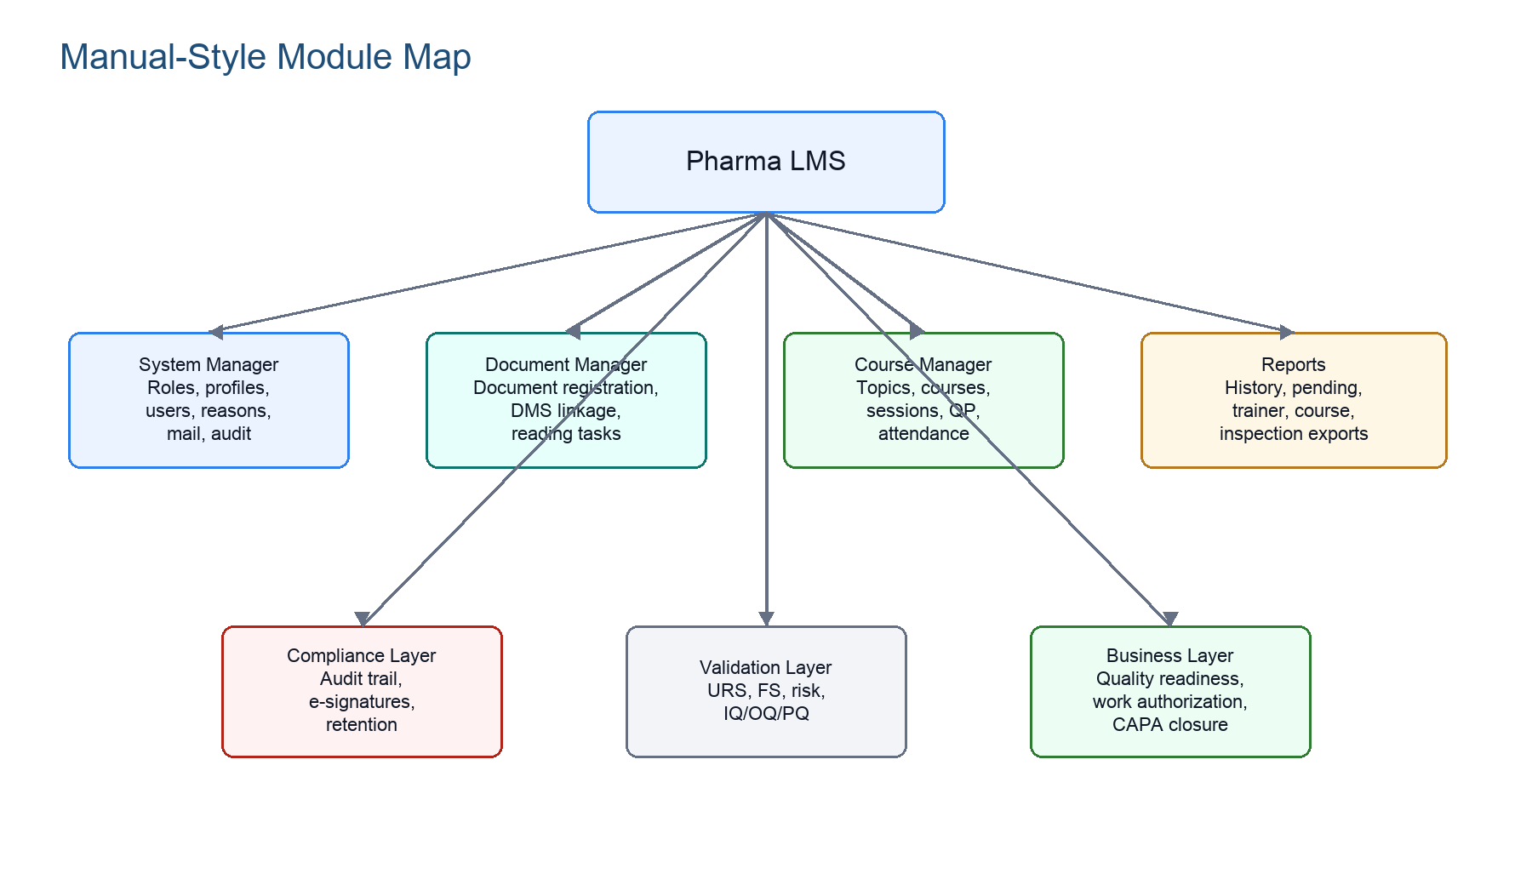
Figure 1. Manual-style module map for the complete Pharma LMS.

3. System Overview
The reference user manual divides learn-iq into System Manager, Course Manager, Document Manager, and Reports. A modern product scope keeps that operational view but adds platform services: identity, audit trail, e-signature, integration, reporting, validation, backup, and lifecycle governance.
Perspective | Description
Operational system | Used daily by administrators, training coordinators, trainers, learners, QA, managers, and auditors.
Compliance system | Maintains GxP electronic records, audit trails, e-signatures, and regulated reports.
Integration system | Works with DMS/docs-iq, QMS/CAPA/deviation/change control, SSO/AD, mail, reporting, storage, and optional biometrics.
Validation system | Requires URS, FS/configuration specification, risk assessment, IQ, OQ, PQ/UAT, traceability matrix, SOPs, and periodic review.
Business system | Controls workforce readiness, training compliance, work authorization, and quality-event closure evidence.

Core definition
A pharma LMS is a controlled training-evidence system. E-learning content is only one input; the regulated output is defensible proof of training, assessment, completion, and review.

4. System Requirements

4.1 Reference Deployment Baseline
Area | Reference baseline from user manual | Modern interpretation
Production server | Quad-core CPU, 3.4 GHz+, 32 GB RAM+, 1 TB+ disk, 1 Gbps NIC. | Size by concurrent users, report volume, attachment storage, audit trail growth, and retention period.
Server software | Windows Server 2016, IIS 7.0+, .NET Framework 4.0, SQL Server 2014/2016. | Document validated legacy baseline and target modernization path such as newer Windows/IIS/SQL or cloud equivalent.
Client | Windows 10, IE 11, MS Excel, display 1024x768+, legacy plugin references. | Use current browser compatibility, responsive design, and shop-floor/tablet support without obsolete plugin dependence.
Network | Minimum 10 Mbps. | Network failure must not corrupt submitted records; retry, transaction, and reconciliation controls are required.
Availability | 24x7 operation expected. | High availability, backup, restore testing, monitoring, maintenance windows, and DR procedures are in scope.

4.2 URS Security and Operational Requirements
- Unique user names; no duplicate, generic, shared, reused, or deleted user accounts.
- Password reset, password aging, first-login change, complexity, masking, idle timeout, and account lockout after configurable invalid attempts.
- User groups, role privileges, global profile, restricted user profile, plant assignment, user session log, unauthorized login log.
- Server-controlled date/time and auto synchronization for network-connected systems.
- Backup of electronic data and audit trail, with periodic restore testing.
- Mandatory fields, acceptable value checks, correct sequence enforcement, confirmation messages, and reason/comment capture.
- Business continuity, disaster recovery, high availability, RTO target of 15 minutes from the Alfa Biomed URS.
- Retirement, withdrawal, disposal, and data migration planning for retained GxP records.

5. Object Workflow
The object workflow is the common pattern behind roles, standard reasons, groups, job responsibilities, topics, courses, sessions, documents, and external training records.
- Authorized user initiates a master or transaction record.
- The system checks role rights, plant/group context, duplicate rules, mandatory fields, data type, sequence, and configured business constraints.
- If no approval is configured, the record becomes active after submission and audit capture.
- If approval is configured, the record moves to approver work item list and requires accept, reject, return, or modification with reason/comment and e-signature.
- Active records become selectable in downstream workflows; obsolete or inactive records remain retrievable for history and reports.
- Every change is captured with user, date/time, action, record, revision, reason, and signature meaning where applicable.
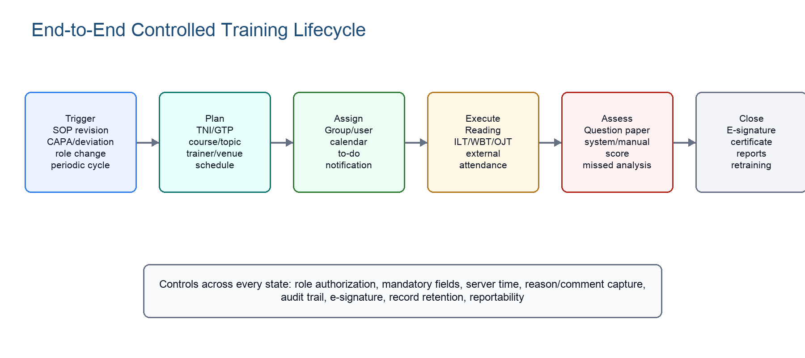
Figure 2. End-to-end controlled training lifecycle.
Mermaid source: object workflow
flowchart TD
A["Initiate record"] --> B["Validate role, plant, mandatory fields"]
B --> C{Approval configured?}
C -- "No" --> D["Active / available"]
C -- "Yes" --> E["Approver work item"]
E --> F{Decision}
F -- "Approve" --> D
F -- "Return / Reject" --> G["Reason, comment, audit trail"]
D --> H["Downstream workflow"]
H --> I["Reports and inspection evidence"]

6. System Manager
System Manager is the administrative control center. It defines who can enter the system, which roles exist, what each role can do, what reasons are available, how notifications work, and how audit trails are reviewed.
Function | Scope | Compliance note
Register new role | Role name, category, hierarchy level, status, approval where configured. | Role creation/modification is audit-trailed and may require approval.
Set global profile | Function and privilege assignment for a role. | Global profile defines the upper permission boundary.
Set user profile | User-specific restrictions under the global profile. | User profile can restrict but should not silently expand role rights.
Register user | Employee code, name, designation, department, section, plant, manager, status. | User ID must be unique and never reused.
Standard reasons | Predefined reasons for approval, return, drop, modification, and status change. | Reasons reduce ambiguous free text and support audit review.
Mail templates | Configurable notifications for assignment, pending tasks, password events, escalations. | Security-sensitive events go only to appropriate recipients.
Session logs | Login/logout and unauthorized attempts. | Supports security monitoring and inspection evidence.
Audit trails | Global profile, user profile, roles, reasons, and administrative changes. | Always-on, printable, non-editable.

7. Document Manager and DMS Integration
The URS requires the LMS to be fully integrated with DMS. In the IQM reference, controlled documents in docs-iq create or drive learn-iq training tasks. This is central to SOP training because users must train on the correct approved revision.
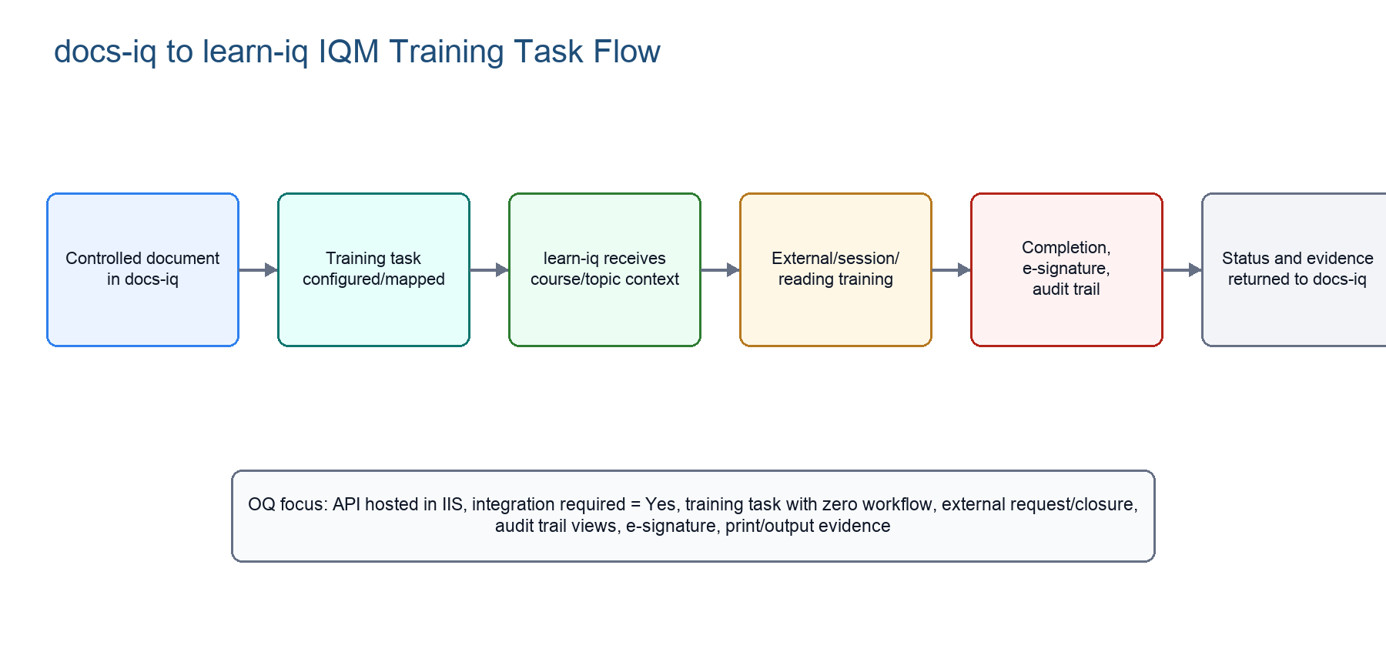
Figure 3. docs-iq to learn-iq IQM training task flow.
DMS/LMS capability | Required behavior
Approved document linkage | LMS receives document identity, title, type, version/revision, main/associate relationship, and training task context.
Training task mapping | Document types can be mapped to training tasks; zero approval workflow is supported where configured in OQ.
Document reading | Learner reads controlled content and signs/acknowledges completion when evaluation is not required.
Document revision | New revisions trigger training lifecycle according to TNI/curriculum rules and document effectiveness process.
Completion feedback | learn-iq returns completion, closure, and evidence context to docs-iq/QMS where required.
Audit trail | Document publish, training task, course/topic selection, request/closure, and completion steps remain audit-visible.

Mermaid source: docs-iq to learn-iq flow
flowchart LR
A["Document approved in docs-iq"] --> B["Training task generated"]
B --> C["learn-iq course/topic/session"]
C --> D["Learner reading or training"]
D --> E["Assessment / attendance / acknowledgement"]
E --> F["E-signature and audit trail"]
F --> G["Completion evidence returned"]

8. Course Manager
Course Manager holds the core training operations. The user manual enumerates a broad set of masters and transactions; the URS adds controlled lifecycle expectations and reportability.
Area | Covered functions
Masters | Topics, courses, training venue, trainer, external trainer, format number, satisfaction scale, feedback/evaluation template, question bank.
Planning | Group Training Plan, training schedule, periodic schedule, induction training, OJT, course invitation, self-nomination, batch formation.
Assessment | Question paper, answer paper response, evaluator workflow, system/manual evaluation, missed-question analysis, marks, QP extension.
Execution | Course sessions, print attendance sheet, online attendance, document reading, external training, completed training, feedback, short/long-term evaluation.
Control | Retraining, task termination, course retraining, revision/change history, expired material handling, role/plant eligibility.
Reports | Course list, course sessions, trainer qualification, employee history, induction/OJT/self-study, pending acknowledgements, assessment release log.

8.1 Training Modalities
Mode | Purpose | Key evidence
Document Reading | Controlled reading without examination. | Read acknowledgement, document version, e-signature, completion date.
Internal Classroom / ILT | Trainer-led internal training. | Schedule, trainer, attendance, scanned sheet, evaluation result.
WBT / Online | Online training and assessment. | Access log, question paper, answer paper, score, attempts.
Blended | Combination of ILT and WBT. | Mode split, participant completion, consolidated qualification status.
OJT | Practical on-the-job competence. | Trainer/evaluator observation, OJT completion, effectiveness evidence.
External | Vendor/webinar/external trainer training. | Request, approval, closure, external evidence attachment, audit trail.
Induction | New employee gate before normal courses. | Induction-required flag, induction trainer group, completion before release.
Remedial / Retraining | Failure, expiry, CAPA, deviation, or periodic refresher. | Trigger, due date, escalation, completion and retest evidence.

8.2 Complete Functional Inventory from the Reference Manual
The following inventory preserves the detailed operating scope from the learn-iq user manual in a compact form. It is meant to help you see the complete breadth of the LMS without having to read every screen-by-screen procedure.
Manual area | Functions covered | Product interpretation
Admin and Security | Register new role, set global profile, register standard reason, reason status update, audit trails. | Core role, privilege, reason, and administrative traceability layer.
Mail Settings | Set mail templates. | Notification templates for training assignment, pending tasks, password events, and escalations.
Biometrics | Biometric initiation and fingerprint enrollment where applicable. | Optional identity/attendance extension requiring separate validation and privacy controls.
Personal Settings | My training calendar, my pending trainings/calendar, personal particulars. | Learner self-service and task visibility.
User Groups | Subgroup, group, subgroup assignment, department, job responsibility, job responsibility acceptance. | Organizational model that drives TNI, curriculum, eligibility, and reporting.
Document Manager | Document registration and document-linked training task behavior. | Controlled document training and DMS/docs-iq integration boundary.
Course Masters | Topic, course, trainer, training venue, external trainer, format number, satisfaction scale, feedback/evaluation template, question bank. | Reusable master data for all training workflows.
Planning | Group Training Plan, training schedule, induction training, OJT, course invitation, self-nomination, batch formation. | Planning layer that turns training needs into assignments and sessions.
Assessment Preparation | Question paper, master answer key, assessment release, QP extension. | Assessment-control layer tied to course/topic and batch/session context.
Attendance and Execution | Print attendance sheet, record attendance online, course sessions, document reading, external training, completed training. | Execution evidence, including actual start/end time and scanned attendance where used.
Evaluation | Respond to question paper, evaluate answer paper, missed question analysis, record marks, feedback, short-term evaluation, long-term evaluation. | Competency and effectiveness evidence.
Exception Handling | Course retraining, pending task termination, remedial actions, task closure. | Controls failed, overdue, or no-longer-applicable assignments with reasons and audit trails.
Open Courses | Self-study open courses. | Learner-accessible optional or open training, still subject to record rules if used for GxP evidence.

8.3 Full Report Inventory from the Reference Manual
Report | What it proves or manages
Qualified Internal Trainer Report | Which internal trainers are qualified for specified topics/courses.
Qualified External Trainer Report | Which external trainers are approved/qualified.
Qualified Trainer Course List Report | Trainer-to-course qualification coverage.
Date-wise Course Session Report | Training sessions by period/date.
Course List Report | Available course master inventory and status.
Individual Employee Report (ALL) | Training status for an employee across courses/tasks.
Induction Training Report | New employee induction completion and pending status.
On Job Training Completion Report | OJT completion evidence.
Self-study Courses Report | Open/self-study course activity.
QP Extension Log Report | Question-paper extension requests and disposition.
Pending Course(s) Acknowledgement Log Report | Pending learner acknowledgements.
Pending Training-Employee List Report | Employees with pending assigned training.
Assessment Release Log Report | Assessment release actions and timing.
Employee Training History | Longitudinal employee training record for inspection.
External Training Closure Log | External training closure and print/evidence output.
Job Responsibility Report and History | Current and historical role-responsibility assignment.

9. Training Execution Workflows

9.1 Course Session Workflow
Step | What happens | Control point
Create session | Select course, topic, method, mode, trainer, batch, plant, venue, date/time. | Role authorization, active masters, plant eligibility.
Prepare question paper | Generate or select questions for sessions requiring examination. | Approved question bank, answer key, evaluation mode.
Assign / invite | Learners receive to-do task, calendar entry, notification, or invitation. | Task traceability and due date.
Conduct training | Trainer performs ILT/OJT or learner completes WBT/document reading. | Attendance/read tracking and server time.
Evaluate | System scores automatically or evaluator scores manually. | Score, pass criteria, retake/retraining decision.
Close | Capture e-signature, completion, certificate, feedback, reports. | Audit trail, signature manifestation, inspection export.

9.2 External Training Workflow
- Configure external-training course and topic availability.
- Authorized user initiates external training request and selects course/topic details.
- System validates lists, mandatory remarks/reasons, and configured percentage criteria.
- Closure records include completion details, print output, supporting evidence, and e-signature.
- Audit trails and closure logs must display complete revision and printed evidence details.
OQ caution
The signed OQ text includes failed bug-linked steps around topic selection, course/topic audit trail views, and external training closure print/log details. A production release must include defect disposition and retest evidence for these controls.

10. Reports, Dashboards, and Analytics
Reports are inspection artifacts and management controls. They must be filterable, printable, exportable, complete, and traceable to the underlying source records.
Report family | Examples
Trainer qualification | Qualified internal trainer, qualified external trainer, qualified trainer course list.
Course/session | Course list, topic-course, date-wise session, complete session, terminated session, scheduled pending courses.
Employee evidence | Individual employee report, employee training history, training card, employee status by course/topic.
Training type | Induction assessment, OJT completion, self-study, document reading pending, external training closure.
Assessment | Question bank, assessment release log, QP extension log, missed-question analysis, training evaluation record.
Organization | Group-wise users, subgroup-wise users, job responsibility current/history, plant-wise training status.
Compliance dashboards | Pending, overdue, at-risk, on-track, locked users, locked quiz/exam, completion totals.

Mermaid source: reporting scope
flowchart LR
A["Analytics Scope"] --> B["Operational Monitoring"]
A --> C["Compliance Monitoring"]
A --> D["Qualification Monitoring"]
A --> E["Management Visibility"]
B --> B1["Schedules / sessions / attendance"]
C --> C1["Pending / overdue / at-risk"]
D --> D1["History / trainer qualification / exams"]
E --> E1["Totals / trends / dashboards"]

11. Architecture and Technology
The target architecture should separate user experience, application services, compliance services, integration services, data/record storage, and operations. This makes the system easier to validate and safer to change.
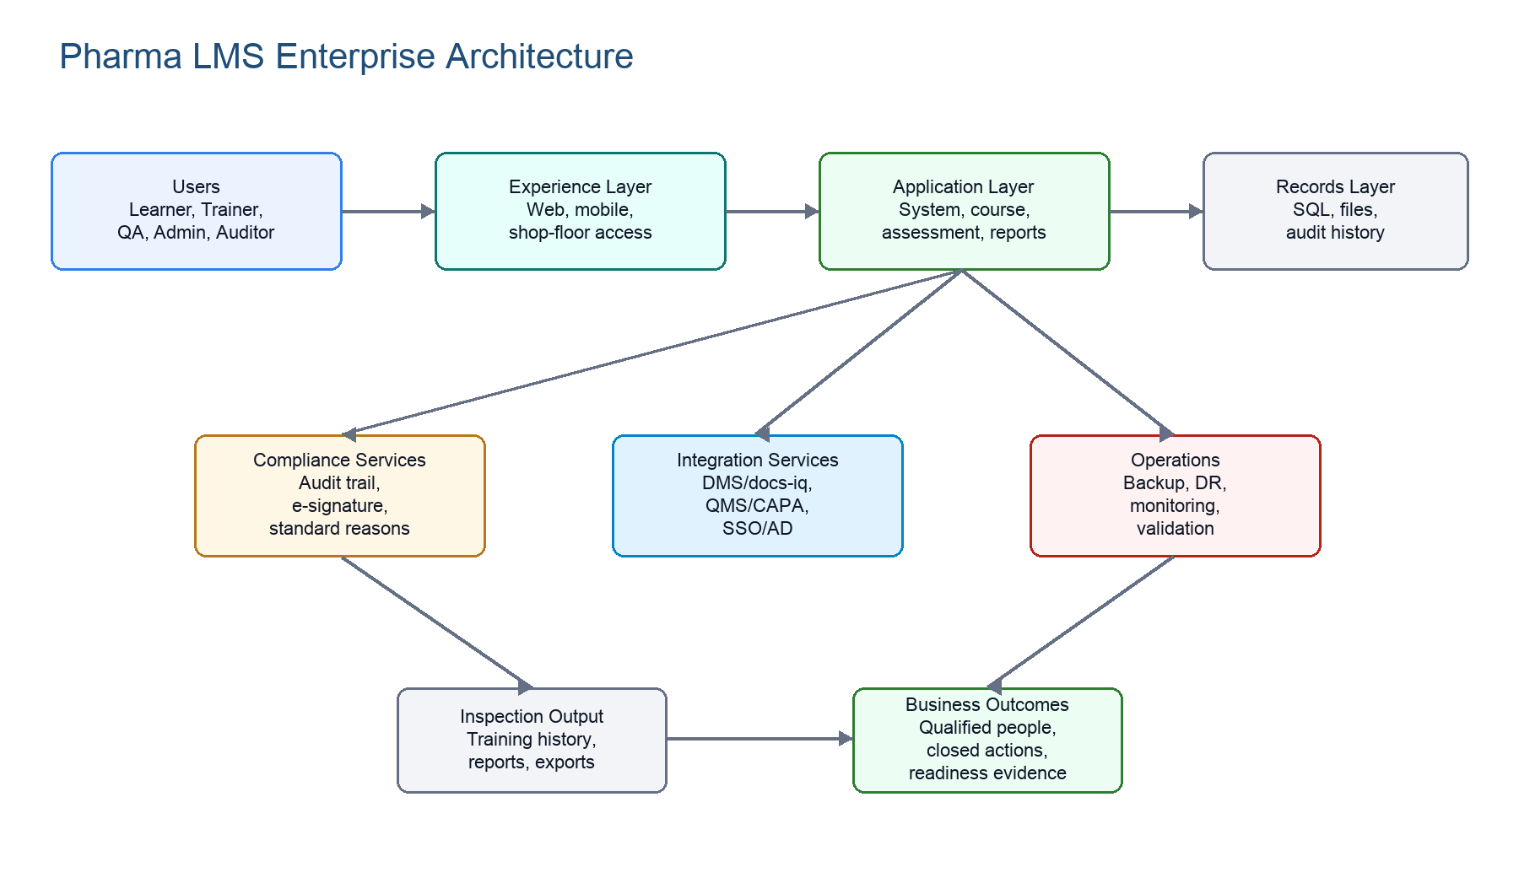
Figure 4. Enterprise architecture for a complete pharma LMS.
Layer | Responsibilities | Validation concern
Experience | Role-specific screens for learner, trainer, coordinator, QA, admin, auditor. | Screens enforce permission and display correct record/signature context.
Application | Courses, sessions, assessment, reports, schedules, dashboards, workflow. | Business rules and state transitions are tested.
Compliance | Audit trail, e-signature, standard reasons, workflow approval, record retention. | Controls are always-on and cannot be bypassed by admin.
Integration | DMS/docs-iq, QMS, CAPA/deviation, SSO/AD, mail, calendar, reporting. | Data exchange preserves value and meaning; failures are recoverable.
Data | Training records, audit trails, attachments, question bank, results, certificates. | Records are durable, attributable, retrievable, and migration-ready.
Operations | Hosting, database, backups, DR, monitoring, support, environments. | IQ/PQ evidence, restore tests, access review, change control.

Mermaid source: logical architecture
flowchart LR
A["Users"] --> B["Browser / Mobile UI"]
B --> C["LMS Application Services"]
C --> D["Compliance Services"]
D --> E["Validated Records Repository"]
C <--> F["DMS / docs-iq"]
C <--> G["QMS / CAPA / Deviation"]
C <--> H["Identity / SSO / AD"]
C --> I["Mail / Escalation"]
E --> J["Reports / Inspection Exports"]

12. Compliance and Data Integrity
Framework | LMS implication | Design response
21 CFR Part 11 | Electronic records and signatures must be attributable, trustworthy, and linked. | Unique users, password controls, e-signatures, signature manifestation, audit trails.
EU GMP Annex 11 | Computerized systems must be validated, secure, auditable, backed up, and reviewed. | CSV lifecycle, access control, audit review, backups, DR, periodic review.
GAMP 5 | Validation is risk-based and tied to configured/custom functions. | URS-to-test traceability, supplier assessment, risk assessment, IQ/OQ/PQ.
ICH Q10 | Training is part of the pharmaceutical quality system. | CAPA/deviation/change integration, effectiveness checks, management metrics.
ALCOA+ | Data must be attributable, legible, contemporaneous, original, accurate, complete, consistent, enduring, available. | Server time, immutable audit, no deletion, versioned records, exports.

12.1 Required Compliance Services
- Audit trail service: always-on, computer-generated, server-time-stamped, non-editable, non-deletable, printable, and retained with the record.
- E-signature service: first signature uses user ID and password; subsequent continuous-session signatures use at least password; every signature shows signer, date/time, and meaning.
- Identity service: unique users, no generic accounts, no user deletion, no user ID reuse, password aging, lockout, session timeout, unauthorized attempt logging.
- Record service: mandatory field checks, valid data ranges, no silent overwrite, no deletion, old-version retrievability, human-readable and electronic copies.
- Continuity service: backup, restore, DR, high availability, RTO target, crash consistency, migration and retirement planning.
Mermaid source: compliance scope
flowchart TD
A["Compliance Scope"] --> B["Identity Control"]
A --> C["Record Control"]
A --> D["Signature Control"]
A --> E["Audit Control"]
A --> F["Continuity Control"]
B --> B1["Unique user IDs"]
C --> C1["Retention and retrieval"]
D --> D1["E-signatures"]
E --> E1["Immutable audit trail"]
F --> F1["Backup and restore"]

13. Validation, OQ Evidence, and Traceability
Validation proves that the configured LMS satisfies the URS in a controlled environment. The signed IQM OQ evidence is particularly important because it tests docs-iq to learn-iq integration, training task initiation, external training request/closure, audit trails, and e-signatures.
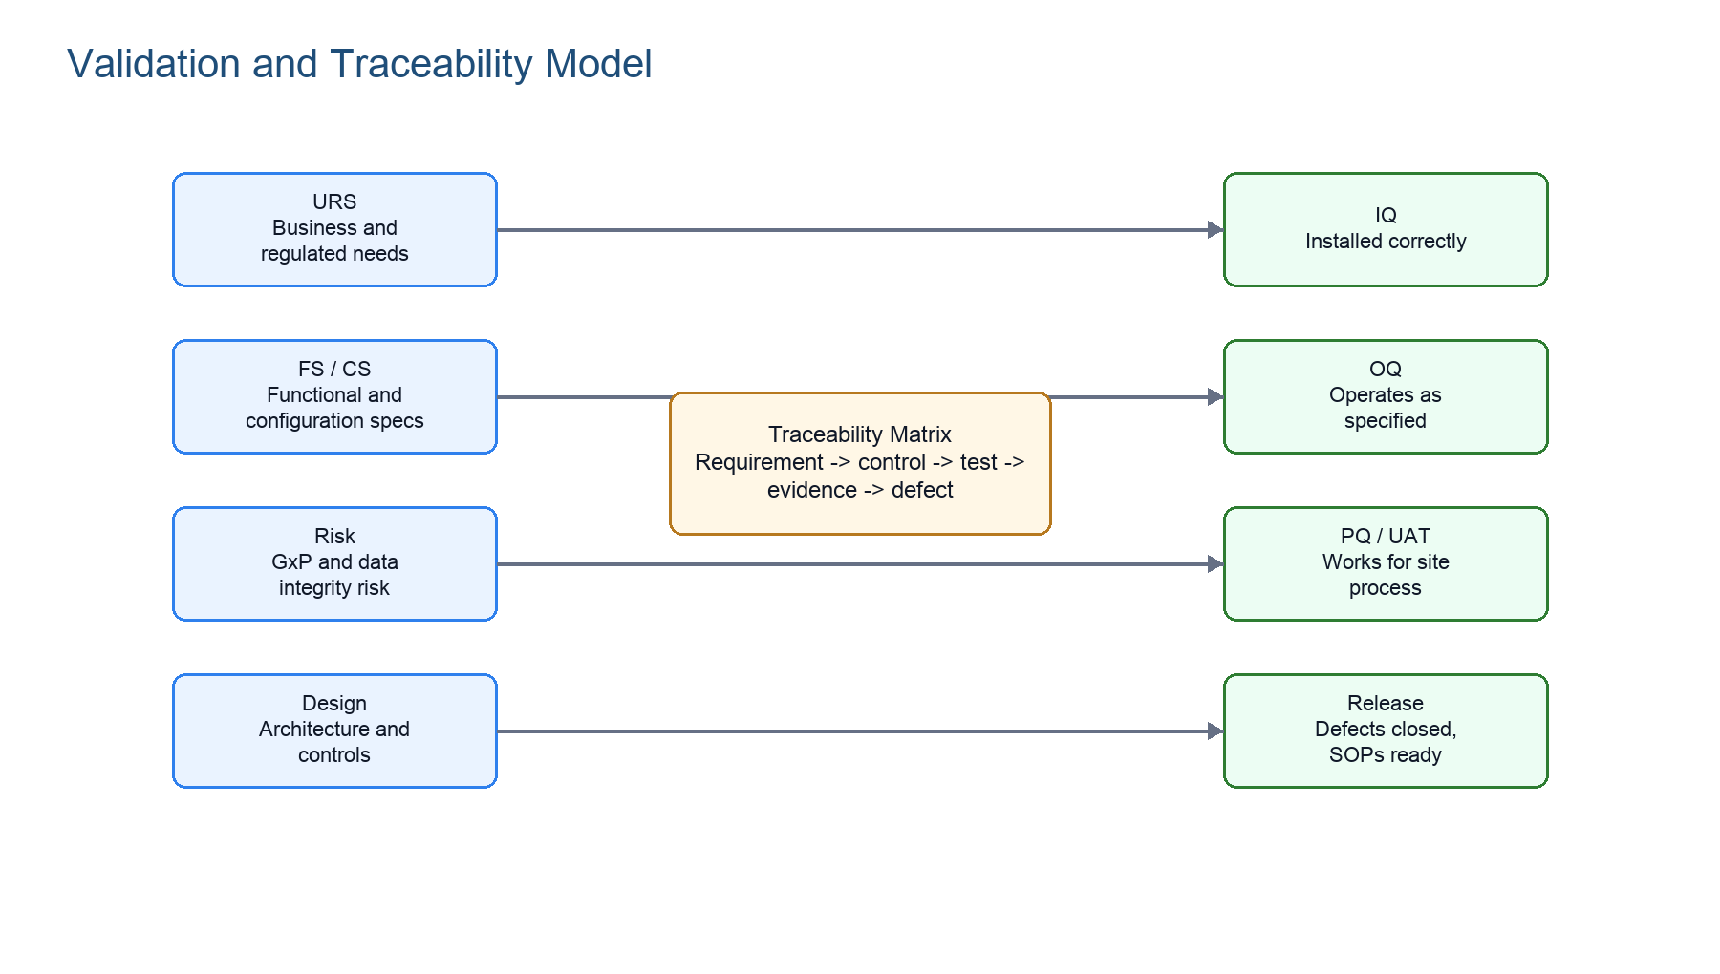
Figure 5. Validation and traceability model.
Artifact | Purpose
URS | Defines user, business, regulatory, security, operational, support, and retirement requirements.
FS / Configuration Specification | Maps requirements to functions, screens, rules, roles, reports, workflows, and configuration.
Risk Assessment | Classifies GxP/data integrity risk and determines test depth.
IQ | Confirms correct installation, environment, version, server, client, database, API/IIS hosting.
OQ | Challenges configured functions, invalid/valid inputs, permissions, audit trail, e-signature, reports, integration.
PQ / UAT | Confirms site-specific business scenarios using actual training patterns and roles.
Traceability Matrix | Connects URS ID to design/configuration, risk, test, result, and defect disposition.

Signed OQ context
The extracted signed OQ text contains 398 result-bearing steps: 371 marked P and 27 marked F with bug-linked failure text. The failed families must be treated as validation risks until formal defect closure and retest evidence are available.

14. Business Operating Model
Role | Business responsibility | System responsibility
System Admin | Maintain controlled access and configuration. | Users, roles, profiles, reasons, mail, security settings.
QA Head / QA Manager | Own compliance oversight and inspection readiness. | Approve critical workflows, review audit trails, access obsolete records.
Training Coordinator | Run training calendar and completion tracking. | Schedules, sessions, invitations, dashboards, pending tasks.
Trainer / Evaluator | Deliver and evaluate training. | Attendance, marks, feedback, evaluation and closure inputs.
Department Head | Ensure team readiness and job responsibility alignment. | Team status, job responsibility, escalations, reports.
Learner / Employee | Complete assigned training and assessments. | To-do list, reading, exam, feedback, certificates.
Auditor | Inspect records without changing them. | Read-only reports, audit trails, evidence packages.

Business takeaway
The LMS becomes the operating memory of workforce readiness. If it cannot show who was qualified at a point in time, the business cannot confidently defend training compliance.

15. Target Product Scope
Priority | Capability layer | Included scope
P0 | Foundation | Users, roles, profiles, groups, departments, job responsibilities, standard reasons, security policy.
P0 | Compliance platform | Audit trail, e-signature, session log, record retention, no deletion, server time, inspection export.
P0 | Learning operations | Courses, topics, trainers, venues, schedules, sessions, attendance, document reading, assessments.
P0 | DMS integration | docs-iq/DMS document training task flow, document version linkage, completion evidence.
P1 | Advanced training | External training, OJT, induction gate, remedial/retraining, periodic review, feedback/effectiveness.
P1 | Reports/dashboards | Inspection reports, employee history, pendency, trainer qualification, session/course reports.
P1 | QMS integration | CAPA, deviation, change-control triggered training and closure evidence.
P2 | Extensions | Biometrics, multilingual UI, offline/mobile enhancements, advanced analytics.

Mermaid source: target scope model
flowchart TD
A["Target Scope Model"] --> B["Foundational"]
A --> C["Learning Operations"]
A --> D["Qualification"]
A --> E["Compliance"]
A --> F["Enterprise"]
B --> B1["Users, roles, profiles"]
C --> C1["Courses, sessions, attendance"]
D --> D1["Assessments, certificates, retraining"]
E --> E1["Part 11, Annex 11, ALCOA+"]
F --> F1["DMS, QMS, mail, reports"]

16. Risks, Decisions, and Implementation Guidance
Risk / decision | Why it matters | Recommended action
Legacy platform references | User manual references IE 11, Flash, .NET 4.0, SQL 2014/2016. | Document modern equivalent stack and validate migrated behavior.
DMS integration complexity | Training is driven by controlled document state and revision. | Define canonical API contracts, retry/reconciliation, and audit mapping.
OQ failures | Signed OQ shows bug-linked failures in audit/closure/topic areas. | Require defect closure, impact assessment, and retest evidence.
CAPA/deviation training | Quality events often require training closure evidence. | Define QMS gating rules and evidence payloads before build.
Mobile/shop-floor use | Convenient access can weaken identity/session controls if not designed. | Validate device support, timeout, e-signature, and secure session behavior.
Scope creep | A pharma LMS can expand into DMS/QMS/HRMS territory. | Keep ownership boundaries clear and integrate rather than duplicating controlled systems.

17. Diagram and Mermaid Library
The attached pharma_learn_scope.docx demonstrates a practical pattern: short explanation, rendered diagram for Word readers, and Mermaid source for maintainers. This manual preserves the same style.
Diagram type | Use it for | Example in this manual
flowchart LR | Architecture and left-to-right integration flows. | DMS/docs-iq to learn-iq IQM flow.
flowchart TD | Scope decomposition and object workflows. | Object workflow and compliance scope.
mindmap | Concept maps such as NFRs and architecture interpretation. | NFR library below.
Rendered PNG | Readers who consume the Word/PDF version. | Figures 1-5.
Mermaid source | Engineers who maintain Markdown/spec versions. | All Mermaid blocks in this section and earlier sections.

Mermaid source: non-functional requirements mindmap
mindmap
root((Non-Functional Requirements))
Security
RBAC
Password policy
Session timeout
Reliability
Backup
Restore
Continuity
Performance
Multi-site support
Searchability
Dashboard responsiveness
Maintainability
Config-driven behavior
Version alignment
Traceability
IDs
Logs
History

18. Appendices

18.1 Consolidated Requirement Matrix
Control area | Reference anchor | Requirement summary | Design / test response
Security | URS 3.1, 4.5 | Unique users, password policy, session timeout, lockout, no generic accounts. | Auth/RBAC/session tests and access matrix.
Audit trail | URS 3.1.15-3.1.32, 4.5.31 | Always-on, who/when/what, non-editable, non-deletable, printable. | Central audit service and OQ challenge tests.
E-signature | URS 3.1.48-3.1.54, 4.5.30 | Two-component first signature, signature meaning, record linkage. | E-signature service and report manifestation tests.
DMS integration | URS 2.1.3.3, IQM OQ | DMS/docs-iq integration and training task flow. | API integration OQ and reconciliation tests.
Training lifecycle | Manual Course Manager, URS 4.2-4.4 | Planning, assignment, execution, assessment, feedback, retraining. | Workflow tests for each training type.
Reports | Manual 6.2, URS 4.3.22 | Trainer, course, employee, pending, history, assessment, induction/OJT reports. | Report filters, print/export, source-record tests.
Recovery | URS 4.6 | Backup, restore, DR, RTO, crash consistency. | Restore test, DR drill, monitoring evidence.
Retirement | URS 4.9.8 | Withdrawal, migration, retained GxP records, disabled interfaces. | Retirement plan and migration verification.

18.2 Glossary
Term | Meaning
LMS | Learning Management System.
DMS | Document Management System, source of controlled SOPs and revisions.
docs-iq | EPIQ document-management module referenced in IQM flow.
learn-iq | EPIQ learning-management module referenced by user manual and OQ.
IQM | Integrated Quality Management connection between EPIQ modules.
TNI | Training Need Identification.
GTP | Group Training Plan.
OQ | Operational Qualification.
ALCOA+ | Attributable, legible, contemporaneous, original, accurate, complete, consistent, enduring, available.
E-signature manifestation | Visible signer, timestamp, and meaning on screen/report/record.

