PHARMA LMS
KNOWLEDGE BASE
Architecture | Functional Scope | Compliance Controls | Validation Evidence
Reference systems: Caliber EPIQ learn-iq, docs-iq to learn-iq IQM, Alfa Biomed LMS URS

Document Attribute | Value
Primary audience | Technology leadership, product managers, validation leads, QA, developers
Document type | Technical knowledge base and architecture reference
Prepared for | Vyuh Tech / Pharma LMS product development
Revision date | 28 Apr 2026
Confidentiality | Confidential working reference

Technical-writing approach
This revision follows product-docs principles: write for the reader's work, keep the structure task-oriented, prefer concrete examples over generic claims, separate facts from recommendations, and make maintenance ownership visible.

1. Source Basis and How to Use This Document
This knowledge base consolidates the product scope, regulated architecture, operating workflows, and validation evidence for a pharmaceutical Learning Management System. It is not a marketing brief. It is a working reference for deciding what the LMS must do, how it should be structured, and which controls must be preserved during implementation.
Source | How it was used
Pharma_LMS_Knowledge_Base.docx | Baseline structure, regulatory framing, and existing product-scope catalog.
usermANUAL.pdf | Learn-iq operational modules, server/client requirements, object workflow, course/session steps, reports, and audit-trail screens.
Learn IQ _ URS.pdf | Alfa Biomed URS: security, regulatory, operational, DMS integration, GMP, data integrity, recovery, support, and retirement requirements.
Pharma_LMS_Textbook.docx | Training-domain explanation, role model, lifecycle model, compliance rationale, and EPIQ platform context.
Docs-iq to Learn-iq IQM OQ PDFs | Integration qualification flow for document-driven training tasks, external training request/closure, audit trail verification, e-signature prompts, and OQ result context.

Scope statement
The LMS must be treated as a GxP compliance system: it controls training obligations, produces electronic records, enforces identity and authorization, and supplies evidence for inspections. The architecture must therefore be validated, auditable, and integrated with document and quality workflows.

1.1 Reader Paths
Reader | Start here | Main questions answered
Product / engineering lead | Sections 2, 4, 5, 9 | What do we build, how is it structured, and where are the hard boundaries?
QA / validation lead | Sections 3, 8, 10, 11 | Which controls, records, and tests prove compliance?
Implementation team | Sections 5, 6, 7, 12 | What workflows, roles, data objects, and integrations are required?
Business sponsor | Sections 2, 9, 13 | What scope is mandatory, optional, or risky to defer?

2. Executive Summary
A pharmaceutical LMS is a regulated training-control system, not a generic e-learning portal. Its core output is defensible evidence: who was trained, on which controlled content and version, when, by whom, with what result, under which electronic signature, and with what audit trail.
- The system must integrate with DMS/docs-iq so approved SOPs and document revisions can trigger training tasks without re-entering controlled content.
- The LMS must support role-based curriculum assignment, induction gating, periodic retraining, remedial training, external training, OJT, document reading, ILT, WBT, and blended learning.
- Every GxP-relevant transaction must be protected by unique identity, access control, audit trail, e-signature linkage, reason/comment capture, and retained electronic records.
- The architecture must separate user experience, application services, compliance services, integration adapters, and persistent records so each layer can be validated and changed under control.
- Validation evidence should trace URS requirements to functional/design controls and to IQ/OQ/PQ scripts, with special attention to failed or bug-linked OQ steps in the signed IQM evidence.
Key product decision
Do not scope the LMS as course delivery first and compliance second. In pharma, course delivery is one workflow inside a larger evidence-generation system.

2.1 What Makes Pharma LMS Different
Dimension | Corporate LMS | Pharma LMS
Primary outcome | Learning access and engagement | Inspection-ready proof of training and competency
Content | Courses and media | Controlled SOPs, policies, protocols, training materials, questionnaires, answer keys
Identity | Convenience login, often SSO only | Unique user ID, no generic accounts, password/e-signature controls, session logs
Records | Progress and scores | GxP records with audit trail, version, signature meaning, retention, and retrievability
Change | Content update | Controlled document revision, approval, retraining trigger, effectiveness evidence
Failure mode | Missed training | Potential GMP observation, CAPA delay, data integrity deficiency, or batch-release risk

3. Regulatory and Quality Framework
The LMS must satisfy the combined expectations of electronic-record regulation, GMP training obligations, quality-system governance, and data-integrity principles. Requirements should be mapped to controls, not left as generic compliance claims.
Framework | LMS implication | Required design response
21 CFR Part 11 | Electronic records and e-signatures must be trustworthy, attributable, and linked to records. | Unique users, password policy, e-signature challenge, signature manifestation, secure audit trail, copy/export controls.
EU GMP Annex 11 | Computerized systems must be validated, secure, auditable, backed up, and periodically reviewed. | CSV lifecycle, access management, audit trail review, backup/restore, incident/CAPA/change-control procedures.
GAMP 5 | Validation effort must be risk-based and proportionate to system category/configuration. | URS-to-test traceability, supplier assessment, risk assessment, IQ/OQ/PQ, configuration and custom-code separation.
ICH Q10 / PQS | Training is part of the pharmaceutical quality system and supports CAPA, change control, deviation, and management review. | QMS integration, training effectiveness, periodic metrics, CAPA/deviation-triggered retraining.
ALCOA+ | Data must be attributable, legible, contemporaneous, original, accurate, complete, consistent, enduring, and available. | Server time, append-only logs, no deletion, versioned records, durable storage, human-readable reports.

3.1 Non-Negotiable Compliance Controls
- No duplicate, shared, generic, reused, or deleted user accounts.
- Passwords are masked, complex, aged, changed on first login, and protected from common-word administrator usage.
- Account lockout occurs after configurable invalid attempts, with unauthorized login attempts logged.
- Audit trail is computer-generated, time-stamped, always on, non-editable, non-deletable, printable, and retained with the related record.
- Every critical transaction records who, when, what, previous value, new value, and reason/comment where applicable.
- E-signatures show signer name, date/time, and meaning on screens, reports, and audit trails, and remain technologically linked to the record.
- The system clock is controlled by the server/time service; users cannot change date/time values to alter record chronology.
- Electronic records and audit trails can be exported in complete human-readable and electronic forms for inspection.

4. Architecture of a Pharmaceutical LMS
The architecture should be organized as a controlled platform with distinct layers. The goal is to keep learning workflows flexible while keeping regulated evidence consistent, validated, and tamper-resistant.
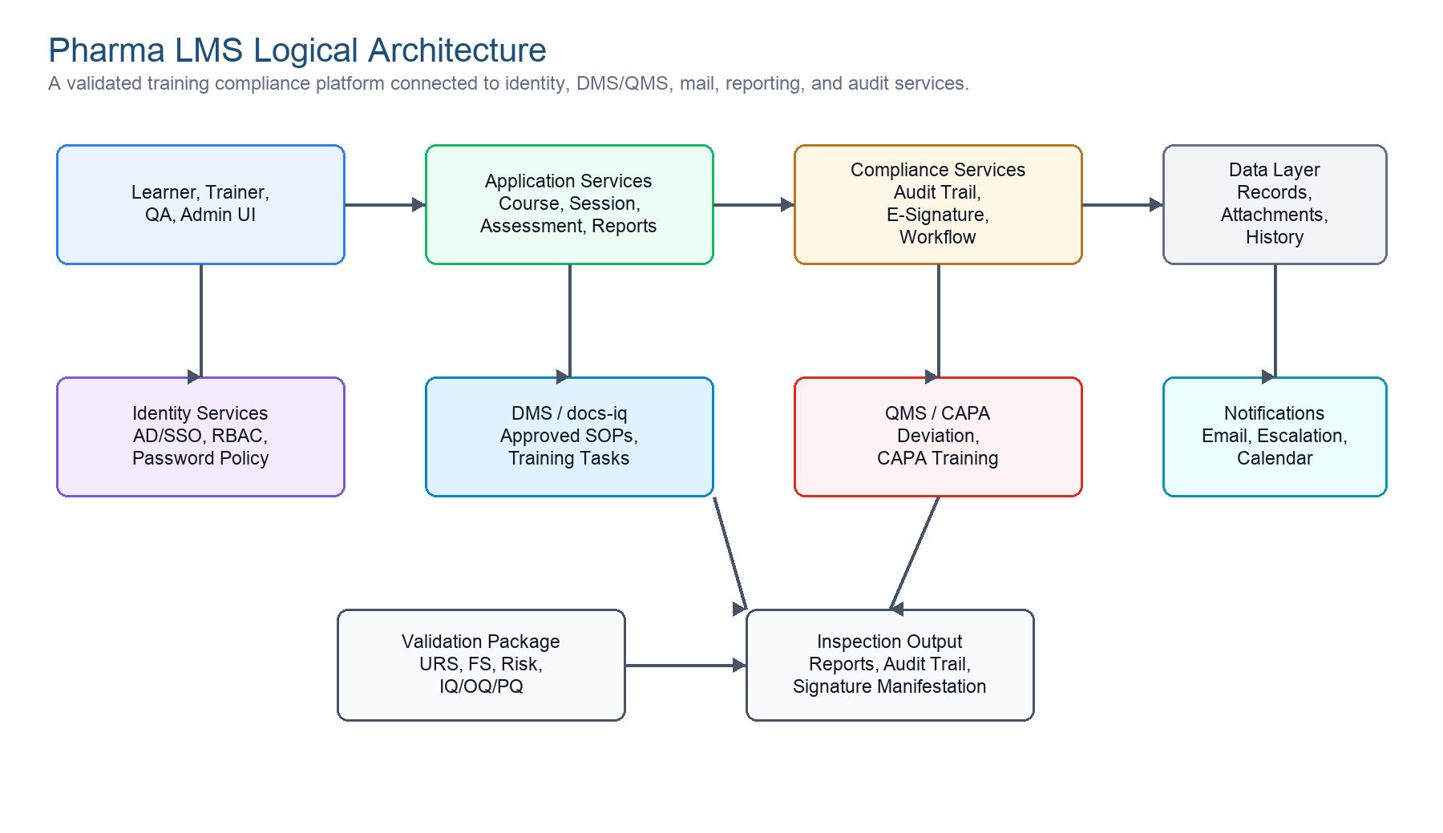
Figure 1. Logical architecture for a validated pharma LMS.
Mermaid source: platform-level context
flowchart LR
A[Users: Learner / Trainer / QA / Admin] --> B[Web and Mobile UI]
B --> C[Application Services]
C --> D[Compliance Services: Audit Trail + E-Signature + Workflow]
D --> E[(Validated Records Repository)]
C <--> F[Identity / AD / SSO]
C <--> G[DMS / docs-iq]
C <--> H[QMS: CAPA / Deviation / Change Control]
C --> I[Email / Escalation Engine]
E --> J[Reports and Inspection Exports]

4.1 Layered Architecture
Layer | Responsibilities | Validation concern
Experience layer | Role-specific screens for learner, trainer, coordinator, QA, auditor, and system administrator. | Screens must enforce role permissions and show correct record/signature context.
Application services | Courses, topics, TNI, GTP, sessions, attendance, assessments, feedback, reports, and dashboards. | Functional requirements, business rules, and workflow state transitions must be tested.
Compliance services | Audit trail, e-signature, standard reasons, workflow approvals, retention, user session logs. | Controls must be always-on and resistant to administrator bypass.
Integration services | DMS/docs-iq, QMS/CAPA/deviation, identity, email, calendar, reporting, archive. | Data exchange must preserve value and meaning; failures must be logged and recoverable.
Data layer | Master data, training records, version history, attachments, question banks, results, certificates, audit trail. | Records must be durable, attributable, backed up, retrievable, and migration-ready.
Operations layer | IIS/application hosting, database, backup/restore, monitoring, support, change control, environments. | IQ/OQ/PQ, backup restore tests, access to OS/database, and release governance.

4.2 Deployment Baseline from Learn-iq Manual
Area | Reference baseline | Architecture note
Production server | Quad-core CPU, 3.4 GHz+, 32 GB RAM+, 1 TB+ expandable disk, 1 Gbps NIC. | Size for concurrent usage, reports, attachments, audit trail growth, and retention.
Server software | Windows Server 2016 64-bit, IIS 7.0+, .NET Framework 4.0, SQL Server 2014/2016. | Legacy EPIQ profile; new designs should document modern equivalents and validation impact.
Client | Windows 10, browser access, MS Excel for exports, 1024x768+ display. | Avoid hard dependency on obsolete plugins; design responsive tablet/shop-floor access.
Network | Minimum 10 Mbps; users may be at different site locations. | Network interruptions must not corrupt data during storage or workflow submission.
Availability | 24x7 operation expected; RTO target in URS: 15 minutes. | High availability, backups, restore tests, DR procedures, and downtime communications are in scope.

4.3 Integration Architecture
The OQ materials show that docs-iq to learn-iq integration is a core architecture concern, not an optional add-on. Document training tasks are initiated from controlled document workflows and then completed through learn-iq training execution and closure evidence.
Integration | Inbound to LMS | Outbound from LMS | Controls
DMS / docs-iq | Approved document metadata, revision, training task, main/associate document relationship. | Training status, closure evidence, document-read completion, audit references. | Integration-required configuration, API hosting, sequence integrity, retries, audit trail.
QMS / CAPA / deviation | Training triggers linked to investigation, CAPA, deviation, change, or effectiveness action. | Completion, failure, overdue status, evidence package. | CAPA cannot close until required training evidence exists where procedure requires it.
Identity / directory | User identity, organizational hierarchy, status, plant/site context. | Session logs and access events may be reviewed by security/QA. | Unique user ID, no reuse, role/profile mapping, deactivation not deletion.
Email / notification | Template and event configuration. | Assignment, reminder, escalation, password and task notifications. | Only appropriate recipients receive security-sensitive notifications.
Reporting / archive | Validated record sources. | PDF/Word/Excel, printable reports, inspection exports, archived records. | Reports must preserve signature manifestation and audit context.

5. Complete Functional Scope
The functional scope below combines the URS, user manual, textbook, and IQM evidence into a product map. Each capability should have clear ownership, record output, audit coverage, and validation tests.
Domain | Must cover | Primary records / evidence
System Manager | Roles, global profile, user profile, standard reasons, mail templates, biometrics where applicable, personal settings, training calendar, pending trainings, audit trails. | Role/profile audit trail, session log, standard reason records, user status history.
User groups and job responsibility | Subgroups, groups, subgroup assignment, departments, job responsibilities, acceptance, alternates, delegation. | Job responsibility current/history reports, user acceptance e-signature, group assignment audit trail.
Course Manager masters | Topics, courses, trainer qualification, venue, external trainers, format numbers, satisfaction scale, feedback/evaluation templates, question bank. | Master records, revisions, approval status, audit trail, question bank report.
Training planning | Group Training Plan, training schedule, periodic schedules, induction, OJT, course invitation, self-nomination, batch formation. | TNI/GTP records, schedule reports, batch records, invitation logs.
Execution and assessment | Document reading, course sessions, online/offline attendance, question paper, answer paper, system/manual evaluation, missed-question analysis, feedback, short/long-term evaluation. | Attendance, answers, marks, result, e-signature, feedback records, certificates.
External and completed training | External request, external training closure, vendor/webinar training, already completed training entry with evidence. | External request/closure records, attachments, print output, audit trail.
Retraining and termination | Course retraining, QP extension, pending task termination, remedial training, expiry-triggered retraining. | Retraining tasks, termination reason, overdue and pending reports.
Reports and dashboards | Qualified trainers, course/session lists, employee history, induction/OJT/self-study reports, pending acknowledgements, assessment release log, training card, group-wise users. | Printable/exportable reports with filter criteria and signature/audit context.

5.1 Training Modalities
Training type | Purpose | Controls to preserve
Document Reading | Learner reads one or more controlled documents without evaluation. | Document version, read acknowledgement, e-signature, completion date, pending report.
Internal Classroom / ILT | Trainer-led session for internal personnel. | Trainer qualification, venue, schedule, attendance, scanned sheet, marks/evaluation.
WBT / online | Learner completes web-based content and online assessment. | Access control, question paper, timed attempts, system scoring, missed-question analysis.
Blended | Mixed ILT and WBT for large release or multi-site training. | Percentage/eligibility rules, both session evidence types, common completion criteria.
On-the-Job | Practical competence built and observed over time. | OJT task, evaluator/trainer record, observation evidence, completion signature.
External training | Vendor, webinar, external trainer, or external course. | Request, closure, evidence attachment, topic/course mapping, audit trail.
Induction | Mandatory onboarding gate for new employees. | Induction-required flag, induction trainer group, completion before general course access.
Remedial / retraining | Corrective training after failure, expiry, CAPA, deviation, or periodic requirement. | Trigger source, due date, escalation, completion evidence, CAPA/QMS link.

5.2 Report Catalog
Reports are not merely analytics. In a regulated LMS, reports are inspection artifacts. They must be filterable, printable, exportable, complete, and traceable to source records.
- Qualified internal trainer, qualified external trainer, and qualified trainer course-list reports.
- Course list, topic-course, date-wise session, complete course session, and terminated course session reports.
- Individual employee report, employee training history, training card, group/subgroup user report, and job responsibility current/history reports.
- Induction, OJT, self-study, document reading pending, pending course acknowledgement, pending employee list, and scheduled courses pending reports.
- Question bank, assessment release log, QP extension log, training evaluation, external training closure, and dashboards for plant/month/status.

6. Core Workflows
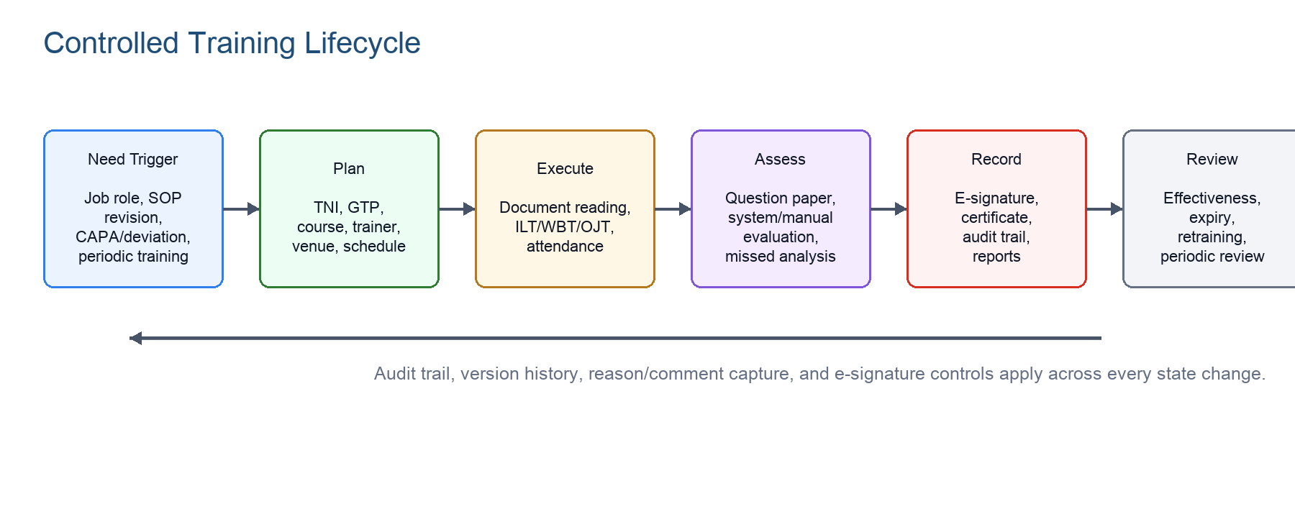
Figure 2. Controlled training lifecycle with persistent compliance controls.
Mermaid source: docs-iq to learn-iq training-task flow
flowchart TD
A[Controlled document approved in DMS/docs-iq] --> B{Training task required?}
B -- No --> C[Publish document without LMS task]
B -- Yes --> D[Create / map Training Task]
D --> E[learn-iq receives task and document metadata]
E --> F[Course / topic / trainee selection]
F --> G[Training session or document reading]
G --> H[Assessment / attendance / acknowledgement]
H --> I[E-signature and audit trail]
I --> J[Completion or retraining decision]
J --> K[Status returned to DMS / QMS evidence package]

6.1 Generic Object Workflow
- Authorized user initiates a master record, training object, schedule, session, or request.
- System validates mandatory fields, acceptable value ranges, sequence, duplicate rules, role permissions, and plant context.
- If approval is configured, the item enters an approval workflow; otherwise it becomes available for authorized use.
- Approver reviews, accepts, rejects, returns, or requests modification with reason/comment and e-signature where required.
- Approved/active objects become selectable in downstream workflows; inactive/obsolete objects remain historically retrievable.
- Every create, modify, approve, return, reject, status change, and e-signature event is recorded in audit trail.

6.2 Course Session Workflow
Step | System behavior | Evidence
Create session | Select course, topic, trainer, trainee group, session type, mode, venue/date/time, evaluation method. | Session registration record and audit trail.
Prepare question paper | Generate/select questions from approved bank when examination is required. | Question paper and versioned answer key.
Invite / assign | Learners receive task, calendar entry, and pending training visibility. | Notification log and to-do assignment.
Record attendance | Capture actual start/end time and batch attendance; upload scanned attendance sheet where used. | Attendance record and attachment.
Assess | System or manual evaluator scores responses and declares qualified/retraining status. | Answer paper, marks, evaluator action, result.
Close | Capture e-signature, certificate/completion, feedback or effectiveness evaluation where applicable. | Certificate, completion report, audit trail.

6.3 External Training Request and Closure
The IQM OQ scripts emphasize external training as a cross-module flow. Courses and topics are selected in learn-iq, external request records are created and revised, closure is performed with evidence, and the training task status is reflected back to docs-iq.
- External training course must be registered with external-training option enabled and mapped topics.
- Authorized user proposes external training request, searches/filters course and topic lists, submits the request, and receives confirmation.
- Closure records capture remarks/reasons, completion details, print output, evidence attachments, and e-signature.
- Audit trails must exist for course, topic, external request, external closure, and document publish/training task records.

7. Roles, Permissions, and Data Model

7.1 Role Architecture
Role | Primary responsibilities | Permission posture
System Administrator | Configure security profile, roles, global profiles, standard reasons, mail settings, users, backup/support interfaces. | Broad configuration rights; must still be audited and cannot bypass compliance controls.
QA Head / QA Manager | Approve critical masters/workflows, review audit trails, oversee compliance, inspect obsolete/expired material. | High assurance reviewer; may access obsolete records and compliance reports.
Training Manager / Coordinator | Maintain training plans, schedules, sessions, trainers, venues, attendance, reports, and escalations. | Operational control within assigned plant/group scope.
Department Head / Manager | Review team training status, assign/confirm job responsibilities, ensure completion and effectiveness. | Read/act on assigned employee and department data.
Qualified Trainer / Evaluator | Conduct sessions, prepare or evaluate assessments, record attendance/marks, support effectiveness checks. | Limited to assigned courses/sessions and qualification scope.
Learner / Employee | Complete assigned reading, training, assessments, feedback, job responsibility acceptance, and personal settings. | Self-service only; no access to other employees' GxP records.
Auditor | Read-only inspection access to reports, audit trails, training history, and evidence packages. | No create/modify rights.

7.2 Core Data Objects
Object | Key attributes | Relationships
User | User ID, employee code, name, department, designation, plant, status, role, manager, joining date. | Belongs to roles/groups/plants; receives TNI, tasks, sessions, records.
Role / profile | Category, role name, hierarchy level, global profile permissions, restricted user profile. | Controls allowed functions and data visibility.
Group / subgroup / department | Code, name, active status, member assignments. | Defines training populations and report filters.
Job responsibility | Role-based responsibilities, user acceptance, revision, alternate responsible person. | Drives curriculum assignment and content visibility.
Training material / document | Type, number, title, version, DMS reference, status, expiry, revision history. | Mapped to topics/courses/tasks and training records.
Topic / course | Topic, course name/code, trainer qualification, training method, validity, passing criteria. | Contains material, question bank, sessions, assessments.
Session / batch | Type, mode, schedule, trainee list, trainer, venue, start/end time, status. | Produces attendance, answers, results, feedback, certificates.
Assessment | Question paper, question bank, answer key, evaluator, score, attempts, missed questions. | Determines qualification or retraining requirement.
Audit trail | User, timestamp, action, record ID, before/after value, reason, e-signature meaning. | Attached to all GxP records and administrative changes.

8. Compliance Services Design

8.1 Audit Trail Service
Audit trail should be a platform service rather than a screen-specific feature. Every module calls the same audit service so record structure, server time, reason/comment capture, and report behavior remain consistent.
Control | Design expectation
Always on | No role, including administrator, can disable or pause audit trail recording.
Server time | Timestamp is derived from controlled server/time service, not client workstation time.
Before/after values | Modified records capture old value, new value, reason/comment, user, role, and signature meaning where applicable.
Immutable storage | Audit records are append-only, not editable, not deletable, and protected from external file manipulation.
Human-readable output | Authorized users can view, filter, print, and export audit trail records without losing meaning.
Retention | Audit trail is retained at least as long as the linked GxP record and remains readable after upgrade/migration.

8.2 E-Signature Service
Requirement | Implementation note
First signature in session | Challenge for both user ID and password, or equivalent validated two-component design.
Subsequent continuous-session signatures | At minimum, password challenge; session continuity rules must be validated.
Signature manifestation | Show printed name, date/time, and meaning such as Review, Approve, Complete, Reject, Return.
Record linkage | Signature is technologically linked to the exact record/revision and cannot be copied to another record.
Uniqueness | Signature identity belongs to one individual only and cannot be reused or reassigned.
Critical actions | Create, modify, initiate, review, approve, accept, reject, return, attendance, assessment, and completion require signature rules by risk.

8.3 Data Integrity and Recovery
- Application data, raw data, audit trails, and attachments must be stored in controlled server repositories, not Windows public folders.
- Network failure during data storage must not change data value or meaning; transaction handling must ensure consistency.
- Backups must include electronic records and audit trails; restore tests must be periodic and documented.
- The URS sets an RTO target of 15 minutes and expects high availability, redundancy, DR, business continuity, and system administration procedures.
- Upgrade and migration plans must preserve readability and retrievability of old-version data.
- Retirement/withdrawal plans must cover user deactivation, interface shutdown, retained GxP records, data reporting, result analysis, and disposal evidence.

9. Validation and OQ Evidence
Validation should demonstrate that the configured LMS and its integrations satisfy the URS under controlled conditions. The documents reviewed include IQM OQ scripts for docs-iq to learn-iq training-task integration and a signed OQ run.
Validation artifact | Expected content
URS | Business, security, regulatory, operational, DMS integration, GMP, recovery, support, and retirement requirements.
Functional specification | Mapped behavior, screens, rules, workflows, reports, signatures, audit trails, integrations.
Risk assessment | GxP impact, data integrity risk, patient/product risk, mitigation controls, test depth.
Configuration specification | Roles, profiles, approval workflows, standard reasons, mail events, central integration flags.
IQ | Installation, server/client prerequisites, IIS/API hosting, database, environment, version, network.
OQ | Functional challenge tests: valid/invalid inputs, permissions, audit trails, e-signatures, reports, integration flow.
PQ/UAT | Site-specific business scenarios: actual departments, courses, induction, external training, CAPA/deviation retraining.
Traceability matrix | URS ID to FS/design, risk control, test script, execution result, defect/CAPA reference.

9.1 docs-iq to learn-iq IQM Flow Verified in OQ
- IQM APIs for both products are hosted in IIS and IQM engine is running.
- docs-iq to learn-iq integration is configured as required/Yes in central configuration.
- Training Task is registered in docs-iq, mapped to main/associate document types, and uses zero approval workflow where scripted.
- Retake Assessment Required and permissible document readings per day are configured as preconditions in the OQ flow.
- External Training Request registration, course/topic search, closure, print output, and audit-trail screens are challenged.
- Training task initiation in docs-iq receives/uses training details after learn-iq closure and e-signature.

9.2 Signed OQ Result Context
Important interpretation
The signed OQ text extraction shows 398 result-bearing steps: 371 marked P and 27 marked F with bug references. This knowledge base treats those failures as validation risk signals requiring defect disposition, retest evidence, and release-impact assessment before production reliance.

Observed issue family | Bug references in extracted OQ text | Documentation / product implication
Topic selection and external training request fields | Bug ID 21800 | Clarify expected behavior, field validation, search/add-item behavior, and retest after fix.
Course/topic audit trail screens and revision display | Bug ID 21801 | Audit trail visibility is a compliance-critical control; failed steps require formal closure evidence.
External training closure log and printed document details | Bug ID 21802 | Closure reports are inspection artifacts; print/export completeness must be verified.

10. Consolidated URS Traceability Matrix
This matrix is intentionally compact. It gives the implementation team a stable control map; the validation matrix should expand each row into individual testable requirements with source IDs.
Control area | Source anchor | Requirement summary | Design / validation response
Security | 3.1.1-3.1.64, 4.5 | Unique users, password reset, password aging, lockout, idle timeout, no generic accounts, no password display. | Authentication/RBAC service, session service, user admin screens, security configuration OQ.
Audit trail | 3.1.15-3.1.32, 4.4.9, 4.5.18-4.5.26, 4.5.31 | Always-on, non-editable, non-deletable, who/when/what, reasons, printable, retained. | Central audit service, audit reports, tamper resistance, audit trail OQ scripts.
E-signature | 3.1.48-3.1.54, 4.5.11-4.5.13, 4.5.30 | Two-component first signature, password challenge, signature manifestation, record linkage. | E-signature service, signature meaning catalog, report rendering, workflow tests.
DMS integration | 2.1.3.3, 4.1.2.3, OQ IQM | Fully integrated with DMS; document-driven training task flow. | docs-iq adapter, task mapping, integration config, retry/logging, end-to-end OQ.
Training lifecycle | 4.1.1, 4.2.1, 4.3, 4.4 | Induction, OJT, ILT, WBT, blended, document reading, external, completed, remedial/retraining. | Course/session services, TNI/GTP, scheduler, attendance, assessment, certificates.
Reports | 4.2.1.20, 4.3.10-4.3.22, manual 6.2 | Trainer, course, employee, induction, OJT, self-study, pending, assessment, history reports. | Report catalog, filters, print/export, inspection-ready signature/audit context.
Data integrity | 3.1.11-3.1.36, 4.5.28-4.5.29 | No unauthorized data changes, valid inputs, mandatory fields, sequence control, ALCOA+. | Validation rules, transactions, immutable records, export/copy controls.
Recovery and continuity | 3.1.13-3.1.14, 4.6 | Backup/restore, DR, RTO 15 min, redundancy/HA, crash consistency. | Ops architecture, backup policy, restore tests, DR plan, IQ/PQ evidence.
Documentation/support | 4.7, 4.9 | Validation deliverables, quality and production instances, manuals, vendor support, patch validation, AMC. | Lifecycle documentation set, supplier agreement, support SOP, release/change process.
Retirement/migration | 4.9.8 | Withdrawal, deactivation, disabled interfaces, retained GxP records, data migration and disposal evidence. | Archive strategy, migration tests, retirement SOP, data readability checks.

11. Non-Functional Requirements
NFR | Requirement | Acceptance evidence
Availability | System should be available 24x7 with controlled maintenance windows. | Monitoring, incident logs, uptime report, maintenance SOP.
Recovery | RTO target: 15 minutes; restore to latest working condition with minimal data loss. | DR test, restore test, backup logs, failover procedure.
Performance | Support at least 300 employees/users in site context and operationally fast workflows. | Load/performance test using representative roles and reports.
Security | Multilevel security for application client, server, and database administrators. | Access matrix, OS/database hardening, periodic access review.
Compatibility | Support legacy baseline where required and document modern browser/mobile equivalents. | Client qualification and responsive/mobile validation evidence.
Localization | English mandatory; Marathi and Hindi considered for local users. | Language pack review, translated UI verification, controlled terminology.
Maintainability | System remains enhancement-ready and durable for long-term use. | Release notes, regression pack, patch validation, configuration management.
Data retention | Regulated records retained, readable, and retrievable according to record schedules. | Archive tests, export tests, migration/retirement plan.

12. Product Build Guidance
The strongest product approach is to build a compliance platform first, then compose training workflows on top of it. This keeps audit trail, e-signature, records, and integration behavior consistent across modules.
Priority | Capability | Rationale
P0 | Identity, RBAC, profile restriction, account status, session log | Every regulated action depends on attributable users and authorized access.
P0 | Audit trail and e-signature platform service | Compliance control used by all modules; hard to retrofit safely.
P0 | Training master data: users, roles, groups, job responsibilities, topics, courses, question bank | Foundation for assignments and reports.
P0 | Document reading, ILT/WBT/OJT sessions, attendance, assessment, certificates | Core training lifecycle.
P0 | DMS/docs-iq integration for training tasks | Explicit URS and OQ scope; required for controlled SOP training.
P1 | External training, remedial/retraining, induction gate, periodic schedule | Needed for complete pharma training coverage.
P1 | Dashboards, escalation, report catalog, exports | Inspection and operational management evidence.
P1 | CAPA/deviation/change-control integration | PQS integration and quality-event retraining.
P2 | Biometrics, advanced analytics, mobile offline enhancements | Useful where site procedures require them; validate separately.

Documentation maintenance rule
Every release should update this knowledge base only where product behavior, requirement interpretation, architecture, or validation evidence has changed. Avoid dumping release notes; convert them into decisions, risks, and testable requirements.

13. Glossary
Term | Meaning in this document
DMS | Document Management System; source of controlled SOPs, policies, protocols, and revisions.
docs-iq | Caliber EPIQ document-management module referenced in IQM integration evidence.
learn-iq | Caliber EPIQ learning-management module referenced by the manual and OQ evidence.
IQM | Integrated Quality Management integration between modules, especially docs-iq to learn-iq training tasks.
TNI | Training Need Identification; curriculum/training requirement derived from role, job responsibility, document, or event.
GTP | Group Training Plan; planned training package for a group/subgroup/population.
OQ | Operational Qualification; documented testing that functions operate as specified in the qualified environment.
ALCOA+ | Data integrity principles: attributable, legible, contemporaneous, original, accurate, complete, consistent, enduring, available.
E-signature manifestation | Visible signer name, date/time, and meaning of signature on records/reports/screens.

14. Open Decisions and Risks
Area | Decision / risk | Recommended action
Legacy technology | Reference manual lists IE 11, Flash, .NET 4.0, SQL Server 2014/2016. | Document modern stack equivalents and validate migration from reference behavior.
OQ failures | Signed OQ includes failed bug-linked steps around topic selection, audit trails, and closure logs. | Track defects to closure, retest, and include evidence in validation package.
DMS integration | Training-task flow is core and must preserve meaning during data exchange. | Define canonical API contract, idempotency, retries, and reconciliation reports.
CAPA/deviation integration | Existing knowledge base needs this for next-generation scope; source URS implies PQS alignment. | Confirm target QMS events, closure gating rules, and evidence payload.
Mobile/shop-floor access | URS prefers mobile availability, but GxP signature/session controls still apply. | Validate device/browser support, timeout behavior, and shop-floor authentication.
Multilingual UI | Marathi and Hindi are requested in URS. | Define translation scope, controlled terms, and language-specific validation sampling.

15. Diagram and Mermaid Reference Appendix
This appendix incorporates the diagramming pattern from pharma_learn_scope.docx: introduce the concept in one or two sentences, include a visual flowchart for readers who scan, and preserve the Mermaid source so the same diagram can be reused in Markdown, product docs, or engineering specs.
Pattern from scope reference | How this knowledge base uses it
Flowchart LR/TD for architecture, integration, compliance, analytics, scope model, risk, and traceability. | Adds reusable Mermaid blocks and rendered flowchart images for scope, compliance, and work-breakdown views.
Mindmap blocks for architecture interpretation and non-functional requirements. | Adds mindmap-ready Mermaid source where branching concepts are more useful than step-by-step process diagrams.
Short labels inside nodes. | Keeps nodes concise so diagrams remain readable in Word, Markdown, and slide decks.
Appendix traceability map. | Connects sources to requirements, design, validation, and OQ evidence.

15.1 Target Scope Model
Use this diagram when explaining product boundaries to business, QA, and engineering stakeholders.
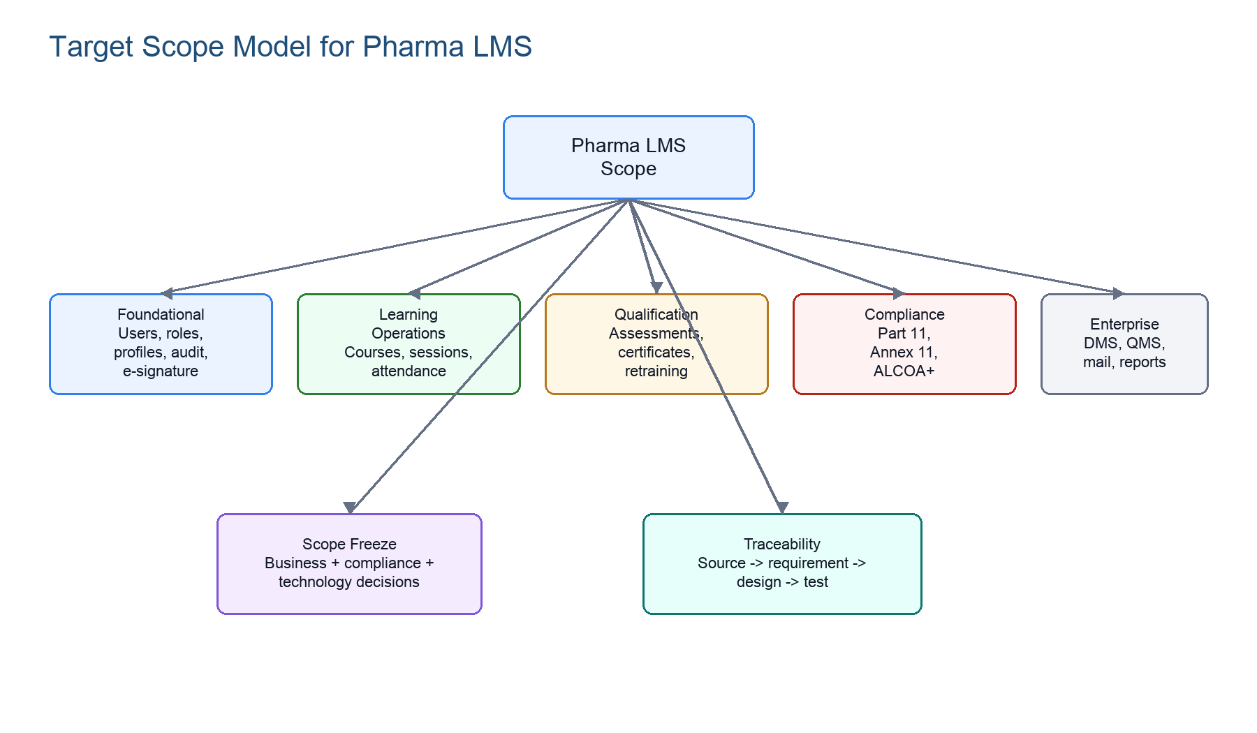
Figure 3. Target scope model adapted from the pharma_learn_scope diagram pattern.
Mermaid source: target scope model
flowchart TD
A["Target Scope Model"] --> B["Foundational"]
A --> C["Learning Operations"]
A --> D["Qualification"]
A --> E["Compliance"]
A --> F["Enterprise"]
B --> B1["Users, roles, hierarchy, plant"]
B --> B2["RBAC, audit trail, e-signature"]
C --> C1["Courses, sessions, attendance"]
C --> C2["Document reading, OJT, external"]
D --> D1["Assessments, certificates, retraining"]
E --> E1["Part 11, Annex 11, ALCOA+"]
F --> F1["DMS, QMS, mail, reporting"]

15.2 Compliance Scope Map
Use this view when aligning URS controls to architecture services and validation tests.
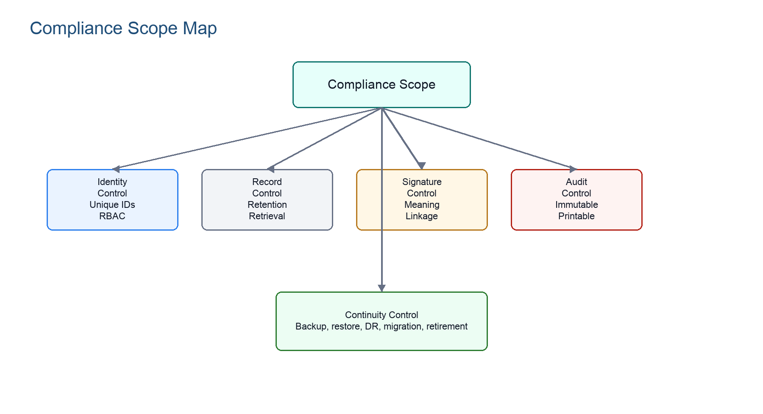
Figure 4. Compliance scope map for regulated LMS controls.
Mermaid source: compliance scope map
flowchart TD
A["Compliance Scope"] --> B["Identity Control"]
A --> C["Record Control"]
A --> D["Signature Control"]
A --> E["Audit Control"]
A --> F["Continuity Control"]
B --> B1["Unique user IDs"]
B --> B2["RBAC and session log"]
C --> C1["Retention and retrieval"]
C --> C2["No deletion / no silent overwrite"]
D --> D1["E-signature meaning"]
D --> D2["Record linkage"]
E --> E1["Immutable audit trail"]
E --> E2["Printable inspection evidence"]
F --> F1["Backup, restore, DR"]

15.3 Scope Definition Work Breakdown
Use this diagram to break a broad LMS initiative into testable definition tracks before implementation.
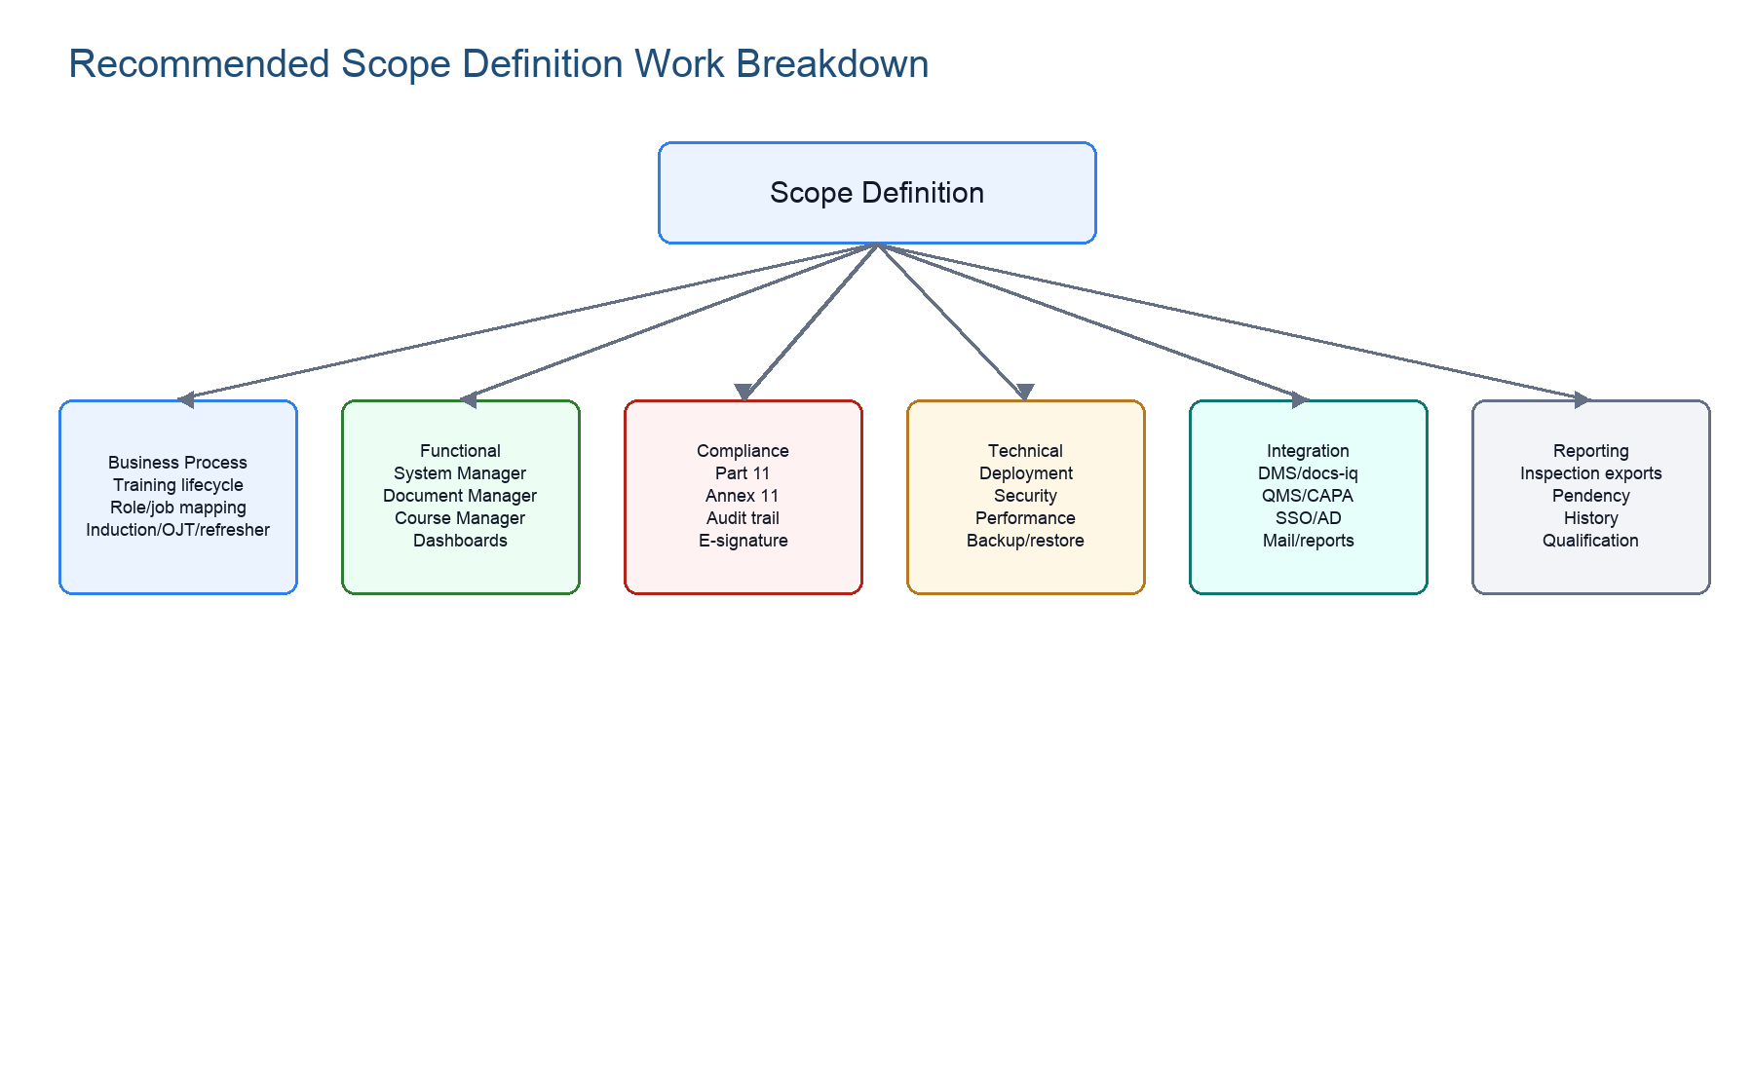
Figure 5. Scope-definition work breakdown adapted from the reference document.
Mermaid source: scope-definition work breakdown
flowchart TD
A["Scope Definition"] --> B["Business Process Scope"]
A --> C["Functional Scope"]
A --> D["Compliance Scope"]
A --> E["Technical Scope"]
A --> F["Integration Scope"]
A --> G["Reporting Scope"]
B --> B1["Training lifecycle"]
B --> B2["Role and job mapping"]
B --> B3["Induction / OJT / refresher"]
C --> C1["System Manager"]
C --> C2["Document Manager"]
C --> C3["Course Manager"]
C --> C4["Dashboards"]
D --> D1["Part 11"]
D --> D2["Annex 11"]
D --> D3["Audit trail"]
D --> D4["E-signature"]
E --> E1["Deployment"]
E --> E2["Security"]
E --> E3["Performance"]
E --> E4["Backup and restore"]
F --> F1["DMS/docs-iq"]
F --> F2["QMS/CAPA"]
F --> F3["SSO/AD and mail"]
G --> G1["Inspection exports"]
G --> G2["Pendency and history"]

15.4 Mermaid Authoring Rules for This Knowledge Base
Rule | Reason
Use quoted node labels, for example A["Audit Trail"]. | Quoted labels handle punctuation, slashes, and regulated terms cleanly.
Prefer LR for architecture/integration and TD for decomposition/work breakdown. | Readers can distinguish horizontal system flow from vertical scope hierarchy.
Keep node text below roughly 5 words where possible. | Short labels render better in Word screenshots, Markdown, and slide decks.
Pair Mermaid source with a rendered figure when the diagram is important. | The rendered figure supports Word readers; the source supports maintainers.
Do not use Mermaid as the only source of a requirement. | Requirements still need prose, source anchor, owner, and validation evidence.

Mermaid source: non-functional requirement mindmap
mindmap
root((Non-Functional Requirements))
Security
RBAC
Password policy
Session timeout
Reliability
Backup
Restore
Continuity
Performance
Multi-site support
Searchability
Dashboard responsiveness
Maintainability
Config-driven behavior
Version alignment
Traceability
IDs
Logs
History

