AI Policy Compliance RAG Assistant

Project Description:
AI Policy Compliance RAG Assistant harnesses Retrieval-Augmented Generation to help employees verify whether a proposed action complies with company policy, replacing a slow manual document search with an evidence-backed answer. The platform includes a Policy Ingestion module, which converts policy PDFs into searchable semantic chunks stored in a vector database, a Retrieval and Reranking module, which selects the most relevant policy clauses for any proposal, and a Compliance Assessment module, which returns a Compliant, Non-Compliant, or Requires Approval verdict together with reasoning, the supporting source and page, and a recommended next step.

Utilizing Google's Gemini API with the gemini-3.6-flash model, grounded on evidence retrieved from ChromaDB, the assistant produces traceable, policy-backed assessments rather than unsupported model opinions. Built with Streamlit as a multi-page application and configured securely through a .env file, the platform gives employees, managers, and compliance teams a fast, transparent way to check proposals against eleven company policy documents before they are ever submitted for approval.

Scenarios
Scenario 1: An employee submits "I want to work remotely for 20 days using my personal laptop." The system embeds the proposal, retrieves matching clauses from the remote work policy, and returns a Non-Compliant verdict because BYOD personal laptops are prohibited for remote operations exceeding five business days, citing the exact source file and page.

Scenario 2: An employee submits "I want to work remotely for 10 days using a company-issued laptop with manager approval." The retrieved evidence shows standard remote work is permitted for up to 30 consecutive calendar days with manager approval and that company-issued hardware satisfies the security requirement, so the assistant returns a Compliant verdict.

Scenario 3: An employee submits "I want to work remotely for 45 consecutive days." Because the request exceeds the 30-day limit, the assistant returns Requires Approval and recommends obtaining written authorization from both Human Resources and the Department Head, exactly as the policy states.

Technical Architecture:
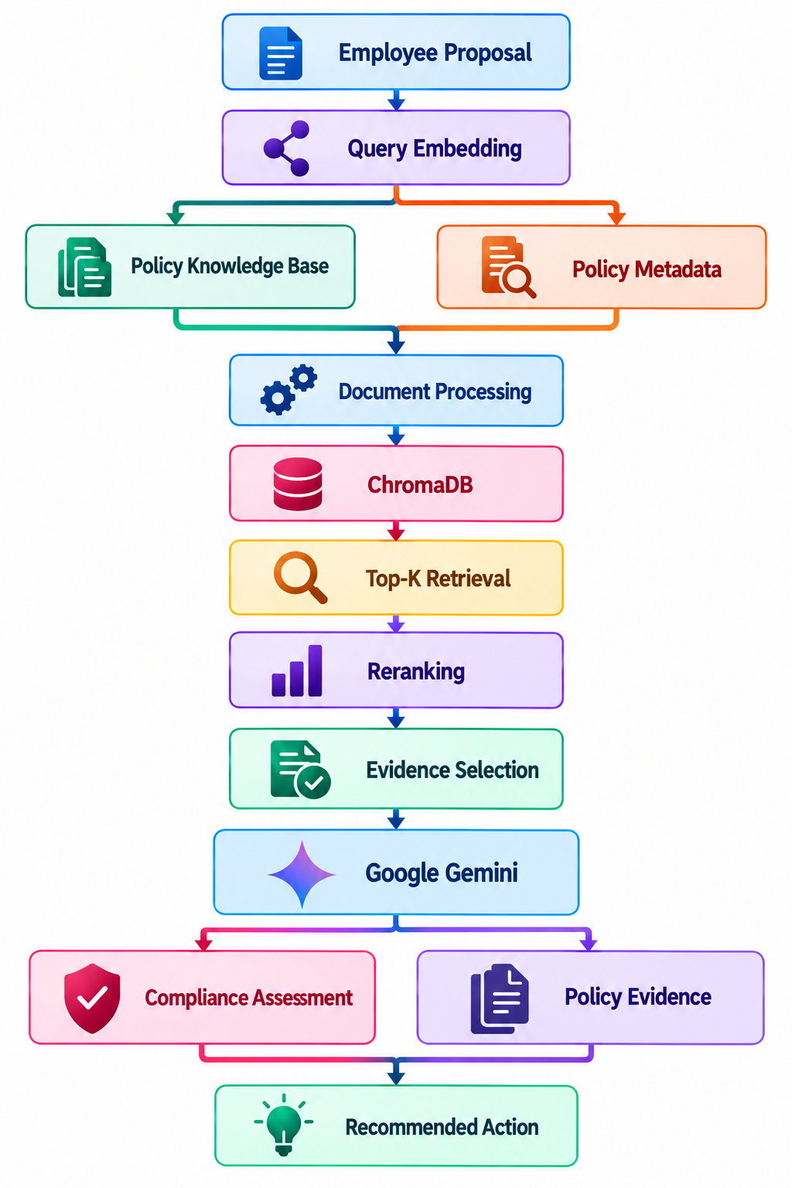

Description: AI Policy Compliance RAG Assistant uses a retrieval-first RAG architecture to deliver evidence-grounded compliance decisions. Policy PDFs are parsed with PyMuPDF, chunked with LangChain text splitters, embedded using all-MiniLM-L6-v2, and persisted in ChromaDB. At query time the employee proposal is embedded, the top-K policy chunks are retrieved, reranked with a ms-marco-MiniLM-L-6-v2 cross-encoder, and the selected evidence is passed to Google Gemini, which returns the compliance status, reasoning, and recommended action to the Streamlit interface.

Pre-requisites:
- Streamlit Framework Knowledge: Streamlit Documentation
- Google Gemini API Familiarity: Gemini API Documentation
- ChromaDB Vector Database Skills: ChromaDB Documentation
- Sentence Transformers Understanding: Sentence Transformers Documentation
- Python Programming Proficiency: Python Documentation
- PDF Text Extraction with PyMuPDF: PyMuPDF Documentation
- Version Control with Git: Git Documentation
- LangChain Text Splitting Concepts: LangChain Text Splitters Guide

Project Workflow:

Milestone 1: Model Selection and Architecture
- Activity 1.1: Generate a Google Gemini API key and configure it securely in the project environment.
- Activity 1.2: Research and select the appropriate embedding, reranking, and generative models for policy compliance analysis.
- Activity 1.3: Define the architecture of the application, detailing interactions between ingestion, retrieval, the LLM, and the frontend.
- Activity 1.4: Set up the development environment, installing necessary libraries and dependencies for Streamlit, ChromaDB, and the Gemini SDK.

Milestone 2: Policy Ingestion Pipeline Development
- Activity 2.1: Develop the ingestion modules: document loader, text splitter, embedding generator, and vector store.
- Activity 2.2: Build the ChromaDB knowledge base and verify that all policy chunks and metadata are stored correctly.

Milestone 3: Retrieval, Reranking and LLM Development
- Activity 3.1: Write the retrieval and reranking logic, then integrate Gemini to produce the final compliance assessment.

Milestone 4: Frontend Development
- Activity 4.1: Design and develop the Streamlit user interface using multi-page navigation, ensuring a responsive and intuitive layout.
- Activity 4.2: Create the About page that documents the technologies, pipeline stages, and policy knowledge base.

Milestone 5: Evaluation and Deployment
- Activity 5.1: Prepare the application for local deployment by configuring the server environment and installing all dependencies.
- Activity 5.2: Evaluate the pipeline against predefined test cases and launch the Streamlit application.

Milestone 6: Conclusion

Milestone 1: Model Selection and Architecture
In this milestone, we focus on selecting the appropriate embedding, reranking, and generative models for our policy compliance needs. This involves researching the capabilities and performance of the available models, ensuring that each chosen component aligns well with the application's objective of retrieving accurate policy evidence and producing grounded compliance assessments across every policy area.

Activity 1.1: Generate a Google Gemini API Key
Before the application can communicate with the Gemini model, you need a valid Gemini API key. Follow the steps below to create one and connect it securely to the project.

• Step 1 — Create a Google AI Studio Account: Visit https://aistudio.google.com and sign in with your Google account to access Google AI Studio.

• Step 2 — Navigate to API Keys: After signing in, select "API Keys" from the left sidebar, or go directly to the API Keys page.

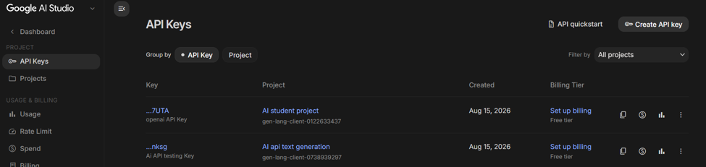
• Step 3 — Create a New API Key: Click the "Create API key" button in the top-right corner and select the Google Cloud project the key should belong to, so it is easy to identify later.

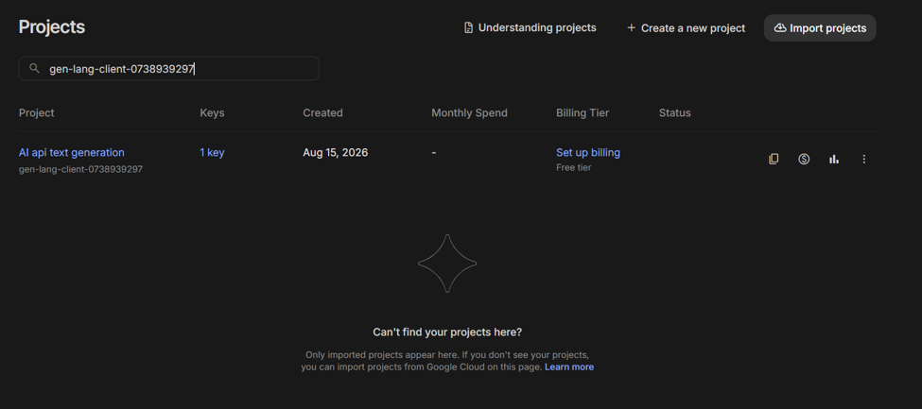
• Step 4 — Copy the API Key: Your key is generated immediately and listed with its project and billing tier. Copy it straight away and store it in a safe place — you will not be able to view the full value again after closing the dialog.

• Step 5 — Add the Key to Your Project: Create a .env file in the root of your project directory (if it does not already exist) and paste the key as shown below:
GEMINI_API_KEY=your_copied_api_key_here
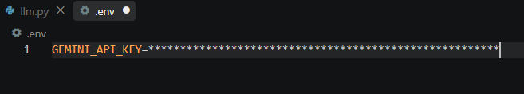

• Step 6 — Verify the Key is Loaded: The src/llm.py file loads this key automatically at startup using python-dotenv:
from dotenv import load_dotenv
load_dotenv()
API_KEY = os.getenv("GEMINI_API_KEY")
client = genai.Client(api_key=API_KEY)

• Important — Never Commit Your API Key: Add .env to your .gitignore file to prevent accidentally pushing the key to a public repository:
.env

Activity 1.2: Research and Select the Appropriate Models
Here are the things that needed to research to select the best models for the project:
- Understand the Project Requirements: Review the specific needs of the compliance assistant, focusing on semantic search across policy documents, precise evidence ranking, and grounded natural-language reasoning.
- Explore the Model Documentation: Visit the Sentence Transformers and Gemini documentation to examine the available models, including their embedding dimensions, context windows, speed, and limitations.
- Evaluate Model Performance: Compare models based on retrieval accuracy, reranking precision, inference latency, and relevance to policy-compliance reasoning tasks.
- Select the Optimal Models: Choose all-MiniLM-L6-v2 for fast, high-quality embeddings, cross-encoder/ms-marco-MiniLM-L-6-v2 for reranking, and gemini-3.6-flash for evidence-grounded assessment generation.

Activity 1.3: Define the Architecture of the Application
- Draft an Architectural Diagram: Create a visual representation of the application architecture, including components like the employee proposal input, query embedding, ChromaDB knowledge base, reranker, and Gemini integration.
- Detail Frontend Functionality: Outline how users interact with the application — entering a proposal, selecting one of the ready-made examples, and reviewing the assessment alongside its expandable evidence.
- Outline Backend Responsibilities: Specify how query.py orchestrates the pipeline, calling retrieve_and_rerank() with retrieve_k=5 and rerank_k=3 before passing the selected evidence to the LLM module.
- Describe AI Integration Points: Define how src/llm.py assembles the evidence block, builds a structured prompt that forbids inventing policies, calls the Gemini API, and returns the four-part assessment to the frontend.

Activity 1.4: Set Up the Development Environment
- Install Python and Pip: Ensure Python 3.10+ is installed on your machine along with pip for dependency management.
- Create a Virtual Environment: Set up a virtual environment using venv to isolate project dependencies:
D:\projects>python -m venv myenv
D:\projects>"d:\projects\venv\Scripts\activate"
(myenv) D:\projects> pip install -r requirements.txt

- Install Streamlit: Use pip to install the Streamlit web framework:
(myenv) D:\projects> pip install streamlit

- Install the Gemini SDK: Install the Google Generative AI library to interact with the Gemini API:
(myenv) D:\projects> pip install gemini-ai

- Install Retrieval Dependencies: Install ChromaDB, Sentence Transformers, PyMuPDF, and D:\projects> pip install chromadb sentence-transformers pymupdf langchain-text-splitters

- Review the Dependency List: The complete requirements.txt pins every library the pipeline needs, from PDF parsing through to evaluation:
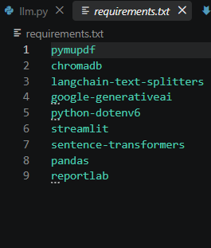

- Set Up Application Structure: Create the project directory structure including folders for src modules, assets, data, chroma_db, project evaluation, and main application files (app.py, app_page.py, about.py, ingest.py, query.py, evaluate.py, requirements.txt).
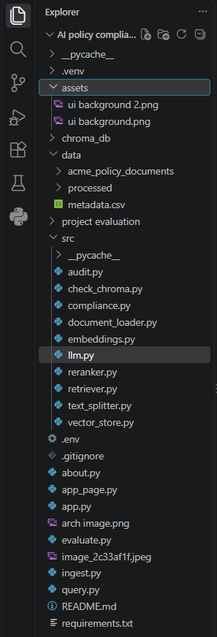

Milestone 2: Policy Ingestion Pipeline Development

Activity 2.1: Develop the Policy Ingestion Modules
Implement the four ingestion stages — loading, chunking, embedding, and storage — as modular files inside src/, orchestrated end to end by a single ingest.py script.
- Document Loader: Uses PyMuPDF to open every PDF in data/acme_policy_documents/policies, extracting text page by page and attaching the source filename and page number as metadata.
- Text Splitter: Applies RecursiveCharacterTextSplitter with chunk_size=800 and chunk_overlap=150 so each chunk stays semantically complete while preserving context across boundaries.
- Embedding Generator: Encodes every chunk into a dense vector with the all-MiniLM-L6-v2 SentenceTransformer model, displaying a progress bar during batch encoding.

Activity 2.2: Build the ChromaDB Knowledge Base
Define the Vector Store:
- Create a persistent ChromaDB client pointing at the local chroma_db directory.
- Create or load a collection named policy_documents to hold every policy chunk.
Store Chunks and Metadata:
- Upsert documents, embeddings, metadatas, and deterministic ids of the form chunk_{i} so re-running ingestion updates rather than duplicates records.
collection.upsert(
documents=documents,
embeddings=embeddings.tolist(),
metadatas=metadatas,
ids=ids
)

Run and Verify the Ingestion:
- Execute the pipeline, which loads 61 pages from 11 policy documents and creates 249 searchable chunks:
(myenv) D:\projects> python ingest.py
- Run src/check_chroma.py to list every collection with its document count and confirm the knowledge base was populated successfully.
(myenv) D:\projects> python check_chroma.py

Milestone 3: Retrieval, Reranking and LLM Development
Milestone 3 focuses on creating and refining the core reasoning logic of the application, which serves as the backbone of the AI Policy Compliance RAG Assistant. In this milestone, you'll set up semantic retrieval, cross-encoder reranking, and Gemini prompt construction, and conduct unit testing to ensure each module performs as expected.

Activity 3.1: Writing the Retrieval and Assessment Logic
Define the Retrieval Module in src/retriever.py:
- Connect to the persistent ChromaDB client and load the policy_documents collection.
- Cache the embedding model with lru_cache so it loads only once per session.
@lru_cache(maxsize=1)
def get_embedding_model():
return SentenceTransformer(MODEL_NAME)

- Encode the employee query and search ChromaDB for the top_k most similar chunks:
def retrieve_documents(query, top_k=5):
model = get_embedding_model()
query_embedding = model.encode([query])
results = collection.query(
query_embeddings=query_embedding.tolist(),
n_results=top_k
)
return results

Define the Reranking Module in src/reranker.py:
- Cross-Encoder Scoring: Builds query-document pairs and scores each one with cross-encoder/ms-marco-MiniLM-L-6-v2, which compares the query and chunk jointly instead of relying on independent vectors.
- Evidence Assembly: Keeps text, score, source, and page together, sorts by descending relevance, and returns only the best top_k results.
scores = reranker.predict(pairs)
ranked.sort(key=lambda x: x["score"], reverse=True)
return ranked[:top_k]

Integrate the Gemini Responses in src/llm.py:
- Assemble an evidence block listing each retrieved chunk with its source, page, and policy text.
- Build a structured prompt that instructs Gemini to analyse the proposal using only the provided evidence and to return four sections:
1. Compliance Status: Compliant, Non-Compliant, or Requires Approval
2. Reason: Brief explanation based on the policy
3. Evidence: Mention the relevant source and page
4. Recommended Action: What the employee should do

- Close the prompt with an explicit grounding constraint so the model cannot invent rules: "Do not invent policies or facts that are not present in the evidence."
- Send the prompt to the model and return the generated text:
response = client.models.generate_content(
model=MODEL_NAME,
contents=prompt
)
return response.text

Orchestrate the Pipeline in query.py:
- process_policy_query() calls retrieve_and_rerank(proposal, retrieve_k=5, rerank_k=3), passes the result to generate_compliance_assessment(), and returns both the evidence and the final assessment to the caller.

Milestone 4: Frontend Development
Milestone 4 focuses on developing a user-friendly and visually appealing interface for the AI Policy Compliance RAG Assistant. This involves designing a dark glassmorphism layout with Streamlit's native components to enhance usability, and creating dynamic content rendering to display the compliance assessment and its supporting policy evidence based on user interactions.

Activity 4.1: Designing and Developing the User Interface
Set Up the Multi-Page Structure:
- Develop app.py as the entry point, configuring the page title, icon, and wide layout, then registering the App and About pages under a single Dashboard section.
- Use st.navigation() and st.Page() so users can move between the compliance tool and the documentation page without losing session state.
pg = st.navigation(
{
"Dashboard": [app_page, about_page]
}
)
pg.run()

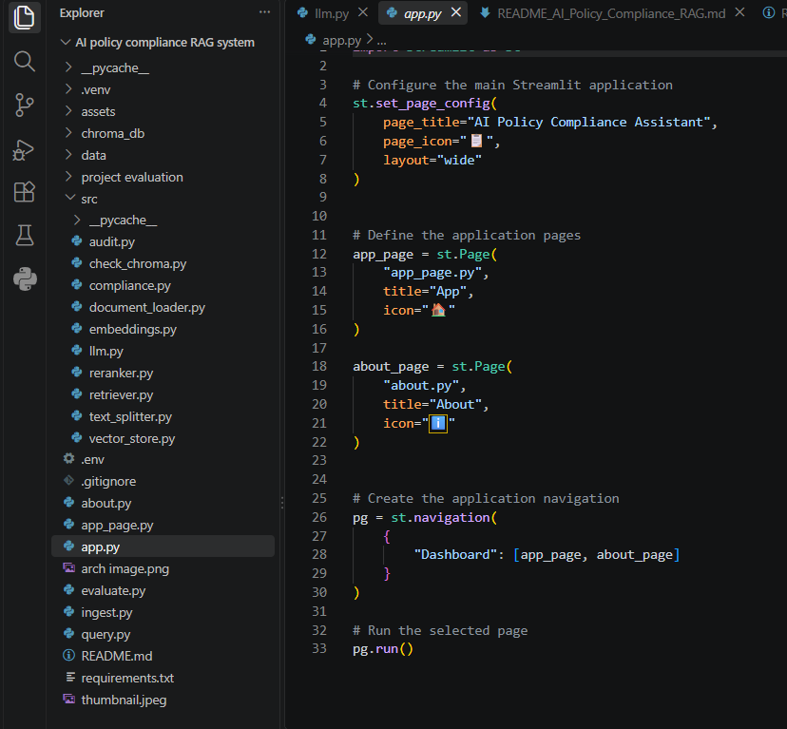
Design a Responsive Layout Using Injected CSS:
- Embed the background image from assets as a base64 data URI with a dark gradient overlay, fixed attachment, and centred positioning.
- Apply a glassmorphism panel to the main workspace using a translucent background, a 12px backdrop blur, rounded corners, and a soft drop shadow.
- Style buttons, text areas, and expanders with translucent surfaces and hover transitions so the interface stays legible against the background.
Create Separate UI Components for Each Output Type:
- Example Buttons: Three one-click proposals — Personal Laptop, Company Laptop, and 45 Days — that populate the text area through st.session_state.
- Proposal Text Area: A 120-pixel input that keeps manually typed text available for the next interaction.
- Evidence Expanders: Collapsible cards labelled with the source file and page, each revealing the rounded relevance score and the full policy text.

Activity 4.2: Creating the About and Documentation Page
Document the Technology Stack:
- Render nine bordered containers across three columns covering Python, Streamlit, PyMuPDF, LangChain Text Splitters, Sentence Transformers, ChromaDB, Cross-Encoder, Google Gemini, and Pandas.
Visualise the Eight-Stage Pipeline:
- Lay out the stages as bordered cards in a snaking two-row grid, each showing its number, icon, title, implementing component, and a one-line description.
- Display the knowledge base metrics with st.metric — 11 policy documents, 61 extracted pages, and 249 policy chunks — followed by the eleven policy areas covered.
Provide an Interactive Demonstration:
- Offer a selectbox of demo proposals with Start Demo and Reset controls that step through the workflow stage by stage using session state, so users can watch a proposal travel from input to recommended action.

Milestone 5: Evaluation and Deployment
In Milestone 5, the focus is on evaluating the pipeline against known test cases to confirm correct operation, and then launching the Streamlit application locally for real-world use. This involves configuring the server environment, managing dependencies, and measuring how accurately the assistant classifies each employee proposal.

Activity 5.1: Preparing the Application for Local Deployment
Set Up a Virtual Environment:
- Open a new terminal in the project root, then create and activate a virtual environment and install all required dependencies from requirements.txt.
(myenv) D:\projects>streamlit run app.py
D:\projects>python -m venv myenv
D:\projects>"d:\projects\venv\Scripts\activate"
(myenv) D:\projects>pip install -r requirements.txt

Configure Environment Variables:
- Create a .env file in the project root and add your Gemini API key. The app loads this automatically using python-dotenv at startup:
GEMINI_API_KEY=your_gemini_api_key_here

Build the Knowledge Base:
- Run the ingestion script once before the first launch so ChromaDB contains all 249 policy chunks:
- (myenv) D:\projects>python injest.py
- Activity 5.2: Pipeline Evaluation and Verification
Prepare the Test Cases:
- Define the expected outcomes in project evaluation/test_cases.csv, where each row holds an id, a proposal, and its expected_status.
- The suite covers all three verdict types — Non-Compliant for a personal laptop over 20 days, Compliant for 10 days on a company laptop, Requires Approval for 45 consecutive days, and Non-Compliant for an unapproved location.
Run the Evaluation Script:
- Execute evaluate.py, which runs every proposal through the full pipeline, extracts the predicted status with a regular expression, and reports the overall accuracy:
- (myenv) D:\projects>python evaluate.py
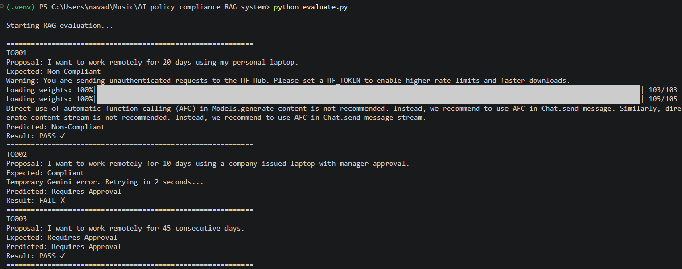
- Status Extraction: extract_status() normalises Markdown bold markers and searches for the structured status line, falling back to older response formats before returning Unknown.
- Retry Handling: run_with_retry() catches temporary Gemini 503 and 429 errors and retries with exponential backoff so a single API hiccup does not end the run.
- Results Logging: Every outcome is collected into a pandas DataFrame, printed as a table, and saved to project evaluation/evaluation_results.csv for review.
Observed Evaluation Behaviour:
- TC001 correctly returned Non-Compliant for the 20-day personal-laptop request, and TC003 correctly returned Requires Approval for the 45-day request, confirming that the retrieved evidence drives the verdict.
- TC002 was predicted as Requires Approval against an expected Compliant, showing that the model applies the approval-process clauses conservatively even when the duration and hardware conditions are satisfied.
- The run also demonstrates the retry logic in action, recovering from a temporary Gemini error before completing the remaining test cases.

Activity 5.3: Launching the Streamlit Application
Start the Streamlit Server:
- Run the application locally using:
(myenv) D:\projects>streamlit run app.py
- Once running, open a browser and navigate to "http://localhost:8501" to access the app.
- Later the app would be deployed in streamlit cloud free tier through github repository.
- Interact with the compliance assistant — test all three example proposals and several custom ones to verify that evidence is retrieved, reranked, and rendered correctly alongside the Gemini assessment.
Important Notes:
- First run is slower: The embedding and cross-encoder models download on first use and are then cached, so subsequent queries respond much faster.
- Re-ingest after policy changes: Whenever a policy PDF is added or edited, re-run ingest.py so the vector store reflects the current document set.
- Keep the database local: The chroma_db directory should stay out of version control, alongside .env, to avoid publishing generated vectors and secrets.

Exploring the Website's Web Pages:

Home / Compliance Page:
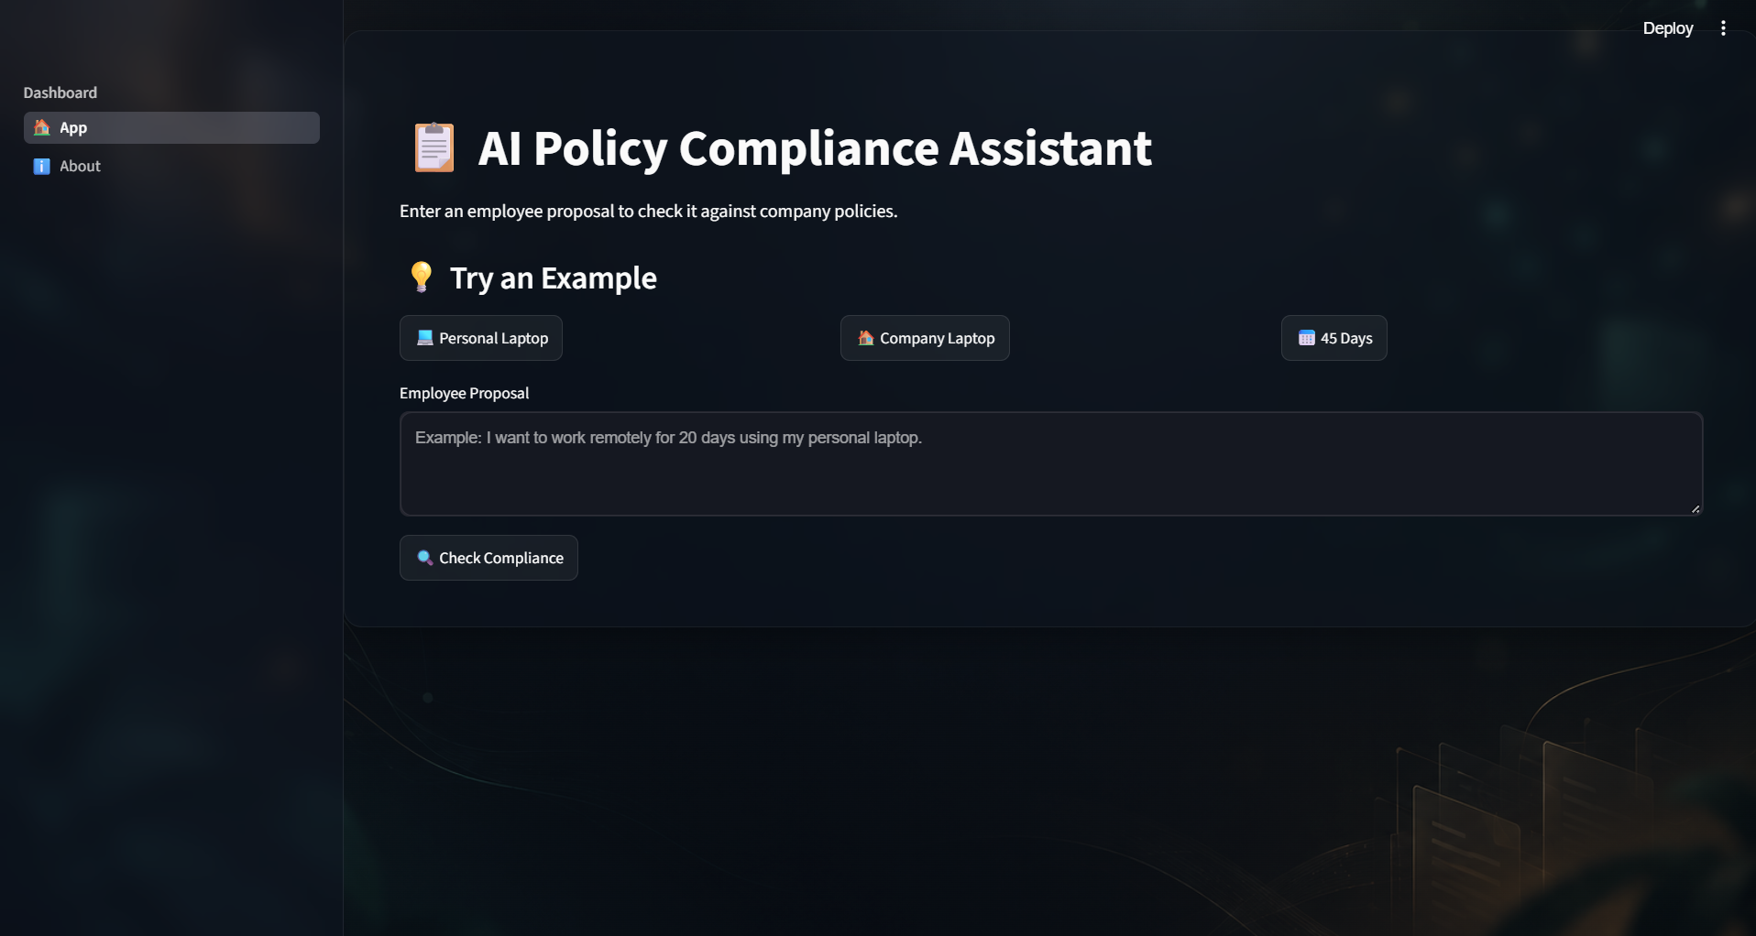
Description: The App page is the primary workspace of the assistant. It features a dark glassmorphism design over a fixed background image, a header displaying the AI Policy Compliance Assistant title with a clipboard icon, and a short instruction line. The main section contains the example buttons, the proposal text area, the Check Compliance action, and the results panel — all on one seamless page.

Input Section:
Description: A glass-styled panel containing the main compliance form. Users enter their proposed action in a text area, or load one of three ready-made examples with a single click, and then press the primary Check Compliance button. While the RAG pipeline runs, a spinner reading "Analyzing policy compliance..." replaces the idle state, and an empty submission raises a warning instead of calling the API.

Results Section:
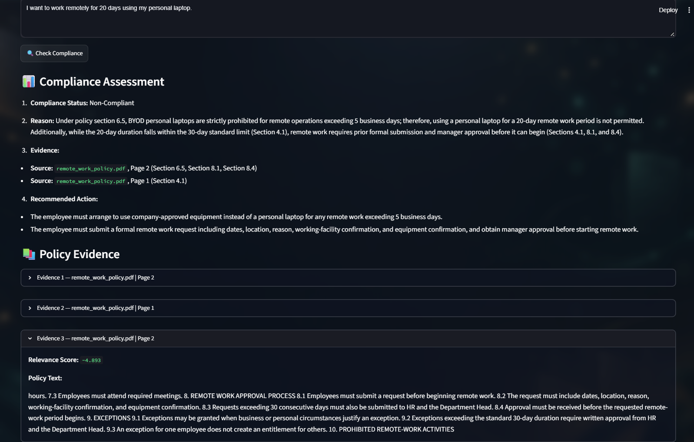
Description: Revealed dynamically after the pipeline completes, this section displays the Gemini output as rendered Markdown under a Compliance Assessment heading, showing the status, reasoning, cited evidence, and recommended action. Beneath it, the Policy Evidence subsection lists each retrieved chunk in its own expander labelled with the source file and page, revealing the relevance score and the full policy text on demand.

About Page:
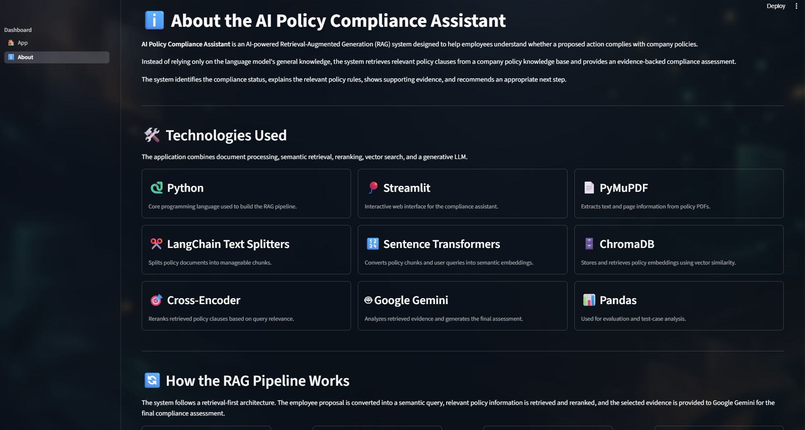
Description: The About page documents the system for reviewers and new users. It opens with a plain explanation of the retrieval-first approach, then presents the nine technology cards covering Python, Streamlit, PyMuPDF, LangChain Text Splitters, Sentence Transformers, ChromaDB, Cross-Encoder, Google Gemini, and Pandas, each in its own bordered container with a one-line summary of the role it plays in the pipeline.

RAG Working Section in About page:
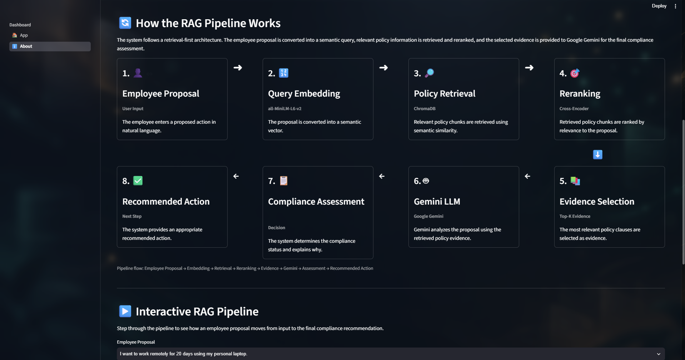
Description: Below the technology cards, the About page renders the eight-stage pipeline as a snaking two-row grid of bordered cards. Each card shows its stage number, icon, title, the implementing component, and a one-line description, with arrows marking the flow from Employee Proposal through Query Embedding, Policy Retrieval, and Reranking, then back along the second row through Evidence Selection, Gemini LLM, Compliance Assessment, and Recommended Action.

Interactive RAG Pipeline Section in About page:
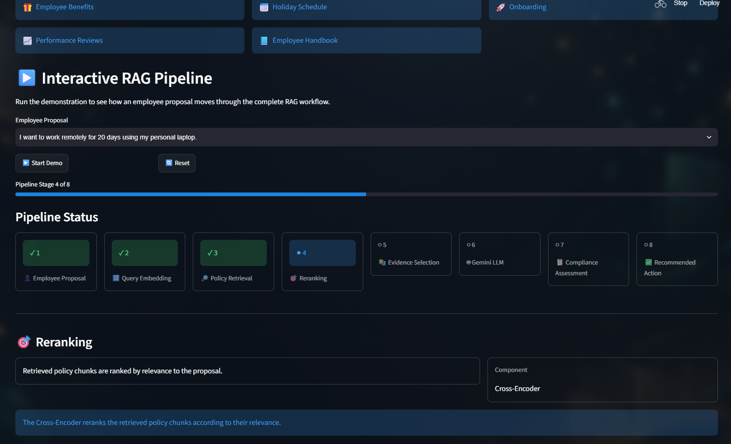
Description: The final section lets reviewers watch the workflow execute rather than just read about it. After selecting one of the demo proposals and pressing Start Demo, a progress bar tracks the current stage, the Pipeline Status cards tick from pending to complete as each stage finishes, and a detail panel below explains the active stage and names the component responsible — for example, the Cross-Encoder during reranking. The eleven policy areas covered by the knowledge base are listed directly above this section.

Conclusion:
AI Policy Compliance RAG Assistant is a retrieval-augmented platform built with Streamlit and styled with a dark glassmorphism UI that streamlines internal policy compliance checks. It combines a ChromaDB knowledge base of 249 policy chunks, all-MiniLM-L6-v2 embeddings, and a ms-marco-MiniLM-L-6-v2 cross-encoder with Google's Gemini model to instantly return a compliance status, cited policy evidence, and a recommended action for any employee proposal. The project, which included model selection, ingestion pipeline development, retrieval and reranking, frontend design, and test-case evaluation, highlights how grounding a language model in retrieved evidence can boost both accuracy and trust for compliance teams, with potential for future scalability.

Looking ahead, the assistant offers significant opportunities for expansion, such as adding hybrid keyword and vector search for policy identifiers, supporting multi-turn clarification when a proposal is ambiguous, and implementing user authentication to save an auditable history of past assessments. By continuously refining the retrieval parameters, expanding the evaluation suite beyond remote work scenarios, and enriching the chunk metadata with policy sections and effective dates, the platform is well-positioned to evolve from a focused demonstration into a comprehensive organisation-wide compliance assistant.

Navadeep J, September 2026, GP 3

