AI Resume & ATS Analyzer: Semantic Resume-to-Job Matching and AI Career Feedback Platform

Project Description:
The AI Resume & ATS Analyzer helps job seekers understand exactly how well their resume matches a target job posting, and what to change to improve their odds. The platform includes a Multi-Format Resume Reader, which extracts text from PDF or image resumes using direct PDF parsing with an OCR fallback, a Three-Dimensional Scoring Engine, which evaluates ATS keyword overlap, SBERT semantic similarity, and structured skill matching independently before combining them into one weighted final score, and an AI Career Coach, which turns those raw numbers into specific, prioritized, rewritten resume guidance.
Utilizing Groq-hosted large language models for structured information extraction and feedback generation, alongside a locally run SBERT embedding model for semantic comparison, the analyzer processes an uploaded resume and a job description — pasted as text or fetched from a URL — to deliver a full fit report in seconds. Built with FastAPI on the backend and a glassmorphic HTML/CSS/JS dashboard on the frontend, the platform gives candidates the same kind of signal an applicant-tracking system would generate, plus the specific, actionable coaching an ATS never provides.

Scenarios
Scenario 1: A final-year student applying for a Machine Learning internship uploads their resume PDF and pastes the internship's job description text. The analyzer extracts both documents, scores them across ATS keywords, semantic similarity, and structured skills, and returns a final match score along with the specific keywords missing from their resume.
Scenario 2: A career switcher with a non-traditional background pastes a job posting URL instead of raw text. The platform fetches and cleans the page content automatically, falling back to a direct HTML scrape when the primary extractor is blocked, so the candidate never has to manually copy the posting.
Scenario 3: A candidate who already has a strong ATS keyword score but a low semantic similarity score uses the AI feedback panel to see exactly why — their resume lists the right buzzwords without describing the underlying work — and receives a rewritten bullet point that keeps their real accomplishment but reframes it in the language the job posting actually uses.

Technical Architecture:
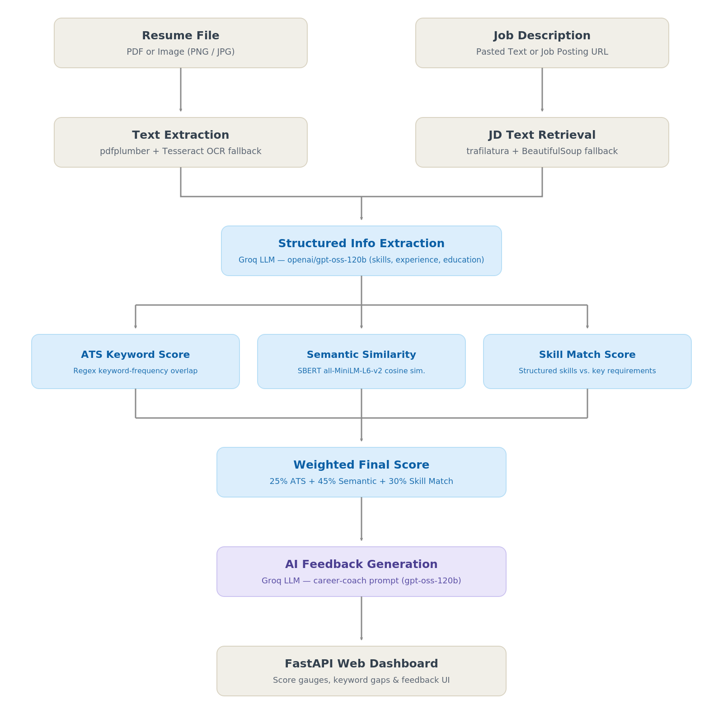

Description:
The AI Resume & ATS Analyzer runs a two-input, multi-stage pipeline. A resume file and a job description enter through independent extraction paths — pdfplumber with a Tesseract OCR fallback for the resume, trafilatura with a BeautifulSoup fallback for the job description — and both extracted texts are then passed to a Groq-hosted LLM that returns structured skills, experience, education, and key requirements as JSON. From that point, three independent scoring engines run in parallel: a regex-based ATS keyword overlap score, an SBERT (all-MiniLM-L6-v2) semantic cosine-similarity score, and a structured skill-overlap score computed from the LLM's own extracted fields. These three scores are combined into a single weighted final score, which — together with the missing-keyword list — is handed to a second Groq LLM call that generates prioritized, human-readable career coaching feedback for the FastAPI-served web dashboard.

Pre-requisites:
- Python Programming Proficiency: Python Documentation
- FastAPI Framework Knowledge: FastAPI Documentation
- Sentence-Transformers / SBERT Familiarity: Sentence-Transformers Docs
- Groq API and LLM Prompting: Groq Documentation
- PDF and OCR Processing: pdfplumber Documentation
- Web Scraping Basics: trafilatura Documentation
- Version Control with Git: Git Documentation
- Kaggle Notebooks and Datasets: Kaggle Docs

Project Workflow:

Milestone 1: Dataset Acquisition and Pipeline Design
- Activity 1.1: Download the resume dataset from Kaggle and explore its category structure inside a Colab notebook.
- Activity 1.2: Prototype PDF and image text extraction with an OCR fallback for scanned resumes.
- Activity 1.3: Prototype job-description ingestion from both pasted text and live URLs.
- Activity 1.4: Design the three-dimensional scoring approach: ATS keywords, SBERT semantics, and structured skills.

Milestone 2: Scoring Engine Development
- Activity 2.1: Implement regex-based ATS keyword extraction and overlap scoring.
- Activity 2.2: Integrate the SBERT all-MiniLM-L6-v2 model for semantic cosine-similarity scoring.
- Activity 2.3: Wire up Groq LLM structured extraction and compute the skill-match score from its output.
- Activity 2.4: Combine all three scores into one weighted final score.

Milestone 3: AI Feedback Generation and Validation
- Activity 3.1: Design the career-coach prompt and generate structured, prioritized feedback via Groq.
- Activity 3.2: Chain every stage into a single full_analysis() function callable end-to-end.
- Activity 3.3: Validate the pipeline across multiple sample resumes from the Kaggle dataset.

Milestone 4: Backend and Frontend Development
- Activity 4.1: Port the notebook pipeline into a modular FastAPI backend with a single /analyze endpoint.
- Activity 4.2: Build the glassmorphic upload-and-results dashboard with HTML, CSS, and vanilla JavaScript.
- Activity 4.3: Wire the frontend to the backend with async form submission and a loading-state overlay.

Milestone 5: Deployment
- Activity 5.1: Prepare the local environment and install dependencies from requirements.txt.
- Activity 5.2: Launch and verify the FastAPI application locally with Uvicorn.
- Activity 5.3: Secure the Groq API key via environment variables ahead of shared or cloud deployment.

Milestone 6: Conclusion

Milestone 1: Dataset Acquisition and Pipeline Design
This milestone focuses on acquiring a large, varied resume dataset to validate the pipeline against, and on prototyping each input-handling stage — resume text extraction and job-description ingestion — before any scoring logic is written.

Activity 1.1: Download and Explore the Resume Dataset
The Kaggle dataset hadikp/resume-data-pdf is downloaded directly inside a Colab notebook via kagglehub, then copied into the local Colab filesystem for fast repeated access during development.
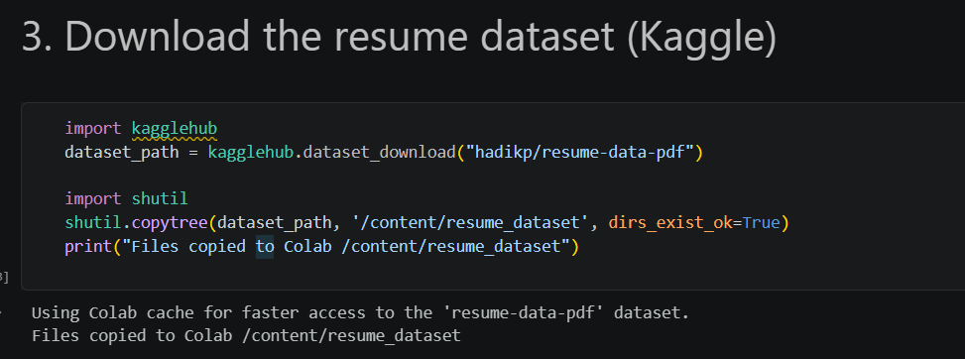
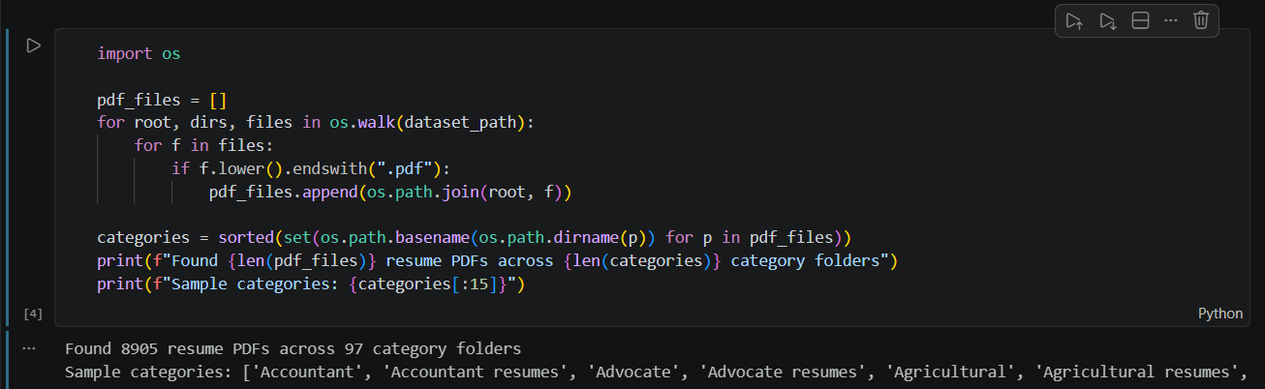
The dataset spans 97 distinct occupational categories — from Accountant and Advocate to Agricultural and Apparel — giving the pipeline a realistic, wide-ranging test bed rather than a narrow, single-domain sample.
This breadth matters because a scoring pipeline tuned only on, say, software-engineering resumes could quietly fail on a nursing or legal resume with entirely different vocabulary and formatting conventions. Spot-checking extraction and scoring across dozens of unrelated categories early on made it far more likely that the final scoring weights would generalize to whatever resume a real user eventually uploads.

Activity 1.2: Prototype Resume Text Extraction
Resume parsing needs to work for both digitally generated PDFs and scanned or image-based resumes. pdfplumber handles the common case directly; when the extracted text is too short to be a real resume, the pipeline automatically falls back to rendering each page as an image and running Tesseract OCR over it.
def extract_text_from_pdf(pdf_path):
text = ""
with pdfplumber.open(pdf_path) as pdf:
for page in pdf.pages:
t = page.extract_text()
if t: text += t + "\n"
if len(text.strip()) < 50: # likely scanned/image-based PDF
images = convert_from_path(pdf_path)
text = "\n".join(pytesseract.image_to_string(img) for img in images)
return text.strip()
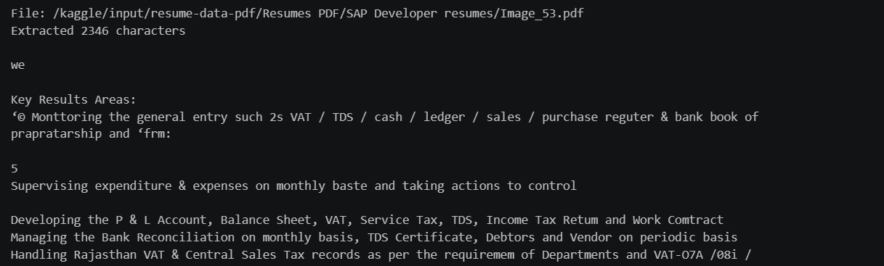

Activity 1.3: Prototype Job Description Ingestion
Job descriptions can arrive as pasted text or as a live URL. For URLs, trafilatura is tried first since it is purpose-built for extracting clean article-like content from a page; if that fails or the page looks bot-blocked, a manual BeautifulSoup scrape strips scripts and styles and returns the raw visible text instead.
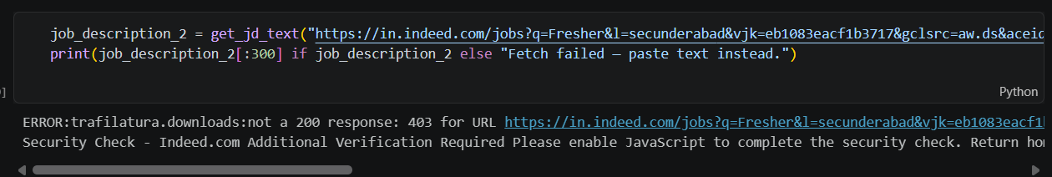

Activity 1.4: Design the Three-Dimensional Scoring Approach
A single similarity metric would miss important failure modes: a resume can be lexically close to a job description without meaning the same thing, or can use the right vocabulary without ever mentioning the specific skills the role needs. Here are the things that needed to be researched to select the right scoring design for the project:
- Understand ATS Behavior: Real applicant-tracking systems lean heavily on exact keyword frequency, so a dedicated keyword-overlap score was needed to mirror that behavior.
- Address Lexical vs. Semantic Gaps: "Designed and implemented ML models" and "built machine learning systems" share almost no keywords but mean nearly the same thing — a case only a semantic embedding model can catch.
- Capture Explicit Skill Requirements: Job postings usually name specific tools and skills directly; a structured extraction step lets the pipeline compare those fields exactly rather than relying on free-text similarity alone.
- Select the Optimal Weighting: Weight the three scores at 25% ATS keywords, 45% semantic similarity, and 30% structured skill match, favoring meaning over exact wording while still respecting real ATS behavior.
This three-way split was a deliberate design choice over a simpler single-score system. A resume could score well on any one dimension for the wrong reasons — for instance, stuffing in job-posting keywords without genuine relevant experience — so triangulating across all three signals makes the final score noticeably harder to game and considerably more informative for the candidate reading it.

Milestone 2: Scoring Engine Development
Milestone 2 implements each of the three independent scoring engines and combines them into the platform's single weighted final score.

Activity 2.1: ATS Keyword Overlap Score
The ATS engine extracts the most frequent meaningful words from both documents — filtering out common stopwords — and reports what fraction of the job description's top keywords also appear in the resume.

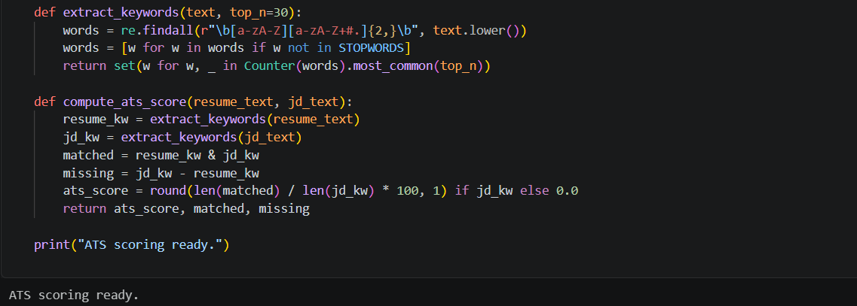

Activity 2.2: SBERT Semantic Similarity Score
Both documents are embedded with the all-MiniLM-L6-v2 sentence-transformer model, and the cosine similarity between the two embeddings becomes the semantic score. This is what allows the platform to recognize that two differently worded descriptions of the same underlying work are, in fact, a strong match.
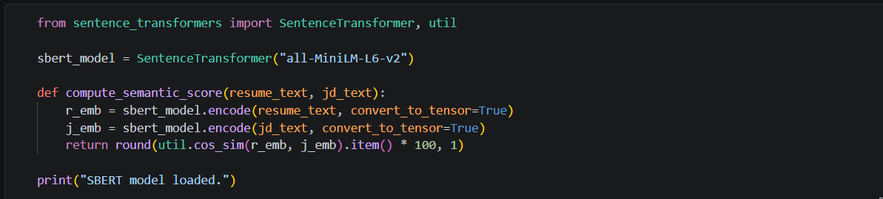
A short illustrative example from the notebook makes the case for semantic over purely lexical scoring: "The dog bites the man" and "The man bites the dog" share every single word, so a lexical similarity score would call them nearly identical, while a semantic model correctly recognizes their meanings are effectively opposite.

Activity 2.3: Structured Skill Match Score
The same Groq LLM call that will later power feedback generation is used here to convert free-text resumes and job descriptions into structured JSON — skills, experience_years, education, and key_requirements — which lets the pipeline compare skill sets directly rather than through free-text keyword matching.
Extracting structured fields with an LLM rather than hand-written regex rules is what lets the system understand a skill described in many different phrasings — "deep learning with PyTorch" and "PyTorch-based model development" both resolve to the same underlying skill once passed through the extraction prompt — something a purely rule-based parser would need dozens of hand-tuned patterns to approximate.
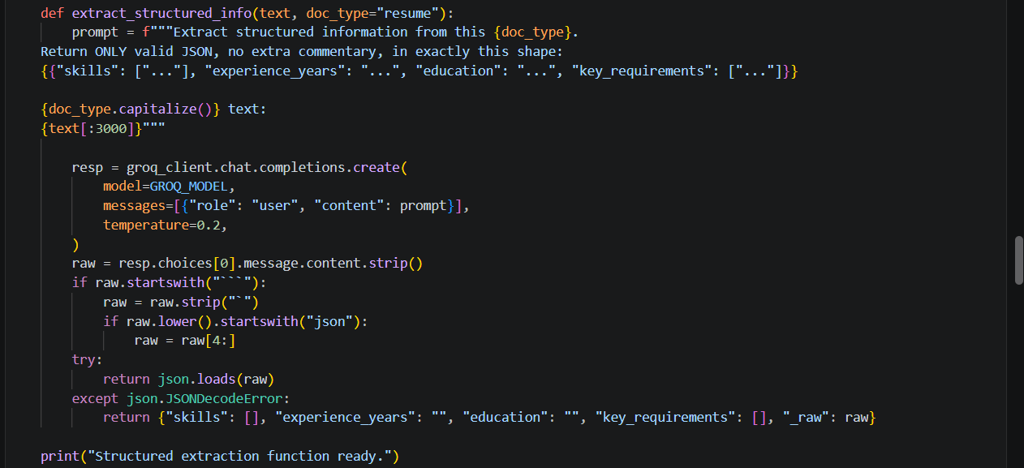
def compute_skill_match_score(resume_info, jd_info):
resume_skills = set(s.lower().strip() for s in resume_info.get("skills", []))
jd_skills = set(s.lower().strip() for s in
jd_info.get("key_requirements", []) + jd_info.get("skills", []))
matched = resume_skills & jd_skills
return round(len(matched) / len(jd_skills) * 100, 1), matched

Activity 2.4: Weighted Final Score
The three independent scores are combined into a single number using fixed weights that favor semantic meaning while still respecting literal ATS behavior and explicit skill requirements.
def compute_final_score(ats_score, semantic_score, skill_match_score):
return round(ats_score * 0.25 + semantic_score * 0.45 + skill_match_score * 0.30, 1)

Milestone 3: AI Feedback Generation and Validation
With all three scores in place, Milestone 3 turns raw numbers into an actionable coaching report, chains every pipeline stage into one callable function, and validates the whole system against multiple real resumes from the dataset.

Activity 3.1: Design the AI Career Coach Prompt
The feedback prompt hands the LLM the resume excerpt, the job description excerpt, all four scores, and the missing-keyword list, and asks for five specific things: an overall fit assessment, the top five resume improvements ranked by impact, which missing keywords are actually worth adding, one rewritten example bullet point, and skills worth learning or highlighting for that specific role.
def generate_feedback(resume_text, jd_text, ats_score, semantic_score,
skill_match_score, final_score, missing_keywords):
prompt = f"""You are an ATS optimization expert and career coach.
...
Provide:
1. Overall fit assessment (2-3 sentences)
2. Top 5 specific resume improvements, prioritized by impact
3. Which missing keywords are genuinely worth adding vs. irrelevant noise
4. One rewritten example bullet point (before -> after)
5. Skills to focus on learning or highlighting for this specific role"""
resp = groq_client.chat.completions.create(model=GROQ_MODEL,
messages=[{"role": "user", "content": prompt}], temperature=0.4)
return resp.choices[0].message.content

Activity 3.2: Chain the Full Pipeline
A single full_analysis() function ties extraction, structured info, all three scores, and feedback generation together, so the entire analysis can be triggered with just a resume file path and a job description.
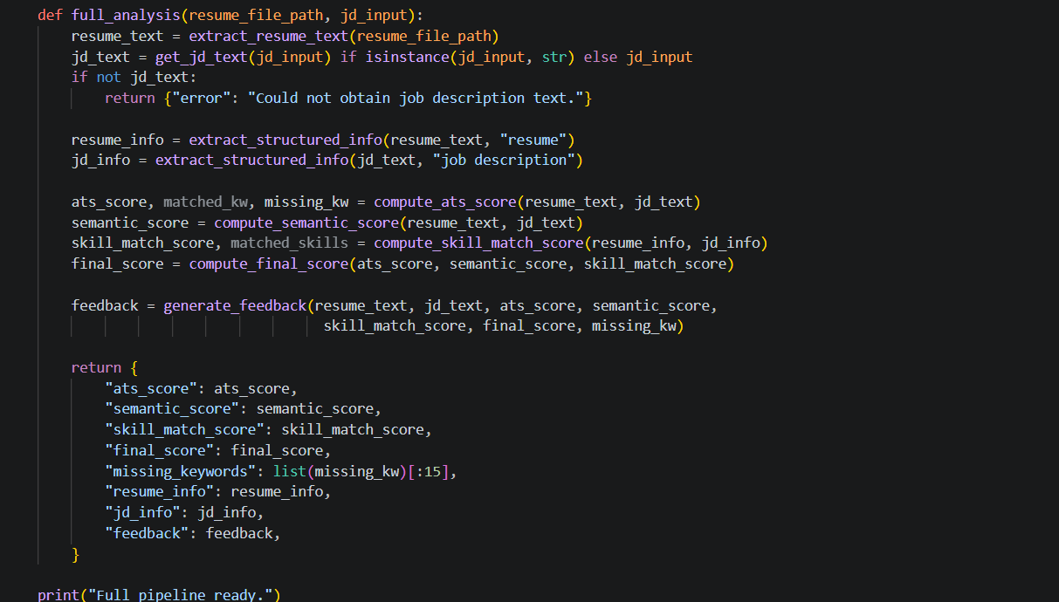

Activity 3.3: Validate Across Multiple Resumes
To confirm the pipeline behaves sensibly rather than returning a lucky one-off result, five random resumes from the Kaggle dataset are each run against the same machine-learning-intern job description, and their scores are printed side by side.
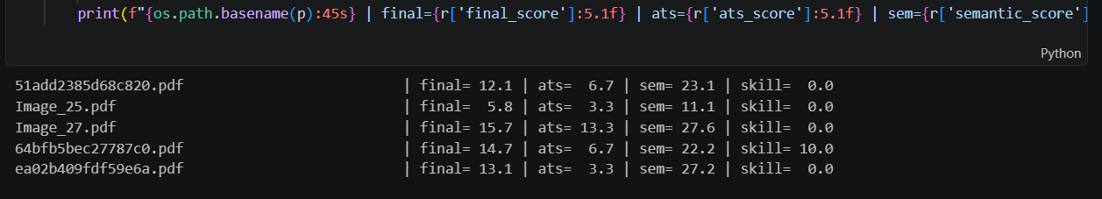
The spread of scores across unrelated resumes — from 5.8 to 15.7 — confirms the scoring engine meaningfully differentiates between candidates rather than collapsing everyone toward the same number, which was the key sanity check before wiring the pipeline into a live web application.

Milestone 4: Backend and Frontend Development
Milestone 4 moves the validated notebook pipeline into a production-shaped FastAPI backend and pairs it with a polished, glassmorphic web dashboard.
Where the notebook version of the pipeline printed results to a cell output, the production version needs to handle real failure modes gracefully: a corrupted upload, a blocked job-board URL, a missing API key, or a resume with too little extractable text. Each stage of the /analyze endpoint is wrapped in its own try/except block that returns a specific, human-readable JSON error rather than a generic server failure, so the frontend can always show the user something actionable.

Activity 4.1: Build the FastAPI Backend
The notebook's functions are split into dedicated pipeline modules — extract.py, jd_input.py, structured.py, ats_score.py, similarity.py, and feedback.py — and orchestrated behind a single POST /analyze endpoint that accepts a resume file plus either pasted job-description text or a URL.
app = FastAPI(title="AI Resume & ATS Analyzer")
@app.post("/analyze")
async def analyze_resume(resume_file: UploadFile = File(...),
jd_type: str = Form("text"),
jd_text: str = Form(None), jd_url: str = Form(None)):
resume_text = extract_resume_text(tmp_path)
jd_text = get_jd_text(jd_text if jd_type == "text" else jd_url)
resume_info = extract_structured_info(resume_text, "resume")
jd_info = extract_structured_info(jd_text, "job description")
ats_score, matched_kw, missing_kw = compute_ats_score(resume_text, jd_text)
semantic_score = compute_semantic_score(resume_text, jd_text)
skill_match_score, matched_skills = compute_skill_match_score(resume_info, jd_info)
final_score = compute_final_score(ats_score, semantic_score, skill_match_score)
feedback = generate_feedback(...)
return JSONResponse(content={...})

Activity 4.2: Build the Glassmorphic Dashboard
The frontend is a single-page dashboard styled with a dark, glassmorphic design system — translucent cards, an indigo-to-cyan gradient background, and a two-step upload flow: a drag-and-drop resume dropzone, followed by a tabbed job-description input that toggles between pasted text and a URL field.
The design system is built around a small set of CSS custom properties — a dark navy background (#0f172a), an indigo accent (#6366f1), and semantic status colors for success, warning, and danger states — so every card, button, and progress bar draws from the same palette. This keeps the interface visually coherent even as new sections, like the keyword-tag lists and the markdown-rendered feedback panel, are added on top of the same base template.
- Step 1 — Upload Resume: a drag-and-drop dropzone accepts PDF, PNG, JPG, and WEBP files and shows a confirmation badge once a file is selected.
- Step 2 — Target Job Description: a toggle switches the input between a pasted-text textarea and a job-URL field, matching the two ingestion paths built in Milestone 1.
- Results Section: a circular final-score gauge, three individual progress bars for ATS, semantic, and skill scores, matched and missing keyword tag lists, and a rendered-markdown AI feedback panel.

Activity 4.3: Wire the Frontend to the Backend
Vanilla JavaScript handles form submission asynchronously against the /analyze endpoint, displaying a four-step loading overlay — parsing the resume, processing the job description, computing SBERT and ATS vectors, and generating Groq AI feedback — before animating the score gauge and progress bars once the response arrives.

Milestone 5: Deployment
Milestone 5 covers running the AI Resume & ATS Analyzer outside the notebook: first locally to confirm correct end-to-end behavior, then hardened for shared or cloud use.

Activity 5.1: Preparing the Application for Local Deployment
A dedicated virtual environment isolates the analyzer's dependencies — FastAPI, Uvicorn, sentence-transformers, pdfplumber, pytesseract, trafilatura, and the Groq client — from other projects on the same machine.
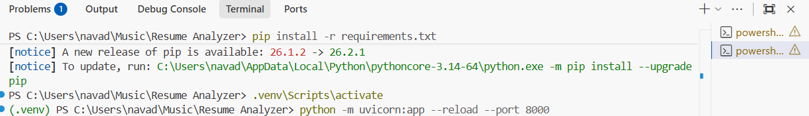

Activity 5.2: Local Testing and Verification
With dependencies installed and a valid GROQ_API_KEY set in the .env file, the application is launched with Uvicorn's auto-reload flag for fast iteration during development.
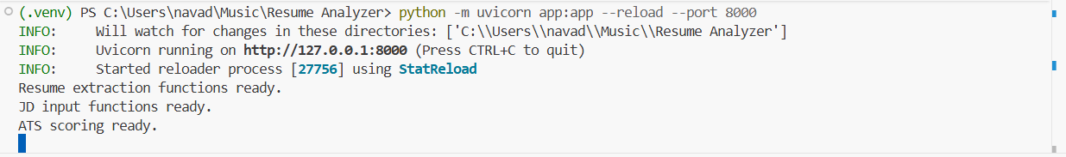

Activity 5.3: Securing the API Key for Shared Deployment
- Environment Variables: GROQ_API_KEY is loaded exclusively from a .env file via python-dotenv and is never hard-coded or committed to version control.
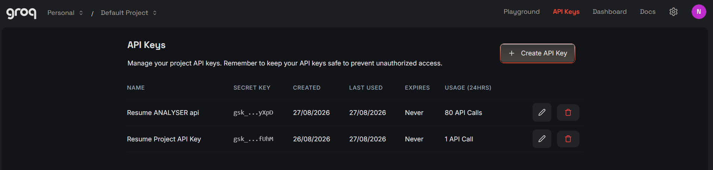
- Pin Dependencies: requirements.txt fixes every package the analyzer depends on so a hosted environment behaves identically to local testing.
- Stateless Backend: Because the FastAPI backend keeps no session state between requests, the same app can be scaled horizontally behind a standard ASGI server without any code changes.
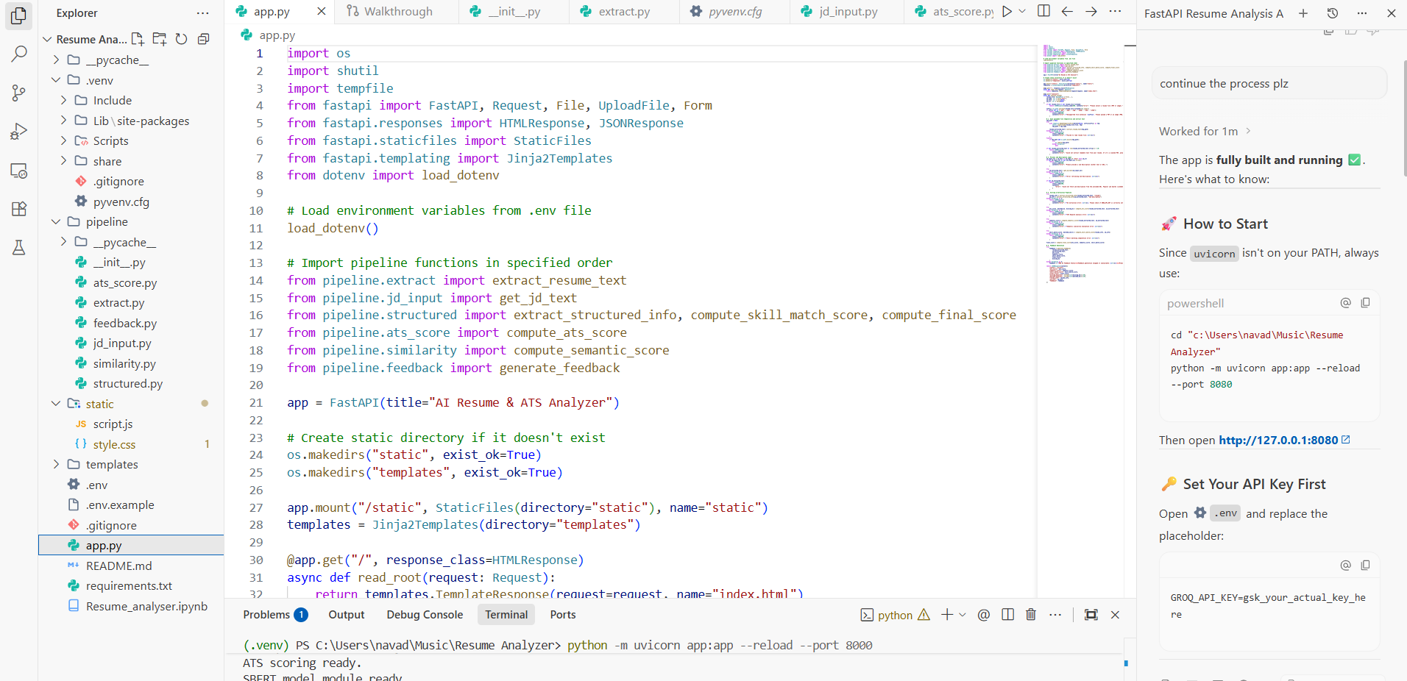
The above image include project structure setup worked in antigravity ide and running with localhost to test the results. Because both the SBERT model and the resume-extraction libraries are loaded once at process startup rather than per-request, a hosted deployment's first request after a cold start carries the model-loading cost while every subsequent request reuses the already-initialized model in memory, keeping typical end-to-end analysis time dominated by the two Groq API round-trips rather than local computation.

Exploring the Application's Interface:

Upload & Job Description Form:
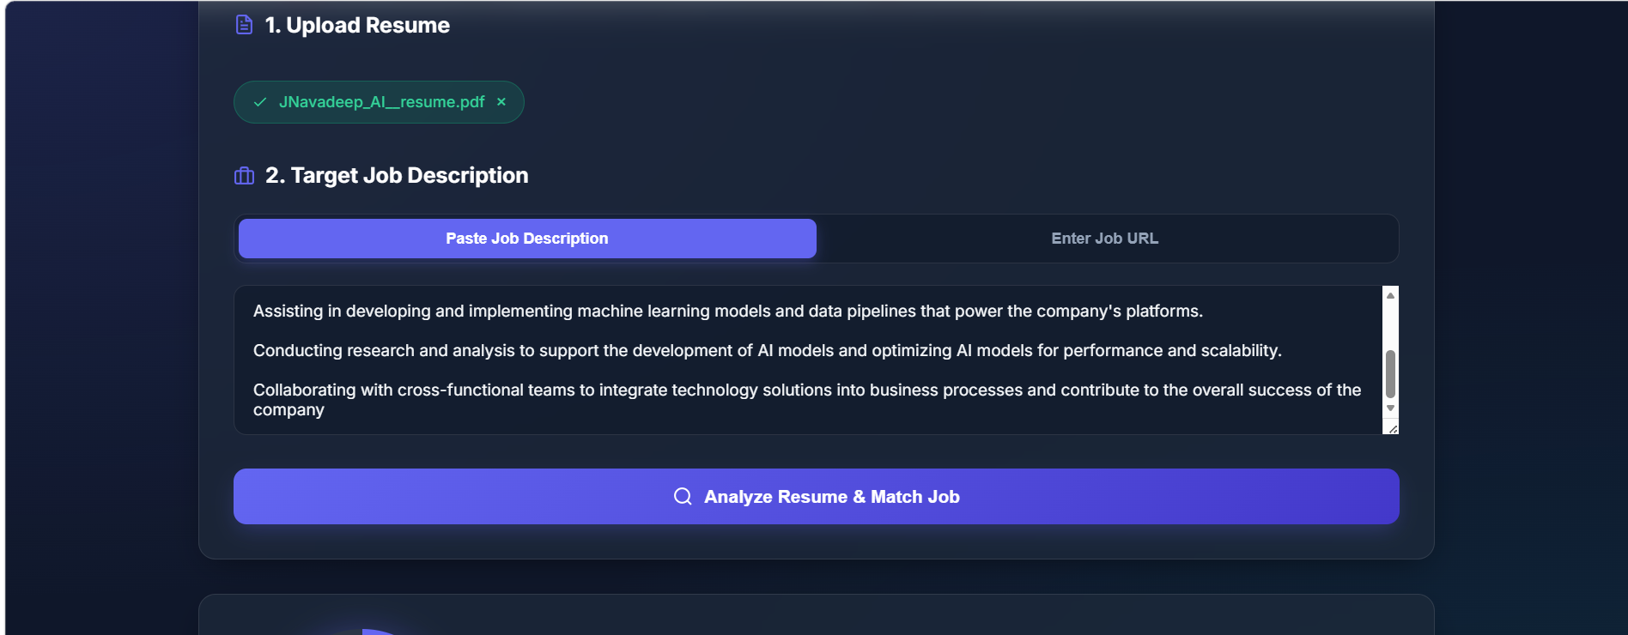
The dashboard opens with a two-step form: uploading a resume file, confirmed with a green checkmark badge, followed by pasting a job description directly or switching to a job-URL tab. Submitting the form triggers the Analyze Resume & Match Job action, which runs the complete extraction-and-scoring pipeline behind the /analyze endpoint and returns a Resume Fit Analysis summary with a circular final-score gauge and a plain-language verdict badge.

AI Career Feedback & Recommendations:
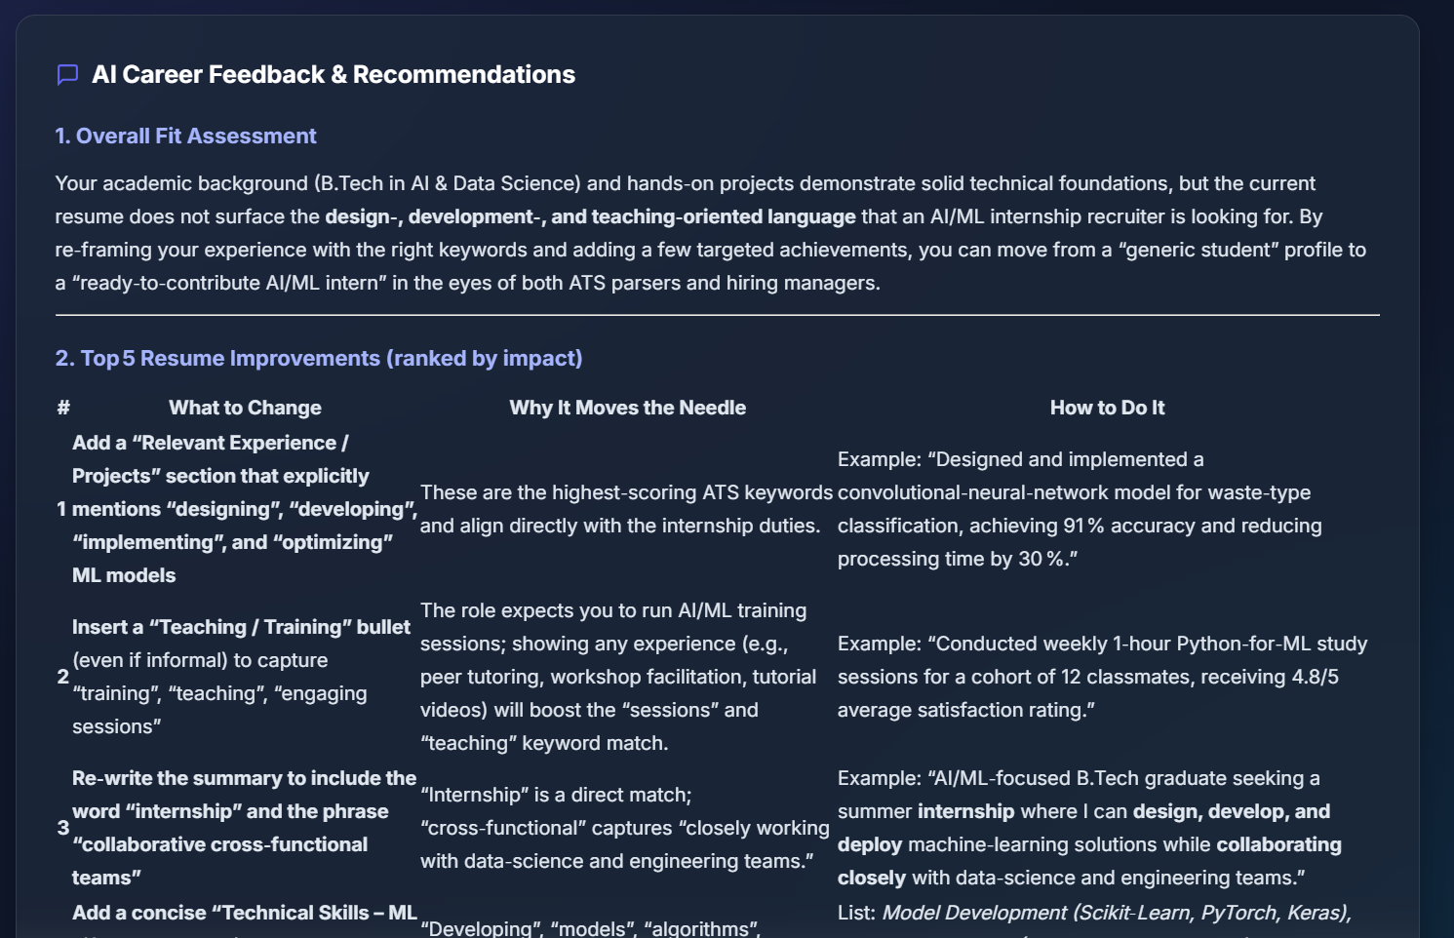
Beneath the score breakdown, the AI Career Feedback panel renders the Groq-generated coaching report as formatted markdown: an overall fit assessment explaining why the score landed where it did, followed by a ranked table of the top five resume improvements, each paired with a concrete example of how to phrase the change.
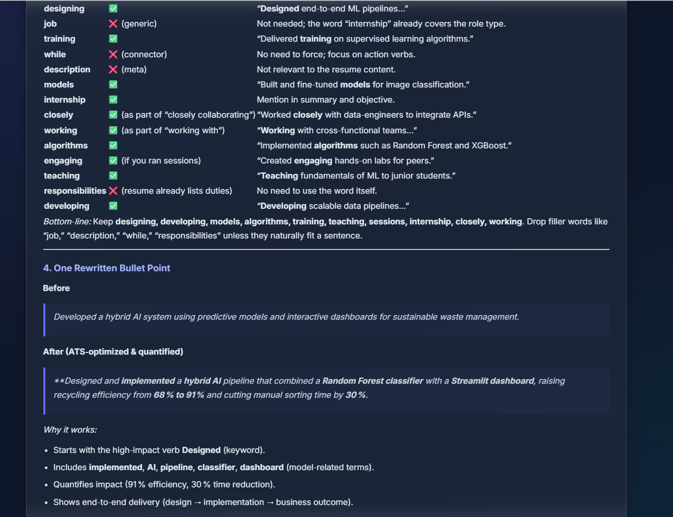
The feedback continues with a keyword-by-keyword worth-adding assessment — flagging genuinely valuable missing terms while dismissing filler words that would not meaningfully help — and finishes with one fully rewritten resume bullet point, shown before and after, that demonstrates exactly how to fold in quantified impact and role-specific language without fabricating experience the candidate does not have.

Conclusion:
The AI Resume & ATS Analyzer combines three independent, purpose-built scoring signals — literal ATS keyword overlap, SBERT semantic similarity, and structured skill matching — into a single transparent final score, and then closes the loop with genuinely actionable, LLM-generated coaching rather than a bare number. Validated across a 97-category, nearly 9,000-resume Kaggle dataset and built on a modular FastAPI backend with a polished glassmorphic dashboard, the platform gives candidates the same signal an applicant-tracking system would compute, plus the specific, prioritized guidance an ATS never provides. Looking ahead, the analyzer offers clear opportunities for expansion, such as supporting multi-resume batch comparison against a single job posting, adding resume-template-aware formatting checks, and fine-tuning the semantic model on domain-specific resume-job pairs to sharpen the similarity score further.

