Module - 4
Cloud Cost Management - Cost Structure, Total Cost of Ownership (TCO) vs. Cloud Costs, Importance of Cost Optimization, Cost Tracking and Analysis - Cloud Billing and Cost Allocation, Cloud Cost Dashboards and Reporting, Identifying Cost Drivers and Anomalies, Cost Optimization Strategies - Rightsizing Resources: VMs, Storage, and Databases, Cloud Cost Tools and Services - Cloud Cost Management Tools (e.g., AWS Cost Explorer, Azure Cost Management)
CLOUD COST MANAGEMENT
•Cloud cost management is crucial for businesses leveraging cloud services to ensure they optimize their expenses while maintaining the necessary resources for their operations.
•Understanding the cost structure of cloud services is fundamental to managing these costs effectively.
•The primary components of a typical cloud cost structure:
1. Compute Costs
Compute costs are usually the largest portion of cloud expenses and include the cost of virtual machines (VMs), containers, and serverless functions. Key factors influencing compute costs are:
•Instance Type and Size: Different VM types (e.g., general-purpose, compute-optimized, memory-optimized) and sizes (e.g., small, medium, large) have different pricing.
•Usage Duration: Billed based on the amount of time instances are running. This can be per second, minute, or hour.
•Reserved Instances and Savings Plans: Discounts are available for committing to use a certain amount of compute resources for a longer period (e.g., 1 or 3 years).
•Auto-scaling: Dynamically adjusts the number of running instances based on demand, which can optimize costs by scaling down during low usage periods.
2. Storage Costs
Storage costs include expenses related to storing data on the cloud.

•Type of Storage: Costs vary by storage type (e.g., SSDs vs. HDDs) and storage class (e.g., standard, infrequent access, archival).
•Amount of Data Stored: Generally charged per GB per month.
•Data Transfer Costs: Fees for data egress (data leaving the cloud), though ingress (data entering the cloud) is often free.
•Storage Operations: Charges for operations like reads and writes, which can vary based on the storage service used.
3. Network Costs
Networking costs involve expenses associated with data transfer within the cloud and between the cloud and external destinations.
•Data Egress: Costs for transferring data out of the cloud provider’s network.
•Data Ingress: Usually free but can incur costs if using specific network services.
•Inter-region Data Transfer: Costs for data transfer between different geographical regions.
•Content Delivery Network (CDN): Costs for distributing content globally, which includes data transfer fees and request charges.
4. Database Costs
Database services, both managed (e.g., Amazon RDS, Google Cloud SQL) and unmanaged, incur various costs:
•Instance Type and Size: Similar to compute costs, database instance types and sizes impact costs.
•Storage Capacity: Amount of data stored in the database.
•Backup and Replication: Additional costs for automated backups and data replication across regions for redundancy.
•Queries and Transactions: Charges based on the number and complexity of queries and transactions executed.
5. Support and Management Costs

•Support Plans: Costs for different levels of support (e.g., basic, developer, business, enterprise) which provide varying degrees of technical support and response times.
•Management Tools: Charges for using tools that help manage and monitor cloud infrastructure (e.g., AWS CloudWatch, Azure Monitor).
6. Security and Compliance Costs
•Identity and Access Management: Costs associated with user authentication and authorization services.
•Security Services: Expenses for security services such as firewalls, DDoS protection, encryption services, and compliance auditing.
Strategies for Effective Cloud Cost Management
1.Right-sizing Resources: Continuously monitor and adjust the size of compute instances to match workload requirements.
2.Using Reserved Instances: Take advantage of discounts for long-term commitments to specific resources.
3.Auto-scaling: Implement auto-scaling to ensure resources are used efficiently based on demand.
4.Storage Tiering: Use different storage classes for different data types based on access frequency.
5.Monitoring and Optimization Tools: Utilize cloud cost management and monitoring tools to gain insights into spending and optimize resource utilization.
6.Regular Audits: Conduct regular cost audits to identify and eliminate underutilized or idle resources.
By understanding and actively managing these components of cloud cost structure, organizations can optimize their cloud expenditures and achieve greater cost efficiency.

TOTAL COST OF OWNERSHIP (TCO)
•The Total Cost of Ownership (TCO) in the context of cloud computing is a comprehensive estimate of the direct and indirect costs associated with the use of cloud services over a given period.
•It includes not only the initial expenses but also the ongoing operational costs, and it can be compared to the costs of traditional on-premises infrastructure to determine the most cost-effective approach.
•A detailed breakdown of the components of TCO for cloud computing:
1. Direct Costs
1.1 Compute Costs
•Instance Usage: The cost of running virtual machines (VMs), containers, and serverless functions.
•Instance Types and Sizes: Different types and sizes of instances (e.g., standard, high-memory, GPU) incur varying costs.
•Reserved Instances/Savings Plans: Discounts obtained by committing to a certain amount of compute usage over one or three years.
1.2 Storage Costs
•Primary Storage: Costs for different storage types (e.g., SSD, HDD) and storage classes (e.g., standard, infrequent access, archival).
•Data Transfer: Charges for data egress and inter-region data transfers.
•Operations: Costs associated with read/write operations, data retrieval, and data management.

1.3 Network Costs
•Bandwidth: Costs for data transfer between regions, to and from the internet, and within the cloud provider’s network.
•CDN Services: Expenses for content delivery networks that distribute data globally.
1.4 Database Costs
•Database Instances: Costs for managed database services based on instance type and size.
•Storage and Backup: Costs for database storage, automated backups, and data replication.
1.5 Additional Service Costs
•Managed Services: Costs for additional cloud services such as machine learning, data analytics, and IoT.
•Support Plans: Charges for technical support at different levels (basic, developer, business, enterprise).
2. Indirect Costs
2.1 Personnel Costs
•Training: Expenses for training IT staff to manage and optimize cloud services.
•Management: Costs for personnel involved in monitoring, managing, and maintaining cloud infrastructure.
2.2 Migration Costs
•Data Transfer: Costs associated with moving data and applications to the cloud.
•Downtime: Potential revenue loss or additional costs due to downtime during the migration process.
•Consulting Services: Expenses for third-party consultants who assist with the migration.

2.3 Security and Compliance
•Security Measures: Costs for implementing security measures such as encryption, firewalls, and DDoS protection.
•Compliance: Expenses related to ensuring compliance with regulations (e.g., GDPR, HIPAA).
3. Operational Costs
3.1 Continuous Optimization
•Monitoring Tools: Expenses for tools and services that monitor cloud usage and performance (e.g., AWS CloudWatch, Azure Monitor).
•Optimization Efforts: Costs for continuous efforts to optimize cloud resource usage and reduce waste.
3.2 Maintenance and Updates
•Software Updates: Costs for keeping cloud software and applications up to date.
•Maintenance Contracts: Expenses for maintenance services and support contracts.
4. Risk Management Costs
•Disaster Recovery: Costs for implementing disaster recovery plans and backup solutions.
•Redundancy: Expenses for ensuring high availability and fault tolerance through redundant systems.
Calculating TCO for Cloud vs. On-Premises
To determine the TCO of cloud infrastructure versus traditional on-premises infrastructure, consider the following steps:
1.Identify All Relevant Costs: Include all direct, indirect, operational, and risk management costs.
2.Estimate Over a Relevant Time Period: Typically, a 3-5 year period is used for TCO analysis.

3.Compare Against On-Premises Costs: Factor in on-premises costs such as hardware, software, facilities, utilities, and personnel.
4.Include Opportunity Costs: Consider the potential revenue opportunities or productivity gains enabled by the cloud.
Benefits of TCO Analysis
•Informed Decision Making: Helps businesses make informed decisions about cloud adoption or migration.
•Cost Efficiency: Identifies potential cost savings and areas for optimization.
•Strategic Planning: Aids in long-term strategic planning and budgeting for IT resources.
By performing a detailed TCO analysis, organizations can better understand the financial implications of moving to the cloud and make decisions that align with their business objectives and financial constraints.
Total Cost of Ownership (TCO) Vs. cloud costs.
When evaluating cloud computing against traditional on-premises infrastructure, it's essential to consider both Total Cost of Ownership (TCO) and cloud costs. While cloud costs refer specifically to the expenses associated with using cloud services, TCO encompasses all costs related to owning and operating an IT infrastructure over its entire lifecycle. Here’s a comparison to help distinguish between the two and understand their implications:
Total Cost of Ownership (TCO)
TCO is a comprehensive assessment that includes all direct and indirect costs associated with purchasing, deploying, operating, and maintaining an IT infrastructure. This includes both initial capital expenditures (CapEx) and ongoing operational expenditures (OpEx).
Components of TCO:
1.Initial Capital Costs (CapEx):
oHardware: Purchase of servers, storage devices, networking equipment, etc.

oSoftware: Licensing fees for operating systems, applications, and other software.
oFacilities: Costs related to physical space, power, cooling, and security for data centers.
2.Operational Costs (OpEx):
oMaintenance: Regular maintenance and repairs of hardware and infrastructure.
oUtilities: Power, cooling, and other utility costs for running a data center.
oPersonnel: Salaries and benefits for IT staff responsible for managing the infrastructure.
oSupport: Technical support contracts and warranties.
oUpgrades: Periodic upgrades to hardware and software to keep the infrastructure current.
3.Indirect Costs:
oDowntime: Costs associated with system outages and downtime.
oDisaster Recovery: Expenses for disaster recovery solutions and backups.
oCompliance: Costs for ensuring compliance with regulatory requirements.
Cloud Costs
Cloud costs refer specifically to the expenses incurred when using cloud services provided by third-party cloud vendors like AWS, Azure, or Google Cloud. These costs are typically operational expenditures (OpEx), and they can be more flexible and scalable compared to traditional on-premises infrastructure costs.
Components of Cloud Costs:
1.Compute Costs:

oInstance Usage: Pay-as-you-go charges for virtual machines, containers, or serverless functions based on usage time and resources.
oReserved Instances/Savings Plans: Discounts for committing to a specific amount of compute usage over a longer period.
2.Storage Costs:
oData Storage: Charges based on the amount and type of data stored.
oData Transfer: Costs for data transfer out of the cloud and between regions.
3.Network Costs:
oBandwidth: Costs associated with data transfer and networking within the cloud environment.
4.Database Costs:
oManaged Database Services: Costs based on the type, size, and usage of database instances.
oOperations: Charges for database transactions and queries.
5.Additional Service Costs:
oManaged Services: Fees for using additional cloud services like machine learning, data analytics, and IoT.
oSupport Plans: Costs for different levels of technical support.
Comparing TCO and Cloud Costs
Initial Investment:
•TCO: Requires significant upfront capital investment in hardware, software, and infrastructure.
•Cloud Costs: Minimal initial investment, primarily pay-as-you-go model, shifting costs to operational expenses.
Scalability and Flexibility:
•TCO: Limited by physical infrastructure; scaling up requires additional capital investment and time.

•Cloud Costs: Highly scalable; resources can be adjusted dynamically based on demand, providing flexibility.
Maintenance and Upgrades:
•TCO: Requires ongoing maintenance, upgrades, and management by in-house IT staff.
•Cloud Costs: Maintenance and upgrades are managed by the cloud provider, reducing the burden on in-house staff.
Cost Predictability:
•TCO: More predictable over the long term with fixed costs for hardware and facilities, but can have variable maintenance and upgrade costs.
•Cloud Costs: Can be variable and sometimes unpredictable due to fluctuating usage, but tools and plans are available to manage and forecast costs.
Personnel and Management:
•TCO: Requires a dedicated team for infrastructure management, including maintenance, security, and compliance.
•Cloud Costs: Reduces the need for a large in-house IT team as many management tasks are handled by the cloud provider.
Making the Decision
1.Evaluate Business Needs: Consider your organization’s specific needs for flexibility, scalability, and budget constraints.
2.Cost Analysis: Perform a detailed cost analysis comparing TCO for on-premises infrastructure and expected cloud costs over a similar period.
3.Long-Term Strategy: Align the decision with your long-term IT and business strategy, considering factors like growth, technological advancements, and market changes.
By understanding the differences between TCO and cloud costs, organizations can make informed decisions about their IT infrastructure, balancing cost efficiency, scalability, and operational needs.

IMPORTANCE OF COST OPTIMIZATION
•Cost optimization is a strategic approach that organizations use to manage and reduce expenses while maximizing business value and operational efficiency.
•Cost optimization plays a crucial role in various aspects of a business, from financial health to competitive advantage.
•Here are some key reasons why cost optimization is important:
1. Enhanced Profitability:
•By reducing unnecessary costs and improving efficiency, businesses can significantly increase their profit margins.
•This is especially critical in highly competitive markets where price sensitivity is high.
2. Sustainable Growth:
•Efficient use of resources ensures that the organization can scale sustainably.
•Cost optimization allows businesses to invest more in growth opportunities such as research and development, marketing, and expansion without compromising financial stability.
3. Competitive Advantage:

•Companies that manage costs effectively can offer products or services at lower prices or with better features, gaining a competitive edge in the market.
4. Risk Management:
•Cost optimization involves evaluating and mitigating financial risks. •By understanding and controlling costs, businesses can better withstand economic downturns or unexpected financial challenges.
5. Improved Cash Flow:
•Reducing costs improves cash flow, allowing the organization to reinvest in key areas, pay down debt, or build a financial cushion for future needs.
6. Resource Allocation:
•Efficient cost management ensures that resources are allocated to the most productive and strategic areas of the business, enhancing overall operational efficiency.
7. Stakeholder Confidence:
•Demonstrating a commitment to cost control can build confidence among investors, shareholders, and creditors, as it reflects prudent financial management.
8. Environmental and Social Responsibility:
•Cost optimization can lead to more sustainable practices, such as reducing waste and improving energy efficiency.
•This not only cuts costs but also aligns with broader corporate social responsibility (CSR) goals.
9. Employee Morale:

•Effective cost management can free up resources to invest in employee development, benefits, and workplace improvements, leading to higher morale and productivity.
10. Innovation and Flexibility:
•By optimizing costs, companies can free up resources to invest in innovation. This allows businesses to be more agile and responsive to market changes and opportunities.
In summary, cost optimization is a vital practice for maintaining the financial health of an organization, enabling growth, improving competitiveness, and ensuring long-term sustainability. It is an ongoing process that requires regular review and adjustment to align with the dynamic business environment.
COST TRACKING
Cost tracking and analysis are critical components of effective financial management within an organization. They involve monitoring, recording, and analysing expenses to ensure they align with budgetary constraints and organizational goals. Here’s a detailed look at how cost tracking and analysis can be conducted:
1. Establishing a Cost Structure:
Categorization: Define categories for various types of costs such as fixed, variable, direct, and indirect costs.
Chart of Accounts: Create a comprehensive chart of accounts to classify and record transactions consistently.
2. Implementing a Tracking System:
Software Tools: Use accounting software or Enterprise Resource Planning (ERP) systems to automate and streamline cost tracking.
Expense Reports: Implement standardized expense reporting procedures for employees to capture and record costs accurately.
3. Data Collection:

Invoice and Receipts Management: Maintain a system for collecting and storing invoices and receipts for all expenses.
Time Tracking For labor costs, use time tracking tools to record the amount of time employees spend on different projects or tasks.
4. Real-Time Monitoring:
Dashboards: Develop real-time dashboards to monitor ongoing costs and compare them against budgets.
Alerts and Notifications: Set up alerts to notify management when spending exceeds certain thresholds.
COST ANALYSIS
1. Variance Analysis:
Budget vs. Actual: Compare actual expenses to budgeted amounts to identify variances.
Root Cause Analysis: Investigate significant variances to understand their causes and take corrective actions.
2. Trend Analysis:
Historical Data: Analyze historical cost data to identify trends and patterns over time.
Seasonal Variations: Consider seasonal factors that might influence cost fluctuations.
3. Cost Allocation:
Activity-Based Costing (ABC): Allocate costs to specific activities or projects to determine the true cost of operations.
Overhead Allocation: Distribute overhead costs accurately across different departments or products.
4. Profitability Analysis:

Product/Service Profitability: Evaluate the profitability of different products or services by comparing their revenue against associated costs.
Customer Profitability: Analyze costs associated with serving different customer segments to determine their profitability.
5. Benchmarking:
Industry Standards: Compare costs against industry benchmarks to gauge efficiency.
Best Practices: Identify and adopt best practices from industry leaders to improve cost management.
6. Scenario Analysis:
What-If Scenarios: Conduct what-if analyses to understand the impact of various cost changes on the overall financial health.
Forecasting: Use predictive analytics to forecast future costs and plan accordingly.
Tools and Techniques
1. Spreadsheet Software:
- Utilize tools like Microsoft Excel or Google Sheets for basic cost tracking and analysis, incorporating formulas, pivot tables, and charts for detailed insights.
2. Business Intelligence (BI) Tools:
- Implement BI tools such as Tableau, Power BI, or QlikView to visualize cost data and generate interactive reports.
3. ERP Systems:
- Use ERP systems like SAP, Oracle, or Microsoft Dynamics for comprehensive cost tracking and integration across various business processes.
4. Project Management Tools:
- Leverage project management tools like Asana, Trello, or Jira to track project-specific costs and ensure alignment with project budgets.
Best Practices
1. Regular Review and Reporting:

- Conduct regular cost reviews and produce detailed reports for stakeholders to ensure transparency and accountability.
2. Continuous Improvement:
- Implement a continuous improvement approach to cost management, regularly seeking ways to optimize and reduce costs without compromising quality.
3. Training and Education
- Provide training for employees on cost tracking tools and techniques to ensure accurate data entry and reporting.
4. Cross-Functional Collaboration:
- Foster collaboration between departments to ensure a holistic approach to cost management and avoid siloed decision-making.
By diligently tracking and analyzing costs, organizations can gain valuable insights into their financial operations, identify opportunities for savings, and make informed decisions that enhance overall profitability and efficiency.
CLOUD BILLING
•Cloud billing is the procedure of producing and sending invoices for using cloud services to customers.
•Most cloud provider carriers provide special billing reports, permitting groups to apprehend their intake patterns.
•These reports provide data on the resources used, the time period of utilization, and associated expenses.
•By comprehensively studying these reports, companies can benefit from insights into their expenditure and make informed decisions to optimize their utilization and reduce costs.
Key Concepts
•Pay-as-You-Go: Most cloud providers charge based on usage, meaning you pay only for what you use.
•Reserved Instances: Discounts for committing to use certain resources over a longer period.

•Spot Instances: Lower-cost instances that can be terminated by the provider at short notice.
•Billing Reports: Detailed reports provided by cloud providers that show usage and costs.
Key Benefits of Cloud Billing
•Cost Transparency: Cloud billing presents designated insights into your utilization, enabling you to understand where in your money is going. This transparency is critical for budgeting and resource allocation.
•Cost Control: By intently monitoring your cloud utilization, you may discover unused or underutilized resources. This information empowers you to lessen or decommission such resources, leading to significant cost savings.
•Forecasting and Budgeting: Cloud billing data may be used to forecast future costs correctly. With this information, companies can create realistic budgets and allocate resources efficaciously.
•Resource Optimization: Cloud billing reports utilization styles. By understanding the pattern, companies can optimize their resources, ensuring they pay only for what they need.
•Cost Allocation: For large businesses, cloud billing permits costs to be allotted to different departments. This granular perception ensures that each department is aware to its cloud usage and may plan its budget correctly.
COST ALLOCATION
•Tags and Labels: Used to categorize resources for better cost tracking (e.g., by project, department, or environment).
•Resource Groups: Grouping related resources to simplify management and billing.
•Budgets and Alerts: Setting spending limits and alerts to monitor and control costs.

•Showback and Chargeback: Internal billing models where costs are shown to or charged back to the respective departments or projects based on their usage.
Implementing Cost Allocation
•Define Cost Centers: Identify and define the different cost centers within your organization (e.g., departments, projects).
•Apply Tags and Labels: Develop a consistent tagging strategy and apply tags to all resources. For example, tags could include “Environment: Production”, “Project: X”, or “Department: IT”.
•Allocate Shared Costs: For shared resources, establish a fair method to distribute costs. This could be based on usage, fixed percentages, or other relevant metrics.
•Regular Reporting and Analysis: Generate regular reports to analyze spending and identify trends. Use these insights to optimize resource allocation and cost management.
•Adjust and Iterate: Continuously refine your cost allocation strategy based on feedback and changing business needs.
Tools for Cloud Billing and Cost Allocation
AWS:
•AWS Cost Explorer
•AWS Budgets
•AWS Cost and Usage Report
•AWS Tagging
Google Cloud:
•Google Cloud Billing Reports
•Google Cloud Budgets and Alerts
•Google Cloud Cost Management Tools •Google Cloud Labels
Microsoft Azure:

•Azure Cost Management and Billing
•Azure Budgets
•Azure Pricing Calculator
•Azure Resource Tags
Tips for Using Cloud Billing Effectively
•Regularly Review Billing Reports: Set up a agenda to study your cloud billing reports regularly. This exercise facilitates you stay updated about your costs and usages.
•Implement Budget Alerts: Most cloud service provider companies offer finances alert features. Utilize these signals to get hold of notifications while your costs attain a targeted threshold. This proactive technique permits you to take immediately action if prices exceed your limit.
•Embrace Automation: Implement automated tools and scripts to optimize your cloud sources. Automation allows in scaling resources based on demand, making sure you are now not overprovisioning and incurring unnecessary prices.
•Collaborate Across Teams: Foster collaboration between IT, finance, and operations groups. By running collectively, those departments can align cloud utilization with business goal, making sure efficient resource allocation and cost management.
•Regularly Update Your Cloud Strategy: Cloud technology have evolves unexpectedly. Regularly verify your cloud strategy to ensure you are utilizing the trendy features and services, optimizing prices, and improving overall performance.
Best Practices for Using Cloud Billing to Monitor Your Costs
•Set Clear Budgets: Define particular budgets to your cloud services and tasks. Regularly review and modify those budgets primarily based on changing business needs and monetary goals.
•Utilize Alerts: Implement billing indicators to get hold of notifications while costs approach or exceed the desired thresholds. Alerts let you take timely actions to govern your spending.

•Detailed Monitoring: Regularly display your cloud billing reviews. Analyze them in detail to identify spending styles, resource usage developments, and areas where expenses may be optimized.
•Resource Tagging: Tag your cloud resource appropriately, in particular in multi-departmental or multi-undertaking environments. Tags permit correct cost allocation, making it easier to discover cost associated with particular projects or groups.
•Rightsizing Resources: Optimize your cloud resource with the aid of deciding on the right instance sizes. Regularly verify your useful resource usage and adjust configurations to healthy your actual workload necessities.
•Implement Automation: Use automation tools and scripts to scale resources based totally on demand. Automated scaling guarantees that you’re now not over-provisioning sources, leading to pointless charges.
•Regular Review Meetings: Schedule regular conferences with relevant groups to study billing reports. Collaboration among IT, finance, and operations departments is essential to align cloud utilization with budgetary constraints.
•Cloud Cost Management Tools: Explore third-party cloud cost management equipment that offer extra capabilities and analytics to optimize your cloud costs effectively.
How to Use Cloud Billing to Monitor Your Costs
offers strong tools and features that will help you display your cost effectively. Here’s a step-by-step guide on how to use GCP’s billing and cost monitor services:
Step 1: Access the GCP Console
Log in to your GCP account and get go to the GCP Console at (https://console.Cloud.Google.Com/).

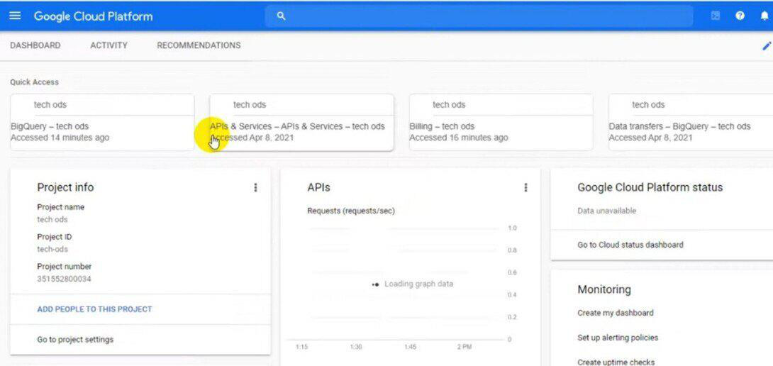
Step 2: Go to the Billing Section
In the GCP Console, navigate to the billing section through clicking at the hamburger menu (three horizontal lines) on the top left, then pick “Billing.”
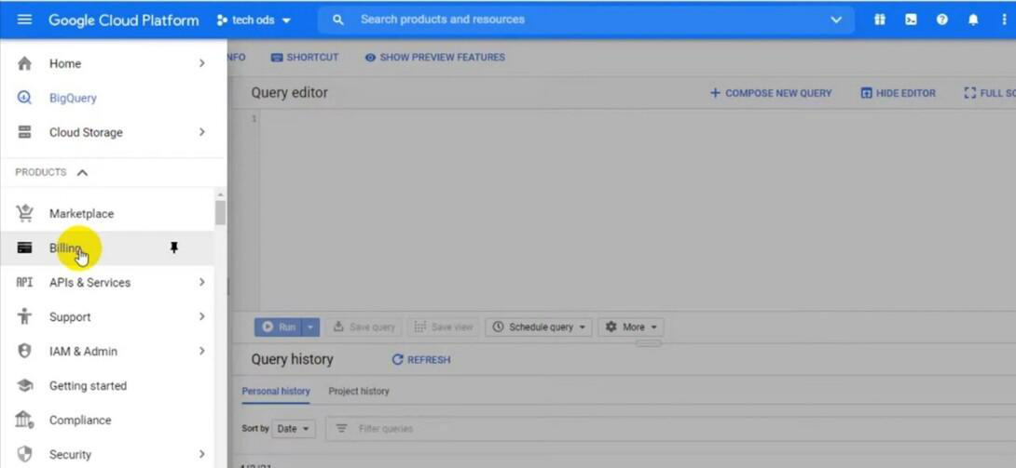
Step 3: Set Up Your Billing Account
If you haven’t set up a billing account, follow the activates to create one. Provide necessary info which includes billing name, address with, and payment information. Once your billing account is set up, you may link your projects to it.
Step 4: Link Your Projects
Link your GCP project to the billing account. This step ensures that each one the costs associated with those projects are consolidated and visible in a single region. In the Billing section, click on on “Link a billing account,” then choose your billing account and click on “Set Account.”

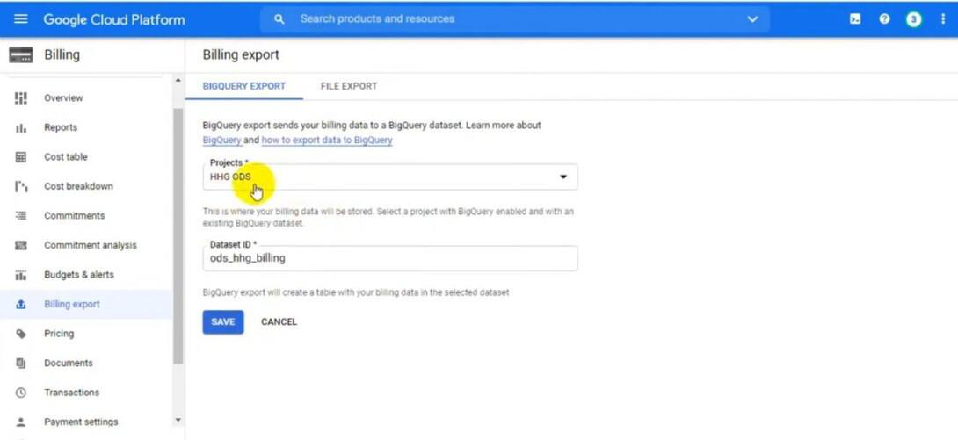
Step 5: Access Billing Reports
In the Billing section, pick out “Reports” from the left menu. Here, you can find various pre-configured reports displaying your cost and usage. Explore options like “Cost Overview,” “Cost Details,” and “Custom Reports” to gain insights of your spending patterns.
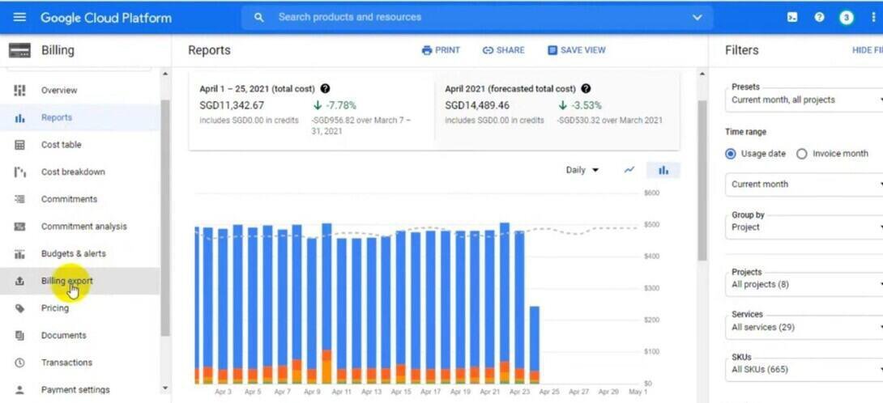
Step 6: Set Budgets and Alerts
Click on “Budgets & alerts” inside the Billing segment. Here, you may installation budgets to restriction your spending for precise projects or resources. Configure budget alerts to obtain notifications when your charges approach or exceed the set limits. Click on “Create Budget” to set up your budget and alert options.

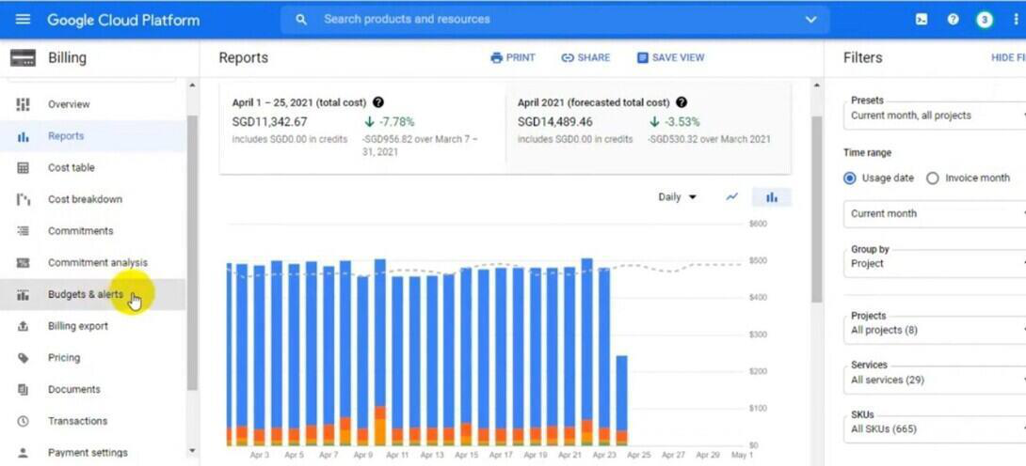
Step 7: Utilize Billing Export to BigQuery
If you want to carry out in-intensity evaluation of your billing information, kept in mind exporting your billing data to BigQuery. This permits you to run SQL-like queries on your billing records, enabling particular and customized price analysis. You can set up billing exports inside the Billing section under the “Billing Export.”
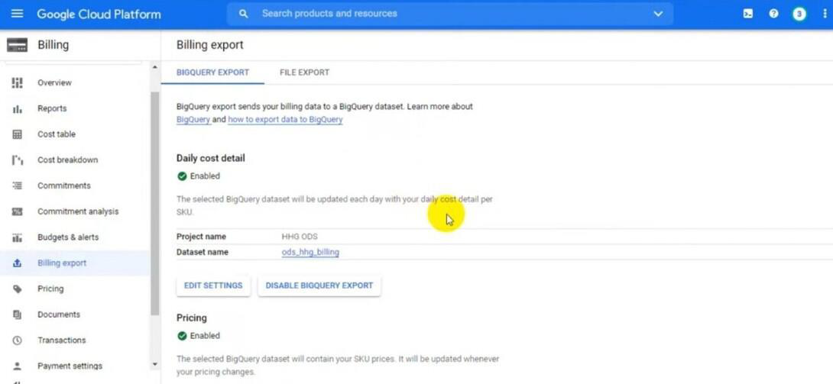
Step 8: Implement Resource Optimization
Regularly evaluation your billing reports to discover underutilized resources. Use tools like Google Cloud’s Rightsizing Recommendations to optimize example sizes primarily based on utilization patterns. Implement automation scripts or policies to scale resources up or down based totally on demand, making sure fee efficiency.
Step 9: Monitor and Fine-Tune

Regularly monitor your billing statistics, in particular in case your usage patterns
change. Adjust your budgets, alerts, and useful resource configurations for this
reason. Stay knowledgeable approximately GCP’s latest cost optimization
features and best practices to constantly fine-tune your setup.
Step 10: Collaborate and Review
Collaborate together with your team participants, in particular IT and finance, to
review billing reports and discuss various strategies. Conduct everyday opinions
to ensure alignment among your cloud spending and your organization’s financial
goals.
CLOUD COST DASHBOARDS AND REPORTING
Cloud Cost Dashboards provide full visibility of AWS cloud costs, allowing you to monitor and manage your expenses effectively.
1.AWS Cost Intelligence Dashboard:
oAn interactive and customizable Amazon Quick Sight dashboard template.
oPart of the Cloud Intelligence Dashboards framework.
oHelps create the foundation for cost management, optimization, and Cloud Financial Management (CFM) goal tracking.
oVisualizes and understands your AWS cost and usage data.
oLeverages AWS Cost and Usage Reports (CUR) for comprehensive cost data.
oIncludes hourly compute visualizations, storage visualizations, and more.
oUsed by companies to optimize spending and identify cost-saving opportunities.
2.Other Cloud Cost Dashboards:
oAll Accounts, All Regions, and All Resources Dashboards: ▪Designed for AWS users with resources across multiple accounts and regions.
▪Provide intuitive, pre-built dashboards for cost visibility.
oOpen Source Multi-Cloud CLI Collie:
▪Allows building a cloud cost dashboard across AWS, Microsoft Azure, and soon Google Cloud.
▪Takes less than 10 minutes to set up and is completely free.
oCloudZero Dashboards:
Cloud Cost Dashboards help you track, analyze, and optimize your cloud spending, leading to better financial management and cost savings.

Creating a open source-Cloud Cost Dashboard
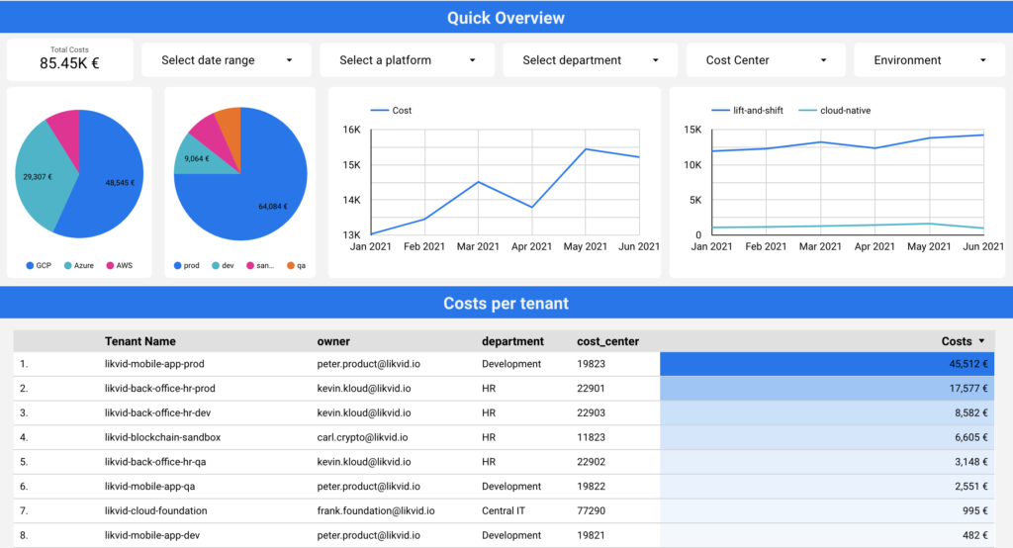
Own Cloud Cost Dashboard!
•Leverage the power of our open-source Collie CLI and you have the necessary cost data extracted within minutes. Duplicate our Google Data Studio Dashboard, connect it to the CSV export
Cloud Reporting
•Reporting in the cloud involves collecting, analyzing, and presenting data generated in a cloud environment so that it is easier to derive and share valuable insights to support everyday business decisions.
•A subcategory of effective cloud management, cloud reporting comprises a set of tools and monitoring best practices.
•Reporting tools ingest metrics, logs, events, and other metadata from a variety of sources. These sources include cloud infrastructures, microservices, containerized apps, and Kubernetes clusters.
•After enriching, analyzing, and normalizing the data, they present it as easy-to-understand charts, graphs, tables, and other visual representations.
So, instead of these rows and columns of unusable numbers and letters…

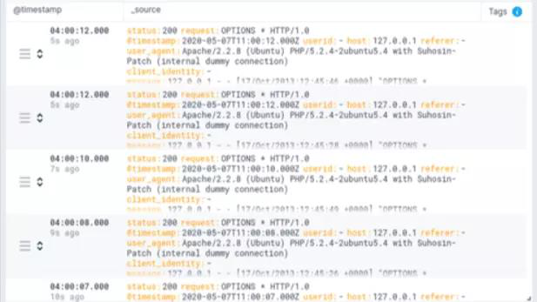
…what you get instead are meaningful insights:
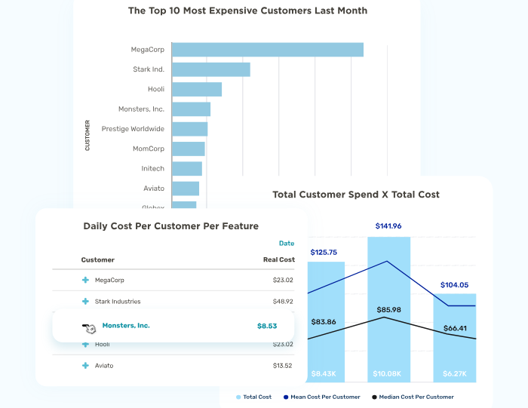
•The tools enable users to report data in a static or interactive format. Most cloud reporting tools also serve as cloud business intelligence tools, enabling stakeholders to gain real-time insights and make timely decisions on the fly.
Advantages Of Cloud Reporting Tools Vs. Traditional On-Premises Business Reporting
Cloud-based reporting differs from traditional reporting tools in several ways.
With cloud reporting, you can:
•Get real-time insights into your cloud environment to govern it effectively.
•Reduce the costs of purchasing, installing, and maintaining on-premises software. For a predictable subscription fee, cloud reporting vendors take care of all the back-end work.
•You pay only for the capabilities you need when you need them.

•Use automation to detect and report abnormal cloud activity before it becomes a problem.
•Enhance collaboration between engineering and finance teams to optimize cloud costs while providing best-in-class customer experiences.
•Share dashboards with anyone, wherever they are, as long as they have an internet connection and valid credentials.
•Make sure you are using the latest, most secure, and most efficient version of the cloud reporting tool you use.
•Share dashboard access with vendors to reconcile cloud reports.
•Build a real-time dashboard for each business process, such as cost per customer and cost per project.
Cloud reporting platforms:
1.Cloud Cost Intelligence: CloudZero
•CloudZero is a modern, full-fledged cloud cost intelligence platform for SaaS and tech brands. Engineers, finance professionals, and executives can use it to track who, what, why, and where their cloud spend is going on AWS
2. Traditional Cloud Cost Reporting: CloudHealth
•CloudHealth, VMware’s cloud cost management tool, provides several reporting capabilities.
• CloudHealth may be a good option for you if you are looking for a platform to combine cost reporting with security and compliance management.
•It | also | offers | reporting | for | hybrid | cloud | and | multi-cloud
environments.
3.Traditional Cloud Cost Reporting: Cloudability
•Cloudability promises to help IT, DevOps, and finance teams optimize cloud resources for cost, quality, and speed.
•The Cloudability dashboard lets you see your cloud costs at a high level, configure Reserved Instances, switch between different accounts, and turn off unused resources.
•You can also use it to rightsize your public cloud resources to minimize costs.
4. Automated Detection And Response: Blumira
•Blumira also offers automated risk detection, known threat blocking, and quick response.
•Blumira integrates seamlessly across cloud environments, identity providers, such as Google Workstation, and endpoint protection solutions.
Blumira can help with CMMC, NIST 800-53, and FFIEC compliance.
5. Secure DevOps Platform: Sysdig
•It provides continuous infrastructure operational monitoring and security reporting.

•Integrate it with multiple platforms to extend its functionality, such as SIEMs like ServiceNow and PagerDuty, registries like DockerHub, and continuous integration and delivery such as Jenkins and Bamboo.
6. Cloud Infrastructure Security: Orca Security
•Orca Security provides agentless security in AWS, GCP, and Azure clouds. It uses a cloud provider’s snapshot mechanism to get a read-only view of data. Orca Security promises this has no performance implications and is agnostic to VPCs, OS credentials, and machine run-states.
•The platform collects data directly from your cloud configuration and the runtime block storage out-of-hand of the workload to enable you to fix vulnerabilities, malware, misconfiguration, and more.
7. Cloud Infrastructure Reporting: SolarWinds
•Solarwinds provides a full-stack platform that lets you monitor and report on your infrastructure health, network performance, and cloud security.
•The platform includes several tools you can use for specific tasks: •AppOptics for infrastructure and application monitoring data •Pingdom for websites and web applications reports
•Loggly for aggregating and analyzing logs, and
•Papertrail for viewing logs quickly.
8. Cloud Log Reporting: Sumo Logic
9. Infrastructure Health Reporting: Sematext
10. Full-stack APM Reporting: DataDog
11. Modern App Environment Reporting: New Relic
12. Root-cause APM Reporting – Dynatrace
13. Native Kubernetes Reporting: Kubernetes Dashboard 14. Open-Source Kubernetes Reporting Tool: The ELK Stack 15. Network Monitoring: Paessler PRTG
IDENTIFYING COST DRIVERS AND ANOMALIES
Identifying cost drivers and anomalies in cloud costs is essential for effective cost management. Here are some steps you can take:
1.Set Transparent Budgets and Limits:
oEstablish clear spending limits for your cloud resources. This helps you track expenses and identify anomalies early on.
oUtilize cloud cost monitoring tools to set up budgets and receive alerts when spending exceeds these limits
2.Use Anomaly Detection Tools:
oLeverage anomaly detection tools to continuously monitor cloud expenditure.

oThese tools compare actual spending against historical data and use machine learning algorithms to predict future costs.
oWhen actual spending significantly deviates from predictions, an alert is triggered
3.AWS Cost Anomaly Detection (for AWS users):
oAWS offers automated cost anomaly detection and root cause analysis.
oYou can set up custom anomaly thresholds and receive alerts via email or Amazon SNS.
oDive deeper into cost drivers based on seasonally-aware patterns (e.g., weekly) to minimize false positives
COMMON CLOUD COST DRIVERS:
1.Compute Resources:
oVirtual machines (VMs), containers, and serverless functions contribute significantly to cloud costs.
oOversized or underutilized instances can lead to unnecessary expenses.
2.Storage:
oStoring data in cloud storage services (e.g., Amazon S3, Azure Blob Storage) incurs costs.
oFrequent data access, data transfer, and backups impact expenses.
3.Data Transfer and Bandwidth:
oTransferring data between regions or across services can be costly. oHigh network bandwidth usage increases charges.
4.Database Services:
oRunning databases (e.g., Amazon RDS, Google Cloud SQL) involves licensing and storage costs.
oQuery complexity and data volume affect expenses.
5.Reserved Instances vs. On-Demand Instances:
oChoosing reserved instances (long-term commitment) vs. on- demand instances (pay-as-you-go) impacts costs.
oAnalyze workload patterns to optimize instance types.
6.Third-Party Services and Marketplace Apps:
oIntegrating third-party services or using marketplace apps adds to expenses.
oRegularly review and prune unused services.
7.Monitoring and Logging:
oEnabling detailed monitoring and logging can increase costs. oBalance visibility with cost considerations.
COST OPTIMIZATION STRATEGIES: RIGHTSIZING RESOURCES

•Rightsizing resources in the cloud involves adjusting the allocation of computing, storage, and database resources to match the actual needs of workloads.
•This helps reduce costs by eliminating over-provisioning and under-utilization. Here are detailed strategies for rightsizing these resources:
Virtual Machines (VMs)
1. Monitoring and Analysis
•Utilize Cloud Provider Tools: Leverage tools like AWS Cloud Watch, Azure Monitor, and Google Cloud Operations Suite to monitor CPU, memory, and disk I/O metrics.
•Analyze Usage Patterns: Identify VMs that are consistently underutilized or over utilized.
2. Auto-Scaling
•Dynamic Scaling: Implement auto-scaling to automatically adjust the number of VMs based on current demand, ensuring you only use and pay for the resources needed at any given time.
3. Instance Types
•Match Workload Requirements: Choose appropriate instance types based on the specific needs of your applications (e.g., compute-optimized
for | CPU-intensive | tasks, | memory-optimized | for | RAM-heavy
applications).
•Regular Review: Periodically review and adjust instance types as workloads change.
4. Reserved Instances and Savings Plans
•Long-Term Savings: Purchase reserved instances or savings plans for predictable workloads to benefit from lower rates compared to on-demand pricing.
•Spot Instances: Use spot instances for non-critical workloads to take advantage of significant cost savings.
5. Idle Resource Identification

•Terminate Idle Instances: Use tools like AWS Trusted Advisor to identify and shut down idle or zombie instances.
6. Right-Sizing Recommendations
•Follow | Cloud | Provider | Recommendations: | Utilize | built-in
recommendations from cloud providers to adjust instance sizes based on actual usage data.
Storage
1. Data Lifecycle Management
•Automate Data Movement: Implement lifecycle policies to move data to lower-cost storage tiers as it ages (e.g., AWS S3 lifecycle policies).
•Archive Infrequent Data: Use archival storage options like AWS Glacier or Azure Cool Blob Storage for data that is rarely accessed.
2. Storage Classes
•Choose Appropriate Classes: Select storage classes based on access frequency and performance needs. Regularly review and adjust as necessary.
3. Snapshots and Backups
•Clean Up Regularly: Delete old snapshots and backups that are no longer needed to free up space and reduce costs.
•Incremental Backups: Utilize incremental backups to minimize storage usage.
4. Compression and Deduplication
•Enable Features: Use data compression and deduplication to reduce the amount of storage needed.
5. Thin Provisioning
•On-Demand Allocation: Implement thin provisioning to allocate storage on an as-needed basis, avoiding the cost of pre-allocated storage that isn't fully utilized.
Databases

1. Right-Sizing Database Instances
•Monitor Performance Metrics: Adjust database instance sizes based on CPU, memory, and disk I/O metrics.
•Horizontal Scaling: Consider horizontal scaling (e.g., sharding) for better resource distribution and cost efficiency.
2. Storage Optimization
•Data Clean-Up: Regularly remove old or unnecessary data to reduce storage costs.
•Schema and Index Optimization: Optimize database schemas and indexes to improve performance and reduce storage needs.
3. Database Engine Choice
•Select Cost-Effective Engines: Choose the appropriate database engine for your workload (e.g., NoSQL for unstructured data, relational for structured data).
•Managed Services: Evaluate managed database services for built-in optimization features.
4. On-Demand vs. Reserved Instances
•Predictable Workloads: Use reserved instances for databases with predictable usage to take advantage of lower pricing.
•Variable Workloads: For variable workloads, consider on-demand or burstable instances.
5. Scaling Strategies
•Auto-Scaling: Implement auto-scaling where supported to automatically adjust resources based on demand.
•Read Replicas: Use read replicas to offload read-heavy operations, improving performance without over-provisioning primary instances.
6. Performance Tuning
•Query Optimization: Regularly tune database queries and configurations to ensure optimal performance and cost efficiency.

•Monitor and Address Bottlenecks: Use monitoring tools to identify and resolve performance bottlenecks.
General Best Practices
1. Cost Monitoring and Alerts
•Set Up Monitoring: Use cost management tools like AWS Cost Explorer, Azure Cost Management, and Google Cloud Billing Reports to track spending and set up alerts for anomalies.
2. Regular Reviews
•Conduct Regular Reviews: Periodically review resource usage and costs to ensure resources are optimally allocated.
•Continuous Improvement: Iterate on optimization strategies based on feedback and changing requirements.
3. Tagging and Resource Management
•Implement Tagging Strategy: Use a robust tagging strategy to track and manage resources effectively.
•Cost Allocation: Use tags to allocate costs to specific departments, projects, or teams for better visibility and accountability.
By implementing these strategies, organizations can optimize their cloud resource usage, reduce costs, and maintain high performance and availability.
CLOUD COST MANAGEMENT TOOLS
AWS Cost Explorer
Cost and Usage Visualization
•AWS Cost Explorer provides users with visual representation of their AWS cost and usage over time, using graphs and tables.
•Visualization simplifies analysis of complex cost and usage data, facilitating quick insights and informed decisions.

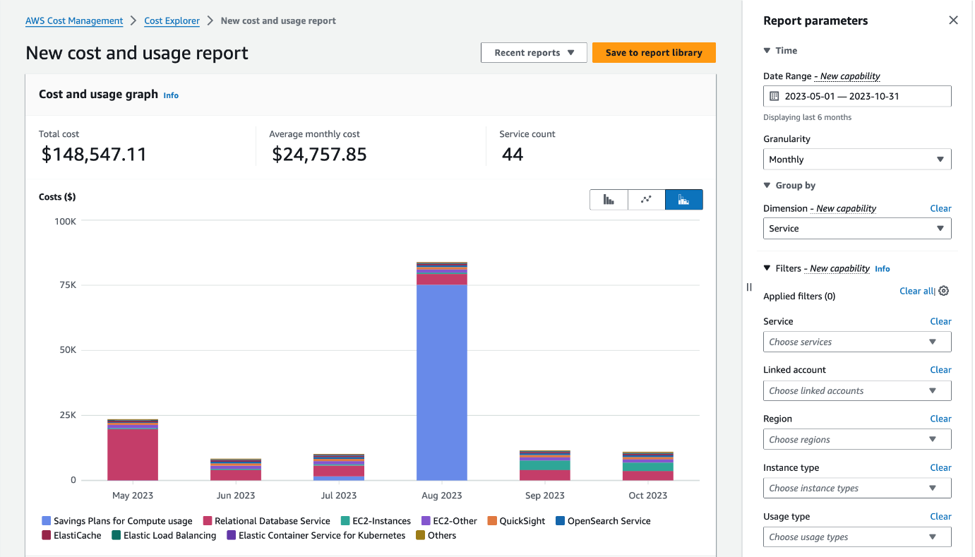
Filter and Group
•You can filter and group your data by a variety of dimensions. For example, you can view your daily/monthly cost grouped by member accounts to understand who is driving your most cost.
•Additionally, you can group your cost by services to view top 9 cost-accruing AWS services in the Cost Explorer graph and view detailed breakdown of cost per service in the table;
•you can also filter cost by a specific service to understand how the spend for that service has changed over a period of time.
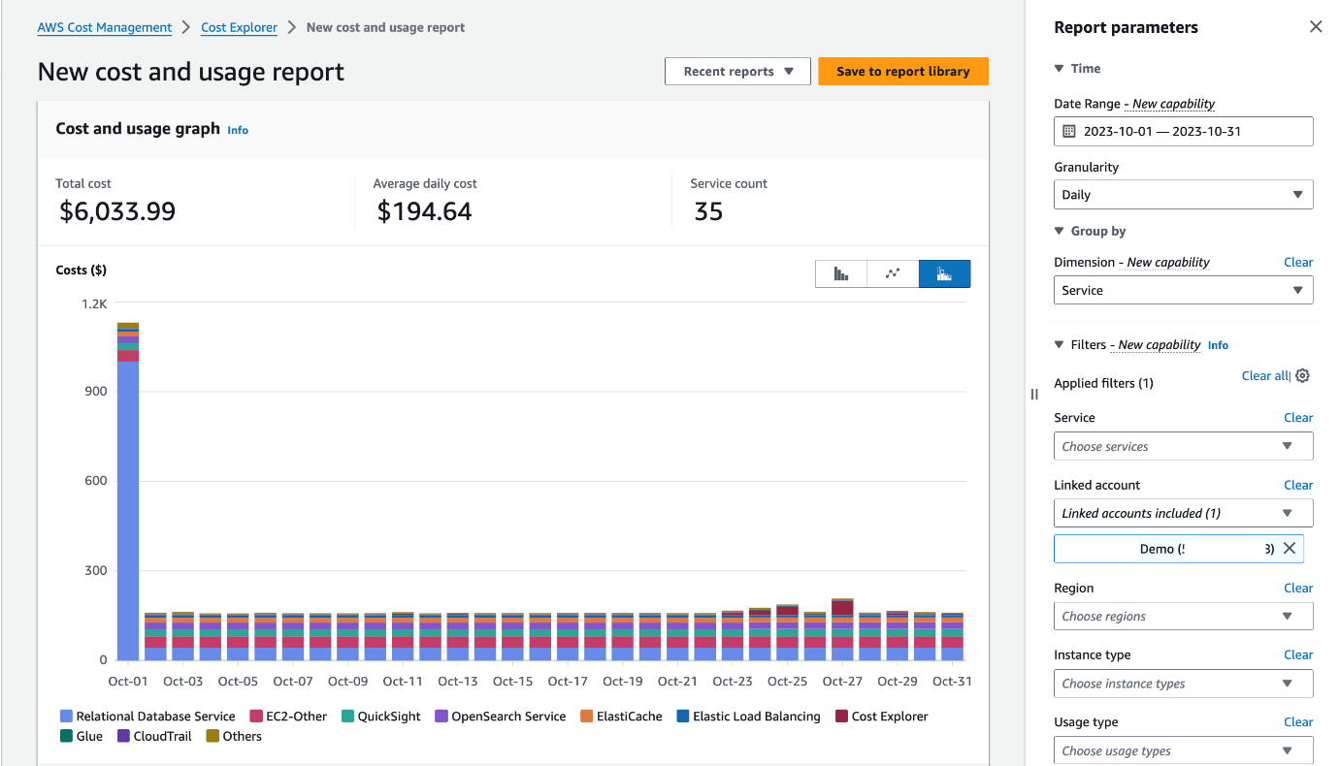
Cost and usage Forecasting
•AWS Cost Explorer can predict future costs and usage based on your historical and current cost and usage pattern.
•This helps organizations plan and budget for upcoming expenses.

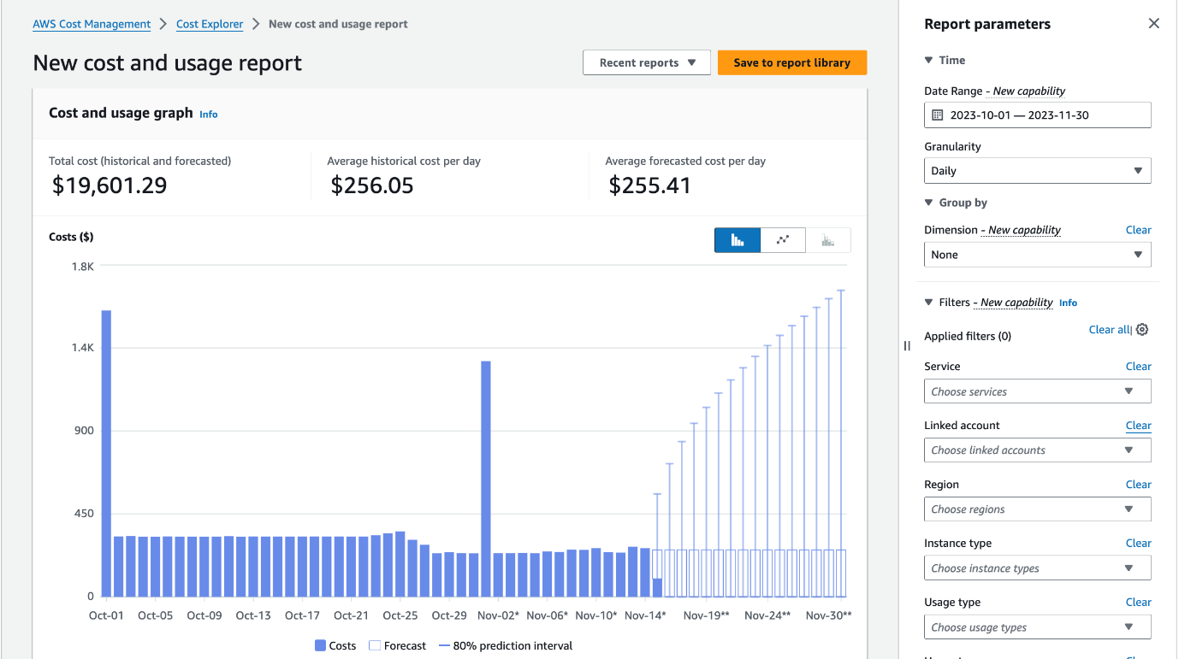
Saved Reports
•Cost Explorer provides preconfigured reports to monitor monthly cost by service, monthly cost by linked account, monthly EC2 running hours costs and usage, Daily costs, and AWS Marketplace costs.
•Additionally, customers can save custom Cost Explorer reports along with their filters and groupings for easy access.
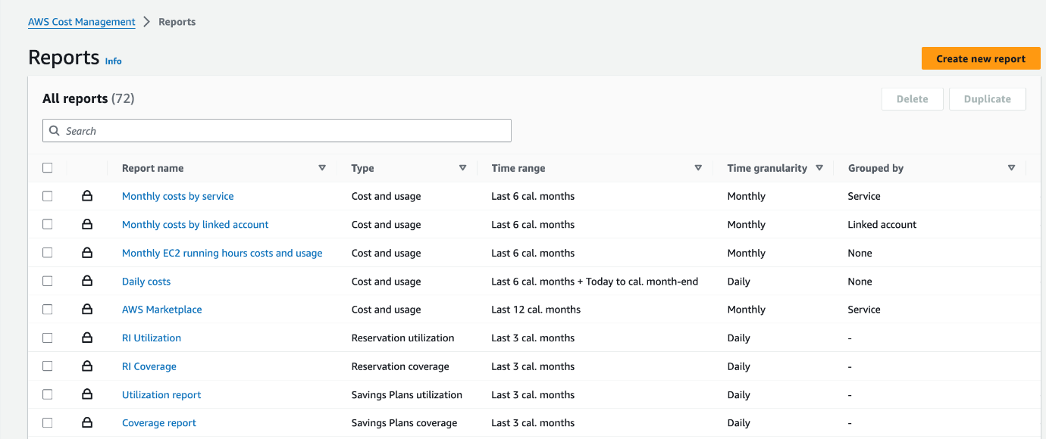
Multi-year history
•Users can perform multi-year historical data analysis at monthly granularity using up to 38 months of history and understand patterns and year-over-year changes in their AWS cost and usage.

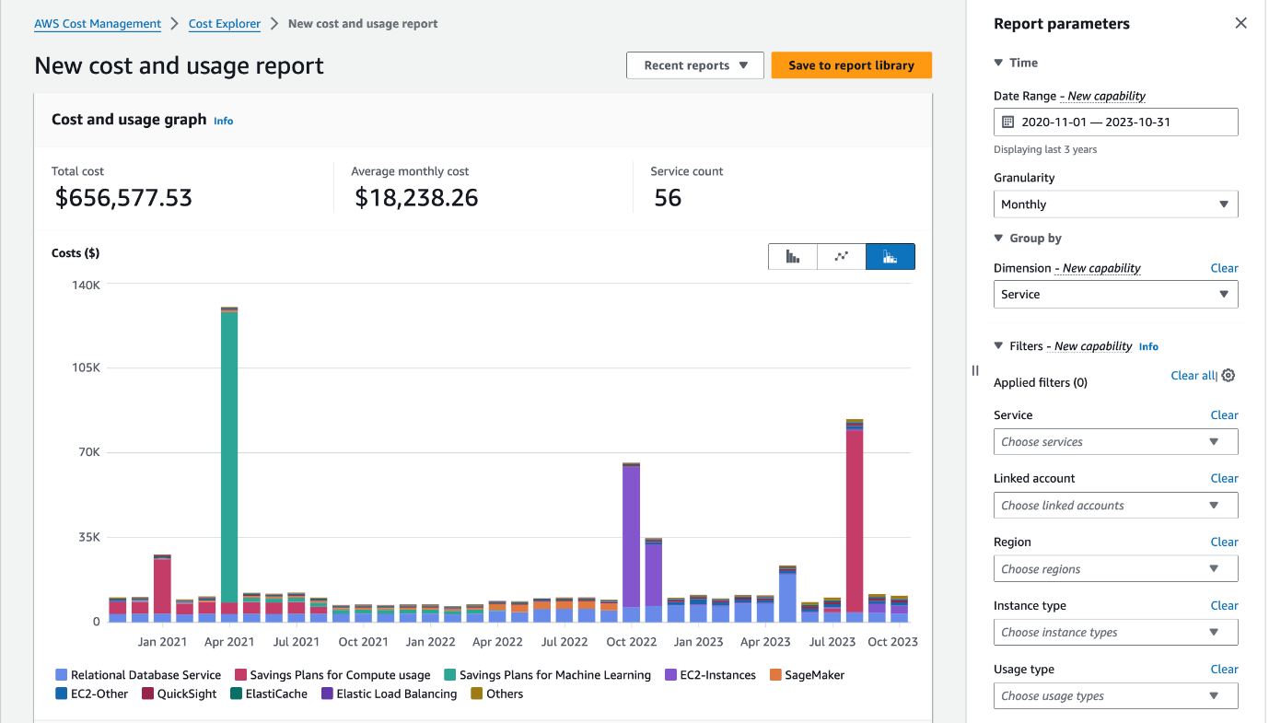
Hourly granularity
•Cost Explorer allows customers to understand their spend for the past 14 days at the most granular hourly level.
•You can monitor your hourly cost and usage to determine appropriate SP/RI commitment or understand peak hour usage.
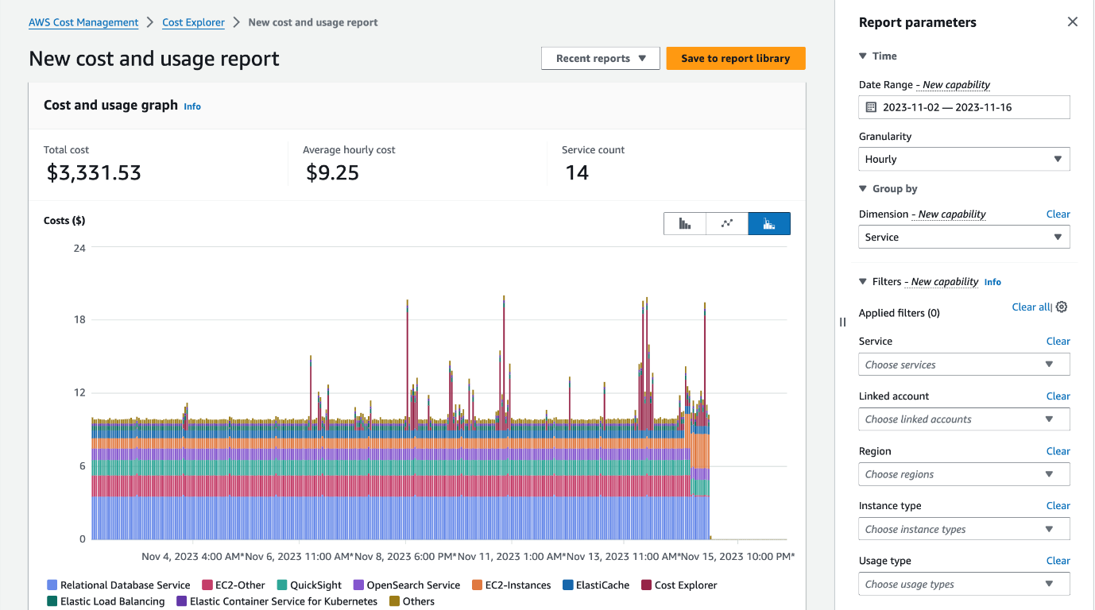
Resource level granularity
•Cost Explorer allows customers to monitor their AWS cost and usage at a resource level to identify cost drivers.
•Cost Explorer supports resource level data for all services at daily granularity and EC2 resource level data at hourly granularity.
•Customers can enable this additional data for the past 14 days.

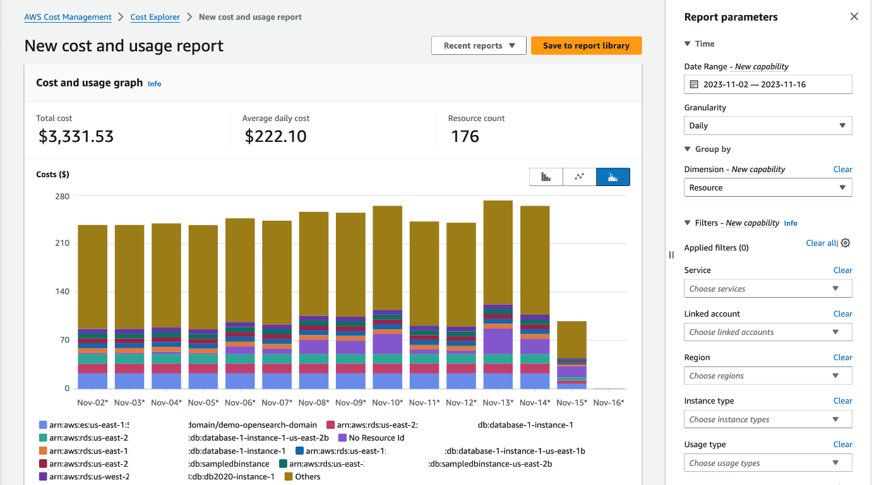
Download your CE view in csv format
•You can download your filtered CE view in CSV file format for offline access as well as easy sharing with other team members.
API access
•AWS Cost Explorer provides programmatic access to all features through API, enabling automation of Cost Management tasks.
Azure Cost Management
•Azure Cost Management is a free solution offered to Azure cloud customers via the Azure portal. It provides information about your overall costs and utilization across all Azure services and Azure Marketplace products. The solution provides insights and reports, and can also provide data about your organization’s use of other cloud providers.
•Once enabled, Azure Cost Management continuously monitors your resources and provides ongoing reports. You can integrate Azure Cost Management with Azure Advisor, and gain cost recommendations tailored to your usage. To further customize your cost management, you can use REST APIs and integrate with Microsoft Power BI.
Benefits of Microsoft Azure Cost Management
•Azure cost management can have two key benefits for your organization: gaining visibility over cloud spending, and helping you map costs to specific departments or initiatives.
Monitor and Optimize Azure Costs
•Azure Cost Management lets you analyze past cloud usage and expenses, and predict future expenses. You can view costs in a daily, monthly, or annual trend, to identify trends and anomalies, and find opportunities for optimization and savings.
•This data comes directly from Azure so it shows the actual units on which your Azure bill is based.

Map Cloud Costs to Departments or Initiatives
•Azure Cost Management classifies your resources into multiple buckets using the concept of cost entities. A cost entity is a department or project in your organization that pays for Azure services. You can also create a cost model that structures resources according to tags that teams have applied to the actual Azure resources.
•Once you have correctly defined cost entities and models, teams can use Azure Cost Management to view and investigate costs associated with their specific project budgets. You can also set budgets and alerts to warn or limit overuse for projects, teams, or specific users.
•Azure Cost Management is designed to help organizations find underutilized resources, eliminate waste and reduce costs.
•4 Ways to Optimize Azure Costs with Azure Cost Management and Related Tools
Cost Analysis Report
The Cost Analysis report in Azure Cost Management allows you to analyze your organization’s costs in detail, segmenting costs using Azure resource attributes. Here are a few examples of questions you can answer with the cost analysis report:
•What will be the costs for the current month? See how much you have spent and whether different cost entities are within their budget.
•Have there been cost anomalies? Check abnormal use of services or cost surges, and check that costs are within a reasonable range and appropriate for normal use.
•Is the invoiced amount as expected? Check your Azure bill against actual usage of services and verify that billing is as you expected. See if there were significant changes from previous months and investigate them.
•How can we split costs between departments/cost entities? Check how Azure costs should be distributed across organizational units, projects, or individuals.
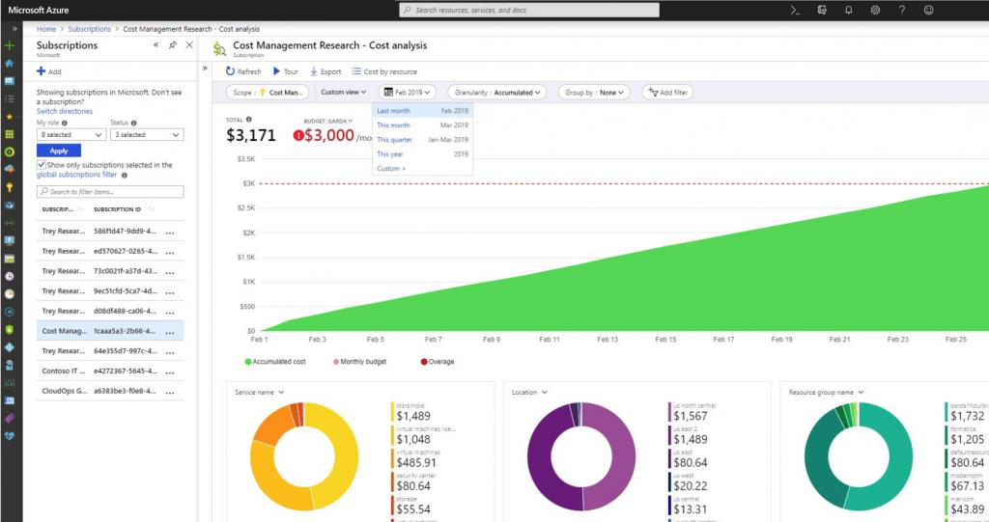

Source: Azure
Azure Budgets
•The Budgets function within Azure Cost Management lets you set a budget for Azure services, based on cost or usage.
•You should revisit budgets on a regular basis to see if specific budgets have run out and make changes as needed.
•Azure Budget also allows you to configure automated triggers for better cloud governance. So for example, when certain budget thresholds are reached, you can configure a service to shut down VMs when the budget is exceeded.
•You can also switch your infrastructure to different service tiers based on budget triggers.
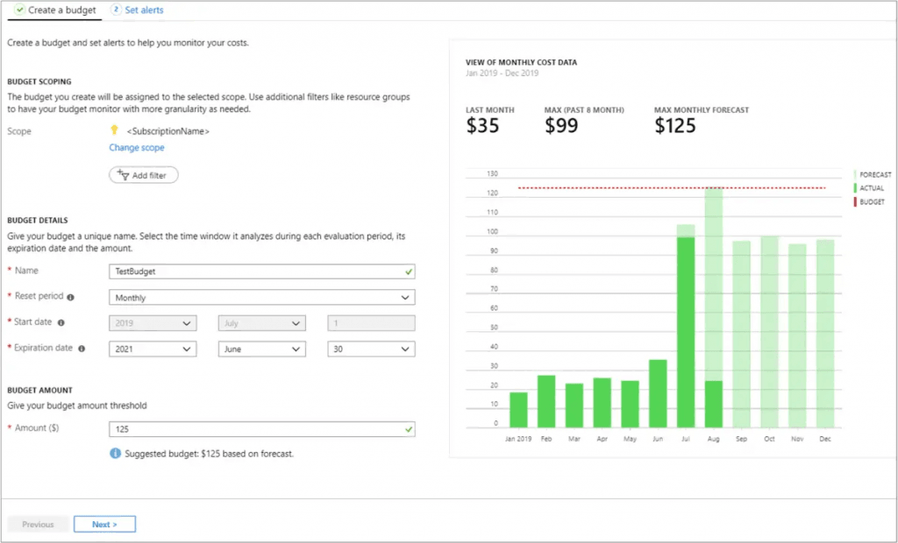
Source: Azure
Azure Pricing Calculator
•Azure Pricing Calculator is commonly used alongside Azure Cost Management, to evaluate pricing for different combinations of Azure services.
•This is valuable when deploying new workloads in Azure, or significantly expanding existing workloads.
•There are many ways to run a specific application or service in Azure, and different services, service tiers or options can have a major effect on costs. •You can use the Pricing Calculator to simulate costs for different configurations, and understand pricing for future use of Azure.

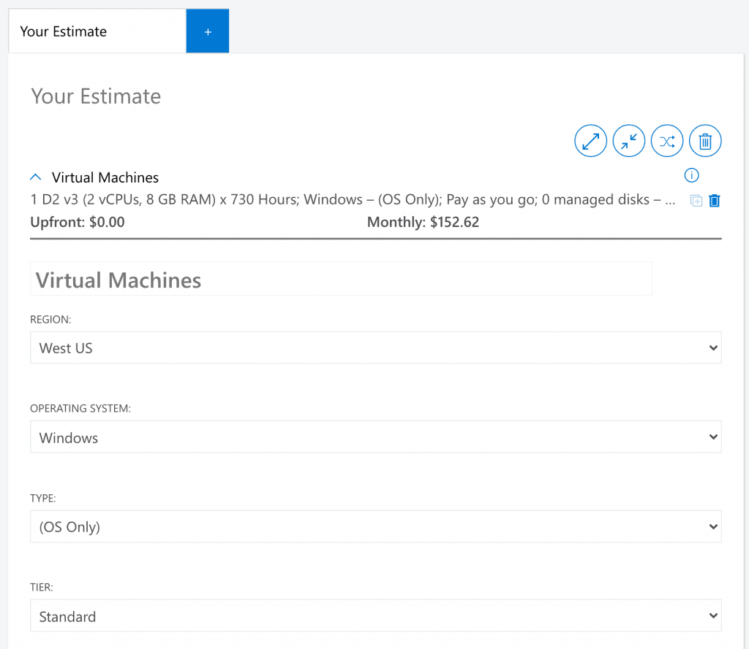
Azure Advisor
Azure Advisor is a service that can identify opportunities for cost savings on Azure, including:
•Underutilized virtual machines, especially in terms of CPU or network utilization. You can then decide whether to shut down or resize the VMs.
•Purchasing Reserved Instances (RIs) for VMs that have been running consistently for a long period of time.
•Removing unused network resources such as ExpressRoute circuits, virtual network gateways or public IPs.
•Optimize database use by right-sizing MariaDB, MySQL or PostgreSQL instances.
