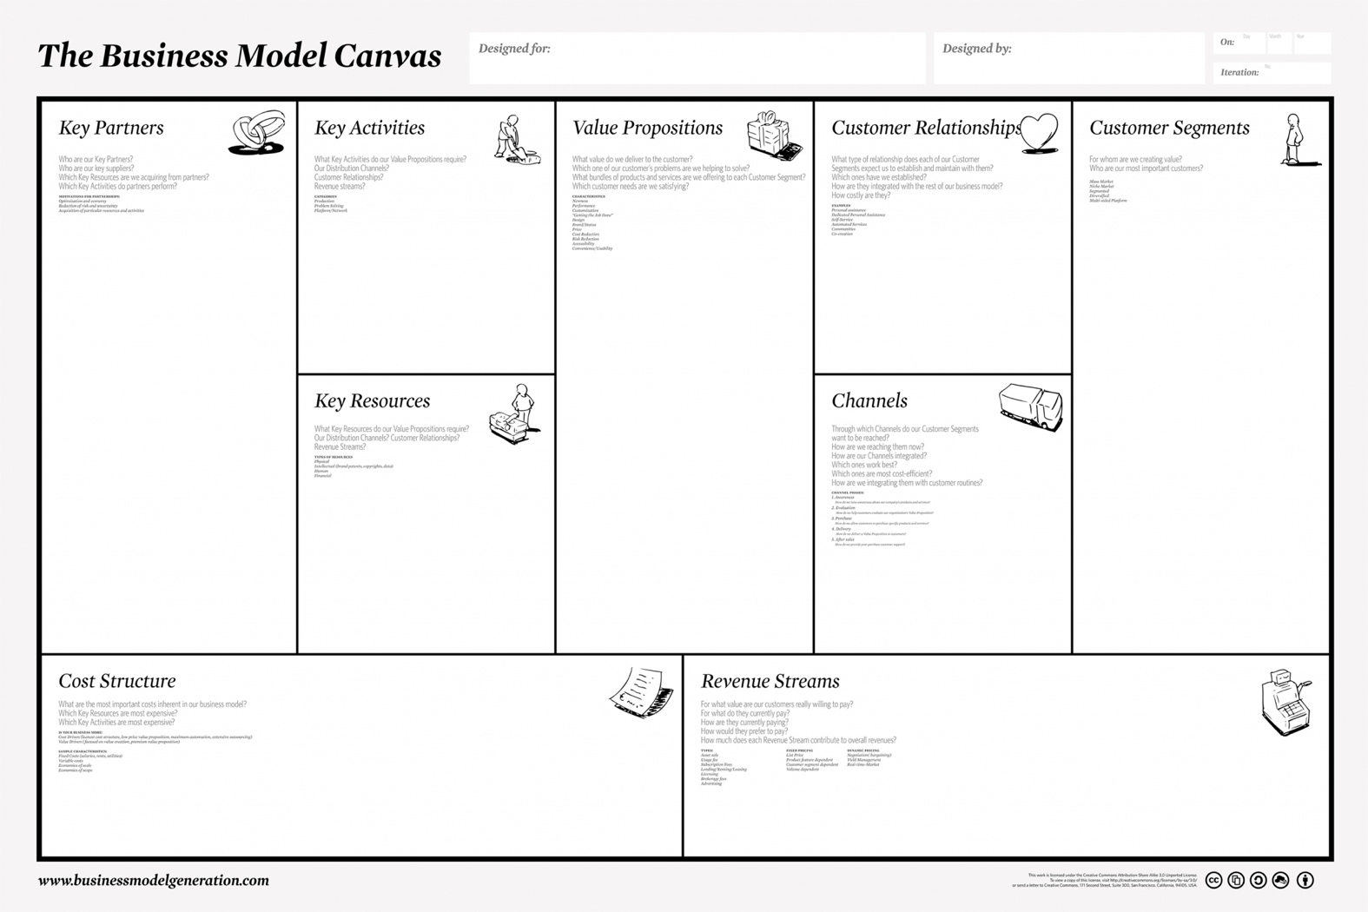

**The Business Model Canvas**



${tool_builder_customer_segments}

*Customer Segments*



*Value Propositions*

${tool_builder_value_proposition}



*Channels*

${tool_builder_channels}



${tool_builder_customer_relationship}

*Customer Relationships*



${tool_builder_revenue_model}

*Revenue Stream*



*Key Resources*

${tool_builder_key_resources}



*Key Activities*

${tool_builder_key_activities}



${tool_builder_key_partners}

*Key Partners*



*Cost Structure*

${tool_builder_cost_structure}