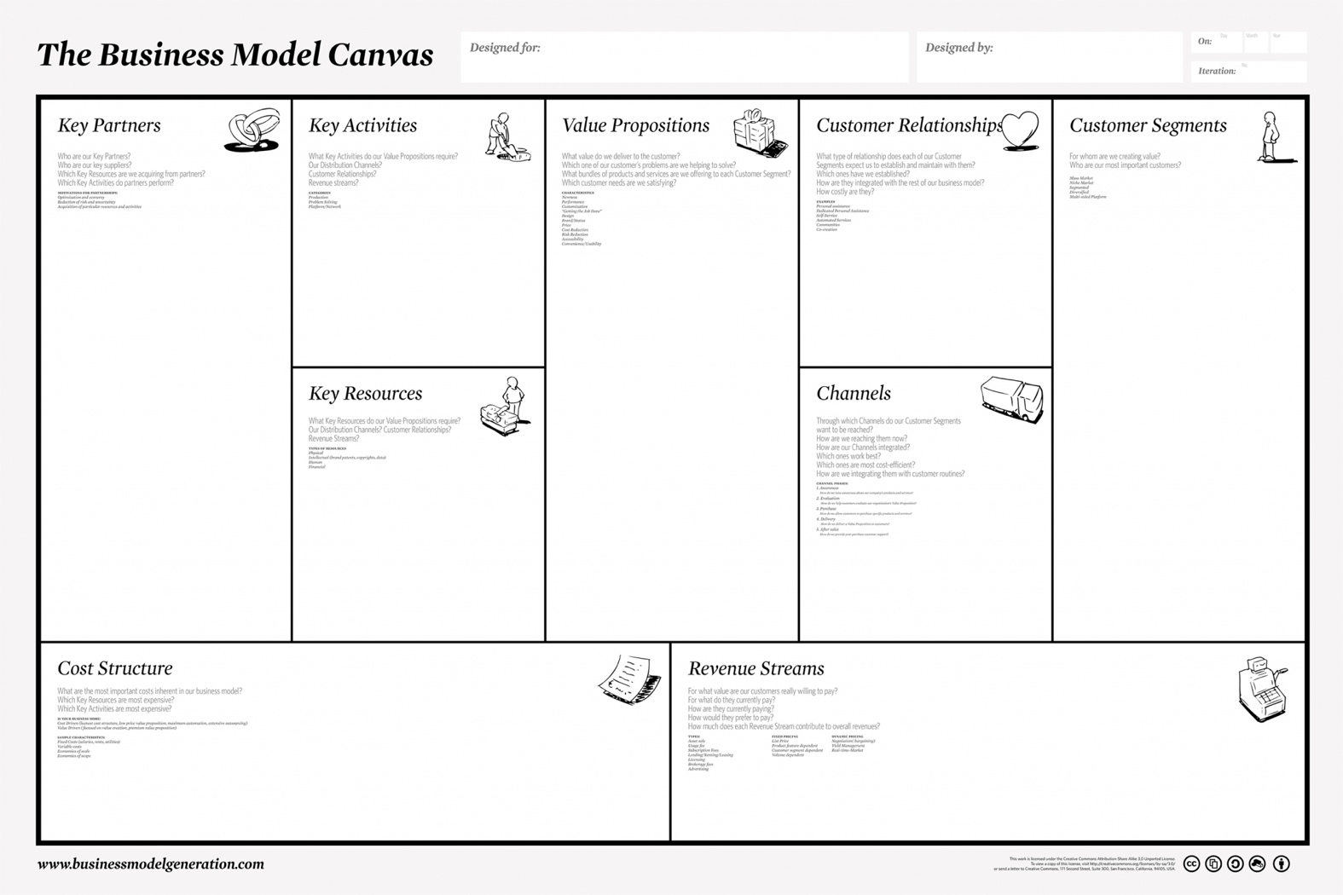

**The Business Model Canvas**



${tool_builder_customer_segments}

*Customer Segments*



${tool_builder_value_proposition}

*Value Propositions*



${tool_builder_channels}

*Channels*



${tool_builder_customer_relationship}

*Customer Relationships*



${tool_builder_revenue_model}

*Revenue Stream*



${tool_builder_key_resources}

*Key Resources*



${tool_builder_key_activities}

*Key Activities*



${tool_builder_key_partners}

*Key Partners*



${tool_builder_cost_structure}

*Cost Structure*