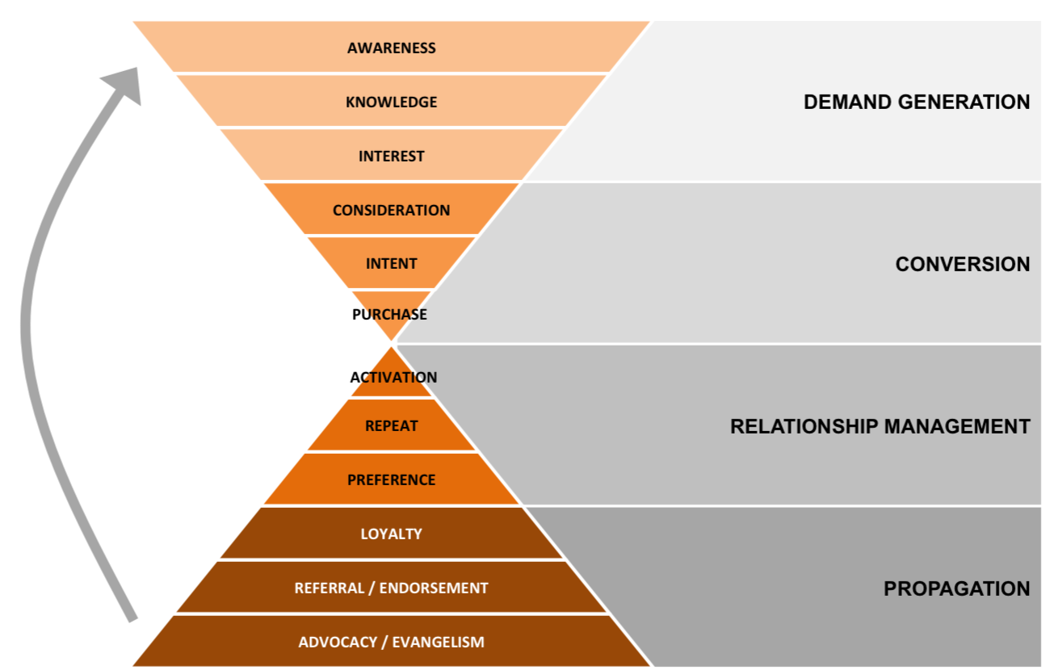

**Customer Journey**

*1. Awareness & Knowledge Phase*

*Demand Generation*



${tool_builder_cj_dg_awareness}

*2. Engagement Or Interest Phase*

*Demand Generation*



${tool_builder_cj_dg_engagement}

*3. Consideration, Evaluation Or Intent Phase*

*Conversion*



${tool_builder_cj_dg_consideration}

*4. Purchase Phase (mid way!)*

*Conversion*



${tool_builder_cj_dg_purchase}

*Relationship  
Management*

*5. Activation Phase*



${tool_builder_cj_dg_activation}

*6. Repeat Phase*

*Relationship  
Management*



${tool_builder_cj_dg_repeat}



*7. Loyalty Phase*

${tool_builder_cj_dg_loyalty}

*Propagation*

*8. Advocacy Phase*

*Propagation*



${tool_builder_cj_dg_advocacy}