

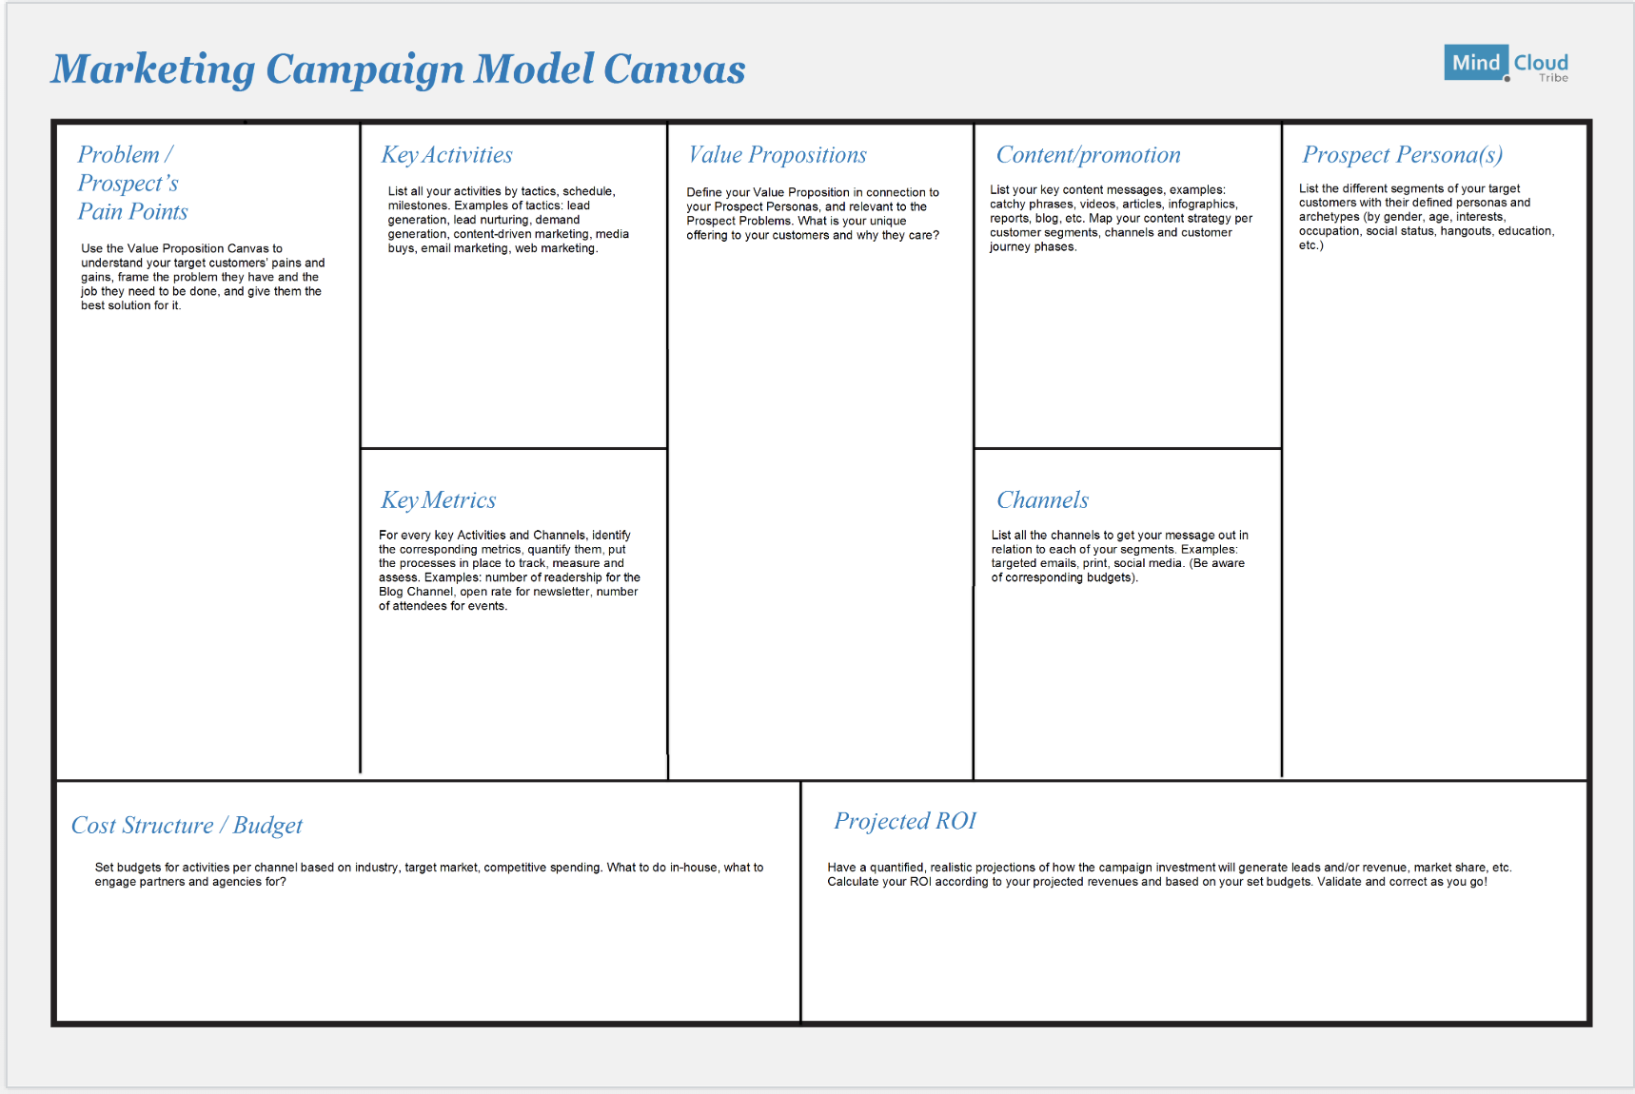

**Marketing Campaign Model Canvas**



${tool_builder_mc_mc_prospect_personas}

*Prospect Personas*



*Prospect Problems*

${tool_builder_mc_mc_prospect_problems}



*Value Proposition*

${tool_builder_mc_mc_value_proposition}



${tool_builder_mc_mc_channels}

*Channels*



${tool_builder_mc_mc_content}

*Content*



*Key Activities*

${tool_builder_mc_mc_key_activities}



*Key Metrics*

${tool_builder_mc_mc_key_metrics}



${tool_builder_mc_mc_kost_structure}

*Cost Structure*



*ROI*

${tool_builder_mc_mc_roi}