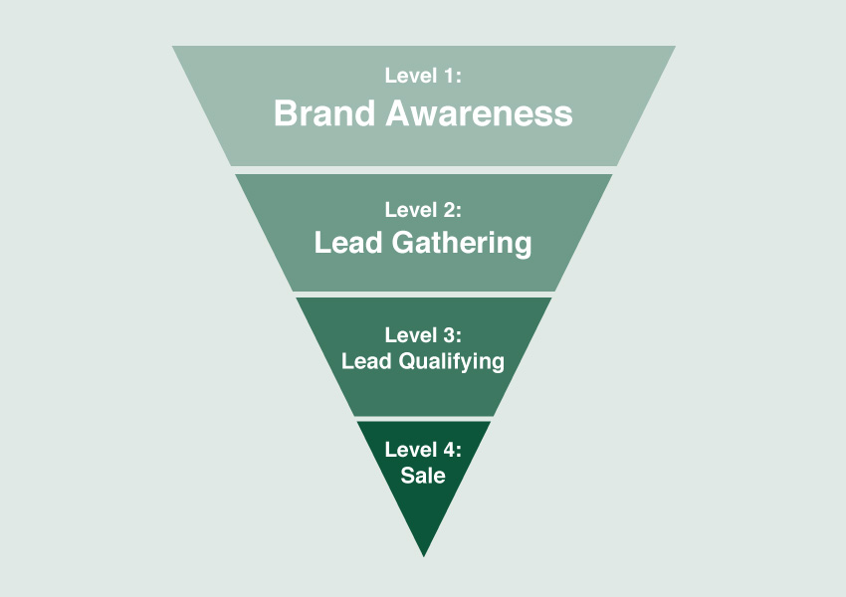

**Online Sales Funnel**

*Stage 1: Brand Awareness*

${tool_builder_osf_brand_awareness}



*Stage 2: Lead Gathering*

${tool_builder_osf_lead_gathering}



*Stage 3: Lead Qualifying*

${tool_builder_osf_lead_qualifying}



***Step 1*** *Optimize your Audience*

*Stage 4: Sale*



${tool_builder_osf_optimize_audience}

***Step 2*** *Optimize your User Experience*

*Stage 4: Sale*

${tool_builder_osf_optimize_experience}



***Step 3*** *Optimize your Metrics of Success*

*Stage 4: Sale*

${tool_builder_osf_optimize_Metrics}





${tool_builder_osf_optimize_testing}

*Stage 4: Sale*

***Step 4*** *Optimize your Testing!*