

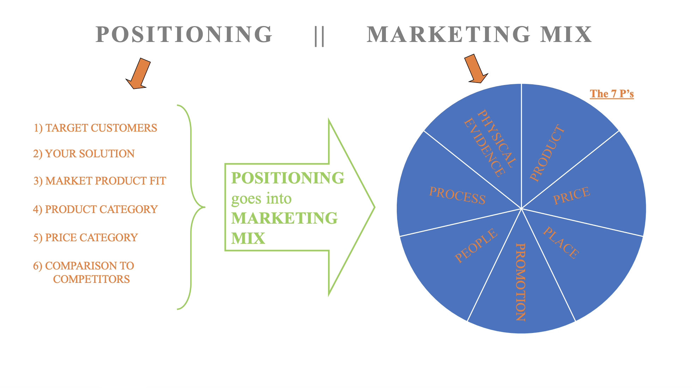

**Positioning & Marketing Mix**



*TARGET CUSTOMERS*

*Positioning*

${tool_builder_target_customers}



*YOUR SOLUTION*

*Positioning*

${tool_builder_offering}



*MARKET PRODUCT FIT*

${tool_builder_need}

*Positioning*



*PRODUCT CATEGORY*

*Positioning*

${tool_builder_product_category}



*PRICE CATEGORY*

*Positioning*

${tool_builder_price_category}



*COMPARISON TO COMPETITORS*

*Positioning*

${tool_builder_solution_competitors}



*PRODUCT OR SERVICE*

*Marketing Mix*

${tool_builder_product_or_service}



${tool_builder_pricing_strategies}

*Marketing Mix*

*PRICE*



${tool_builder_product_customer}

*Marketing Mix*

*PLACE*



*PROMOTIONAL CHANNELS*

*Marketing Mix*

${tool_builder_promotional_channels}



${tool_builder_people_for_team}

*Marketing Mix*

*PEOPLE*



${tool_builder_execution}

*Marketing Mix*

*PROCESSES*



${tool_builder_great_experience}

*Marketing Mix*

*PHYSICAL EVIDENCE*