

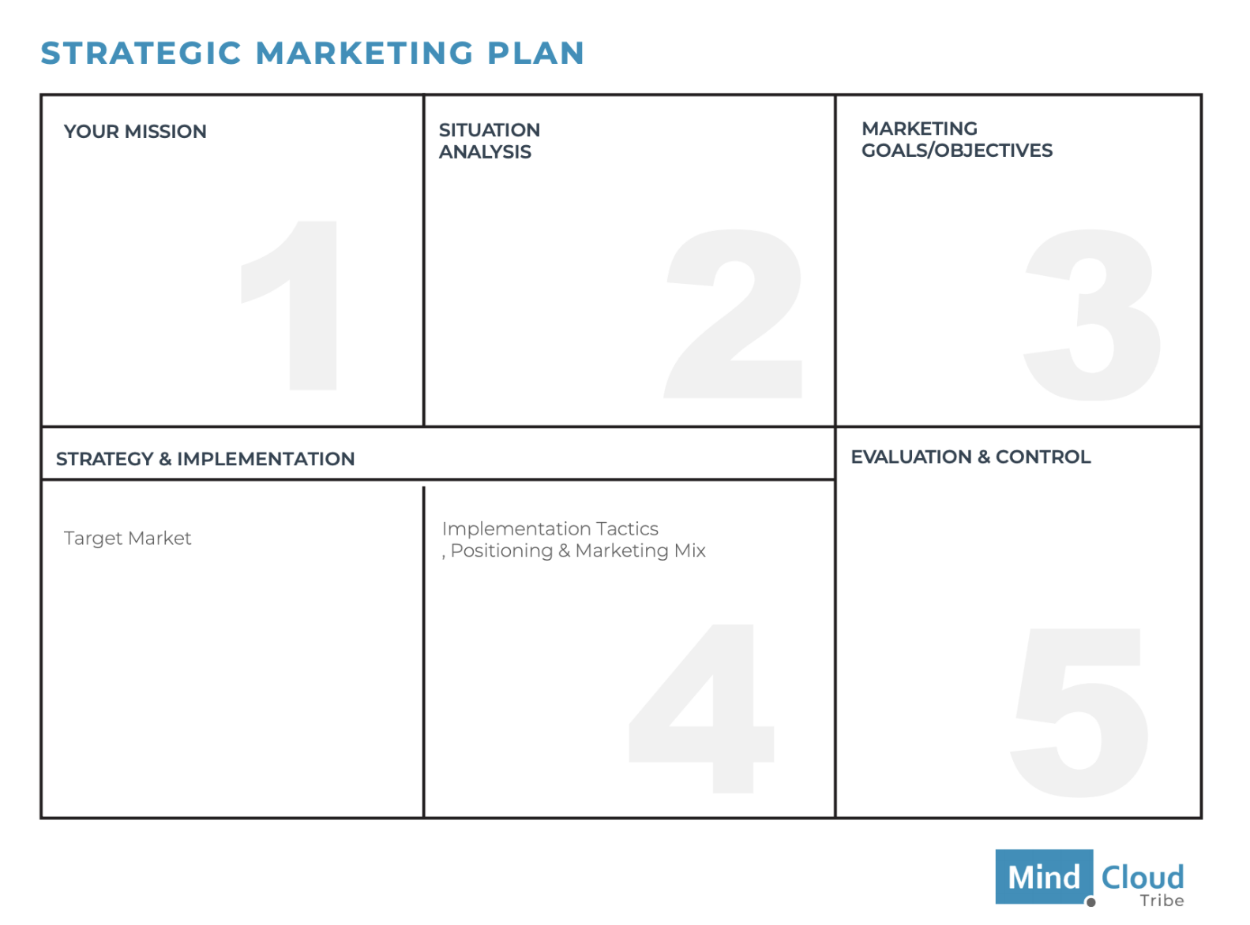

**Strategic Marketing Plan**



${tool_builder_strg_mkt_mission}

*YOUR MISSION*



*SITUATION ANALYSIS*

${tool_builder_strg_mkt_situational_analysis}



*MARKETING GOALS /  
OBJECTIVES*

${tool_builder_strg_mkt_objectives}



*Target Market*

${tool_builder_strg_mkt_target_market}



*Implementation Tactics, Positioning & Marketing Mix*

${tool_builder_strg_mkt_implementation_tactics}



*EVALUATION & CONTROL*

${tool_builder_strg_mkt_evaluation}