

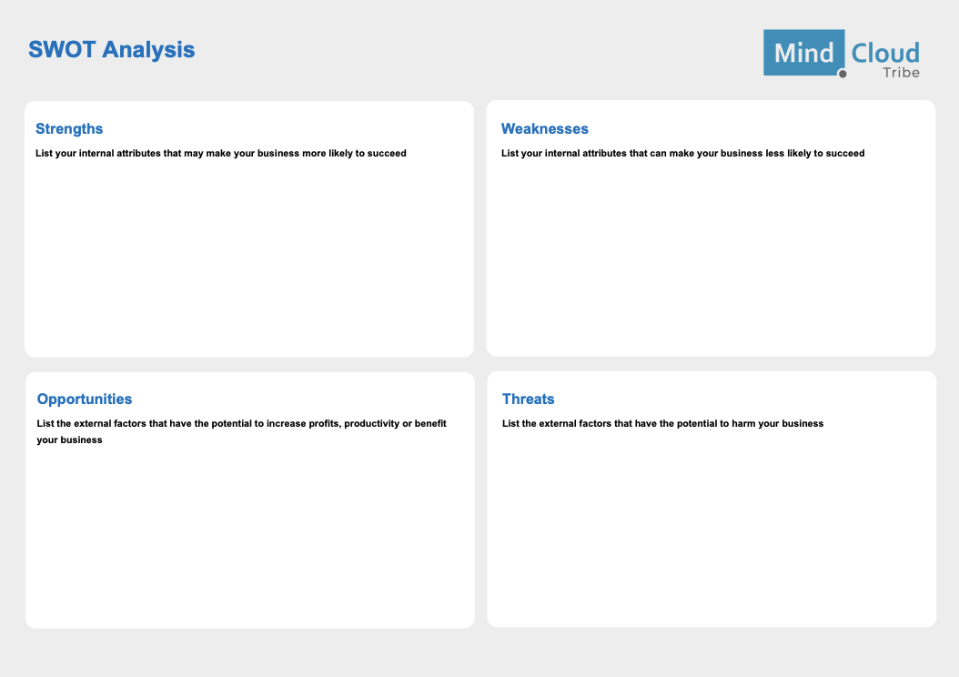

**The SWOT Analysis**



*Strengths*

${tool_builder_strengths}



*Weaknesses*

${tool_builder_weaknessess}



*Opportunities*

${tool_builder_opportunities}



*Threats*

${tool_builder_threats}