# ======JSP======

### ----------------------------------------------Introduction to JSP----------------------------------------------

**JSP** technology is used to create dynamic web applications. **JSP** pages are easier to maintain then a **Servlet**. JSP pages are opposite of Servlets as a servlet adds HTML code inside Java code, while JSP adds Java code inside HTML using JSP tags. Everything a Servlet can do, a JSP page can also do it.

JSP enables us to write HTML pages containing tags, inside which we can include powerful Java programs. **Using JSP, one can easily separate Presentation and Business logic** as a web designer can design and update JSP pages creating the presentation layer and java developer can write server side complex computational code without concerning the web design. And both the layers can easily interact over HTTP requests.

#### In the end a JSP becomes a Servlet

**JSP** pages are converted into **Servlet** by the Web Container. The Container translates a JSP page into servlet **class source(.java)** file and then compiles into a Java Servlet class.

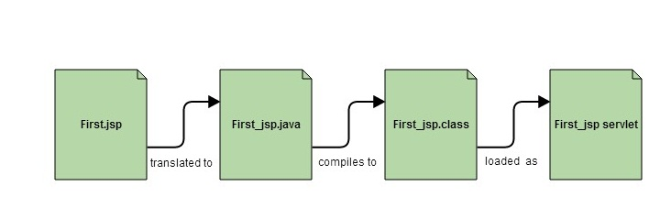

#### Why JSP is preffered over servlets?

* JSP provides an easier way to code dynamic web pages.
* JSP does not require additional files like, java class files, web.xml etc
* Any change in the JSP code is handled by Web Container(Application server like tomcat), and doesn't require re-compilation.
* JSP pages can be directly accessed, and web.xml mapping is not required like in servlets.

#### Advantage of JSP

* Easy to maintain and code.
* High Performance and Scalability.
* JSP is built on Java technology, so it is platform independent.

### ----------------------------------------------Lifecycle of JSP----------------------------------------------

A JSP page is converted into Servlet in order to service requests. The translation of a JSP page to a Servlet is called Lifecycle of JSP. JSP Lifecycle is exactly same as the Servlet Lifecycle, with one additional first step, which is, translation of JSP code to Servlet code. Following are the JSP Lifecycle steps:

1. Translation of JSP to Servlet code.
2. Compilation of Servlet to bytecode.
3. Loading Servlet class.
4. Creating servlet instance.
5. Initialization by calling jspInit() method
6. Request Processing by calling _jspService() method
7. Destroying by calling jspDestroy() method

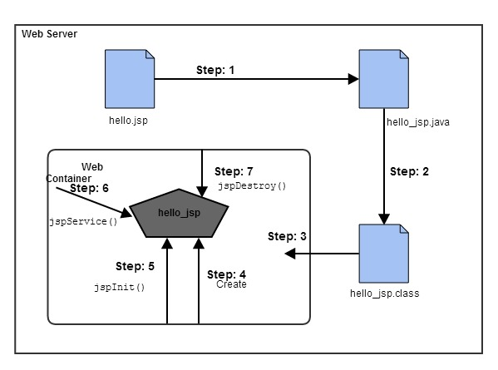

**Web Container** translates JSP code into a **servlet class source(.java) file**, then compiles that into a java servlet class. In the third step, the servlet class bytecode is loaded using classloader. The Container then creates an instance of that servlet class.

The initialized servlet can now service request. For each request the **Web Container** call the **_jspService()** method. When the Container removes the servlet instance from service, it calls the **jspDestroy()** method to perform any required clean up.

#### What happens to a JSP when it is translated into Servlet

Let's see what really happens to JSP code when it is translated into Servlet. The code written inside <% %> is JSP code.

<html>

<head>

<title>My First JSP Page</title>

</head>

**<%**

**int count = 0;**

**%>**

<body>

Page Count is:

**<% out.println(++count); %>**

</body>

</html>

The above JSP page(hello.jsp) becomes this Servlet

public class **hello_jsp** extends HttpServlet

{

public void _jspService(*HttpServletRequest* request, *HttpServletResponse* response)

throws IOException,ServletException

{

PrintWriter out = response.getWriter();

response.setContenType("text/html");

out.write("<html><body>");

int count=0;

out.write("Page count is:");

out.print(++count);

out.write("</body></html>");

}

}

This is just to explain, what happens internally. As a JSP developer, you do not have to worry about how a JSP page is converted to a Servlet, as it is done automatically by the web container.

======JSP Scripting Element======

### ----------------------------------------------JSP Scripting Element----------------------------------------------

JSP Scripting element are written inside <% %> tags. These code inside <% %> tags are processed by the JSP engine during translation of the JSP page. Any other text in the JSP page is considered as HTML code or plain text.

**Example:**

<html>

<head>

<title>My First JSP Page</title>

</head>

**<%**

**int count = 0;**

**%>**

<body>

Page Count is **<% out.println(++count); %>**

</body>

Just to experiment, try removing the <% %> scriplet tag from the above code and run it as JSP. You will see that everything is printed as it is on the browser, because without the scriplet tag, everything is considered plain HTML code.

#### There are five different types of scripting elements

|  |  |
| --- | --- |
| **Scripting Element** | **Example** |
| **Comment** | <%-- comment --%> |
| **Directive** | <%@ directive %> |
| **Declaration** | <%! declarations %> |
| **Scriptlet** | <% scriplets %> |
| **Expression** | <%= expression %> |

#### JSP Comment

JSP Comment is used when you are creating a JSP page and want to put in comments about what you are doing. JSP comments are only seen in the JSP page. These comments are not included in servlet source code during translation phase, nor they appear in the HTTP response. Syntax of JSP comment is as follows :

<%-- JSP comment --%>

**Simple Example of JSP Comment**

<html>

<head>

<title>My First JSP Page</title>

</head>

**<%**

**int count = 0;**

**%>**

<body>

*<%-- Code to show page count --%>*

Page Count is **<% out.println(++count); %>**

</body>

**NOTE :** Adding comments in your code is considered to be a good practice in Programming world.

### ----------------------------------------------Scriptlet Tag----------------------------------------------

Scriptlet Tag allows you to write java code inside JSP page. Scriptlet tag implements the _jspService method functionality by writing script/java code. Syntax of Scriptlet Tag is as follows :

<% *java code* %>

#### Example of Scriptlet

In this example, we will show number of page visit.

<html>

<head>

<title>My First JSP Page</title>

</head>

**<%**

**int count = 0;**

**%>**

<body>

Page Count is **<% out.println(++count); %>**

</body>

</html>

We have been using the above example since last few lessons and in this scriptlet tags are used. Everything written inside the scriptlet tag is compiled as java code. Like in the above example, we initialize count variable of type int with a value of 0. And then we print it while using ++ operator to perform addition on it.

JSP makes it so easy to perform calculations, database interactions etc directly from inside the HTML code. Just write your java code inside the scriptlet tags.

#### Example of JSP Scriptlet Tag

In this example, we will create a simple JSP page which retrieves the name of the user from the request parameter. The **index.html** page will get the username from the user.

**index.html**

<form method="**POST**" action="**welcome.jsp**">

Name <input type="text" name="*user*" >

<input type="submit" value="Submit">

</form>

In the above HTML file, we have created a form, with an input text field for user to enter his/her name, and a Submit button to submit the form. On submission an HTTP Post request ( method="**POST**" ) is made to the welcome.jsp file ( action="**welcome.jsp**" ), with the form values.

**welcome.jsp**

<html>

<head>

<meta http-equiv="Content-Type" content="text/html; charset=UTF-8">

<title>Welcome Page</title>

</head>

**<%**

**String user = request.getParameter("user");**

**%>**

<body>

Hello, **<% out.println(user); %>**

</body>

</html>

As we know that a JSP code is translated to Servlet code, in which _jspService method is executed which has **HttpServletRequest** and **HttpServletResponse** as argument. So in the **welcome.jsp** file, **request** is the HTTP Request and it has all the parameters sent from the form in index.html page, which we can be easily get using getParameter() with name of parameter as argument, to get its value.

#### Mixing scriptlet Tag and HTML

Let's see how we can utilize the power of JSP scripting with HTML to build dynamic webpages with help of a few examples.

If we want to create a Table in HTML with some dynamic data, for example by reading data from some MySQL table or file. How to do that? Here we will describe you the technique by creating a table with numbers 1 to n.

<table border = 1>

**<%**

for ( int i = 0; i < n; i++ ) {

**%>**

<tr>

<td>Number</td>

<td><%= i+1 %></td>

</tr>

**<%**

}

**%>**

</table>

The above piece of code will go inside the <body> tag of the JSP file and will work when you initialize n with some value.

Also, observer closely we have only included the java code inside the scriptlet tag, and all the HTML part is outside of it. Similarly we can do plenty of stuff.

Here is one more very simple example :

**<%**

if ( hello ) {

**%>**

<p>Hello, world</p>

**<%**

} else {

**%>**

<p>Goodbye, world</p>

**<%**

}

**%>**

Above code is using if-else condition to evaluate what to show, based on the value of a **boolean** variable named hello.

You can even ask user to enter the value of hello, using HTML Form and evaluate your JSP code based on that.

### ----------------------------------------------Declaration Tag----------------------------------------------

We know that at the end a JSP page is translated into Servlet class. So when we declare a variable or method in JSP inside **Declaration Tag**, it means the declaration is made inside the Servlet class but outside the service(or any other) method. You can declare static member, instance variable and methods inside **Declaration Tag**. Syntax of Declaration Tag :

<%! *declaration* %>

#### Example of Declaration Tag

<html>

<head>

<title>My First JSP Page</title>

</head>

**<%!**

**int count = 0;**

**%>**

<body>

Page Count is:

**<% out.println(++count); %>**

</body>

</html>

In the above code, we have used the declaration tag to declare variable count. The above JSP page becomes this Servlet :

public class hello_jsp extends HttpServlet

{

**int count=0;**

public void **_jspService**(HttpServletRequest request, HttpServletResponse response)

throws IOException,ServletException

{

PrintWriter out = response.getWriter();

response.setContenType("text/html");

out.write("<html><body>");

out.write("Page count is:");

out.print(++count);

out.write("</body></html>");

}

}

In the above servlet, we can see that variable count is declared outside the _jspservice() method. If we declare the same variable using scriptlet tag, it will come inside the service method, as seen in the last lesson.

#### When to use Declaration tag and not scriptlet tag

If you want to include any method in your JSP file, then you must use the declaration tag, because during translation phase of JSP, methods and variables inside the declaration tag, becomes instance methods and instance variables and are also assigned default values.

For example :

<html>

<head>

<title>My First JSP Page</title>

</head>

**<%!**

int *count* = 0;

int **getCount**() {

System.out.println( "In getCount() method" );

return count;

}

**%>**

<body>

Page Count is:

**<%** out.println(**getCount()**); **%>**

</body>

</html>

Above code will be translated into following servlet :

public class hello_jsp extends HttpServlet

{

**int count = 0;**

int **getCount**() {

System.out.println( "In getCount() method" );

return count;

}

public void **_jspService**(HttpServletRequest request, HttpServletResponse response)

throws IOException,ServletException

{

PrintWriter out = response.getWriter();

response.setContenType("text/html");

out.write("<html><body>");

out.write("Page count is:");

out.print(*getCount()*);

out.write("</body></html>");

}

}

While, anything we add in scriptlet tag, goes inside the _jspservice() method, therefore we cannot add any function inside the scriptlet tag, as on compilation it will try to create a function getCount() inside the service method, and in Java, method inside a method is not allowed.

### ----------------------------------------------Directive Tag----------------------------------------------

**Directive Tag** gives special instruction to Web Container at the time of page translation. Directive tags are of three types: **page**, **include** and **taglib**.

|  |  |
| --- | --- |
| **Directive** | **Description** |
| <%@ page ... %> | defines page dependent properties such as language, session, errorPage etc. |
| <%@ include ... %> | defines file to be included. |
| <%@ taglib ... %> | declares tag library used in the page |

We'll discuss about **include** and **taglib** directive later. You can place page directive anywhere in the JSP file, but it is good practice to make it as the first statement of the JSP page.

The **Page directive** defines a number of page dependent properties which communicates with the Web Container at the time of translation. Basic syntax of using the page directive is <%@ page attribute="value" %> where attributes can be one of the following :

* *import* attribute
* *language* attribute
* *extends* attribute
* *session* attribute
* *isThreadSafe* attribute
* *isErrorPage* attribute
* *errorPage* attribute
* *contentType* attribute
* *autoFlush* attribute
* *buffer* attribute

#### import attribute

The import attribute defines the set of classes and packages that must be imported in servlet class definition. For example

<%@ page import="java.util.Date" %>

or

<%@ page import="java.util.Date,java.net.*" %>

#### language attribute

language attribute defines scripting language to be used in the page.

#### extends attribute

extends attribute defines the class name of the superclass of the servlet class that is generated from the JSP page.

#### session attribute

session attribute defines whether the JSP page is participating in an HTTP session. The value is either true or false.

#### isThreadSafe attribute

isThreadSafe attribute declares whether the JSP is thread-safe. The value is either true or false

#### isErrorPage attribute

isErrorPage attribute declares whether the current JSP Page represents another JSP's error page.

#### errorPage attribute

errorPage attribute indicates another JSP page that will handle all the run time exceptions thrown by current JSP page. It specifies the URL path of another page to which a request is to be dispatched to handle run time exceptions thrown by current JSP page.

#### contentType attribute

contentType attribute defines the MIME type for the JSP response.

#### autoFlush attribute

autoFlush attribute defines whether the buffered output is flushed automatically. The default value is "true".

#### buffer attribute

buffer attribute defines how buffering is handled by the implicit **out** object.

### ----------------------------------------------Expression Tag----------------------------------------------

Expression Tag is used to print out java language expression that is put between the tags. An expression tag can hold any java language expression that can be used as an argument to the **out.print()** method. Syntax of Expression Tag

<%= *JavaExpression* %>

**When the Container sees this**

<%= (2*5) %>

**It turns it into this:**

out.print((2*5));

**Note:** Never end an expression with semicolon inside Expression Tag. Like this:

<%= (2*5); %>

#### Example of Expression Tag

<html>

<head>

<title>My First JSP Page</title>

</head>

**<%**

**int count = 0;**

**%>**

<body>

Page Count is **<%= ++count %>**

</body>

## ======JSP Implicit Object======

### ----------------------------------------------Implicit Objects in JSP----------------------------------------------

JSP provide access to some implicit object which represent some commonly used objects for servlets that JSP page developers might need to use. For example you can retrieve HTML form parameter data by using **request** variable, which represent the **HttpServletRequest** object.

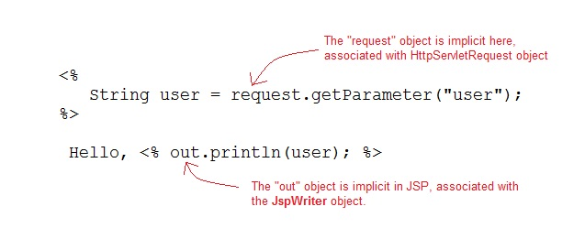

#### Following are the JSP implicit object

|  |  |
| --- | --- |
| **Implicit Object** | **Description** |
| **request** | The **HttpServletRequest** object associated with the request. |
| **response** | The **HttpServletRequest** object associated with the response that is sent back to the browser. |
| **out** | The **JspWriter** object associated with the output stream of the response. |
| **session** | The **HttpSession** object associated with the session for the given user of request. |
| **application** | The **ServletContext** object for the web application. |
| **config** | The **ServletConfig** object associated with the servlet for current JSP page. |
| **pageContext** | The **PageContext** object that encapsulates the enviroment of a single request for this current JSP page |
| **page** | The **page** variable is equivalent to **this** variable of Java programming language. |
| **exception** | The **exception** object represents the **Throwable** object that was thrown by some other JSP page. |

All of them are very useful and you will slowly get to know all of them as you will move ahead into your career working on live projects. For example: When you will create an application where in User sessions have to be created session will come into picture, request is used when you have form submissions in your application etc.

We will learn about these in details later on.

# ======JSP Directive Element======

### ----------------------------------------------Include Directive----------------------------------------------

The *include* directive tells the Web Container to copy everything in the included file and paste it into current JSP file. Syntax of **include** directive is:

<%@ **include** file="filename.jsp" %>

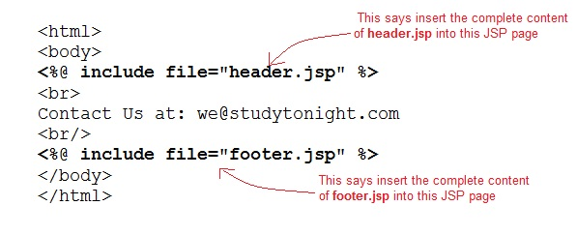

#### Example of include directive

**welcome.jsp**

<html>

<head>

<title>Welcome Page</title>

</head>

<body>

**<%@ include file="header.jsp" %>**

Welcome, User

</body>

</html>

**header.jsp**

<html>

<body>

<img src="header.jpg" alt="This is Header image" / >

</body>

</html>

The example above is showcasing a very standard practice. Whenever we are building a web application, with webpages, all of which have the top navbar and bottom footer same. We make them as separate jsp files and include them using the include directive in all the pages. Hence whenever we have to update something in the top navbar or footer, we just have to do it at one place. Handy, isn't it?

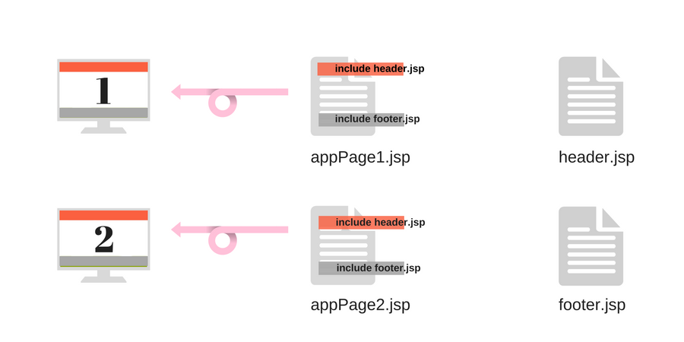

One more standard application of include directive is, if you create a separate jsp file, with some commonly used functions, kind of like a util jsp file. Which can be included in the web pages wherever you want to use those functions. 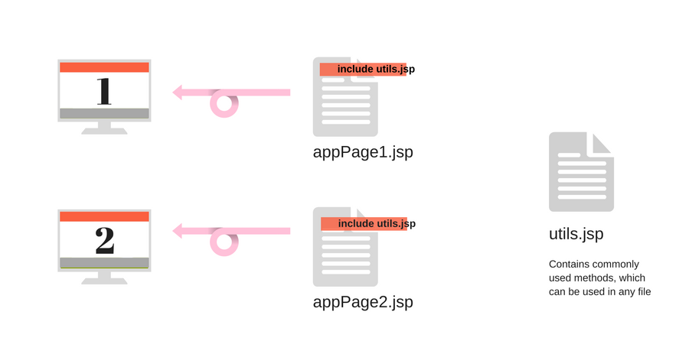

Similarly, there are many ways in which this directive proves to be quite useful in giving a structure to your web application code.

### ----------------------------------------------Taglib Directive----------------------------------------------

The **taglib** directive is used to define tag library that the current JSP page uses. A JSP page might include several tag library. JavaServer Pages Standard Tag Library (JSTL), is a collection of useful JSP tags, which provides mahy commonly used core functionalities. It has support for many general, structural tasks such as iteration and conditionals, readymade tags for manipulating XML documents, internationalization tags, and for performing SQL operations. Syntax of taglib directive is:

<%@ *taglib* **prefix**="prefixOfTag" **uri**="uriOfTagLibrary" %>

The prefix is used to distinguish the custom tag from other libary custom tag. Prefix is prepended to the custom tag name. Every custom tag must have a prefix.

The URI is the unique name for Tag Library.

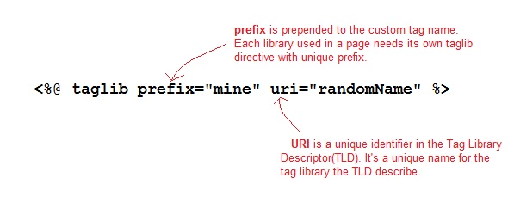

You can name the prefix anything, but it should be unique.

#### Using Taglib Directive

To use the JSTL in your application you must have the jstl.jar in your webapps /WEB-INF/lib directory. Download the jar file from

page.

There are many readymade JST Libraries available which you use to make your life easier. Following is a broad division on dufferent groups of JST libraries :

1. **Core Tags** - URI → *http://java.sun.com/jsp/jstl/core*
2. **Formatting Tags** - URI → *http://java.sun.com/jsp/jstl/fmt*
3. **SQL Tags** - URI → *http://java.sun.com/jsp/jstl/sql*
4. **XML Tags** - URI → *http://java.sun.com/jsp/jstl/xml*
5. **JSTL Functions** - URI → *http://java.sun.com/jsp/jstl/functions*

# ======JSP Exception Handling======

### ----------------------------------------------Exception Handling----------------------------------------------

Exception Handling is a process of handling exceptional condition that might occur in your application. Exception Handling in JSP is much easier than Java Technology exception handling. Although JSP Technology also uses the same exception class objects.

It is quite obvious that you dont want to show error stack trace to any random user surfing your website. You can't prevent all errors in your application but you can atleast give a user friendly error response page.

#### Ways to perform Exception Handling in JSP

JSP provide 3 different ways to perform exception handling:

1. Using **isErrorPage** and **errorPage** attribute of page directive.
2. Using **<error-page>** tag in **Deployment Descriptor**.
3. Using simple try...catch block.

#### Example of isErrorPage and errorPage attribute

isErrorPage attribute in page directive officially appoints a JSP page as an error page.

**error.jsp**

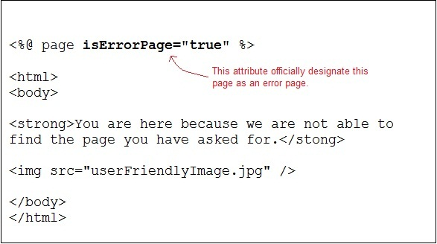

errorPage attribute in a page directive informs the Web Container that if an exception occurs in the current page, forward the request to the specified error page.

**sum.jsp**

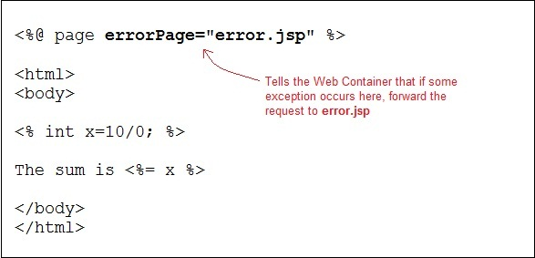

Whenever an exception occurs in sum.jsp page the user is redirected to the error.jsp page, where either you can display a nice message, or you can also print the exception trace into a file/database in the background, to check later what caused the error.

#### Declaring error page in Deployment Descriptor

You can also declare error pages in the DD for the entire Web Apllication. Using <error-page> tag in the **Deployment Descriptor**. You can even configure different error pages for different exception types, or HTTP error code type(503, 500 etc).

**Declaring an error page for all type of exception**

<error-page>

<exception-type>**java.lang.Throwable**</exception-type>

<location>**/error.jsp**</location>

</error-page>

**Declaring an error page for more detailed exception**

<error-page>

<exception-type>**java.lang.ArithmeticException**</exception-type>

<location>**/error.jsp**</location>

</error-page>

**Declaring an error page based on HTTP Status code**

<error-page>

<error-code>404</error-code>

<location>**/error.jsp**</location>

</error-page>

#### Using the try...catch block

Using try...catch block is just like how it is used in Core Java.

<html>

<head>

<title>Try...Catch Example</title>

</head>

<body>

**<%**

**try**{

int i = 100;

i = i / 0;

out.println("The answer is " + i);

}

**catch** (Exception *e*){

out.println("An exception occurred: " + *e*.**getMessage()**);

}

**%>**

</body>

</html>

# ======JSP Standard Tag======

### ----------------------------------------------Standard Tag(Action Element) ----------------------------------------------

JSP specification provides **Standard**(Action) tags for use within your JSP pages. These tags are used to remove or eliminate scriptlet code from your JSP page because scriplet code are technically not recommended nowadays. It's considered to be bad practice to put java code directly inside your JSP page.

Standard tags begin with the jsp: prefix. There are many JSP Standard Action tag which are used to perform some specific task.

The following are some JSP Standard Action Tags available:

|  |  |
| --- | --- |
| **Action Tag** | **Description** |
| jsp:forward | forward the request to a new page  Usage : <jsp:forward page="Relative URL" /> |
| jsp:useBean | instantiates a JavaBean  Usage : <jsp:useBean id="beanId" /> |
| jsp:getProperty | retrieves a property from a JavaBean instance.  Usage :  <jsp:useBean id="beanId" ... />  ...  <jsp:getProperty name="beanId" property="someProperty" .../>  Where, **beanName** is the name of pre-defined bean whose property we want to access. |
| jsp:setProperty | store data in property of any JavaBeans instance.  Usage :  <jsp:useBean id="beanId" ... />  ...  <jsp:setProperty name="beanId" property="someProperty" value="some value"/>  Where, **beanName** is the name of pre-defined bean whose property we want to access. |
| jsp:include | includes the runtime response of a JSP page into the current page. |
| jsp:plugin | Generates client browser-specific construct that makes an OBJECT or EMBED tag for the Java Applets |
| jsp:fallback | Supplies alternate text if java plugin is unavailable on the client. You can print a message using this, if the included jsp plugin is not loaded. |
| jsp:element | Defines XML elements dynamically |
| jsp:attribute | defines dynamically defined XML element's attribute |
| jsp:body | Used within standard or custom tags to supply the tag body. |
| jsp:param | Adds parameters to the request object. |
| jsp:text | Used to write template text in JSP pages and documents.  Usage : <jsp:text>Template data</jsp:text> |

### ----------------------------------------------JavaBean Components----------------------------------------------

A JavaBeans component is a Java class with the following features:

* A no-argument constructor.
* Properties defined with accessors and mutators(getter and setter method).
* Class must not define any public instance variables.
* The class must implement the **java.io.Serializable** interface.

#### Example of a JavaBean

**import** *java.io.Serializable*;

public class **StudentBean** implements **Serializable**

{

private String **name**;

private int **roll**;

public *StudentBean*()

{

this.name="";

this.roll="";

}

public void *setName*(String name)

{

this.name = name;

}

public String *getName*()

{

return name;

}

public int *getRoll*()

{

return roll;

}

public void *setRoll*(int roll)

{

this.roll = roll;

}

}

#### Using a JavaBean in JSP page

JavaBeans can be used in any JSP page using the <jsp:useBean> tag, For example:

<**jsp:useBean** id="bean name" scope="fully qualified path of bean" typeSpec/>

#### Using any JavaBean property in JSP page

JavaBeans can be used in any JSP page using the <jsp:useBean> tag, <jsp:setProperty> tag and <jsp:getProperty> tag , For example:

<**jsp:useBean** id="id" class="bean class name" scope="fully qualified path of bean">

<**jsp:setProperty** name="beans id" property="property name" value="value"/>

<**jsp:getProperty** name="beans id" property="property name"/>

...........

</**jsp:useBean**>

### ----------------------------------------------jsp:useBean Tag----------------------------------------------

If you want to interact with a JavaBeans component using the Action tag in a JSP page, you must first declare a bean. The <jsp:useBean> is a way of declaring and initializing the actual bean object. By **bean** we mean JavaBean component object. Syntax of **<jsp:useBean>** tag

<jsp:useBean id = "beanName" class = "className"

scope = "page | request | session | application">

Here the **id** attribute specifies the name of the bean. **Scope** attribute specify where the bean is stored. The **class** attribute specify the fully qualified classname.

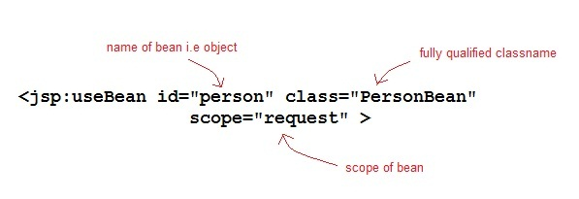

Given a useBean declaration of following :

<jsp:useBean id="myBean" class="PersonBean" scope="request" />

is equivalent to the following java code,

**PersonBean** myBean = (**PersonBean**)request.getAttribute("myBean");

if(myBean == null)

{

myBean = new **PersonBean**();

request.setAttribute("*myBean*", **myBean**);

}

If **jsp:useBean** tag is used with a body, the content of the body is only executed if the bean is created. If the bean already exists in the named scope, the body is skipped.

#### Example

In this example we will see how <jsp:useBean> standard tag is used to declare and initialize a bean object. We will use PersonBean class as JavaBean Component.

**PersonBean.java**

**import** *java.io.Serializable*;

public class **PersonBean** implements **Serializable**

{

private String **name**;

public *PersonBean*()

{

this.name="";

}

public void *setName*(String name)

{

this.name = name;

}

public String *getName*()

{

return name;

}

}

**hello.jsp**

<html>

<head>

<title>Welcome Page</title>

</head>

<**jsp:useBean** id="person" class="PersonBean" scope="request" />

<body>

*//Use the bean here...*

</body>

</html>

Here **jsp:useBean** declares a "person" bean in the jsp page which can be used there. How to use it, modify it, we will study in coming lessons.

### ----------------------------------------------jsp:getProperty Tag----------------------------------------------

The getProperty tag is used to retrieve a property from a JavaBeans instance. The syntax of the **getProperty** tag is as follows:

<**jsp:getProperty** name="beanName" property="propertyName" />

The name attribute represents the name of the JavaBean instance. The property attribute represents the property of the JavaBean whose value we want to get.

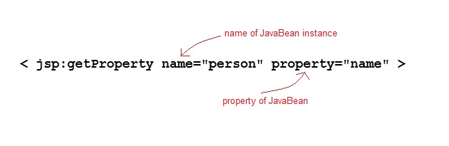

#### Example of getProperty with Java Bean

Following is our Java class.

**PersonBean.java**

**import** *java.io.Serializable*;

public class **PersonBean** implements **Serializable**

{

private String **name**;

public *PersonBean*()

{

this.name="";

}

public void *setName*(String name)

{

this.name = name;

}

public String *getName*()

{

return name;

}

}

**hello.jsp**

<html>

<head>

<title>Welcome Page</title>

</head>

<**jsp:useBean** id="person" class="PersonBean" scope="request" />

<body>

Name of Person is : <**jsp:getProperty** name="person" property="name" />

</body>

</html>

This will print the value of the property. What if you need to change the value of the property. Let's learn how to set value of the property in our next lesson.

### ----------------------------------------------jsp:setProperty Tag----------------------------------------------

The setProperty tag is used to store data in JavaBeans instances. The syntax of **setProperty** tag is:

<jsp:setProperty name="beanName" property="*">

or

<jsp:setProperty name="beanName" property="propertyName">

or

<jsp:setProperty name="beanName" property="propertyName" param="parameterName">

or

<jsp:setProperty name="beanName" property="propertyName" value="propertyValue">

The **name** attribute specifies the name of javaBean instances. This must match the **id** attribute specified in the jsp:useBean tag. The **property** attribute specifies which property of the bean to access.

#### Example of setProperty with Java Bean

Following is our Java class.

**PersonBean.java**

**import** *java.io.Serializable*;

public class **PersonBean** implements **Serializable**

{

private String **name**;

public *PersonBean*()

{

this.name="";

}

public void *setName*(String name)

{

this.name = name;

}

public String *getName*()

{

return name;

}

}

**hello.jsp**

<html>

<head>

<title>Welcome Page</title>

</head>

<**jsp:useBean** id="person" class="PersonBean" scope="request" />

<**jsp:setProperty** name="person" property="name" value="Viraj" />

<body>

Name of Person is : <**jsp:getProperty** name="person" property="name" />

</body>

</html>

Output will be → Name of Person is : Viraj

Similarly we can have a very complex Java Bean as well, with many properties. We can easily get and set all the properties using the jsp:useBean, jsp:setProperty, jsp:getProperty.

# =======Expression Language =======

### -------------------------------------------------Expression Language----------------------------------------------

Expression Language(EL) was added to JSP 2.0 specification. The purpose of EL is to produce scriptless JSP pages. The syntax of EL in a JSP is as follows:

${expr}

Here **expr** is a valid EL expression. An expression can be mixed with static text/values and can also be combined with other expressions to form larger expression.

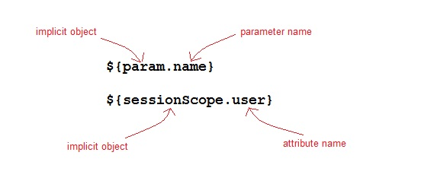

#### How EL expression is used?

EL expression can be used in two ways in a JSP page

1. As attribute values in standard and custom tags. Example:
2. <jsp:include page="${location}">

Where **location** variable is separately defines in the jsp page.

Expressions can also be used in jsp:setProperty to set a properties value, using other bean properties like : If we have a bean named **Square** with properties *length*, *breadth* and *area*.

<**jsp:setProperty** name="square" property="area" value="**${square.length*square.breadth}**" />

1. To output in HTML tag :
2. <h1>Welcome ${name}</h1>

To deactivate the evaluation of EL expressions, we specify the isELIgnored attribute of the page directive as below:

<%@ page **isELIgnored** ="*true|false*" %>

#### EL Implicit Objects

Following are the implicit objects in EL :

|  |  |
| --- | --- |
| **Implicit Object** | **Description** |
| **pageContext** | It represents the PageContext object. |
| **pageScope** | It is used to access the value of any variable which is set in the **Page** scope |
| **requestScope** | It is used to access the value of any variable which is set in the **Request** scope. |
| **sessionScope** | It is used to access the value of any variable which is set in the **Session** scope |
| **applicationScope** | It is used to access the value of any variable which is set in the **Application** scope |
| **param** | Map a request parameter name to a single value |
| **paramValues** | Map a request parameter name to corresponding array of string values. |
| **header** | Map containing header names and single string values. |
| **headerValues** | Map containing header names to corresponding array of string values. |
| **cookie** | Map containing cookie names and single string values. |

#### Example of EL

**index.jsp**

<form method="**POST**" action="**welcome.jsp**">

Name <input type="text" name="*user*" >

<input type="submit" value="Submit">

</form>

**welcome.jsp**

<html>

<head>

<title>Welcome Page</title>

</head>

<body>

<h1>Welcome **${param.name}**</h1>

</body>

</html>

#### Arithmetic Operations available in EL

Following are the arithmetic operators avilable in EL:

|  |  |
| --- | --- |
| **Arithmetic Operation** | **Operator** |
| Addition | + |
| Substraction | - |
| Multiplication | * |
| Division | / and div |
| Remainder | % and mod |

#### Logical and Relational Operators available in EL

Following are the logical operator and comparators avilable in EL:

|  |  |
| --- | --- |
| **Logical and Relational Operator** | **Operator** |
| Equals | == and eq |
| Not equals | != and ne |
| Less Than | < and lt |
| Greater Than | > and gt |
| Greater Than or Equal | >= and ge |
| Less Than or Equal | <= and le |
| And | && and and |
| Or | || and or |
| Not | ! and not |

# ========JSTL and Custom Tag ========

### ------------------------------------------------------ JSTL ------------------------------------------------------

JSP Standard Tag Library(JSTL) is a standard library of readymade tags. The JSTL contains several tags that can remove scriplet code from a JSP page by providing some ready to use, already implemented common functionalities.

JSTL is divided into 5 groups:

1. **JSTL Core**: JSTL Core provides several core tags such as **if**, **forEach**, **import**, **out** etc to support some basic scripting task. Url to include JSTL Core Tag inside JSP page is →

<%@ taglib prefix="c" uri="http://java.sun.com/jsp/jstl/core" %>

1. **JSTL Formatting**: JSTL Formatting library provides tags to format text, date, number for Internationalised web sites. Url to include JSTL Formatting Tags inside JSP page is →

<%@ taglib prefix="fmt" uri="http://java.sun.com/jsp/jstl/fmt" %>

1. **JSTL sql**: JSTL SQL library provides support for Relational Database Connection and tags to perform operations like insert, delete, update, select etc on SQL databases. Url to include JSTL SQL Tag inside JSP page is →

<%@ taglib prefix="sql" uri="http://java.sun.com/jsp/jstl/sql" %>

1. **JSTL XML**: JSTL XML library provides support for XML processing. It provides flow control, transformation features etc. Url to include JSTL XML Tag inside JSP page is →

<%@ taglib prefix="x" uri="http://java.sun.com/jsp/jstl/xml" %>

1. **JSTL functions**: JSTL functions library provides support for string manipulation. Url to include JSTL Function Tag inside JSP page is →

<%@ taglib prefix="fn" uri="http://java.sun.com/jsp/jstl/functions" %>

#### JSTL Core Library

The JSTL core library contains several tags that can be used to eliminate the basic scripting overhead such as for loop, if...else conditions etc from a JSP Page. Let's study some important tags of JSTL Core library.

* **JSTL if tag**: The if tag is a conditional tag used to evaluate conditional expressions. When a body is supplied with if tag, the body is evaluated only when the expression is true. For Example :

<%@ taglib uri="*http://java.sun.com/jsp/jstl/core*" prefix="**c**" %>

<html>

<head>

<title>Tag Example</title>

</head>

<body>

<**c:if** test="**${param.name == 'studytonight'}**">

<p>Welcome to ${param.name} </p>

</**c:if**>

</body>

</html>

* **JSTL out tag**: The out tag is used to evaluate an expression and write the result to **JspWriter**. For Example :

<%@ taglib uri="*http://java.sun.com/jsp/jstl/core*" prefix="**c**" %>

<html>

<head>

<title>Tag Example</title>

</head>

<body>

<**c:out** value="**${param.name}**" default="StudyTonight" />

</body>

</html>

The value attribute specifies the expression to be written to the JspWriter. The default attribute specifies the value to be written if the expression evaluates null.

* **JSTL forEach tag**: This tag provides a mechanism for iteration within a JSP page. JSTL forEach tag works similarly to **enhanced for** loop of Java Technology. You can use this tag to iterate over an existing collection of items. For Example :

<%@ taglib uri="*http://java.sun.com/jsp/jstl/core*" prefix="**c**" %>

<html>

<head>

<title>Tag Example</title>

</head>

<body>

<**c:forEach** var="message" items="**${errorMsgs}**" >

<li>**${message}**</li>

</**c:forEach**>

</body>

</html>

Here the attribute **items** has its value as an EL expression which is a collection of error messages. Each item in the iteration will be stored in a variable called **message** which will be available in the body of the **forEach** tag.

* **JSTL choose, when, otherwise tag**: These are conditional tags used to implement conditional operations. If the test condition of the when tag evaluates to true, then the content within when tag is evaluated, otherwise the content within the otherwise tag is evaluated.

We can also implement if-else-if construct by using multiple **when** tag. The **when** tags are mutually exclusive, that means the first when tag which evaluates to true is evaluated and then, the control exits the choose block. If none of the when condition evaluates to true, then otherwise condition is evaluated. For Example

<%@ taglib uri="*http://java.sun.com/jsp/jstl/core*" prefix="**c**" %>

<html>

<head>

<title>Tag Example</title>

</head>

<body>

<**c:forEach** var="tutorial" items="**${MyTutorialMap}**" begin="0" end="5" varStatus="status">

<**c:choose**>

<**c:when** test="**${status.count %2 == 0 }**">

<p> Divisible by 2 : *${tutorial.key}* </p>

<br/>

</**c:when**>

<**c:when** test="**${status.count %5 == 0 }**">

<p > Divisible by 5 : *${tutorial.key}* </p>

<br/>

</**c:when**>

<**c:otherwise**>

<p> Neither divisible by 2 nor 5 : *${tutorial.key}* </p><br/>

</**c:otherwise**>

</**c:choose**>

</**c:forEach**>

</body>

</html>

* **JSTL import tag**: < c:import> tag is used to dynamically add the contents from the provided URL to the current page, at request time. The URL resource used in the < c:import> url attribute can be from outside the web Container. For Example :

<%@ taglib uri="*http://java.sun.com/jsp/jstl/core*" prefix="**c**" %>

<html>

<head>

<title>Tag Example</title>

</head>

<body>

<**c:import** url="*http://www.example.com/hello.html*">>

<**c:param** name="showproducts" value="true"/>

</**c:import**>

</body>

</html>

* **JSTL url tag**: The JSTL url tag is used to store a url in a variable and also perform url rewriting when necessary. For Example

<%@ taglib uri="*http://java.sun.com/jsp/jstl/core*" prefix="**c**" %>

<html>

<head>

<title>Tag Example</title>

</head>

<body>

<a href='<**c:url** value="/home.jsp"/>' > Go Home </a>

</body>

</html>

* **JSTL set tag**: The JSTL set tag is used to store a variable in specified scope or update the property of JavaBean instance. Following is the example of setting the **name** property of a Student bean :

<%@ taglib uri="*http://java.sun.com/jsp/jstl/core*" prefix="**c**" %>

<html>

<head>

<title>Tag Example</title>

</head>

<body>

<**c:set** target="student" property="name" value="**${param.name}**" />

</body>

</html>

* **JSTL catch tag**: The JSTL catch tag is used to handle exception and doesn't forward the page to the error page. For Example :

<%@ taglib uri="*http://java.sun.com/jsp/jstl/core*" prefix="**c**" %>

<html>

<head>

<title>Tag Example</title>

</head>

<body>

<**c:catch**>

**<%** int a = 0;

int b = 10;

int c = b/a;

**%>**

</**c:catch**>

</body>

</html>

### --------------------------------------------------------------Custom Tag------------------------------------------------------

When EL and Standard Action elements aren't enough to remove scriptlet code from your JSP Page, you can use Custom Tags. Custom tags are nothing but user-defined tags.

Custom tags are an excellent way to abstract the complexity of business logic from the presentation of Web pages in a way that is easy for the Web author to use and control. It also allows for reusability as custom tags can be used again and again.

#### Format of Custom tag

The format of a custom tag can either be empty, called an **Empty tag**, or can contain a body, called a **Body tag**. The number of attributes that a tag will accept depends on the implementation of the Tag Handler class.

**Syntax for an Empty Tag is :**

<**tagLibraryPrefix**:*customTagName* attribute1="*attributeName*"

attribute2="*attributeName*" ... />

**The Syntax for a Custom Body Tag is :**

<**tagLibraryPrefix**:*customTagName* attribute1="*attributeName*"

attribute2="*attributeName*" ... />

*< --Body of custom tag-- >*

</**tagLibraryPrefix**:*customTagName*>

Creating custom tags is considered as a very good practice in JSP world. Always try to create and use your own custom tags from frequently used operations in your JSP application. Let's move to the next lesson and study how to create a Custom tag.

### ------------------------------------------------------Creating a Custom Tag------------------------------------------------------

To create a Custom Tag the following components are required :

1. The **Tag Handler** class which should extend SimpleTagSupport.
2. The **Tag Library Descriptor(TLD)** file
3. Use the Custom Tag in your JSP file

#### Tag Handler Class

You can create a Tag Handler class in two different ways:

1. By implementing one of three interfaces : SimpleTag, Tag or BodyTag, which define methods that are invoked during the life cycle of the tag.
2. By extending an abstract base class that implements the SimpleTag, Tag, or BodyTag interfaces. The **SimpleTagSupport**, **TagSupport**, and **BodyTagSupport** classes implement the SimpleTag, Tag andBodyTag interfaces . Extending these classes relieves the tag handler class from having to implement all methods in the interfaces and also provides other convenient functionality.

#### Tag Library Descriptor

A Tag Library Descriptor is an XML document that contains information about a library as a whole and about each tag contained in the library. TLDs are used by the web container to validate the tags and also by JSP page development tools.

Tag library descriptor file must have the extension .tld and must be packaged in the **/WEB-INF/** directory or subdirectory of the WAR file or in the **/META-INF/** directory or subdirectory of a tag library packaged in a JAR.

#### Example of Custom Tag

In our example, we will be creating a Tag Handler class that extends the **TagSupport** class. When we extend this class, we have to override the method doStartTag(). There are two other methods of this class namely doEndTag() and release(), that we can decide to override or not depending on our requirement.

**CountMatches.java**

package com.studytonight.taghandler;

import java.io.IOException;

import javax.servlet.jsp.*;

import org.apache.commons.lang.StringUtils;

public class **CountMatches** extends **TagSupport** {

private String **inputstring**;

private String **lookupstring**;

public String **getInputstring**() {

return inputstring;

}

public void **setInputstring**(String *inputstring*) {

this.inputstring = inputstring;

}

public String **getLookupstring**() {

return lookupstring;

}

public void **setLookupstring**(String *lookupstring*) {

this.lookupstring = lookupstring;

}

@Override

public int **doStartTag**() throws JspException {

try {

JspWriter out = pageContext.getOut();

out.println(StringUtils.countMatches(inputstring, lookupstring));

}

catch (IOException e) {

e.printStackTrace();

}

return SKIP_BODY;

}

}

In the above code, we have an implementation of the doStartTag() method which is must if we are extending **TagSupport** class. We have declared two variables inputstring and lookupstring. These variables represents the **attributes** of the custom tag. We must provide getter and setter for these variables in order to set the values into these variables that will be provided at the time of using this custom tag. We can also specify whether these attributes are required or not.

**CountMatchesDescriptor.tld**

<?xml version="*1.0*" encoding="*UTF-8*"?>

<taglib>

<tlibversion>1.0</tlibversion>

<jspversion>1.1</jspversion>

<shortname>**cntmtchs**</shortname>

<info>Sample taglib for Substr operation</info>

<uri>*http://studytonight.com/jsp/taglib/countmatches*</uri>

<tag>

<name>**countmatches**</name>

<tagclass>**com.studytonight.taghandler.CountMatches**</tagclass>

<info>String Utility</info>

<attribute>

<name>**inputstring**</name>

<required>**true**</required>

</attribute>

<attribute>

<name>**lookupstring**</name>

<required>**true**</required>

</attribute>

</tag>

</taglib>

The taglib element specifies the schema, required JSP version and the tags within this tag library. Each **tag** element within the TLD represents an individual custom tag that exist in the library. Each of these tag should have a tag handler class associated with them.

The **uri** element represents a Uniform Resource Identifier that uniquely identifies the tag library.

The two **attribute** elements within the **tag** element represents that the tag has two attributes and the **true** value provided to the **required** element represents that both of these attributes are required for the tag to function properly.

**test.jsp**

<%@taglib prefix="**mytag**" uri="*/WEB-INF/CountMatchesDescriptor.tld*"%>

<html>

<**mytag:countmatches** inputstring="*Studytonight*" lookupstring="*t*">

</**mytag:countmatches**>

</html>

If this tag works fine it should print a value 3 in the browser as there 't' occurs 3 times in the word 'Studytonight'.