FINAL PROJECT DOCUMENTATION
NAME | Christian Kerby N. Navallo
PROJECT TITLE | CKN Lawfirm Document Management System
SUBJECT:  CODE:  TIME: | IT15/L Integrative Programming and Technologies  8478  5:30-7:30
TOPIC (Type of Business Process) | #17 Document Management System
Products/Services | Law Firm
Website/Deployed (Link) | http://ckndocument.runasp.net/
API/ALGO/MODEL: | Paymongo, Recaptcha, OpenAI
Security Features | Authentication and Authorization,ReCaptcha, Input Validation, RBAC(RoleBasedAccess),
Target user/s: | CLIENT (External User), Staff(Documents Processor), Admin, Viewer / Auditor (Read-Only User)
Subs System / Management Transaction/Modules | 1.Document Storage Module  2.Version Control Module  3.Access Control Module  4.Document Retrieval Module  5.Archiving and Retention Module  6. Subscription Management Module  7. Billing & Accounting Module (CKN Platform)
LOGO | 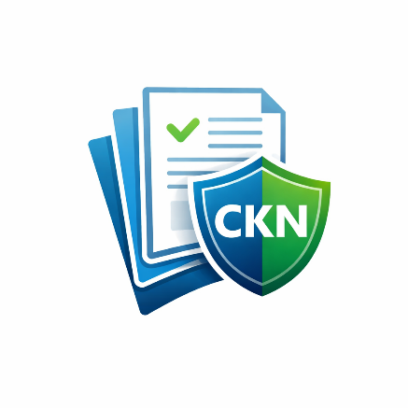
Project Objectives: | - To provide a centralized platform for storing, organizing, and retrieving digital documents securely, reducing reliance on physical records and manual filing systems.  - To implement role-based access control that ensures only authorized users such as administrators, staff, clients or viewers can access documents according to their assigned permissions.  - To support document version control that allows tracking of document changes, prevents data loss, and maintains the integrity of official records.  - To enforce document retention and archiving policies to comply with organizational and legal requirements while preventing unauthorized deletion of important documents.  - To improve operational efficiency and accountability by integrating audit logs that track document access, uploads, edits, and approvals within the system.
Project Description: | The project is a web-based Document Management System (DMS) designed to help organizations securely store, manage, and track digital documents. The system is intended for use by clients who submit documents, staff who process and review records, administrators who manage users and policies, and authorized viewers or auditors who require read-only access. Users expect the system to be secure, easy to use, and accessible online while ensuring proper control over sensitive information.  The application aims to improve organizational efficiency by reducing manual document handling, minimizing data loss, and ensuring proper version control and document retention. By centralizing documents in a cloud-based environment, the system enhances security, accountability, and compliance with record-keeping requirements, benefiting both organizations and their clients.  The system will be developed using ASP.NET C# Web (Blazor/Razor Pages) in Visual Studio 2022, with SQL Server managed through SSMS for data storage. It will be hosted using MonsterASP.NET, utilize AWS for cloud storage, and be deployed with a registered domain for online accessibility. These technologies were chosen for their reliability, security features, and compatibility with enterprise-level web applications, ensuring the system meets performance, scalability, and security requirements.
Type of Users/ Role-Based Access | 1. Superadmin  Username: superadmin  Password: SuperAdmin@123  2. Lawfirm Admin  Username: Clientlawfirm5  Password: Str0ng!Passw0rd  3. Lawyer  Username: lawyeraccount1  Password: SkyLight#2026  4. Staff(Metadata Manager)  Username: navallolawyer1  Password: SkyLight#2026  5. Client  Username: client4  Password: Str0ng!Passw0rd  6. Auditor  Username: auditoraccount1  Password: SkyLight#2026
Use Case Diagram  (Role-Based Access) | 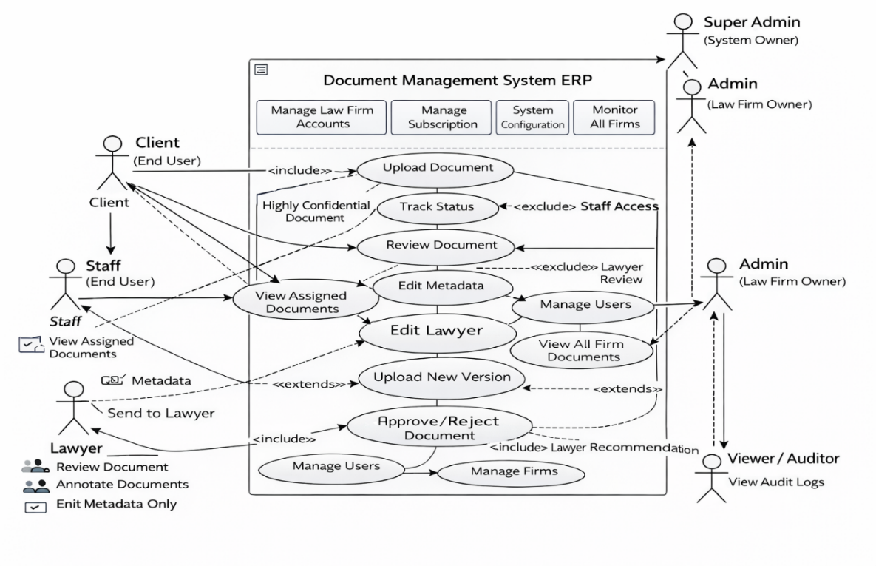
Data Dictionary | ABC Employees Monitoring Management System  FOLLOW THIS FORMAT  Users table  Field Names Datatype Length Description  UserID-PK Int-AI 9 User’s ID Number  Name Text 50 User’s Full Name  Role Text 25 User’s Role/Function  UserName Text 25 User’s Name or email  Password Text 25 User’s Password  Employees Registration table  Field Names Datatype Length Description  EmpID-PK Int-AI 9 Employees ’s ID Number  UserID-FK Int 9 User’s ID Number  EmpNumber Text 25 Employees ’s Company Number  LastName Text 20 Employees ’s Last Name  FirstName Text 30 Employees ’s First Name  MiddleName Text 20 Employees ’s Middle Name
Entity Relational Diagram (ERD) | 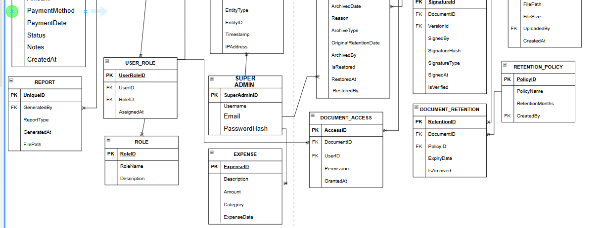  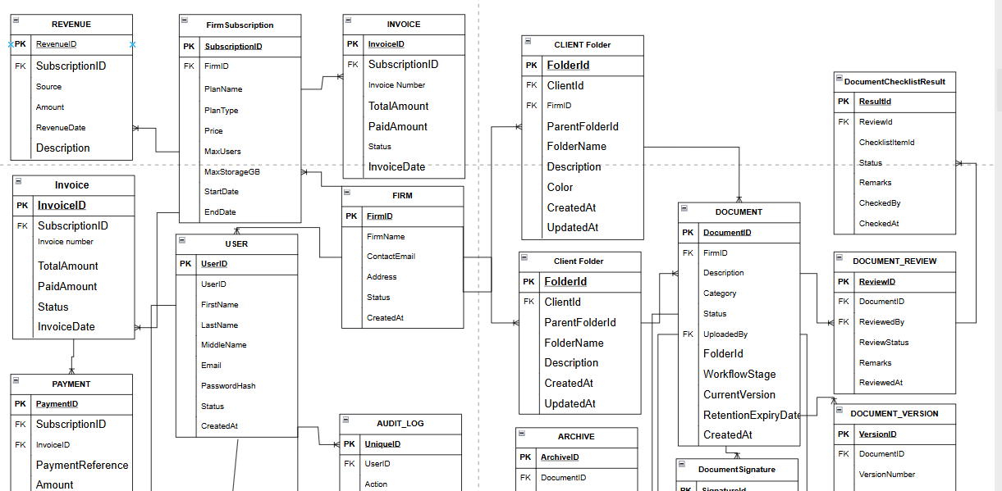
Prototype (Frontend) | SCREENSHOTS AND DESCRIPTION  - Each prototype screen must include a clear screenshot – ALL Transactions.  - Add a label name to each image.  Provide a brief description for each screen to guide users on its functionality and how to interact with it.
Prototype (Backend) | SCREENSHOTS AND DESCRIPTION (Source Code)  - Each prototype screen must include a clear screenshot.  - Add a label name to each image.  API/Algo Usage: Mention the APIs/Algos used and their specific role in the showcased functionality.
API FUNCTIONS/  FEATURES | SCREENSHOTS AND DESCRIPTION (Source Code)  - Each prototype screen must include a clear screenshot.  - Add a label name to each image.  Discuss the process on how it works.
SECURITY FEATURES | SCREENSHOTS AND DESCRIPTION (Source Code)  - Each prototype screen must include a clear screenshot.  - Add a label name to each image.  Discuss the process on how it works.
Date Submitted:
Teacher’s Feedback | _________________________________________________________________  _________________________________________________________________  _________________________________________________________________  _________________________________________________________________  _________________________________________________________________  _________________________________________________________________  ________________________________ __________________________  Student’s Signature (after feedbacking) Teacher’s Signature

