NAME | Christian Kerby Navallo
PROJECT TITLE | CKN Platform – Lawfirm Document Management System
SUBJECT:  CODE:  TIME: | IT15/L Integrative Programming and Technologies  8478  5:30-7:30
TOPIC (Type of Business Process) | #17 Document Management System
Products/Services | ERP Platform for Law Firms (Subscription-Based) - The system operates as a subscription-based ERP platform where law firms subscribe to access the Document Management System as a core product.
Agile Model - SDLC | In the Agile Requirements and Planning phase, the CKN ERP Platform – Law Firm Document Management System is planned by identifying the need for a secure, web-based platform that allows law firms to store, manage, and track documents efficiently. Through research-based business rules, the system is designed to support different users such as clients, staff, administrators, and auditors, each with specific responsibilities and access rights. The goal of this phase is to clearly define what the system must do, how it will support secure document handling, and how development will be organized into manageable Agile sprints.  To ensure the system meets its objectives, the following key activities are defined:  - Business Needs  - Centralized digital storage for legal documents  - Secure and organized document processing  - User Roles  - Client – uploads, views, and tracks submitted documents  - Staff (Document Processor) – reviews, edits, and creates document versions  - Admin – manages users, security, approvals, and system rules  - Viewer/Auditor – views approved documents in read-only mode  - System Objectives  - Role-based access control  - Document version tracking  - Audit logging and activity monitoring  - Document retention and archiving  - Agile Planning  - System requirements are written as user stories  - Features are prioritized based on importance  - Development is divided into Agile sprints for iterative delivery  - Technology Stack  - ASP.NET C# (MVC Razor)  - SQL Server (SSMS)  - MonsterASP.NET for hosting/cloud storage  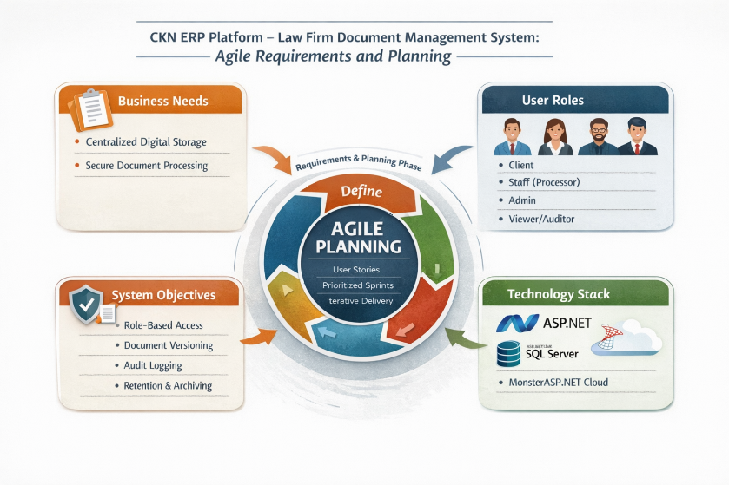
Use Case Diagram  (Diagram Only) | 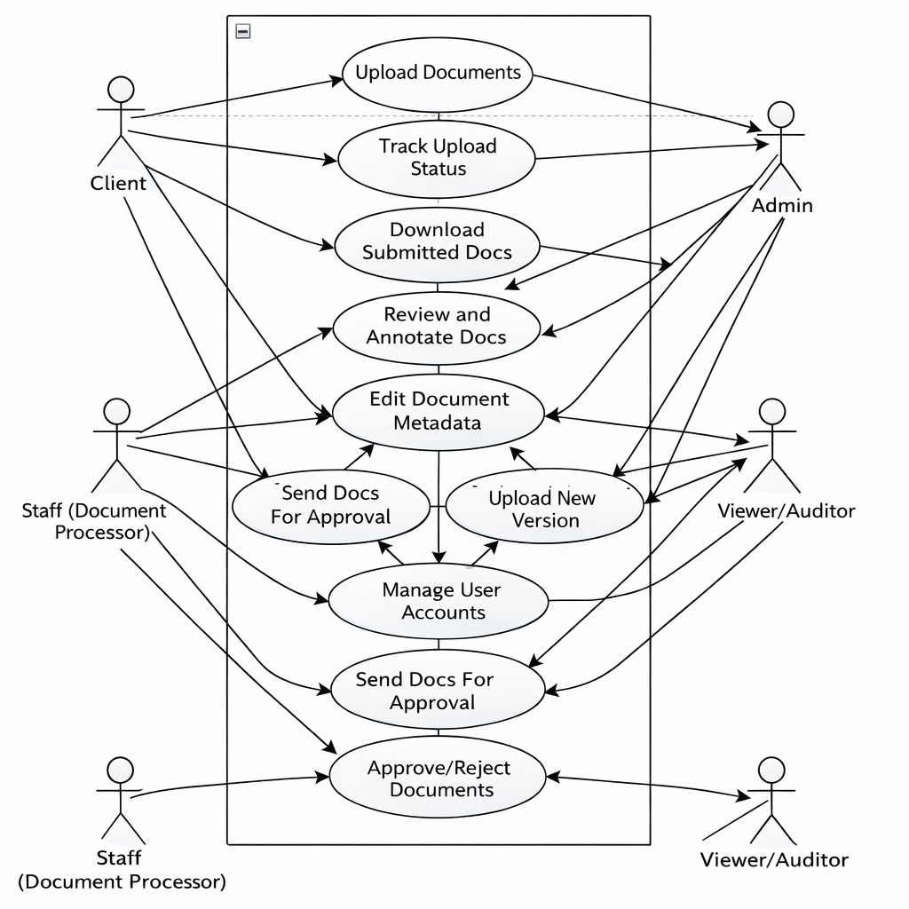
Entity Relational Diagram | 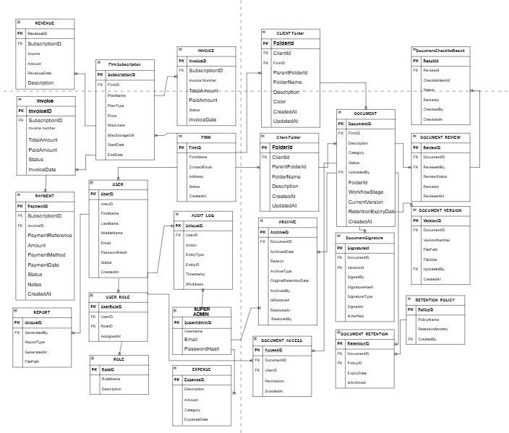
Data Dictionary | CKN – Lawfirm Document Management System  Firm table  Firm Subcription table  User table  Role table  User_Role Table  Document Table  DocumentVersion Table  Document checklist table  DocumentReview Table  DocumentSignature Table  Audit_Log Table  FirmSubscription Table  Invoice Table  ClientFolder Table  Document_Access Table  Document_Retention Table  Retention_Policy Table  Archive Table  NotificationTable  Payment Table  Revenue Table  Expense Table  SUPER ADMIN Table
  Field Names | Datatype | Length | Description
  FirmID-PK | int
    4 bytes
    Unique identifier of the law firm
  FirmName | varchar | 150
    Name of the law firm
  ContactEmail | varchar | 100
    Official email address
  Address | varchar | 255
    Office address
  Status | varchar | 50
    Firm status (Active, Inactive)
  Field Names | Datatype | Length | Description
  SubscriptionID-PK | int
    4 bytes
    Unique subscription record
  FirmID-FK | int
    4 bytes
    Subscribed law firm
  PlanName | nvarchar | 100
    Plan name (Basic, Pro, Enterprise)
  PlanType |  | 50
    nvarchar
    Monthly, Annual
  Price |  | 12,2
    decimal
    Subscription price
  MaxUsers | int
    4 bytes
    Allowed number of users
   | int
    MaxStorageGB
    4 bytes
    Storage limit
  StartDate | date
    Subscription start
  EndDate | date
    Subscription end
  Field Names | Datatype | Length | Description
  UserID-PK | int
    4 bytes
    Unique user ID
  FirmID-FK | Int
    4 bytes
    Firm to which user belongs
  FirstName | varchar | 100 | User first name
  LastName | varchar | 100
    User last name
  MiddleName | varchar | 100
    User last name
  Email | varchar | 100
    User login email
  Username | nvarchar | 100
    User login name
  PasswordHash | varchar | 255
    Encrypted password
   | varchar | 11
    PhoneNumber
    User contact number
  Status | varchar | 50
    Account status
  Department | nvarchar | 100
    Department of user
   | nvarchar | 100
    Position
    Job position
  Field Names | Datatype | Length | Description
  RoleID-PK | int
    4 bytes
    Unique role ID
  RoleName | varchar
    50
    Role name (Admin, Staff, Client)
  Field Names | Datatype | Length | Description
  UserRoleID-PK | int
    4 bytes
    Unique record ID
  UserID-FK | Int
    Int
    Assigned user
  RoleID-FK | Int | Int
    Assigned role
  Field Names | Datatype | Length | Description
  DocumentID-PK | int
    4 bytes
    DocumentID
  FirmID-FK | Int
    4 bytes
    Firm owner
  UploadedBy | Int
    4 bytes
    User who uploaded
  Title | varchar | 255
    Document title
  Description | text | -
    Document description
  Category | varchar | 100
    Type of document
  Status | varchar | 50
    Pending, Approved, Rejected
   |  | 50
    WorkflowStage
    varchar
    Stage of processing
  FolderId | int
    4 bytes
    Storage folder
   | int
    CurrentVersion
    4 bytes
    Current version number
  RetentionExpiryDate | datetime
    8 bytes
    Archive deadline
   |  |  | Upload date
    CreatedAt
    datetime
    8 bytes
  Field Names | Datatype | Length | Description
  VersionId-PK | int
    4 bytes
    Unique version
  -FK | Int
    DocumentId
    4 bytes
    Parent document
  VersionNumber | Int
    4 bytes
    Version number
   | nvarchar | 1000
    FilePath
    File location
  FileSize | bigint | 8 bytes
    File size
  UploadedBy | int
    4 bytes
    Uploaded by
  IsCurrentVersion | bit | 1
    Marks active version
  CreatedAt |  |  | Date uploaded
    datetime
    8 bytes
  Field Names | Datatype | Length | Description
  ResultId-PK | int
    4 bytes
    Unique checklist result ID
  -FK | Int
    ReviewId
    4 bytes
    Linked document review
   | Int
    ChecklistItemId
    4 bytes
    Checklist requirement
   | varchar | 50
    Status
    Passed, Failed, Pending
  Remarks | nvarchar | 500
    Reviewer comments
  CheckedBy | int
    4 bytes
    User who verified
  CheckedAt | datetime | 1
    Date verified
  Field Names | Datatype | Length | Description
  ReviewId-PK | int
    4 bytes
    Review ID
  -FK | Int
    DocumentId
    4 bytes
    Reviewed document
  ReviewedBy | Int
    4 bytes
    Reviewer
   | varchar | 50
    ReviewStatus
    Approved / Rejected
  Remarks |  | max
    nvarchar
    Review comments
   | datetime
    ReviewedAt
    8 bytes
    Review date
   | bit |  | Compliance done
    IsChecklistComplete
    1
  Field Names | Datatype | Length | Description
  SignatureId-PK | int
    4 bytes
    Unique signature record
  -FK | Int
    DocumentId
    4 bytes
    Parent document
  VersionId-FK | int
    4 bytes
    Document version signed
   | int
    SignedBy
    4 bytes
    User who signed
   | nvarchar | 255
    SignatureHash
    Digital signature hash
   | varchar
    SignatureType
    50
    E-Signature, Digital
    SignedAt
    datetime
    8 bytes
    Date & time signed
  IsVerified | bit | 1 | Signature verified
  Field Names | Datatype | Length | Description
  AuditID-PK | int
    4 bytes
    Log ID
  -FK | Int
    UserID
    4 bytes
    User who did action
  Action | nvarchar
    100
    Activity
   | varchar | 100
    EntityType
    Table affected
  EntityID | int | 4 bytes
    Record affected
  Timestamp | datetime
    8 bytes
    Date/time
   |  | 1000 | Action details
    Description
    nvarchar
  Field Names | Datatype | Length | Description
  -PK | int
    SubscriptionID
    4 bytes
    Subscription ID
  -FK | Int
    FirmID
    4 bytes
    Subscriber
  PlanType | nvarchar
    50
    Plan type
   | nvarchar | 50
    Status
    Active / Expired
  StartDate |  | -
    date
    Start date
   | date | - | End date
    EndDate
  Field Names | Datatype | Length | Description
  InvoiceID-PK | int |  | Invoice ID
    4 bytes
  -FK | Int
    SubscriptionID
    4 bytes
    Linked subscription
   | varchar | 50
    InvoiceNumber
    Invoice code
  TotalAmount | decimal | 12,2 | Total Bill
  PaidAmount | PaidAmount | 12,2
    Amount paid
  Status |  | 50
    nvarchar
    Paid, Pending
   | date | — | Issue date
    InvoiceDate
  Field Names | Datatype | Length | Description
  FolderId-PK | int
    4 bytes
    Unique folder ID
  ClientId-FK | Int | 4 bytes
    Owner (client)
  FirmId-FK | int
    4 bytes
    Firm that owns folder
   | int
    ParentFolderId
    4 bytes
    Parent folder (subfolder)
  FolderName | nvarchar | 255
    Folder name
  Description |  | 500
    nvarchar
    Folder description
  Color | varchar | 20
    Folder color tag
    CreatedAt
    datetime
    8 bytes
    Date created
   |  |  | Last update
    UpdatedAt
    datetime
    8 bytes
  Field Names | Datatype | Length | Description
  AccessID-PK | int
    4 bytes
    Access record ID
  DocumentID-FK | Int | 4 bytes
    Document
  UserID-FK | int
    4 bytes
    User granted
   | varchar | 50
    Permission
    Read, Write, Approve
  GrantedAt | datetime
    8 bytes
    Date granted
  Field Names | Datatype | Length | Description
  RetentionID-PK | int
    4 bytes
    Retention record
  DocumentID-FK | Int | 4 bytes
    Document
  PolicyID-FK | int
    4 bytes
    Retention rule
   | date | -
    ExpiryDate
    Archive date
  IsArchived | bit |  | Already Archived
    1
  Field Names | Datatype | Length | Description
  PolicyID-PK | int
    4 bytes
    Policy ID
   | varchar | 100
    PolicyName
    Policy name
   | int
    RetentionMonths
    4 bytes
    Months to keep
   | int |  | Admin creator
    CreatedBy
    4 bytes
  Field Names | Datatype | Length | Description
  ArchiveID-PK | int
    4 bytes
    Archive record
  DocumentID-FK | Int | 4 bytes
    Archived document
  ArchivedDate
    datetime
    8 bytes
    Date archived
   | varchar
    Reason
    255
    Reason for archive
  ArchiveType | varchar
    50
    Auto / Manual
   | datetime
    OriginalRetentionDate
    8 bytes
    Original expiry
   | int
    ArchivedBy
    4 bytes
    Admin
   | bit | 1
    IsRestored
    Restored flag
   | datetime
    RestoredAt
    8 bytes
    Restore date
  RestoredBy | int |  | Who restored
    4 bytes
  Field Names | Datatype | Length | Description
  NotificationId-PK | int
    4 bytes
    Notification ID
  -FK- | Int | 4 bytes
    UserId
    Recipient
  DocumentId-FK | int
    4 bytes
    Related document
   | nvarchar | 255
    Title
    Notification title
   | nvarchar
    Message
    max
    Message content
   | varchar
    NotificationType
    50
    Alert type
  ActionUrl | nvarchar | 500 | Link
   | bit | 1
    IsRead
    Read flag
  CreatedAt
    datetime
    8 bytes
    Sent date
  ReadAt | datetime | 8 bytes | Read date
  Field Names | Datatype | Length | Description
  PaymentID -PK | int
    4 bytes
    Payment ID
  -FK | Int | 4 bytes
    SubscriptionID
    Related subscription
  InvoiceID-FK | int
    4 bytes
    Invoice paid
   | nvarchar
    PaymentReference
    50
    Payment code
  Amount | decimal
    12,2
    Amount paid
  PaymentMethod |  | 50 | Method
    nvarchar
  PaymentDate |  | -
    date
    Date paid
  Status | nvarchar | 50
    Completed / Pending
  Notes | nvarchar
    500
    Remarks
  CreatedAt | datetime | bytes | Created
  Field Names | Datatype | Length | Description
  RevenueID -PK | int
    4 bytes
    Revenue record
  SubscriptionID-FK
    int
    4 bytes
    Source firm
  Source | nvarchar
    100
    Subscription, Upgrade
   | decimal
    Amount
    12,2
    Revenue amount
  RevenueDate | date
    -
    Date earned
  Description | nvarchar | 500 | Notes
  CreatedAt | datetime |  | Date logged
    8 bytes
  Field Names | Datatype | Length | Description
  ExpenseID-PK | int
    4 bytes
    Expense ID
  Description
    nvarchar
    255
    Expense description
  Amount | decimal
    12,2
    Cost
   | nvarchar
    Category
    100
    Type
  ExpenseDate | date
    -
    Date
  Notes | nvarchar | 50 | Remarks
  Status | nvarchar |  | CreatedAt
    50
  CreatedAt | datetime |  | Created
    8 bytes
   | datetime |  | Updated
    UpdatedAt
    8 bytes
  Field Names | Datatype | Length | Description
   | int
    SuperAdminId
    4 bytes
    System owner
  Username
    nvarchar
    100
    Login
   | nvarchar | 255
    Email
    Email
   | nvarchar
    PasswordHash
    255
    Encrypted
  FirstName | nvarchar
    100
    Name
  LastName | nvarchar | 100 | Surname
  PhoneNumber | nvarchar | 11 | Contact
  Status | nvarchar | 20 | Active
  LastLoginAt | datetime
    8 bytes
    Last login
  CreatedAt | datetime |  | Created
    8 bytes
Teacher’s Feedback | _________________________________________________________________  _________________________________________________________________  _________________________________________________________________  _________________________________________________________________  _________________________________________________________________  _________________________________________________________________  ________________________________ __________________________  Student’s Signature (after feedbacking) Teacher’s Signature

