

Protecting Transactions in a Coffee Shop with Free Wi-Fi

In Partial Fulfilment of the Requirements in IT11/L

Submitted by:
Navallo, Christian Kerby N.
Toylo, Vincent Ray

Submitted to:
Lloyd Ryan Largo

Abstract

In today’s service-oriented businesses such as cafés and coffee shops, networking plays a critical role in daily operations. A coffee shop relies heavily on its network to process customer payments through POS terminals, manage administrative tasks in the manager’s office, support staff connectivity, and provide free Wi-Fi access for guests. A reliable and secure network infrastructure is essential to ensure smooth business operations, protect sensitive financial data, and maintain customer trust while delivering convenient internet access.
The primary networking issues identified in this scenario include the use of a flat network where all devices share the same broadcast domain, the absence of inter-VLAN routing for controlled communication, and weak wireless security configurations. POS terminals handling sensitive payment data are exposed to the same network as guest devices, increasing the risk of data interception and unauthorized access. Additionally, the Manager’s Office cannot securely access sales data due to the lack of proper routing between network segments.
To address these challenges, a redesigned network architecture was proposed using Virtual Local Area Networks (VLANs) to logically separate POS, Management, Staff, and Guest networks. Inter-VLAN routing was implemented using a router-on-a-stick configuration to allow controlled communication where necessary, particularly between the POS and Management VLANs. Secure wireless configurations were also applied by assigning separate SSIDs for Staff and Guest Wi-Fi and enabling strong encryption to prevent unauthorized access.
This design was motivated by the need to enhance security, improve network performance, and ensure compliance with best practices in network segmentation. By isolating sensitive systems from public access and enforcing controlled routing, the coffee shop benefits from reduced security risks, improved reliability, and better manageability of its network infrastructure while still offering free Wi-Fi services to customers.

Table of Contents
Page
Project Title 1
Abstract 2
Table of Contents 3
Problem Statement 4
Problem Statement 1 4
Problem Statement 2 4
Problem Statement 3 4
Goal and Objectives 4
Specific Objective 1 4
Specific Objective 2 4
Specific Objective 3 4
Network Design/Topology 5
Configuration & Testing 6
VLAN Configuration 7
Router Configuration 8
IP Addressing Scheme 9
Connectivity Test Results 10
References 11

Problem Statement

Problem Statement 1 – Lack of VLAN Segmentation
The coffee shop currently operates on a flat network where POS terminals, manager PCs, staff devices, and guest Wi-Fi users are connected to the same network. This lack of segmentation exposes sensitive financial transactions to unnecessary security risks and increases broadcast traffic, negatively affecting network performance.
Problem Statement 2 – No Inter-VLAN Routing
The absence of inter-VLAN routing prevents secure and controlled communication between departments. Specifically, the Manager’s Office cannot access POS sales data because there is no routing mechanism to allow traffic between separate network segments.
Problem Statement 3 – Insecure Wireless Configuration
The wireless routers are configured with default SSIDs and weak passwords. This makes the network vulnerable to unauthorized access, allowing attackers or unintended users to connect easily and potentially intercept sensitive data.

Goal and Objectives
Overall Goal
To design and implement a secure and efficient network infrastructure for a coffee shop using Cisco Packet Tracer by applying VLAN segmentation, inter-VLAN routing, and secure wireless configurations.
Specific Objective 1
To implement VLAN segmentation that separates POS terminals, Management computers, Staff Wi-Fi devices, and Guest Wi-Fi devices into distinct broadcast domains, reducing security risks and improving network performance.
Specific Objective 2
To enable inter-VLAN routing that allows controlled communication between selected VLANs, particularly enabling the Manager’s Office to securely access POS transaction data.
Specific Objective 3
To configure secure wireless networks by creating separate SSIDs for Staff and Guest users and applying strong encryption and passwords to prevent unauthorized access.

Network Design/Topology
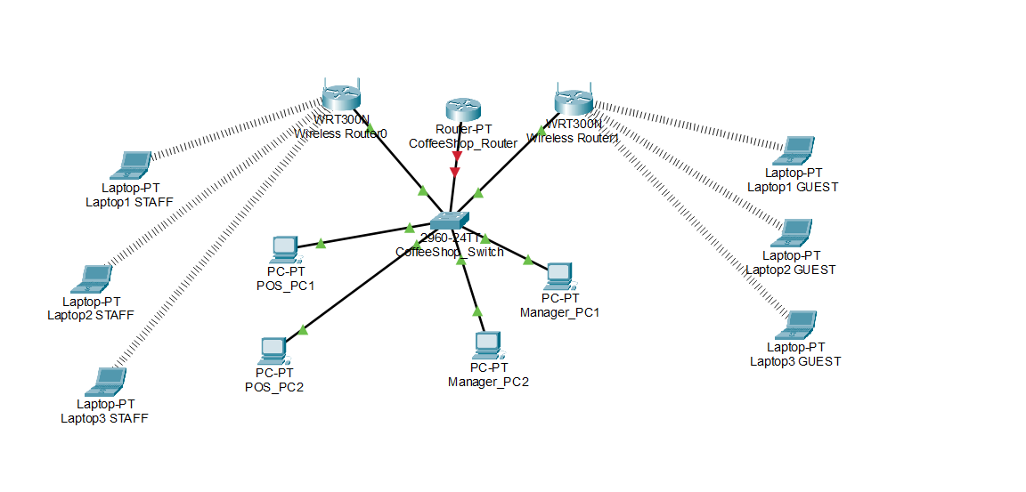
Devices Used
- 1 Router with inter-VLAN routing capability
- 2 Wireless Routers (Staff Wi-Fi and Guest Wi-Fi)
- 1 Cisco 2960 Switch
- 2 POS PCs
- 2 Manager Office PCs
- 3 Staff Laptops
- Multiple Guest Laptops
VLAN Assignments
VLAN ID | VLAN Name | Purpose
10 | POS | Payment processing terminals
20 | MANAGEMENT | Manager’s office computers
30 | STAFF | Employee wireless devices
40 | GUEST | Customer Wi-Fi access

Configuration & Testing
Provide details of your configuration and test results in the following structured format:
Example:

1. VLAN Configuration
Insert the configuration commands and screenshots for creating VLANs on the switch. Example:
Switch> enable
Switch# configure terminal
Switch(config)# vlan 10
Switch(config-vlan)# name Faculty
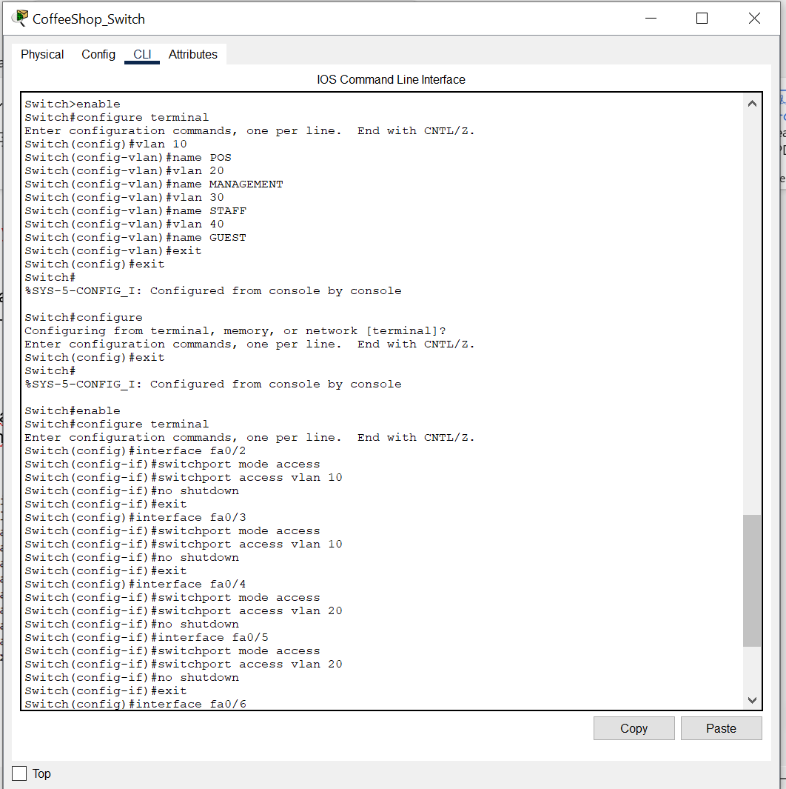
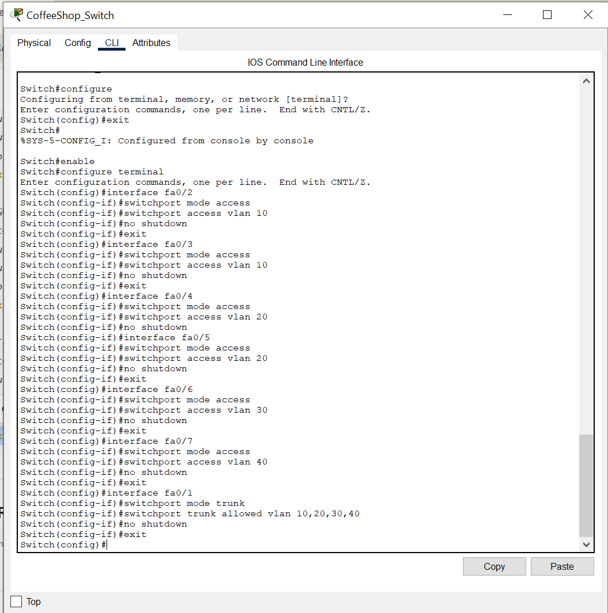

2. Router Configuration (Inter-VLAN + Wireless)
Insert the configuration commands for enabling inter-VLAN routing and setting up wireless. Example:
Router> enable
Router# configure terminal
Router(config)# interface g0/0.10
Router(config-subif)# encapsulation dot1Q 10
Router(config-subif)# ip address 192.168.10.1 255.255.255.0
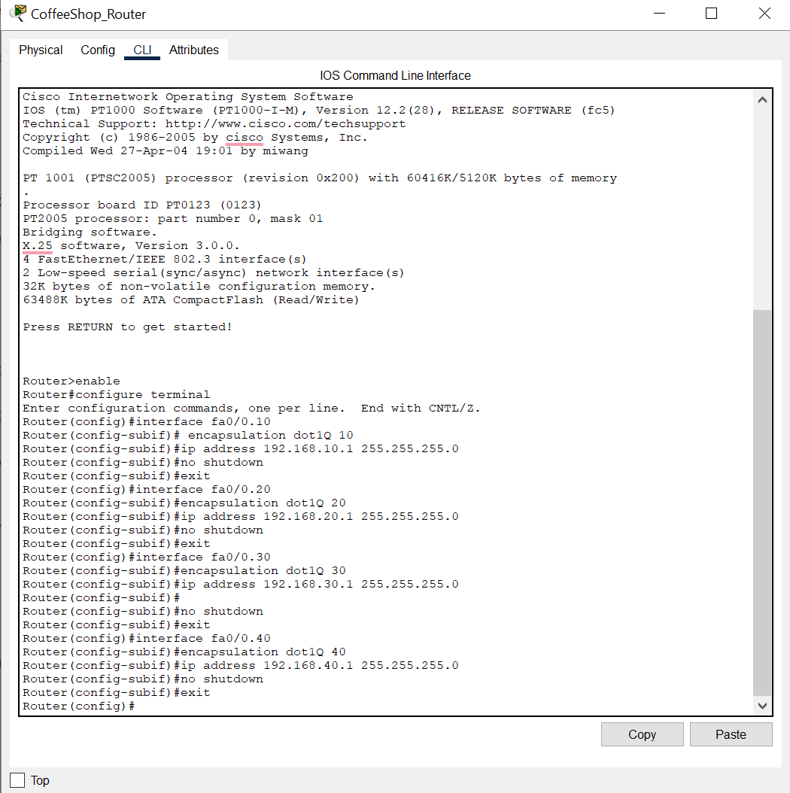

3. IP Addressing Scheme
Fill in the table below to show your complete IP addressing plan:
Department / VLAN | Network Address | Subnet Mask | Default Gateway
POS(VLAN 10) | 192.168.10.0/24 | 255.255.255.0 | 192.168.10.1
MANAGEMENT (VLAN 20) | 192.168.20.0/24 | 255.255.255.0 | 192.168.20.1
STAFF(VLAN 30) | 192.168.30.0/24 | 255.255.255.0 | 192.168.30.1
GUEST(VLAN40) | 192.168.30.0/24 | 255.255.255.0 | 192.168.40.1

4. Connectivity Test Results
Provide proof of successful connectivity:
- Ping tests between VLANs (screenshots)
- Verification that access restrictions are working as intended
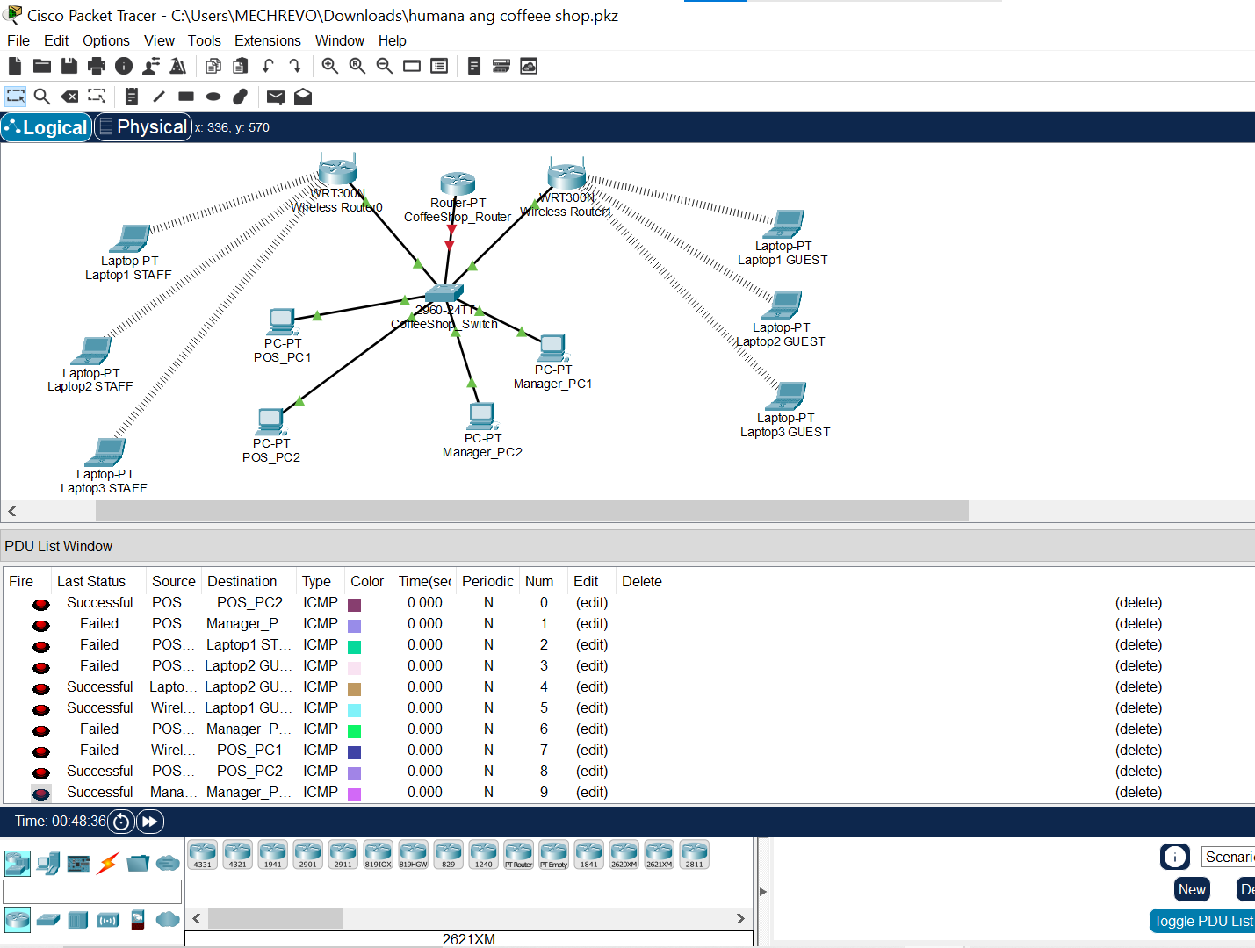

References

Cisco Networking Academy. (2021). Introduction to networks companion guide. Cisco Press.
Cisco. (2024, March 15). How to configure a wireless router in Packet Tracer. Cisco Networking Academy. https://www.netacad.com/resources/labs

