FINAL PROJECT DOCUMENTATION
NAME | Christian Kerby N. Navallo
PROJECT TITLE | CKN Lawfirm Document Management System
SUBJECT:  CODE:  TIME: | IT15/L Integrative Programming and Technologies  8478  5:30-7:30
TOPIC (Type of Business Process) | #17 Document Management System
Products/Services | Law Firm
Website/Deployed (Link) | http://ckndocument.runasp.net/
API/ALGO/MODEL: | Paymongo, Recaptcha, OpenAI
Security Features | Authentication and Authorization,ReCaptcha, Input Validation, RBAC(RoleBasedAccess),
Target user/s: | CLIENT (External User), Staff(Documents Processor), Admin, Viewer / Auditor (Read-Only User)
Subs System / Management Transaction/Modules | 1.Document Storage Module  2.Version Control Module  3.Access Control Module  4.Document Retrieval Module  5.Archiving and Retention Module  6. Subscription Management Module  7. Billing & Accounting Module (CKN Platform)
LOGO | 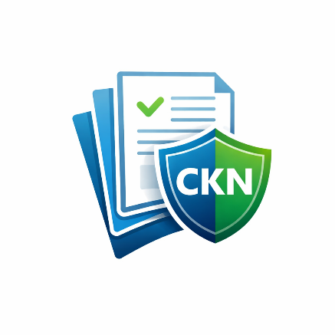
Project Objectives: | - To provide a centralized platform for storing, organizing, and retrieving digital documents securely, reducing reliance on physical records and manual filing systems.  - To implement role-based access control that ensures only authorized users such as administrators, staff, clients or viewers can access documents according to their assigned permissions.  - To support document version control that allows tracking of document changes, prevents data loss, and maintains the integrity of official records.  - To enforce document retention and archiving policies to comply with organizational and legal requirements while preventing unauthorized deletion of important documents.  - To improve operational efficiency and accountability by integrating audit logs that track document access, uploads, edits, and approvals within the system.
Project Description: | The project is a web-based Document Management System (DMS) designed to help organizations securely store, manage, and track digital documents. The system is intended for use by clients who submit documents, staff who process and review records, administrators who manage users and policies, and authorized viewers or auditors who require read-only access. Users expect the system to be secure, easy to use, and accessible online while ensuring proper control over sensitive information.  The application aims to improve organizational efficiency by reducing manual document handling, minimizing data loss, and ensuring proper version control and document retention. By centralizing documents in a cloud-based environment, the system enhances security, accountability, and compliance with record-keeping requirements, benefiting both organizations and their clients.  The system will be developed using ASP.NET C# Web (Blazor/Razor Pages) in Visual Studio 2022, with SQL Server managed through SSMS for data storage. It will be hosted using MonsterASP.NET, utilize AWS for cloud storage, and be deployed with a registered domain for online accessibility. These technologies were chosen for their reliability, security features, and compatibility with enterprise-level web applications, ensuring the system meets performance, scalability, and security requirements.
Type of Users/ Role-Based Access | 1. Superadmin  Username: superadmin  Password: SuperAdmin@123  2. Lawfirm Admin  Username: Clientlawfirm5  Password: Str0ng!Passw0rd  3. Lawyer  Username: lawyeraccount1  Password: SkyLight#2026  4. Staff(Metadata Manager)  Username: navallolawyer1  Password: SkyLight#2026  5. Client  Username: client4  Password: Str0ng!Passw0rd  6. Auditor  Username: auditoraccount1  Password: SkyLight#2026
Use Case Diagram  (Role-Based Access) | 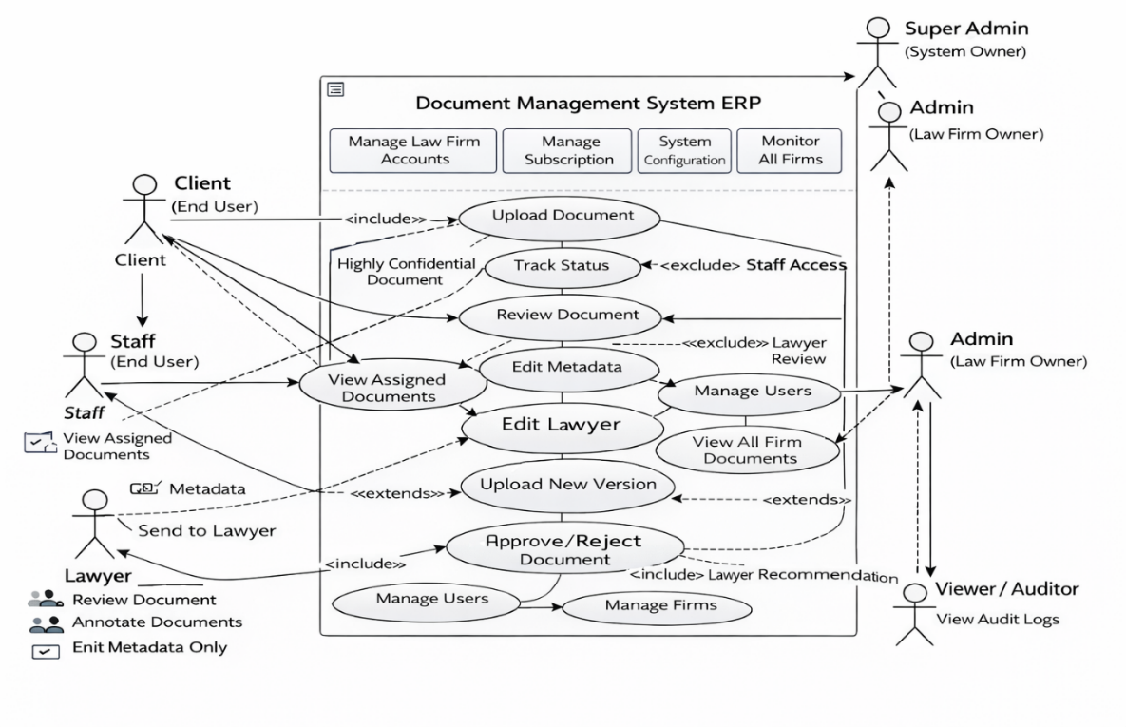
Data Dictionary | CKN Lawfirm Document Management System  Firm table  Field Names Datatype Length Description  FirmID-PK int Int-AI 4 bytes Unique identifier of the law firm  FirmName varchar 50 Name of the law firm  ContactEmail varchar 50 Official email address  Address varchar 100 Office address  Status varchar 10 Firm status (Active, Inactive)  Firm Subcription table  Field Names Datatype Length Description  SubscriptionID-PK int 4 bytes Unique subscription record  FirmID-FK Int 4 bytes Subscribed law firm  PlanName nvarchar 50 Plan name (Basic, Pro, Enterprise)  PlanType nvarchar 50 Monthly, Annual  Price nvarchar 15 Subscription price  MaxUsers int 4 bytes Allowed number of users  User table  Field Names Datatype Length Description  UserID-PK int 4 bytes Unique user ID  FirmID-FK Int 4 bytes Firm to which user belongs  FirstName varchar 50 User first name  LastName varchar 50 User last name  MiddleName varchar 50 User Middle name  Email varchar 50 User login email  Username varchar 50 User login name  PasswordHash varchar 50 Encrypted password  PhoneNumber varchar 11 User contact number  Status varchar 50 Account status  Department nvarchar 50 Department of user  Position nvarchar 20 Job position  Role table  Field Names Datatype Length Description  RoleID-PK int 4 bytes Unique role ID  RoleName varchar 10 Role name (Admin, Staff, Client, Auditor,Lawyer)  User_Role Table  Field Names Datatype Length Description  UserRoleID-PK int 4 bytes Unique record ID  UserID-FK Int 4 bytes Assigned user  RoleID-FK Int 4 bytes Assigned role  Document Table  Field Names Datatype Length Description  DocumentID-PK int 4 bytes DocumentID  FirmID-FK Int 4 bytes Firm owner  UploadedBy Int 4 bytes User first name  Title varchar 50 Document Title  Description text - Document description  Category varchar 50 Type of document  Status varchar 10 Pending, Approved, Rejected  WorkflowStage varchar 50 Stage of processing  FolderId int 4 bytes Storage folder  CurrentVersion int 4 bytes Current version number  RetentionExpiryDate datetime 8 bytes Archive deadline  CreatedAt datetime 8 bytes Upload Date  DocumentVersion Table  Field Names Datatype Length Description  VersionId-PK int 4 bytes Unique version  DocumentId -FK Int 4 bytes Parent document  VersionNumber Int 4 bytes Version number  FilePath nvarchar 1000 File location  FileSize bigint 8 bytes File size  Category varchar 50 Type of document  UploadedBy int 4 bytes Uploaded by  IsCurrentVersion bit 1 Marks active version  CreatedAt datetime 8 bytes Date uploaded  Document checklist Table  Field Names Datatype Length Description  ResultId-PK int 4 bytes Unique checklist result ID  ReviewId-FK Int 4 bytes Linked document review  ChecklistItemId Int 4 bytes Checklist requirement  Status varchar 10 Passed, Failed, Pending  Remarks nvarchar 255 Reviewer comments  CheckedBy int 4 bytes User who verified  CheckedAt datetime 1 Date verified  DocumentReview Table  Field Names Datatype Length Description  ReviewId-PK int 4 bytes Review ID  DocumentId -FK Int 4 bytes Reviewed document  ReviewedBy Int 4 bytes Reviewer  ReviewStatus varchar 10 Approved / Rejected  Remarks nvarchar 255 Review comments  ReviewedAt datetime 8 bytes Review date  IsChecklistComplete bit 1 Compliance done  DocumentSignature Table  Field Names Datatype Length Description  SignatureId-PK int 4 bytes Unique signature record  DocumentId -FK Int 4 bytes Parent document  VersionId-FK Int 4 bytes Document version signed  SignedBy int 4 bytes E-Signature, Digital  SignatureHash varchar 50 File size  SignatureType varchar 50 E-Signature, Digital  SignedAt datetime 8 bytes Date & time signed  IsCurrentVersion bit 1 Marks active version  IsVerified bit 1 Signature verified  Audit_Log Table  Field Names Datatype Length Description  AuditID-PK int 4 bytes Log ID  UserID -FK Int 4 bytes User who did action  Action nvarchar 50 Activity  EntityType varchar 50 Table affected  EntityID int 4 bytes Record affected  Timestamp datetime 8 bytes Date/time  Description nvarchar 100 Action details  Invoice Table  Field Names Datatype Length Description  InvoiceID-PK int 4 bytes Invoice ID  SubscriptionID -FK Int 4 bytes Linked subscription  InvoiceNumber varchar 50 Invoice code  TotalAmount decimal 12,2 Total Bill  PaidAmount decimal 12,2 Amount paid  Status nvarchar 50 Paid, Pending  InvoiceDate date - Issue date  ClientFolder Table  Field Names Datatype Length Description  FolderId-PK int 4 bytes Unique folder ID  ClientId-FK Int 4 bytes Owner (client)  FirmId-FK Int 4 bytes Firm that owns folder  ParentFolderId int 4 bytes Parent folder (subfolder)  FolderName nvarchar 50 Folder name  Description nvarchar 100 Folder description  Color varchar 20 Folder color tag  CreatedAt datetime 8 bytes Date created  UpdatedAt datetime 8 bytes Last update  Document_Access Table  Field Names Datatype Length Description  AccessID-PK int 4 bytes Access record ID  DocumentID-FK Int 4 bytes Document  UserID-FK Int 4 bytes User granted  Permission varchar 50 Read, Write, Approve  GrantedAt datetime 8 bytes Date granted  Document_Retention Table  Field Names Datatype Length Description  RetentionID-PK int 4 bytes Retention record  DocumentId -FK Int 4 bytes Document  PolicyID-FK Int 4 bytes Retention rule  ExpiryDate date - Archive date  IsArchived bit 1 Already Archived  Retention_Policy Table  Field Names Datatype Length Description  PolicyID-PK int 4 bytes Policy ID  PolicyName varchar 100 Policy name  RetentionMonths Int 4 bytes Months to keep  CreatedBy int 4 bytes Admin creator  Archive Table  Field Names Datatype Length Description  ArchiveID-PK int 4 bytes Archive record  DocumentID-FK Int 4 bytes Archived document  ArchivedDate datetime 8 bytes Date archived  Reason varchar 50 Reason for archive  ArchiveType varchar 10 Auto / Manual  OriginalRetentionDate datetime 8 bytes Original expiry  ArchivedBy int 4 bytes Admin  IsRestored bit 1 Restored flag  RestoredAt datetime 8 bytes Restore date  RestoredBy int 4 bytes Who restored  NotificationTable  Field Names Datatype Length Description  NotificationId-PK int 4 bytes Notification ID  UserId-FK Int 4 bytes Recipient  DocumentId-FK Int 4 bytes Related document  Message nvarchar max Message content  NotificationType varchar 50 Alert type  ActionUrl nvarchar 500 Link  IsRead Bit 1 Read flag  CreatedAt datetime 8 bytes Sent date  ReadAt datetime 8 bytes Read date  Payment Table  Field Names Datatype Length Description  PaymentID -PK int 4 bytes Payment ID  SubscriptionID -FK Int 4 bytes Related subscription  InvoiceID -FK Int 4 bytes Invoice paid  PaymentReference nvarchar 50 Payment code  Amount decimal 12,2 Amount paid  PaymentMethod nvarchar 50 Method  PaymentDate date - Date paid  Status nvarchar 10 Completed / Pending  Completed / Pending datetime 8 bytes Created  Revenue Table  Field Names Datatype Length Description  RevenueID -PK int 4 bytes Revenue record  SubscriptionID -FK Int 4 bytes Source firm  Source nvarchar 4 bytes Subscription, Upgrade  Amount decimal 12,2 Revenue amount  RevenueDate date - Date earned  Description nvarchar 100 Notes  CreatedAt datetime 8 bytes Date logged
Entity Relational Diagram (ERD) | 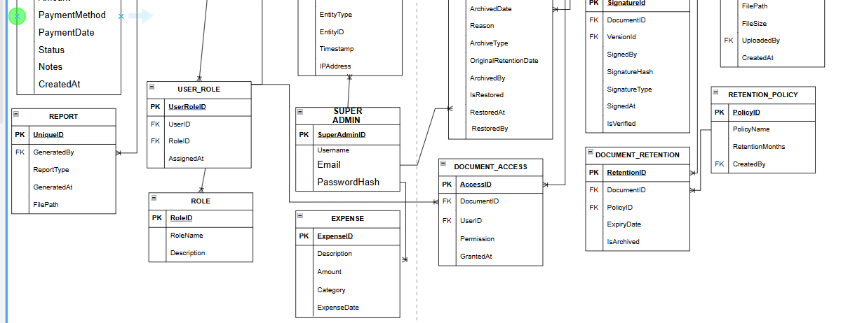  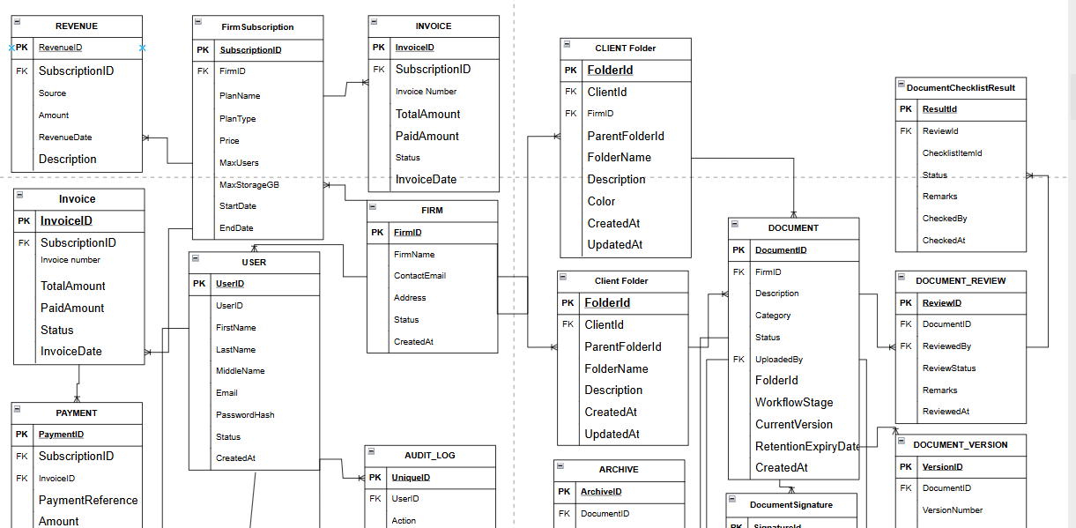
Prototype (Frontend) | SCREENSHOTS AND DESCRIPTION  - Each prototype screen must include a clear screenshot – ALL Transactions.  - Add a label name to each image.  Provide a brief description for each screen to guide users on its functionality and how to interact with it.
Prototype (Backend) | SCREENSHOTS AND DESCRIPTION (Source Code)  - Each prototype screen must include a clear screenshot.  - Add a label name to each image.  API/Algo Usage: Mention the APIs/Algos used and their specific role in the showcased functionality.
API FUNCTIONS/  FEATURES | SCREENSHOTS AND DESCRIPTION (Source Code)  - Each prototype screen must include a clear screenshot.  - Add a label name to each image.  Discuss the process on how it works.
SECURITY FEATURES | SCREENSHOTS AND DESCRIPTION (Source Code)  - Each prototype screen must include a clear screenshot.  - Add a label name to each image.  Discuss the process on how it works.
Date Submitted:
Teacher’s Feedback | _________________________________________________________________  _________________________________________________________________  _________________________________________________________________  _________________________________________________________________  _________________________________________________________________  _________________________________________________________________  ________________________________ __________________________  Student’s Signature (after feedbacking) Teacher’s Signature

