

Sales and Inventory System for Ks Ply Tire Trading

In Partial fulfillment of the requirements in IT12/L System Integration and Architecture

Presented By:

Navallo, Christian Kerby N. Vale, Benz Carl C. Toylo, Vincent Ray

Presented To:

Kyle Gian Latina
IT12L Adviser

September 9 ,2025

A C K N O W L E D G M E N T

TABLE OF CONTENTS

Page
Chapter 1 INTRODUCTION Company Profile Organizational Chart
Description of the Existing System

LIST OF TABLES

Table Page
1 Name of Table

LIST OF FIGURES

Figure Page

1 Name of Figure

Chapter 1 THE COMPANY
Company Profile
In 2018, 8Ply Tire Trading was founded by Ma’am Mabelle S. Alderite. At first, her business journey was very small and simple. She started by buying and selling tires online, using Facebook as her only platform to reach customers. Even though the business was small, Ma’am Mabelle had a natural talent for sales talk. She knew how to communicate well with people, how to explain the products, and how to convince customers to trust her. Because of this, she was able to meet many potential buyers who later became her loyal customers.

At the beginning, most of her customers were only from Davao City, but as time went by, her reach expanded. More and more customers from outside Davao began to order from her online shop. Since she could no longer handle all the work alone, she decided to hire a delivery man to help bring the tires directly to her buyers. This step made her business more organized and reliable.

The business continued to grow little by little. Eventually, it reached the point where Ma’am Mabelle decided to open her first physical store located in Mapa, Davao City. In this store, she not only sold tires but also started to offer small services such as oil changes and tire replacement. She also hired more employees to support the daily operations of the business. She had a cashier to handle payments, a mechanic to work on vehicle services, and a driver to deliver online orders.

To make the business more systematic, she also created a separate office for sales. This is where Ma’am Mabelle and her staff would sit down, calculate the monthly income, track expenses, and prepare reports. Even though the business used a manual system at that time, it was still managed carefully.
As the business grew bigger, Ma’am Mabelle partnered with her mother’s business, combining resources like staff and delivery drivers. This teamwork helped strengthen the operations and gave her more support in serving

customers efficiently. Over time, the business transitioned into a new name: KS Tire Trading. With its main branch and a new office in Maa, KS Tire Trading continues to operate and expand. Today, the business is more stable and trusted by many customers in the region. Ma’am Mabelle’s journey from selling tires online through Facebook to building a physical store and eventually managing a larger trading business shows her dedication, hard work, and ability to adapt to the changing needs of the market.

KS Tire Trading now stands as a reliable tire provider, known not only for its products but also for its good service and the strong relationship it has built with its customers throughout the years.

Organizational Chart
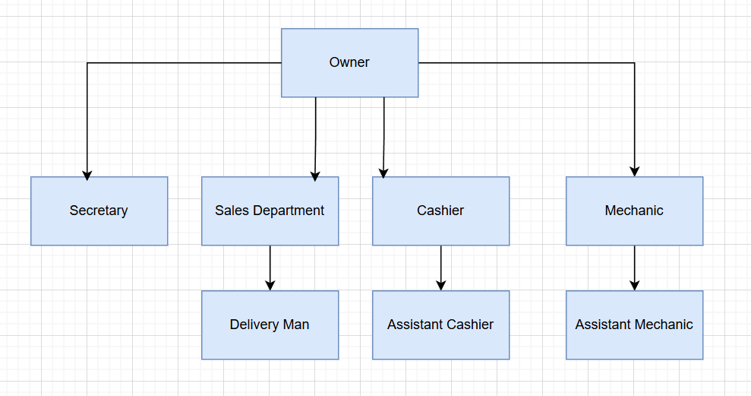

Figure 1. Organizational Chart

Business Environment
KS Tire Trading operates in a traditional business setting where most of the processes are done manually. The company follows a fixed working schedule from 8:00 AM to 5:00 PM, with employees receiving their salary every Saturday. The organization is small but functional, with each employee assigned to specific roles that help keep the business running smoothly.
The cashier plays a dual role in the business. Aside from handling customer payments, the cashier is also in charge of managing inventory and recording sales transactions. This ensures that the daily income and stock of products are properly monitored, although the system remains manual.
On the service side, the mechanic is responsible for handling customer vehicle needs such as tire replacement, oil change, and other basic maintenance services offered by the shop. This division of tasks allows the business to cater to both product sales and customer services effectively.
Delivery services are also provided, where an assigned driver handles online orders placed through the company’s Facebook page or directly from customers outside the physical store. This helps the business reach a wider market and maintain convenience for buyers who cannot personally visit the shop.
In terms of employee management, KS Tire Trading implements a straightforward salary system. Employees are paid weekly every Saturday, based on their daily attendance. If an employee is absent, a salary deduction is applied equivalent to the minimum wage for that day. This policy encourages punctuality and regular attendance, ensuring smooth operations and fair compensation.
Although the processes are not yet automated, KS Tire Trading maintains a clear structure in its daily operations. Ma’am Mabelle and her office staff handle the preparation of monthly sales reports and financial calculations, making sure the business stays organized and on track.
The business environment of KS Tire Trading reflects a small but growing enterprise that relies heavily on manual processes, teamwork, and the

dedication of its employees. Despite the limitations, it continues to provide reliable products and services to its customers in Davao City and beyond.

Description of the Existing System

Daily Time Record

KS Tire Trading uses a manual Daily Time Record (DTR) to monitor attendance. Employees work from 8:00 AM to 5:00 PM, with slight tolerance for being a few minutes late, but they must strictly log out at 5:00 PM. Absences are taken seriously; employees must inform Ma’am Mabelle beforehand, otherwise, a salary deduction equivalent to one day’s minimum wage applies. The DTR is the basis for computing weekly salaries, which are given every Saturday.

Cash Advances

KS Tire Trading allows employees to request cash advances, but the process is manual and informal. Employees must directly ask permission from Ma’am Mabelle, who decides whether to approve or deny the request. If approved, the amount is deducted from the employee’s weekly salary, which is given every Saturday. All records of cash advances are written manually, making the process simple but dependent on accurate monitoring by the cashier or management.

Preparation for Pay slip

At KS Tire Trading, salaries are prepared manually every Saturday. Ma’am Mabelle checks the Daily Time Record, absences, and cash advances. She writes a simple payment slip showing the total pay and deductions. Afterward, she personally hands the salary in cash along with the slip.

Computation of Salary

At KS Tire Trading, salaries are computed weekly. The basis is the Daily Time Record from 8:00 AM to 5:00 PM. If an employee is absent, a deduction of one day’s minimum wage is applied. Cash advances are also deducted from the total weekly pay. The final amount is then prepared and given every Saturday.

Generation of Pay slip

After computation, Ma’am Mabelle writes a simple payslip by hand, showing the employee’s gross pay, deductions, and final salary. She then hands the payslip together with the cash salary every Saturday. There is no hard calculating in salary because at the time they applied, everything is fixed and already stated.

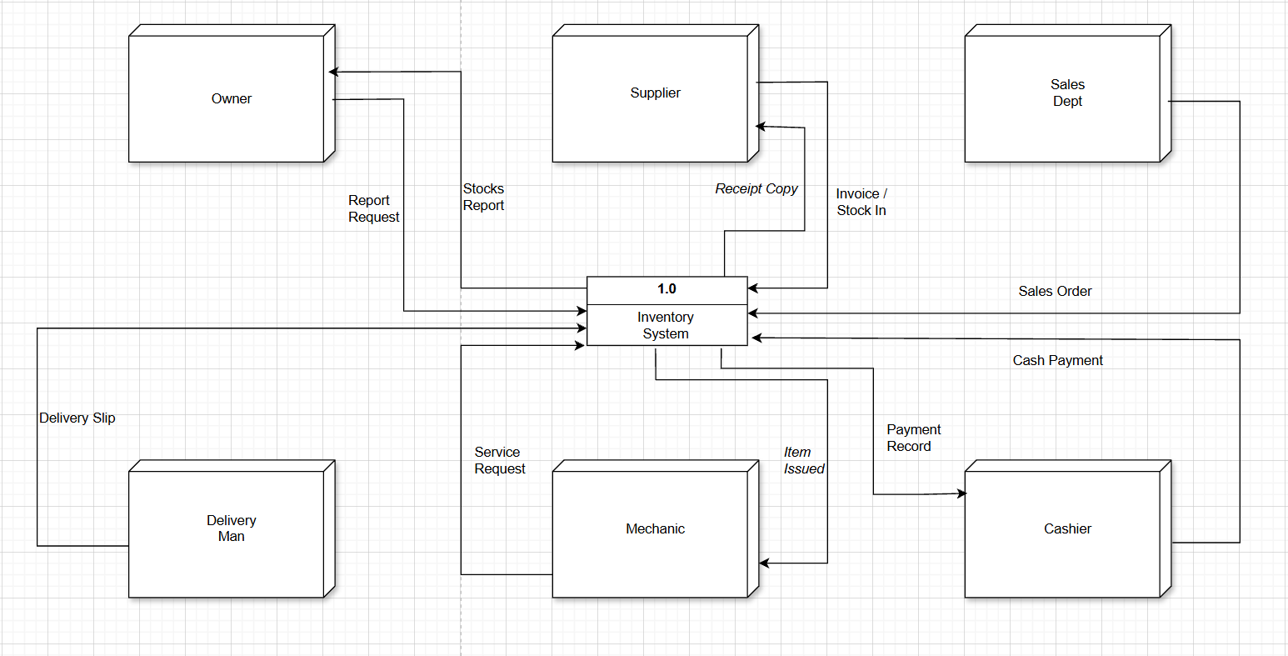
Data Flow Diagram

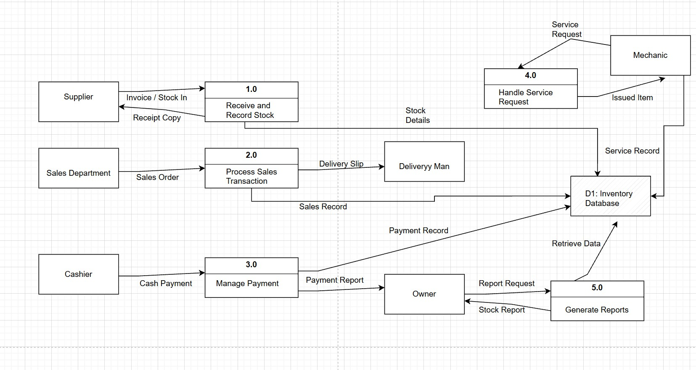

Figure 3. Level 0 Diagram

Figure 3. Level 0 Diagram

Chapter 2 THE PROBLEM
Statement of the Problem

KS Tire Trading has steadily grown from an online tire-selling business into a recognized physical store in Davao City. However, its current operations still rely heavily on manual processes that hinder efficiency and long-term growth. Inventory checking is performed manually, making stock monitoring prone to errors and delays. The point-of-sale system and record-keeping are also paper-based, which increases the risk of miscalculations and data loss. In terms of marketing, promotion is limited to a Facebook page, restricting the company’s ability to reach a wider market. Furthermore, there is no online booking system for vehicle services such as tire replacement and oil changes, resulting in walk-in congestion and scheduling difficulties. Lastly, the absence of an integrated management system creates challenges in coordinating sales, delivery, and service operations. If these issues remain unresolved, the business may struggle to keep pace with competitors that utilize more advanced and automated solutions..

Validating the Daily Time Record of the Employee is Time consuming.
At KS Tire Trading, several processes remain manual, making daily operations time-consuming, inefficient, and prone to errors. One major concern is the validation of the Daily Time Record (DTR). Employees record their attendance manually on log sheets, and during payroll preparation, Ma’am Mabelle must check these logs one by one to confirm absences, tardiness, and proper time-outs. This repetitive process consumes a lot of time and effort, especially as the number of employees grows, and increases the likelihood of errors in attendance validation.
The processing of cash advances is also informal and handwritten. Employees personally request advances from Ma’am Mabelle, and the records are manually listed by the cashier or management. Since there is no centralized system, any missed entry may cause inconsistencies and disputes in payroll deductions, making the process unreliable.
Another problem is the manual computation of salaries. Every Saturday, Ma’am Mabelle reviews the DTR, checks absences, applies deductions, and subtracts cash advances. Each step must be done by hand, which is not only time-consuming but also vulnerable to miscalculations. As the workforce increases, this task becomes even more tedious and difficult to manage efficiently.
Lastly, the generation of payslips is inefficient. After computing salaries, Ma’am Mabelle writes each payslip by hand, indicating the gross pay, deductions, and net salary before handing it to employees with their cash pay. This slows down the payroll process further and makes it difficult to keep a reliable archive of past payslips, as everything is stored only on paper.
Overall, these manual processes DTR validation, cash advance processing, salary computation, and payslip generation consume significant time, require extra effort, and are prone to human error. Without adopting a more systematic and automated approach, KS Tire Trading may continue to face operational inefficiencies that hinder accuracy, productivity, and long-term growth.
Tedious process in updating and monitoring the Cash Advance Form of the Employees
At KS Tire Trading, the process of updating and monitoring the cash advance records of employees is still done manually. Whenever an employee requests a cash advance, the approval is given directly by Ma’am Mabelle, and the transaction is recorded by hand in a logbook or simple record sheet. During payroll preparation, these records must be reviewed again to deduct the correct amounts from the employee’s weekly salary.
This process is tedious because every cash advance transaction has to be checked individually against the records. If an entry is misplaced, forgotten, or incorrectly written, it may cause errors in salary computation and lead to disputes with employees. Since there is no automated tracking or centralized database, the responsibility of ensuring the accuracy of these records falls entirely on manual monitoring by the cashier and management. As the number of employees grows, this task becomes more difficult to handle and consumes more time, reducing efficiency in payroll operations.

.

Tiresome in preparing the Salary of the Employees

At KS Tire Trading, salaries are prepared manually every Saturday. Ma’am Mabelle checks the Daily Time Record, absences, and cash advances before computing the weekly pay. This becomes tiresome because every salary must be checked and calculated by hand. As the number of employees increases, the process consumes more time, effort, and is prone to errors.

Feasibility Study

Operational Feasibility

The proposed system is operationally feasible because it can improve the efficiency of KS Tire Trading’s current processes. At present, the company relies on manual inventory checking, handwritten point-of-sale records, and simple promotion through Facebook. These methods take more time, are prone to errors, and make it difficult to track transactions and services. By adopting an automated system, the business can manage inventory more accurately, generate sales records systematically, and allow customers to book services in advance. This will make daily operations smoother and more reliable.

Technical Feasibility

The company is technically feasible because KS Tire Trading already has access to basic computer equipment and internet connectivity. The proposed solution will use software that can handle sales recording, inventory tracking, and service booking. These technologies do not require high-end infrastructure, only a stable computer setup and proper training for employees. Since the tools needed are readily available and affordable, the technical requirements are within reach of the company.

Economic Feasibility
From a financial perspective, the project is considered economically viable because its long-term benefits will outweigh the initial investment. While the company may need to allocate funds for software development, installation, and employee training, these costs are justified by the efficiency the system will bring. Automated inventory monitoring will reduce losses caused by stock errors, while accurate digital sales recording will provide better financial tracking. In addition, introducing an online service booking feature can attract more customers and generate higher revenue. Over time, these improvements will lower operational costs and increase profitability, making the project a cost-effective solution for KS Tire Trading.

Table 1. Development Team Estimated Cost (9weeks)
Human Resource for Developing the system | Number | Rate per hour | Man Days  (8 hours/day) | Total Amount
Front End Developer | X 1 | Php 197.00 | 360 hrs | ₱70,920.00
Back End Developer | X 1 | ₱197.00 | 360 hrs | ₱70,920.00
Project Manager / Systems Analyst | X 1 | Php 391.00 | 360 hrs | ₱378,000.00
Total Cost |  |  |  | ₱519,840.00

The rate per hour of the resource personnel is taken from the hourly rate for industry in the Philippines as shown from the source indicated below.
Source

PayScale (2020). Hourly Rate for Industry in the Philippines. Retrieved from https://www.payscale.com/research/PH/Industry=Software_Development/Hourly_Rate

Table 2. Hardware and Software Cost
Hardware and Software Specs | No of units needed | Price | Total Amount
Laptops (8GB RAM, 512GB SSD, Windows 10)  Desktop PC (8GB RAM, 1TB HDD, Windows 10)  External HDD (1TB)  3 Licensed MS Office (Student Edition)  Free Tools: Visual Studio Code, Canva, Figma | X2  X1  X1  X3 | ₱20,000  ₱3,000  ₱2,500 each
  ₱25,000 each
  .
  ₱80,500.00

Table 3. Effort Cost
Activities | Cost
 | 5,000
  Meeting Meals (₱200 × 5 pax × 5 meetings)
Printing and Documentation Cost | 1,500.00
Gasoline Cost/ Transportation | 4,500.00
 | 1,000.00
  Contingency Fund (miscellaneous expenses)
TOTAL Cost | Php 12,000.00

Schedule
The table below shows the estimated project duration is ten (9) weeks from Monday to Saturday. Tester and Programmers will start from start 8:00am up to 7:00pm. The Project Manager spend four (4) daily to do the task.

Table 4. Gantt Chart
Activities | Week |  |  |  |  |  |  |  |  |  | Responsibility
Activities | 1 | 2 | 3 | 4 | 5 | 6 | 7 | 8 | 9 | 10 | Responsibility
Identifying problems, opportunities and objectives |  |  |  |  |  |  |  |  |  |  | PM  (24 hrs)
Determining human information requirements |  |  |  |  |  |  |  |  |  |  | PM  (24 hrs)
Analyzing system needs |  |  |  |  |  |  |  |  |  |  | PM  (24 hrs)
Designing the recommended system |  |  |  |  |  |  |  |  |  |  | Programmer (60 hrs)
Developing and documenting software |  |  |  |  |  |  |  |  |  |  | Programmer (240 hrs)
Testing and Maintaining the system |  |  |  |  |  |  |  |  |  |  | Tester (60 hrs)
Implementing and evaluating the  system |  |  |  |  |  |  |  |  |  |  | Programmer  (60 hrs)
The impact of Maintenance |  |  |  |  |  |  |  |  |  |  | PM  (4 hrs only)

Chapter 3 THE SOLUTION
Methodology
The researcher will utilize the Systems Development Life Cycle with Human Computer Interaction model, of which it follows the eight (8) steps in incremental manner.

Identifying problems, opportunities and objectives
The Impact of Maintenance
Determining human information requirements
Implementing and evaluating the system
Analyzing system needs
Testing and Maintaining the system
Designing the recommended system
Developing and documenting software
Figure 4. SDLC Cycle

System Objectives

To integrate Jeon-soft Database to the Payroll System

The database of Jeon-soft system will automatically link to the payroll system and generates a DTR report of every employee. Those employees under manufacturing department will also use the Jeon-soft system. The DTR from the remote areas will be automatically synchronized to the payroll system.

To provide a module for filling up the Cash Advances

The prototype will provide an online module for Cash Advances of every employee, they will just log in their account so that they can access the online form for Cash advances. After they fill up the form the employee will submit it for approval process. Then after the submission, the prototype will automatically notify the admin account specifically in the Cash Advance list that there are some employees who submit a CA form for approval.

To automatically generate CA deduction per pay day and monitor cash advances payment
The prototype system has a feature that will automatically deduct the CA of the employee every pay day based on minimum amount. If in case the employee would like to increase the CA deduction, he/she alter the minimum amount using their account. The system captures the amount being entered by the employee and automatically deducts from their next payroll date. The admin account as well as the employee account can monitor the Cash Advance payment.

To check employee of CA balances

Every employee in the company are required to have an account. One of the features of the account is that the employee can review their CA balances.

To provide accurate and efficient payroll report

The proposed pay roll system is already linked with the Jeon-soft database where every employee who log in and log out using the biometric will be stored in the database and then linked in the pay roll. The pay roll report is

more accurate and efficient because the it lessens the human intervention and paper consumptions.

To view and print the pay slip online

Every employee has its own account, with that they can access and print their own pay slip through online. Anytime and anywhere they could be able to check the update of their account and the company’s official announcements.

System Requirements

Hardware Requirements
The system is running with internet connectivity to link the DTR and the payroll system. To smoothly run the system, there is a need for the following hardware specifications.

For Accounting and HR use
- A Computer Set for the Accountant intended for payroll and accounting reports with MSi A320 A10 9700 processor, 8GB RAM DDR4, 500GB HD for file storage, A4Tech Keyboard Mouse, 19 in Monitor, Headset, printer, AVR and a computer table. The HR department will use their existing computer set.
- A router, Cat 5 cable to connect the computer of Accounting Department and HR directly to the Internet Service Provider.
For employees use

- A Computer Set for the Accountant intended for payroll and accounting reports with MSi A320 A10 9700 processor, 8GB RAM DDR4, 500GB HD for file storage, A4Tech Keyboard Mouse, 19 in Monitor, Headset, AVR.

- A router, Cat 5 cable to connect the computer of employees to the Internet Service Provider for capturing the daily time record and remote application of leave and cash advances.

Software Requirements
To run the system smoothly, it must have the following software requirements for both employees, HR and accounting.
  - The platform must be in Windows 10, MS Office 2010, and a MYSQL database.
  - The recommended browser for the system is Google Chrome latest version.

Entity Relationship Diagram
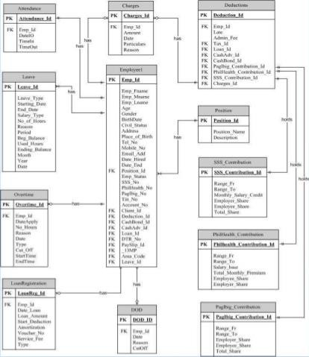

Figure 5. Entity Relationship Diagram

USE CASE



Log-in

Log-out

View DTR

HR

Calculate Payroll

View

Employee
File Leave

Apply Cash Advance
Accounting

Generate
report

Figure 6. USE Case

Scope and Limitation
The study is focusing on the payroll system of the company from the recording of the employees DTR, calculations of the payroll and the generation of the pay slip. The system is a standalone because only the HR is the authorized personnel to prepare the payroll of the employees.
The prototype will integrate the database from Jeon-soft DTR system to the payroll system to automatically capture the number of hours rendered by the employees and the number of overtime hours. Also, the prototype will automatically calculate the SSS deduction based on the SSS Salary

contribution table. For the cash advances, the prototype has its own table to keep the payment made and the remaining balances of the employee. It will automatically deduct the balances and stop the deduction when fully paid. If in case employee has to increase the minimum amount for deductions, the prototype will provide an interface to modify the amount. The prototype also automatically provides a deduction for Philhealth and HDMF.

Security Plan

The system will utilize the VPN-IPSec security, where it uses a tunneling system to access the system in an intranet infrastructure for the security of the application over the internet. For the user control, each user will have their own username and password. The HR and accounting departments have their own access privilege. The HR can only access the employees’ records in terms of their daily time record summary, update employees’ status and approve leave applications of the employees. The authorized users in the accounting department cannot manipulate the DTR approved by the HR. The accounting department can only use the DTR records for determining the numbers of days worked and the rate of the employee. In terms of cash advances approval, the system can automatically monitor if employee has still existing advances, approval of current advances will become pending. The system also will automatically notify each employee to update their password every six (6) months for security purposes.

Implementation Plan
The researcher will recommend for a direct implementation to determine the effectiveness of the system as early as possible. Early detection of bugs can be addressed immediately while the development team are still available.

System Evaluation
The evaluation of the system is based on the likert rating scale, of which five (5) is the highest and one (1) is the lowest in terms of the level of satisfaction.
5 Very Satisfied 4 Satisfied 3 Fair 2 Poor 1 Needs improvement

Table 6. System Evaluation
Criteria | 5 | 4 | 3 | 2 | 1
Ease of Installation
Ease of Use
Compatibility with the hardware requirements
Compatibility with the software requirements
Security
Responsiveness of the application with the

different browsers and devices

System Prototypes

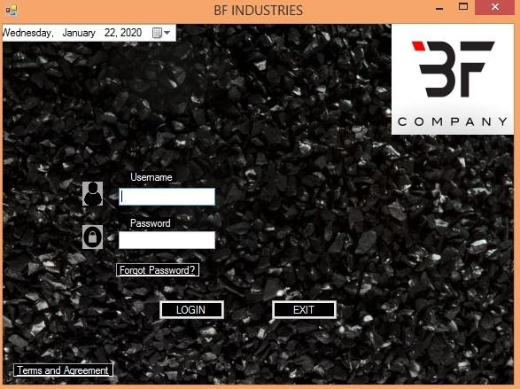
Admin Interface

Figure 7. Login Form
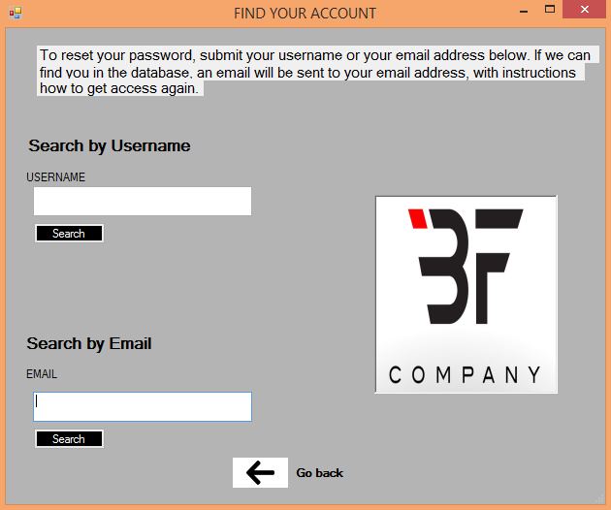
This is the form where the admin need to fill-up his/her account together with the email and password in order for him/her to log-in his account and as well as the Forgot Password link button and the Terms and Agreement link button.

Figure 8. Forgot Password
This form will be the one to pop up when you clicked the Forgot Password in the Log in form. This Figure is being used if the admin forgot his/her account password, then he/she will fill-up his/her email account or own username.

Figure 12. Terms and Agreement

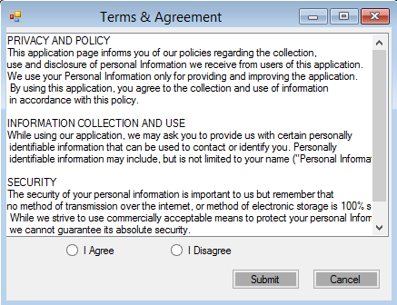
Figure 9. Data Privacy

This form will be the one to pop up when you clicked the Terms and Agreement link button in the Log in form. This phase is where the admin is reading the Terms and Agreement of the System, in order for them to enter the system they need to accept first the Agreement of the system.
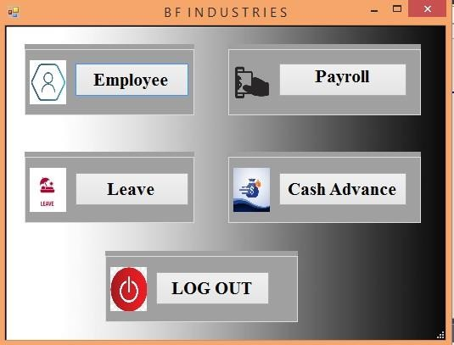

Figure 10. Home Page
This form is the home page of the system under the admin account. The homepage consists of 5 different kinds of Button which is the Employee button for the employee management form, Payroll button for the Payroll Form, leave button for the leave details like Leave list and Leave request, Cash Advance

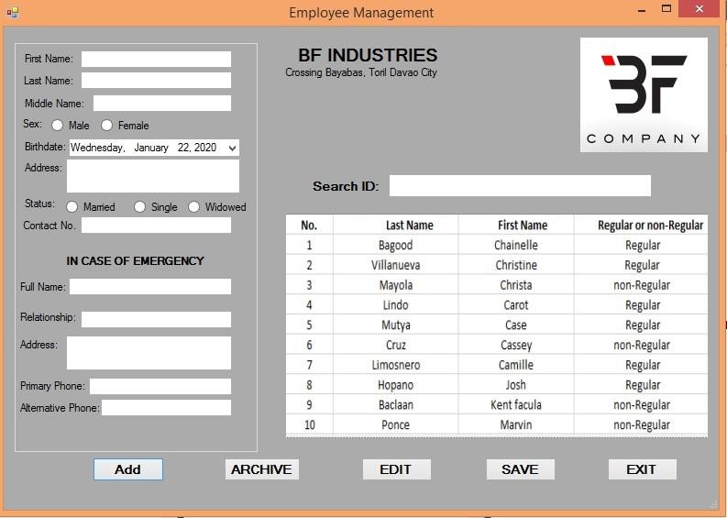
button for the Cash Advance list and Cash Advance request, , and the Log out button to log out the current log in account or you wish to change account.

Figure 11. Employee Form

The Employee management form under the Employee button in the homepage form is the processes were the admin could add, archive, and edit employee information. The admin can also use the search box for the fast searching of the employee this is the main list of every employee in the company.
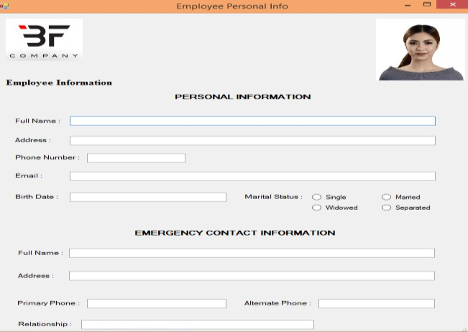

Figure 12. Employee Personal Info. Form

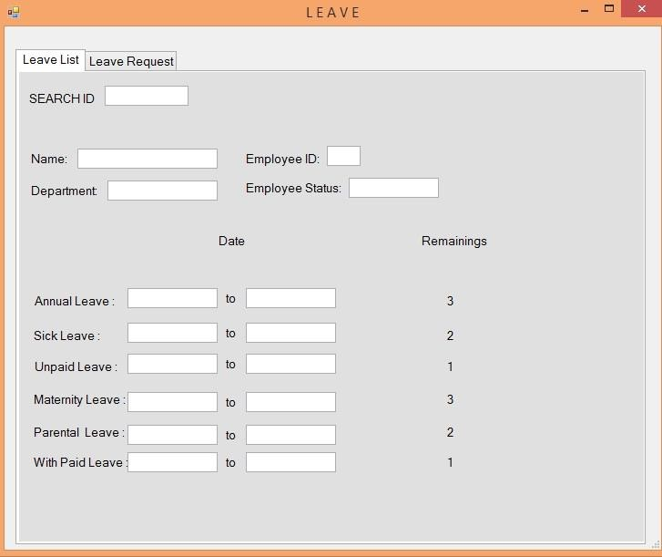
This form will show up when the admin will click some names in the Employee form list in figure 14. This form shows the Personal Information of every employee in the company including the Emergency Contact information of the employee.

Figure 13. Leave List

This form is under the Leave button in the homepage. This form shows that the admin can search employees and check the leave details of every employees and can know what is the remaining leaves that the employee can used. The admin can only use the search box for searching the specified employee.
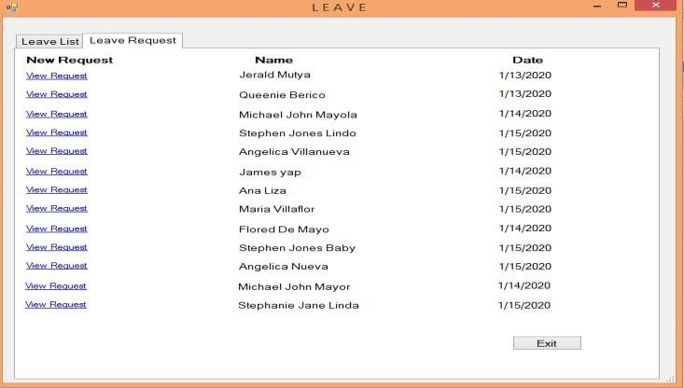

Figure 14. Leave Request

This form is the other tab under the Leave button in the Homepage. This form shows one of the features of the system where in the admin can see the leave request from every employee, and he/she will know who are those employees whom take their leaves. The admin can view their leave request form by clicking the View request link button.
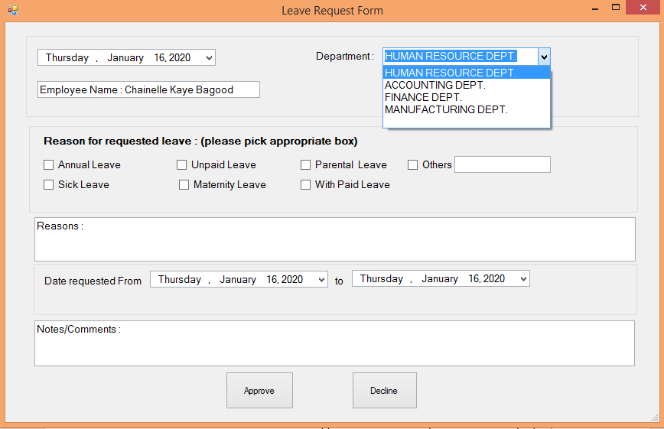

Figure 15. Approve Leave Form

After clicking the View request link button this Form will be the one to pop up and it shows on how the admin approved the leave request from the employee, then after that the admin approved the request then it will notify to the employees account that the request he/she submitted is already approved.
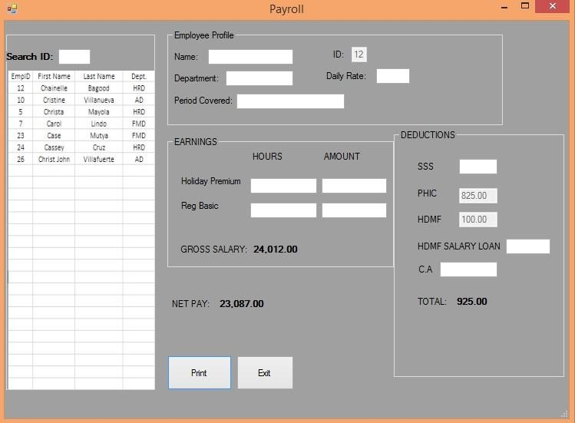
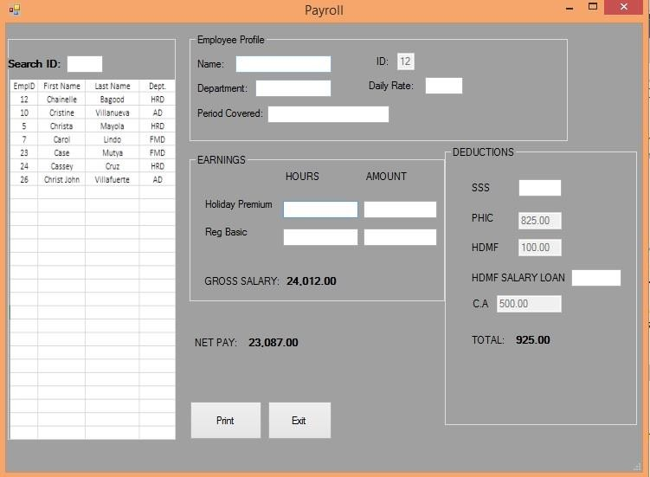

Figure 16. Payroll

This Payroll form is under the Payroll button in the homepage. This form shows that the admin can search the names of employee in the search box for the calculation of every employee’s payroll. Then after all of the Calculations for the payroll the admin then can already print the payroll.
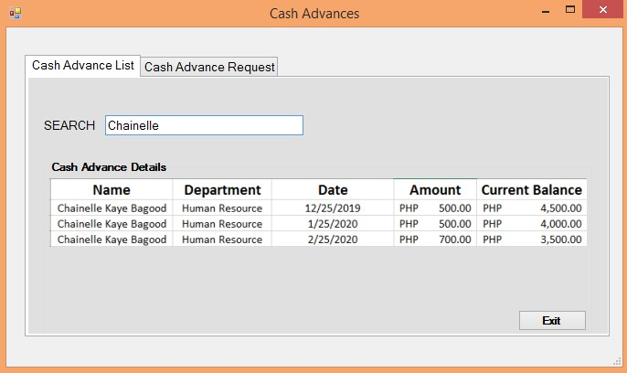

Figure 17. Cash Advance List
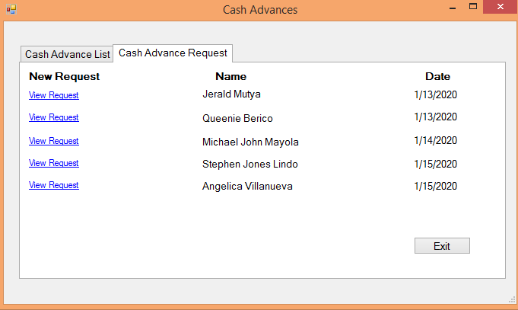
This form is under the Cash Advance button in the homepage. This form shows that the admin can search employees and see the Cash Advance history of the employee.

Figure 18. Cash Advance Request

This form is the one of the two (2) tab of the form Cash Advances button in the homepage. One of the features of the system is that the admin can see the Cash Advance request from every employee, and he/she will know who are those employees whom take their Cash Advances. The admin can view the CA request by clicking the View request link button.
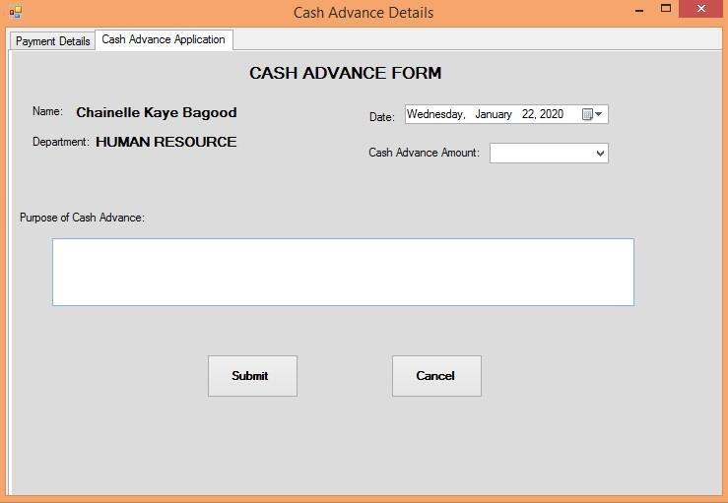

Figure 19. Approval of Cash Advance Request
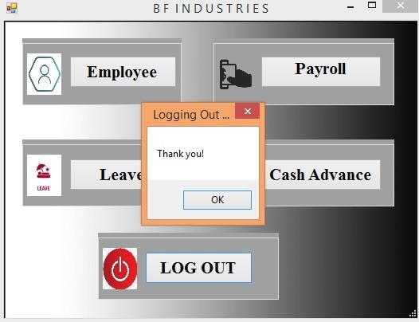
After clicking the view request link button this form will be the one to pop up. This form shows on how the admin approved the Cash Advance request from the employee, then after that the admin approved the request then it will notify to the employees account that the request he/she submitted is already approved.

Figure 23. Log out

After all of the transaction or process that done inside the system if the admin then wants to log out in the system, then he/she can just easily click the log out button to log out successfully in the system.

User Interface
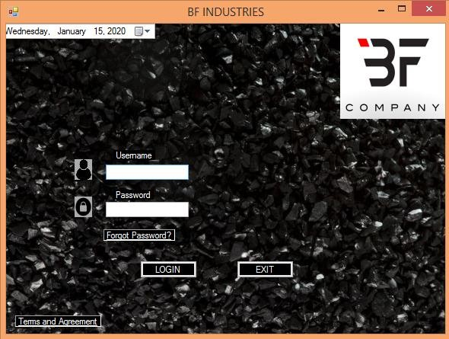

Figure 20. Log-in Form
This is the form where the admin need to fill-up his/her account together with the email and password in order for him/her to log-in his account and as well as the Forgot Password link button and the Terms and Agreement link
button.

Figure 21. Forgot Password

This form will be the one to pop up when you clicked the Forgot Password in the Log in form. This Figure is being used if the admin forgot his/her account password, then he/she will fill-up his/her email account or own username.

Figure 22. Terms and Agreement

This form is where the user is reading the Terms and Agreement of the System, then if the user agree the Terms and agreement of the system the he/she will click first the “I agree” button and submit it, so that he/she can use the system.
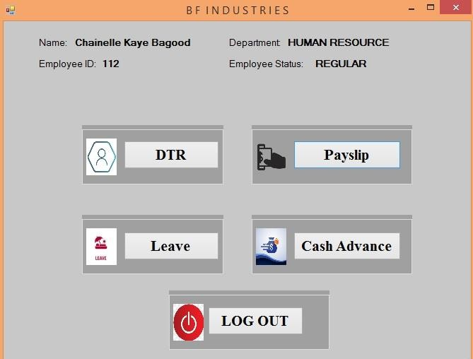

Figure 23. Home Page

This form is the home page under the user account the home page consists 5 buttons which is the Employee button, this button is being used by the employee if he/she want to know his/her daily attendance. The Payroll button this button is every time the employee wants to see his/her own pay slip. The leave button is used for filling up leave because the system itself has a features that the application for leave is through online. The Cash advance button is used also by the employee for them to take CA through online. And the Log out button, this button is being used if the employee wants to log out his/her account.
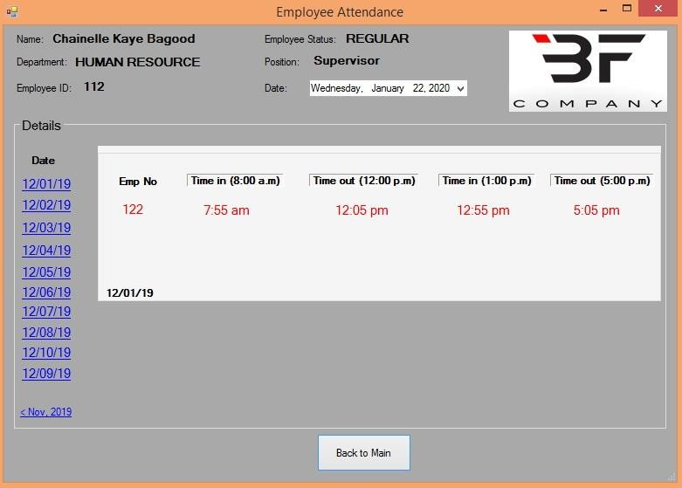

Figure 24. Employee Attendance

This form shows that the user/employee can see his/her own daily attendance in order for him/her to be aware about his/her own performance.

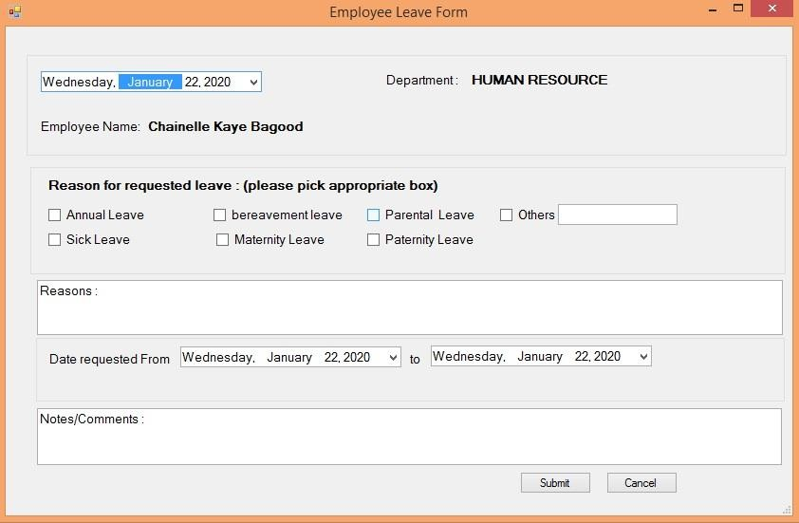

Figure 25. Employee Leave Form

This form is the leave form of the employees, wherein the employee can apply leave through online, he/she only need to filled up all the information in the leave form and click the “submit “button if he/she want to submit it and wait for approval from the admin, and if not he/she just click the “cancel” button if he/she want to cancel his application.

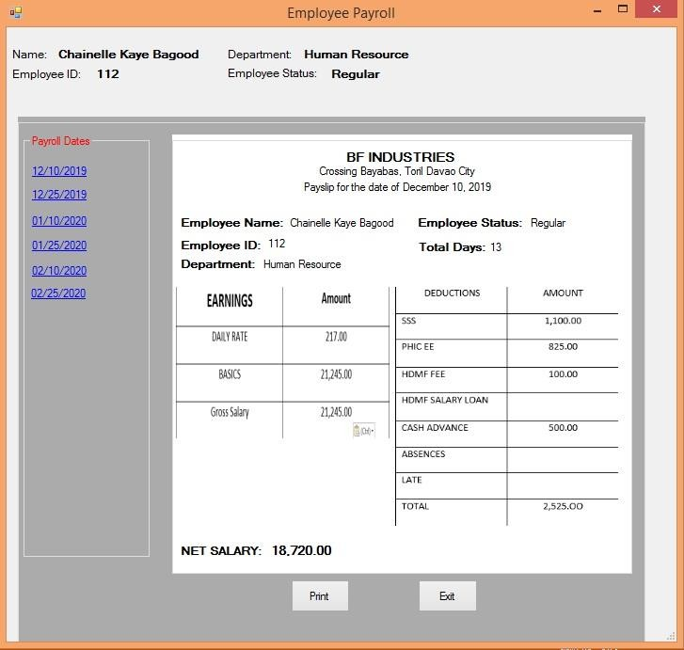

Figure 26. Employee Payroll

This form is one of the features of the system where in the employee can see his/her own pay slip, and if he/she want to print it then he/she will click the “print” button for him/her to print his/her own pay slip. And if he/she don’t want print his/her pay slip the he/she will just click the “exit” button to go back to main
page.
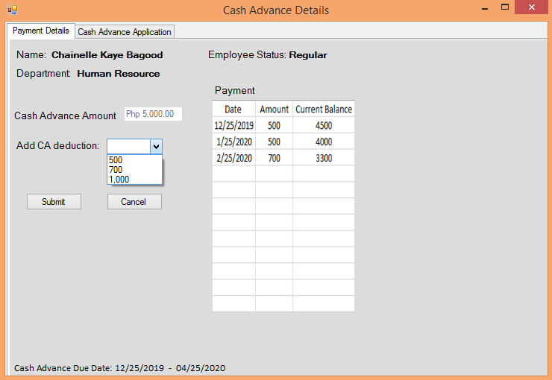

Figure 27. Cash Advance Payment Details

This form shows that the employee can see his/her Cash Advance history payments, and can request to increase deduction for his/her account, and if he/she want increase his/her CA deduction then he/she will just click the “submit” button then the deduction will automatically deduct his/her own payroll, but if he/she don’t want to increase his/her CA deduction then he/she will click the “cancel” button to cancel his/her own request.

Figure 28. Cash Advance Form

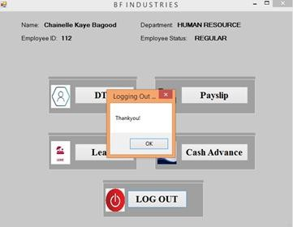
This form is the other tab form of Cash advance button which is the Cash Advance form, if the employee wants to take his/her CA he/she can apply through online by using this online CA form. Then after he/she finished to filled up the CA form then he/she will click the “submit” button then his/her form will be forwarded to the admin account then the admin will be the one to approved the CA request from the employee. But if he/she wants to cancel his/her request then he/she will click the “cancel” button to cancel request.

Figure 29. Log out

This form is the Log out process of the system under the user account, if the employee wants to log-out his/her account then he/she will just click the “log-out” button then he/she will successfully log out his account.

Super Admin Interface
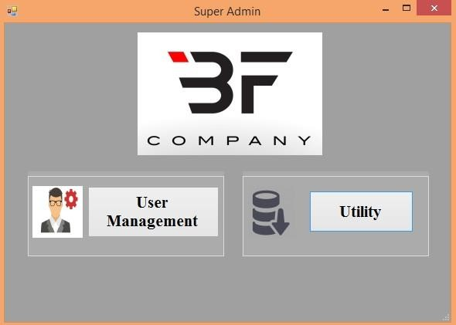
Figure 30. Super Admin Interface

This form is the super admin interface that has two (2) different button the User management and utility button.
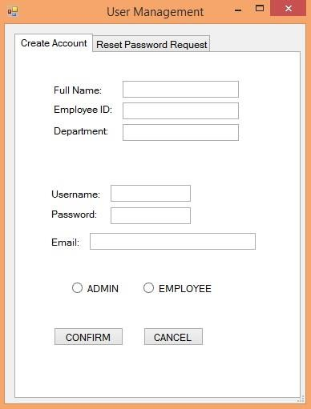

Figure 31. User Management

This form is the user management where in this form is the form where the super admin created the accounts of every users of the system.
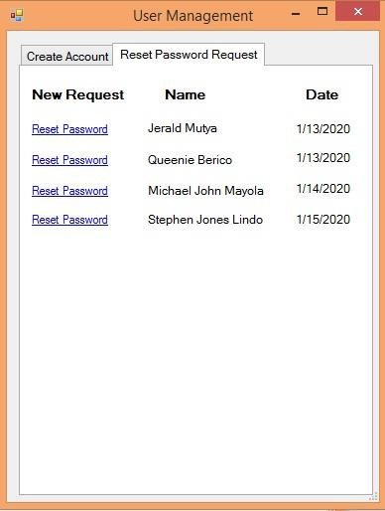

Figure 32. Reset Password Request
This form is the process where the super admin will reset every user password. This process is being done if the user forgot his/her own account password.

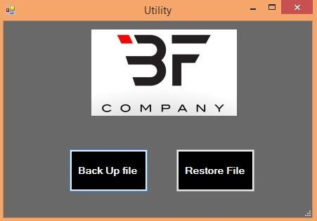

Figure 33. Systems Utility

This form is the other button under the super admin interface, this form has a two (2) different button, the backup file and restore file button.
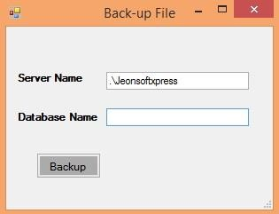

Figure 34. Backup File

This form will pop up if the super admin will click the “backup file”: button, this form is used if the super admin wants to have a backup file of some important files in the company.

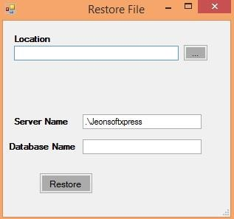

Figure 35. Restore File

This form is the restore file form under the super admin interface, this form is used if one of the users of the system deleted some important files so then the super admin will go to the utility and go to this form, and he/she can just easily restore the delete file.

Appendix A
Test Plan and Test Cases

Appendix B Survey Questionnaire

Appendix C Curriculum Vitae

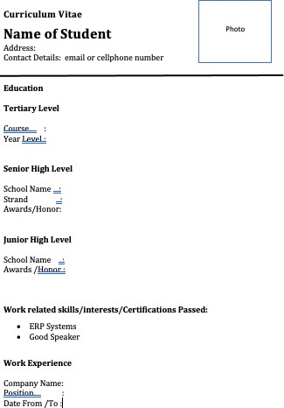

Appendix D Source Code

