Create an ISO image using FreeISO Creator:-

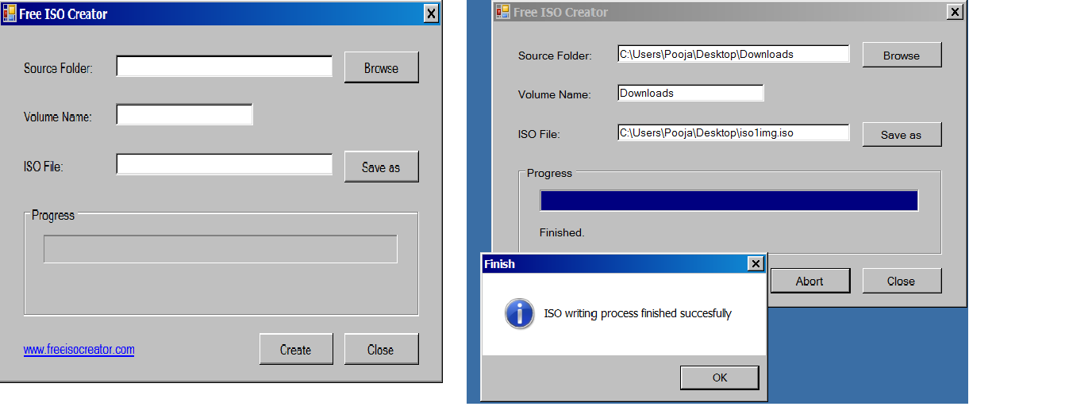

Make disk (or USB) bootable using Rufus :-

