Optimizing User, Group, and Role Management with Access Control and Workflows

Team ID: 7E81A8A8D0A263F6CD843106DD26DA72

Team Members:

Team Leader: NAVANEETHAKRISHNAN J

Team Member 1: ELAMARAN D

Team Member 2: MOHAMMED BAYAAZ M

Team Member 3: KISHORE N S

Category: Access Control and Workflow Automation

Problem Statement

Managing users, groups, and roles in modern organizations across multiple systems is a complex and inefficient task prone to security vulnerabilities. Manual

and decentralized access control processes result in excessive permissions, operational inefficiencies, compliance challenges with inadequate audit trails, scalability issues, and poor user experience due to slow access granting.

Objectives

Centralize user, group, and role management in one platform.

Implement secure Role-Based Access Control (RBAC) policies.

Automate workflows for provisioning, access modification, and revocation.

Ensure regulatory compliance with detailed audit trails and access reviews.

Reduce manual tasks to improve administrative efficiency.

Design a scalable system for growing organizations.

Enhance user experience with faster access and approval processes.

Skills Required Programming: Python, Java

Database Management: SQL, NoSQL

Access Control and Security: RBAC, Authentication, Authorization

Workflow Automation and Scripting

Web Development: HTML, CSS, JavaScript API Integration

Cloud Deployment Testing and Debugging Project Description:

This project aims to develop a centralized platform for managing users, groups, and roles with integrated RBAC and automated workflows. The system streamlines access management by automating user onboarding, role changes, and access revocation while supporting compliance and security requirements. It reduces errors caused by manual processing, improves operational efficiency, and enhances user experience. The system is scalable and adaptable to organizational growth, providing audit trails for compliance and security assurance.

Milestones and Activities

Milestone 1: Setup Environment and Architecture Configure cloud and development tools.

Define system architecture including database schema. Establish development and testing environments.

Milestone 2: Create User, Group, and Role Entities

Develop database tables representing users, groups, and roles.

Define RBAC policies and permissions. Build administration interfaces.

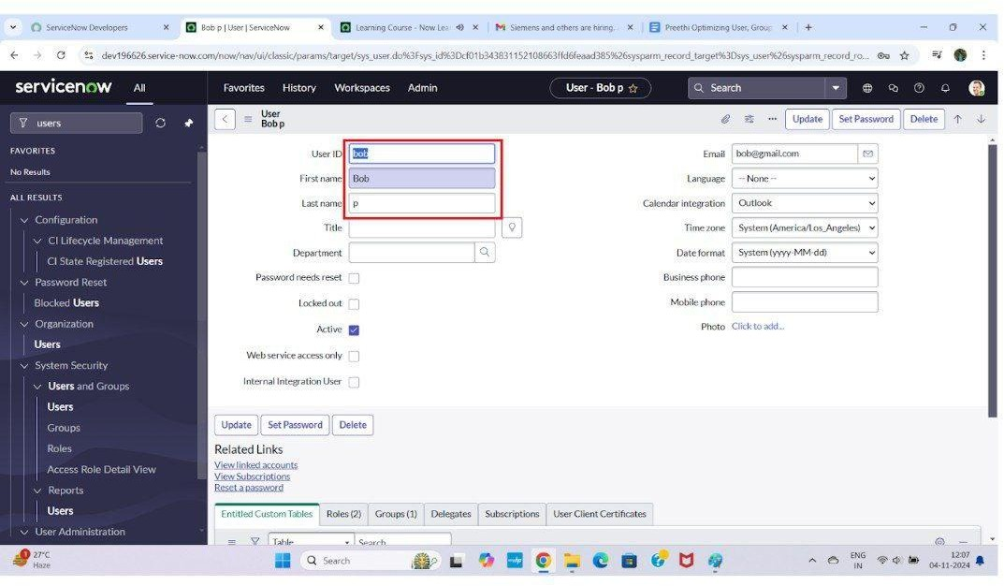

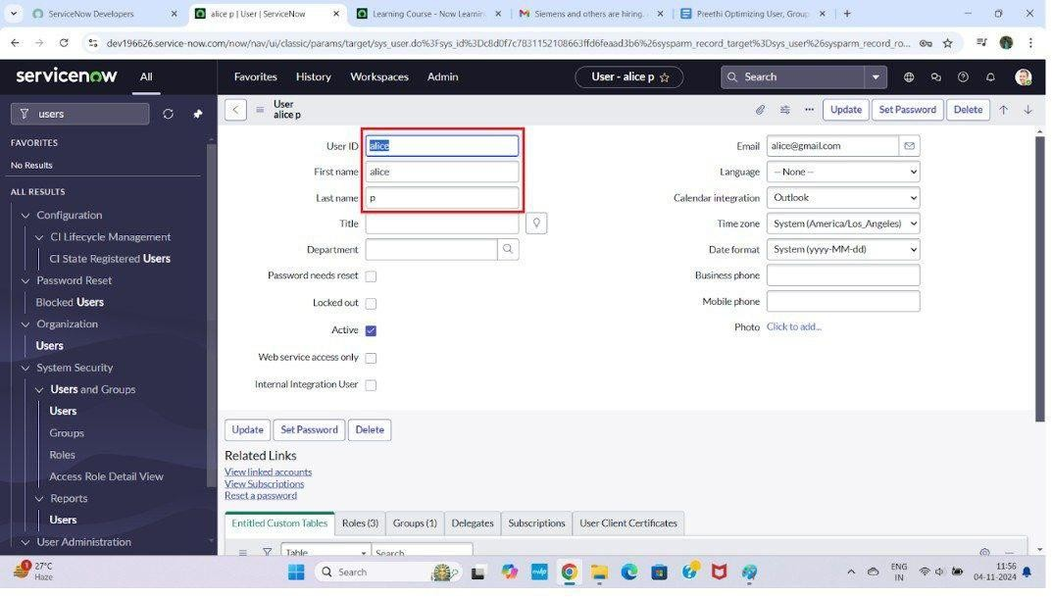

Milestone 3: Implement Workflow Automation

Design and implement automated workflows for access provisioning, modification, and revocation.

Build approval processes with role-based approvers. Integrate notifications for workflow stages.

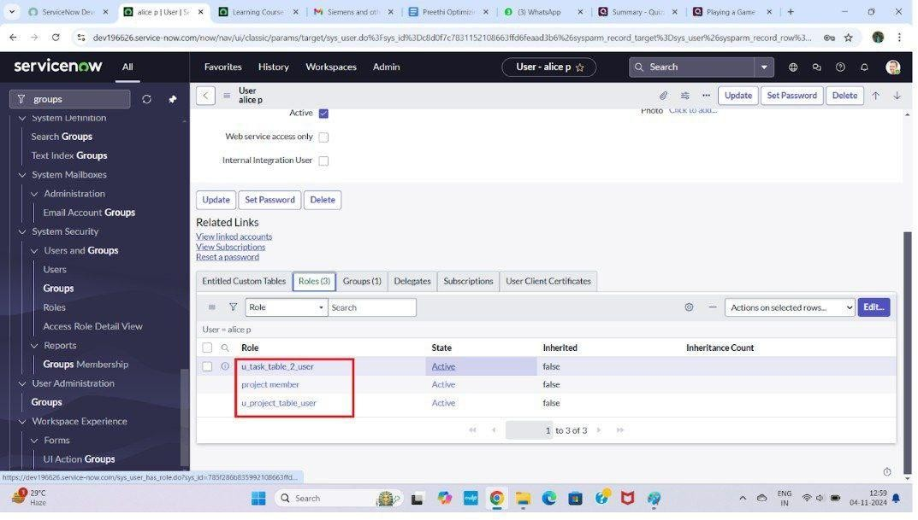

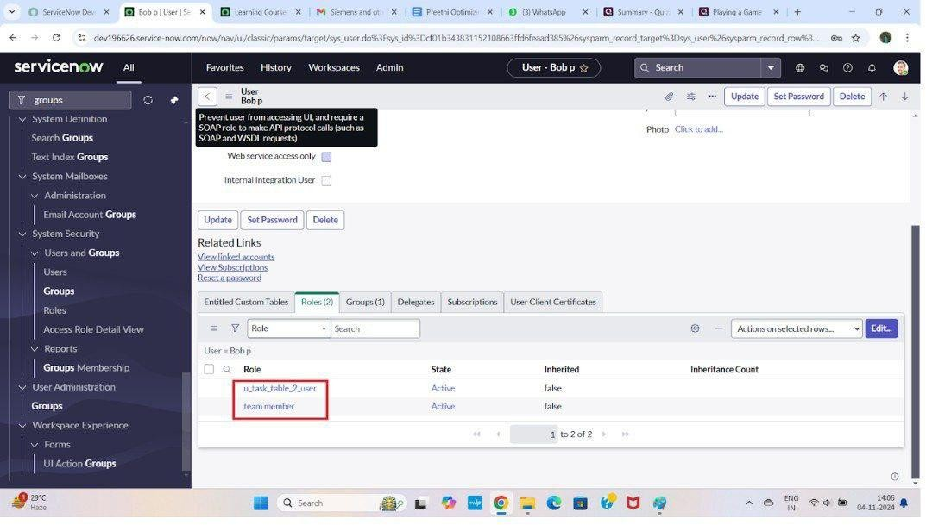

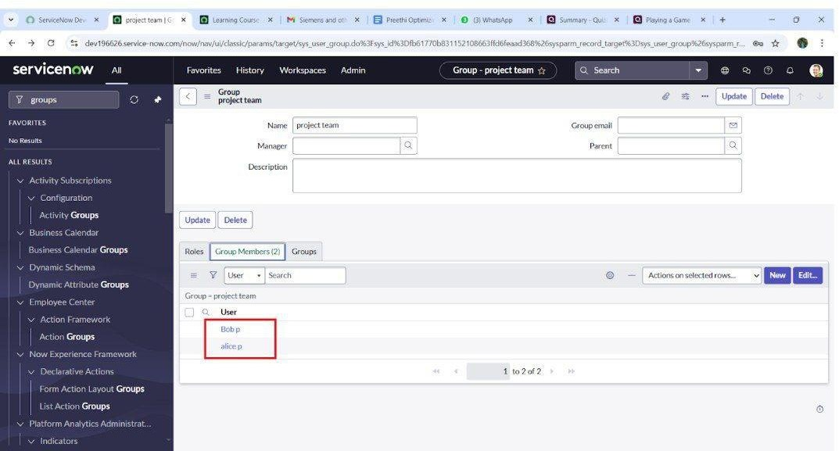

Milestone 4: Implement Approval Actions

Define action to update access task status to

“completed” upon task completion.

Create “Ask for Approval” actions routed to approvers

(e.g., Alice P).

Test approval and rejection scenarios.

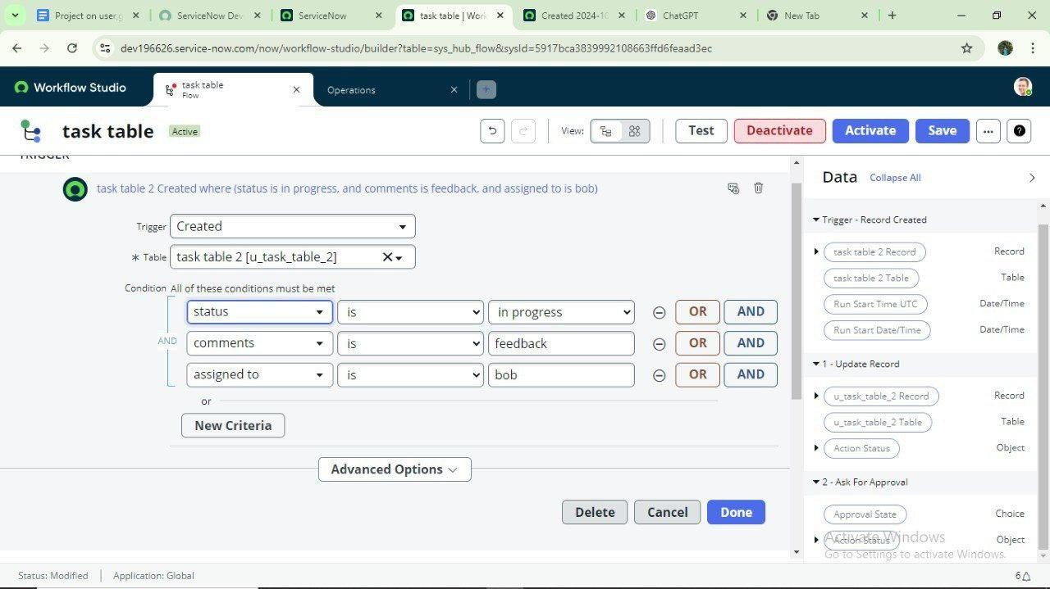

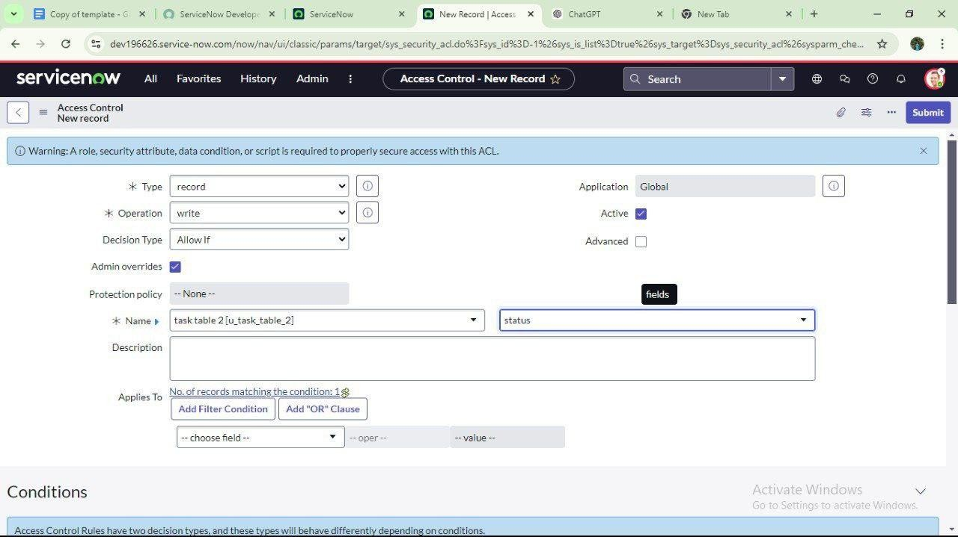

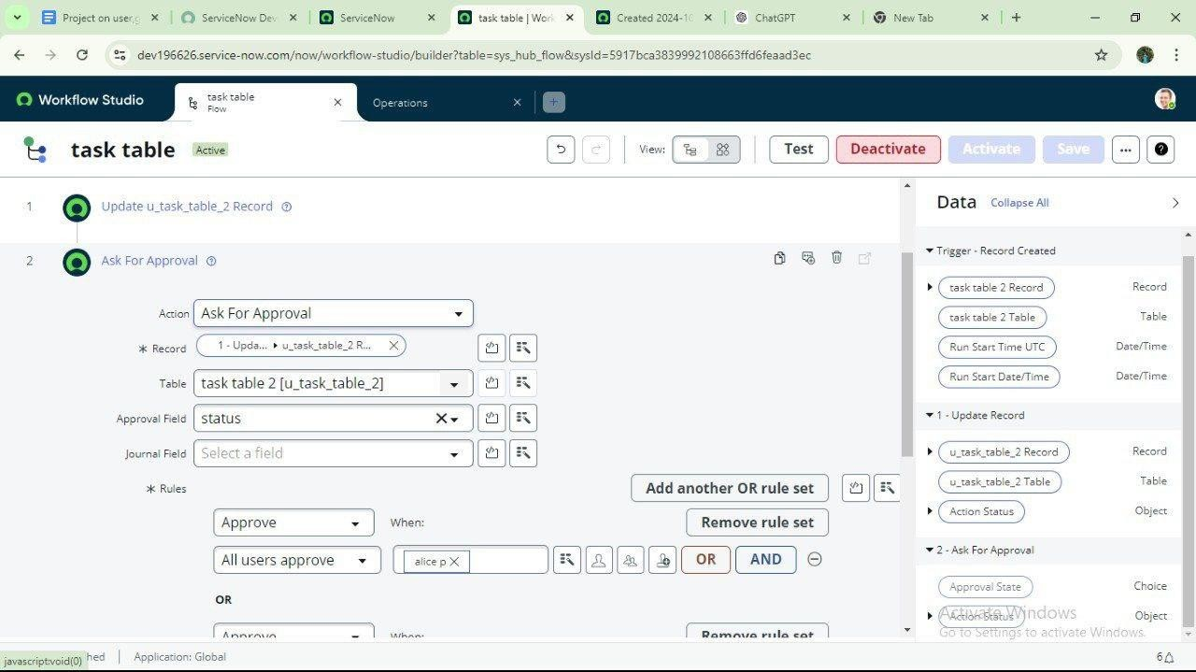

Milestone 5: Configure Task and Approval Management

Create task tables and approval interfaces for requesters and approvers.

Enable tracking of task statuses from initiation through approval.

Milestone 6: Enable Audit Logs and Compliance Reporting

Enable detailed logging of all access-related changes.

Design reports and dashboards supporting compliance audits and reviews.

Example Workflow

User requests for access trigger workflow actions updating task statuses.

Approval requests are sent to designated approvers via automated notifications.

Approvers review and approve/reject access requests.

Approved requests automatically provision access; rejected requests are logged.

System maintains audit trails for compliance.

Conclusion :

This project demonstrates a comprehensive solution for streamlined and secure management of users, groups, and roles. Through RBAC and workflow automation, it addresses security risks, operational inefficiencies, and compliance challenges. The system is scalable to meet organizational growth, reduces administrative overhead, and improves user productivity.