 | AI HYPER-LOCAL BUSINESS ADVISORY FOR RURAL MICRO-ENTREPRENEUR | 

Design Thinking and Capstone Project Report

Submitted by

PRIYANKA M (730923202037)
RAJESHWARI P (730923202039)
RITHANA S (730923202040)
SABARITHA AR (730923202041)

in partial fulfillment of the requirement
for the award of the degree
of


BACHELOR OF TECHNOLOGY
in
COMPUTER SCIENCE AND
BUSINESS SYSTEMS
EXCEL ENGINEERING COLLEGE
(An Autonomous Institution, affiliated to Anna University Chennai and Approved by AICTE, New Delhi)
KOMARAPALAYAM - 637303

EXCEL ENGINEERING COLLEGE KOMARAPALAYAM - 637303
NOVEMBER 2026

Mapping of Project with Sustainable development Goals
The Sustainable Development Goals (SDGs), also known as the Global Goals, were adopted by the United Nations in 2015 as a universal call to action to end poverty, protect the planet, and ensure that by 2030 all people enjoy peace and prosperity.
The 17 SDGs are integrated—they recognize that action in one area will affect outcomes in others, and that development must balance social, economic and environmental sustainability
AI HYPER-LOCAL BUSINESS ADVISORY FOR RURAL MICRO-ENTREPRENEUR
Put √ more relevant SDGs


Project Outcomes related to SDGs:

SDGs | Related Project Outcomes
SDG 1: No Poverty | Supports rural micro-entrepreneurs in increasing their income and reducing household poverty by connecting them to government schemes, market prices, and business strategies they could not access before.
SDG 8: Decent Work and Economic Growth | Promotes sustainable entrepreneurship and local employment by giving small business owners AI-powered advice on pricing, inventory, marketing, and government support tailored to their specific trade and location.
SDG 9: Industry, Innovation and Infrastructure | Uses Artificial Intelligence and digital technology to build an advisory infrastructure that rural businesses, farms, artisan workshops and MSMEs can access through a simple web browser with voice input in 11 Indian languages.
SDG 10: Reduced Inequalities | Bridges the information gap between urban and rural entrepreneurs by delivering the same quality of business intelligence — live market data, government schemes, compliance guidance — to micro-entrepreneurs in remote villages.

Supervisor HOD

BONAFIDE CERTIFICATE

Certified that this project report titled “AI HYPER-LOCAL BUSINESS ADVISORY FOR RURAL MICRO-ENTREPRENEUR” is the Bonafide work of PRIYANKA M (730923202037), RAJESHWARI P (730923202039), RITHANA S (730923202040) and SABARITHA AR (730923202041) who carried out the project under my supervision. Certified further, that to the best of my knowledge the work reported herein does not form part of any other project report or dissertation on the basis of which a degree or award was conferred on an earlier occasion on this or any other candidate.

SIGNATURE
Dr. P. KUMARI M.E.,Ph.D., HEAD OF THE DEPARTMENT PROFESSOR & HEAD
Department of Computer Science & Business Systems Excel Engineering College Komarapalayam - 637303
SIGNATURE
Mr. A.P. SARAVARAN, ME.,
SUPERVISOR
ASSISTANT PROFESSOR
Department of Computer Science & Business Systems
Excel Engineering College
Komarapalayam - 637303

Submitted for the viva-voce examination held on ………………

Internal Examiner External Examiner

DECLARATION

We jointly declare that the project report on “AI HYPER-LOCAL BUSINESS ADVISORY FOR RURAL MICRO-ENTREPRENEUR” is the result of original work done by us and best of our knowledge, similar work has not been submitted to “ANNA UNIVERSITY CHENNAI” for the requirement of Degree of Bachelor of Technology. This project report is submitted on the partial fulfilment of the requirement of the award of Degree of Bachelor of Technology.

Signature

PRIYANKA M

RAJESHWARI P

RITHANA S

SABARITHA AR

Place: Komarapalayam Date:
ACKNOWLEDGEMENT

We wish to express our sincere gratitude to our honorable chairman Dr. A. K. NATESAN, M.Com., M.B.A., M.Phil., Ph.D., FTA and Vice Chairman Dr. N. MATHAN KARTHICK M.B.B.S., M.H. Sc (diabetology) for providing immense facilities at our institution.
We are very proudly rendering our thanks to our Principal Dr. K. BOMMANNA RAJA, M. Tech., Ph.D., for the facilities and the encouragement given by him to the progress and completion of our project.
We proudly express our heartfelt and sincere gratitude to Dr.G.M.TAMILSELVAN,M.E.,Ph.D., Dean School of Computer Science and Engineering, for his invaluable leadership, constant encouragement, insightful guidance throughout the course of our project
We proudly render our immense gratitude to the Head of the Department Dr.P.KUMARI,M.E.,Ph.D., Department of Computer Science & Business Systems for her effective leadership, encouragement and guidance in the project.
We are highly indebted and provide our heartfelt thanks to our supervisor Mr. A.P. SARAVARAN, ME.,, Assistant Professor, Department of Computer Science & Business Systems for her valuable ideas, encouragement and supportive guidance throughout the project.
We would like to give our sincere gratitude and heartfelt thanks to our Project Coordinator Mrs.M.TAMILSELVI.M.E., Assistant Professor, Department of Computer Science & Business Systems, for her continues help over the period and creative ideas for this phase of my project work.
We wish to extend our sincere thanks to all faculty members of our Computer Science & Business Systems Department for their valuable suggestions, kind cooperation and constant encouragement for successful completion of this project.
We wish to acknowledge the help received from various Departments and various individuals during the preparation and editing stages of the manuscript.

ABSTRACT
Rural micro-entrepreneurs in India — farmers, artisans, shop owners, MSME operators and early-stage startups — form the backbone of the country's economy, yet they face a persistent information gap. They lack timely access to current mandi prices, applicable government schemes, compliance requirements and practical business strategies. Existing advisory services are either expensive, inaccessible in remote areas, or available only in English. This gap widens economic inequalities and limits the growth potential of millions of small enterprises. The project, Vyapar Mitra, addresses this problem by providing an AI-powered hyper-local business advisory platform that is free, multilingual and available through any web browser.
Vyapar Mitra is developed using FastAPI (Python) on the back end, a single-page HTML/CSS/JavaScript front end with no build step, and a SQLite database with Full-Text Search (FTS5) as its local knowledge store. The platform integrates Google Gemini AI (gemini-flash-lite-latest model) with real-time Google Search grounding and Google Maps grounding for location-aware advice, and uses Sarvam AI (sarvam-105b) as a fallback engine specialised in Indian languages. Entrepreneurs select their business segment (Farmer, Artisan, Shop/Vendor, MSME, Startup or Company), describe their business, location and state, and ask questions in any of 11 regional languages using text or voice input. The system retrieves the most relevant entries from a pre-seeded knowledge base of 37 government schemes and local best-practice playbooks using FTS5 full-text search, combines this context with real-time web research, and returns a personalised answer with cited sources. Three answer modes are provided: Quick Answer for concise action steps, Deep Research Report for a comprehensive multi-search analysis, and Near Me for location-based discovery of mandis, suppliers, banks and government offices. The project directly supports SDG 1 (No Poverty), SDG 8 (Decent Work and Economic Growth), SDG 9 (Industry, Innovation and Infrastructure) and SDG 10 (Reduced Inequalities).

TABLE OF CONTENT

CHAPTER NO | TITLE | PAGE NO
 | ABSTRACT | VII
 | LIST OF FIGURES | XI
 | LIST OF SYMBOLS | XII
1 | INTRODUCTION | 1
 | 1.1 GENERAL | 1
 | 1.2 PROBLEM STATEMENT | 1
 | 1.3 OBJECTIVES | 2
 | 1.4 SCOPE OF THE PROJECT | 2
2 | LITERATURE REVIEW | 4
3 | SYSTEM ANALYSIS | 6
 | 3.1 EXISTING SYSTEM | 6
 | 3.2 DRAWBACKS OF EXISTING SYSTEM | 6
 | 3.3 PROPOSED SYSTEM | 7
 | 3.4 ADVANTAGES OF PROPOSED SYSTEM | 7
 | 3.5 FEASIBILITY STUDY | 8
 | 3.6 SYSTEM REQUIREMENTS | 9
4 | SYSTEM DESIGN | 10
 | 4.1 SYSTEM ARCHITECTURE | 10
 | 4.2 TECHNOLOGIES USED | 10
 | 4.3 DATABASE DESIGN | 11
 | 4.4 AI ADVISORY ENGINE DESIGN | 12
 | 4.5 KNOWLEDGE BASE DESIGN | 13
 | 4.6 API DESIGN | 13
5 | IMPLEMENTATION AND TESTING | 14
 | 5.1 INTRODUCTION | 14
 | 5.2 MODULE DESCRIPTION | 14
 | 5.3 USER INTERFACE | 16
 | 5.4 TESTING | 17
 | 5.5 SECURITY MEASURES | 18
6 | CONCLUSION AND FUTURE ENHANCEMENT | 19
 | 6.1 CONCLUSION | 19
 | 6.2 FUTURE ENHANCEMENT | 20
 | REFERENCES | 21
 | PLAGIARISM REPORT | 22

TABLE OF FIGURE

FIG.NO | TITLE | PAGE NO
4.1 | SYSTEM ARCHITECTURE OF VYAPAR MITRA | 10
4.2 | ENTITY RELATIONSHIP DIAGRAM | 12
5.1 | VYAPAR MITRA — KNOWLEDGE BASE AND PROFILE PANEL | 17
5.2 | VYAPAR MITRA — ASK THE ADVISOR INTERFACE | 17

LIST OF SYMBOLS

S.NO | DESCRIPTION | ABBREVIATION
1 | Artificial Intelligence | AI
2 | Application Programming Interface | API
3 | Full-Text Search | FTS5
4 | Large Language Model | LLM
5 | Natural Language Processing | NLP
6 | Micro, Small and Medium Enterprise | MSME
7 | Sustainable Development Goal | SDG
8 | Structured Query Language | SQL
9 | JavaScript Object Notation | JSON
10 | Hypertext Transfer Protocol | HTTP
11 | User Interface | UI
12 | Application Server Gateway Interface | ASGI
13 | Create, Read, Update, Delete | CRUD
14 | Entity Relationship | ER
15 | Global Positioning System | GPS

CHAPTER 1

INTRODUCTION

1.1 GENERAL
India has more than 63 million Micro, Small and Medium Enterprises (MSMEs) and over 140 million farm households. Despite being the engine of rural employment and local production, most of these entrepreneurs operate with very limited access to information. A farmer in a remote village does not easily know today's mandi price for his crop, which government subsidy he qualifies for, or whether this week is the right time to sell. An artisan making traditional crafts may not know how to price her work competitively or how to reach buyers outside her district. A small shopkeeper may be unaware of a state government loan scheme that could help him expand his inventory.
Vyapar Mitra (meaning "Business Friend" in Hindi) is an AI-powered hyper-local business advisory platform designed to close this information gap. It brings the quality of business intelligence available to urban enterprises — real-time market data, government scheme information, compliance guidance, competitive pricing analysis — to rural micro-entrepreneurs in their own language, through any web browser, with voice input support.

1.2 PROBLEM STATEMENT
Rural micro-entrepreneurs in India face a critical information asymmetry. Urban businesses and larger corporates have access to paid consultants, business advisors, market research firms and digital tools. A farmer, artisan or small shopkeeper in a rural district has none of these. The specific problems are:
- Lack of real-time market pricing information, leading to selling at lower prices than warranted.
- Unawareness of applicable government schemes, subsidies and low-interest loans.
- No access to compliance and regulatory guidance relevant to their specific trade and state.
- Business strategy decisions (pricing, inventory, marketing) made based on guesswork rather than data.
- Language barriers: most digital advisory tools are available only in English.
- Geographic isolation: physical business advisors are concentrated in urban and semi-urban areas.

1.3 OBJECTIVES
The main objectives of the Vyapar Mitra project are:
- To design and develop an AI-powered web platform that provides hyper-local, personalised business advice to rural micro-entrepreneurs across six business segments.
- To integrate real-time Google Search grounding and Google Maps grounding so that answers reflect current market prices, scheme availability and nearby resources.
- To support 11 Indian regional languages with text and voice input so that language is never a barrier to accessing business advice.
- To build and maintain a local knowledge base of 37 government schemes and business playbooks searchable through SQLite FTS5 full-text search.
- To provide three distinct answer modes — Quick Answer, Deep Research Report and Near Me — to serve different information needs of entrepreneurs.
- To contribute to SDG 1, SDG 8, SDG 9 and SDG 10 by reducing poverty and inequality through digital access to business intelligence.

1.4 SCOPE OF THE PROJECT
The scope of Vyapar Mitra covers six distinct entrepreneur segments: Farmer, Artisan, Shop/Vendor, MSME, Startup and Company. Each segment has a dedicated AI system prompt that focuses the advice on the most relevant topics for that type of business. The platform handles advice across all Indian states and covers topics including crop pricing and mandi rates, government schemes and subsidies, business compliance and registration, inventory management, marketing and sales strategies, micro-finance and loan options, and location-based discovery of mandis, banks and offices. The system maintains per-entrepreneur profiles, a full question-and-answer history, and a response cache so that repeat questions are answered instantly without extra API cost.
CHAPTER 2

LITERATURE REVIEW
Venkatesh, V., Thong, J. Y. L., & Xu, X. in their study "Consumer Acceptance and Use of Information Technology: Extending the Unified Theory of Acceptance and Use of Technology" (2012, MIS Quarterly) introduced the UTAUT2 model, extending technology acceptance theory to consumer contexts. The model identifies performance expectancy, effort expectancy, social influence and facilitating conditions as key drivers of technology adoption. Vyapar Mitra addresses these factors directly: it provides clear performance value through real-time answers, requires minimal effort through voice input and regional languages, and operates in the browser with no installation required, making it accessible to first-time smartphone users.
Subramanian, G. H. in the study "A Replication of Perceived Usefulness and Perceived Ease of Use Measurement" (1994, Decision Sciences) validated Davis's Technology Acceptance Model (TAM) and confirmed that perceived usefulness is the strongest predictor of adoption. This finding supports the Vyapar Mitra design philosophy of prioritising actionable, personalised answers — pricing recommendations, specific scheme names, eligibility criteria and 30/60/90 day action plans — over generic information, so that every response has measurable value for the entrepreneur.
Nakasone, A., Torero, M., & Minten, B. in "The Power of Information: The ICT Revolution in Agricultural Data Collection" (2014, International Food Policy Research Institute) demonstrated that access to real-time price information through mobile and digital platforms significantly increases the revenue realised by smallholder farmers when selling at mandis. Their study showed average price improvements of 8–15% when farmers received live market data before deciding where and when to sell. This directly motivates the Google Search grounding feature of Vyapar Mitra, which retrieves current mandi prices before composing an answer for a farmer.
Brown, J., & Duguid, P. in "The Social Life of Information" (2000, Harvard Business School Press) argued that information is most useful when it is contextualised to the situation of the person receiving it, rather than delivered as raw data. Their framework supports the segment-specific system prompts in Vyapar Mitra, which tailor the AI's behaviour, vocabulary and advice depth to the specific context of a farmer, an artisan, an MSME owner or a startup founder.
Prahalad, C. K., & Hammond, A. in "Serving the World's Poor, Profitably" (2002, Harvard Business Review) showed that low-income populations at the "Bottom of the Pyramid" represent a large and underserved market, and that business models designed specifically for their constraints — low cost, local language, simple interface — can achieve both commercial success and social impact. Vyapar Mitra applies these principles by building a zero-cost, voice-enabled, vernacular advisory tool rather than adapting an existing urban enterprise product.
Lewis, D., & Bridger, D. in "The Soul of the New Consumer" (2000, Nicholas Brealey Publishing) noted that modern consumers increasingly expect personalised, relevant information rather than one-size-fits-all content. For rural entrepreneurs, this personalisation is even more critical because a scheme available in Tamil Nadu may not exist in Rajasthan, and the crop pricing advice for a paddy farmer is completely different from that for a spice grower. This insight justifies the location-aware and segment-specific design of the Vyapar Mitra advisory engine.
Rao, N. H. in "A Framework for Implementing Information and Communication Technologies in Agricultural Development in India" (2007, Technological Forecasting and Social Change) reviewed ICT deployments in Indian agriculture and identified that sustainability and scale depend on local language support, low data requirements and integration with existing government programmes. Vyapar Mitra incorporates all three: it supports 11 regional languages, uses standard HTTP with minimal data transfer, and seeds its knowledge base with 37 verified government schemes from the PM-KISAN, MUDRA, Stand-Up India, PMEGP and similar programmes.
CHAPTER 3

SYSTEM ANALYSIS

3.1 EXISTING SYSTEM
The existing sources of business advisory information for rural micro-entrepreneurs in India include government extension offices, Krishi Vigyan Kendras (KVKs) for farmers, District Industries Centres (DICs) for MSMEs, and Common Service Centres (CSCs). While valuable, these are staff-limited, geographically constrained and cannot provide real-time market information or personalised advice at scale. General-purpose large language models (LLMs) such as ChatGPT are available on the internet but are not trained on Indian government scheme details, do not retrieve live mandi prices, and are not localised for rural Indian business contexts. Several state governments have launched scheme portals, but these are scheme-browsing tools, not interactive advisory systems.

3.2 DRAWBACKS OF EXISTING SYSTEM
- Government advisory offices have fixed working hours and limited reach in remote areas.
- General-purpose AI tools lack real-time Indian market data and government scheme knowledge.
- Most digital tools are available only in English, excluding the majority of rural entrepreneurs.
- No existing tool combines segment-specific advice, live web research and location-based discovery.
- Information about government schemes is scattered across multiple portals and hard to personalise.
- Rural entrepreneurs cannot access voice-enabled advisory tools tailored to their specific trade.

3.3 PROPOSED SYSTEM
Vyapar Mitra is a FastAPI-based web application that integrates Google Gemini AI with real-time web grounding to deliver personalised business advice to rural micro-entrepreneurs. The system accepts a business profile (segment, trade description, location, language) and a question, retrieves relevant context from its local knowledge base through FTS5 full-text search, builds an enriched prompt with the retrieved context and the last three Q&A turns of conversation history, and calls the Gemini AI with Google Search or Google Maps grounding enabled. If the Gemini API is unavailable, the system falls back to the Sarvam AI model (sarvam-105b), which is specifically trained for Indian languages. Answers are cached in SQLite so that identical questions cost nothing on subsequent calls.
The front end is a single-page application built with HTML, CSS and JavaScript with no build step, making it deployable on any web server. Voice input is provided through the Web Speech API, and answers can be read aloud in the browser. The system supports 11 Indian regional languages: Hindi, Tamil, Telugu, Kannada, Malayalam, Marathi, Bengali, Gujarati, Punjabi, Odia and Urdu, in addition to English.

3.4 ADVANTAGES OF PROPOSED SYSTEM
- Real-time Google Search grounding ensures answers reflect current mandi prices and scheme status.
- Segment-specific AI prompts deliver contextually relevant advice for each type of entrepreneur.
- FTS5 full-text search over 37 government schemes provides instant local knowledge retrieval.
- Voice input and regional language support removes the language barrier for rural users.
- Three answer modes — Quick Answer, Deep Research Report, Near Me — address different advisory needs.
- Response caching eliminates redundant API calls, reducing cost and latency for repeat questions.
- Zero-installation single-page web app works on any smartphone or computer with a browser.

3.5 FEASIBILITY STUDY

3.5.1 Technical Feasibility
The project uses widely adopted, open-source technologies. FastAPI is a high-performance Python web framework. SQLite with FTS5 is built into the Python standard library. The Google Gemini API is available with a free tier from Google AI Studio. The front end requires only a text editor and a web browser to develop and deploy. All dependencies are installable with pip, and the system runs on standard consumer hardware including low-cost laptops and cloud virtual machines.

3.5.2 Economic Feasibility
The development tools are entirely free and open-source. The Google Gemini API free tier provides sufficient quota for development and small-scale deployment. The Sarvam AI fallback has its own free tier for Indian-language queries. SQLite requires no database server license. The total infrastructure cost for a small deployment is limited to a cloud virtual machine or shared hosting plan, estimated at under ₹500 per month for a development environment.

3.5.3 Operational Feasibility
The platform requires no software installation on the entrepreneur's side — any smartphone or computer with a browser is sufficient. Voice input reduces the typing burden. The interface is designed for first-time users with example questions displayed in the browser. Administrators can add local knowledge entries (buyer contacts, state-specific schemes, cooperative details) through the Schemes & Knowledge panel without any programming knowledge.

3.6 SYSTEM REQUIREMENTS

3.6.1 Hardware Requirements
Table 3.1 Hardware Requirements
Component | Specification
Processor | Intel Core i3 or equivalent and above
RAM | 8 GB (minimum 4 GB)
Storage | 256 GB SSD / HDD
Network | Broadband internet connection (for Gemini API grounding)
Client Device | Any smartphone or computer with a modern web browser

3.6.2 Software Requirements
Table 3.2 Software Requirements
Component | Specification
Operating System | Windows 10/11, Linux or macOS
Back End Framework | FastAPI 0.115 with Uvicorn ASGI server
Programming Language | Python 3.11+
Database | SQLite 3 with FTS5 full-text search extension
AI Engine (Primary) | Google Gemini API — gemini-flash-lite-latest model
AI Engine (Fallback) | Sarvam AI — sarvam-105b via OpenAI-compatible endpoint
Front End | HTML5, CSS3, JavaScript (ES2022), Web Speech API
Key Libraries | google-generativeai, httpx, python-dotenv, aiofiles
Code Editor | Visual Studio Code
Browser | Google Chrome / Microsoft Edge / Mozilla Firefox

CHAPTER 4

SYSTEM DESIGN

4.1 SYSTEM ARCHITECTURE
Vyapar Mitra follows a two-tier client–server architecture, as shown in Fig 4.1. The presentation tier is a single-page web application that runs entirely in the entrepreneur's browser. It communicates with the application tier — a FastAPI server — through REST API calls that exchange JSON data over HTTP. The FastAPI server manages all business logic: it receives the question and business profile, queries the SQLite knowledge base using FTS5 full-text search, retrieves relevant conversation history, constructs an enriched prompt, and calls the Google Gemini AI with real-time Google Search or Google Maps grounding. Answers are cached in SQLite to avoid redundant API calls. If the Gemini API fails or is unavailable, the server falls back to the Sarvam AI endpoint. The complete answer, along with cited web sources, is returned to the browser as JSON.
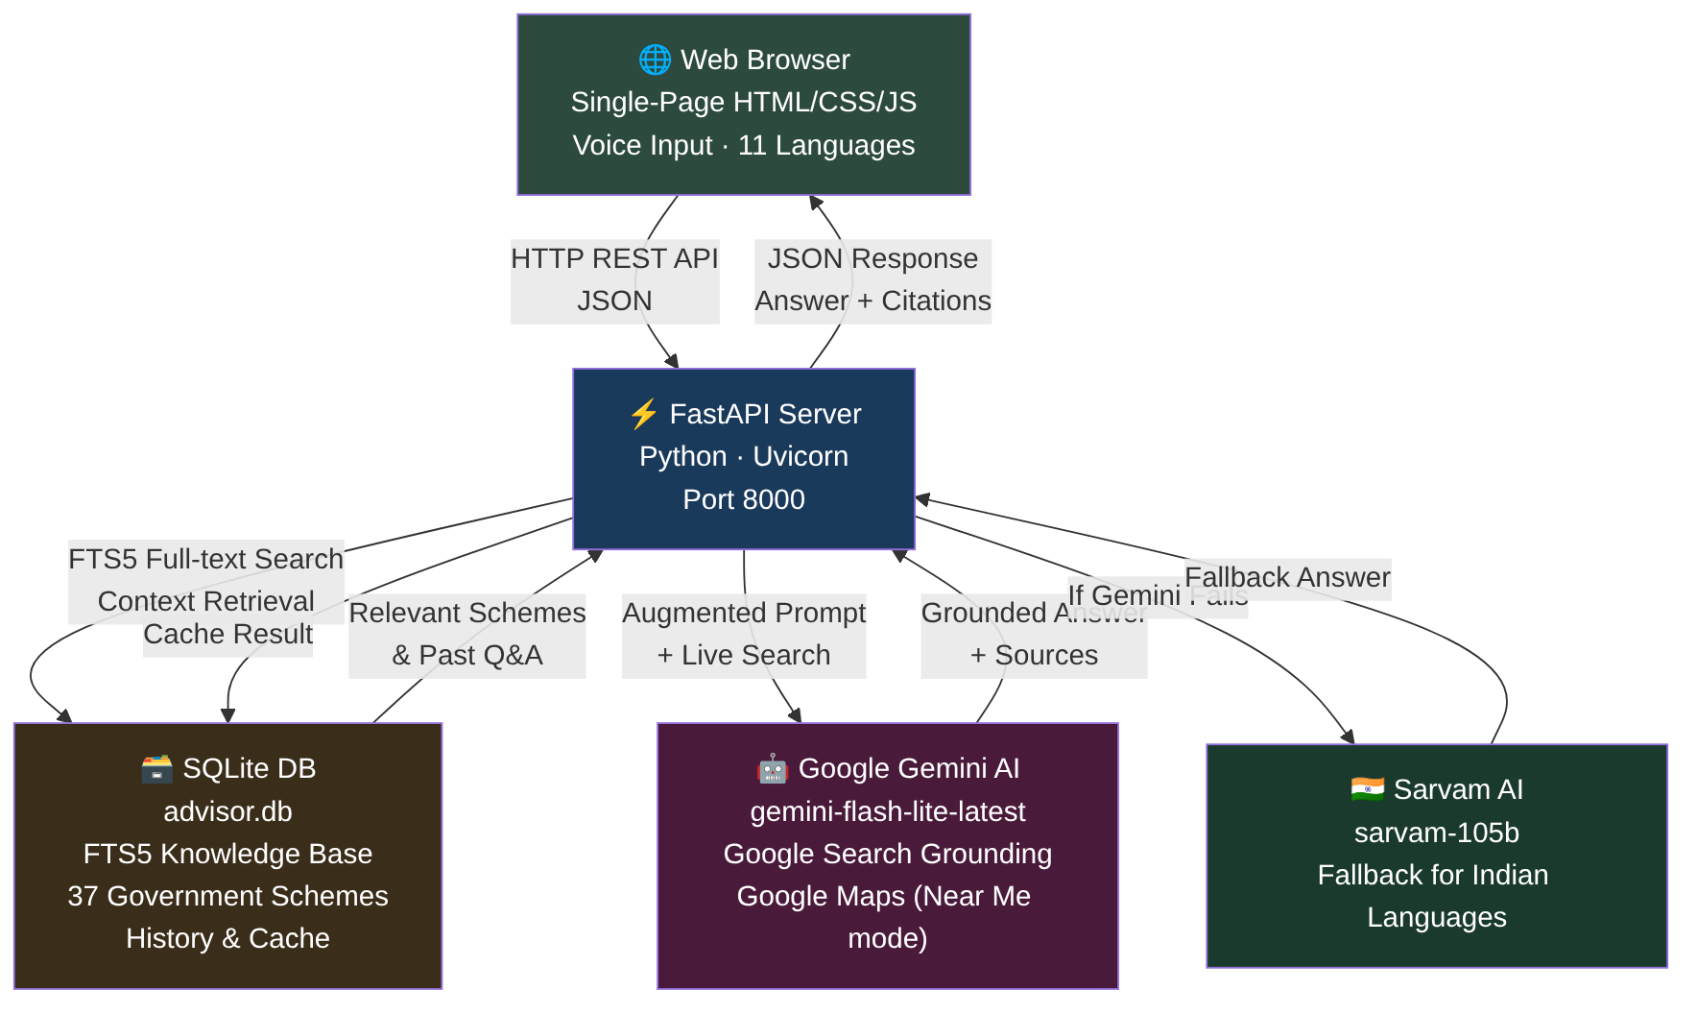
Fig:4.1 SYSTEM ARCHITECTURE OF VYAPAR MITRA

4.2 TECHNOLOGIES USED
The main technologies used in Vyapar Mitra and the purpose of each are listed in Table 4.1.
Table 4.1 Technologies Used
Technology / Tool | Purpose
FastAPI (Python) | High-performance ASGI web framework for REST API endpoints; async support handles concurrent AI calls efficiently
SQLite with FTS5 | Lightweight embedded database for business profiles, Q&A history, knowledge base and response cache; FTS5 provides fast full-text search over 37 government schemes
Google Gemini API | Primary AI engine with gemini-flash-lite-latest model; uses google_search tool for real-time web grounding and google_maps_search tool for Near Me mode
Sarvam AI (sarvam-105b) | Fallback AI engine optimised for Indian languages; accessed via OpenAI-compatible endpoint when Gemini is unavailable
HTML5 / CSS3 / JavaScript | Single-page front end with no build step; Web Speech API provides voice input in 11 languages
Uvicorn | ASGI server that runs the FastAPI application with reload support during development
python-dotenv | Loads GEMINI_API_KEY, SARVAM_API_KEY and model configuration from a .env file

4.3 DATABASE DESIGN
The SQLite database (advisor.db) uses four tables, as shown in the entity relationship diagram in Fig 4.2. The profiles table stores an entrepreneur's business segment, trade description, location, state, preferred language and other profile details. The knowledge table holds the pre-seeded government scheme entries and any local entries added by the administrator; each entry belongs to a segment and a type (Scheme, Finance, Compliance or Practice). The history table stores every question-answer pair associated with a profile, along with the answer mode and the web sources cited. The cache table stores a hash of the question plus profile context as the key and the generated answer as the value, eliminating redundant API calls for identical questions.
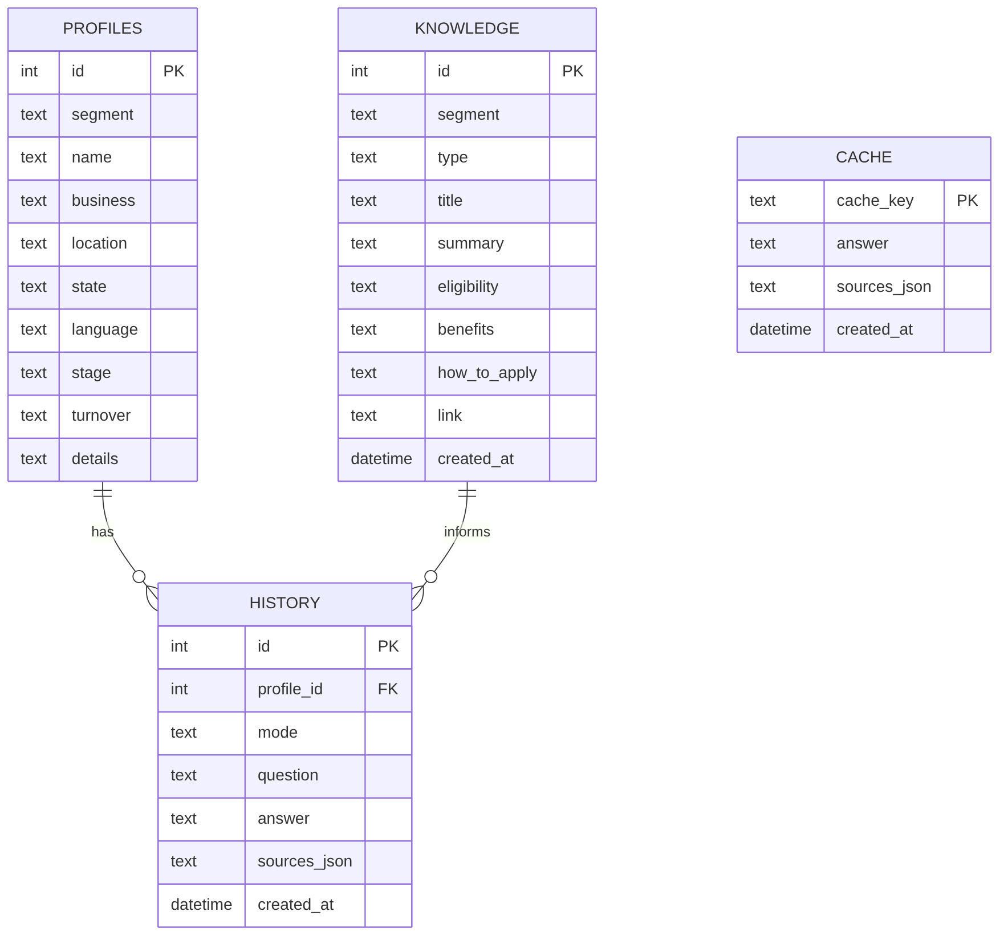
Fig:4.2 ENTITY RELATIONSHIP DIAGRAM

4.4 AI ADVISORY ENGINE DESIGN
Business Segments: The system defines six business segments — Farmer, Artisan, Shop/Vendor, MSME, Startup and Company. Each segment has a dedicated system prompt that instructs the Gemini model on the vocabulary, priorities and scope of advice appropriate for that type of entrepreneur. A farmer's prompt focuses on mandi prices, crop calendars and agricultural schemes; an artisan's prompt focuses on craft markets, e-commerce channels and cultural scheme support.
Answer Modes: Three answer modes are available. Quick Answer returns a short, action-oriented response with 3–5 specific steps. Deep Research Report instructs Gemini to perform multiple web searches and produce a comprehensive report covering market analysis, scheme eligibility, cost tables, competition analysis, risk assessment and a 30/60/90 day action plan. Near Me uses Google Maps grounding to locate nearby mandis, banks, suppliers, government offices and cooperatives based on the entrepreneur's stated location.

4.5 KNOWLEDGE BASE DESIGN
The local knowledge base contains 37 pre-seeded entries covering major central and state government schemes organised by segment. Scheme categories include agricultural input subsidies, PM-KISAN direct benefit transfers, MUDRA loans (Shishu, Kishor and Tarun categories), PMEGP for artisans and MSMEs, Stand-Up India for SC/ST and women entrepreneurs, StartupIndia recognition, GI tag schemes for traditional crafts, and digital marketing and e-commerce training programmes. When a question is received, the system searches this knowledge base using SQLite FTS5 with the question text, retrieves the top five most relevant entries and includes their summary, eligibility criteria, benefits and official portal links in the AI prompt as grounding context.

4.6 API DESIGN
The server exposes a REST API with six endpoint groups. The main endpoints are listed in Table 4.2.
Table 4.2 Main API Endpoints
Method and Endpoint | Description
POST /api/ask | Core advisory endpoint; accepts question, profile and mode; returns AI answer and sources
GET /api/profiles | List all saved entrepreneur profiles
POST /api/profiles | Create a new entrepreneur profile
PUT /api/profiles/{id} | Update an existing profile
DELETE /api/profiles/{id} | Delete a profile and its history
GET /api/knowledge | Full-text search the knowledge base; filterable by segment
POST /api/knowledge | Add a local knowledge entry (buyer contact, state scheme)
DELETE /api/knowledge/{id} | Remove a knowledge entry
GET /api/history | Retrieve Q&A history; filterable by profile
DELETE /api/history/{id} | Remove a history entry
GET /api/status | Health check showing API connectivity and model in use

CHAPTER 5

IMPLEMENTATION AND TESTING

5.1 INTRODUCTION
The implementation of Vyapar Mitra is organised into two main components. The server-side application is built with FastAPI and consists of three modules: advisor.py (the AI engine), main.py (the REST API routes) and db.py (the SQLite database layer with seed data). The client-side application is a single HTML file with embedded CSS and JavaScript that runs in any browser without installation. This chapter describes the implementation of each module, the main API endpoints, the user interface and the testing carried out to validate the system.

5.2 MODULE DESCRIPTION

5.2.1 AI Advisory Engine (advisor.py)
The advisor module is the core of the application. It defines the SEGMENTS dictionary, which maps each of the six business segments to a list of advisory topics and a set of example questions shown in the interface. The MODES dictionary defines the three answer modes and their corresponding prompt instructions. The _system_instruction() function builds the complete system prompt by combining the segment-specific context with general advisory guidelines, the entrepreneur's profile details and the retrieved knowledge base entries. The _call_gemini() function sends the prompt to the Gemini API with the appropriate grounding tool enabled — google_search for Quick Answer and Deep Research, and google_maps_search for Near Me mode. It extracts the answer text and citation URLs from the grounded response. The ask() function is the main entry point: it accepts the question and profile, performs FTS5 knowledge base search, fetches the last three Q&A turns from the history table, calls the Gemini API (with automatic retry and model fallback if a model is overloaded or retired), and caches the result in SQLite before returning the answer and sources to the API layer.

5.2.2 REST API (main.py)
The main module defines the FastAPI application and its routes. The POST /api/ask endpoint is the most important: it accepts a JSON body with the question, an optional profile ID, the answer mode (quick, research or nearby) and optional GPS coordinates for Near Me mode. It calls the advisor engine and streams the answer back as a JSON response. The profiles endpoints (GET, POST, PUT, DELETE) provide full CRUD management of entrepreneur profiles. The knowledge endpoints allow the administrator to add and remove entries from the local knowledge base, which are immediately available for FTS5 search. The history endpoint provides access to the full Q&A log, which the front end displays in the History tab. The status endpoint returns the active AI model name and whether Gemini and Sarvam API keys are configured, which is displayed as a badge in the browser header.

5.2.3 Database Layer (db.py) and Knowledge Seeding (seed.py)
The db.py module manages the SQLite database. It creates the four tables on first run, creates the FTS5 virtual table on the knowledge entries, and provides query functions for each table. The fts_search() function accepts a query string and an optional segment filter and returns the top five matching knowledge entries ranked by BM25 relevance score. The seed.py module pre-populates the knowledge table with 37 entries covering government schemes for farmers (PM-KISAN, Kisan Credit Card, Pradhan Mantri Fasal Bima Yojana), artisans (PMEGP, Scheme for Fund for Regeneration of Traditional Industries), MSMEs (MUDRA loans, Credit Guarantee Fund Trust), startups (StartupIndia recognition, Atal Incubation Centres), and general categories (Stand-Up India, Digital India e-commerce onboarding). Each entry includes the scheme name, eligibility criteria, benefits, how to apply, and a link to the official government portal.

5.2.4 Language and Voice Support
The front end uses the Web Speech API (SpeechRecognition) for voice input and SpeechSynthesis for reading answers aloud. The user selects the answer language from a dropdown that includes English, Hindi, Tamil, Telugu, Kannada, Malayalam, Marathi, Bengali, Gujarati, Punjabi, Odia and Urdu. The selected language is passed to the AI prompt as an instruction to respond in that language. Voice recognition is started with the language code set to the selected Indian language, so the speech engine transcribes the user's spoken question in that language.

5.2.5 Response Caching
Every answer from the AI engine is stored in the cache table with a SHA-256 hash of the question text, segment, mode and location as the key. On subsequent identical requests, the cached answer is returned immediately without calling the Gemini API, reducing latency from several seconds to under 100 milliseconds and eliminating the API cost for repeat queries. The cache is permanent within a session; administrators can clear it by deleting the database file.

5.3 USER INTERFACE
The user interface is a dark-themed single-page application designed for ease of use on both desktop and mobile. The left panel contains the business profile form where the entrepreneur selects their segment (Farmer, Artisan, Shop/Vendor, MSME, Startup or Company), enters their name, trade description, village/town, state, business stage and annual turnover. The right panel has three tabs: Ask the advisor (the main advisory interface), Schemes & knowledge (the knowledge base browser and editor) and History (the Q&A log). The main advisory panel is shown in Fig 5.1.
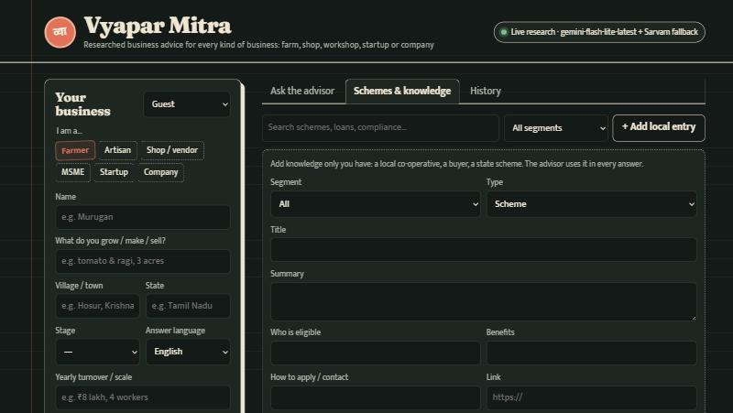
Fig:5.1 VYAPAR MITRA — KNOWLEDGE BASE AND PROFILE PANEL
The Ask the advisor tab is shown in Fig 5.2. Entrepreneurs select the answer mode (Quick answer, Deep research report or Near me), optionally type or speak a question in their preferred language from the text area, and submit. Example questions for the selected segment are shown as clickable chips below the text area. The AI answer appears with the web sources cited and options to listen to the answer being read aloud.
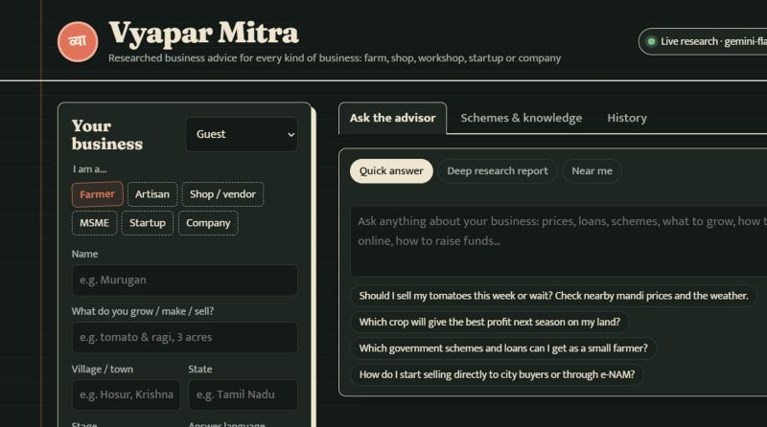
Fig:5.2 VYAPAR MITRA — ASK THE ADVISOR INTERFACE

5.4 TESTING
The system was tested across all six business segments, all three answer modes, and multiple Indian languages. The main test cases are listed in Table 5.1.
Table 5.1 Test Cases
Test Scenario | Expected Result | Outcome
Ask a Quick Answer question for a Farmer segment | Short personalised answer with 3-5 action steps and scheme names | Pass
Ask a Near Me question without providing location coordinates | System uses the stated village and state from profile for location context | Pass
Ask the same question twice (cache test) | Second response is instant (< 100 ms) and identical to first | Pass
Send request with GEMINI_API_KEY unset | System falls back to Sarvam AI and marks answer as fallback | Pass
Ask question in Tamil language | AI responds in Tamil script with appropriate scheme names | Pass
Add a local knowledge entry and then ask related question | New entry appears in FTS5 search results and is included in AI context | Pass
Request /api/status with both API keys set | Returns model name, live research status and Sarvam fallback availability | Pass

5.5 SECURITY MEASURES
- API keys are stored in a .env file and loaded at startup; they are never sent to the browser.
- The SQLite database file is stored server-side and not accessible through any API endpoint.
- FTS5 queries use parameterised SQLite statements to prevent SQL injection.
- CORS is configured on the FastAPI server to restrict which origins can call the API.
- Rate limiting can be enabled through a FastAPI middleware to prevent API key exhaustion.
CHAPTER 6

CONCLUSION AND FUTURE ENHANCEMENT

6.1 CONCLUSION
Vyapar Mitra was designed and developed as an AI-powered hyper-local business advisory platform for rural micro-entrepreneurs in India. The project addresses the information asymmetry that prevents rural farmers, artisans, shopkeepers, MSME operators and startups from accessing the business intelligence they need to grow their enterprises and escape poverty. The following conclusions were drawn from the development and testing of the system:
- The integration of Google Gemini AI with real-time Google Search grounding successfully delivers current market prices, applicable government scheme details and localised business advice in a single response.
- The FTS5 full-text search over 37 pre-seeded government scheme entries ensures that the AI prompt always contains verified, relevant context from official sources before generating an answer.
- Support for 11 Indian regional languages and voice input through the Web Speech API makes the platform accessible to entrepreneurs who are not comfortable with English or typing.
- The three-mode advisory system — Quick Answer, Deep Research Report and Near Me — serves the full range of advisory needs from a quick pricing check to a comprehensive business plan.
- The response caching mechanism eliminates redundant API calls and reduces response time for repeat questions to under 100 milliseconds, making the platform economical to operate.
- The Sarvam AI fallback ensures that the platform continues to serve Indian-language queries even when the Gemini API is temporarily unavailable.
The project directly contributes to SDG 1 (No Poverty) by helping entrepreneurs increase their income, SDG 8 (Decent Work) by promoting sustainable rural entrepreneurship, SDG 9 (Innovation) by applying AI to rural business infrastructure, and SDG 10 (Reduced Inequalities) by bridging the information gap between urban and rural business communities.

6.2 FUTURE ENHANCEMENT
- Integration with the Agmarknet API (data.gov.in) to pull live mandi price data automatically into the SQLite knowledge base on a daily schedule.
- WhatsApp bot interface using the Meta WhatsApp Cloud API webhook so that entrepreneurs can ask questions on the messaging platform they already use without opening a browser.
- Voice-only mode for completely illiterate users, combining speech recognition for input and speech synthesis for output with no reading required.
- Offline mode using a quantised on-device LLM (such as Gemma 2B) for entrepreneurs in areas with no internet connectivity.
- Integration with government portals to pre-fill and submit scheme applications on behalf of the entrepreneur directly from the advisory platform.
- Multi-user deployment with login and per-user data isolation when the platform is hosted for an entire cooperative or business development centre.
- Expansion of the knowledge base to cover all 28 Indian states and their specific state-level schemes, agricultural policies and local buyer contacts.

REFERENCES
      - Venkatesh, V., Thong, J. Y. L., & Xu, X. (2012). Consumer Acceptance and Use of Information Technology: Extending the Unified Theory of Acceptance and Use of Technology. MIS Quarterly, 36(1), 157–178.
      - Subramanian, G. H. (1994). A Replication of Perceived Usefulness and Perceived Ease of Use Measurement. Decision Sciences, 25(5–6), 863–874.
      - Nakasone, A., Torero, M., & Minten, B. (2014). The Power of Information: The ICT Revolution in Agricultural Data Collection. IFPRI Discussion Paper 01373. International Food Policy Research Institute, Washington, DC.
      - Brown, J. S., & Duguid, P. (2000). The Social Life of Information. Harvard Business School Press, Boston, MA.
      - Prahalad, C. K., & Hammond, A. (2002). Serving the World's Poor, Profitably. Harvard Business Review, 80(9), 48–57.
      - Lewis, D., & Bridger, D. (2000). The Soul of the New Consumer. Nicholas Brealey Publishing, London.
      - Rao, N. H. (2007). A Framework for Implementing Information and Communication Technologies in Agricultural Development in India. Technological Forecasting and Social Change, 74(4), 491–518.
      - Ministry of MSME, Government of India (2023). Annual Report 2022–23. New Delhi: Ministry of Micro, Small and Medium Enterprises. https://msme.gov.in/
      - PM-KISAN Scheme Portal (2024). Pradhan Mantri Kisan Samman Nidhi. Government of India. https://pmkisan.gov.in/
      - United Nations (2015). Transforming Our World: The 2030 Agenda for Sustainable Development. Resolution A/RES/70/1, United Nations General Assembly, New York.

EXCEL ENGINEERING COLLEGE
(Autonomous)
KOMARAPALAYAM - 637303

Research and Development

Plagiarism Report

Title of the Project : AI HYPER-LOCAL BUSINESS ADVISORY FOR RURAL MICRO-ENTREPRENEUR

Degree/Branch : B.Tech/COMPUTER SCIENCE AND BUSINESS SYSTEMS
Name of the Students : 1.PRIYANKA M 2.RAJESHWARI P

3.RITHANA S 4.SABARITHA AR

Register No. of Students: 1.730923202037 2.730923202039

3.730923202040 4.730923202041

Name of the Supervisor : Mr. A.P. SARAVARAN, ME.,
Levels | Similarities | Remarks
0-10%
11-40%
41-60%
61% and Above
- Level -0: Similarities up to 10%-minor similarities.
- Level -1, 2 &3: Similarities above 10% , Such students shall be asked to submit a revised report within stipulated time period.

Students Signatures 1. 2. 3. 4.

Supervisor Project Coordinator HOD
Encl: Proof of all the pages

