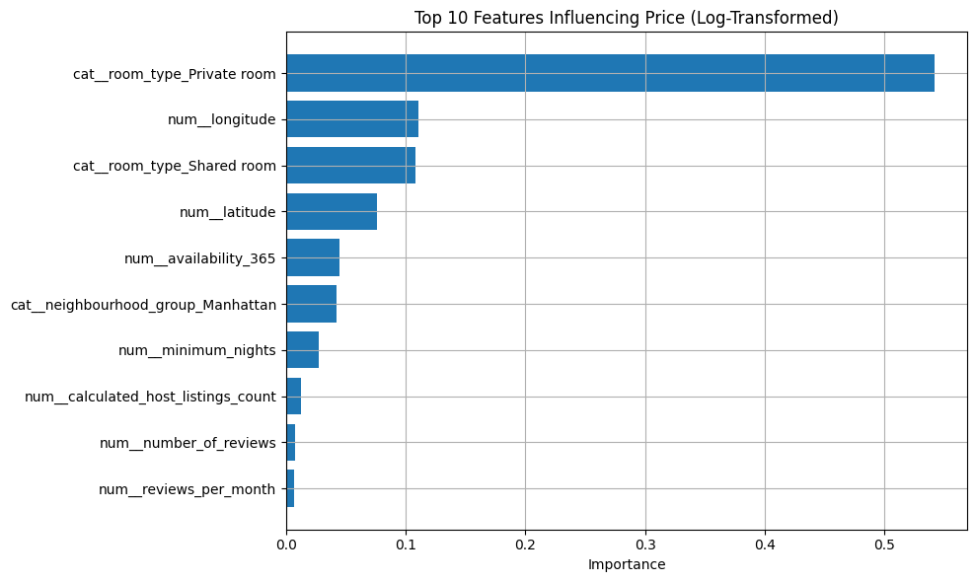

**🧠 What the Plot Tells Us?**

**1. Room Type: Private Room is the dominant factor**

* cat__room_type_Private room contributes **over 50%** of total importance.
* This means: if a listing is a *private room*, the model drastically adjusts the predicted price downward.
* Suggests the model treats *room type* as the most reliable signal for pricing.
* Takeaway: The pricing structure is **primarily driven by room categorization**, not host behavior or location.

**2. Longitude and Latitude matter, but not equally**

* num__longitude has more impact than latitude, possibly due to how NYC is laid out (east-west pricing variation is stronger).
* Suggests **location is important**, but in this model it’s **less powerful than room type**.

**3. Shared Room is a weaker, but still relevant price signal**

* cat__room_type_Shared room is moderately important — it's associated with **lower pricing**, but occurs less frequently than private rooms.

**4. Availability & Manhattan location contribute modestly**

* availability_365 and cat__neighbourhood_group_Manhattan matter, but much less.
* Availability affects income potential, but maybe not direct price.

**5. Other features have very little impact**

* minimum_nights, host_listings_count, reviews, etc. have **minimal predictive power** in this setup.
* These might still matter when **combined** or **engineered into smarter features** (like availability * reviews, or listing_age).