ANATOLIAN HIEROGLYPHIC INSCRIPTIONS IV

In my previous article, The Anatolian Hieroglyphic Inscriptions III, I had mentioned the two simultaneous battles of c. 750 BC of the Proto-Armenians, that is, in the north and south of their habitation places in the country of Aram. The Proto-Armenian habitation places, the Aram country of Armenian traditions¹, can be described as south-east and central Anatolia, that is, from the borders of Urartu or the Euphrates River to the west to Kayseri and its surrounding districts; in the north, from the Kaska lands down south to the Syrian border and Cilicia Trachea together with its northern districts. In my previous article I had also quoted and translated the Topada Inscription concerning the northern battle of Wasusaramimasa (= Throne or Kingdom of god Sarma, in Armenian traditions the name is just Harma – S of Sarma > H. Please note that the ancient Proto-Armenian names of the kings have sometime in 2nd or 3rd century AD have been translated into classical Armenian for the understanding of the people of the time) of Tabal, which with its capital city of Kululu was practically bordering the Kaska lands.
In this article I shall discuss the Cekke Inscription of c. 750 BC of Kamana (No Will – a child king could not have been any different. In Armenian traditions’ Havanak = Little Consenter) of Carchemish, and give the full translation of the text with accompanying comments and explanations.
Kamana was the first-borne of Astiruwa (= Mighty Thinker or Just Soul), who died sometime about c. 770 BC in the plague that had spread throughout the habitation places of the Proto-Armenians. Iarairaisa (= Attached to the Mighty Thinker/Just Soul), the Chancellor of Astiruwa, had taken over the government of the country of Carchemish and, according to what he writes in inscriptions Car.A6, A7 and A15b, was ruling like a king. When Kamana was 12 years old Iarairaisa raised him to the throne of Carchemish, but, still, he was in charge of the government of the realm – this is what one concludes by reading his inscription of Car.A6, irrespective the fact that at the very end of his inscription Car.A5a Kamana says: “He (the deceased Astiruwa) left the regions to the suffering Queen to rule”.
The treaty between the northern Bar-Ga’ya of the Kaska people, and the southern Kingdom of Arpat, Mati’ilu of the Aramaeans², I presume, had the intention of simultaneously attacking the Proto-Armenian kingdoms that existed between them and taking over the lands, which would make them greater powers. As we have seen, the northern campaign failed according to the Topada inscription; it was no different in the case of the southern battle, as detailed in Cekke inscription under discussion.
The Cekke inscription appears to be in good order and is longer than the Topada, thus more detailed. The date of c.750 BC for its execution is acceptable, since at the time of the erection of the stele, Iarairaisa had already died in Nineveh (754/3 BC)³, and his son Sastura had become the new chancellor of the kingdom of Carchemish. It appears the language and its attunement to the script was perfected by the time of Kamana, and the scribe, who composed the Cekke inscription, was well qualified for the task, since he had produced so many fine idiomatic phrases, which do not have the same power in translation, and are not as impressive as the original.
It is possible that Kamana’s badly damaged Inscription, Carchemish A4a, is also in connection with the subject of Mati’ilu’s attack on one of his cities named after him as Kamana.
The various details and explanations of the phrases or words I shall enumerate in my notes at the end of this article. My translation, in block letters, is followed by its transliterated part in parenthesis, and each section of the text is split to its sentences.

THE CEKKE INSCRIPTION, No.28:

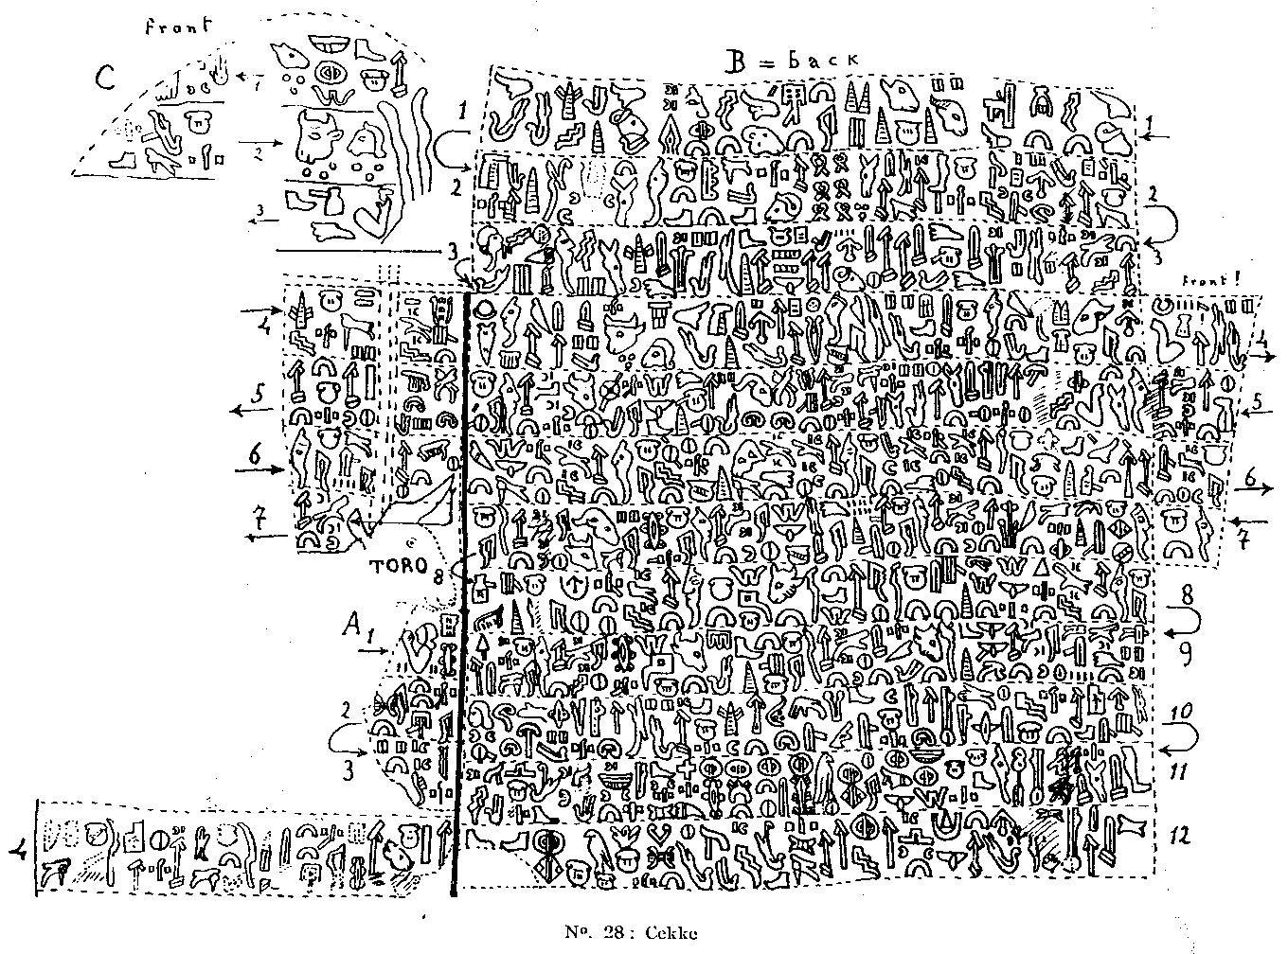

A1.1: AMU mi ki (191 = SUN =) TI-wa+ra sa Sa-sa-tu+ra sa wa-sa mi sa mi-ti
My most knowledgeable Sastura (Amu mi ki (TI⁴ wa+ra=) Tiw-ara sa Sastura sa) is the chancellor to my kingdom (wasa mi sa miti).

A1.2: A-wa zi-(sa) (382= BAR) pa u-(pa) za (ki) (191=SUN=) TI-wa+ra sa Sa-sa-tu+ra-ia (i-na) a-pa-sa na (65=) TUWA ta / za ha-wa (267=) WANA zi a-pa-(na sa) a-ta
Due to (awa zi sa) his superior knowledge (Tiw-ara sa), whoever he talked to (pa upa za) Sastura outwitted him (i-na a-pasa na), punished (Tuwa⁵ ta) and dismissed (wa na) such individuals (za hawa) because (zi) he had seen through them (a-pana sa a-ta).

B1.3: `Ka-ma-na sa (371=) TARAWANA sa Kara-ka-mi-sa CITY u-pa CITY COUNTRY tara `Sa-sa-tu+ra sa `Ka-ma-na sa NA li sa mi-ti
Kamana is the ruler of Carchemish city (Kamana sa tara-wa-na⁶ sa Karakamisa city) where Sastura (upa Sastura sa) is the chancellor (Na li sa miti) of the city and country of Kamana’s government (Kamana sa city country tara)

B1.4: Ka-ma-na na CITY CITY mi na na ka-na
He went round (na kana) to the city of Kamana (Kamana na city), one of my cities (city mi na).

B2.5: Pu wa na za CITY (58=) PISI na (344=) ‘SASA’ sa za a-pa sa-ti (314=) KATU sa
He attacked the city (pu wa na za city) as if in reprimand (pisi na sasa sa za), thenceforth calm came to an end (apa sati katu sa).

B2.6: ta na ti-wa ma-za (6x399=) 600 (404+100=) ASU :· i-za pi ta za
He gave the priests (ta na tiwa) a beating (maza) and by force seized 600 of their donkeys (600 asu i-za pi ta za).

B2.7: / (82=) TÁ+ra pa-wa (57=) PI na (382= BAR) (260=) “WA” i+ra (388=) TARA
He carried (tára⁷ pawa) their provisions (pi na) to his own domain (ira tara)

B2.8: (268=) HUR ma-na za (260=) WA za `Wa+ra pa-ta
He carries on attacking (wa za `Wara-pa-ta⁸) and spreads such turmoil (hur mana za).

B3.9: sa za (45=)”INFANT” na wa za pi mi na / (390=) LORD-ia la, la pa+ra-ia na za
His son (Infant na) attacked me (pi mi na) and became the overlord (of Kamanna city) (Lord-ia la) and they honoured him (la para-ia na za),

B3.10: za-ia ha-mi (268=) HUR ma-na zi
Since he was spreading turmoil everywhere (za-ia hami hur mana zi)

B3.11: wa za (348=) LATALI nu hu ti za CITY pi mi na
His numerous hordes (hu ti za) persevering a great (wa za Latali nu) attack on my city (city pi mi na).

B3.12: / (390=) LORD-ia la CITY mi na za,
He is the ruler (Lord-ia na za) of my realm’s city (la city mi).

B3.13: na mi a-ha zu-ia na (388=) TARA (14=) PARA na
All around the kingdom (tara para na) and for me (na mi) created fear (aha) and confusion (zu-ia na)

B4.14: (336=) USA a-pa li za i-zi-ia
Afterwards (upa) there was (izi-ia) much disturbances (usa li za)

B4.15: mi na wa (105+404=) WAWA :· (516=) FIFTEEN (111=) GARA
He took my cows (mi na wa wawa) and fifteen lambs (fifteen gara)

B4.16: ka-na pu CITY-ia (384=) TUWA (268=) HUR na
Marched around ravaging (kana pu) and set fire to the city (citi-ia tu-wa hur na)

B4.17: zi wa za tu (501=) TURA-a-i li sa pi mi na tara ti wa+ra-ia pa-wa a-ha li sa-na upa sa
At the same time (zi) killing a great number (wa za tu tura-a-i li sa). Attacking me (pi mi na) and setting on fire the great realm (tara ti wara-ia) he caused much fear (pawa aha li sana) for everyone (upa sa)

B4.18: (14=) PARA ti COUNTRY (347= UPA) u-pa sa / (268=) HUR sa (33=) MITA mi+ra sa zi pi mi na …
All over the great country (para ti country) he set fire to my properties (hur sa mi-ta mi-ira sa), because I attacked him (zi pi mi na)…

B4.19: CITY mi na pa-wa (517=) SUSU ta mi-(397=)-SU⁹ “INFANT” na ki ta+ra sa
He imposed tax (pawa susu ta) on my city (city mi na) and his son (infant na) was getting fat (misu na) as supreme authority (ki tara sa).

B5.20: (31=HISA) Hi-sa hi-mi na (382=BAR) ha-za na sa pa-wa za sa-ha pu zi sa
He (the father) is now sick (hisa himi na) and is in trouble (haza na sa pawa za) because (zi) he has grown weak (saha pu sa).

B5.21: “INFANT” na wa za sa a-sa za (32=) TA li (i+ra) na sa (363=) URA-ia zi ha
His son went to see him (Infant na wa za a-sa za), he gave him many goods (ta li ira na sa) as he was laden with them (ura-ia zi ha),

B5.22: a-wa (217=) USATU ha+ra-ia za sa-ha zi mi na / wa za a+ra za
Eventually his attack lost its drive (awa usatu hara za saha) since I was resisting all of his offensives (zi mi na wa za ara za).

B5.23: “INFANT” na wa za ha ki ta+ra sa (31=HISA) hi-sa hi-mi na
His son went to his quarters to see him (Infant na wa za ha ki tara sa) where he now lay sick (hi-sa himi na),

B5.24: zi ha+ra la pa+ra CITY TARK-hu-ti wa+ra sa
Because while attacking the magnificent city (zi hara la para city) god Tark-the-great-charger burned him (Tarkhuti wara sa).

B5.25: `Ha+ra na u-sa ha “INFANT” na wa za sa a-sa pa `Ha+ra
Hara, his rebellious son (Hara na usa ha infant na) went to talk to him (wa za sa asa pa). Hara,

B6.26: li sa TARK-hu-ta wa+ra sa-ha “INFANT” na za sa a-pa-sa
His matured son `Hara (the last name of B5.25) (Infant na za sa a-pasa) was full of threatening rumble and fire (li sa tark-hu¹⁰ ta wara saha).

B6.27: `Ha+ra na sa-ha wa+ra-i sa CITY sa-ta “INFANT” la sa-ha
`Hara drove onward and arrived in the city (`Hara na saha wara-i sa City sata) where his princely brothers were (Infant la saha).

B6.28: “INFANT” na za sa a-pa-sa na-na sa “INFANT” la wa+ra sa-ha
His own grown sons (Infant na za a-pasa nana sa), the royal offsprings, lived there (Infant la wara saha).

B6.29: “INFANT” na za sa a-pa sa la(+ra) ta pa-ti CITY `Ka-pa+ra sa `Xa-za-ia+ra sa-ha
His brothers, `Kapara and `Xazaiara (Infant na za sa `Kapara sa Xazaiara saha) later besieged the city ((apa sa pati city) by stealth (lara ta).

B6.30: “INFANT” na i-sa a-pa sa-ta i+ra mi sa za ha mu sa-ha
His sons (Hara’s) (Infant na i-sa) later (apa) came over with my goods (sata ira mi sa) to stay with me (za ha mu saha).

B7.31: “INFANT” na za sa a-pa-sa a-pa ku-ru ta i+ra CITY ta wa (508=LI) li sa su zi sa-ha
His matured brothers (Hara’s) (Infant na za sa a-pasa) later disappeared (apa kuru ta), crawling out (su zi saha) of the city with a large quantity of goods (ira city ta wa li sa)

B7.32: “INFANT” na za sa a-pa sa-ha za+ra i+ra nu CITY la sa pi-ia TARK-hu i-sa-ha
After the brothers left (Infant na za sa apa saha) their soldiers (zara ira) joined the authority of our city (nu city la sa), thank god! (pi-ia Tark-hu i-saha)

B7.33: “INFANT” na za sa a-pa sa (191=SUN=) TI-wa+ra mi sa sa ta u-sa ha “INFANT” na za sa a-pa sa
Later (apa sa) I taught and educated (tiw-ara mi sa sa tu usa ha) his sons (infant na za sa). But they (apa sa), his sons (infant na za sa)

B8.34: sa+ra mu ta+ra CITY pa-s(u) sa hu-ha wa+ra sa-ha
Offended the elders (pasu sa huha) and absconded (wara saha) with the goods of my palace in the city (sara mu tara city).

B8.35: “INFANT” na za sa a-pa sa (199+85=) HAL pa mu sa a-sa-ti ha-za sa-ha
Afterwards (apa) the sons ceased their attacks (infant na za sa hal pa mu sa a-sati) and the difficulties vanished (haza saha);

B8.36: a-pa sa i-sa ta+ra CITY (363=) URA ha-sa TARK-hu wa-su wa sa “INFANT” na za sa a-pa sa
Thereafter (apa), the city of this realm (sa i-sa tara city) achieved prosperity (ura hasa) with the support of (god) Tark-the-charger of the kingdom (Tark-hu wasu wa sa). To his grown sons (infant na za sa a-pasa),

B9.37: (366=) TANAMI mi / “INFANT” la sa ta i+ra mi sa ha
Those princely boys (infant la sa) I had given everything (Tanami mi ta ira mi saha).

B9.38: “INFANT” na za sa hu hu+ra ta ti CITY a-mu sa wa li na-ia sa ha
As my repayment for taking good care of them (a-mu sa wa li na-ia sa ha), these sons of his (Infant na za sa) caused damage by fire to the great city (hu hura ta ti city).

B9.39: “INFANT” na za sa a-pa sa-sa ta+ra pa-ti CITY (431=) ILA na
In order (apa) to reprimand (sasa) these sons of his (Infant na za sa), I besieged the palace of his city (tara pati city ila na),

B9.40: u-sa (199+85=) HAL pa (191=SUN=) TI-wa+ra sa-ha “INFANT” na za sa a-pa sa / wa ta su+ra i-zi
and mounted a fierce attack (usa hal pa ti wara saha). In the end (apa sa) his sons (infant na za sa) were put to the sword (wa ta sura izi).

B10.41: “PERSON” ha+ra ma-hi ta χa la mi na
The wounded people (Person hara) of my suffering realm (χa la mi na) died (mahi ta).

B10.42: a-wa ar-hi zi pi mi na / za-ti pa-wa CITY mi na
This was (a-wa) the beginning of my attack (arhi zi pi mi na) with selected men of my city (zati pawa city mi na)

B10.43: χa sa (368=ATUWATISATARA=) BAD hi ta i+ra na-na pa i+ra na pa-wa ar-hi zi
(In order) to destroy this wreched (χa sa BAD) person of depraved origins (hi ta ira nana pawa) and repay him for starting a fight (pa ira na arhi zi).

B10.44: arha (501=) TURA ta la ha i-na pa-wa sa za ti (267=) WANA i+ra (268=) HUR
ta+ra pi
Henceforth (arha), I put his state to the sword (tura ta la ha i-na pawa sa za). Many of his houses (ti wana ira) were set on fire (hur tara pi).

B11.45: (82=) TANA-ia wa za za-ia i+ra (ta) arha (280=) HAMMER-i a-pa-ti pa-wa
At the time (arha) he was removing his possessions (tana-ia wa za za-ia ira ta), while besieged and was being pounded (arha hammer-i a-pati pawa).

B11.46: (182=) TIPA God TARK, God KARAHUHA sa, God KU-BIRD ha, God (165=) LAWA-i God sa-ha God MOON sa God SUN (309=) CROSS wa la “TI”-wa tu
(The images of) Gods Tark, Karhuha, Kupapa, all good gods (tipa god Tark, God Karahuha, and God Kupapa, lawa-i), and Gods Moon and Sun (god saha God Moon sa God Sun), given by the state to the serving priests (cross wa la tiwa tu).

B11.47: a-wa / (182=) “TIPA” sa su+ra na / na si+na ti (201=) TASA-XARA pa-wa su+ra
na-na /
It was the gods who had him killed (a-wa tipa sa sura na), he suffered in vain (na sina ti tasa-χara) and his offsprings were killed (pawa sura nana),

B12.47: (96= TARAPATI) (ta+ra sa-ti na) God Ku-BIRD-pa-pa sa pa-wa (476=WASA) wa-sa ha-na
(and his reign came to an end) (tara sati na). The god Kupapa granted this person kingship (god kupapa sa pawa wasa hana),

B12.48: su+ra na / na si+na ti wa tu-ta za zi God-na zi
But because of his vanity he was killed (sura na, na sina zi), he put up a great fight (ti wa tu ta za) but died nevertheless (god-na zi).

B12.49: / (201=) “TASA-XARA” sa (185=HUSA) hu sa za (268=) HUR na (nu) a-ta …
He caused suffering (tasa-χara sa) and his hordes (hu sa za) set us on fire (hur na nu a-ta)

B12.50: arha i-zi-ia tu … (my addition) (-u ta tipa sasa za sa)
Irrespective of what happened (arha izi-ia) gods of heaven (tipa) grant him (tu-u ta) redemption (sasa za sa).

C. Front: … za ti-pa GOD TARK (105=) WAWA (404 = :·) … ti na+ra ta pa-wa (105=) WAWA :· (111=) GARA :· (6=) NAHA sa+ra la ti
To the gods of heaven (za tipa) god Tark, a calf (god Tark wawa) … Approach the great fire (ti nara¹¹ ta pawa) and to venerate the great realm (sara la ti). offer the sacrifice of a bull and a lamb (wawa gara naha)

N O T E S;

1. This Aram habitation of the Prroto-Armenians was the reason the Greeks called that country “Protin Armenia”, and the Armenians called themselves “Aramian Nation”. The Armenian writers, even in 5th century AD, were useing the name of Aram country when referring to the various cities found therein. However, the battle between Mati’ilu of Arpat and the Proto-Armenians, we note, is ascribed to Aram, as the leader of the Proto Armenian army (the name of the country presented as a person), and the enemy, the Aramaeans of Arpat are presented with the name of their supreme god Baal-Shamin (Barsham in Armenian), because by the time the battle was written down, 1200 years later, the traditions had forgotten the names of the kings of both sides.
2. A. K. Grayson. Cambridge Ancient History”, Volume III, Part I, p.277.
3. G. Soultanian. The Pre-History of the Armenians, The Proto-Armenian Hieroglyphic Inscriptions of Aram, Published by Bennett and Bloom, London, 2004. For the death of Yarairaisa see Kamana’s Inscription Carchemish A24, pp.95-99.
4. (191 = SUN =) TI. For the Proto-Armenian’s the Sun has always been on top position of the hierarchy of gods, which is the reason they call it TI, written in capital letters. Kamana must have been so impressed by Sastura’s abilities that he uses the highest term while presenting him.
5. (65 =) TUWA. There are six homonymous TUWA words in the inscriptions. This particular tuwa means punishment, penalty, fine, compensation, etc – the present word is tugank’ (w>g + k’ plural suffix). For detailed explanations of all homonymous words see: G. Soultanian, The Prehistory of the Armenians, volume IV, 2013.
6. (371 =) TARAWANA. The literal meaning of the compound is “came to the perch”, understood as “raised to the throne” - the present word would be taŗə-ga-na (w>g). But the chancellor of the king could also seat in judgement, as the case was with Yarairaisa (Car.A6 line 1), in which case, he, too, could claim the title of Tarawana.
7. (82 =) TA+ra. This ta+ra has nothing to do with the perch, throne or judging. It is the word tana (present word is tan-il), which means to carry away, to withstand, to transport, etc. The scribe has used the syllabic value of TA of tana, adding the ra thorn, thus achieving the sense of “he carried off” – the present word is tarav .
8. `Warapata. This is a very clever way of letting us understand two different senses of the same word at the same time. The first sense is the compound of wara pa ta, which means “he who attacks and sets on fire”. The second sense is the name of the city of Arpat, which tells us who is the enemy; to make this clear the scribe has placed a grave before the initial `Wa syllable, such as the grave placed, as a rule, on the initial letter (from our perspective) or syllable of names.
9. (397 =) SU. This sign means number 10 (present language does not use the word, but we note it in yeresun (30 or three tens), k’arasun (40 or four tens), etc.). The scribe has used the sign twice, one on top of the other, and got the word SUSU, which means tax, duty, levy, etc. (the present word is susu-ni). The second SU word of the sentence is used as the second syllable of miSU, which means meat (present mis) and the sense is “he was getting rich” with a literal meaning of “meaty” = he was getting meaty/fat/rich by imposing tax on the people.
10. The word Tark must have the god glyph (No.360) before it in order to express “God Thunder”. Without the god sign the word means only “thunder”, as we see in Boybeypinarı inscription from Commagene, Line IIIB3, which says: Tark wa nu wa tu, meaning “comes around like thunder”. The present text has used the word as Tark hu, meaning “threatening rumble”.
11. NARA. This word usually means split, buttonhole, slit, etc. But, considering that in those times the use of the word ‘eye’ was taboo, nara was the best and nearest word they could use in order to make others understand that they intended to express the sense of an eye. Katuwa in his inscription Car.A11c.3 curses his enemy, saying: “nara” sa kura wa (= his slits to be blinded – nara is the same as in the present language and kur is kuyr). In the present case nara is used in the sense of “omphalos” (Ancient Greeks believed that Delphi with its omphalos was he centre of the world). However, besides the Greeks many nations had the same belief, one of which we note in the text, where Kamana says: wa ti nara = approach the great eye-of-fire, that is approach the omphalos wherein is the perpetual fire.

