Speculations on the Genesis of the Minoan Linear A Script

An Examination of the Transformation of the Signs of the Cretan
Hieroglyphic Script into the Signs of the Linear A Script.

This discussion will examine the conversion of the more ‘picture-like’ signs of the Cretan Hieroglyphic Script into the abbreviated sign forms that constitute the Linear A Script. The techniques employed to effect this change are explored in detail. Scholars are encouraged to consider all of the various forms of the signs of the Linear A script rather than relying solely on the ‘Table of Standard Linear AB Signs’ published in GORILA V. In regard to the signs of the Cretan Hieroglyphic Script (CHS), it is important to visually review the inscribed seal stones and their impressions in order to gain a sense of what the standard ‘Hieroglyphic’ sign looks like. In “The Corpus of Hieroglyphic Inscription of Crete” (CHIC), the ‘catalog of sign forms’ on pages 385-431 is a convenient list of the categories of signs as organized by Olivier and Godart. There is though no substitute for reviewing quality images of the actual inscribed artifacts. These can be found in CHIC on pages 180 – 331 for seal stones and pages 123 – 179 for seal stone impressions
The following examination of the individual signs of the CHS is organized by syllabic consonantal categories ( d-z ) beginning with a review of the signs for the single vowel signs. It is clear that Linear A was a more convenient to use script than the CHS, particularly when writing on clay tablets. Linear A mostly avoids making use of signs that have small circular elements, preferring instead small short lines or strokes distantly reminiscent of cuneiform wedge marks. Vertical lines predominate and the more picture-like signs tend to be ‘ideograms’ or non-syllabic symbols. Due to the methods and techniques used to transform the CHS signs into their Linear A counterparts, the impression emerges that one very clever person may have achieved this conversion process. This suspicion of a single author for Linear A script is but speculation based on the sign comparisons that follow. The sign correlations suggested below reflect this authors assessment of the CHS, along with the suggestions made by a variety of scholars as well as the comparisons provided by the authors of CHIC on page 19 of CHIC.
The following value assignments that agree with the comparisons made on page 19 of CHIC are indicated with a plus (+) mark. The syllabic values suggested by this author are speculations based on the evidence presented herein and in CHIC, as well as from many other sources. These signs are indicated with a question mark this way: (?). Though many of these assignments may seem obvious, the scholarly community is largely undecided or in disagreement on the correlation of most of the well represented signs of these two scripts. The many speculative value assignments that I have made in this work represent the more probable of the possible designations. These assignments are based on the published evidence. My conclusions are the result of forty years of study on this subject. I have reviewed this information countless times and I am confident that the overwhelming majority of these speculations are valid and correct. The reader will note that the transformation of the Cretan Hieroglyphic signs into their Linear A counterparts was primarily accomplished by the following methods:

- Reduction to simplified elements or a single element of the CHS sign.
- Sectioning along the CHS sign’s vertical axis.
- Utilizing a ‘stick-figure’ approach to simplifying the CHS signs.
- Putting simplified CHS sign images or “icons” on top of an upright line or stick.

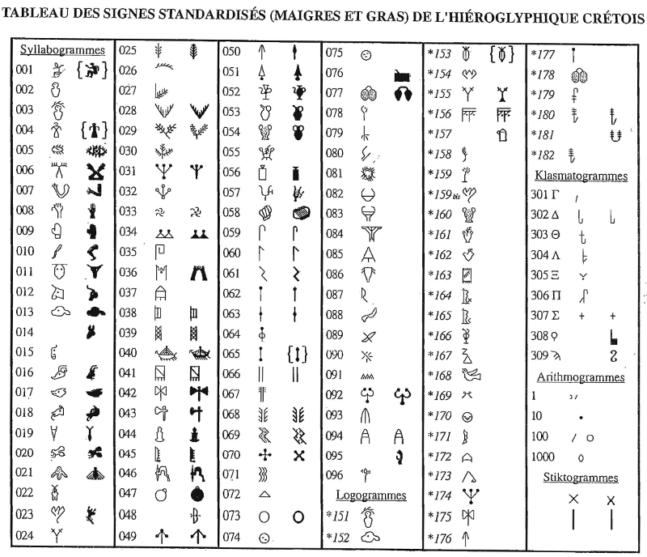

Reproduced from Corpus Hieroglyphicarium Inscriptionum Cretae by Olivier and Godart page 17

Linear AB Sign List, Godart and Olivier, 1985
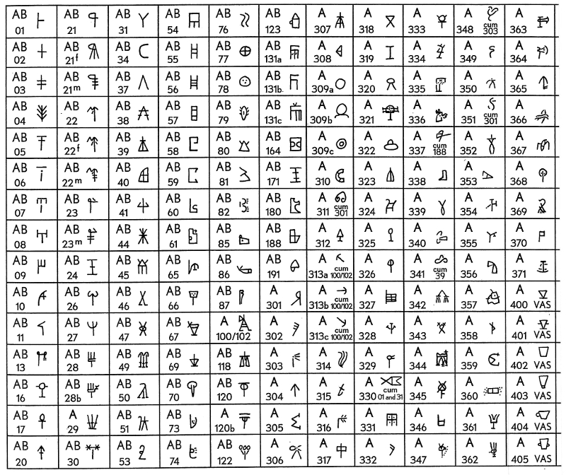

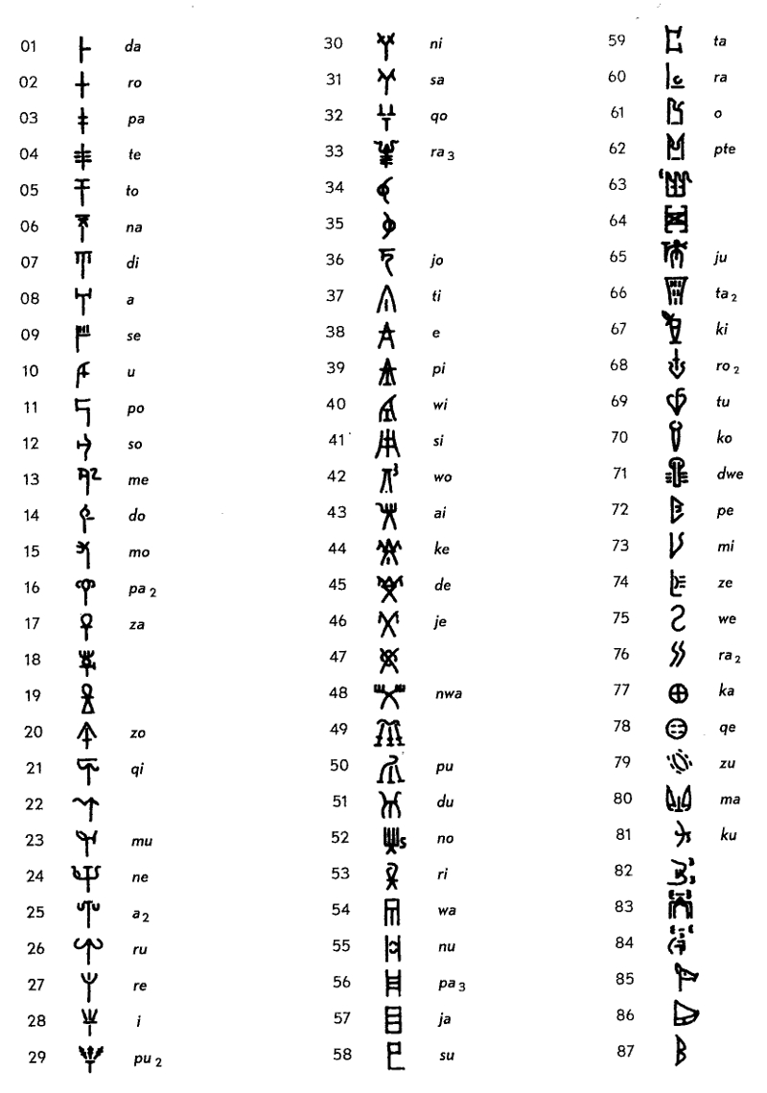
Linear B Sign List, from Chadwick's “The Decipherment of Linear B”

Evan's Cretan Hieroglyphic Sign List
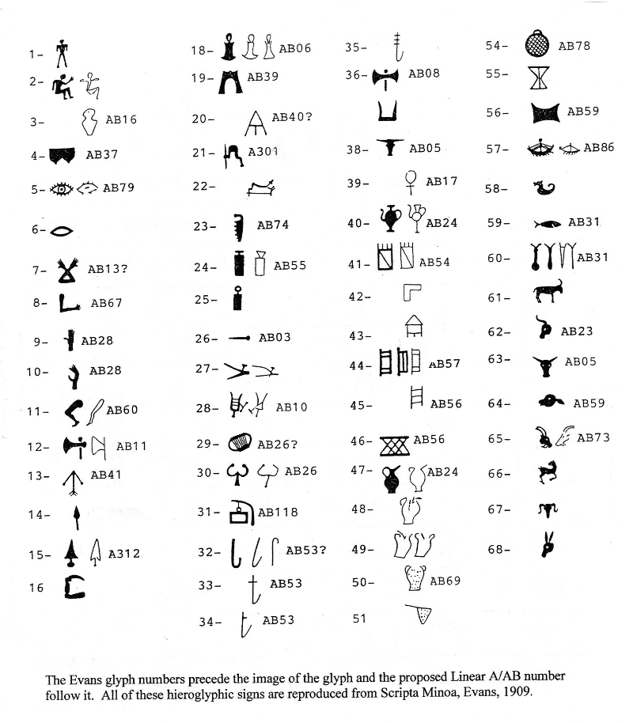

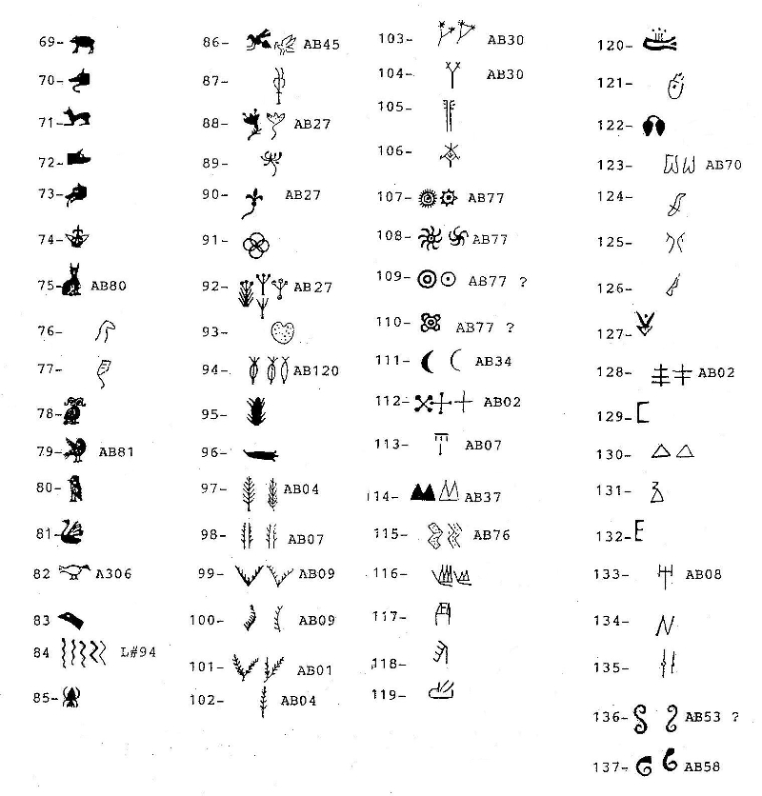

Table of Phaistos Disc Signs, A. Evans, Scripta Minoa, 1909, Oxford

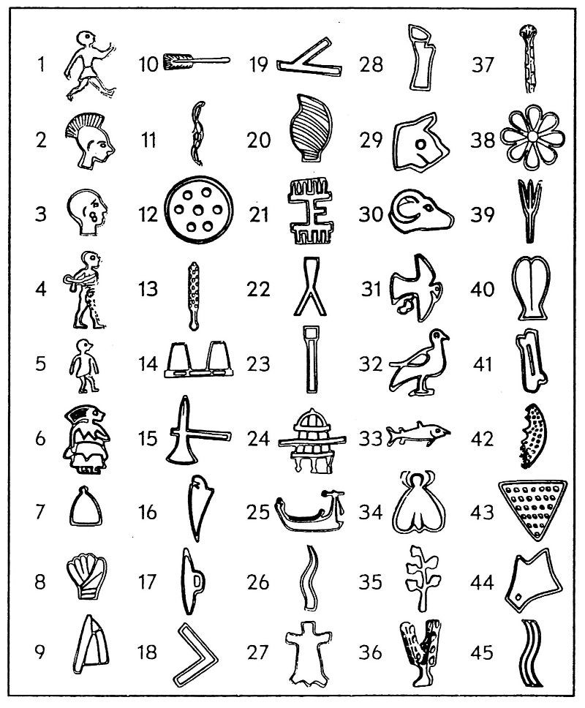

Cretan Hieroglyphic Sign Grid with Speculated Syllabic Values

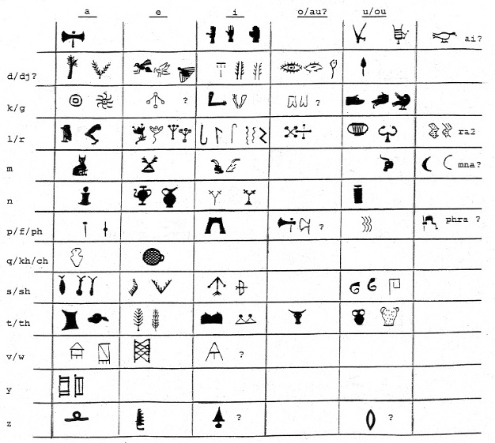
M Manning 2009

A List of Syllabic sign Designations and Speculative Values for the Symbols of the

Cretan Hieroglyphic Script

This list of Cretan Hieroglyphic signs consists of signs that appear in sign groups. Thus the likelihood is that almost all of these signs represent phonetic syllables. The order and assigned numbers are as established in CHIC by Godart and Olivier. Signs not listed in CHIC are listed by their Evans numbers (E#'s). After each CHIC number the CHS signs are described based on this author's assessment of what these signs are depictions of. Thus each sign is assigned a suitable title or 'sign-theme' for the purpose of this discussion. After this, each sign's syllabic value is given based on its assumed Linear A equivalent. Sixteen of these equivalent Linear A or AB syllabic values are based on the Table of Sign Comparison on page 19 in CHIC. These signs are indicated with a (+). All of the signs thus marked are also in agreement with this author’s assessment of the signs of the CHS. The speculative sign values of other scholars are also given in the syllable by syllable assessment listing that follows this sign list. This author's speculative syllabic value assignments are followed by (?). Speculative CHS sign values marked this way: (?)* are those which are well supported by the available evidence. Each line ends with a count of how many sign groups the sign appears in, as listed in CHIC, pages 320-379. It is important to remember that in the CHS, some syllables may be represented by more than one symbol. Sign groups in the Linear A Script are read from left to right while in the CHS sign groups tend to be read from the right to left, though there are many exceptions to this rule.

#002 'a man's upper torso' > AB16 / 'qa' (?)* 8
#003 second version of #002 with a 'branch over the head' > AB16 + da? 3
#004 'an image of a woman' sign. 1
#005 the 'eye sign' > Linear A #79 'do' (?)* and Linear B#14 'do' 13
#006 'bound hands or prisoner' sign > AB13 / 'me' (?)* 11

#007 'bent arm' sign > AB67 / 'ki' (?)* 9
#008 'the hand' sign > AB28/ ' i ' (+) 10
#009 'the second hand' sign > AB28 / ' i ' (?) 13 #010 'the leg' sign > AB60/ 'la, ra' (?)* 15

#011 'the bull's head' sign > AB05/ possibly 'tau'(?) 27

#012 'the cow's head' sign > AB23/ 'mu' (?) 5
#013 'the calf's head' sign > AB59/ 'ta' (?)* 31
#014 'the donkey head' sign - syllabic value unknown- 5
#016 'the goat head' sign > AB73/ 'mi' (?)* 22

#017 and #018 'dog's head' signs >A B51/ 'ku' (?)* 16
#019 'the fish' sign > AB31/ 'sa' (+) 45
#020, #021 and #022 the 'honey bee' signs > AB45/ 'de' (?)* 14
#023 'the lily' sign > AB27/ 're/le' (?) * 15
#024 'the fig tree or olive tree' sign > AB30/ 'ni' (+) 1
#025 'the tree' sign > AB04/ 'te' (+) 12
#027, #029 and #030 'the branch' signs > AB01/ 'da' (?)* 24
#028 'the feather or wing' sign > AB09/ 'se' (?)* 23
#031 probably a simplified form of #23, 'the lily' sign (?) > AB27/ 'le/re' (+) 37
#032 'the tripod' sign > AB44/ 'ke' (?) 9
#033 and #073 two forms of the 'potter's wheel' sign > AB77 / 'ka' (?)* 11
#034 'the woman's breast' sign > AB37/ 'ti' (?)* 37
#035 'the ram's horn' sign > AB58/ 'su' (?) 3
#036 'the building' sign > AB39/ 'pi' (?)* 15
#037 probably a simple drawing of 'a tent' > AB40/ 'wi' (?) 3
#038 'the window or door' sign > AB57/ 'ya' (+) 47
#039 'the lattice' sign > AB56/ 'pa3' (?)* 7

#040 'the ship' sign > AB86(+) an ideographic sign for 'ship'? 17
#041 'the weaver's loom' sign > AB 54/ 'wa' (+) 23

#042 'the double ax' sign > AB08/ 'a' (+) 58
#043 'the single ax blade' sign > AB11/ 'po' (or LB12, 'so' ?) 4
#044 'the chisel' sign > AB06/ 'na' (?)* 19
#045 'the wood saw' sign > AB74/ 'ze' (+) 4
#046 'the engraving tool with a bovine foot handle' sign > A301, 'phra'(?) 6
#047 'the sieve' sign > AB78/ 'qe' (?)* 25
#048 and #049 'archery' signs, 'arrow heads and bows' > AB41/ ' si ' (?)* 59
#050 'the spear' sign A304/ 'du' in the CHS(?), in Linear A, an ideographic sign for spear (?) 29
#051 'the sword' sign A312/ an ideographic sign for 'sword' (?) 8
#052 'the wine amphora' sign > AB24/ 'ne' (+) - an ideographic sign for amphora? 5

#053 'the water amphora' sign ? > AB24/ 'ne' (?)* 13

#054 'the flask' sign > AB69/ 'tu' (?)* 17

#056 'the mallet' sign > AB55/ 'nu' (?)* 55
#057 'a musical instrument' > AB10/ 'u' (?) * 42

#058 and #092 'the harp or lyre' signs, #092 > AB26/ 'lu,ru' (+) 5+26 = 31
#059 'the shepherd's crook' sign > AB53/ 'li,ri'(?) 5
#060 'the harvesting tool, pruning shear or scythe' signs > AB53/ 'li,ri' (?) 15
#061 'the second scythe and worm' signs > AB53/ 'li,ri' (?)* 40
#062, #063 and #064 'scepter or club' signs > AB03/ 'pa' (?)* 23

#068 'the water or rain' sign > AB07/ 'di' (?)* 12
#069 'the eyebrow?' sign > AB76/ 'ra2' (+) 4
#070 'the rose' sign > AB02/ 'ro/lo' (+) 68
#071 'the hair' sign > AB50/ 'pu' (?)* 2
#076 unknown object 3
#077 'the male genitalia' sign > AB70/ 'ko,go' (?)* 19
#085 'a form of #037, 'a tent'? sign > AB40/ 'wi' 2
#094 'a mason's compass' ? > AB38/ 'e' 3
#095 -a few 'owl or bird-like signs, the rest are problematic- 'ra' ? 3?

List of Included Evans Cretan Hieroglyphic Signs - 2nd Part

Evans #75 ‘cat head' signs > AB80 / 'ma' (?) 9
Evans #138 ‘loop or sacred knot’ signs > AB17 / za' (?) 5
Evans #137 ‘ram’s horn' signs > AB58 / 'su' (?) 12
Evans #79 ‘flying bird’ signs > AB81 / 'ku' (?) 6
Evans #6 ‘mouth or flame’ signs > AB79? / 'zu' (?) 3 Evans #82 ‘walking duck’ signs > A306 / 'ai' (?) 5 Evans #111 ‘moon’ signs > AB34 / 'mna'? (?) 5

These two lists include many signs from both scripts that are not considered to be 'well represented' signs. They are included here in order to present a more complete list of CHS signs and their potential Linear A equivalents.

Note on frequency ratings for individual CHS signs. The relative frequency strength of a CHS sign is determined on the basis of the total number of CHS signs. This count varies depending on which signs are included in the count. For this discussion, the total number of CHS signs is estimated at 1668 syllabic signs (this total includes signs that are not recognized by the authors of CHIC as syllabic signs). Totals given by other scholars range from about 1000 signs to 1555 to something less than 2000. The frequency ratings given below for the individual CHS signs indicate the percentage of the total CHS sign count that each sign represents. Thus the CHS sign #070 'ro/lo', at 71 signs, equals 4.25% of the whole count of CHS signs.

A Sign by Sign Assessment of the Cretan Hieroglyphic Script Signs

The CHS sign groups listed below for the purpose of comparing them with Linear A sign groups consist of CHS signs that are either those suggested in CHIC on page 19, indicated by (+) or those signs listed above that are very probably correctly (though speculatively) assigned Linear A values. The CHS and Linear A sign groups listed below for the purpose of comparison, may not include all of the potential matching sign groups available for consideration. The reader can find more potentially matching sign groups by referring to the CHS sign groups listed on pages 320-379 in CHIC and the sign group index for the Linear A script listed in GORILA V. These assignments are based on an exhaustive analysis of the available published evidence on the CHS in an effort to avoid having these designations be little more than the product of a complex and determined series of rationalizations. In order to arrive at valid syllabic value assignments for the signs of the CHS we must avoid projecting the sign themes of the CHS signs upon the signs of the Linear A script. The possibility of making errors in this process is greatly reduced though because we are comparing a limited number of signs from both scripts. If there are enough comparable sign groups in the Linear A script that match CHS sign groups, then we should be able to make more or less valid comparisons and indeed we can, if only speculatively. We can provide support to these speculative value assignments by locating corresponding sign groups in both scripts. The list of the CHS signs compared and agreed upon by the authors of CHIC and accepted as correct by this author, provide us with sixteen well supported CHS signs. These signs from the CHIC Table of Sign Comparisons on page 19 of CHIC are: #008/i, #019/sa, #024/ni, #052/ne, #025/te, #031/re, #035/su, #038/ya, #041/wa, #042/a, #043/po?, #045/ze, #051/zi, #069/ra2, #070/ro and #092/ru. Of these CHS signs, fourteen of them can be considered to be well represented signs. Well represented signs are defined herein as those CHS signs that appear in at least ten different sign groups listed in CHIC.
For example the CHIC sign #048 is most likely to be a more complete version of the 'archery' sign (a bow and arrow) equal to the CHS sign #049 the 'arrowhead ' sign. Other minor signs appear to be simplifications of well represented signs that were probably created as shortened depictions of standard signs for use on the archival accounting documents. Most of these minor signs are few in number and so are not discussed to any extent in this work.

The Vowel Signs

CHS 042 > AB08

‘a’ The CHS sign #042 'a' is simplified into a ‘four stroke’ figure that retains the essential aspects of the Hieroglyphic ‘double-ax’ sign to become AB08. See page 402 in CHIC, the example from #068.r. A! This CHS sign has a total of 72 appearances in the CHS.

CHS 094 > AB38 ?

‘e’ The existence of this syllabic sign in the Cretan Hieroglyphic Script is uncertain with only three examples listed on page 421 of CHIC. The authors of CHIC suggest that the sign they refer to as #094 is equivalent to AB38 / ‘e’. The problem here is that of the three examples of #094, the one on CHIC#241 looks like a mason’s compass while on CHIC#251 the sign may be a version of sign #057. The example of sign #094 from the Mallia Stone may also be an example of the ‘sistrum’ sign #057, if it is pictured upside-down (resulting here in the sign group 'u ti nu'[057,034,056]. Thus the evidence for an ‘e’ syllable in the Hieroglyphic script is inadequate, though the possibility that AB38 may be an image of a ‘mason's compass’ is certainly worthy of consideration.

CHS 008 and 009 > AB28

‘i’ The Cretan Hieroglyphic ‘upraised hand’ sign #008 is reduced to AB28, a stick-figure 'hand' sign with three or four vertical fingers and a horizontal thumb. Some of the Linear A examples of the sign AB28 are so similar to the Cretan Hieroglyphic ‘hand’ signs that the correlation between #008 and the Linear A sign AB28 seems certain. The ‘gloved hand’, sign #009 is very probably an alternate form of #008. It is also possible that one of the two CHS ‘hand’ signs represent a ‘hi’ or aspirated ‘i’ syllable. Whatever the case may be, the ‘puffy’ or ‘inflated’ hand sign is eliminated in the process of the creation of the Linear A Script. The Hieroglyphic sign #009 though does compare well to the Phaistos Disc sign D#08. The combined total number of 'hand' signs is 24.

AB188

‘o’ It has been speculated that the CHS sign #076 is the precursor of AB61, the Linear B ‘o’ sign. There is also the Linear A sign A188, that may also represent this vowel. As there are only three examples of #076, it is very uncertain as to the value of this CHS sign. The occurrences of #076 on seal stones, seems to suggest that it is a syllabic sign.

CHS 057 > AB10

‘u’ The image of what appears to be a 'rhythmic musical instrument' (CHS sign #057), possibly related to an ancient Egyptian sistrum, with a total of least 48 examples, is a frequently used sign in the CHS. The conversion of this sign is a clear example of simplifying a CHS sign by cutting it in half along it’s vertical axis. In this case the parts to the left of the sign’s vertical axis are removed to create AB10. The CHS example of #057 on seal stone CHIC#038.b is an obvious ancestor of AB10, representing the vowel ‘u’. There are a number of poorly drawn versions of this sign in Liner A. The small ‘arm’ that extends from the midpoint of the right side of the instrument’s ‘yoke’, should have one small vertical stroke to represent what appears to be a wand or hammer. The frequency percentage for CHS sign #057 is 2.88% and for AB10, 1.64%. The importance of CHS #057 requires that several sign group comparisons be given here.

#057 CHS sign groups: AB10 Linear A sign groups:

u re [057,023] (CHIC #049.b) u re wi (HT 25a.2)

a u ya [042,057,038] (CHIC #056.dA) ya ta i A301 u ya (AP Za 1)

u ti nu [#057, 034, 056] ) (in CHIC X9) ta na ra te u ti nu (IO Za 2a-b.2)
ta na i A301 u ti nu (IO Za 6)

There are at least another ten CHS #057 sign groups that can be matched to Linear A, AB10 sign groups.

The Consonant Vowel Signs

CHS #027, #029 and #030 >AB01

‘da’ The CHS sign #029 has the greatest potential to be the predecessor of AB01 / 'da'. Most of the Linear A examples of this sign consist of a vertical line with a shorter stroke intersecting on the sign’s right side at an upward angle. The CHS sign #029 has ‘leaves’ protruding from the 'branches' while in Linear A there are no leaves. AB01 is then a simplified ‘forked branch’ sign. Compare AB01 to the Phaistos Disc sign D#19. A count of all of the potential CHS ‘da’ signs result in a frequency percentage of 1.92%, compared to 3.36% in Linear A for AB01. The signs designated as CHS #027 and #030 are likely to be variant forms of #029. The authors of CHIC have not compared CHIC sign #029 to AB01.

CHS Sign Groups | Linear B01
da wa un ko ya [029,041,056,077,038](#200) | da wa[ (KN Za 10b)
]da si [029,049](CHIC #054.d) | da si A118 (X4)
]da ro [029,070](CHIC #052.d) | da ro pa (HT 38.2), a da ro (ARKH 5.2)  ki da ro (HT117a.9)
wa da to [037,029,011](CHIC #057.d)  nu te da to [056,025,029,011](CHIC #182) | a si da to i (ARKH 2.2-3)
a da ke to [042,029,032,011](CHIC #057.a) | a da ki si ka (KH 5.1)
sa u da [019,057,029](CHIC #190) | a ra u da (KH 5.1-2)
CHS #020,#021 and #022 > AB45

'de’ These are the ‘honey bee’ or ‘flying insect’ CHS signs #020, #021 and #022. They are transformed into one of the more complex of the Linear A signs, AB45. AB45 bears some resemblance to #021, though the probability is that the person who devised Linear A simply designed a stick figure drawing of a ‘honey-bee’ to replace the CHS 'honey bee' signs. There were three or four versions of AB45 used in Linear A. On the Phaistos Disc there is D#34 which appears to be a trim drawing of a honey bee. The total of the CHS 'honey bee' signs produce a frequency percentage of .84%, comparing well to AB45 at .97%. This symbol may be an onomatopoetic sign. The CHS signs #020-022 are not compared to AB45 in CHIC.

CHS - CHIC signs #020, #021 and #022 AB45

i ko ta de [009,077,013,020](CHIC #003.cB, #139) ta de (CR? Zf1) au ta de (KO? Zf2)

a de [042,020](CHIC #143) a de (ZA 10b.4)

de nu lo ri [022,056,070,061](CHIC #071, #059.dB) de nu (HT 11b.1)

CHS #068 > AB07

‘di’ In the CHS this syllable seems to be represented by a sign-theme that is suggestive of ‘flowing or falling water’(CHS sign #068). The Linear A sign that seems to portray the concept of ‘falling water’ or ‘raindrops’ is AB07. This sign consists of a horizontal line (a cloud) above small dots or small strokes (representing raindrops). The CHS sign #068 may be a depiction of flowing water. This sign was probably discarded in favor of AB07 simply because AB07 is easier to write. It is also possible that some of the ‘micro-signs’ used on seal stone are examples of ‘raindrop’ signs. This could account for the weakness of this syllable in the CHS. The frequency for the CHS sign #068 is .96% compared to 2.61% for AB07/ 'di ' in the Linear A Script.

CHS #068 AB07

]ya la di [038,010,068](CHIC #044.a) ]sa la di (HT27a.5)

re di [031,068](CHIC #040.b2) di re di na (HT 98a2-3)
re di se (HT 141.2)

CHS #005 > AB79

‘do’ There is some confusion in the assignment of an AB value to the ‘eye’ signs in the Linear A and B scripts. Simply put, the CHS ‘eye’ sign, #005 is the most likely equivalent Linear A #79 'do' and the Linear B sign #14 'do'. The Linear B sign #79 is thought to represent the syllabic value of 'zu', though it could also represent a variant form of Linear B #14, as it can be compared to the CHS sign (#005) and Evans #6. Linear B #14 ('do') is an example of a simplified 'eye' sign set up on a vertical line or ‘stick’. The significant quantity of the 'eye' sign CHS #005 in the sign group [#005, #044], (do na ?) on seal stones considerably effects the frequency comparison of 3.00% for the CHS sign #005 and .82% for AB79 in the Linear A Script. Godart and Olivier compare #005 to Linear A and B #79 on page 19 of CHIC. The CHS sign #078 may also be an 'eye' sign.

CHS #050 > AB51

‘du’ That the CHS ‘spear’ sign #050 represented the syllable ‘du’ appears to be a well supported probability. Matching sign pairs in the CHS and Linear A script such as: ‘-du re-’, ‘-do du-’, ‘-du ni-’ among others, plus similar frequency percentages, adds weight to this conclusion. The creator (or creators) of the Linear A Script seem to have dispensed with the ‘spear’ sign’s syllabic role by utilizing it as an ideographic sign, probably to represent actual spears (see GORILA V, A304, pg.287). There may be a connection between the Greek term for a spear, ‘dore’ and the Linear A and CHS sign group ‘-du re-’[050,031]. The Linear A sign AB51, represents the 'du' syllable in the Linear A Script. The sign AB51 consists of a simplified ‘person-glyph’ with an ‘arm’ extending out to the right, on which sits a ‘stick figure child’. The Linear A sign AB13 also utilizes this same stick figure ‘person-glyph’. It appears as though the CHS sign #050 was needed to serve as the ideogram for 'spears' (A304) and so it seems likely that AB51 (‘a mother with a child’) was selected to represent the ‘du’ syllable in the Linear A script because it conformed to the acrophonic method of sign selection, that seemingly was sometimes utilized in the Cretan Writing system.

CHS sign CHIC #050 | Linear AB51
du mi [050,016](CHIC #032.a) da du mi ne (KN Zf31)

du re ti [050,031,034](CHIC #314-a) a du re[ (KH 4.1)
du re za se (ZA 10a.5, 20.1-2)

tu do du [054,005,050,](CHIC #273-a) do du (HT 99b.2)
lo do du [070,005,050](CHIC #273-c) ]do du (HT 51b.2)

di i nu du lo [068,009,056,050,070](CHIC #119.c) nu du A331 (HT 40.1)

ku du [017,050](CHIC #234-a, #310-b) ]ku du li (PH? 31b.2)
u ku du [057,018,050](CHIC #306-d)

lu sa na du sa se nu (CHIC #294b) a pu2 na du (HT 14.3)
wi na du (KH 5.3)

du ni [024,050](CHIC #043.a) a du ni ta na (ARKH 5.1)
ti du ni (HT 49)
wa du ni (HT 6b.1)

]a si du [042,049,050](CHIC #178) ma si du (HT 45.1)
]si du (HT 123b.4)

The GORILA V index lists ,along with A304, a variation which adds two strokes to the lower part of the sign. This variation is very similar to the Linear B sign for the syllable ‘zo’ (AB20). This sign in Linear A (‘A304 + pa’) appears to function primarily as a type of ideogram. Also note that the Greek word for a spear is ‘doru / dore’. Could this term be derived from Minoan ‘dure’? CHIC does not compare sign #050 to AB51. For a very interesting example of this CHS sign see the seal stone CHIC #297-a. Inscribed above a ‘Gorgon’s head’ is the sign group ‘du-sa’. Compare this sign group to the Greek prefix ‘dus-’, (evil, bad, faulty, diseased) and to the mythical Medusa.
CHS #033 and #073 > AB 77

‘ka’ The two CHS circular signs, #033 and #073, are the most likely equivalents of AB77 / ‘ka’. AB77 is probably a simplified representation of a ‘potter’s wheel’ with crossed lines serving to center the hunk of clay. An example of just such a potters wheel was found during the excavation of Fournou Korfi, Crete (dating back to c. 2200 B.C.). The CHS sign #033 represents the spinning of the potter’s wheel while #073 simply portrays the discus-like top of the potter’s wheel. The most probable sign-theme for the ' ka ' syllable is that of 'ceramics' or 'pottery'. There are other symbols used on seal stones that are also likely to represent the ‘ ka ’ syllable. These signs depict interlocking and concentric circles (E#109), probably seal stone engravers variations on the theme characteristic of a ‘potter’s wheel’ and ceramics in general, including images of 'potters at work' (E#2). On the Phaistos Disc there is a variation on the 'Potter's wheel' theme, D#12. Note also that some of the Linear A examples of AB77 /‘ka’ suggest spinning discs in the flares extending from the outer ends of the crossed lines. The percentages of occurrences for the CHS ‘potter’s wheels’ signs and AB77, though not close, are both strong and so, comparable. The question of whether all of these various circular images (Evans sign #s 107-110) actually represent the syllable ‘ka/ga’ cannot be convincingly resolved, despite the volume of examples presented here. The apparent existence in both scripts of the sign group 'ka na si' [033/073,044,049] undeniably reminds us of the place name “Knososs”. The possibility that this Pre-Greek sign group later becomes in Greek, this well-known place name, is deserving of serious consideration. This place name may be a fusion of two terms: ‘ka na’ (cane?) and ‘na si’ [044,049]. It appears that many of these unrecognized circular signs could be listed as variations of either CHIC #033 or #073 (see seal stone #258c for example). It may be that the presumed IE term ‘ker-4’ and the Lat. term ‘carbo-’ both referring to fire and charcoal, could ultimately be derived from the same source as the potential Minoan acrophonic term underlying the theme of this CHS symbol.
Disks and Rings / CHIC #073  la ka ya [010,073,038](CHIC #260-b) | Linear A AB77  ka ya A539 (HT 24b.2)
ta si ka [013,049,073](CHIC #119.r, 120.r.A) | si ka (X7)
ka qa li [073,002,061](CHIC #113.a) | ka qa (PK 1.1)
ka lo [073,070](CHIC #198, 069.r2) | ka lo na (HT11a.2)  ka lo pa3 (HT31.3)
lu ka [092,073](CHIC #207-a) | u na lu ka[ (PK Za 12c)  li lu ka (TY 2.5)
du ka to pa [050,073,011,062](CHIC #267-c) | du ka (MI 2.2)
Spinning disks / CHIC #033 | AB 77
si ka #055 [049,033,055](CHIC #077) | si ka (X7)
ko mi ka [077,016,033](CHIC #290-d) | mi ka[ (HT 135a.2)
ko qe ka [077,047,033](CHIC #065.c) | qe ka (HT 85b.1)

Potters and potters’ wheels, Spinning Disks

and Concentric Circles, Evans #107-110

ka ru pi [E#2,092,056](CHIC #229-a) | ka ru (HT 97a.1)
ka na si [E#2,044,049](CHIC #240-a) | u na ka na si (X4)
ka na si [E#108,044,049](CHIC #247, #260a)  #046 ka na [046,E#108,044](CHIC #257-c) | ka na (HT 23a.1)
ka ku [E#109,018](CHIC 222-a) | ka ku (HT 62+73.2)  ka ku pa (HT 16.1, Wc3015, 3016a)
ka pa[ (CHIC #223-b) | ka pa (X5)
mi ka [016,E#108](CHIC #247-a) | mi ka [ (HT 135.a)
i ka sa to pi [008,E#108,019-](CHIC #282-a)  i ka sa to pi [008,E#108,019,011,036] | i ka (HT91.1, 102.4)  ka sa (KE 1.1)
ka mi ko [E#108,016,077](CHIC #290-d) | A61 ka mi za si i na (PK 1.3-4)
ka ki ti [E#110,007,034](CHIC #308-b) | ka ki (HT 37.1.5)  di ka ki (HT 52a.2)

CHS #032 > AB44

‘ke’ The sign AB44 is the only sign in the Linear A script that can be said to be a depiction of a ‘tripod’. The Phaistos Disk sign D#40 is a simple but elegant depiction of a tripod. The only CHS sign that resembles a tripod is #032. This sign is pictured in CHIC’s table of signs in an upside-down orientation (pg. 397). The Linear B ‘ke’ sign is a rather elaborate version of a tripod with a three ‘prong’ top and two long legs underneath, as well as a shorter leg that seems to suggest perspective. The ‘ball feet’ of the CHS ‘tripod’ sign #032 are abandoned in the design of the Linear A sign AB44, while three short lines above an added center line are include on the Linear A sign in order to depict the top of a tripod stand. The result is one of the more difficult to write signs of the Linear A Script. The CHS sign (#032) frequency percentage of .54% compares well to .52% for AB44 /‘ke’. On the CHS seal stone impression #149 is an example of a sign that is listed as the sign #031, though it could well be a tripod sign, #032. Note that the ‘stems’ of this example emerge directly from the ‘ball’ at the ‘base’ of this sign, distinguishing it from the typical version of #031. The Egyptian sign that resembles the Linear AB 44 sign is G# F31. Though this Egyptian sign is not a representation of a tripod, it does look much like AB44. The sign #032 is not recognized as equivalent to AB44 in CHIC. The up or down orientation of this sign varies in the CHS. There are no other Cretan Hieroglyphic signs that resemble a tripod. Only a few potential correlations can be found to support the proposed syllabic assignment for this sign:

CHS Sign CHIC #032 Linear AB 44

i? ke ta /ta ke i [008,032,013](CHIC #057.b) ta ke[ (ZA 21a.4)

ze le ro ke do? [045,023,070,032,078](CHIC #058.d) ro ke (HT 98a.4)

ke i nu [032,009,056](CHIC #104.a) te su de ke i (KN Zf 31)

CHS #007 > AB67

' ki ' The CHS sign #007 is a depiction of a 'bent arm' which is similar to the Egyptian Hieroglyphic 'bent arm' signs G#s V31, W10a and D41, meaning to 'eat or drink'. In the Linear A script the sign that suggests drinking is AB67, a depiction of a 'kylix' or drinking cup. On the Phaistos Disc we find a very 'kylix'-like sign, D#16. The probability here is that the CHS 'bent arm' sign was replaced in the Linear A script by the 'drinking cup' sign AB 67, a sign that was easier to write. Some potential sign group correlations are:

CHS sign #007 Linear AB67

ki ra me re [007,010,006,023](CHIC #043-a) ki ra (HT 103, Za 8.1)
a si ki ra (KH 20.2)
ki ki ra[ (HT 85-b)

ya ki mi [072,038,007,016](CHIC #098-a) yaki pa3[ (PH 28a)
ya ki [ (ZA 26-a)

ki lo [007,070](CHIC #114-a) a ki lo (ARKH 4b4)

This speculation results in three Linear A sign group correlations out of the nine appearances of the ‘bent arm’ sign in the CHS Script. If #007 equals AB67 then the ‘ki’ syllable is under represented in the CHS with a frequency percentage of only .54% compared to AB67 at 2.65%.

CHS #077 > AB70

‘ko’ The Linear A sign AB70 certainly seems to be, in appearance, a quick sketch of ‘male genitalia’. It is not so easy to define the identity of the CHS sign #077. Some examples of sign #077 do resemble ‘testicles’ (see CHIC page 417), while others look like seeds or nuts. Well they do! The CHS sign group 'a,ko,a' [042, 077, 042](CHIC #095) looks quite a bit like the Linear A sign group ‘a ko a ne’. There are five AB70 sign group correlations out of nine CHS 'ko' sign groups, suggesting the proposal that the CHS sign #077 = AB70 could be valid. There are 20 examples of the sign #077. Note that there is an Egyptian ‘male genitalia’ sign designated Gardiner #D52. If this identification of AB70 is acceptable, then the CHS sign CHIC #077, which appears to be a depiction of a pair of testicles, could well equate to AB70, ko/go. The following potential correspondences are offered in support of this designation:

CHIC #077 | Linear AB70
i ko ta de [009,077,013,020](CHIC #003.c) ]ru i ko (HT 24-a.5)

ko mi ka [077,016,033](CHIC #290-d) a ti ka a du ko mi (ZA Wc 2.1-2)
ko ya [077,038](CHIC #293-a) ko ya (HT 119.2)

a ko a [042,077,042](CHIC #095) a ko a ne (PK Za 11b)
]ko a du wa (TY 3a.6)

di ko mu(?) [068,077,012?](CHIC #079-a) di di ko ra me[ (ZA 11a.1)

Some of the symbols listed in CHIC with the #077 designation are questionable. The examples from the CHS inscriptions CHIC #164, #294 and #200 could be interpreted as breast signs (#034/‘ti/thi’). It can also be said that this sign, #077 has a greater frequency in the CHS script than does AB70 in the Linear A script. The sign CHIC #077 is not recognized in CHIC as comparable to AB70. The evidence does not convincingly support the speculation that AB70 is a Linear A simplified sketch of ‘male genitalia’. Certainly AB70 could be an image of something else, but of what? If the suggested identity of the image portrayed by AB70 is correct, then it can be said that there is no syllabic sign in the CHS that could be a match for AB70 other than the sign CHIC #077.

CHIC #017 and #018 > AB81

‘ku’ The Linear A ‘flying bird’ sign is AB 81/ ‘ku’. This same sign theme was sometimes used in the CHS as a substitute for the ‘dog’s head’ sign (see CHIC seal stone #283.d). The creator of the Linear A Script seems to have chosen to dispense with the ‘dog’s head’ signs, in all likelihood, simply because the ‘flying bird’ sign was not only easier to inscribe, it was a more elegant and perhaps a more acceptable sign theme. Note that the acrophonic principle seems to be at work here. The Greek word for dog, “kuon” may be a Minoan loan word, while the Linear A “flying bird” sign could have been inspired by the term “kumindus”, a type of Aegean night hawk. The frequency percentages for the sign AB81 and the CHIC signs # 017 + 018 are comparable. Also Garth Owens agrees that the CHS 'flying bird' equates to AB81.
The ‘flying bird’ sign does appear in the CHS script on seal stone CHIC#283-d and the medallion CHIC#104. It also can be found on the three-sided seal stone #247 as a flying bird with outstretched wings above a goat sign [016] and a spinning disk [033] thus- ‘ku-mi-ka’. On the seal stone #283 side –d, a ‘flying bird’ sign (E#79) also appears before the ‘wild goat’ sign (#016). On another seal stone, a dog is attacking a wild goat [018,016](ku,mi). The possibility that the ‘dogs head’ signs are the ‘acrophonic match’ for the ‘flying bird’ sign in the Linear A script seems to be a strong one. The Phaistos Disk sign D#31 is very reminiscent of the ‘bird’ sign on the seal stone CHIC#283. The Disk’s ‘bird’ symbol, D#31 also conforms well to the flying bird on the medallion CHIC #104. There is a ‘flying bird’ sign in the Egyptian script, G# G40. The proposed correspondence between the CHS ‘kuon’ signs (017-018) and the Linear A ‘kumindus’ sign (AB81) seems to agree with the surviving evidence. The standard GORILA V depiction of the sign AB81 does not look much like a ‘flying bird’, unlike the one found on Chadwick’s Linear B sign list (1987). The following sign group comparisons provide support for the proposed value of ‘ku’ for the CHS signs 017 and 018:

CHS Signs CHIC #017 and #018 Linear AB81

ku du [017,050](CHIC #234a,310b) ]ku du li (PH? 31b.2)
u ku du [057,017,050](CHIC #306-d)

ku pa3 do [018,039,005](CHIC #142) ku pa3 nu (x8)
ku pa3[ (HT 101.4)

]ka ku lo[ [033,018,070](CHIC #055.a) ka ku pa (HT 16.1, Wc 3015a, 3016a)
ka ku ne te (ZA 10b.6)

mu mi pa ku [012,016,062,018](CHIC #271-a) a di da ki ti pa ku (KN Zc6.2)
AB65 ku na pa ku nu[ (KN Zc 6.3)

na pi ku [044,036,018](CHIC #225-a, #300-c) pi ku do (TY 3b.2)

a ku [042,017](CHIC #039.b) a ku mi na (ZA 10a.1-2)
a ku A65 pa A118 (PA 1)
a ku tu A361[ (TY 3a.7)

ya ku ti si [038,017,034,049](CHIC #021.c) ya ku ti (KN 1a.1)
ya ku (MA 2b)

i ne ku [008,053,017](CHIC #128) da ne ku ti (HT 117a 8-9)
ne ku[ (HT 55a.2)

CHS #010 > AB60

‘la / ra’ The example of the Linear A sign AB60 on IO Zb 10, strongly suggests that AB60 is a brief drawing of a ‘boot’/ or ‘shoe’. In the Cretan Hieroglyphic Script there is the often seen portrayal of a ‘leg’, the sign #010. The greater likelihood here is that the CHS ‘leg’ sign, #010 was simply reduced to a ‘foot or boot’ sign resulting in AB60. Though this may seem like an obvious transition, few scholars in this field have accepted this speculation. The Phaistos Disc sign D#1 is a simple drawing of a 'running man'. This theme can be linked to the sign theme for both AB60 and CHS sign #010. The frequency percentages also compare well at 2.99% for AB60 and for #010 (+ #095) a total of 3.84%.
The CHS sign #095 also appears to represent a ‘ra’ syllable and so is included in the total for the ‘la/ra’ designation. Some examples of #095 resemble a 'bird' or an 'owl' (see seal stone #205.a) while others seem to represent a 'hand' (see seal stone #203b). There are nine examples of #095 listed in CHIC. See also W.C. Brice's article in Kadmos #36, pages 93-96 for a discussion of #095.
The curled ‘toe’ design of the AB60 ‘boot or shoe’ sign suggests a type of shoe woven of linen or leather. There are nine supporting sign group correlations for the AB60 = #010 assignment. This includes the three consecutive signs ‘-la ti se’ (CHIC#317) and ‘la ti se’ (HT 6.2). The sign #095 appears in only two sign groups.

CHIC #010 | Linear AB60
a u la ti se[ [042,057,010,034,028,](CHIC #317) | la ti se (HT 6b.2)
ya la [038,010](CHIC X14) | ]ya la (KN Wc 30)
ya la re [038,010,031](CHIC X25) | du la re (KN Zc 7.1)
di la to de [068,010,011,020](CHIC #272-c) | do di la (HT Wc 3011, 3012a)  ]di la di na (PH 1a.1)
] di la ya [068,010,038](CHIC #044.a) | ki ki la ya (HT 85b.1)
tu la tu [054,010,054](CHIC #267-a)  la tu (CHIC #155) | a la tu (ZA 7a.1-2)  a la tu me (HT Wc 3024 / gorila VI )
re me ra ki [031,006,010,007](CHIC #043.a1) | a ka ra ki ta- (PE Zb 3 / gorila VI)
la re [010,031](CHIC #254-a) | qa A118 la re (HT96b.1-2)  wi la re mi te (ZA9.6)
se lu ra [028,092,010](CHIC #172) | a lu ra (HT 11a.1)
ki la mi re [007,010,016,031](CHIC #043.a) | ki la (HT 103.5, ZA 8.1)
la te [010,025](CHIC #043.a2) | ta na la te u ti nu (IO Za 2a-b.2)  ]la te[ (ZA 19)

CHS #023 and #031 > AB27

'le/re' This CHS sign, 'le/re' #031 seems to be a depiction of a flower, possibly a lily, crocus or an iris. The simplified depiction of this sign in Linear A, AB27, is typical of the transformation of CHS signs into a more abbreviated linear form. The CHS sign #023 is also likely to be equivalent to CHS sign #031, which seems to be a much more stylized form of #023. Some have compared AB27 to a trident, but its 'flower like' nature is supported by the way the CHS sign #031 is depicted on seal stones. Compare the forms of #023 on page 394 in CHIC to the Linear A 'lily' signs (AB27) on page XXXlll of the table of sign variations in GORILA V. Note the example from KO Za 1b. In support of the speculation that #023 also equals AB27 consider the following:

CHIC#023 AB27

u le lo ku [057,023,070,018](CHIC#324) ka le lo (HT Wc 3003)
na si le [044,049,023](CHIC#089.a) si le (PH(?) 31a.3, b[4], HT 4.2)
nu le [057,023,051](CHIC#039) ]te nu le[ (KH 6.2, HT 154Ja.2)
le li sa u [023,061,019,057](CHIC#036.a) ]ma le li mi de[ (PH 30.2)
u le [057,023](CHIC#243.g) u le wi (HT 25a)

CHS signs #059, #060 and #061 > AB53

'li and ri' Two of the CHS symbols that represent these syllables seem to be images of farming implements. The CHS sign #059 appears to be a 'crook' used for controlling live stock. The CHS sign #060 is probably a shearing or harvesting device such as a scythe or pruning shear. The Linear A sign AB53 looks more like a scythe, while the Phaistos Disk sign D#18 looks more like a pruning blade. Note that the Phaistos Disk sign D#18 sign is not a square angle, but is off- square enough to be a shearing tool of some kind.
The Linear A signs formally referred to as L#72 and L#94 are thought to represent the ‘li/ri’ syllables (see Packard 1974 pg.107). L#94(CHS #061) is the ‘worm’ or ‘snake’ sign which is often portrayed as a ‘s’ curve. In the Linear B script we see that the ‘worm’ sign represents the syllable ‘we’ and that the sign for ‘li/ri’ (AB53) is distinctively made so as to eliminate any confusion between it and the ‘we’ sign AB75. In the Linear A inscriptions there is little distinction between these two signs and so they have been combined as AB53 in GORILA. The underlying concept of L#72 (AB53 / li/ri) and CHIC #059 and #060 seems to be that of a ‘harvesting instrument’ and so images of scythes, sickles, shepherd’s crooks and other types of hooks are used to represent this syllable. The concept behind L#94 (CHIC #061) is that of a coiling or spiraling thing, probably a worm. It seems reasonable to conclude that the differentiation between the signs AB53 and Linear B#75 indicates something, though the use of these signs in Linear A reveals little difference in the way they are used in sign groups. The presence of the signs, CHIC #059-#061 in the CHS suggests the origin of these two Linear signs. The CHS signs in question may well represent a clear distinction between the syllables ‘ri’ and ‘li’ in the earlier CHS. A comparison of CHS sign groups containing CHIC #059-#061 and Linear A sign groups with the sign AB53, reinforce the suggestion that these CHS signs equate to AB53. It must be kept in mind that the reading direction of many of the CHS sign groups is uncertain. In support of the speculation that CHIC #059 and #060 (the ‘harvesting tool’ signs) equate to AB53 consider the following:

CHS Sign (CHIC 059-060) | Linear AB53
ri tu le / le tu li [059,054,031](CHIC #017-c) a tu li si ti (KN Zb5)
qi ri tu qa (HT 23a)

ri ya sa [059,038,019](CHIC #004-c) a ri ya (PH 28a)

nu ri pu? [056,059](CHIC #242-a) ]nu ri ya (PK Zc 13)

ri ta [060,013](CHIC #059-bA) ri ta (KH 6)
su ki ri ta (PH Wa 32)
]ma ta ri ta[ (KH 90)

a ro ri na [042,070,060,044](CHIC #074-a) i ku ri na (HT 90)
ri na nu [060,044,056](CHIC #271-c) tu qi ri na (HT 129)
ta ri na (HT 10b)
di ri na (HT 93a, 102.3)

ta li tu [013,060](CHIC# 034.a) ta li na / ta ri na (HT 10b.)
]ta ri (CHIC #115-b)

a pa ri [042,063,060](CHIC #112-d) ] tu pa ri (HT 79)

CHIC #061 Linear AB53

li re sa [061,031,019](CHIC #273.b) ]ma li re i (HT 6b)
]si tu li re (HT 3.5)
ya re ra li [038,031,010,061](CHIC #270) ]ma ra li mi de[ (PH 30.2)
]ra li (HT 122a)
]ra li de[ (HT 113)

]pa sa li [062,019,061](CHIC#028.c) pa sa li ya (HT 24a.4)
i da pa3 i sa li (PH 6.4)
sa li[ (ZA 21b.3)

a tu li [042,054,061](CHIC#293.c,303.b)
a tu li su [042,054,061,E#137](#303-c, 293-c) a tu li si ti (KN Zb5)
tu li [054,061](CHIC #062-a) ]si tu li re (HT 3.5)

a li ta si [042,061,013,049](CHIC #054-a) a li ni ta (HT 25a.3, ZA 8.2-3)
a li (CHIC #035-a) a li su (HT 118.3)

pa qe li re [063,047,061,031](CHIC #052-a) sa qe li (HT 11b)
u qe li [057,047,061](CHIC #032-b) qe li ya (HT 3.2)

di li [068,061](CHIC #085-a) ]u di li ki[ (PH 7a)

a pa li [042,062,061](CHIC #095) ]tu pa li (HT 79)

i nu li [009,056,061](CHIC #156, 018-b) ]nu li ya[ (PK Zc 13)

se li si qe [028,061,049,047](CHIC #034.a) ki li si (TY 36.1)
a tu li si ti (KN Zb5)

It appears that the signs CHIC #059-#061 correlate well to the Linear A sign AB53. They are not recognized as such in CHIC (pg.19). The symbol D#18 on the Phaistos Disk seems to be a shortened form of CHIC #060. Since there are forty-two examples of CHIC #061 and only fifteen examples of #059 and #060 combined, it may be that #061 became, over time, the sign form for the 'li/ri' syllable for the CHS.

CHS sign #070 > AB02

This is the consonant/vowel signs for 'lo and ro'. There is little doubt that the CHS sign #070 is the equivalent of the Linear A sign AB02/ 'lo,ro'. One speculation is that this sign represents a very simplified depiction of a rose. If you take the two CHS versions of this sign and superimpose them, you will see that they create a 'rosette'. Consider here the Phaistos Disk sign #38. The syllabic value of CHS sign #070 seems to be indisputable.

CHS sign #058 and #092 > AB26

'lu and ru' These two signs appear to be simple depictions of a lyre or harp. See seal stones #123 and #283b for examples of the CHS sign #058. The CHS sign #092 seems to be a more simplified version of this same musical instrument. A few of the examples of the CHS 'lyre' sign, #092, do depict strings. They are to be found on #262.a and #299.g. I think that we can conclude that the CHS signs #058 and #092 are both 'lyre' signs and that they probably both represent the 'lu/ ru' syllables. The sign #092 is recognized, or compared in CHIC as equating to AB26/ 'lu,ru', while #058 is not. Only #092 survived the conversion of the CHS into the Linear A script. That the sign #058 equates to #092 is supported by the following sign group comparisons.

CHIC sign #058 Linear sign AB26

qa ru [002,058](CHIC #053.e) qa qa ru (HT 1182-3)

ru ta re nu [056,013,058](CHIC #283-b) mi ru ta ra re (HT 117a.4-5)

A note on the L/R series, as illustrated above, each of the signs of the L/R series seems to have two forms:

la/ra – CHIC #010 ('la/ra') and CHIC #095 ('ra')

le/re – CHIC #023 ('le/re') and CHIC #031 ('le/re')

li/ri – CHIC #059 and #060 ('li/ri') , and CHIC #061 ('li/ri')

lo/ro – CHIC #070 ('lo/ro') , which appears in two orientations: upright and diagonal.

lu/ru – CHIC #058 ('lu/ru') and CHIC #092 ('lu/ru')

This may indicate that the CHS provided a means that scribes could use to differentiate between the two liquid consonants 'l and r'. This potential seems to have been abandoned, for the most part, in the Linear A script. Note that the word 'lyre' (Greek, 'lura') is recognized by many scholars as being a 'non-Indo-European' term. The seal stone impression #123 has a sign group that may illustrate the 'r / l' relationship of the CHIC signs #058 and #092. It reads from left to right, [#092, #058], most likely “lurus”, perhaps the Minoan term for 'lyre' ?

Evans #75 > AB80

'ma' This CHS sign is not recognized by the authors of CHIC as a syllabic element in the CHS. This is odd in that GORILA V has three pages of AB 80 (the Linear A 'cat head' sign) sign groups. I suspect that the CHS 'cat head' sign was not included in CHIC as it does not appear on any of the archival documents. With only nine examples of the 'cat head' sign, in the CHS (on #123, #157, #196, 247c, #257a, 283c, #287c, #295c and #309a) it is likely that this syllable is represented by more than one sign. The image of a cat in the CHS is replaced in the Linear A script with a simple diamond shape to which ears and eyes have been added. See GORILA V page XLI, in Linear A sign variations, for examples of the AB80 sign. The Phaistos Disc sign D#29 looks very much like a 'cat's head'. Garth Owens and J. Younger both agree with this assignment for Evan's #75 sign. The 'cat head' sign is probably an onomatopoetical one. Here are some potentially matching sign groups.

Evans # 75 AB80

ma li ya la re [E#75,061,038,010,031](CHIC #257-a) ma li re i( HT 6b.2-3)
si lu ma li ta ( HT 90.2-3)

ma do na [E#75,005,044](CHIC #295) ma do (HT102.3-4)

ma ru re [E#75,092,031](CHIC#123) ma ru wi te (PYR 1.1)
ma ru (HT 17a.3)
With only about nine examples of the 'cat's head' sign on CHS seal stones and their impressions, the 'ma' syllable is significantly under-represented in the CHS compared to the frequency of AB80 in the Linear A script. The CHIC sign #014 may also represent the 'ma' syllable. There are four potential sign group matches out of the five #014(ma?) sign groups listed in CHIC for this sign. The CHS sign #040 may also represent the 'ma' syllable. There are though problems with both of these speculative assignments.

CHIC #006 > AB13

'me' That the CHS sign CHIC #006 is a depiction of two hands crossed over at the wrists can be confirmed by examining the seal stones #246b, #268.g, #276.b and #302.g. The most probable implication here is that this symbol represents a pair of bound hands, in other words, those of a prisoner or captive. On the Phaistos Disc we see that the sign D#4 appears to be a depiction of a prisoner with his hands tied together behind his back. In the Linear A script we can see that only the sign AB13 resembles D#4 and so it can be said that AB13 is likely to be a brief sketch of the same thing. Though this cannot be said for certain, it is nevertheless, the most probable conclusion for #006. Again, AB13 is much easier to draw than is the sign CHIC #006.

CHIC Sign #006 AB13

mu pa me [012,062,006](CHIC #302-c) i ya pa me (KH 7a.3)
]tu me pa ya (HT 154a.1)

ki la me re [007,010,006,031](CHIC #043.a1) di di ko la me[ (ZA 11a.1)

si wa me te [049,041,006,025](CHIC #316) de me te (HT 94b.5)

CHIC sign #016 > AB73

'mi' The Cretan Hieroglyphic representation of a goat’s head is the most likely ancestor of the Linear A sign AB73. AB73 has an eye-like feature on the inside of the curved line on its lower right side. In some examples the straighter left-side line has a curling top that is suggestive of a horn. See the examples of AB73 signs from Zakro (ZA 6b, ZA Ha,b, ZA Hr). These aspects of AB73’s form leads to the logical conclusion that AB73 is the abbreviated Linear A form of the CHS ‘goat head’ sign (#016). There is simply no other Linear A syllabic sign, other than AB73, that compares well to the CHS ‘goat head’ sign. Some have compared AB67 to CHIC sign # 016, yet AB67 is clearly a 'cup' not an animal head. Also AB67 has no 'eye' like feature. The CHS sign #016 can be compared to the Egyptian Hieroglyphic sign G#E7. The importance of the #016 sign requires that support for this value assignment be given here:

CHS sign CHIC# 016 Linear AB73

mi sa nu [016,019,056](CHIC #193) ]i mi sa ra (HT 27a.3)

mi tu [016,054](CHIC #003-b) mi tu (HT 117a.2, 135a.2)

a mi du [042,016,050](CHIC #003-d) a mi da du (ZA 10a)

a si mi [042,049,016(CHIC #112-a) si mi ta (HT 96a.2-3)

ko mi ka [077,016,033](CHIC# 290-d) mi ka[ (HT 135a.2)

mi nu ko [016,056,077](CHIC #112-b, #294-d) mi nu te (HT 86a.5, 95a.2, 106.1)
da mi nu (HT 117a.8)
qe de mi nu (MA 1a, b)

u mi [057,016](CHIC #003-d) u mi na si (HT 28b.1-2, 117a.1-2)

ya ki mi [?,072,038,007,016]CHIC #098.a) ]ki mi ra2 (HT 54a.3)

The significance of images of wild goats in Cretan art is considerable (see seal stone #283.d). The correlation between the CHS sign CHIC #016 and the Linear A sign AB73 ('mi') seems the most probable possibility available.

CHIC #012 > AB 23

'mu' There are only six examples of the ‘cow head’ sign, CHIC #012 in the CHS, all of which have one horn visible in a profile view. The question of whether this Cretan Hieroglyphic sign can be equated to AB23 cannot be satisfactorily resolved due to scarcity of examples of this sign in both scripts. There are about fifteen examples of AB23, five in final position. There is only one potential sign group match and it is an unlikely one at best, [012,031,092],'mu re ru' (CHIC #080.a) and 'mu ru' on (HT 3.4). There is an ‘ox head’ sign, G# F1, in the Egyptian Hieroglyphic Script. There is a ‘cow head’ sign on the Phaistos Disk, D#44. It is also in profile and in keeping with the variant nature of the Disk signs, it has no horn. If CHIC sign #012 does equal AB 23 then it can be said that the CHIC sign #012 is an example of an onomatopoetic symbol. J. Younger agrees that CHIC #012 = AB 23.

CHIC #044 > AB06

'na' The Linear A sign AB06/ 'na' is one of the most numerous signs in the Linear A script. We can expect that its match in the CHS is also going to have a very strong frequency. Since AB06 consists of only one stippled vertical line and one small horizontal dash at its top, finding its match is not easily done based on appearances alone. The CHS sign #044 is listed in CHIC along with a series of six other 'tool' signs on page 17. Of all these 'tool' signs, #044 is the most probable match for AB06. The CHS sign appears to be an image of a large 'construction wood chisel', an indispensable implement for Bronze Age carpenters. Arthur Evans described #044 as a ‘trowel’ or digging tool.
CHIC sign #044 more closely resembles a ‘broad chisel’ suitable for surfacing or notching thick sections of wood. In the CHIC Table of Sign Variations, some examples of this sign have a longer ‘handle portion’ for grasping at the top of the image (see the examples on CHIC# 277.g and #307.d). Though there is a possibility that this sign is a depiction of a ‘bronze razor’, this seems unlikely as many of the better examples of this sign on seal stones give the impression that the ‘blade’ of this implement is rather thick. Compare the CHS sign #044 to the Egyptian Hieroglyph Gardiner #U22. Note that the round or ball-like projection at the top of #044 is consistent with the appearance of an impact-pad for a mallet or hammer. AB06 compares well to the sign D#23 on the Phaistos Disc. The Egyptian Hieroglyphic sign of a ‘slender shank’ chisel (Gardiner# U23) may well be the model for the Linear A sign, AB06. Thus equating the CHS sign #044 (a broad chisel) to AB06 (a slender chisel) is a reasonable correlation. This conclusion is further supported by the strong frequency of occurrence for both signs. A visual comparison of the Egyptian ‘chisel’ sign and AB06 suggests that the Linear A sign is the same image reduced to its essential aspects. The sign #044 is the second most numerous of the CHS signs. The Phaistos Disk ‘chisel sign’, sign D#23, also has a strong frequency and appears to be the equivalent of AB06/ 'na'. CHIC #044 is not compared to AB06 in CHIC. The correlation of the CHS sign #044 and the Linear A sign AB06 is supported by the following sign group comparisons:

CHIC #044 Linear AB06

ro ta na [070,013,044](CHIC #184) a ta na te (ZA 9.4, 10a.2)
ta na ra ti u ti nu (IO Za 2a-b)

ri na nu [060,044,056](CHIC #271-c) di ri na (HT 93a.1-2, 102.3)
a ro ri na [042,070,060,044](CHIC #074.a) ta ri na (HT 129.2)

wa re na [041,031,044](CHIC # 307-d) a re pi re na (ZA Zb 3.2)

tu na su [054,044,Evans#137](CHIC #152) ]ku pa3 na tu na te[ (AP Za 2.1)
da na tu (ARKH 6.1)

-ru sa na du sa se nu (CHIC #294.b) a re sa na (THE Zb 2)

ku na pi te [018,044,036,025](CHIC #255-a) da ku na (HT 103.4)
ka-lo ku na (ZA 15a.1)

na si [#044, #049] (X60) u na ka na si (KO Za 1c, PK Za 8b, TL Za 1b)

do na [#005, #044] (X30) lu do na (HT 11b.3)
]ku do na[ (HT 64.1)

CHIC #052 and #053 > AB24

'ne' In the Linear A script there seems to be two versions of AB24/'ne' pictured on page XXXII of GORILA V. One is a simple ' I ' figure with a small horizontal line at the midpoint, while the other is a minimal drawing of an amphora with a handle and spout. In the CHS we find two signs, #052 and #053 that can be described as images of two types of amphorae. Is it reasonable to assume that these two CHS signs equal AB24? Why was it necessary to have two symbols for the CHS 'ne' syllable? It could be that the #052 represents a final 'ne' syllable while the #053 sign may represent the 'ne' syllable in general. The spouted form of this sign may be a portrayal of a metal vessel rather than a ceramic one. Note that these two signs do not appear together in the same sign group. The more elegant form of this sign, CHS sign #052, appears eight times in the CHS sign group ‘a sa-sa ra ne’. This sign group also appears in Linear A as ‘a sa sa ra’. In keeping with Linear A spelling rules, this sign group may have an unsigned final ‘n’. An example of this group is found on the seal stone CHIC #205. It begins with two indicator signs below the blades of a double axe sign (‘a’). The inscription reads from the right to the left: ‘double axe’, the ‘fish’ sign twice, the ‘owl’ sign (095) and the long ‘spouted jug’ sign #052. After the ‘jug’ sign is another small ‘x’ indicator sign that signals the end of the sign group (the ‘owl’ sign #095 is discussed in this list under the syllable ‘la/ra/rha’). The more elegant spouted jug was incorporated into Linear A as the primary symbol for the ‘ne’ syllable, AB24. On the Phaistos Disk, this sign appears as an amphora, D#20 that looks much like like CHIC #053. The sign group ‘a sa sa ra ne’ appears to be an epithet of the goddess, probably referring to her as a great lord, or ‘saran’. This sign group in Linear A is often followed by AB13 (‘me’). This sign group may also be related to the Philistine term for ‘lords’ (or ‘kings’), ‘seranim’. The sign CHIC #052 is equated to AB24 in CHIC. The possibility that the other ‘ewer/jug’ or ‘amphora’ sign, CHIC #053, is also equivalent to AB24 finds some support in the following sign group comparisons.

CHIC #053 AB24

ne ti re lo [053,034,031,70](CHIC #001.g) ]ne ti (PK 1.1)
]su ne ti [035,053,034](CHIC #115.a) da ku se ne ti (HT 104.1-2)

i ne ku [008,053,017](CHIC #128) ne ku[ (HT 55a.2)
da ne ku ti (HT 117a8-9)

a ne [042,053](CHIC #151) a ne[ (THE Zb3)
a ko a ne (PK ZA 116)

qe ne [047,053](CHIC #065.a) na qi ne[ (HT 135a.3)
na qi ne mi na (HT 115a.2-3)

The entry ‘qe ne’ above could indicate that in the CHS, the ‘sieve’ sign (CHIC #047) was used to represent the values of both ‘qe’ and ‘qi’. Note that there is also an Egyptian ‘amphora’- like sign, G# W9.

CHIC #024 > AB30

'ni' Though there are only ten examples of this sign in the CHS, its correlation to AB30 is indisputable. This sign is used on accounting tablets as an ideogram for figs. The variant form of this sign that appears on the Phaistos Disk and the Arkalochori Axe looks as if it is intended to represent a fig or an olive tree. This sign is compared to AB30 in CHIC.

CHIC #056 > AB55

'nu' The Linear A sign AB55 appears to be a simplified version of the Hieroglyphic ‘mallet’ sign, mimalized to the degree that it does not compare easily to its match in the Cretan Hieroglyphic Script, CHIC #056. Compare the CHS sign #056 to the Egyptian sign G# U27. The AB55/ 'nu' version is probably a reduced image of the ‘handle' of a type of wooden mallet. This is unlike the CHS version of this sign that appears to depict the entire traditional ‘Old World’ style 'wooden mallet' (#056). See CHIC page 411, variations #193, #255.b and #298.a. There are about fifty distinct sign groups that employ this sign in the CHS. In support of this syllabic value assignment, consider the following potentially corresponding sign groups:

CHIC #056 | Linear AB55
sa mi nu su [019,016,056,E#137](CHIC #193) da mi nu (HT 117a.8)
u mi nu [057,016,056](CHIC #294-d) mi nu te (HT 86a.5, 95a.2, 106.1)

u ti nu [057,034,056](CHIC 9x) ta na ra te u ti nu (IO Za 2a-b.2)
ta na i A301 u ti nu (IO Za 6)

ti nu [034,056](CHIC #049.c, #061.b) ti nu sa si (CHIC #061.d)
ti nu ya (HT 115b.2)
ti nu ko si ya da- [034,056,077,049,038,029](CHIC #328)

-lu sa na pa sa se nu (CHIC #294-b) qa ki se nu ti (CR? Zf 1)

]lo #055 u nu [070,055,057,056](CHIC #103.a) u nu qe (HT 26a.3-4)

de nu lo ri [022,056,070,061](CHIC #071) ]de nu (HT 11b.1)

pa nu qe i pi [062,056,009,047,036](CHIC #126) pa nu qe (ZA 14.4)

pa3 nu #014 [039,056,014](CHIC #306-c) ku pa3 nu (x8)

a nu le [042,056,031](CHIC #061.a) ]te nu le[ (KH 6.2)

pa ti qa nu lo [062,034,002,056,070](CHIC #328-1) qa nu ma (HT 116a.6, KH 88.1)

nu ri [056,059](CHIC #242-a, 018.b) ]nu ri ya[ (PK Zc 13)

nu du na si [056,050,044,049](CHIC #180) nu du (HT 40.1)

ta nu di [013,056,068](CHIC #002.c) ta nu ni ki na (PL Zf 1)
]ta nu mu ti (KN Za 10a)

The first example above is a sign group that reminds us of the mythological Minos. Also the tendency in the CHS to add a syllabic sign for the final ‘-s’ is also present here, thus this sign group appears to read ‘sa – mi nu su’ (sa- minos). The CHS sign #056 is not compared to AB55/ ‘nu’ in CHIC.

CHIC #062, #063, #064 and #065 > AB03

'pa' The Linear A sign AB03 is most likely a simplified depiction of a scepter or mace. AB03 consists of one vertical line intersected mid-point with two short horizontal lines. The CHS signs #062 - #064 consist of one vertical line which has a ball at its top or center. The authors of CHIC have not equated any of the #062- #064 signs to AB03. Once again, this is a very well represented sign in both scripts. J. Younger also identifies CHIC #063 as equating to AB03/'pa', while Garth Owens equates #062 to AB03. I've concluded that they are both right. There is one sign on the Phaistos Disc that looks similar to a scepter and that is D#13. In support of the above designation for the CHS signs #062 - #064 consider the following sign group comparisons.

CHIC Sign #062 AB03

]pa sa li [062,019,061](CHIC #028.c) pa sa li ya (HT 24.1)
i pa sa ya (KH 10.3)

pa nu qe i pi [062,056,047,009,036](CHIC #126) pa nu qe (ZA 14.4)

me pa mu / mu pa me [006,062,012](CHIC #302-c) ]tu me pa ya[ (HT 154 A.1)
i ya pa me (KH 7a.3)

ku pa mi mu [018,062,016,012](CHIC #271-a) ku pa (ZA 11b, HT 110.a)
a di da ki ti pa ku (KN Zc 6.2)

a pa li [042,062,061](CHIC #095-b) ]tu pa li (HT 79+83.2)

CHIC Sign #063

pa qe li re [063,047,061,031](CHIC #052.a) ka pa qe (HT 6a.4-5)

]a pa li [042,063,060](CHIC #112.d)

u le a pa li [057,023,042,063,060](CHIC #113.d) ]tu pa li (HT 79+83.2)

du ro ta pa ya [050,070,013,063,038](CHIC #112.c) pa ya (HT 41a.4)
pa ya re (X4)

pa do [063,005](CHIC #066.c) ku pa do (KH 5.3)
pa do du pu si ti [063,005,050,071,049.034](CHIC#065.a)

CHIC sign #064

pa do[ [064,096](CHIC #087.a) ku pa do (KH 5.3)

]pa da[ [064,029](CHIC #330) pa da lu A65 ki (TY 2.3)

The second sign group in this list of sign group comparisons may be read differently depending on where you chose to begin reading. The seal stone impression #126, on page 186 in CHIC has the sign pair 'i pi', a 'hand' sign plus the 'building' sign. This sign pair appears in four different sign groups in GORILA V. If we remove the 'i pi' sign group from seal impression #126 we are left with 'pa nu qe'. The 'X' mark on this seal stone seems to be used to highlight the more important sign group. On seal stone #126 the sign group 'pa nu qe', is probably a proper name or family name and so is the important sign group on this seal impression, as indicated by the 'X-mark' next to the 'pa' sign.

‘pe’/ ‘phe’ (Evans #122? > A305?)

'pe/phe' The Mycenaean Linear B script has a symbol for the syllable ‘pe’. It can be compared to D#14, a sign that looks like a ‘yoke or harness’ on the Phaistos Disc. The identity of this syllabic sign in Linear A and the CHS is problematic. The table of standard signs in GORILA V lists a sign, A305, which is the most likely Linear A sign to equate to the Linear B sign #72 for ‘pe/phe’. In the GORILA V Index it appears in only seven sign groups. Another possible example of this sign can be found on the early Linear A tablet from Phaistos, PH 12a. It begins a sign group that may be read as ‘phe-la-sa-ta’. Taking into account the Linear A syllabic spelling rules, this sign group could be read ‘phelasta’, perhaps. The existence of a 'pe' sign in the CHS is uncertain.

CHIC #036 > AB39

' pi,fi ' The Linear A sign AB39 ' pi/phi ' is similar to some of the forms of the CHIC sign #036. See page 399 in CHIC and page XXXIV in GORILA V. The Linear A sign AB39 has two primary variations, one that looks like a triangle topped by a cross and another that has a base that curves upward with a central vertical line and two or three strokes at its top. The CHS sign #036 is an image of what looks like a structure with an arched 'entry way' topped by two or three peeked projections. On the Phaistos Disc we find the sign D#24 which looks very much like a type of building, possibly a shrine or tomb. There are also 'building' signs in the Egyptian Hieroglyphic script, G#01 and #021. It is reasonable to conclude that AB39 is a very simplified depiction of a structure of some kind. In support of this speculation the following sign group comparisons are presented here.

CHIC sign #036 Linear AB39

pi ru [036,092] (x8) ]pi ru se[ (ZA 4a.2)

ta pi / pi ta [013-036](#304.b) ]ta pi si di (HT 4.3)
da i pi ta (ZA 8.5, 10a.4-5)
qe pi ta (HT 6a.6)

pi re [036,031[(112.d) a re pi re na (ZA Zb 3.2)

na pi ku se [044-036-018-028](CHIC #255.a, #300.c) pi ku do (TY 3b.2)

pi nu le a si se [036-056-031-042-049-028](#255.b) pi nu[ (KH 86.2)

le ru pi [031-092-036](CHIC #254.g, #272.b) ]lo ru pi[ (tablet PE 2, GORILA VI)

Though these sign group comparisons do not prove that CHIC #36 is the equivalent of AB39/'pi', they do lend some support to the speculation. Added to this are the visible similarities and the identifiable sign theme of 'a type of building' for both signs. This leads to the conclusion that CHIC #036 and AB39 both represent the 'pi/phi' syllable in the Cretan Writing System.

CHIC #043 > AB11

'po/pho' This sign is a depiction of a single blade ax. It only appears in four different sign groups in the CHS and six times in the GORILA V Index. It does appear twice on the unusual seal stone CHIC #314 where it is in the sign group 'ku po' [018,043]. This sign group could be seen as an Aegean term that survives in Greek as 'kuphos' which means 'bent or bowed forward'. There are no matching CHS sign groups in Linear A. There is only one example of a very similar sign on the Phaistos Disc, D #15.

CHIC #071 > AB50

'pu/fu' There are about sixteen sign groups with the Linear A sign AB 50/ 'pu'. There are only two examples of this ‘hair’ sign in the CHS script, assuming that CHIC#071 is the only ‘pu/fu’ syllabic sign in that script. There is only one potential corresponding sign group: ‘ti? si pu du do pa’ [072- 049- 071- 050 - 005 – 063], (CHIC#065.a) and ']si pu'(HT Zb 161). There is a strong similarity between the Linear A ‘hair sign’ and the Egyptian Hieroglyphic ‘hair’ sign; Gardiner# D3. Though the CHS ‘hair’ sign differs from the Linear A ‘hair’ sign, the CHS version does look like hair all the same. Among the CHS impressions there is an example of a sign that looks very much like AB 50. It can be found on CHIC #154 (see also #242a and 254b). This unrecognized sign may well be the source of the Linear AB50 (pu,fu) sign. The sign, CHIC #071 is not equated to AB50/ 'pu', in CHIC.

CHIC #002 and #003 > AB16

'qa/kha?' This sign, in both the CHS and Linear A, appears to be a depiction of 'a man's head'. There are about 38 sign groups in Linear A with AB16 and about 10 sign groups with the CHIC sign #002 in the CHS. The sign AB16 is most often depicted as a round circle or 'head' with loops or short strokes for ears. CHIC #002 and #003 depict a 'head', sometimes with a dot for an eye. See the Mallia stone (#328) in CHIC for a more refined version of this sign. It seems obvious to me that AB16 and CHIC #002 and #003 represent the same image and probably the same syllable. AB16 resembles the Egyptian Hieroglyphic sign, Gardiner # D2. CHIC #002 also appears twice with a branch of leaves over it (CHIC#003) and it can be assumed that these examples represent an ideogram (‘qa’+ ‘te’or 'da'?). Some sign groups in the Linear A index that include AB16 can be matched to similar sign groups in the CHS:

CHS Sign CHIC #002 | Linear AB16
ka qa li [073,002,061](CHIC #113.a) ka qa (HT 23a.4, PK 1.1)

pa ti qa nu ro- [062,034,002,056,070](CHIC #328) qa nu ma (HT 116a.6, KH 88.1)

qa ti [002,034](CHIC #058.c) qa ti da te (HT 12.1)
qa ti ki (KH 7a.4)

CHIC #047 > AB78

'qe' The Cretan Hieroglyphic ‘sieve’ sign (#047) compares well to the Linear A sign AB78. The CHS version of this sign displays a distinctive 'half circle handle' while AB78 has no 'handle'. The transformation of #047 simply eliminated the cross-hatching within the circle, replacing them with a few token 'dots'. The triangle shaped ‘sieve’ sign D#43 on the Phaistos Disk is in keeping with the Disc’s variant type of Hieroglyphic style. The CHS sign #047 can be compared to the Egyptian sign G# Aa1. The Linear sign AB78 has a significant frequency in Linear A as does #047 in the CHS script. The syllabic value of this sign in Linear A is uncertain, however a sound similar to an aspirated ‘khe’ or ‘che’ is plausible. The CHIC sign #047 is not compared to the Linear sign AB78 in CHIC. J. Younger agrees that the CHIC sign #047 = AB78. The following sign groups are offered as evidence that the CHS sign CHIC #047, the ‘sieve’ sign, equates to the Linear sign AB78.

CHS Sign CHIC #047 | Linear Sign AB78
qe si ta [047,049,013](CHIC #312-c) | qe si te (MA Ze 11)  qe si do e (ZA 4a.5, 15a.2, ZA 8a)
nu qe re [056,047,031](CHIC #166, #032.a) | pa nu qe (ZA 14.4)
u qe li [057,047,061](CHIC #032.b)  u qe li (CHIC #032.b) | sa qe li (HT 11b.4)  qe li ya[ (HT 3.2)  u qe ti (PL Zf 1)

CHIC#019 > AB31

'sa' There is no reason to dispute that the Cretan Hieroglyphic ‘fish’ symbol (CHIC #019) equates to AB31 / ‘sa’ of the Linear A script (which looks like our modern 'Y' symbol) and the authors of CHIC agree. Some CHS examples of this sign seem to depict a squid rather than a fish. The strokes of the tail of the ‘fish’ sign should be near to equal in length, just as the head should be either pointed or round. The Phaistos Disk has a 'fish' sign, D#33 that probably equates to AB31 / ‘sa’ as it looks very much like a tuna fish. In the Egyptian Hieroglyphic Script the ‘fish’ sign is G# K2.

CHIC #028 > AB09

'se' This is the CHS ‘feather’ or ‘bird’s wing’ sign #028. That this is an image of a 'bird's wing' or 'a feather' is reinforced by the examples on seal stones #172, #186, #255.b, #280.a and #296.a. This sign is well represented in all of the Cretan scripts. The Egyptian Hieroglyphic Script also has a feather sign (G# H6) and a wing sign (G#H5). The GORILA Linear A designation of this sign is AB09. On the Phaistos Disk there is the sign D#10 which looks very much like 'arrow feathers'. In the Linear A script this sign frequently appears in the final position. In the CHS, CHIC lists 18 out of 26 sign groups that ‘begin’ with this sign (reading left to right). This sign (CHIC# 028) is not compared to AB09 in CHIC. The uncertainty in regard to the reading direction is something that must be considered whenever reviewing CHS inscriptions. For the CHS ‘feather’ sign (‘se’), the following list of potential sign group correspondences are offered in support of this suggested assignment:

CHS Sign CHIC #028 | Linear A AB09
a u ra? ti se[ [042,057,088,034,028](CHIC#317) | ra ti se (HT 6b.2)
- du sa se nu [-050,019,028,056](CHIC #294-b) | qa ki se nu ti (CR? Zf 1)
pa ri de se [062,061,020,028](CHIC #303-a)  wa de se[ [041,020,028](CHIC #160) | te su de se ke i (KN Zf 31)
ku ki se [018,007,028](CHIC #296.a) | di ki se (HT 87.3, 117b.2)
a se do [042,028,005](CHIC #280-a) | a se (HT 81.1, 93a.3, 132.1, ZA Zb 3.1)  a se tu qi (PH 2.1)
ro se re [070,028,031](CHIC #307-b) | ]se re za (KH 20.4)
qe si li se [047,049,061,028](CHIC #186) | -pa ya ta li se- (KN Zf 13)
la ru se [010,092,028](CHIC #172) | ]pi ru se[ (ZA 4a.2)  me mi ya ru se wa (ZA Zg 35 / GORILA VI)
se ya qa [028,038,002](CHIC #058-d)  ke ya se[ [032,038,028](CHIC #008-c) | pa se ya (HT Wc 3001, 3002)  a se ya (HT 115a.4)  -na si ya se (PE Zb 3 / GORILA VI)

CHIC #049 > AB41

'si' This sign is the ‘bow and arrow’ motif. It is one of the most frequent and distinctive signs in the Cretan Writing System. The CHS version, #049 is almost certainly a stylized depiction of an 'arrow head'. Compare it to the Egyptian sign G# T11. Understandably CHIC #049 probably equates to AB41 (a bow and arrow) and the Phaistos Disk sign D#11. This can be said with some confidence regardless of the fact that the Disc variant does not appear to display any arrows.
The correlation between AB41 and CHIC #049 is reinforced by examples of CHIC #049 in the CHIC table of variations that depict flights or feathers on some of the better examples of the CHS ‘arrow’ signs (see CHIC #186, 276.g, 277.g, 293.d, 295.a and 298.d) on pages 407 and 408 of CHIC. The Linear sign AB41, the CHS signs #048 & #049 and the Phaistos Disk sign #11, all depict images relating to 'archery', presumably the sign theme for these signs. The fact that #049 is the most numerous of the CHS signs is largely due to its frequent pairing with #044(‘na’). If these pairings are not included in its frequency calculation then the CHIC sign #049 can be compared to AB41 with 3.12% (52 signs) of the whole count of CHS signs, while AB41/ ‘si’, is at 2.91% (78signs) of the total of Linear A signs listed in GORILA V. The sign position profiles (initial, medial and final) for these two signs appear to be similar as well. The CHS sign #049 appears to be incorrectly compared to AB37 in CHIC. The correlation between AB41 and CHIC #049 is reinforced by the following examples:

CHS sign CHIC #049 | Linear AB41
a wa si [042,041,049](CHIC #101-a) a ma wa si (CR? Zf 1)

na si [044,049](in CHIC x75) u mi na si (HT 28b.1-2, 117a.1-2)
u ti na si [057,034,044,049](CHIC #302-a)

]a si du[ [042,049,050](CHIC #178) a si do to i (ARKH 2.2-3)

]a si du[ (CHIC #178) ]si du (HT 123b.4)
na si du nu [044,049,050,056](CHIC #180) si du mna ku mi (HT 110a.1)

si ru[ <?> [049,092](CHIC #061-d) si ru (HT 55a.2)
si ru te (IO Za 2a.2, KO Za 1d…)
si ru te i di (IO Za 14 / GORILA VI )
]i pi qi ma si ru (IO Za 15 / GORILA VI )

]da si [029,049](CHIC #054-d) da si AB118 (HT 13.5, 85a.3-4, 99b.1)

CHIC #035 > AB58

'su' The Linear A sign AB58 is compared to CHIC #035 in CHIC. Since these two signs are nearly identical this comes as no surprise. There are however two ‘ram’s horn’ signs in the CHS, one that is listed as a syllabic element in CHIC and one that is not. The first is CHIC#035 (a squared spiral, see G# O4) and the second is the seal stone version of a 'ram’s horn' sign. The more linear-like version of this sign, CHIC#035 appears on three different archival documents. There are no potential sign group correspondences between this sign (#035) and AB58.The other CHS ‘ram’s horn’ sign (Evans #137) is considered to be a decorative element by the authors of CHIC. That the ‘ram’s horn’ motif is used as a decoration on some seal stones does not eliminate it from having syllabic potential. This is supported by the fact that on many seal stones this sign is depicted as equal in size to the signs that it accompanies. The tendency of the 'rams horn' sign to occupy the final position in many sign groups may reflect a Pre-Greek suffix, perhaps ‘-sos’. The following list of sign groups are offered in support of the proposal that the CHS ‘ram’s horn’ sign equates to AB58.

CHS Ram's Head Sign, Evans #137 Linear AB58

ya a su [038,042,E#137](CHIC#276-a) a su ya (HT 11a 3-4)

lu li su pi [092,061,E#137,036](CHIC#265-c) ]li su ma (HT 81.2)
a tu li su [042,054,061,E#137](CHIC#303-b)

su ma su [E#137,E#75,E#137](CHIC#s 287-c) wi ya su ma ti ti (HT Zd 157)

su pa su 040 [E#137,062,E#137,040](CHIC#127) ]ku su pa[ (ZA 13)

do na su [005,044,E#137](CHIC#246-a) ta na su te[ (PR Za1a)
This somewhat provisional list of sign groups represents most of the 'ram's horn' signs that have potential syllabic value. It seems likely then that at least some of the decorative ‘ram’s horns’ are syllabic elements. The CHS ‘ram’s horn’ sign probably equates to the Phaistos Disk sign D#30, a 'rams head' sign that, in keeping with the character of the Disc script, has been elaborated upon. The spiraling of the 'ram’s horn' seems to be the consistent theme and feature of this symbol in the Cretan Writing system.

CHIC #013 > AB59

'ta' The Linear A sign AB59 appears to be an abbreviated depiction of a ‘cow-hide’. This sign has been reduced to a drawing of one half of a 'cow's hide', having been cut vertically to remove the left side of the image. Compare AB59 to Evan's sign #56 that he compares to Bronze Age copper ingots that were shaped like an 'ox hide'. On the Phaistos Disc we find D#27, a complete image of an 'ox hide'. In Linear A the sign AB180 may have been employed to emphasize or differentiate the ideographic ‘cow-hide’ sign from the syllabic sign (AB59/'ta'). The ‘cow-hide’ symbol is very under-represented in the Cretan Hieroglyphic inscriptions. Examples of it are found on a flat clay CHS label HM 1676, on seal stone HM 97 (CHIC #271 side –c) and on Evans #P.13-b. An early Linear A tablet from Phaistos, PH 12a, also has an example of this sign. Compare these signs to the Egyptian sign G#F7. The fact that ‘ox hide’ shaped copper ingots were important commodities in Bronze Age Crete may explain the need for AB180 in the Linear A Script. Since the CHS ‘cow or ox-hide’ sign is rare, it is reasonable to assume that the CHS used another sign to represent the ‘ta’ syllable. One of the signs among the CHS ‘bovine-heads’ has a very strong frequency and this is CHIC #013 the ‘calf’s head’ sign. Compare it to the Egyptian sign G# E2. There are about forty examples of sign groups containing #013 listed in CHIC. Of these, about sixteen CHS sign groups can be matched with Linear A sign groups containing the syllable ‘ta/tha’, AB59. This includes the prefix ‘a ta i-’ which appears at least eight times in the Linear A index. The case for this assignment is a strong one. It may be that the theme of this sign (CHIC#013) is that of a ‘calf head’ as a commodity or resource. Moreover the animal is an important livestock asset that eventually ends its use-fullness as a ‘cow-hide’, (AB59). In the Linear A script the 'calf's head' sign seems to have been assigned a new role as AB85 representing the 'au' syllable. There are four examples of AB85 listed in GORILA V.
Another bovine head, the ‘snout-forward bull's head’ sign, also seems to be auxiliary to the syllable 'ta'. This sign, CHIC#011 with twenty-eight appearances is probably the precursor to AB05/ ‘to’. It is possible that in the CHS this sign represented the sound of ‘tau’. The minimal strength of AB05 (‘to’) in Linear A suggests a more limited role for this sign in that script. The authors of CHIC do not compare CHIC #013 to AB59. The following is a partial list of potential sign group correlations for the speculation that CHIC #013 = AB59:

CHIC #013 AB59/'ta'

a ta i [042,013,009](CHIC#091.a) a ta i se (K7b.2)
a ta i A301 (ZA Zb 3.23)

ta du [013,050](CHIC#264a.) ]ta du li te (HT 4.2)

ta nu i [013,056,008](CHIC#076.a) ta nu ni ki na (KN Za 10a)
ta nu pa3 [013,056,039](CHIC#304.9)
lu ta nu [058,013,056](CHIC#283.B)

i ko ta de [009,077,013,020](CHIC #139, #003) au ta de (KO? Zf2), a ta de (CR? Zf 1)

ta sa ru [013,019,092](CHIC#277.b) ta sa (HT26a.2, 97a.5)
si ta sa [049,013,019](CHIC#307.a)

]ta ri [013,060](CHIC #115.b) ta ri na (HT 10b.1-2)

tu li ta[ [054,061,013](CHIC#034.a) li ta AB46 (KH 6.4)
li ta[ [060,013](CHIC #059.bA) su ki li ta (PH Wa 32)

CHIC #025 > AB04

'te' This the 'tree' sign, AB04 in the Linear A script and in the CHS sign CHIC #025. As this symbol is visually very much the same in both scripts there is no doubt as to its syllabic value.

CHIC #034 > AB37

'ti' This syllable is represented by a number of symbols that appear to be distinctly feminine motifs. The Cretan Hieroglyphic version of this sign portrays ‘female breasts’, (#034) while a more stylized ‘mountain - like’ sign (Evans #114) is employed on CHS labels and accounting documents. Though Evans concludes that this sign, CHIC #034, is a depiction of a pair of mountains, he does not explain why eleven of these signs have 'dots' set at the very apex of these 'mountains'. The conclusion that #034 is a depiction of a 'pair of female breasts' is much more in keeping with the available evidence.
The CHS ‘breast’ symbol, CHIC #034, is the most likely sign to equate to the Linear A sign AB37. Garth Owens seems to agree with this conclusion. The Linear A sign is simply the CHS sign #034 reduced to one breast with little else to distinguish it from an upside down V than an occasional curved top or sometimes a dot at its apex to suggest a 'nipple'. Note that some scholars have confused AB37 with the 'arrowhead sign' CHIC sign #049. There are two signs listed in CHIC as examples of the sign #077 (on the seal impression #164 and the seal stone #200) that may actually be ‘female breast’ signs (CHIC #034). Note how well the Egyptian Hieroglyphic signs, Gardiner # D27 and #D27a, compare to some examples of the sign #034 in CHIC on page 398. Note also that sign D#7 on the Phaistos Disc looks very much like the Egyptian 'breast' sign #D27. With about fifty clear examples of the sign #034, it is possible to make a number of supporting correlations with Linear A #034 sign groups:

CHS Sign CHIC #034 LinearA Sign AB37

ti nu [034,056](CHIC#049-c, #061-b) ti nu ya (HT 115b.2)

u ti nu [057,034,056](CHIC x9) ta na ra ti u ti nu (IO Za 2a-b.2, IO Za 6)

ti ki ka? [034,007,E#109](CHIC #308-b) qa ti ki (KH 7a.4)
a ti ki 040 [042,034,007,040](CHIC #070)

ya ku ti si [038,017,034,049](CHIC #021-c) ya ku ti (KH 1a.1)

a u ra ti se- [042,057,010,034,028-](CHIC #317) ra ti se (HT 6b.2)
ya ra ti [038,010,034](CHIC #239-a) a du ra ti (KN 1b.1)
pa3 ka ra ti (HT 8a.1-2)

u ti na si [057,034,044,049](CHIC #302-a) u ti (HT10b.1)
ya ma u ti (MA Zc.2)

qa ti [002,034](CHIC #358.c) qa ti da te (HT12.1)

ne ti re lo [053,034,031,070](CHIC# 001.g) ]ne ti (PK 1.1)
]su ne ti [035,053,034](CHIC# 115.a) da ku se ne ti (HT 104.1-2)

CHIC #011 > AB05

'to' The CHS ‘bull’s head’ sign is #011. The central difficulty with this sign is determining its syllabic value in the Cretan Hieroglyphic and Linear A scripts. There are only eleven sign groups containing this sign in the Linear A index. The fact that there are twenty-seven sign groups in the CHS script with this sign, suggests that the CHS syllabic sign had a more expansive role in this script. There seems little reason to doubt that the CHS ‘bull’s head’ sign equates to the Linear sign AB05. Compare the stylized ‘bull’s head’ sign on seal stone CHIC #272 to the Linear A sign AB05. The CHS examples of CHIC #011 on page 390 of CHIC (#s 013.g, 015.g, 024.g, 025.g, 041.b and 272) all have clear similarities to the Linear A sign AB05. We see here an upper horizontal line representing the bull's horns, above a pair of eyes connected by a central vertical line representing the bull's snout. In the Linear A script all of these elements are indicated with three simple lines. The potential for this sign to possess ideographic or decorative uses in the CHS script should not be overlooked. The ‘bull’s head’ sign may well represent the syllable ‘tau/tou’, which would be in harmony with the Greek word for a bull, which of course is ‘tauros’. It may be more correct to view this sign as one which is auxiliary to the ‘ta’ sign rather than as a distinct ‘o’ symbol. The sign CHIC #011 is not compared to AB05 in CHIC. The following potential correspondences lend their support to the speculation that the CHS ‘bulls head’ sign equates to the Linear A sign AB05:
CHS CHIC #011 | Linear A AB05
to i di [011,009,068](CHIC #225-a) se to i ya (PR Za 1b)
a si da to i (ARKH 2.2-3)

]ya to [038,011](CHIC #025.c) ya to ya[ (ZA 4a.2)

wa re to [041,031,011](CHIC #271-b) qa re to (HT 132.1-2)

a wa to [042,041,011](CHIC #027.b) da wa [-] du wa to (KN Za 10b)

CHIC #054 > AB69

'tu' This is the ‘flask’ sign. It is always depicted in the CHS as a two-handled 'amphora-like' container which, in the more linear archival hieroglyphic script, is portrayed with a dotted or speckled pattern on its surface. The resemblance of CHS sign #054 to the Linear A sign AB69, is more pronounced in some Linear A examples than others. All examples of AB69 have a central stem that is often curled over like a hook at the sign's top. AB69 seems to be an image of a 'flask' while CHIC #054 looks more like a specialized storage amphora. That the CHIC sign #054 is the precursor to AB69 is less than certain, but probable all the same. The following potentially corresponding sign groups lend support to equating AB69 to CHIC #054.

CHIC #054 AB69

tu la tu [054,010,054](CHIC #267.a) na la tu me (HT Wc 3024)

su na tu [E#137,044,054](CHIC #152) la na tu su (PK 1.6)
ku pa3 na tu (HT 47a-2,119.3)
da na tu (ARKH 6.1)

ti tu ya [034,054,038](CHIC#057.2) ya ti tu ku (LA Zb1)

a tu li [042,054,061](CHIC#293.c, 303.b) a tu li si ti (KN Zb5)

ne tu ya [052,054,038](CHIC#130) ai tu ya (HT 115b.3)

]ri tu re [059,054,031](CHIC#017.c) ]tu re (HT 42+59.6)

mi tu [016,054](CHIC#003.b) mi tu (HT 117a.2)

]a tu [042,054](CHIC#189) ]a tu (HT 87.5)

It could be that the Linear A sign, AB69 is more specifically a flask for perfumed oil. The Linear A version of this sign is also depicted as if it is hanging from a cord. Note that the sign group 'a tu li' above probably equates to the place name Tulisos. The CHS sign CHIC #054 is not compared to AB69 in CHIC.

CHIC #041 > AB54

'wa'/'va' The symbol that CHIC lists as #041 is very likely to equate to AB54/ 'wa’. This sign appears to be a portrayal of a 'weavers loom'. The GORILA V Linear A index of sign groups lends some support to the probability that CHIC #041 represents this sound value. The Linear A sign, AB54 resembles the Egyptian sign G# O33. The Phaistos Disc sign D#21 can also be compared to AB 54/'wa' (or perhaps 'va'). On page 19 CHIC does compare CHIC sign #041 to AB54.

CHIC #039 > AB56

'pa3'/we/ve ? This CHS sign appears to be a representation of a trellis or vine lattice. Visually it compares well to AB56. The CHS sign #039 has two vertical lines connected by short diagonal lines while the Linear A sign AB56 has two vertical lines joined by three horizontal lines. Both of these symbols can be seen as a 'trellis' or 'vine lattice'. The Linear A sign is usually referred to as pa3. In this work the sign AB56 has been assigned the speculative value of ‘we’/‘ve’ (possibly Gk. ‘oi’). Consider the Linear A sign groups, ‘pa3 ni’ / ‘pa3 nu’. CHIC #039 appears in eight sign groups in the CHIC Cretan Hieroglyphic sign group index. Of those, three can be correlated to sign groups in the Linear A index. That the sign CHIC #039 is an image of a trellis for the cultivation of the grape seems to be a sound assumption. The CHS sign #039 is not compared to ‘pa3’ in CHIC.
CHS #039  pa3 nu ta [039,056,013](CHIC #036-c) | AB 56  ku pa3 nu (X6)
ku pa3 do [018,039,005](CHIC #142)  ku pa3 (CHIC #037.b) | ku pa3 pa3 (HT 88.4)
sa pa3 ya le [019,039,038,031](CHIC #303-c) | se sa pa3 (PH 2.4)

CHIC #085 > AB40

'wi/vi' It is unclear if the CHS sign CHIC #085 equates to the Linear sign AB40/'wi'. There are
only two examples of #085 in the CHS. The sign AB40 and the Phaistos Disk sign D#9 have the appearance of a tent that is leaning to one side. The CHS sign #085 occurs in only one sign group on a clay label from Knossos: 'x-mark-vi to' [x, 085, 011](CHIC #041.b). In the Linear A script the ‘wi/vi’ sign (AB40) is followed by a ‘t’ syllable four times out of a total of twenty sign groups. CHIC #085 also bears some resemblance to CHIC sign #037. It should be noted that the CHS signs #085 and #037 are similar enough to AB54/'wa' to keep their relation to AB 40 in doubt.

CHIC #038 > AB57

'ya' This sign is characterized as a ‘gate’ or ‘door’. There are more than eighty examples of this symbol listed in the CHIC index of signs. The use of this syllabic element on Cretan seal stones as well as in Linear A, suggests that it can be used as either a prefix or a suffix. This sign may well be a pronominal element. On seal stones it often appears after or before a personal name. There is a similar looking Egyptian ‘door’ sign; G# O-11. CHIC does compare CHIC #038 to AB57, the Linear A ‘ya’ syllabic sign.
Evans #138 > AB17

'za' This is the “ankh” symbol (compare to G# S34). It is uncertain if the Evans sign #39 represented a syllabic element prior to the introduction of Linear A. Evans refers to only two examples. The Linear A ‘ankh’ sign is AB17/'za'. There is though an uncommon CHS symbol that only appears on a few seals, Evans #138. He regards this glyph as decorative empty space filler. He also describes it as ‘a coil’. This CHS sign (Evans #138) does share some characteristics with the Phaistos Disk sign D#22 and the Linear A sign AB17 / ‘za’. The speculation here is that these symbols represent a ‘sacred knot’ or ‘loop of rope or cloth’. The CHS 'knot' symbol, Evans#138, is consistent with this theme. There are two versions of Evans #138. See seal stones CHIC #s 187, #249, #288 and #301c. If we take the Evans #138 symbols found on the seal stones #288.d and #301c and add a short vertical line to the center of its under side, the result is a symbol that looks very much like AB17. The use of this sign in the CHS can be compared to sign groups in Linear A:
Evans #138/a sacred knot? | Linear sign AB17
pi lu re za [036,092,031,E#138](#288d) | re za (HT 13.2, 88.1)
ku re za A301[018,031,E#138,046](#301c) | ki re za (ZA 1a.1)  ]a se re za[ (KH 13.2)
za ne i [E#138,053,008](CHIC #187) ]si za ne ku (KN Zf 31)

Evans makes mention of the Egyptian determinative for linen binding and compares his #138 CHS sign to the Egyptian ‘twisted cord’ sign ‘sen’ and the symbol for ‘to tie up and bundle’, ‘kes’. The Egyptian symbol is best described as a loop of chord (G# V6, V7 and V24). The depictions on Cretan seal stones of this symbol are best described as a looped chord, or one that is about to be tied into a knot.

CHIC #045 > AB74

'ze' Despite a low frequency of occurrence, the ‘wood saw’ sign is represented in all branches of the Cretan Writing System. The linear sign is AB74/'ze' and on the Phaistos Disk it seems to be represented by D#42. On the seal stone CHIC #298-b can be read (based on the syllabic values assigned herein) the name ‘lo ri sa ze lo’ [070,061,019,045,070]. The two cross-pommels in this group could be decorations as they flank the other signs, however this seems the less likely case as the name Larissa has a very ancient presence in the Aegean. The last element of this group, ‘zelo’, is reminiscent of the Greek term ‘zelos’. This CHS sign (#045) is compared to AB74 in CHIC.

CHIC #051 > A312

'zi/ksi'? The Linear A ‘sword’ sign (A312) easily compares to the Cretan Hieroglyphic sign CHIC #051. Both of these signs appear in sign groups seven times. The syllabic value of A312 is very much in doubt. There is at least one potential correlation between the CHS and Linear A sign group use of this symbol: 'wa #051' (CHIC #089.b, a clay label) and 'wa + A312' (HT 38.3).
One potential correlation out of seven examples is not impressive and it is hampered by the fact that the CHIC #089.b example consists of three ‘sword’ signs. The Linear A example is a ligature, possibly indicating a type of woven fabric. The CHS example is on a clay label that could have been used to indicate a specific type of fabric. The CHS ‘sword’ sign appears on the Malia Stone, which seems to confirm that it has a syllabic value. A312 and CHIC #051 are compared on pg.19 of CHIC. Note that most of the Linear A examples of the ‘sword’ sign, A312, appear before ‘t’ syllables. The Linear B ‘sword’ sign, L.B. #20 (‘zo’), differs only slightly from the Linear A sign A312. The existence of the 'Non-Indo-European' term ‘xiphos’ (a sword) in the Greek lexicon may indicate what syllable CHIC #051 represents. Thus it is possible that the ‘sword’ sign in the CHS and Linear A Script represents the syllable ‘ksi’ or ‘xi’.
Evans #6? > Linear B. #79

'zu' It is due to the fact that there is a symbol for the syllable ‘zu’ in the Linear B sign list that this entry is included in this review of Cretan Hieroglyphic signs. The problem here is that AB79 (‘do’) the Linear A ‘eye- sign’ is unlike the L.B. sign #79. The Linear B ‘zu’ sign (L.B. #79) is somewhat more similar to the CHS ‘mouth or flame'(?) sign Evans #6. Compare Evans#6 to the Egyptian sign G#D21. While Linear A79 is clearly an ‘eye’ sign, as it has a pupil and outward radiating eye lashes, the Linear B #79 has stippled lines parallel to the edges of the lens-shaped center of the sign (see Bennett's L.B. sign list). The Linear B ‘eye’ sign is L.B. #14 (‘do’). It is unknown as to what the underlying theme of L.B.#79 is, if it is not an ‘eye’ sign. One possibility is that it represents the image of a flame, perhaps that of an oil lamp. If this is the case then perhaps one of the ‘lamp’ or ‘lantern- like' signs (AB61 or AB123) of the Linear A script could represent this syllable. The existence of a sign in the CHS that represents the syllable ‘zu’ is at this point only a speculation. Keep in mind that the remaining unassigned potentially syllabic symbols in the Linear A script are growing few in number. There is though a CHS 'logogram', #153, that is similar in appearance to Evans #6. These are listed on page 423 of CHIC. Of these, two of them look more like Evans #6 than they do the 'logogram' #153. They are on #068.r.b and #118.a. Including the three examples discussed below, this makes five signs that may be considered versions of Evans #6. Whether or not these are equivalent to the Linear B sign #79/'zu' is highly speculative.
Though there are only these six examples of the ‘mouth or flame’ sign’ (Evans#6) in the CHS, the way they are used suggest that they have a syllabic value, could it be the syllable zu? The likelihood is that the Linear A script does have a sign to represent the ‘zu’ syllable due to the fact that the ‘u’-series is so well represented in this script. The examples of the sign Evans #6 on archival labels #020, #068, impressions #118, #120 and seal stones CHIC, #251-a, #300-b are in appearance very much alike. On the CHIC seal stone #251-a, we find a sign which looks like the ‘flame?’ sign (Evans #6), yet it is listed in CHIC as an example of an amphora sign #052 (‘ne’).
Though it is understandable that the authors of CHIC suspect that this example of the Evans #6 sign is the ‘amphora' or 'ewer’ sign, it is unlike any of the other examples of #053 (or #052 / ne) listed in CHIC. It lacks a spout, a handle and a base. The examples of Evans #6, the ‘flame’? sign are sharply pointed and oriented vertically.

CHIC# 251b-a a - sa - sa - ra? - zu?
CHIC# 300-b ya – ra – zu? – le – phu

The frequently seen Linear A sign group ‘a sa sa ra’ appears seven times suffixed with #052
(a sa sa ra ne) and twice by itself in the CHS. In the Linear A script this sign group is often suffixed with a ‘me’ sign, AB13. It is conceivable that this sign group may have also been suffixed with another syllable. This sign (Evans #6) has been included in the Cretan Hieroglyphic Sign Grid along with a strong question mark. All things considered, the resemblance between Evans #6 and the Linear B sign #79 (zu) is too strong to ignore.

Conclusion

The Cretan Hieroglyphic Script played a significant role in the steady cultural and economic growth that took place during the Old Palace or Middle Minoan Period (2100-1750 BC). This period was blessed with both peace and prosperity, resulting in an expansion of Crete’s agricultural production and overseas trade. The architectural remains of villages, towns, villas and palaces all linked with an extensive and well-organized system of roads, reflects the elevated level of a sophisticated and tasteful society. Prosperous farmers and highly skilled or specialized craftsmen produced shiploads of portable wealth that were transported throughout the Eastern Mediterranean by brave and enterprising Minoan sea captains. These exports included textiles, resins, ornate weapons, pottery, wine and perfumed oil. The Middle Minoans imported copper, tin, silver, gold, lead, precious and semi-precious stones and ivory as well as ebony and other hardwoods. It was in this period that the Minoans established trading posts in the Dodecanese Islands, coastal regions of Western Anatolia, Cyprus, at Ugarit in Syria and on the southwestern coast of Canaan. Trade with ports in the Nile Delta were conducted on a regular basis and played an important role in the Egyptian economy.
The evidence of the religious practices of this period reveal a considerable degree of uniformity in Bronze Age Crete. There are no large temples or sacred complexes, in contrast to other Bronze Age civilizations. Natural cult centers at certain caves and mountain top shrines served the faithful, along with small holy enclosures in private homes and within the palaces and villas. The worship of a goddess was a consistent feature of their religion. The likelihood is that there were also traditional ancestor cults. Evidence also suggests that a hierarchy of priests and priestess regularly conducted a series of established secret, as well as public rites. Some of these practices probably originated in the less civilized Neolithic past of the Aegean and Anatolian regions.
It is difficult to say with any certainty just how the island was administered. The probability is that there were councils of elders and family heads that exercised some level of local control. Some of the individuals referred to as ‘lare’ and ‘dona’ on the CHS seal stones may have been members of such local administrations. It is likely that there were also regional governors or provincial lords and these may have resided in some of the smaller palaces and country ‘villas’. Island-wide rule by a king in our sense of the word is unlikely. The ‘minu’ or ‘Minos’ of the CHS and Linear A scripts may have been more of an overlord than an autocratic king. In other words, a lord elected by a council of lords. Minoan society consisted of upper, middle and lower classes as indicated by the remains of their homes and the nature of the grave goods found in tombs. The architectural remains also suggest that their civilization was centered on the family. The palace of Knossos, for example, is, for the most part, a vast collection of living quarters, probably for ‘royal-families’ and their guests. The colorful and stable Old Palace period is characterized by a continuous increase in the wealth and living standard for the people of Bronze Age Crete. The Middle Minoan period ended with a catastrophic earthquake that destroyed most of the palaces (c.1720 BC?). These grand structures were immediately rebuilt, larger and more impressive than before the disaster.
The CHS is the earliest well attested system of writing in the Aegean (c.2100-1650 BC).The primary evidence of this script are the relatively numerous Middle Minoan seal stones and the impressions left by them in clay. Many of these objects display CHS sign groups consisting of signs that appear to be the ancestors of the later Linear A signs. These fascinating objects reinforce the impression that the creation of ancient writing systems are an outgrowth of a combination of art, craftsmanship, and commerce. There are also archival examples of this script that consist of clay tablets, bars, ‘medallions’ and other labels. The sum of all of these inscriptions amounts to little more than three hundred examples or “documents”. This results in a total of about fifteen hundred plus signs that are assumed to have syllabic value.
It is probably accurate to say that the CHS script is the result of both a variety of distant influences and local innovations. Certainly a portion of these symbols can be associated with the neighboring regions of Anatolia and the Balkans. These decorative motifs are likely to have been drawn from the Neolithic and Chalcholithic cultural matrix of the Aegean littoral. Most of these signs reflect the material needs and assets of the pre-literate phase of that era. It is not surprising then to find similar signs in use, at the dawn of history throughout the East Mediterranean region including Mesopotamia, Egypt, and the Levant.
As Sir Arthur Evans steadfastly insisted, there is clear evidence of sign borrowing from the Egyptian Hieroglyphic system within the CHS. I suspect that as much as 50%-60% of the CHS symbols are likely to have been derived from the signs of the Egyptian Hieroglyphic Script. These Egyptian elements appear to have been assigned Cretan phonetic values and for the most part, there doesn’t appear to have been an attempt to retain their original Egyptian sound values. It is worth noting that the Cretan numerical system, like the Egyptian, is a decimal system. Also worthy of consideration is the possibility that the scribes of Crete may have adopted some of the ideographic meanings of these borrowed signs. It is difficult for scholars to assess just how familiar the people of Crete were with culture and civilization of ancient Egypt during the third and second millennium B.C. Some Bronze Age Egyptian imports have been found in Crete and the presence of Egyptian scarabs and stone vessels seem to indicate trade links going back to the time of the Pyramid builders (c.2600 B.C.).
The CHS employed on seal stones appears to be, for the most part, syllabic in nature. In general, most of these signs were purposely fashioned in a manner so as to make them both readable and decorative. On seal stones these syllabic signs are often accompanied by motifs that, though decorative, are unlikely to have actual phonetic value. This fact need not be viewed as inconsistent or contradictory. It appears that most of the Cretan seal stones were created to be convenient ‘identity’ indicating devices, suitable for conducting commerce, while at the same time being attractive and charming items in themselves.
It is the opinion of this author that most of the sign groups found on Middle Minoan seal stones were selected in order to provide important information about the identity of the owners of the seal stones, as well as some useful terms that were employed in conducting transactions of various types. Most seal stone engravers seem to have made an effort to design distinctive seal faces that furnished their clients with attractive and useful personal imprinting devices. The evidence suggests to me that the bulk of MM seal stones are likely to have been used by landowners, manufactures administrators and others, to label their merchandise and the products of their estates. Another segment of the seal stones appear to have been employed by various professions, religious authorities and other important persons of Middle Minoan Crete. The Cretan Hieroglyphic Script was also utilized on the archival or accounting documents of the regional administrations. There is a distinct difference between the types of sign groups that appear on the accounting documents (clay bars, lames/strips and tablets) and those that appear on seal stones, though proper nouns seem to predominate in both areas. Of the ten most frequent sign groups only the sign group 'na si' [044-049] appears on these accounting documents more than a few times.
Though the Minoan language will defy decipherment until a known language is found that it can be compared to, some terminology surviving in Greek and other ancient languages may be related to Linear A sign groups. My personal opinion is that the Cretan language is most likely related to certain Pre-Indo-European (before 2200 BC) Anatolian languages of Asia Minor such as Hattic and Kaskian. If the signs of the CHS can be more reliably equated to those of the Linear A Script, then some of the sign groups of the CHS may, in time be provisionally or speculatively defined.
The great majority (about 80%) of the seal stones listed in CHIC have sign groups that are likely to represent proper nouns. This can be determined since proper names tend to be distinctive in that they are rarely seen more than once or twice in the CHIC sign group list. It is reasonable to assume that the majority of these proper nouns are family or personal names along with some place names. On single-sided seal stones, proper names are most often represented by 'full-sized' symbols. My suggestion here is that the three and four-sided seal stones appear to have been designed for use by more than one member of a family, a household or administrative facility. It is also on these 'multi-sided' seal stones that the most frequent sign groups predominate. I suspect that some of the family seal stones probably have specialized terms (titles) that refer to the male or female heads of the family. I have also concluded that seal stones probably displayed a term referring to the household or residence as a whole. This would allow any member of a family or a household to make use of the seal. A term referring to the household or estate as a whole would also be useful for identifying the provenance of goods. This could be accomplished by making an impression indicating the family name along with another indicating the household. For example, a clay sealing attached to a bundle of woven fabric could then read “from the house of Paroni”.
It should be noted that on seal stones dominated by the ten most frequent sign groups, there are often smaller ‘extra signs’ accompanying them. These ‘sub-text’ signs or ‘mini-signs’ are very likely employed in order to represent proper nouns, mostly those on the three and four sided seal stones where there is not an entire seal face dedicated to portraying a ‘full sized’ representation of a personal name. The use of these small signs on seal stones increased their functionality without requiring more space to do so. At the same time they added to the distinctive appearance of the resulting seal impression. Middle Minoan seal stone impressions on clay seals or labels in particular (CHIC #123-179) serve to illustrate the functions of seal stones and the signs that appear on them during this period. These clay labels, made of small pieces of terracotta, were attached by embedded cords to packages or shipments of outgoing goods. In my opinion, the seal impressions on these clay labels provided a way for producers to indicate the origin of the shipment, as well as to serve as a token of receipt. Thus the most frequently used sign groups are likely to be terms designating the personal or social status (and sometimes the profession) of the seal’s owner or owners. The more frequently seen sign groups predominate on those seal stones that do not seem to have obvious depictions of proper names inscribed on them. Based on the sign values suggested herein, there are among the ten most frequent CHS sign groups, two that are used in Linear A in a religious context. The probability is that some of Middle Minoan Crete’s more prominent citizens owned several seal stones, depending on the extent of their responsibilities.
One reasonable assumption utilized by those studying the CHS is that, in general, the signs that appear on the ‘archival’ documents are believed to represent syllabic values, while those signs that only appear on seal stones and seal impressions are suspected of being decorative in nature. This view, though understandably cautious, may be unnecessarily limited in its perspective. One point to consider here is the fact that the signs of the archival CHS are more simplified, or ‘linear’ than most of those seen on seal stones. This raises the possibility that some of the sign groups from the archival sources have been abbreviated, perhaps by dropping the final ‘-n or –s’ syllable, as is commonly done in Linear A and B. This could explain why at least some of the CHS symbols are less likely to appear in the limited amount of archival material available. It is safe to assume that most of the archival signs are syllabic elements, yet with so few examples to consider, it is very probable that a number of valid syllabic signs are simply not present in the existing quantity archival inscriptions. Clearly there is no convincing reason to doubt that the archival script and that of the seal impressions and seal stones represent the same writing system and that they are used to record the same language. One way to verify if a CHS sign represents a phonetic value is to correlate it to a sign in the Linear A Script. By locating matching sign groups in both scripts one can better speculate on the phonetic values of the CHS signs. This serves as the basis for many of the value assignments given in the above list of CHS signs. Other factors such as the underlying character or theme of a sign, as well as visual similarities and the frequency of the sign's appearances, add to the list of considerations that were employed to assign potential values to the CHS signs listed above. It is important to remember that unlike with the Linear A script, in the CHS there is not an established or standard orientation for many of the signs. We are unsure whether or not signs like CHIC#032 or #056 have an up or down side in many instances. Other signs almost always appear in an “upright” position, the most obvious example of this are the animal heads, (CHIC#011-#018). This same lack of a standard approach to writing is also seen in the tendency of the reading direction to vary in the CHS.
It is reasonable to assume that many of the seal stone inscriptions in the CHS consist of terms delineating societal relationships, and personal, family, or place names. Occupational designations, titles and terms useful in conducing transactions are also likely to be found inscribed on seal stones. This probably accounts for the great variety of different sign groups despite the relatively small number of existing CHS sign groups overall.

A brief summary of the existing Cretan Hieroglyphic Script inscriptions is as follows:

-The total number of CHS signs is 1569+ symbols listed in CHIC as potential syllabic signs.
-The total number of sign groups on seal stones and clay seal impressions is 307 sign groups
appearing on a total of 150 artifacts.
-The total number of CHS sign groups from all other sources is 274, from a total of 120 artifacts.
-This results in a total number of 581 CHS sign groups.
-Of these sign groups about 110 of them consist of the three most frequently repeated
sign groups. They are: [#044, #049] (na,si?), [#006, #044] (do na?) and [#010, #031](la re?).

The scientific study of Cretan seal stones begins with the work of Arthur Evans. There is, and probably always will be doubt and confusion surrounding the question of assigning syllabic values to the signs of the Cretan Hieroglyphic Script. It appears that, as the result of the creation of the Linear A Script, several CHS symbols were cast aside, while some signs not present or rarely used in the CHS were adopted into the Linear A Script. The assignment of Linear AB syllabic values to the signs of the CHS requires that paleographers justify or explain why they have assigned a particular Linear AB value to a suspected corresponding sign in the CHS. A generalized reference to visual similarities without more specific supporting evidence is open to reasonable doubt and criticism. The authors of CHIC provide a partial list of suggested sign comparisons on page 19 in their essential work on the subject of the CHS. Endeavoring to equate the signs of these two Cretan scripts requires an almost bewildering set of proposals, speculations and assumptions. Describing the transformation of CHS signs into corresponding Linear A signs necessitates the formulation of a specific morphological theory for most of the proposed sign correlations. A set or collection of criterion must be carefully adhered to while engaging in this process.
Other than an estimation of the identity of the physical objects portrayed by the signs of both scripts, I have also compared the frequency totals (the general strength of occurrence) for each sign, sign position profiles, sign group correlations and potential onomatopoetic and acrophonic sign equivalents. The identification of the objects portrayed is an important observation that is not all that difficult for the majority of the signs of CHS. This ‘identification’ process is though, only one of the criteria that must be employed to equate the symbols of the two scripts. It must be noted that both the CHS and Linear A were in in use during the MM III period. To quote G. Owens, it is “….likely that Cretan Hieroglyphic and Linear A are different forms of what is basically the same script... “

The correlation of selected sign groups from the two scripts represents the last aspect of this process. Sign group comparisons require that one first have a collection of carefully considered assignments for all of the well-represented signs of the CHS. The above assignments are based on an exhaustive analysis of the available published evidence on the CHS. Of great value in this process are the lists of sign variations found in both GORILA V and CHIC as well as other Linear A material such as N. Platon's finds from Kato Zakro.
There are about thirty-four CHS signs that appear more than ten times in different sign groups. These 'well represented' signs are: 042+(a), 057(u), 008+,009(i), 029,030(da), 020-022(de), 068(di), 005(do), 050(du), 033 and 073(ka), 077(ko), 017 and 018(ku), 010(la/ra), 023 and 031+(le/re), 059,060,061(li/ri), 070+(lo/ro), 058 and 092+(lu/ru), 016(mi), 044(na), 052+ and 053(ne), 056(nu), 062(pa), 036(pi), 047(qe), 019+(sa), 028(se), 049(si), 013(ta), 025+(te), 034(ti), 011(to), 054+(tu), 041+(wa), and 041+(ya).
Of this list of well represented signs, twelve of them are compared to CHS signs in CHIC on page 19. They are indicated above by a (+) after their sign number. The remaining signs are my speculations, though other scholars also agree with some of these designations. The challenge here for Cretan Writing System scholars is to either come up with their own list of speculations or, where possible validate or support the speculations I have suggested above. The speculative values that I have suggested are based on four criteria:

-Visible similarities between the symbols of the CHS and those of the Linear A Script.
-Matching or similar sign themes.
-Matching sign-groups (of two or three matching signs) between Linear A and CHS sign groups.
-Similarities in the strength of the frequency for individual signs that appear in both scripts, See David Packard's work 'Minoan Linear A' 1974.

Though these four criteria may not completely verify seemingly matching signs of the two scripts, they do provide a strong basis for a series of sound plausible speculations. In regard to the list of well represented signs of the CHS presented above, I must point out to the community of Aegean scholars the importance of arriving at a consensus as to the establishment of a list of the most likely syllabic values for these symbols. The values assigned to these symbols herein are not my opinions alone, but are a collection of conclusions reached by a variety of scholars beginning with Arthur Evans, the discoverer of the ruins of Knossos. The fields of archeology, linguistics, anthropology and etymology, to mention a few, will all benefit greatly if Aegean scholarship could resolve this problem. Our understanding of the Bronze Age Civilization of Crete will deepen as our knowledge of their culture grows, reflecting our expanded understanding of the CHS.

M.B. Manning
2009 copyright #Txu 1-672-242 (excerpts from 'The Persistent Puzzle')
E-Mail to: adurynth@gmail.com.

List of References

Brice, W. C.
Notes On Linear A
Kadmos, 1983

Budge, W. A.
The Egyptian Language (1910)
1966, Routledge & K. Paul London

Chadwick, J.
The Mycenaean World
1976, Cambridge University Press

Christopoulos and Bastias
Pre-History and Proto- History
1974, London

Davies, W. V.
Egyptian Hieroglyphs
1987, University of California Press

Doblhofer, E.
Voices In Stone, pg. 298
1961, Viking Press

Drews, R
Greater Anatolia and the Indo Hittite Language Family
2001, Journal of Indo-European Studies
Monograph Series, #26

Duhoux, Y.
The Pre-Hellenic Language of Crete
1998, Journal of Indo-European Studies

Duhoux, Y.
How Not to Decipher the Phaistos Disk: A Review
2000, American Journal of Archaeology, #104

Evans, A. J.
Scripta Minoa
1909, Clarendon Press, Oxford

Evans, A. J.
The Palace of Minos, vol. 1-4
1921-1935, London
Finkelberg, Margalit
The Language of Linear A: Greek, Semitic or Anatolian
2001, Journal of Indo-European Studies
Monograph Studies #38

Gordon, C. H.
Evidence for the Minoan Language
1966, New Jersey

Grumach, E.
The Structure of the Cretan Hieroglyphic Script
1964, Bulletin of the John Rylands Library

Grumach, E
The Structure of Minoan Linear Scripts
1970, Bulletin of the John Rylands Library

Higgins, R.
The Archaeology of Minoan Crete
1973, Walck, New York

Mallory, J.P. 1989
In Search of the Indo-Europeans
Thames and Hudson Ltd. London

Nagy, G 1963
Greek– like Elements in Linear A
Greek, Roman, and Byzantine Studies 4:181-211

Negbi, Ora 1994
The ‘Libyan Landscape’ from Thera a Review of Aegean
Enterprise Overseas in the Late Minoan 1A Period

Olivier, Godart & Porsat, 1996
Corpus Hieroglyphicarium Inscriptionum Crete
De Boccard, Paris

Owens, G 2000
Pre-Hellenic Languages of Crete: Debate and Discussion
Journal of Indo-European studies vol. 28 #1&, Spring/Summer 2000, pg.241

Packard, David W. 1976
Minoan Linear A
University Press

Palaima, T.G. 1990 (editor)
Aegean Seals, Sealings and Administration
University of Liege

Patria, Erica 1989
The Misunderstanding of Linear A
Minos vol. 23

Platon, N. 1975 ( with W.C.Brice )
Inscribed Tablets and Pithos of the Linear A System from Zakros
Athens

Renfrew, C, 1998
Word of Minos: the Minoan Contribution to Mycenaean Greek
and the Linguistic Geography of the Bronze Age Aegean
Cambridge Archaeological Journal 8:2

Robinson, Andrew
Lost Languages
McGraw Hill, 2002

Sakellarion, M.B. 1974
The Mediterranean Substratum
(from) Prehistory and Proto-history
Christopoulos and Bastias
London

Scott, R and Liddell, H.G. 1996 edition
Greek-English Lexicon ( first published 1843 )
Clarendon Press, Oxford

Soesbergen, S.A. 1979
Thracian Personal, Ethnic and Topographic Names in Linear A
Kadmos volume 18

Wharton, E.R. 1882
Etymological Lexicon of Classical Greek
Ares Publishers, Chicago

The goal of this work is to assign the most probable syllabic values to the signs of the Cretan Hieroglyphic Script. By expanding our knowledge of the Cretan Writing System scholars may be able to better assess the influence of the Minoan language upon Early Greek and other Mediterranean languages. This work provides readers with illustrations of all of the signs of the Minoan and Linear B Scripts. There are 32 pages of discussions on the signs of the Cretan Hieroglyphic Script. Readers are also provided with sign group comparisons between Linear A and the Cretan Hieroglyphic Script. M. B. Manning E-Mail: adurynth@gmail.com

