Database Foundations for Business Analytics [BUAN 6320.502]

Name – Navarurh Kumar

NETID – NXK180010

Question 2 - 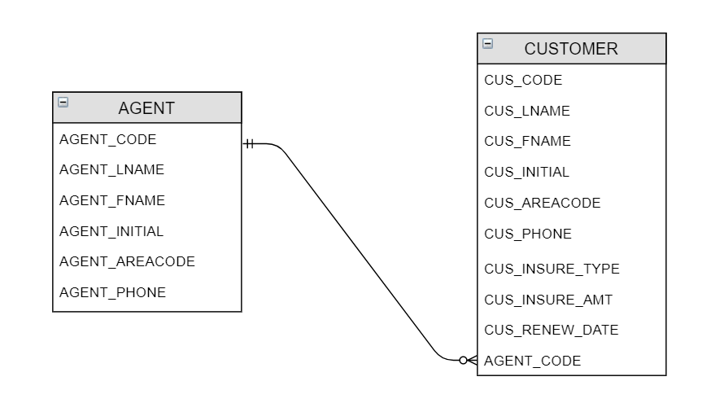

Question 3 –

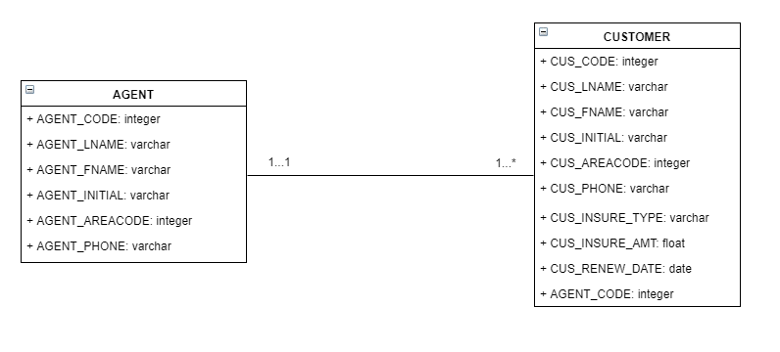

Question 5 –

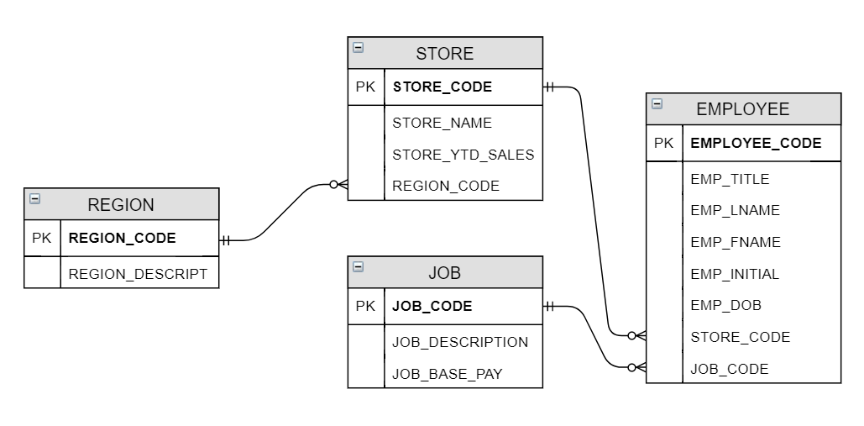

Question 6 –

|  |  |  |
| --- | --- | --- |
| **Table Name** | **Primary Key** | **Foreign Key** |
| REGION | REGION_CODE | NONE |
| STORE | STORE_CODE | REGION_CODE, EMP_CODE |
| EMPLOYEE | EMP_CODE | STORE_CODE |

Question 7 –

Yes, all 3 tables exhibit entity integrity.  
Entity integrity implies that a table has a defined primary key column which can identify each row of data uniquely and no values in the primary key column are empty/null. ﻿﻿﻿﻿﻿﻿﻿﻿﻿﻿﻿﻿﻿﻿

Table REGION - has primary key REGION_CODE and all values for this column are not-null and uniquely identifiable.

Table STORE ﻿- has primary key STORE_CODE and all values for this column are not-null and uniquely identifiable.

Table EMPLOYEE ﻿- has primary key EMP_CODE and all values for this column are not-null and uniquely identifiable.

Question 8 –

Yes, the ﻿2 tables that have foreign keys ﻿﻿exhibit referential integrity﻿﻿﻿﻿﻿﻿.  
Referential integrity implies that if a table contains a FOREIGN KEY reference then the foreign key column is in full agreement with the primary key being referenced by it. There should be no errant values or null values in the foreign key column.

Table REGION - NA

Table EMPLOYEE - has the foreign key STORE_CODE and this column follows the data present in the STORE_CODE primary key column in STORE table.

Table STORE - has foreign keys REGION_CODE and EMP_CODE and both these columns are consistent with the primary keys EMP_CODE from EMPLOYEE and REGION_CODE from REGION tables. ﻿﻿﻿﻿﻿﻿﻿﻿﻿﻿﻿﻿﻿﻿﻿﻿﻿﻿﻿﻿﻿﻿﻿﻿﻿﻿﻿﻿﻿﻿﻿﻿﻿﻿﻿﻿﻿﻿﻿﻿﻿﻿﻿﻿﻿﻿﻿﻿﻿﻿﻿﻿

Question 10 –

