Homework 3

Name – Navarurh Kumar

ID – NXK180010

**Q1.**

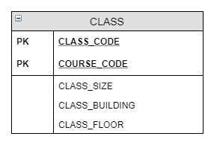

Here the underlined part represents the primary key components. We have 2 attributes making up the composite key component of this entity.

**Q6.**

**Part A**

C1 – C2: This is a partial relationship as C2 only depends on C1 and not the whole primary key made up of C1 and C3

C4 – C5: This is a transitive dependence as C5 only depends on C4 and C4 isn’t a component of the primary key set

C1, C3 – C2, C4, C5: this is a proper set of dependencies as C2 C4 and C5 are fully dependent on the full primary key which is made up of C1 and C3

**Part B**

This is a 2NF representation of the given problem -

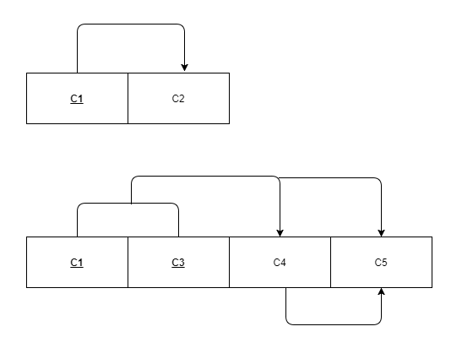

**Part C**

This is a 3NF representation of the same

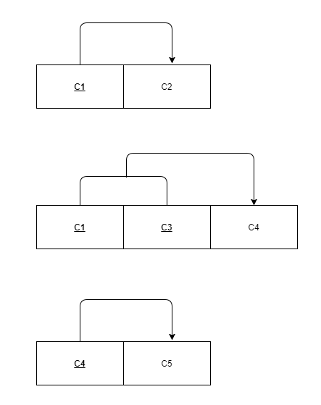

**Q7.**

**Part A** 2NF representation

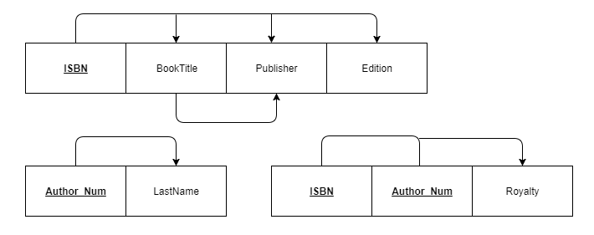

**Part B** 3NF representation

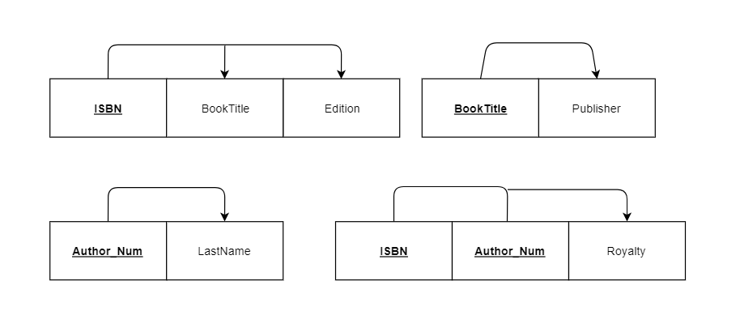

**Q8.** 2NF representation of the model

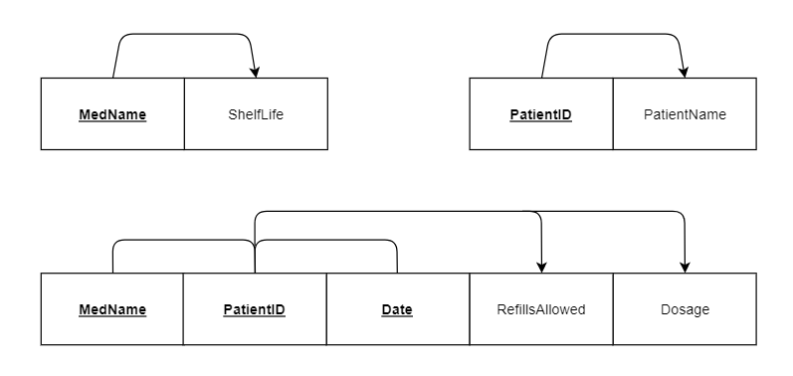

**Q9.** 3NF representation of the given problem

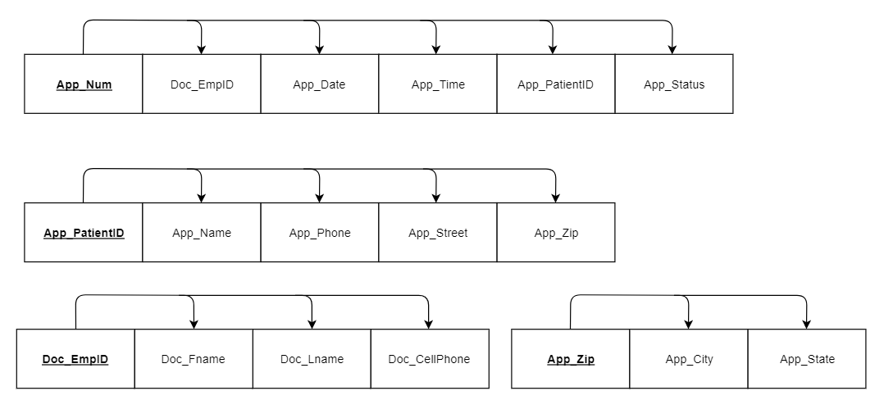

**Q10.** 3NF representation of the given problem

