**Practice Assignment: DB Fundamentals SQL**

Read the brief case below. Using MS SQL, complete the questions.

**Atlas Bikes**

Atlas Bikes has been selling their bikes since 1975 in the United States. They expanded to Australia and Germany in the year 2015. The bikes are sold via a trusted network of sales outlets, which are not owned by Atlas Bikes. As a measure to improve their footprint in the market, Atlas sales wants to open new stores which will be owned by them. To do this, the Senior Management wants to review the numbers and come up with their expansion strategy.

**Question Solutions:**

1. Download from eLearning the Atlas_Bikes-Data_Broker_Dump-Repeating_Groups.csv and normalize into separate tables following the procedures in Chapter 6 (Don’t forget to set Constraints).

|  |  |  |  |  |  |  |  |  |
| --- | --- | --- | --- | --- | --- | --- | --- | --- |
| **Column Name** | **#** | **Data Type** | **Not Null** | **Auto Increment** | **Key** | **Default** | **Extra** | **Comment** |
| **SALES** |  |  |  |  |  |  |  |  |
| SALES_YEAR | 7 | smallint(6) | TRUE | FALSE | [NULL] | [NULL] |  |  |
| SALES_REVENUE | 9 | decimal(20,0) | TRUE | FALSE | [NULL] | [NULL] |  |  |
| SALES_QUANTITY | 10 | decimal(20,0) | TRUE | FALSE | [NULL] | [NULL] |  |  |
| SALES_OUTLET_ID | 3 | int(11) | FALSE | FALSE | [NULL] | [NULL] |  |  |
| SALES_MONTH | 8 | varchar(3) | TRUE | FALSE | [NULL] | [NULL] |  |  |
| SALES_ID | 1 | int(11) | TRUE | FALSE | PRI | [NULL] |  |  |
| PRODUCT_ID | 6 | int(11) | FALSE | FALSE | [NULL] | [NULL] |  |  |
| PRODUCT_CATEGORY_ID | 5 | int(11) | FALSE | FALSE | [NULL] | [NULL] |  |  |
| DISTRIBUTION_CHANNEL_ID | 4 | int(11) | FALSE | FALSE | [NULL] | [NULL] |  |  |
| COUNTRY_ID | 2 | int(11) | FALSE | FALSE | [NULL] | [NULL] |  |  |
|  |  |  |  |  |  |  |  |  |
| **SALES_OUTLET** |  |  |  |  |  |  |  |  |
| SALES_OUTLET_ID | 1 | int(11) | TRUE | FALSE | PRI | [NULL] |  |  |
| SALES_OUTLET_NAME | 2 | varchar(30) | TRUE | FALSE | [NULL] | [NULL] |  |  |
| SALES_OUTLET_LOCATION | 3 | varchar(30) | TRUE | FALSE | [NULL] | [NULL] |  |  |
| COUNTRY_ID | 4 | int(11) | FALSE | FALSE | [NULL] | [NULL] |  |  |
|  |  |  |  |  |  |  |  |  |
| **PRODUCT_CATEGORY** |  |  |  |  |  |  |  |  |
| PRODUCT_CATEGORY_ID | 1 | int(11) | TRUE | FALSE | PRI | [NULL] |  |  |
| PRODUCT_CATEGORY_NAME | 2 | varchar(30) | TRUE | FALSE | [NULL] | [NULL] |  |  |
|  |  |  |  |  |  |  |  |  |
| **PRODUCT** |  |  |  |  |  |  |  |  |
| PRODUCT_ID | 1 | int(11) | TRUE | FALSE | PRI | [NULL] |  |  |
| PRODUCT_NAME | 2 | varchar(30) | TRUE | FALSE | [NULL] | [NULL] |  |  |
| PRODUCT_CATEGORY_ID | 3 | int(11) | FALSE | FALSE | [NULL] | [NULL] |  |  |
|  |  |  |  |  |  |  |  |  |
| **DISTRIBUTION_CHANNEL** |  |  |  |  |  |  |  |  |
| DISTRIBUTION_CHANNEL_ID | 1 | int(11) | TRUE | FALSE | PRI | [NULL] |  |  |
| DISTRIBUTION_CHANNEL_NAME | 2 | varchar(30) | TRUE | FALSE | [NULL] | [NULL] |  |  |
| DISTRIBUTION_CHANNEL_NOTE | 3 | varchar(30) | FALSE | FALSE | [NULL] | [NULL] |  |  |
|  |  |  |  |  |  |  |  |  |
| **COUNTRY** |  |  |  |  |  |  |  |  |
| COUNTRY_ID | 1 | int(11) | TRUE | FALSE | PRI | [NULL] |  |  |
| COUNTRY_NAME | 2 | varchar(30) | TRUE | FALSE | [NULL] | [NULL] |  |  |
| COUNTRY_POPULATION | 3 | decimal(20,0) | TRUE | FALSE | [NULL] | [NULL] |  |  |

1. Produce the ERD for the schema using erWin or DBeaver.

**Use the ER Diagram below to understand the Data Model**

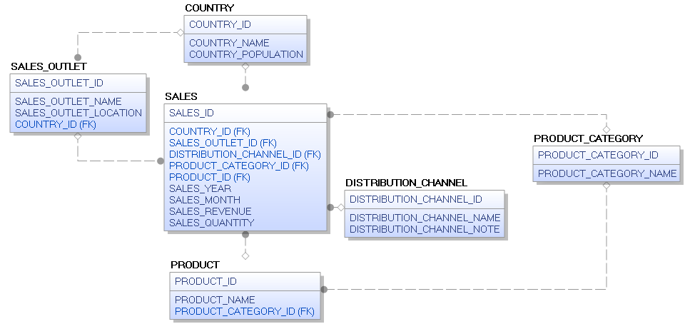

1. List the country name and population for each country, order by COUNTRY_NAME. [Hint: you will use the columns country_name, country_population and the table country]

**SELECT COUNTRY_NAME, COUNTRY_POPULATION FROM COUNTRY**

**ORDER BY COUNTRY_NAME;**

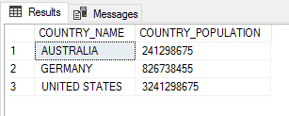

1. How many Products are sold by Atlas Bikes? [Hint: you will use the function COUNT(*) and the table product] Name the column as “NUMBER OF PRODUCTS”

**SELECT COUNT(*) AS "NUMBER OF PRODUCTS" FROM PRODUCT;**

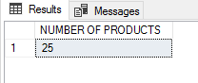

1. List all the Sales Outlets that are in the United States.[Hint: The COUNTRY_ID of United States is 1003]

**SELECT * FROM SALES_OUTLET WHERE COUNTRY_ID=1003;**

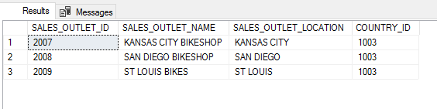

1. List the names all the Product_Categories.

**SELECT \***

**FROM PRODUCT_CATEGORY;**

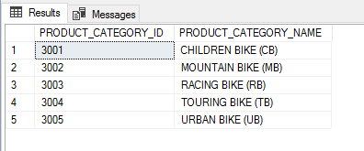

1. How many Distribution Channels are there? Name the column as “Number of DC”. [Hint: you will use the function COUNT(DISTRIBUTION_CHANNEL_ID)]

**SELECT COUNT(DISTRIBUTION_CHANNEL_ID) AS "NUMBER OF DC"**

**FROM DISTRIBUTION_CHANNEL;**

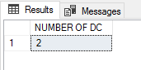

1. What was the Total Revenue generated from Germany in the years 2015 and 2016? [Hint: The Country_ID of Germany is 1002. Use the SUM function. Also use TO_CHAR(COLUMN_NAME,'$99,99,99,99,999')to change the format of the revenue]. Call the header “SALES_TOT_GERMANY” and display the result in US Dollars.

**SELECT FORMAT(SUM(SALES_REVENUE),'C') AS SALES_TOT_GERMANY**

**FROM SALES WHERE COUNTRY_ID=1002;**

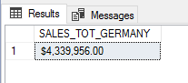

1. List the PRODUCT_NAME and PRODUCT_CATEGORY_NAME for each of the Products. Sort the list in the Descending order of the Product_Name [Hint: Use an INNER JOIN and table name aliases to write your query].

**SELECT P.PRODUCT_NAME, C.PRODUCT_CATEGORY_NAME**

**FROM PRODUCT P**

**INNER JOIN PRODUCT_CATEGORY C ON P.PRODUCT_CATEGORY_ID = C.PRODUCT_CATEGORY_ID**

**ORDER BY P.PRODUCT_NAME DESC;**

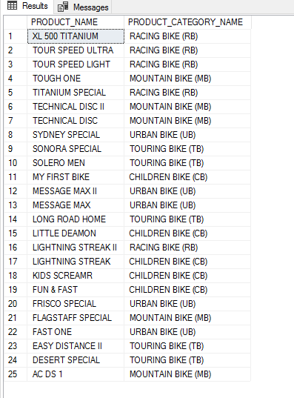

1. What was the Total Revenue for Atlas Bikes for the year 2015 and 2016. Format the revenue to show the unit of measure as US Dollars. [Hint: Use GROUP BY expression to aggregate the revenue for 2015 and 2016.

**SELECT FORMAT(SUM(S.SALES_REVENUE), 'C') AS TOTAL_REVENUE**

**FROM SALES S**

**WHERE S.SALES_YEAR IN (2015, 2016);**

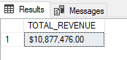

1. For the year 2015, list the Quantity of Bikes sold by each Sales Outlet. The header for the Sales Outlet name would be “Outlet Name” and the Sales Quantity should be marked as “Quantity Sold”. [Hint: Use INNER JOIN on Sales and Sales_Outlet tables. Also use the GROUP BY expression]

**SELECT O.SALES_OUTLET_NAME AS 'Outlet Name', SUM(S.SALES_QUANTITY) AS 'Quantity Sold'**

**FROM SALES_OUTLET O**

**INNER JOIN SALES S ON O.SALES_OUTLET_ID = S.SALES_OUTLET_ID**

**GROUP BY O.SALES_OUTLET_NAME;**

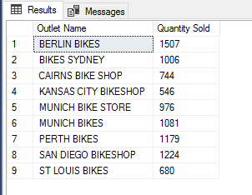

1. List the Sales Outlet Names and their Total Revenue for 2015 and 2016. Show the revenue in US Dollars. The header for the total revenue should be REVENUE.

**SELECT O.SALES_OUTLET_NAME AS 'Outlet Name', FORMAT(SUM(S.SALES_REVENUE), 'C') AS 'REVENUE'**

**FROM SALES_OUTLET O**

**INNER JOIN SALES S ON O.SALES_OUTLET_ID = S.SALES_OUTLET_ID**

**WHERE S.SALES_YEAR IN (2015, 2016)**

**GROUP BY O.SALES_OUTLET_NAME;**

