High-Level Design Document

# OPC UA Server for Air Conditioner Controller using Unified Automation SDK

## 1. Overview

This Console application implements an OPC UA server using the Unified Automation SDK version 4.2.1. It simulates an air conditioner controller by exposing variables such as:  
- Temperature  
- TemperatureSetpoint  
- Humidity  
- HumiditySetpoint  
- State  
These variables are initialized from an XML configuration file and updated periodically by a simulator class.

## 2. Architecture Diagram

The following diagram illustrates the high-level architecture of the system:

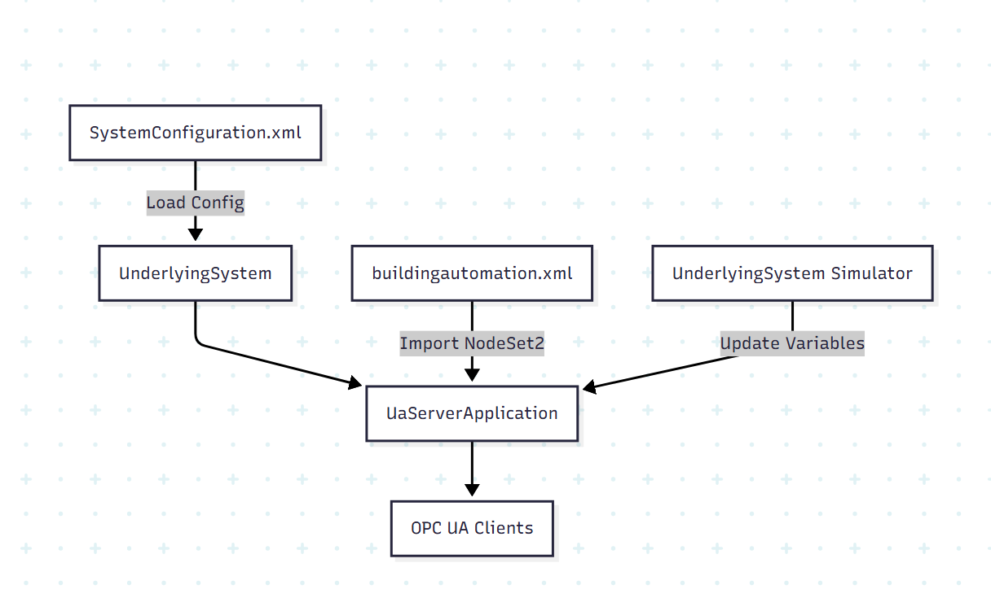

## 3. Key Components

### 3.1 OPCUAServerManager

Base Class: ServerManager (Unified Automation)  
Responsibilities:

- Initializes NodeManagers.

- Handles session management, security, and communication protocols.

### 3.1 ControllerNodeManager

Base Class: ControllerNodeManager (Unified Automation)  
Responsibilities:   
- Load node set from buildingautomation.xml  
- Register address space  
- Bind variables to data sources

### 3.2 UnderlyingSystem

Responsibilities:  
- Parse SystemConfiguration.xml  
- Provide initial values for the variables  
- Map XML values to OPC UA nodes

- Periodically update variable values

- Simulate realistic environmental changes

### 3.3 NodeSet Loader

Input: buildingautomation.xml (NodeSet2 format)  
Tool: UaModeler (used to generate C++/C#/XML code)  
Responsibilities:  
- Define custom types and nodes  
- Generate code or XML for integration

## 4. Model – Node -Variable relation

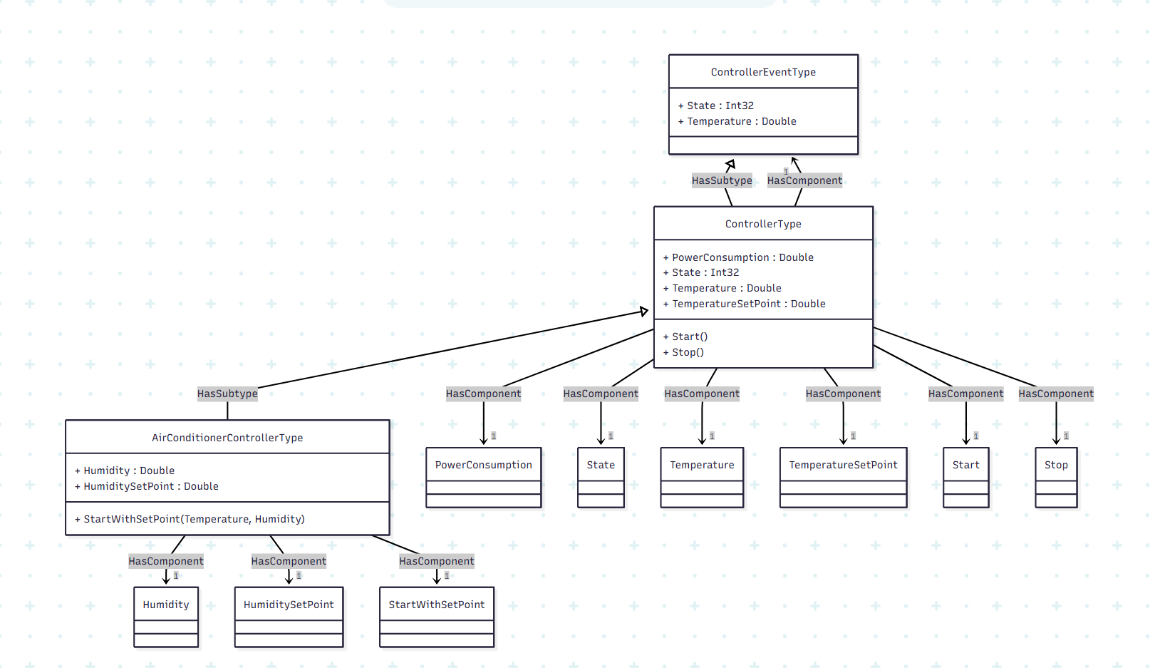

## 5. Data Flow

1. Startup:  
- UaServerApplication initializes the server.  
- buildingautomation.xml is loaded to define the address space.  
- SystemConfiguration.xml is parsed for initial values.  
  
2. Simulation:  
- UnderlyingSystem starts a timer.  
- It updates the values of the nodes periodically.  
  
3. Client Interaction:  
- OPC UA clients connect and read/write exposed variables.

## 7. Tools & SDKs

- Unified Automation SDK (C++ or .NET)  
- UaModeler for generating node models  
- Visual Studio 2022

## 8. Future Enhancements

- Add logging and diagnostics   
- Web-based monitoring dashboard