Retail Sales Trend Monitoring Project

# 📌 Project Overview

This project aims to help a retail chain monitor stores with increasing sales trends.  
We use time-series sales data to detect upward trends using linear regression and visualize them through a Streamlit dashboard.

# 📘 Sample Data

Sample of the sales_data.csv file:

store_id date sales  
 101 2023-01-01 1500  
 101 2023-01-02 1600  
 101 2023-01-03 1700  
 101 2023-01-04 1800  
 101 2023-01-05 1900

# 📓 Trend Detection Using Linear Regression

We calculate the sales trend for each store using linear regression:

Trend detection result:

store_id slope trend  
 101 100.0 Increasing  
 102 -50.0 Decreasing

# 📊 Example Trend Plot

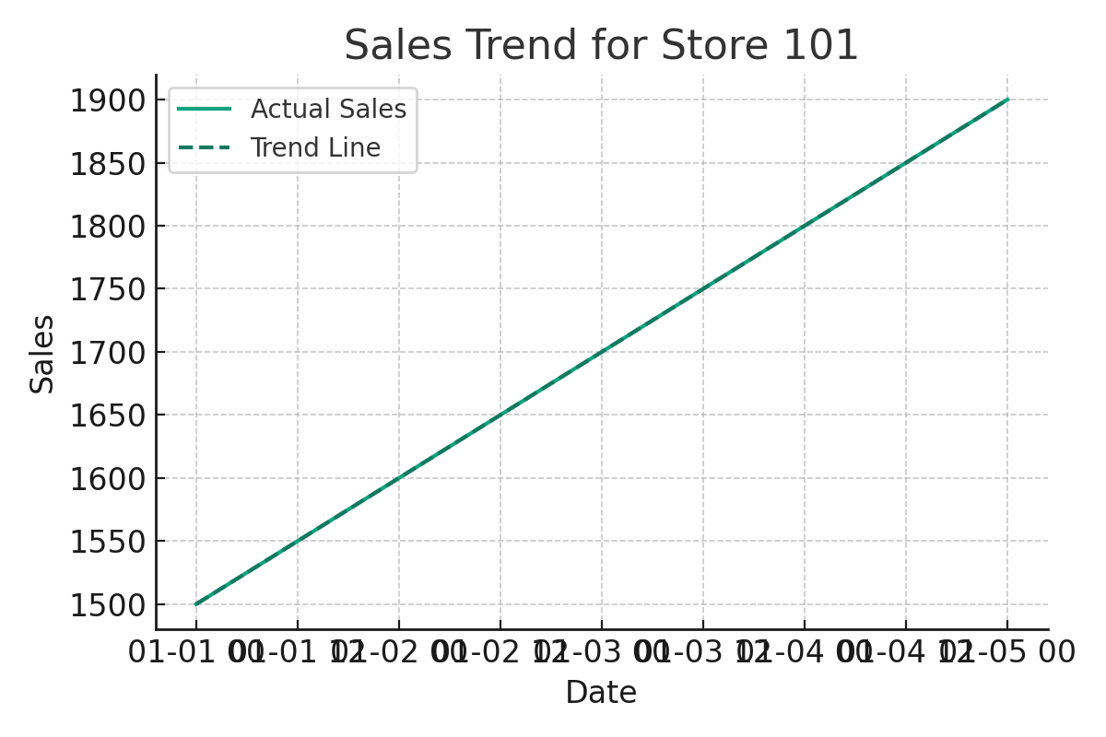

# 🚀 Streamlit Dashboard Code

Below is the code for the Streamlit dashboard:

import streamlit as st  
import pandas as pd  
import matplotlib.pyplot as plt  
from sklearn.linear_model import LinearRegression  
  
df = pd.read_csv('sales_data.csv', parse_dates=['date'])  
trends = pd.read_csv('store_trends.csv')  
  
st.title("📈 Store Sales Trend Monitor")  
store_ids = df['store_id'].unique()  
selected_store = st.selectbox("Select a store", store_ids)  
  
store_data = df[df['store_id'] == selected_store].copy()  
store_data['day_num'] = (store_data['date'] - store_data['date'].min()).dt.days  
  
X = store_data[['day_num']]  
y = store_data['sales']  
model = LinearRegression().fit(X, y)  
predicted = model.predict(X)  
  
fig, ax = plt.subplots()  
ax.plot(store_data['date'], y, label='Actual Sales')  
ax.plot(store_data['date'], predicted, label='Trend Line', linestyle='--')  
ax.set_title(f"Sales Trend for Store {selected_store}")  
ax.set_xlabel("Date")  
ax.set_ylabel("Sales")  
ax.legend()  
st.pyplot(fig)  
  
trend_info = trends[trends['store_id'] == selected_store]  
if not trend_info.empty:  
 st.markdown(f"### 📊 Trend: **{trend_info.iloc[0]['trend']}**")