Binary Search Tree
- A prominent data structure used in many systems programming applications for representing and managing dynamic sets.
- Average case complexity of Search, Insert, and Delete Operations is O(log n), where n is the number of nodes in the tree.
- DEF: A binary tree in which the nodes are labeled with elements of an ordered dynamic set and the following BST property is satisfied: all elements stored in the left subtree of any node x are less than the element stored at x and all elements stored in the right subtree of x are greater than the element at x.
- An Example: Figure shows a binary search tree. Notice that this tree is obtained by inserting the values 13, 3, 4, 12, 14, 10, 5, 1, 8, 2, 7, 9, 11, 6, 18 in that order, starting from an empty tree.
- Note that inorder traversal of a binary search tree always gives a sorted sequence of the values. This is a direct consequence of the BST property. This provides a way of sorting a given sequence of keys: first, create a BST with these keys and then do an inorder traversal of the BST so created.
- Note that the highest valued element in a BST can be found by traversing from the root in the right direction all along until a node with no right link is found (we can call that the rightmost element in the BST).
- The lowest valued element in a BST can be found by traversing from the root in the left direction all along until a node with no left link is found (we can call that the leftmost element in the BST).
- Search is straightforward in a BST. Start with the root and keep moving left or right using the BST property. If the key we are seeking is present, this search procedure will lead us to the key. If the key is not present, we end up in a null link.
- Insertion in a BST is also a straightforward operation. If we need to insert an element x, we first search for x. If x is present, there is nothing to do. If x is not present, then our search procedure ends in a null link. It is at this position of this null link that x will be included.
- If we repeatedly insert a sorted sequence of values to form a BST, we obtain a completely skewed BST. The height of such a tree is n - 1 if the tree has n nodes. Thus, the worst case complexity of searching or inserting an element into a BST having n nodes is O(n).
Construct a BST using 8, 3, 6,7,10,4,1,14,13
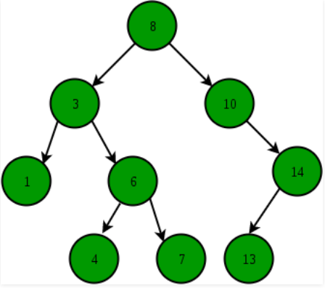

2) Construct a Binary search Tree using following node elements value 13, 3, 4, 12, 14, 10, 5, 1, 8, 2, 7, 9, 11, 6, 18 and perform Traversal.

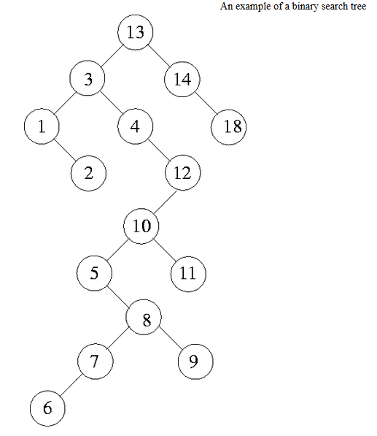

In order Traverse: Left, Root, Right
- 1,2,3,4,5,6,7,8,9,10,11,12,13,14,18

Pre order Traverse: Root, Left, Right
- 13,3,1,2,4,12,10,5,8,7,6,9,11,14,18

Post order Traverse: Left, Right
- 2,1,6,7,9,8,5,11,10,12,4,3,18,14,13

Implementation of BST.

#include<stdio.h>
struct node
{
int data;
struct node *left,*right;

}*root=NULL,*temp;

struct node* insert(struct node*,int);
struct node* delet(struct node * ,int);
void inorder(struct node *);
void preorder(struct node *);
void postorder(struct node *);

struct node* insert(struct node *root,int ele)
{
if(root==NULL)
{
temp=(struct node*)malloc(sizeof(struct node));
temp->data=ele;
temp->left= NULL;
temp->right=NULL;
return (temp);
}
else if(ele>root->data)
root->right=insert(root->right,ele);
else if(ele<root->data)
root->left=insert(root->left,ele);
return (root);
}

struct node* delet(struct node *root, int ele)
{
if (root == NULL)
printf("\n Tree is empty");
else if(ele < root->data)
root->left = delet(root->left,ele);
else if(ele > root->data)
root->right = delet(root->right,ele);
else if(root->left == NULL && root->right == NULL)
{
free(root);

}
else if(root->left == NULL && root->right != NULL)
{
temp=root->right;
root->data = temp->data;
free(temp);
}
else if(root->left != NULL && root->right == NULL)
{
temp=root->left;
root->data = temp->data;
free(temp);
}
else if(root->left != NULL && root->right != NULL)
{
temp =root->left;

while(temp->right != NULL)
temp=temp->right;

root->data = temp->data;

root->right=delet(root->right,temp->data);

}
return(root);

}

void inorder(struct node *root)
{
if(root!=NULL)
{
inorder(root->left);
printf("%d\t",root->data);
inorder(root->right);
}
}

void preorder(struct node *root)
{
if(root!=NULL)
{
printf("%d\t",root->data);
preorder(root->left);
preorder(root->right);
}
}

void postorder(struct node *root)
{
if(root!=NULL)
{
postorder(root->left);
postorder(root->right);
printf("%d\t",root->data);
}
}

main()
{
int ele,op,n;
do
{
printf("\n******Main Menu****\n");
printf("1.Insert\n2.Delete\n3.Display");
printf("\nEnter your option");
scanf("%d",&op);
switch(op)
{
case 1: printf("\nEnter element to insert");
scanf("%d",&ele);
root=insert(root,ele);
break;

case 2: printf("\nEnter element to delete");
scanf("%d",&ele);
root=delet(root,ele);
printf("\nThe element is deleted\n");
break;

case 3:
printf("whtat order u want to display");
printf("\n\n1.inorder\n2.postorder\n3.preorder");
printf("enter ur option");
scanf("%d",&n);
switch(n)
{
case 1:inorder(root);
break;
case 2:postorder(root);
break;
case 3:preorder(root);
break;
}
}
}while(op<=3);

}

----------------------------------------------AVL Tree-----------------------------------------------------
AVL tree is a self balanced binary search tree. That means, an AVL tree is also a binary search tree but it is a balanced tree. A binary tree is said to be balanced, if the difference between the hieghts of left and right subtrees of every node in the tree is either -1, 0 or +1. In other words, a binary tree is said to be balanced if for every node, height of its children differ by at most one. In an AVL tree, every node maintains a extra information known as balance factor. The AVL tree was introduced in the year of 1962 by G.M. Adelson-Velsky and E.M. Landis.
An AVL tree is defined as follows...
An AVL tree is a balanced binary search tree. In an AVL tree, balance factor of every node is either -1, 0 or +1.
Balance factor of a node is the difference between the heights of left and right subtrees of that node. The balance factor of a node is calculated either height of left subtree - height of right subtree (OR) height of right subtree - height of left subtree. In the following explanation, we are calculating as follows...
Balance factor = heightOfLeftSubtree - heightOfRightSubtree

Example
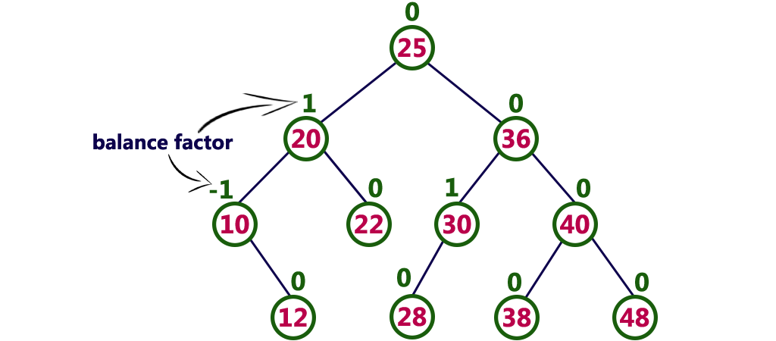
The above tree is a binary search tree and every node is satisfying balance factor condition. So this tree is said to be an AVL tree.

AVL Tree Rotations
Rotation is the process of moving the nodes to either left or right to make tree balanced.
There are four rotations and they are classified into two types.

Single Left Rotation
In LL Rotation every node moves one position to left from the current position. To understand LL Rotation, let us consider following insertion operations into an AVL Tree...
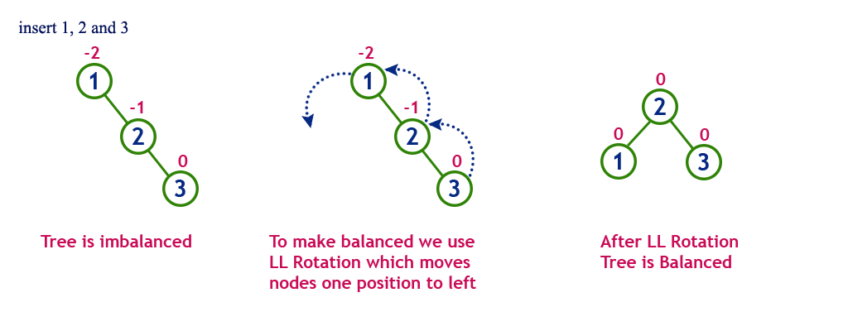

Single Right Rotation
In RR Rotation every node moves one position to right from the current position. To understand RR Rotation, let us consider following insertion operations into an AVL Tree...
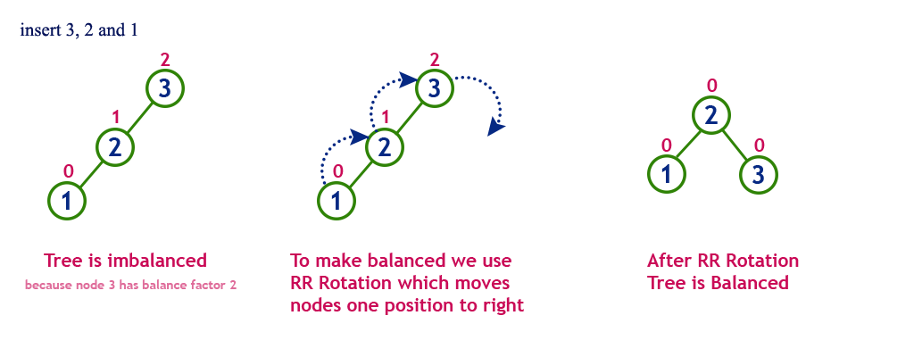

Left Right Rotation (LR Rotation)
The LR Rotation is combination of single left rotation followed by single right rotation. In LR Roration, first every node moves one position to left then one position to right from the current position. To understand LR Rotation, let us consider following insertion operations into an AVL Tree...
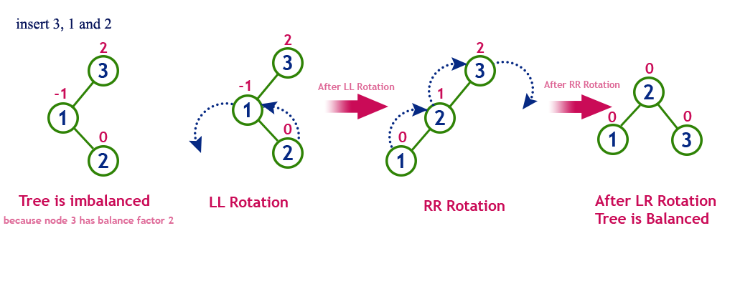

Right Left Rotation (RL Rotation)
The RL Rotation is combination of single right rotation followed by single left rotation. In RL Roration, first every node moves one position to right then one position to left from the current position. To understand RL Rotation, let us consider following insertion operations into an AVL Tree...
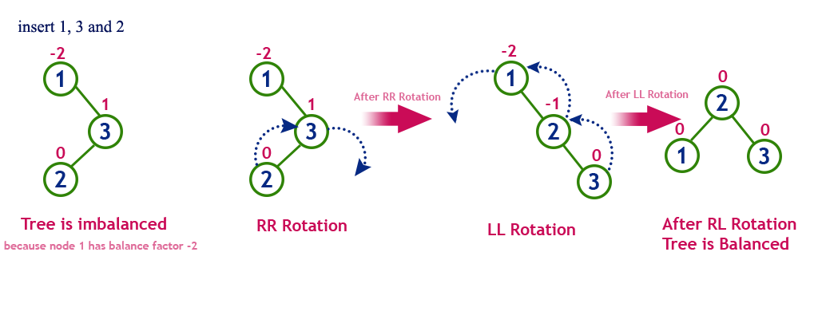

Operations on an AVL Tree
The following operations are performed on an AVL tree...
- Search
- Insertion
- Deletion

Construct an AVL Tree by inserting numbers from 1 to 8.
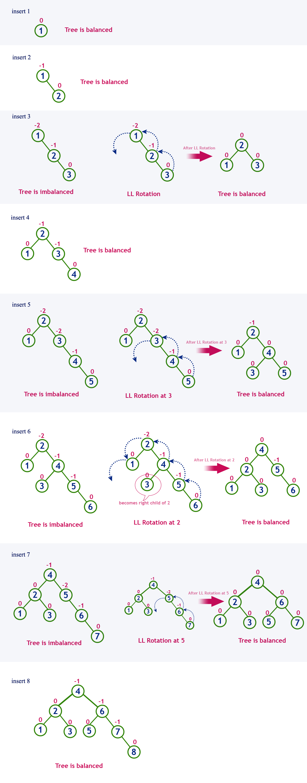
Implementation of AVL tree
#include<stdio.h>
struct node
{
int data,ht;
struct node *left,*right;

}*root=NULL,*temp;

struct node* insert(struct node *root, int x) /* AVL Tree Creation */
{
if(root==NULL)
{
temp =(struct node*)malloc(sizeof(struct node));
temp->data=x;
temp->left=NULL;
temp->right=NULL;
return (temp);
}
else if(x< root->data) ` /* insert in left subtree*/
{
root->left=insert(root->left,x);
if(BF(root)==2)
{
if(x < root->left->data)
root=LL(root);
else
root=LR(root);
}
}
else if(x > root->data) /* insert in right subtree*/
{
root->right=insert(root->right,x);
if(BF(root)==-2)
{
if(x>root->right->data)
root=RR(root);
else
root=RL(root);
}
}
root->ht=height(root);
return(root);
}

struct node * rotateright(struct node *x)
{
struct node *y;

y=x->left;
x->left=NULL;
y->right=x;

x->ht=height(x);
y->ht=height(y);

return(y);
}

struct node *rotateleft(struct node *x)
{
struct node *y;
y=x->right;
x->right=NULL;

y->left=x;
x->ht=height(x);
y->ht=height(y);
return(y);
}

struct node *RR(struct node *root)
{
root=rotateleft(root);
return(root);
}

struct node *LL(struct node *root)
{
root=rotateright(root);
return(root);
}

struct node *LR(struct node *root)
{
root->left=rotateleft(root->left);
root=rotateright(root);
return(root);
}
struct node *RL(struct node *root)
{
root->right=rotateright(root->right);
root=rotateleft(root);
return(root);
}
int BF(struct node *root)
{
int lh,rh;
if(root==NULL)
return(0);
if(root->left==NULL)
lh=0;
else
lh=1+root->left->ht;

if(root->right==NULL)
rh=0;
else
rh=1+root->right->ht;
return(lh-rh);
}
void preorder(struct node *root)
{
if(root!=NULL)
{
printf("%d(Bf=%d)\t",root->data,BF(root));
preorder(root->left);
preorder(root->right);
}
}
void inorder(struct node *root)
{
if(root!=NULL)
{
inorder(root->left);
printf("%d(Bf=%d)\t",root->data,BF(root));
inorder(root->right);
}
}
void postorder(struct node *root)
{
if(root!=NULL)
{
postorder(root->left);
postorder(root->right);
printf("%d(Bf=%d)\t",root->data,BF(root));
}
}
int height(struct node *root)
{
int lh,rh;
if(root==NULL)
return(0);
if(root->left==NULL)
lh=0;
else
lh=1+root->left->ht;

if(root->right==NULL)
rh=0;
else
rh=1+root->right->ht;

if(lh>rh)
return(lh);

return(rh);
}

struct node *Delete(struct node *root,int x)
{
struct node *p;
if(root==NULL)

{
return NULL;
}
else if(x> root->data)/* insertin right subtree*/
{
root->right=Delete(root->right,x);
if(BF(root)==2)
if(BF(root->left)>=0)
root=LL(root);
else
root=LR(root);
}
else if(x<root->data)
{
root->left=Delete(root->left,x);
if(BF(root)==-2)/*Rebalanceduring windup*/
if(BF(root->right)<=0)
root=RR(root);
else
root=RL(root);
}
else
{
/*data to be deleted is found*/
if(root->right!=NULL)
{ /*delete its inordersuccesor*/
p=root->right;
while(p->left!= NULL)
p=p->left;
root->data=p->data;
root->right=Delete(root->right,p->data);

if(BF(root)==2)/*Rebalanceduring windup*/
if(BF(root->left)>=0)
root=LL(root);
else
root=LR(root);
}
else
return(root->left);
}
root->ht=height(root);
return(root);
}

void main()
{
int x,n,i,op;
do
{
printf("\n1)Create:\n2)Insert:\n3)Delete:\n4)Print:\n5)Quit:");
printf("\n\nEnterYour Choice:");
scanf("%d",&op);
switch(op)
{
case 1:printf("\nEnter no. of elements:");
scanf("%d",&n);
printf("\nEnter tree data:");
root=NULL;
for(i=0;i<n;i++)
{
scanf("%d",&x);
root=insert(root,x);
}
break;
case 2: printf("\nEnter a data:");
scanf("%d",&x);
root=insert(root,x);
break;
case 3: printf("\nEnter a data:");
scanf("%d",&x);
root=Delete(root,x);
break;
case 4: printf("\nPreordersequence:\n");
preorder(root);
printf("\nInordersequence:\n");
inorder(root);
printf("\n");
}
}while(op!=5);
}
---------------------------------------------Splay Tree----------------------------------------------------
Splay Tree is a self - adjusted Binary Search Tree in which every operation on an element rearranges the tree so that the element is placed at the root position of the tree.
In a splay tree, every operation is performed at root of the tree. All the operations on a splay tree are involved with a common operation called "Splaying".
Splaying an element is the process of bringing it to the root position by performing suitable rotation operations.
In a splay tree, splaying an element rearrange all the elements in the tree so that splayed element is placed at root of the tree.
With the help of splaying an element we can bring most frequently used element closer to the root of the tree so that any operation on those element performed quickly. That means the splaying operation automatically brings more frequently used elements closer to the root of the tree.
Every operation on a splay tree performs the splaying operation. For example, the insertion operation first inserts the new element as it inserted into the binary search tree, after insertion the newly inserted element is splayed so that it is placed at root of the tree. The search operation in a splay tree is search the element using binary search process then splay the searched element so that it placed at the root of the tree.
In a splay tree, to splay any element we use the following rotation operations...
Rotations in Splay Tree
- 1. Zig Rotation
- 2. Zag Rotation
- 3. Zig - Zig Rotation
- 4. Zag - Zag Rotation
- 5. Zig - Zag Rotation
- 6. Zag - Zig Rotation

Examples

Zig Rotation
The Zig Rotation in a splay tree is similar to the single right rotation in AVL Tree rotations. In zig rotation every node moves one position to thr righ from its current position. Consider the following example...
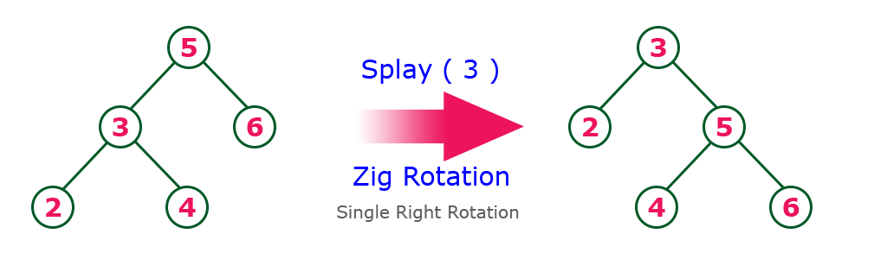

Zag Rotation
The Zag Rotation in a splay tree is similar to the single left rotation in AVL Tree rotations. In zag rotation every node moves one position to the left from its current position. Consider the following example...
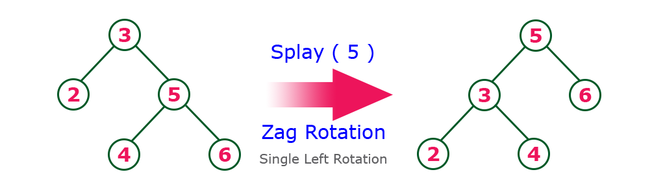

Zig-Zig Rotation
The Zig-Zig Rotation in a splay tree is a double zig rotation. In zig-zig rotation every node moves two position to the right from its current position. Consider the following example...
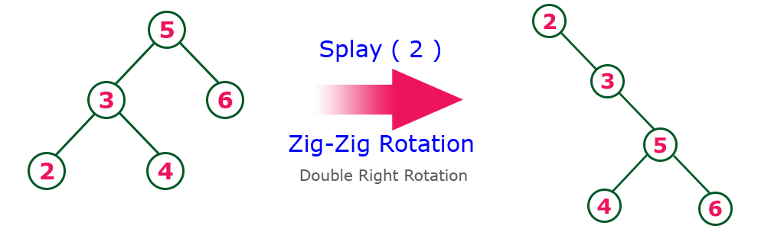

Zag-Zag Rotation
The Zag-Zag Rotation in a splay tree is a double zag rotation. In zag-zag rotation every node moves two position to the left from its current position. Consider the following example...
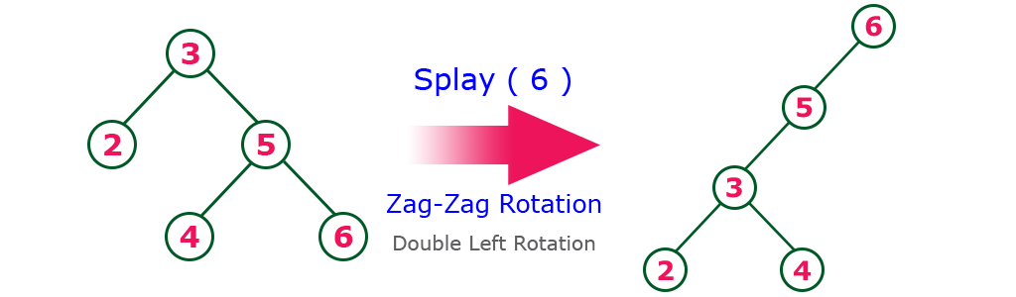

Zig-Zag Rotation
The Zig-Zag Rotation in a splay tree is a sequence of zig rotation followed by zag rotation. In zig-zag rotation every node moves one position to the right followed by one position to the left from its current position. Consider the following example...
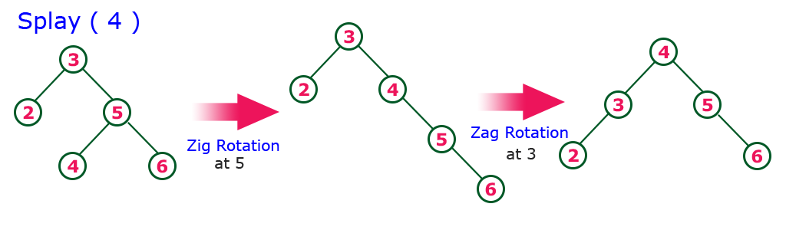

Zag-Zig Rotation
The Zag-Zig Rotation in a splay tree is a sequence of zag rotation followed by zig rotation. In zag-zig rotation every node moves one position to the left followed by one position to the right from its current position. Consider the following example...
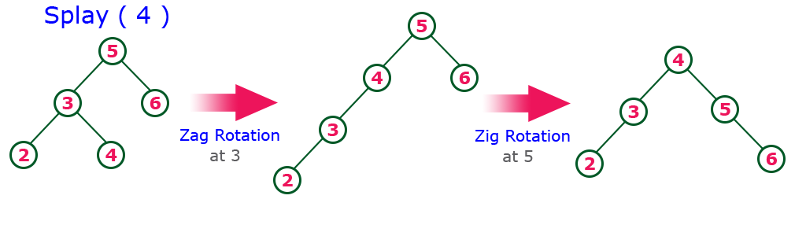

Every Splay tree must be a binary search tree but it is need not to be balanced tree.

