SESSION NUMBER: 01
Session Outcome: 1) Students are come to know, what is time and space complexity?
2) Students are able to analyse the complexity of any type of algorithms.

Time in Minutes | Topic | BTL | Teaching– Learning Method | Active Learning Methods
30 | Lecture-1  Mathematical Background  Definitions of Asymptotic notations - O(n), Ω(n) and Ɵ(n) – Best, Average and Worst Case  Ref: chapter-2 of Data structures and algorithm analysis in C by Mark Allen Weiss | 1 | Lecturing, Discussion
15 | Lecture-2:  Deliver a mathematical calculation of running time of sample algorithm and ask the students to analyze it.  Algorithm: Time taken  - Start ------ 0  - Input: Read ‘n’ ------ 1  - initialize: sum=0, i=1 ------ 2  - Process: sum = sum + i ------ n  - i = i +1 ------ n  - if ( i < = n ) go to step 4 ------ n +1  - Output:  - print ‘sum’ ------ 1  - Stop ------ 0  Total time in function f(n) = 3n + 4  Ref: chapter-2 of Data structures and algorithm analysis in C by Mark Allen Weiss | 1 | Lecturing, Discussion
05 | Conclusion |  | Lecturing, Discussion

SESSION NUMBER: 02
Session Outcome: 1. Calculate the running time of an algorithm .
2. Students are able to identify the incremental order of time complexity

Time in Minutes | Topic | BTL | Teaching– Learning Method | Active Learning Methods
30 | Lecture-1  Running time calculations, A simple example General rules  Ask the students to find the running time of Following problems.  - Problem  For( i=0; i < n-1 ; i++)  Printf(“%d”, i+75);  - Problem  For( i=0; i < n-1 ; i++)  { For (j=0;j<m-2;j++)  Printf(“*”);  Printf(“\n”);  }  - Problem  For( i=0; i < n ; i++)  { For (j=0;j<n;j++)  Printf(“*”);  Printf(“\n”);  }  Ref: chapter-2 of Data structures and algorithm analysis in C by Mark Allen Weiss | 2 | Lecturing, Discussion
15 | Lecture-2  Logarithms in Running time and checking analysis. Ask the students to perform binary search algorithm and analyze the time complexity.  Discuss the O (1), O (log n), O (n/2), O (n), O (n²), O (n³) . . .  Ref: chapter-2 of Data structures and algorithm analysis in C by Mark Allen Weiss | 2 | Lecturing, Discussion
05 | Conclusion |  | Lecturing, Discussion

SESSION NUMBER: 03
Session Outcome: 1. Implement insertion sort.
2. Analyze time complexity of insertion sort.
Time in Minutes | Topic | BT L | Teaching– Learning  Method | Active Learning  Methods
5 | Recap |  | Lecturing, Discussion
10 | Practice session-1:  Consider there are 10 group of members in cinema hall for taking tickets from counter, arrange the group of members in a line according to the height of a persons. The height of persons are given in centimeters as follows:165,170,145,150,170,120,135,145,160,130.  After each iteration, draw the elements in array. | 3 | Lecturing, Discussion
20 | Sub topic -1 (Lecture):  Explain How insertion sort works and analyze its time complexity.  Algorithm:  - Read “n” elements as input in array  - Process  for (i = 1 ; i < n ; i++)  {  J = i;  while((j > 0) && (a[J] < a[J-1]))  {  t = a[J];  a[J] = a[J-1];  a[J-1] = t;  J--;  }  - Display sorted array as output | 2 | Lecturing, Discussion
10 | Practice session -2:  Bangalore City, where peace prevails most of the time. Not everyone is a huge fan of peace, though. Certainly not Mr. XYZ, whose identity is not known to us - yet. Mr. XYZ has somehow managed to bring zombies to Bangalore City to attack and destroy the city.If he sees a zombie , he marks them in his list with their power. After generating the entire list of power of these creatures, he decides to arrange this data.All the zombies arranged in ascending sorted manner of their power.  The powers are given as:2, 3, 10, 12, 15, 22, 21, 13, 18, 21, 17.  Implement Insertion sort program to arrange the powers in ascending order. | 3 | Lecturing, Discussion
5 | Conclusion

SESSION NUMBER:04

Session Outcome: 1. Implement shell sort
2. Analyze time complexities
Time in Minutes | Topic | BT L | Teaching– Learning Method | Active Learning Methods
5 | Lecture  A lower bound for simple sorting algorithms | 2 | Lecturing, Discussion | QUIZ
10 | Subtopic -1 (Lecture):  Explain how shell sort works using shell's original sequence: N/2, N/4, ..., 1 (repeatedly divide by 2). Explain Hibbard, Sedgewick increments. | 2 | Lecturing, Discussion | QUIZ
20 | Ask the students to implement shell sort by using insertion sort independently for each pass for practice session 1.  Algorithm:  - Read “n” elements as input in array  - Process  m=n/2;  while(m>0)  {  for( i=m;i<n;i++)  {  for(j=i-m;j>=0;j=j-m)  {  if (a[j] >a[j+m])  {  t=a[j];  a[j]=a[j+m];  a[j+m]=t;  }  }  /* Identify the pass here and print the each passes elements */  }  m=m/2;  }  - Display the sorted as elements output | 3 | Lecturing, Discussion | QUIZ
10 | Subtopic -2 (Lecture):  Analyze the time complexity ofshell sort. Discuss what disadvantages of insertion sort does the shell sortovercome.  [ Classic Data Structures 2Nd Ed. By Samanta, SamantaDebasis] | 4 | Lecturing, Discussion | QUIZ
05 | Conclusion |  | Lecturing, Discussion | QUIZ

SESSION NUMBER:05

Session Outcome: 1. Implement heap sort
2. Analyze time complexities of heap sort
Time in Minutes | Topic | BT L | Teaching– Learning Method | Active Learning Methods
5 | Introduction to Heap sorting | 2 | Lecturing, Discussion | QUIZ
10 | Sub-topic-1(lecture):  Explain Heap order property and two phases of heap sort (1. Heap Creation 2. Sorting via deletion) with an example  Explain Max and Min Heap:  Heap Property: All nodes are either greater than or equal to or less than or equal to each of its children. If the parent nodes are greater than their child nodes, heap is called a Max-Heap, and if the parent nodes are smaller than their child nodes, heap is called Min-Heap. | 2 | Lecturing, Discussion | QUIZ
20 | Practice session - 1:  Ask the students to write an algorithm to sort the elements using heap sort technique and also analyze its time complexity.  Analysis time Complexity of Heap Sort  Worst Case Time Complexity: O(n*log n)  Best Case Time Complexity: O(n*log n)  Average Time Complexity: O(n*log n) | 3 | Lecturing, Discussion | QUIZ
10 | Practice session - 2:  Suppose we are sorting an array of eight integers using heapsort, and we have just finished some heapify (either maxheapify or minheapify) operations. The array now looks like this: 16 14 15 10 12 27 28 How many heapify operations have been performed on root of heap? | 4 | Lecturing, Discussion | QUIZ
05 | Conclusion |  | Lecturing, Discussion | QUIZ

SESSION NUMBER:06

Session Outcome: 1. Understand the concept and Implementation of Merge sort
2. Analyze the divide and conquer principle
Time in Minutes | Topic | BT L | Teaching– Learning Method | Active Learning Methods
5 | Introduction to Merge sorting | 2 | Lecturing, Discussion | QUIZ
10 | Sub-topic-1(lecture):  Explain Merge sort and its basics with an example  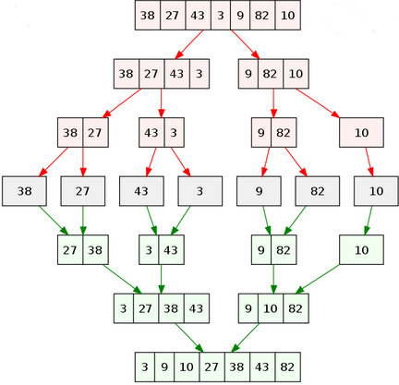 | 2 | Lecturing, Discussion | QUIZ
20 | Practice session - 1:  Here is an array of ten integers:  5 3 8 9 1 7 0 2 6 4  Draw this array after the TWO recursive calls of merge sort are completed, and before the final merge step has occurred.  [Data Structures and Other Objects Using C++ by Michael Main and Walter Savitch] | 2 | Lecturing, Discussion | QUIZ
10 | Sub-topic-2(lecture):  Analyze the complexity of merge sort algorithm.  MergeSort(arr[], l, r)  If r > l  {1. Find the middle point to divide the array into two halves: middle m = (l+r)/2  2. Call mergeSort for first half:  Call mergeSort(arr, l, m)  3. Call mergeSort for second half:  Call mergeSort(arr, m+1, r)  4. Merge the two halves sorted in step 2&3:  Call merge(arr, l, m, r) | 3 | Lecturing, Discussion | QUIZ
05 | Conclusion |  | Lecturing, Discussion | QUIZ

SESSION NUMBER: 07
Session Outcome: 1. Analyse the time complexity of Quick sort algorithm for Best and worst cases.
Time in Minutes | Topic | BTL |  | Teaching– Learning Method |  | Active Learning Methods
05 | Recap / Introduction |  | Lecturing, Discussion
05 | Sub-topic 1(Lecture):  Explain Quick sort algorithm with best case derivation. | 2
15 | Practice session 1:  Ask the students to sort the following data using quick sort: 99,22,66,11,55,33, 44,88, 77, 29, 67, 54, 90 and then analyse the Best case for Quick sort | 4
05 | Sub-topic 2 (Lecture):  Explain Quick sort algorithm with worst case derivation. | 2
15 | Practice session 2: (LTC)  Ask the Students to analyze the following code for quick sort using the system :  void quicksort(int a[10], int first, int last)  {  int pivot,j,t,i;  if(first<last)  {  pivot=first; i=first; j=last;  while(i<j)  {  while(a[i] <= a[pivot]) i++;  while(a[j]>a[pivot]) j--;  if(i<j) { t=a[i]; a[i]=a[j]; a[j]=t; }  }  t=a[pivot]; a[pivot]=a[j]; a[j]=t;  quicksort(a,first,j-1);  quicksort(a,j+1,last);  }  }  https://www.geeksforgeeks.org/quick-sort/ | 4
05 | Conclusion & Summary

SESSION NUMBER: 08

Session Outcome: 1. At the end of this session students will Understand the basic concept of Bucket Sort and it’s time complexity.

Time in Minutes | Topic | BTL | Teaching– Learning Method | Active Learning Methods
5 | Recap/Introduction: |  | Lecturing, Discussion
15 | Sub topic – 1 (Lecture):  Explain the data partitioning strategies using the example of the bucket sort. | 2 | Lecturing, Discussion
20 | Practical session – 1:  Ask the students to sort the following data using bucket sort :  80, 50, 30, 10, 90, 60, 0, 70, 40, 20, 50  Analyse the following algorithm for time complexity  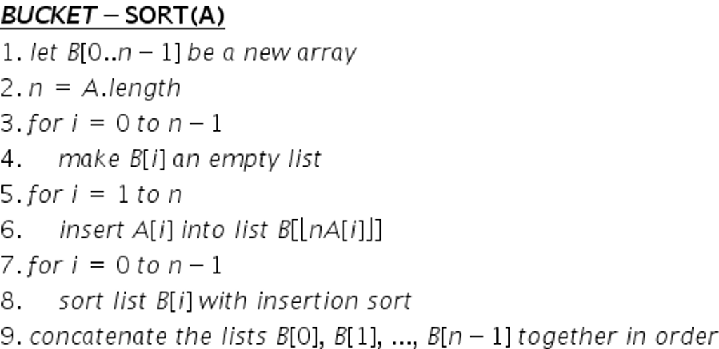 | 3 | Lecturing, Discussion
5 | Sub topic –3 (Lecture):  Analyze the complexity of bucket sort with suitable example | 4 | Lecturing, Discussion
5 | Conclusion |  | Lecturing, Discussion

SESSION NUMBER: 09
SessionOutcome:1. To implement external sorting.
2. To analyze the time complexity of externalsorting.
Time in Minutes | Topic | BT L | Teaching– Learning Method | Active Learning Methods
5 | Recap / Introduction:
10 | Sub-topic-1(lecture):  Explain External sorting and two phases of external sorting (1. Sort phase 2. Merge phase) with an example. | 2
10 | Practice session - 1:  Ask the students to write an algorithm to sort the elements using External sorting technique and also analyze its time complexity. | 2 | Lecturing, Discussion
20 | Practice Session(LTC):  Ask the students to write and execute a C program to solve the following example.  N = 14, M = 3 (14 records on tape Ta1, memory capacity: 3 records.)  T1: 17, 3, 29, 56, 24, 18, 4, 9, 10, 6, 45, 36, 11, 43  [Donald Knuth, The Art of Computer Programming, Volume 3: | 3 | Lecturing, Discussion
 | Sorting and Searching, Second Edition. Addison-Wesley]
5 | Conclusion

SESSION NUMBER: 10
Session Outcome: 1. Implement linear data structures like linked lists.
Time in Minutes | s | BTL | Teaching Learning  Method | Active Learning  Methods
5 | Lecture | 2
Definition of ADT (Abstract Data Types), Type of ADT.

Ref: https://www.geeksforgeeks.org/abstract-data-types/
 | Lecture
 | Revise single linked list with diagram’s
15 | The list ADT | 1
 | Ref: chapter-3 of Data structures and algorithm analysis in C by
 | Mark Allen Weiss
25 | Practice Session 1:  Suppose the Personnel file of a small company contain the following data for all its employees SSN(social security number),Name and salary. A Linked list is used to store the Ask the students to write a function to sort the records based on SSN?  For the following ADT- data structure create and display the following structure members for ‘n’ train information.  struct node  {  int train_no;  char train_name[20], source[20], destination[20];  float AC1_ fare, AC2_fare, AC3_fare, SL_fare, Gen_fare;  } t[20]; | 3 | Lecturing, Discussion
 | Ref : “Data Structures “by Forozan
05 | Conclusion

