Documentation of Website Portfolio Mobile

Navprateek Bhullar(200246735)

Advance Web Programming (COMP2068)

Prof. Tim

September 26, 2013

Documentation of the website:-

The website I developed for my project of comp2068 (Advanced Web Development) is Nav Bhullar <http://webdesign4.georgianc.on.ca/~200246735/comp2068/project1/> . It is a simple portfolio mobile site which have 7 pages of code in total including 1 .js files, 1 .css files.

1. As it is my portfolio site , so the name of company here is Nav Bhullar nd the logo of company is NB having a computer on left with a doctor cross sign. It totally reflects my personality being a web developer.



2. Nav bar:- Nav bar is the navigation bar of my portfolio site. It take viewers to 3 different links in the website. Pages in nav bar are Home , About Me, Contact Me. Nav bar of other pages except index.html i.e. home button have back buttons included in it which directs user to the previous location.

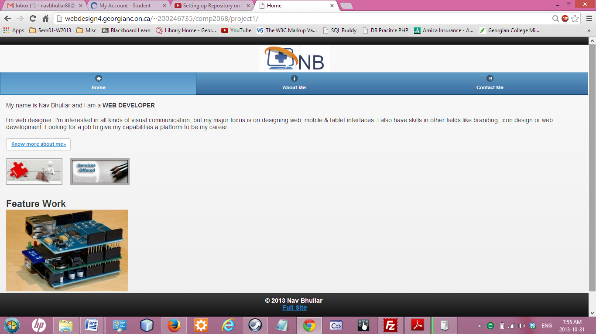

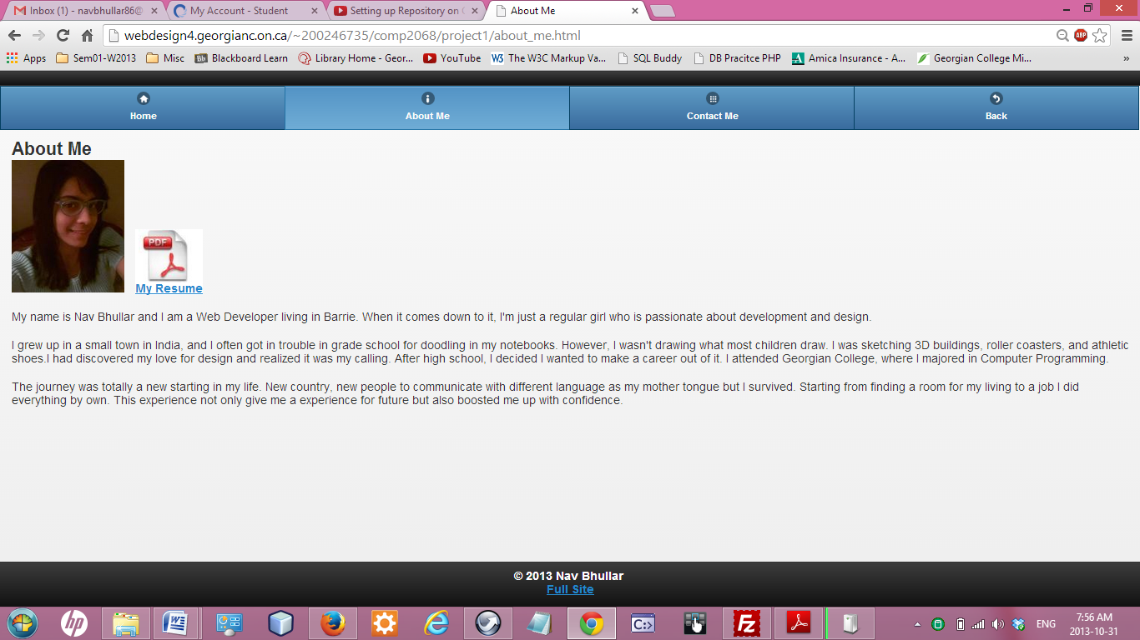

3. I added featured work on homepage which include three pictures and external links stored in each images which takes viewers to the details or view of the project. I used an internal javascript on home page i.e. index.html

It also have two picture buttons which take users to project.html and services.html page respectively. Project.html page give details about the projects which I have done in past and when clicked on pictures of projects.html page it will redirect the user to the respective projects.

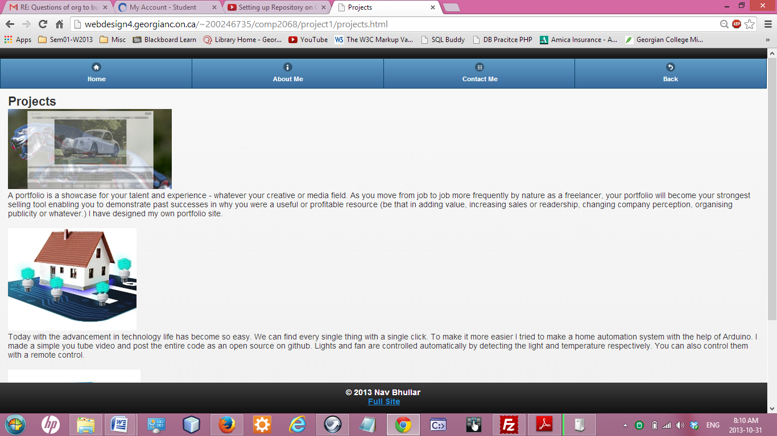

Services.html page give idea of the services offered to the users.

It also have full site option in the footer which redirect desktop site to mobile version if user screen is less than 699

4. Next page is about_me.html. It includes my resume as a pdf file users can view it and also download it. It have my personal biographic section and also have my current image.

5. Contact_me.html give users my contact details it have keep connected section which takes users to my social networking profiles. It also give user to dial my number and send me email.

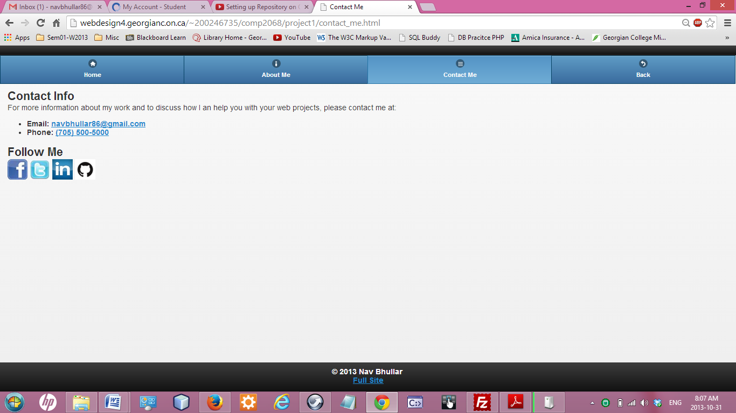

I downloaded my theme from <http://jquerymobile.com/themeroller/>

and fonts from "http://fonts.googleapis.com/css?family=Source+Sans+Pro:200"