Website module

To create a new menu (using module):
In .xml file,

<?xml version="1.0" encoding="utf-8"?>
<odoo>
<data>
<record id="Customised Cake" model="website.menu">
<field name="name">Cake Order</field><!-- Menu Name -->
<field name="url">/cake/order/form</field>
<field name="parent_id" ref="website.main_menu"/>
<field name="sequence" type="int">80</field><!-- Menu order-->
</record>
</data>
</odoo>

A menu “Cake order” will be created ,on clicking the menu call will passed to the controller which contain the url (ie here ‘/cake/order/form’)
Create a controllers folder.
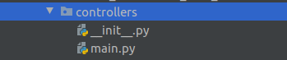
In the __init__.py file import the file main.py
# -*- coding: utf-8 -*-
from . import main

a
Also import the controllers in the __init__.py file
# -*- coding: utf-8 -*-
from . import controllers
Create a controller , import the required library ,then define the route and then define the function
# -*- coding: utf-8 -*-
from odoo import http
from odoo.http import request
class CakeOrder(http.Controller):
@http.route('/cake/order/form', type="http", auth="public",
website=True)
def order_form(self):
return request.render(
'cake_order.cake_order_tmpl', {})

Either you can render a template or redirect to another page.
To render a template ,
return request.render(‘module_name.template_id,{data :if you want to pass any data to the template})
To redirect to a page ,
return request.redirect('page_url')
For example if you want to redirect to shop page ,then
return request.redirect('/shop')
In the above code , when clicking the menu “Cake order” which will render a template with some input fields .

<?xml version="1.0" encoding="utf-8"?>
<odoo>
<template id="custom_cake_order_template">
<t t-call="website.layout">
<form action="/customised_cake/order/form/submit" method="post">
<div id="wrap" class="oe_structure oe_empty custom_cake">
<section class="s_text_block pt32 pb32">
<div class="container">
<div class="content">
<center>
<h2 style="margin-top:20px;">
CUSTOMISED CAKE ORDER FORM
</h2>
<table style="margin-top:50px;">
<tr>
<td>
<input type="text"
name="name" class="cake_details" placeholder="Name"/>
</td>
<td style="padding-left:20px;">
<input type="text" name="phone" class="cake_details"
placeholder="Mobile"/>
</td>
</tr>
<tr>
<td colspan="2">
<input type="text" name="email" class="email"
placeholder="Email" style="width:100%"/>
</td>
</tr>
<tr>
<td colspan="2">
<input type="text" name="message_on_cake"
class="cake_details"
placeholder="Message on the Cake"
style="width:100%"/>
</td>
</tr>
<tr>
<td colspan="2">
<input type="text"name="cake_size"
class="cake_details" placeholder="Weight and Dimensions"
style="width:100%"/>
</td>
</tr>
<tr>
<td>
<input type="text" name="delivery_time" id="date"
class="cake_details"
placeholder="Delivery Date"/>
</td>
<td style="padding-left:20px;">
<input type="text" name="delivery_to"
class="cake_details"
placeholder="Delivery To"/>
</td>
</tr>
</table>
</center>
<div>
<p class="text-center">
<input type="submit" id="order_cake" value="Submit"
class="btn"
style="margin-top:10px;background-color:#977124;color:white"/>
<input type="hidden" name="csrf_token"
t-att-value="request.csrf_token()"/>
</p>
</div>
</div>
</div>
</section>
</div>
</form>
</t>
</template>
</odoo>

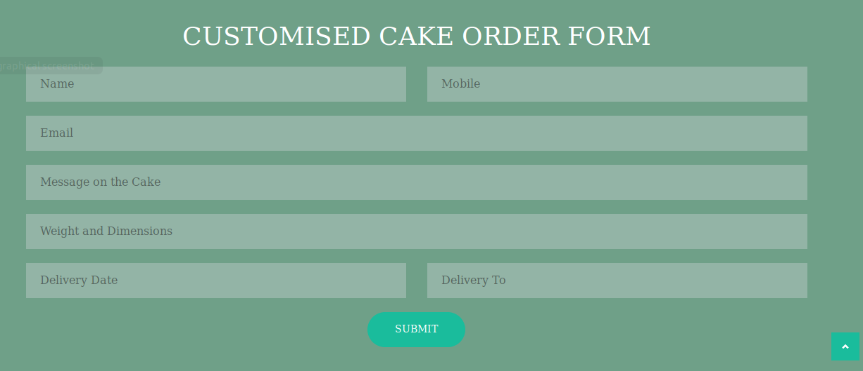

On submitting this form , the call pass to the route that given in the form action, in the above code the call pass to the route ‘/customised_cake/order/form/submit’,ie in the controller
@http.route('/customised_cake/order/form/submit', type="http",
methods=['GET', 'POST'], auth="public", website=True)
def submit_form(self, **post):
#your code
return

The variable post contains all the values that were submitted in the form ,
For example ,if you want to get the value of input field from the form ,
phone_no = post.get(phone),here ‘phone’ is the name of the input field in the form. (<input type=”text” name=”phone”/>)

For more details about controllers ,refer the following blog:
https://www.cybrosys.com/blog/web-controllers-in-odoo

Inheriting a template:

If you want to add a field or display something ,we have to inherit the existing template
For example If I want to add a field in product details page ,
<?xml version="1.0" encoding="utf-8"?>
<odoo>
<data>
<template id="web_product_remarks" inherit_id="website_sale.product">
<xpath expr="//a[@id='add_to_cart']" position="after">
<div>
<br/>
Remark:
<textarea type="textarea" name="remarks" placeholder="Add Remarks here.." style="margin-top: 5%;width:100%"/>
</div>
</xpath>
</template>
</data>
</odoo>

Create a template like above ,then give the inherit_id (external id) of the template that you want to xpath.The above code will create a text area for product remarks under the add to cart button

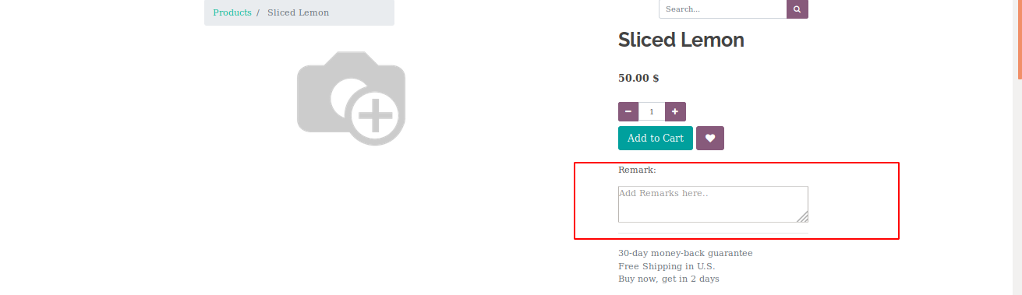
Customisation of a page:
Refer the following blog:
blog:https://www.cybrosys.com/blog/how-to-customize-odoo-12-website-home-page

