Product Requirements Document

Submission 1 Specification

**Team LANS**

SWEN90007 SM2 2022 Project

In charge:  
Mohammad Saood **Abbasi** <mohammadsaoo@student.unimelb.edu.au>

Arman **Arethna** <aarethna@student.unimelb.edu.au>

Navdeep **Beniwal** <nbeniwal@student.unimelb.edu.au>

Levi **McKenzie-Kirkbright** <levim@student.unimelb.edu.au>



Revision History

|  |  |  |  |
| --- | --- | --- | --- |
| Date | Version | Description | Author(s) |
| 26/07/22 | 01.00-D01 | Created document based on Luke’s template. Added initial Use Cases for the hotel system. | Levi |
| 27/07/22 | 01.00-D02 | Started Domain Model section and added Inspiration section. | Levi |
| 30/07/22 | 01.00-D03 | Conceptual class category list | Everyone |
| 06/08/22 | 01.00-D04 | Added Use Cases and reviewed existing ones | Saood |
| 06/08/22 | 01.00-D05 | Added Use Cases and reviewed existing ones | Arman |
| 06/08/22 | 01.00-D06 | Added Use Cases and reviewed existing ones | Navdeep |
| 06/08/22 | 01.00-D07 | Edit previously added Use Cases | Levi |
| 06/08/22 | 01.00-D08 | Organize and consolidate Use Cases | Everyone |
| 06/08/22 | 01.00-D09 | Add draft domain model diagram | Everyone |
| 10/08/22 | 01.00-D10 | Use Case diagram (1st draft) | Arman |
| 13/08/22 | 01.00-D11 | Add Domain Model Glossary | Levi |
| 13/08/22 | 01.00-D12 | Update Domain Model | Everyone |
| 13/08/22 | 01.00-D13 | Separate Extension Use Cases | Everyone |
| 13/08/22 | 01.00-D14 | Use Case diagram (2nd draft) | Navdeep, Saood |
| 15/08/22 | 01.00-D15 | Use Case diagram (final draft) | Levi |

Contents

Contents 3

1. Introduction 6

1.1 Proposal 7

1.2 Target Users 7

1.3 Conventions, terms and abbreviations 7

2. Actors 7

3. Use Cases 7

3.1 Use Case Diagram 8

3.2 Register/ Sign Up 8

3.3 Approve/Reject Hotel Owner Sign-Up Request 8

3.4 Search Hotels 8

3.5 View Hotel/Room Details 8

3.6 Make Bookings 8

3.7 Modify Bookings 8

3.8 Delete Bookings 9

3.9 View Bookings 9

3.10 Create Hotel 9

3.11 Modify Hotel Details 9

3.12 Delete Hotel 9

3.13 Create Room 9

3.14 Modify Room Details 9

3.15 Delete Room 9

3.16 Add Hoteliers to Hotel 9

3.17 Manage Role Based Access Configuration 9

3.18 Login and Logout from the System 10

3.19 Update Profile 10

3.20 Change Account Password 10

3.21 Filter Search Results 10

3.22 Sort Search Results 10

3.23 Manage Hotel Policies 10

4. Domain Model 10

4.1 Domain Model Description 10

4.1.1 Domain Model Summary 10

4.1.2 Domain Model Glossary 11

4.2 Domain Model Diagram 11

5. Extensions Use Cases 12

5.1 View FAQs 12

5.2 Manage FAQs 12

5.3 Book Business Services 12

5.4 Make Payments 12

5.5 Request Refund 13

5.6 Customer Reviews 13

5.7 Book Airport Pick-up and Drop-off 13

5.8 Location Wise Recommendations 13

5.9 View Embedded Location Map 13

5.10 Make Enquiry 13

5.11 Web Check-In 13

5.12 View Job Opportunities 13

5.13 Choose Language of system text 13

5.14 Create Multi-Location Itinerary 13

5.15 Register for Hotel Loyalty Programs 13

5.16 View Virtual Models of rooms 14

# Introduction

## Proposal

This document contains the first submission of the project for SWEN90007 Software Modelling and Design, 2022. It specifies use cases, actors, and the system’s domain model.

## Target Users

This document is intended for SWEN90007 teaching staff and other SWEN90007 students, particularly the LANS team.

## Conventions, terms and abbreviations

This section explains the concept of some important terms that will be used throughout this document. These terms are detailed alphabetically in the following table.

|  |  |
| --- | --- |
| Term | Description |
| “Team” or “the Team” or “LANS” | The project team. |

# Actors

|  |  |
| --- | --- |
| Actor | Description |
| Customer (CU) | A user that can search and view hotels. They may or may not be logged in. If logged in, they can also create and manage bookings. |
| Hotelier (HO) | A user logged in as a Hotelier; manages one or more hotels. |
| Hotel Group Admin (GA) | A user that is logged in as the Owner of a particular hotel. All Hotel Owners are also Hoteliers; they can do everything a normal Hotelier can do. They can also add or remove hoteliers from the hotel and delete the hotel itself. |
| Administrator (AD) | A single user (clarify: “a single admin account”) that is the administrator of the platform. They can view users, bookings, and hotel inventory. |

# Use Cases

A Use Case describes how an end-user uses a system. Use Cases capture the user’s goals and the possible interactions between the user and the system. Use cases also capture the outcome of those interactions, including things that can go wrong.

## Register/ Sign Up

**Actors:** Customer, Hotel Owner

**Basic Flow**: A user can enter basic details like name, email, contact number and create a password to register their account within the system.

## Approve/Reject Hotel Owner Sign-Up Request

**Actors:** Admin

**Basic Flow:** Sign-up requests from the hotel group owner get routed to the platform admin who holds the final approval authority to allocate extended privileges to the hotel group owner account.

## Search Hotels

**Actors**: Customer

**Basic flow**: a customer can search for listings of available rooms in hotels across Australia and the world. The customer can perform a string search of either the hotel’s name or the hotel’s postcode. A user does not need to be logged in to search Hotels and Rooms. Search results can be refined using various inclusion criteria, such as:

* The desired check-in and check-out date
* Price range
* Number of bedrooms
* Number of bathrooms
* Square meters
* Number of beds, and
* Other amenities, e.g., air conditioning, pool, or gym.

## View Hotel/Room Details

**Actors**: Customer

**Basic Flow**: A customer can click on any of the listed hotel/rooms listed in the search results. A user does not need to be logged in to view Hotel or Room details.

## Make Bookings

**Actors**: Customer

**Basic flow**: A customer can add one or more rooms to their shopping cart before finalizing their transaction. When they are ready to finalize their booking, they can book all the rooms in a single transaction. Once a customer adds a room to their cart, they have a certain amount of time (“booking timer”) during which the selected rooms will not be bookable by another customer (e.g., 15 minutes). If the booking timer elapses, the selected rooms may be booked by another customer.

## Modify Bookings

**Actors**: Customer, Hotelier

**Basic flow**: Once a customer has made a booking, they may modify the book. For example, they may want to add extra days to the booking. The booking may only be modified if the attempted modification is valid. For example, a customer may only add more days to a booking if another customer has not already booked the room for those days. Same operations can be done by hoteliers.

## Delete Bookings

**Actors**: Customer, Hotelier

**Basic flow**: Once a customer has made a booking, they may modify the book. For example, they may want to delete a booking they have already made. Same operations can be done by hoteliers.

## View Bookings

**Actors**: Customer, Hotelier, Hotel Owner

**Basic flow**: Customers can see their own booking list. A hotelier or hotel owner may see aggregated booking information for a hotel (e.g., a table of all the available rooms for a given date range). They may also view a specific hotel room and see its historical bookings, current booking (if any), and any upcoming bookings.

## Create Hotel

**Actors**: Hotel Owner

**Basic flow**: A hotel owner may create a new hotel in the database.

## Modify Hotel Details

**Actors**: Hotel Owner

**Basic flow**: A hotel owner can modify the details, such as the address, of a hotel.

## Delete Hotel

**Actors**: Hotel Owner

**Basic flow**: A hotel owner may delete a hotel from the database.

## Create Room

**Actors**: Hotel Owner

**Basic flow**: A hotel owner may create new room types within each hotel. If hotel rooms are identical, the hotelier can add multiple at the same time.

## Modify Room Details

**Actors**: Hotel Owner

**Basic flow**: A hotel owner can modify the details, such as the number of rooms and amenities available.

## Delete Room

**Actors**: Hotel Owner

**Basic flow**: They may also delete the hotels and rooms in the database.

## Add Hoteliers to Hotel

**Actors**: Hotel Owner

**Basic flow**: To help manage bookings at their hotels, the owner of a hotel can add other users as Hoteliers. The hoteliers have the privileges outlined in relevant use cases.

## Manage Role Based Access Configuration

**Actors**: Admin

**Basic Flow**: The Admin limits the accessibility control of different Users of the system (Customer, Hotel Owners and Hoteliers)

## Login and Logout from the System

**Actors**: Admin, Customer, Hotelier, Hotel Owner

**Basic Flow**: Grant different users access to different functionalities on the website.

## Update Profile

**Actors**: Customer, Hotelier, Hotel Owner

**Basic Flow**: Allow the users to update their profile details (Name, Contact Details)

## Change Account Password

**Actors**: Admin, Customer, Hotelier, Hotel Owner

**Basic Flow**: Allow users to change login information for their accounts.

## Filter Search Results

**Actors**: Customer

**Basic Flow**: Allow users to filter the search results by features (pool, spa, Wi-Fi, air conditioner, gym, breakfast inclusion, business services), price, rating, property class, property type, accessibility (wheelchair, lift, accessible bathroom)

## Sort Search Results

**Actors**: Customer

**Basic Flow**: Allow users to sort the search results based on price, property class.

## Manage Hotel Policies

**Actors**: Hotel Owners

**Basic Flow**: Allow users to set policies, such as cancellation policies, for the customers’ bookings. Example: Cancellation of hotel rooms allowed till 24 hours prior to stay.

## Use Case Diagrams

We have split our Use Case diagram into two (2) major subsystems for clarity of communication as including all Use Cases on a single diagram was too complex to comprehend easily.

### Use Case Diagram 1: Hotel Administration

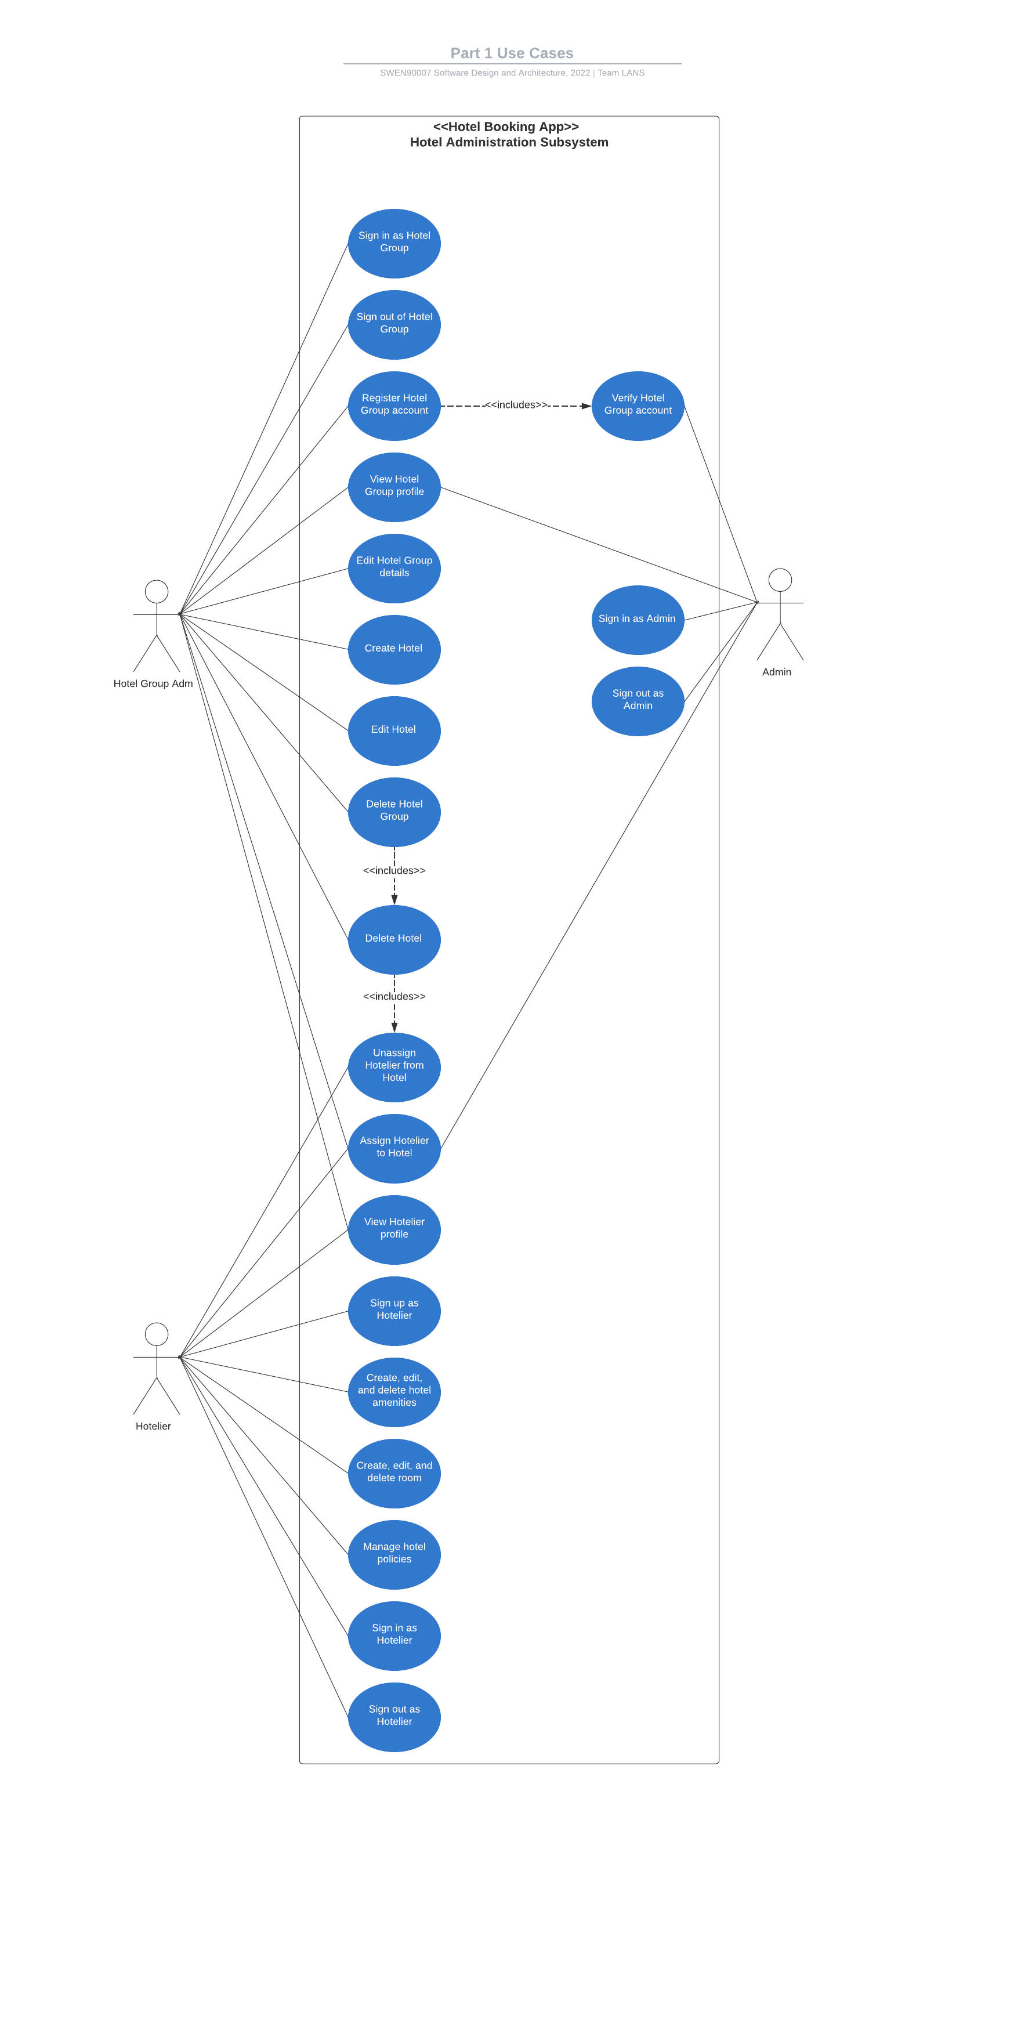

### Use Case Diagram 2: Customer Booking

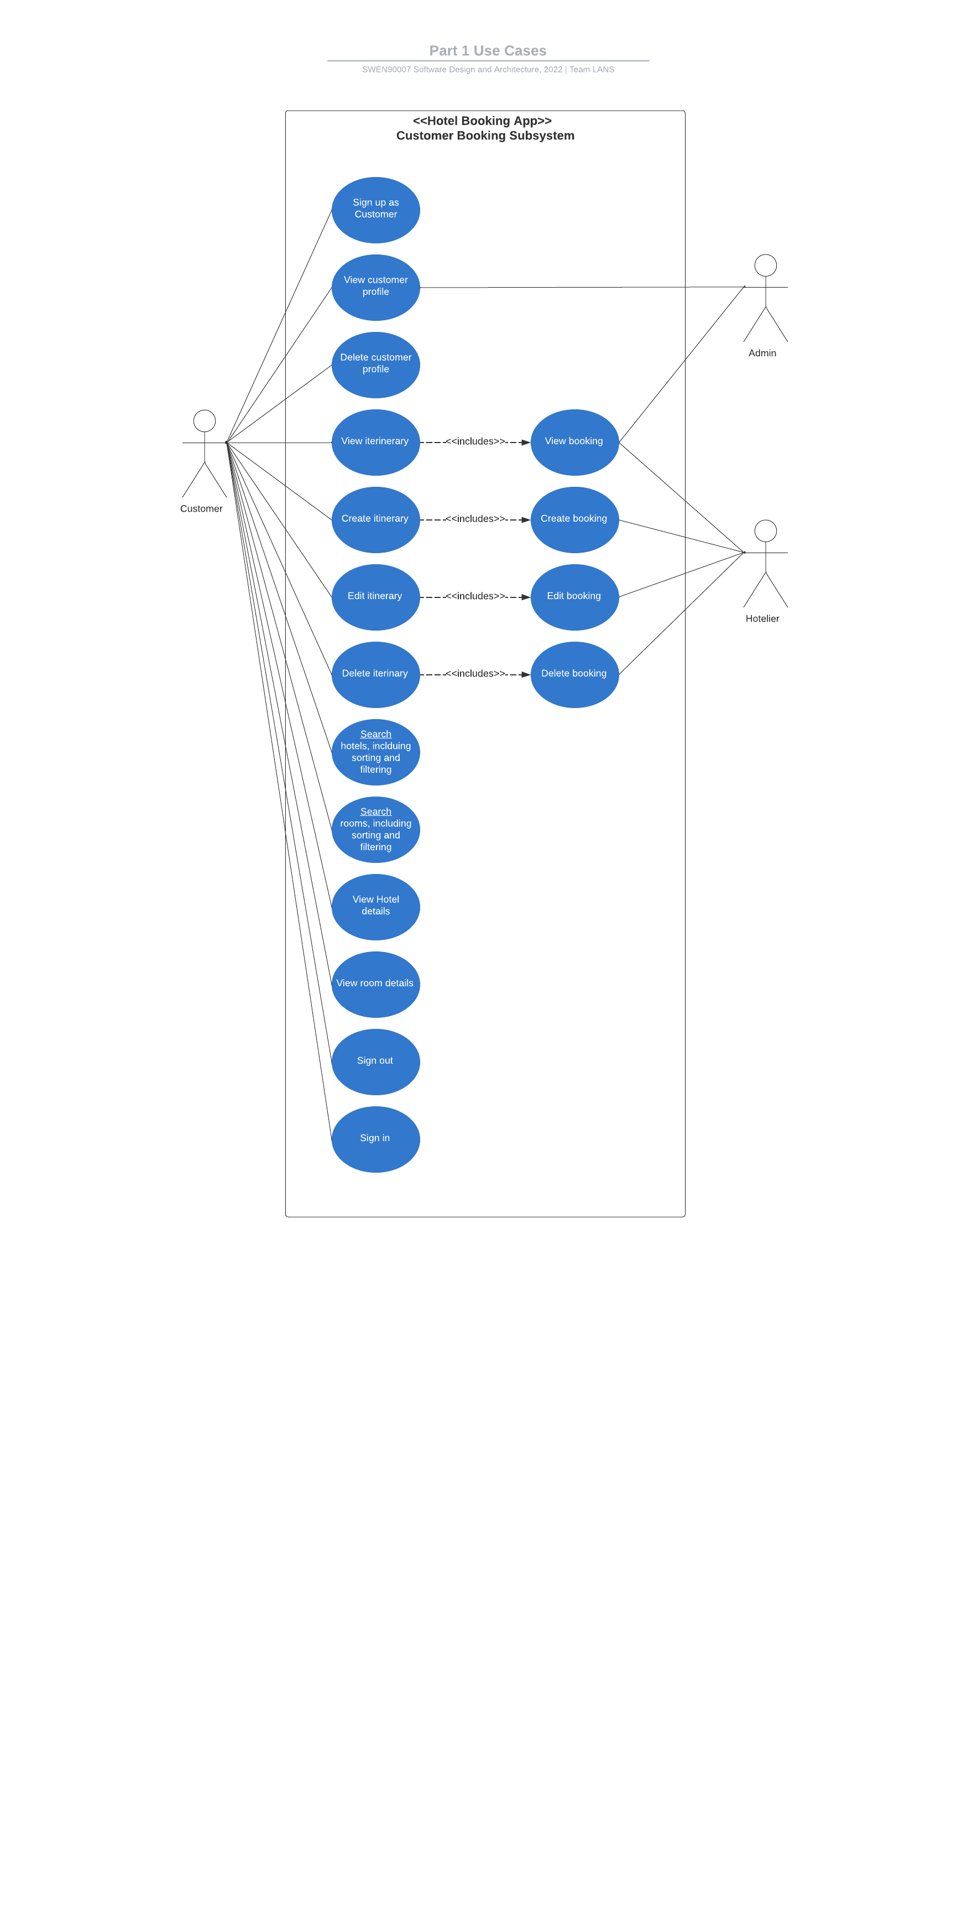

# Domain Model

## Domain Model Description

Based on the specifications provided for the Hotel Booking App, the system entities, attributes and business rules are summarized below. The summary will assist in understanding the Domain Model Diagram in section 4.4.

### Domain Model Summary

* In our system, a user can correspond to either a Platform Admin, Hotel Group Admin, Hotelier, or a Customer.
* One Platform Admin can approve and manage many Hotel Group Admins.
* One Platform Admin can also manage one or more Customers registered on the platform.
* Each Hotel Group Admin can appoint a Hotelier for a hotel owned by the Hotel Group.
* Each Hotel Group can own a single or multiple Hotels.
* One Hotelier is responsible for managing one of the Hotel owned by a Hotel Group.
* Each Hotelier is also responsible for curating RoomSpecifications for the rooms available at the Hotel he is managing.
* Each Room Specification further contains a list of Features available for the specific type of Room.
* One Hotel can contain single or multiple Rooms.
* Each Hotel can have one or many Policies depending on the use case.
* Each Hotel can have one or many Amenities which are separate from the Amenities provided with the Rooms.
* Each customer can build either no, single, or multiple Itineraries
* Each Itinerary can include single or multiple Bookings, and each Booking is associated with a single Room.
* Each Room can be booked in the name of the Customer making the booking, or even in the name of the Guest who will be staying at the Hotel.
* With each Booking, a Customer also has the option to have multiple Addon's included with their Booking.

### Domain Model Glossary

We have used different terminology from the project specification to increase the clarity and specificity of our model. Below are relevant terms that we wish to disambiguate.

* **Platform Admin**: Platform Admin corresponds to the “Admin” in the specification.
* We aim to model real-world situations in which an organization owns multiple hotels, for example Marriott or Hilton hotel groups, where each Hotel is managed by one or Hoteliers. To disambiguate these roles, we create Hotel Group Admin and Hotelier.
  + **Hotel Group Admin**: the account that owns the Hotels. It can create Hotels and add Hoteliers to each Hotel.
  + **Hotelier**: Hoteliers are responsible for managing the rooms, booking, amenities, and so forth, for the their specific Hotel.
* We aim to model real-world situations in which a single Customer (with an account on the platform) makes a books multiple rooms for multiple guests at a single Hotel. We disambiguate between the following terms.
  + **Customer**: a user that has an account that they use for creating Itineraries and Bookings.
  + **Booking**: a Booking is a reservation of a single Room in a particular Hotel for a specific calendar period.
  + **Guest**: the specific person(s) that will be staying in the Room during a Booking. The Guest may be the Customer or someone else.
  + **Itinerary**: a group of bookings. Each itinerary contains at least one Booking and allows a customer to make multiple Bookings simultaneously in a single business transaction.

## Domain Model Diagram

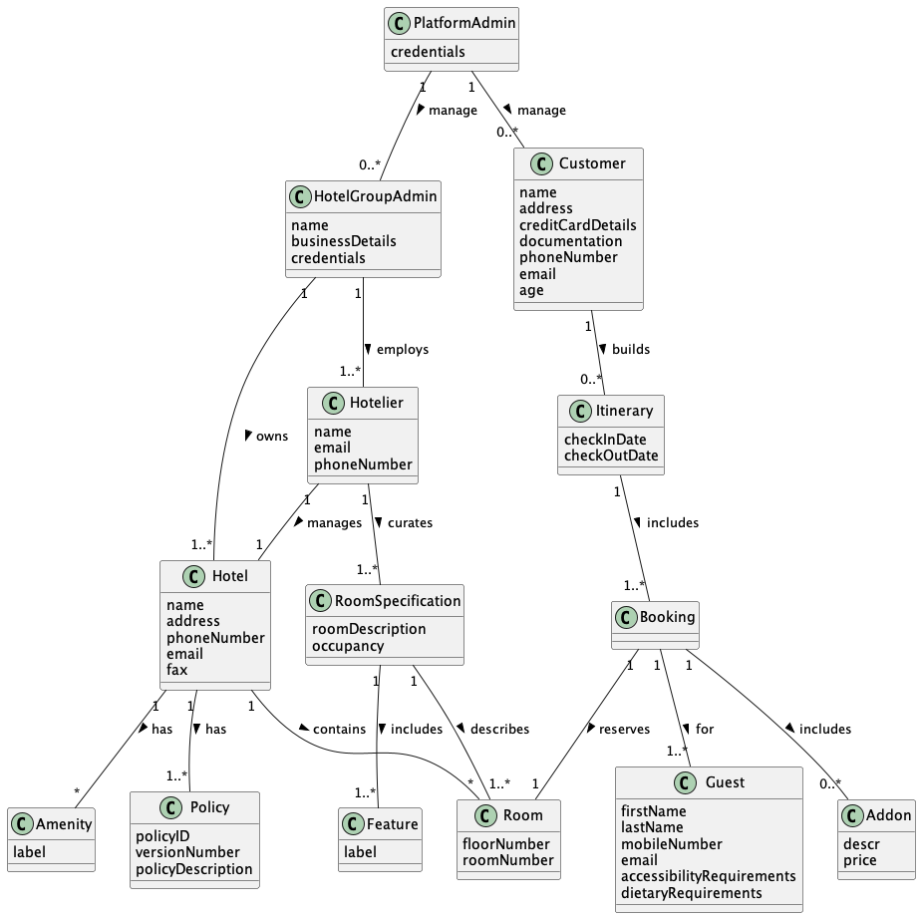

# Extensions Use Cases

The following Use Cases are *extensions* that the team has explored during our research of the domain. They are **not** included in Use Cases, Use Case Diagram or Domain Model. However, we have included these extensions documentation purposes. The team may attempt Extension Use Cases if time permits.

## View FAQs

**Actors**: Customer

**Basic Flow**: When a Hotel/Room page is opened, the user can browse through the FAQs section at the bottom of the page which displays questions in the sequence of most asked questions first.

## Manage FAQs

**Actors**: Hoteliers

**Basic Flow**: A hotelier can manage the FAQs posted on the platform, including answering the questions, and allowing certain questions to be displayed in the FAQs section.

## Book Business Services

Actors: Customers

Basic Flow: Allow users to book common hotel spaces (conference rooms, banquet halls)

## Make Payments

Actors: Customer

Basic Flow: A user can make payments while making the booking. The user should also receive a generated receipt on the provided email.

## Request Refund

Actors: Customer

Basic Flow: Allow users to lodge a request for a refund for an unsatisfactory stay.

## Customer Reviews

Actors: Customer

Basic Flow: Allow users to leave reviews and describe their experiences at hotels.

## Book Airport Pick-up and Drop-off

Actors: Customer

Basic Flow: Allow users to book combination deals on hotels (Airport pick-up + drop-off + hotel stay)

## Location Wise Recommendations

Actors: Customer

Basic Flow: Allow users to receive recommendations of hotels near their current location.

## View Embedded Location Map

Actors: Customer

Basic Flow: Displaying an embedded map containing the location of the hotel, and if clicked then user is redirected to the Google Maps app (if on mobile) or to browser-based app (if on desktop).

## Make Enquiry

Actors: Customers

Basic Flow: Allow customers to speak with the hoteliers via an enquiry board for specifications.

## Web Check-In

Actors: Customers

Basic Flow: Guests who do not wish to wait in the hotel lobbies are allowed to check in directly prior to arrival.

## View Job Opportunities

Actors: Customers

Basic Flow: Allow users to apply for jobs to the said third party booking service.

## Choose Language of system text

Actors: Customer, Admin

Basic Flow: Allow users to view web pages in multiple languages post render. Default language will be English.

## Create Multi-Location Itinerary

Actors: Customer

Basic Flow: Allow users to create an itinerary consisting of multiple hotels in the same trip.

## Register for Hotel Loyalty Programs

Actors: Customers

Basic Flow: Allow users to access loyalty program privileges by redirection to respective third-party hotel websites.

## View Virtual Models of rooms

Actors: Customers

Basic Flow: Allow users to view 3D models of rooms