Fetch and display to STDOUT Ansible facts using the setup module

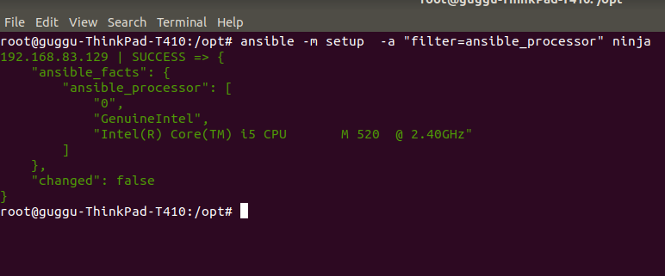

Fetch and display the value of fully qualified domain name (FQDN) of each host from their Ansible facts.

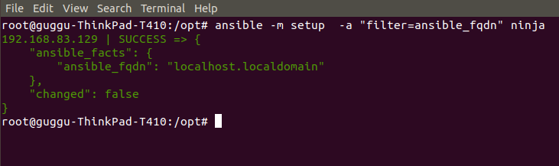
Display the uptime of all hosts using the command module.

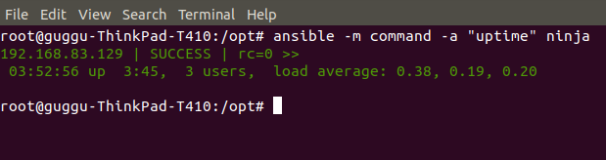

Ping all hosts except the 'control' host using the --limit option
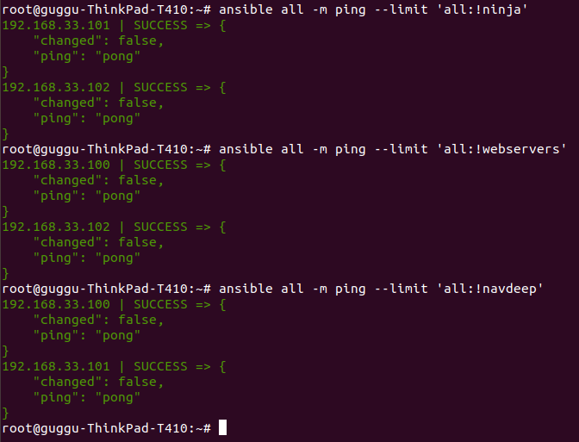
Setup Java8 on the hosts in the "App" group using the apt module.

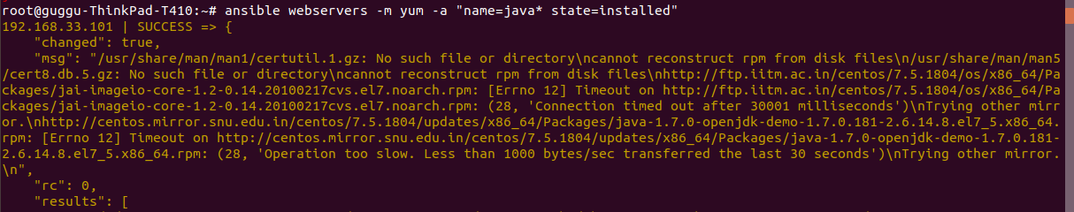
Setup and enable the EPEL package repository on the hosts in the "web" group using the yum module.
CentOS systems use the latest epel-release package
