Assigment Week 3 day3
Assigment No.1
Part C -> Gitclone and list content of cloned directory

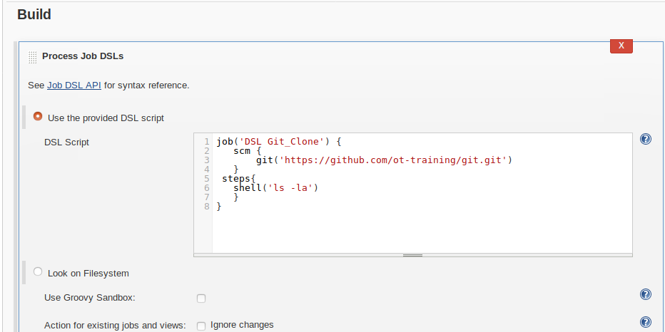

Part: D -> build periodically Job
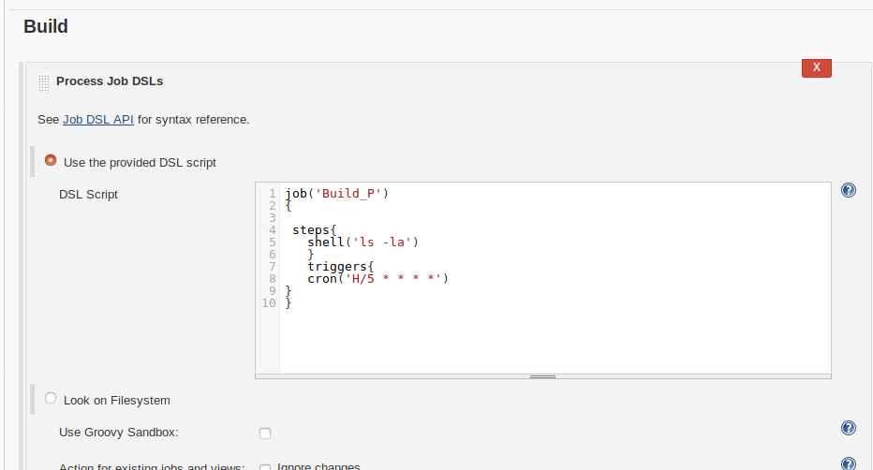

Part: B -> hellotoperson Job (Take SALUTATION as choice parameter & NAME as string parameter)

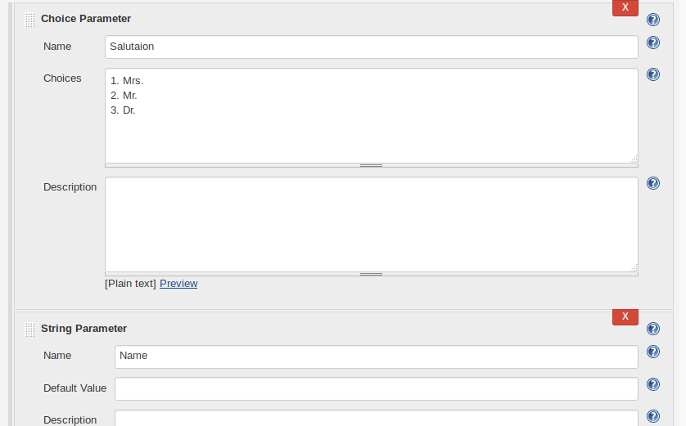

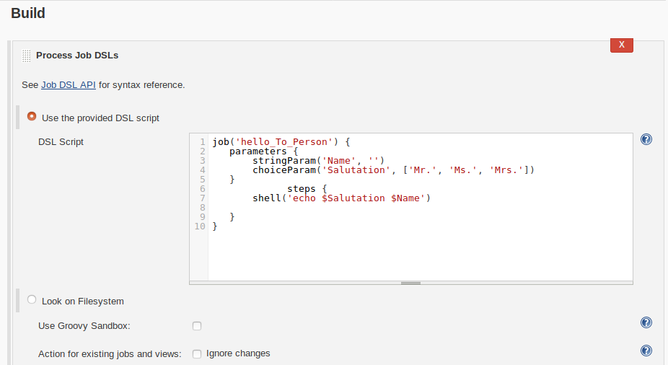

Part : -> helloworld Job
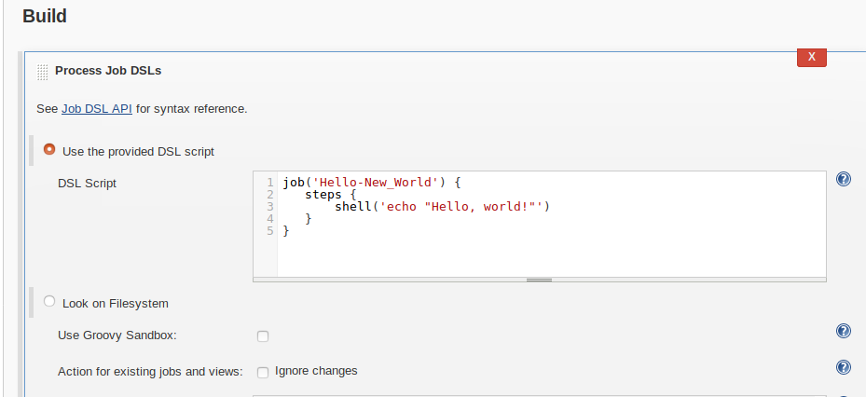

Task -E pollscm Job

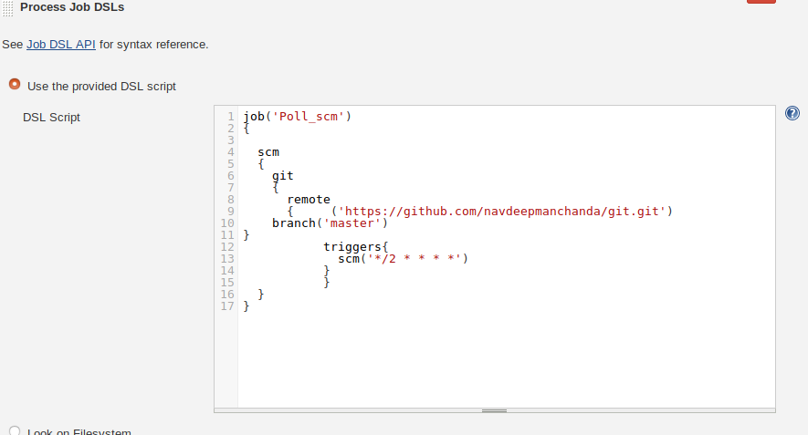

Task : F upstream Job (This job have helloworld job as upstream)

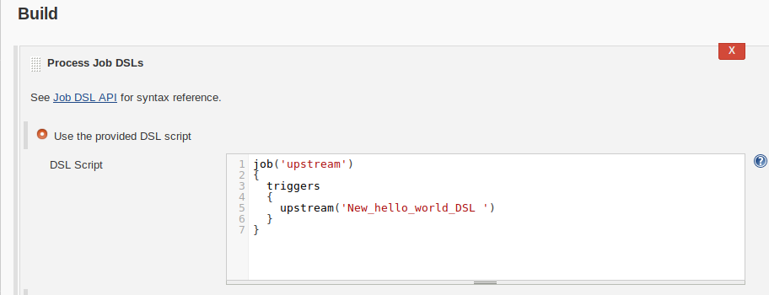

Task:G downstream Job
