Docker Activity Day-1

Run a ubuntu 16.04 container
- Name the container: "ub01"
- Set the hostname of container: "ub.example.com"
- Assign memory : 800 MB
- Set environment variables
- NAME: $(yourname)
- ORG: Opstree
- TEAM: Ninja
- TASK: Docker
- Set above defined variables from a file
- Set container default login directory to /var/log

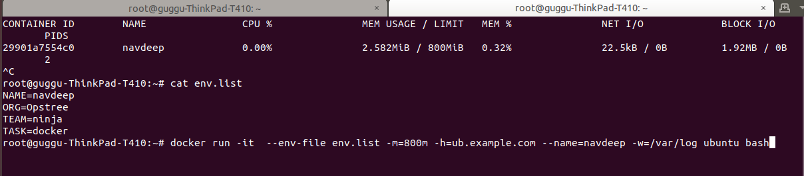
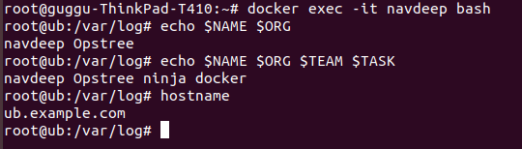
------------------------------------------------------------------------------------------------------------------
Docker Lifecycle

- Start an Ubuntu 14.04 container
- Get /var/log/dpkg.log on your host machine from container
- Delete /var/log/dpkg.log that file from container
- Create a new image of the current state of container and it "ubuntu:custom"
- Remove the container
- Run a new container of fresh image "ubuntu:custom"
- Check for the earlier deleted file inside the container
- Copy that file to container from host machine
- Recheck the file inside container.

Solution:
# docker cp navdeep:/var/log/dpkg.log /home/guggu ->copy from container to host machine
# docker exec -it navdeep -> to enter into container
# rm -f var/log/dpkg.log ->to remove file in container
# ctrl +p+q ->back to host machine
# docker commit -a "Navdeep Manchanda" -m "Commit without dpkg.log file" navdeep log:nav1 ->create image of running container at current state
# docker rm -f 29901a7554c0 -> to remove container
# docker run -it log:nav1 bash -> creation of new container using image
# docker exec -it 0cfc6d355991 bash ->enter into new container
# Checked for dpkg.log file but not found.
# docker cp dpkg.log 0cfc6d355991:/var/log ->manually copy dpkg.log file to container

Docker Inspection

- Run a ubuntu container and inspect the following info
- IP Address
- Mac Address
- Hostname
- Container Name
- Environment Variables

Solution:
docker inspect -f='{{.Config.Env}}{{.Name}}{{.Config.Hostname}}{{range .NetworkSettings.Networks}}{{.IPAddress}}{{.MacAddress}}{{end}}' 0cfc6d355991
Output:
[NAME=navdeep ORG=Opstree TEAM=ninja TASK=docker PATH=/usr/local/sbin:/usr/local/bin:/usr/sbin:/usr/bin:/sbin:/bin]/suspicious_edison0cfc6d355991172.17.0.302:42:ac:11:00:03
----------------------------------------------------------------------------------------------------------------------
Docker Monitoring:

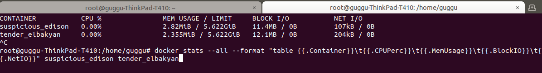
docker stats --all --format "table {{.Container}}\t{{.CPUPerc}}\t{{.MemUsage}}\t{{.BlockIO}}\t{{.NetIO}}" suspicious_edison tender_elbakyan

