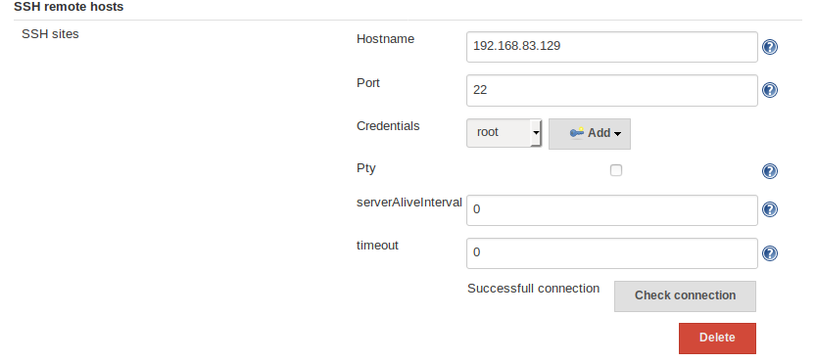
Assignment -2

Assignment -1

-bash-4.2$ ssh root@192.168.83.129
Last login: Tue Jun 5 03:35:05 2018 from 192.168.83.129
[root@localhost ~]#

Assignment 3

