DAY 3 JENKINS

- Assignment 1

Install Nginx
# sudo apt-get install nginx
# sudo systemctl status nginx

  - Install below listed plugins
    - SSH plugin
    - Git plugin
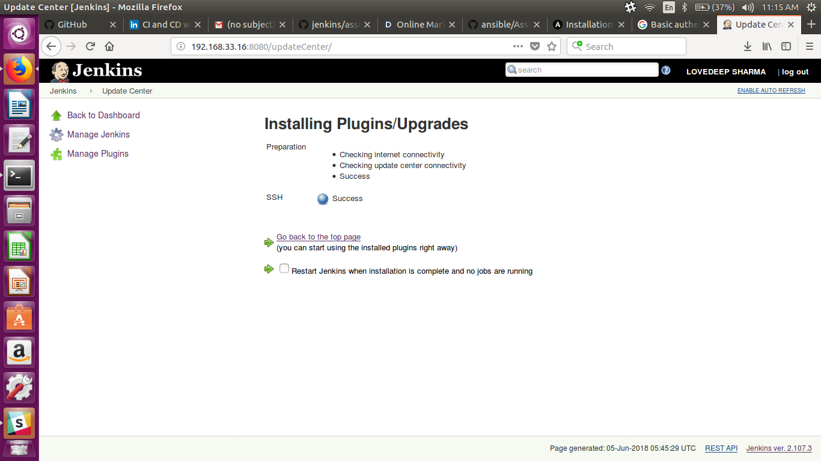

- Assignment2
  - Enable password less login between jenkins & root user
# sudo su jenkins
# cd /var/lib/
# mkdir .ssh
# cd .ssh
# ssh-keygen -t rsa
# cat id_rsa.pub
( copy the public key and paste it to root .ssh directory)
# sudo su root
# cd .ssh
# sudo vim authorised_keys
# sudo vim /etc/ssh/ssh_config
( Uncomment Strictly host checking and add no )

  - Check Global configuration and provide SSH remote host(root) details

- Assignment3
  - Create a tag creator Jenkins Job
  - Job will create tag on your forked repo.
  - Job should accept 2 parameters
    - SRC_BRANCH
    - TAG_NAME
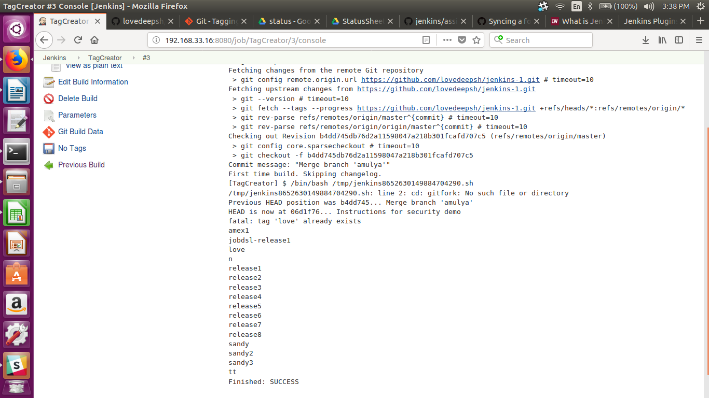

- Assignment4
  - Sync your forked jenkins repo with https://github.com/ot-training/jenkins.git (using multiple remote).
# cd /var/lib/jenkins/workspace/TagCreator/
# sudo git remote add upstream https://github.com/lovedeepsh/jenkins-1.git
# sudo git fetch upstream

  - Create a Deployer Jenkins Job(static-code-deployment).
  - It will checkout code from https://github.com//jenkins.git (your forked repo).
  - Job will require a parameter TAG_NAME
  - It will use SSH Publish plugin to publish files from jenkins server to target server
  - Deploy index.html (existed inside attendees/assignments/day7) into nginx doc root.
  - Update index.html (with your name) and create a new tag.
  - Deploy with new tag.
- Created new job “Deploy”
- Also installed Publish over ssh plugin
- Gave the string parameter for tag
- Provided the git repository in source code management
- Selected the post build option for “Send build artifacts over ssh”
- Go tot manage jenkins and configure system. At the end, provide the details for the ssh server.
- Now you can select the sever in post build – send build artifacts over ssh
- Provided the tranfer details for index.html
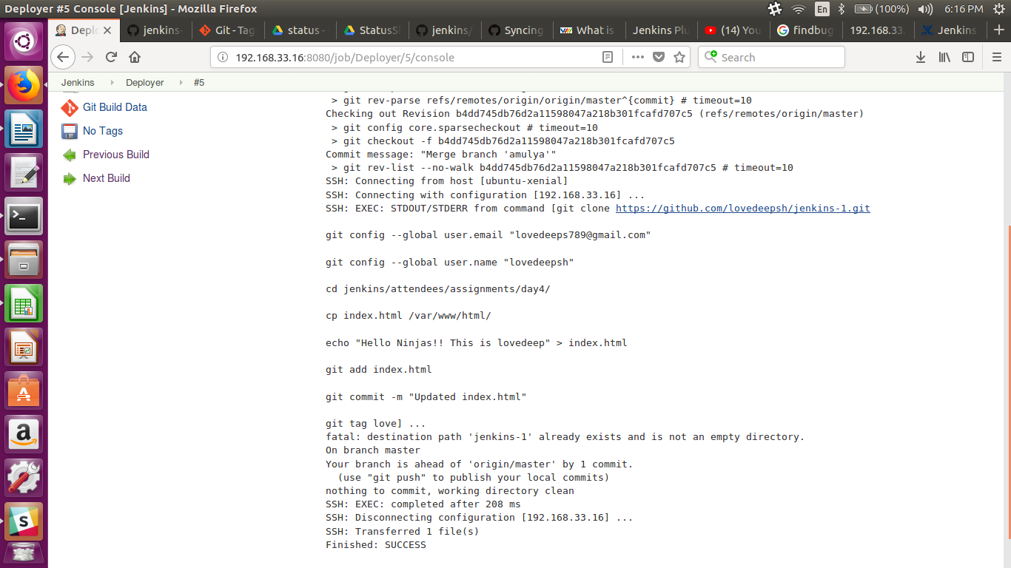

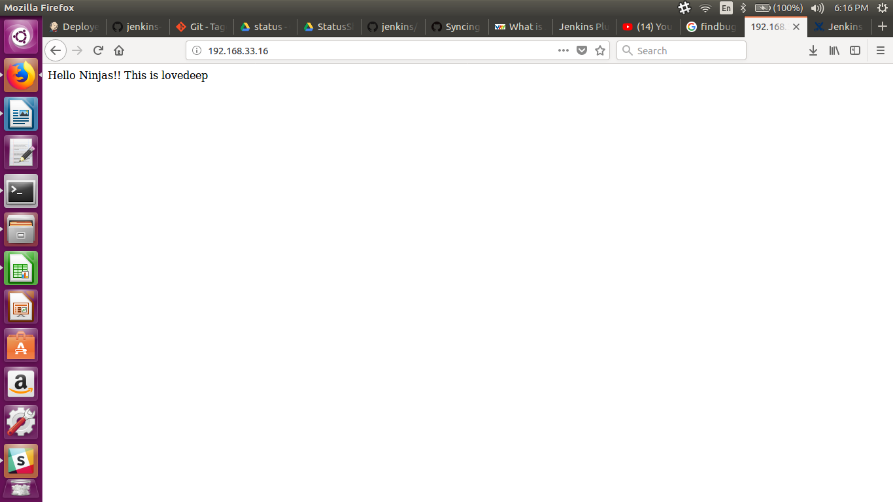
- Assignment5
  - Install tomcat7
  - Install mysql
  - Fork ContinuousIntegration from opstree account.
  - Create a job Spring3HibernateApp-deployment
    - This job will be copy of static-code-deployment
    - Update deploymnet target to tomcat webapps directory
    - This job and code-stability (job from 6th day assignmnet) will have common workspace.
  - Deploy Spring3HibernateApp.war into tomcat7 (pick from workspace, copy into webapp of tomcat)
  - Verify you can acecess http://:8080/Spring3HibernateApp/

- Assignment6
  - Configure nginx in a way so that it can serve
    - static file (index.html) at http://
    - java application (Spring3HibernateApp) at http:///Spring3HibernateApp/
Hint: Add another location (Spring3HibernateApp/) and proxy_pass details in your nginx configireation.

- Assignment7
  - Deploy a demo node application
    - Fork node-js-sample repo into your account
    - Create a jenkins job to build node code and create a tar file(artifact)
    - Stop already application, Deploy tar file on a target server and start application again. Hint: Use pm2 to start and stop node process (process management)

