DAY 7 JENKINS

- Assignment 1
1.Create 2 slave and them to jenkins master.
- Create ssh connection between master and slave machines.
- Add the ssh credential in the Jenkins UI credentials.
- Go to Manage Jenkins.
- Click on Manage nodes.
- Click on New Node on the left side.
- Provide Node Name and select Permanent agent.
- Then provide name, description, no. of executors, remote root directory.
- Launch method vis ssh.
- Provide host name and credentials & click save.
- Click on the nodes one by one and then click launch node.
- Now the nodes are being started.
- I have added 2 nodes i.e. vagrant, lovedeep.
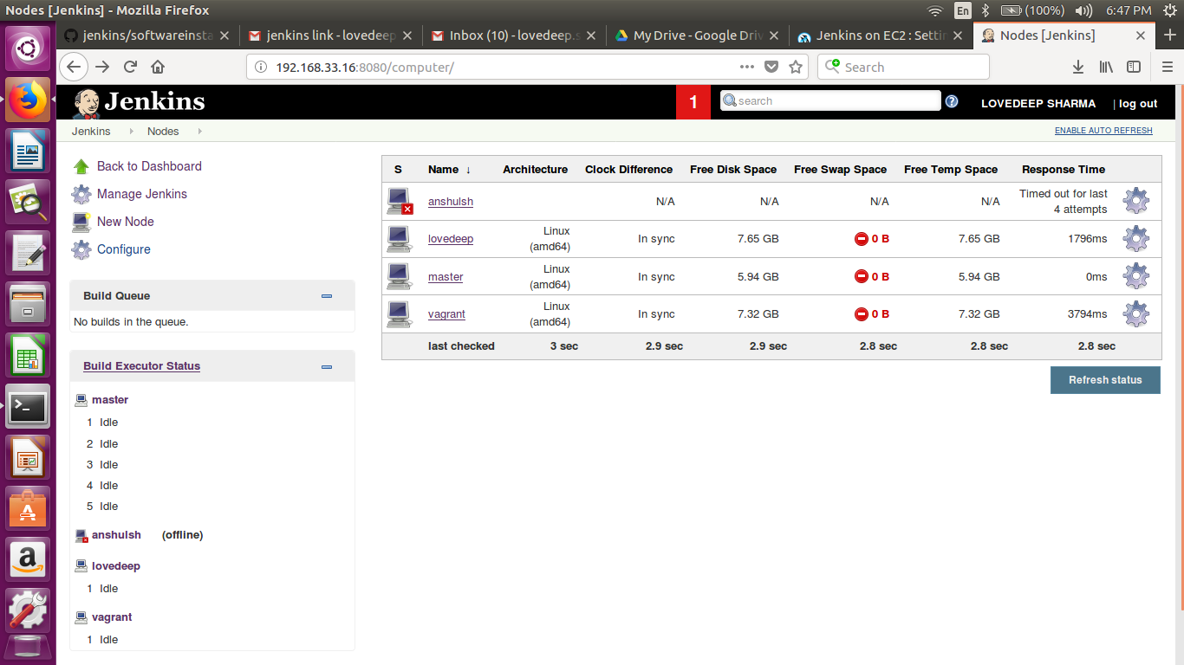

- Restrict jobs for a specific jenkins slave.
- Click on any particular job which you want to restrict for a specific jenkins slave.
- Click on Configure job.
- Click on the checkbox for “Restrict where this project can be run” in General section of that particular job.
- Give the name of slave in the box of Label expression.
- Click on save at the end and start a build for that job.
- Now check that your job is running on that particular slave.
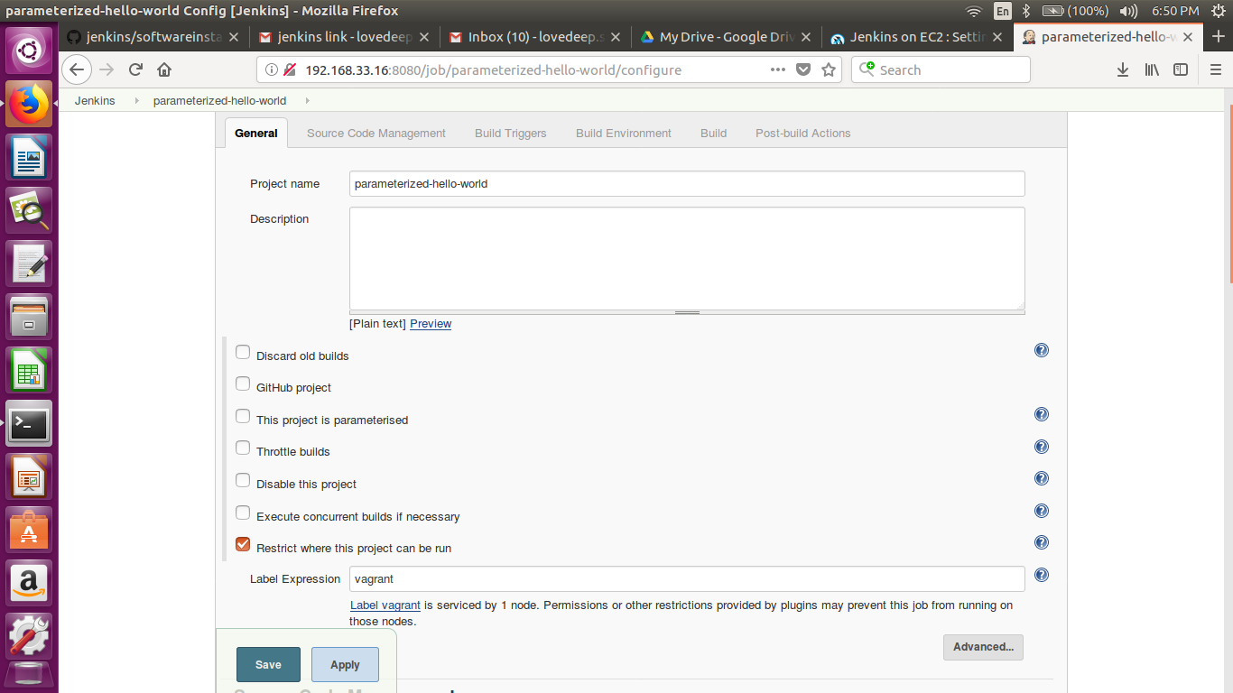
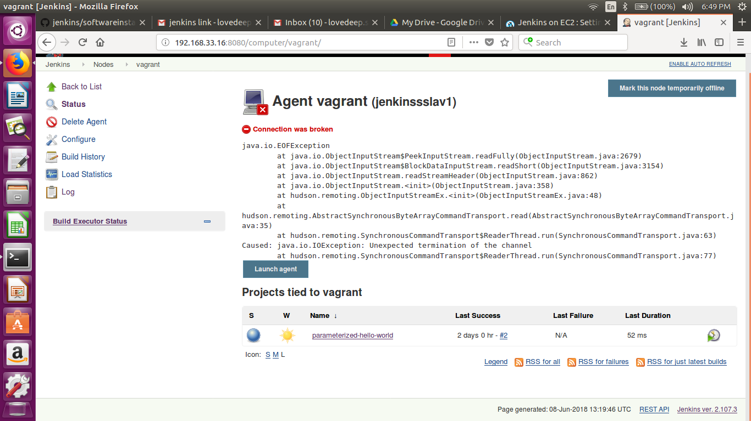

- Create a job that can run on either salve(any of the two).
- Provided the same label to both the nodes while configuring them.
- Gave the name “multiple”
- Now, I gave the label expression “multiple” in the configuration of the various jobs.
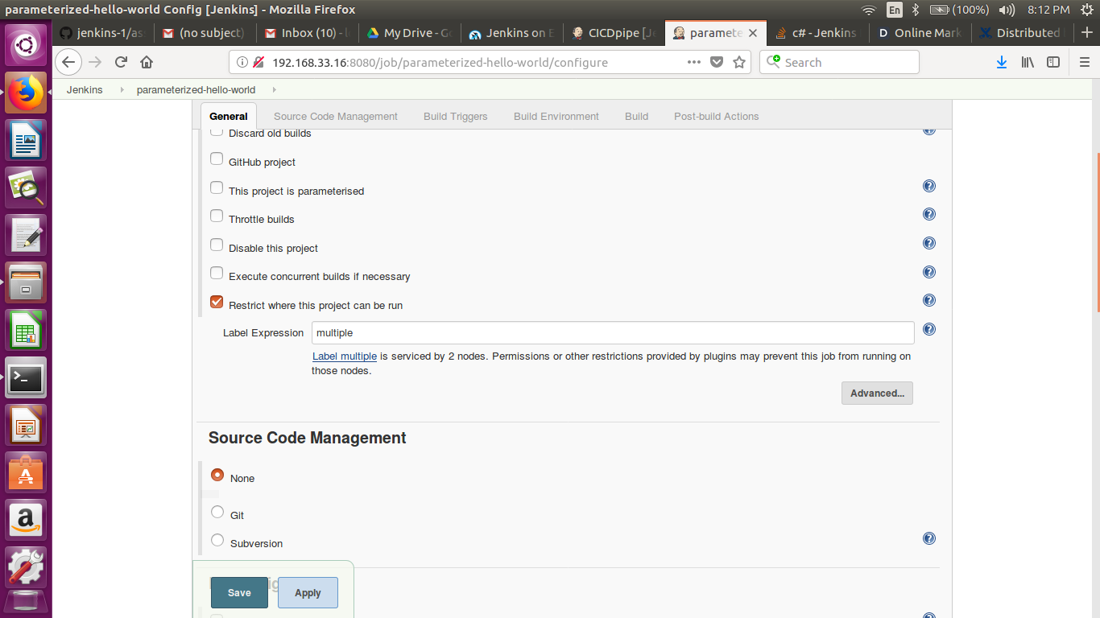

- Assignment 2
Use jenkins rest api to
  - Get the list of all jobs

# curl -u lovedeepsh:b64f2444a08e4169cf8c844cfe568d82 http://192.168.33.16:8080/api/json?pretty=true

{
"_class" : "hudson.model.Hudson",
"assignedLabels" : [
{
"name" : "master"
}
],
"mode" : "NORMAL",
"nodeDescription" : "the master Jenkins node",
"nodeName" : "",
"numExecutors" : 5,
"description" : null,
"jobs" : [
{
"_class" : "hudson.maven.MavenModuleSet",
"name" : "codecoverage",
"url" : "http://192.168.33.16:8080/job/codecoverage/",
"color" : "blue"
},
{
"_class" : "hudson.model.FreeStyleProject",
"name" : "codestability",
"url" : "http://192.168.33.16:8080/job/codestability/",
"color" : "blue"
},
{
"_class" : "hudson.maven.MavenModuleSet",
"name" : "codestability2",
"url" : "http://192.168.33.16:8080/job/codestability2/",
"color" : "blue"
},
{
"_class" : "hudson.maven.MavenModuleSet",
"name" : "codestabilityday3",
"url" : "http://192.168.33.16:8080/job/codestabilityday3/",
"color" : "blue"
},
{
"_class" : "hudson.model.FreeStyleProject",
"name" : "Deployer",
"url" : "http://192.168.33.16:8080/job/Deployer/",
"color" : "blue"
},
{
"_class" : "hudson.model.FreeStyleProject",
"name" : "emailtest",
"url" : "http://192.168.33.16:8080/job/emailtest/",
"color" : "blue"
},
{
"_class" : "org.jenkinsci.plugins.workflow.job.WorkflowJob",
"name" : "first",
"url" : "http://192.168.33.16:8080/job/first/",
"color" : "notbuilt"
},
{
"_class" : "hudson.model.FreeStyleProject",
"name" : "hello downstream",
"url" : "http://192.168.33.16:8080/job/hello%20downstream/",
"color" : "blue"
},
{
"_class" : "hudson.model.FreeStyleProject",
"name" : "hello git",
"url" : "http://192.168.33.16:8080/job/hello%20git/",
"color" : "blue"
},
{
"_class" : "hudson.model.FreeStyleProject",
"name" : "hello periodical",
"url" : "http://192.168.33.16:8080/job/hello%20periodical/",
"color" : "blue"
},
{
"_class" : "hudson.model.FreeStyleProject",
"name" : "hello person",
"url" : "http://192.168.33.16:8080/job/hello%20person/",
"color" : "blue"
},
{
"_class" : "hudson.model.FreeStyleProject",
"name" : "hello poll",
"url" : "http://192.168.33.16:8080/job/hello%20poll/",
"color" : "blue"
},
{
"_class" : "hudson.model.FreeStyleProject",
"name" : "hello upstream",
"url" : "http://192.168.33.16:8080/job/hello%20upstream/",
"color" : "blue"
},
{
"_class" : "hudson.model.FreeStyleProject",
"name" : "helloCICD",
"url" : "http://192.168.33.16:8080/job/helloCICD/",
"color" : "blue"
},
{
"_class" : "hudson.maven.MavenModuleSet",
"name" : "helloCICD2",
"url" : "http://192.168.33.16:8080/job/helloCICD2/",
"color" : "blue"
},
{
"_class" : "hudson.model.FreeStyleProject",
"name" : "ninja-jobs",
"url" : "http://192.168.33.16:8080/job/ninja-jobs/",
"color" : "blue"
},
{
"_class" : "hudson.model.FreeStyleProject",
"name" : "parameterized-hello-world",
"url" : "http://192.168.33.16:8080/job/parameterized-hello-world/",
"color" : "blue"
},
{
"_class" : "org.jenkinsci.plugins.workflow.job.WorkflowJob",
"name" : "pipeline1",
"url" : "http://192.168.33.16:8080/job/pipeline1/",
"color" : "blue"
},
{
"_class" : "hudson.model.FreeStyleProject",
"name" : "SeedJob",
"url" : "http://192.168.33.16:8080/job/SeedJob/",
"color" : "blue"
},
{
"_class" : "hudson.maven.MavenModuleSet",
"name" : "seedjobm",
"url" : "http://192.168.33.16:8080/job/seedjobm/",
"color" : "notbuilt"
},
{
"_class" : "hudson.maven.MavenModuleSet",
"name" : "Spring3HibernateApp",
"url" : "http://192.168.33.16:8080/job/Spring3HibernateApp/",
"color" : "blue"
},
{
"_class" : "hudson.maven.MavenModuleSet",
"name" : "staticcodeanalysis",
"url" : "http://192.168.33.16:8080/job/staticcodeanalysis/",
"color" : "blue"
},
{
"_class" : "hudson.model.FreeStyleProject",
"name" : "TagCreator",
"url" : "http://192.168.33.16:8080/job/TagCreator/",
"color" : "blue"
},
{
"_class" : "hudson.model.FreeStyleProject",
"name" : "test",
"url" : "http://192.168.33.16:8080/job/test/",
"color" : "notbuilt"
},
{
"_class" : "hudson.model.FreeStyleProject",
"name" : "testm",
"url" : "http://192.168.33.16:8080/job/testm/",
"color" : "blue"
}
],
"overallLoad" : {

},
"primaryView" : {
"_class" : "hudson.model.AllView",
"name" : "all",
"url" : "http://192.168.33.16:8080/"
},
"quietingDown" : false,
"slaveAgentPort" : -1,
"unlabeledLoad" : {
"_class" : "jenkins.model.UnlabeledLoadStatistics"
},
"useCrumbs" : true,
"useSecurity" : true,
"views" : [
{
"_class" : "hudson.model.AllView",
"name" : "all",
"url" : "http://192.168.33.16:8080/"
},
{
"_class" : "hudson.plugins.nested_view.NestedView",
"name" : "complex-jobs",
"url" : "http://192.168.33.16:8080/view/complex-jobs/"
},
{
"_class" : "hudson.plugins.nested_view.NestedView",
"name" : "coplex-jobs",
"url" : "http://192.168.33.16:8080/view/coplex-jobs/"
},
{
"_class" : "hudson.plugins.nested_view.NestedView",
"name" : "simple-jobs",
"url" : "http://192.168.33.16:8080/view/simple-jobs/"
}
]
}

  - Get the last build status
# curl -u lovedeepsh:b64f2444a08e4169cf8c844cfe568d82 http://192.168.33.16:8080/job/helloCICD2/lastSuccessfulBuild/api/json

{"_class":"hudson.maven.MavenModuleSetBuild","actions":[{"_class":"hudson.model.CauseAction","causes":[{"_class":"hudson.model.Cause$UserIdCause","shortDescription":"Started by user LOVEDEEP SHARMA","userId":"lovedeepsh","userName":"LOVEDEEP SHARMA"}]},{"_class":"hudson.plugins.git.util.BuildData","buildsByBranchName":{"refs/remotes/origin/master":{"_class":"hudson.plugins.git.util.Build","buildNumber":1,"buildResult":null,"marked":{"SHA1":"87357a4c6054e980c7d2e0412a090bb4e687a1f9","branch":[{"SHA1":"87357a4c6054e980c7d2e0412a090bb4e687a1f9","name":"refs/remotes/origin/master"}]},"revision":{"SHA1":"87357a4c6054e980c7d2e0412a090bb4e687a1f9","branch":[{"SHA1":"87357a4c6054e980c7d2e0412a090bb4e687a1f9","name":"refs/remotes/origin/master"}]}}},"lastBuiltRevision":{"SHA1":"87357a4c6054e980c7d2e0412a090bb4e687a1f9","branch":[{"SHA1":"87357a4c6054e980c7d2e0412a090bb4e687a1f9","name":"refs/remotes/origin/master"}]},"remoteUrls":["https://github.com/lovedeepsh/ContinuousIntegration.git"],"scmName":""},{"_class":"hudson.plugins.git.GitTagAction"},{},{"_class":"hudson.maven.reporters.SurefireAggregatedReport","failCount":0,"skipCount":0,"totalCount":6,"urlName":"testReport"},{"_class":"hudson.maven.reporters.MavenAggregatedArtifactRecord"},{},{},{}],"artifacts":[],"building":false,"description":null,"displayName":"#1","duration":74099,"estimatedDuration":74099,"executor":null,"fullDisplayName":"helloCICD2 #1","id":"1","keepLog":false,"number":1,"queueId":47,"result":"SUCCESS","timestamp":1528443925590,"url":"http://192.168.33.16:8080/job/helloCICD2/1/","builtOn":"","changeSet":{"_class":"hudson.plugins.git.GitChangeSetList","items":[],"kind":"git"},"culprits":[],"mavenArtifacts":{},"mavenVersionUsed":"3.5.3"}

  - Get the console o/p of a job build.
# curl -s -S -u lovedeepsh:b64f2444a08e4169cf8c844cfe568d82 http://192.168.33.16:8080/job/parameterized-hello-world/2/logText/progressiveText?start=0

Started by user LOVEDEEP SHARMA
Building in workspace /var/lib/jenkins/workspace/parameterized-hello-world
[parameterized-hello-world] $ /bin/sh -xe /tmp/jenkins3099275406497963907.sh
+ echo Hello world!
Hello world!
Triggering a new build of hello upstream
Finished: SUCCESS

  - Trigger a jenkins job build
curl -s -S -u lovedeepsh:b64f2444a08e4169cf8c844cfe568d82 -X POST http://192.168.33.16:8080/job/helloCICD2/build

