DAY 4 JENKINS

Assignment 1

- Install Jenkins using package.
# sudo add-apt-repository ppa:webupd8team/java
# sudo apt-get update
# sudo apt-get install oracle-java8-installer
# sudo apt-get install oracle-java8-set-default
# cd /etc/environment
(edit JAVA_HOME=/usr/lib/jvm/java-8-oracle
JRE_HOME=/usr/lib/jvm/java-8-oracle/jre)
Install jenkins now
# wget -q -O - https://pkg.jenkins.io/debian/jenkins.io.key | sudo apt-key add -
# sudo sh -c 'echo deb http://pkg.jenkins.io/debian-stable binary/ > /etc/apt/sources.list.d/jenkins.list'
# sudo apt-get update
# sudo apt-get install jenkins

- Run jenkins war on the top of a tomcat server.

Assignment 2
- Install any five plugin and use them.
1. git plugin
2. git parameter
3. aws ec2 plugin
4. pipeline
- Install a plugin manually.

Assignment 3
- Create a freestyle job to print "Hello world".
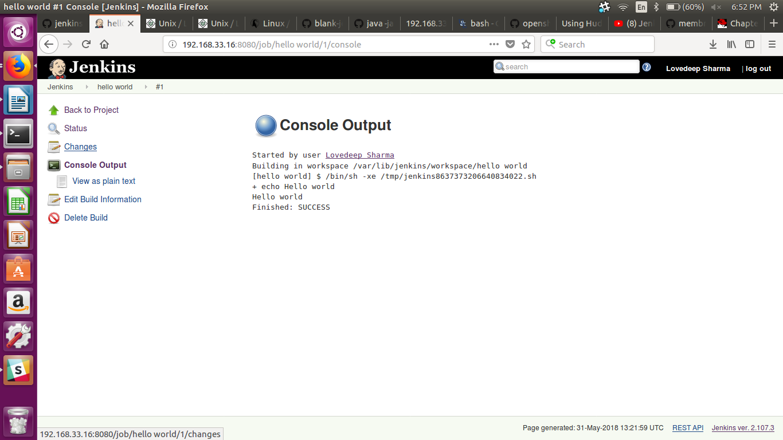

- Create a freestyle job to which take absolute path of a directory then
  - List all files and directories inside that.
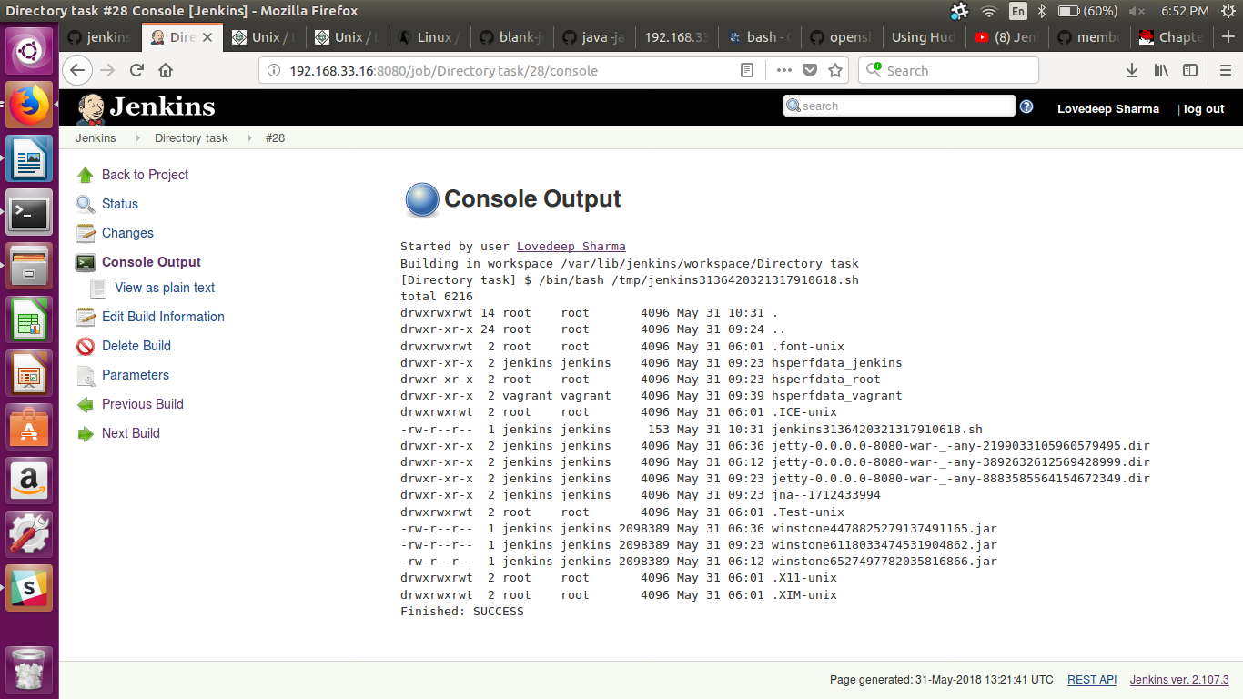
  - Print a message "drectory not exist" if directory doesn't exist on file system
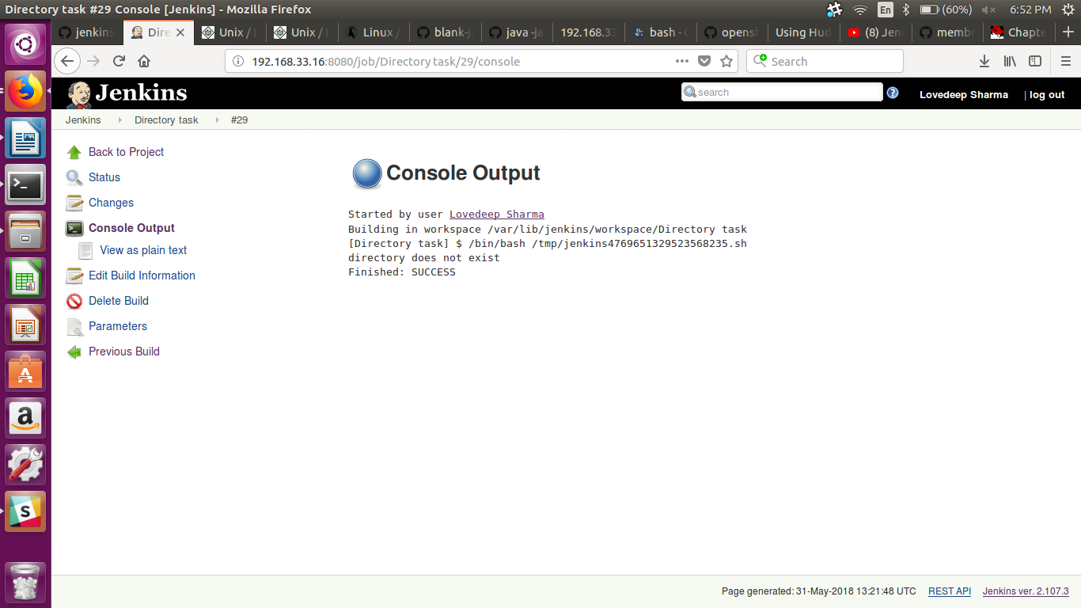
  - Print "Inappropriate permissions" if you don't have permissions to list files.
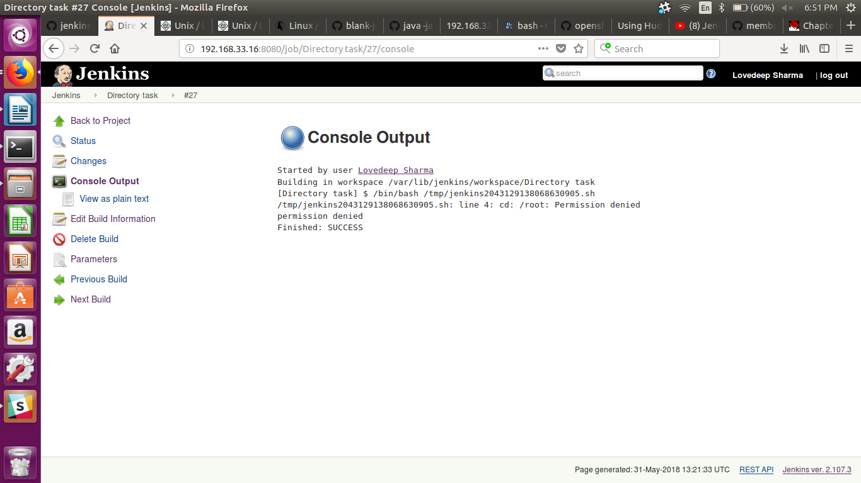
- Create a job to clone your jenkins repo and cat a file from it.
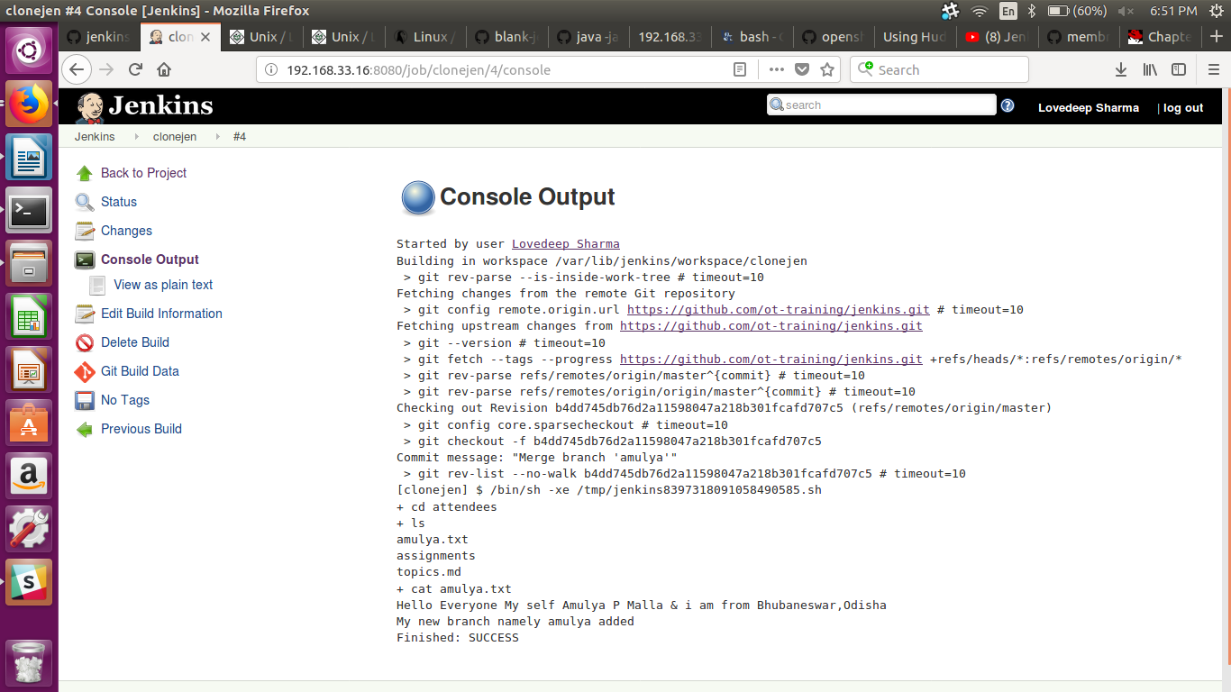

- Create tag using git plugin.
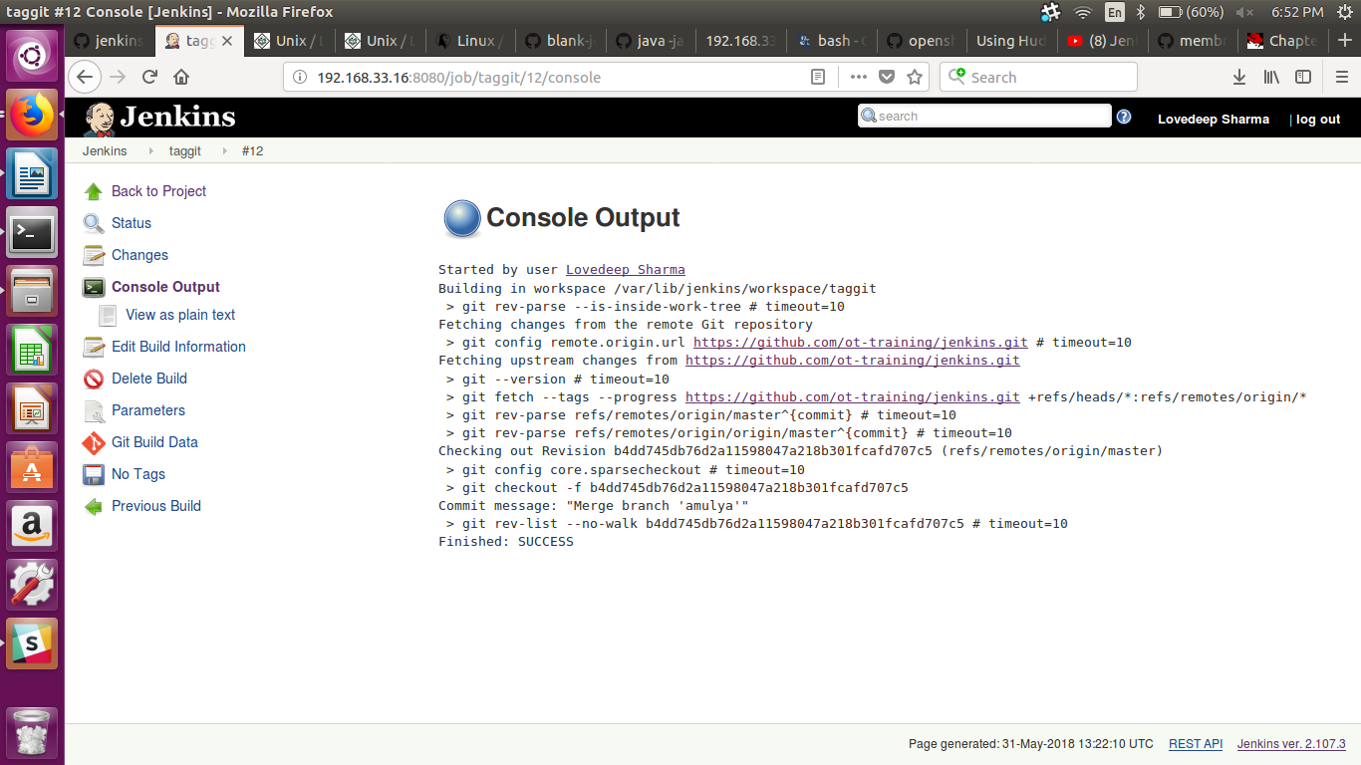

Assignment4:
- Increase and decrease number of executors and observe the build queue.
I created 10 executers.
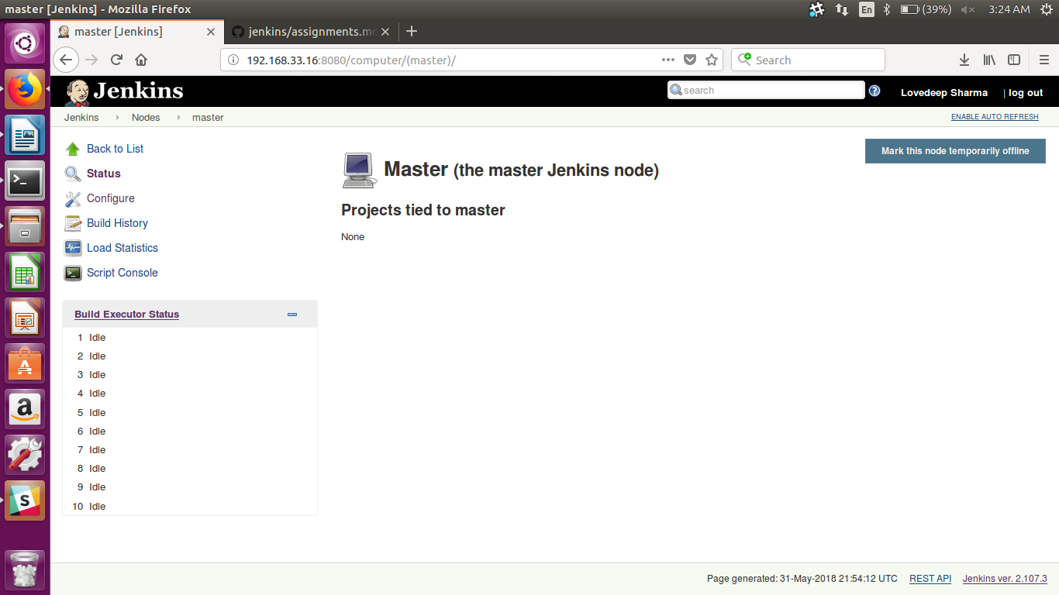
Decrease the size to 5
