Note: **Head point to latest commit**

Adding a file to local repo / To create a local repo git init

To config the author git config --global user.email “<your email>” *To link the remote repo git remote add origin <https://github.com/navdeepmor/fjp6.git> git remote -v

To add a file in staging area git add <file name> To commit file git commit <file name> -m “first commit by me” or git commit -a -m “” --> all the files in staging area are likely to be push before that it is tag

To see info on untracked, tack commit ex: No commit yet git status

git push -u origin main *Force push git push origin main -f

Fetch data or file git pull origin main * git pull --allow -unrelated -histories origin master init, remote add and pull git clone <repo link> --> <https://github.com/Navdeep902/project.git>

Resolving conflict (edit the file) git add . git commit -m “conflict check” git pull origin main

To create new branch git branch <branch name> To list branch git branch To move to other branch git checkout bugfix --> <branch name> To list all the files in the current branch git ls -files * git status on branch <branch name> Merge two branch git merge bugfix --> (checkout with master) Create a new remote branch

Remove remote origin git remote remove origin git remote -v

Give file at that dir dir

Deployment: Settings > GitHub Pages [click on check it out here!] > Source [Select main] & then Save

**---------------------------------------------------------------------------------------------------------------**

Ref:

git? VCS Diff. bet. git & github?

Local repo. --> Remote repo.

Life cycle of git: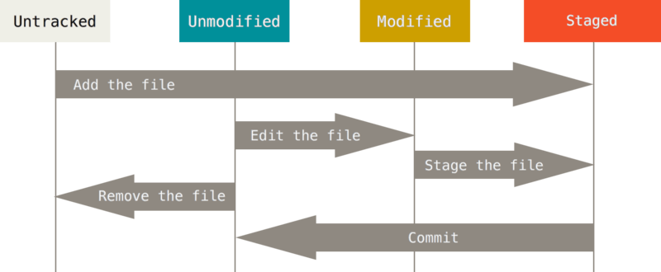

Untracked U: newly created or deleted. Unmodified: There is no change from last save point. Modified: There is change from last save point. Commit: new save point created.