**DataWeave expression Transform:**

Json: will accept object { key: value }, array & give {key: value}, array respectively.

Xml: will not accept empty object, array

**Json to xml:** For converting json to xml we should have a root element like trains in below ex. 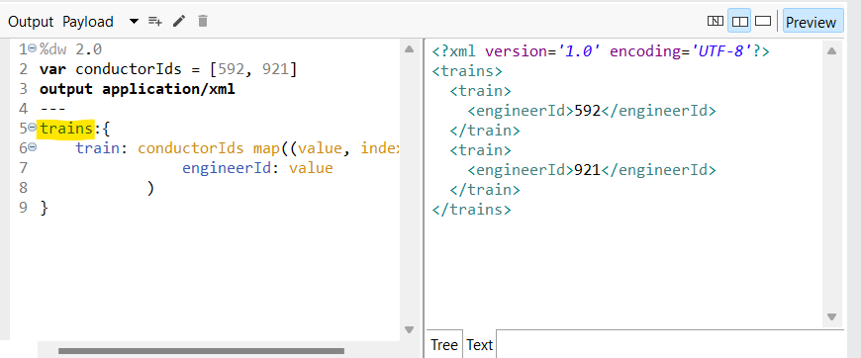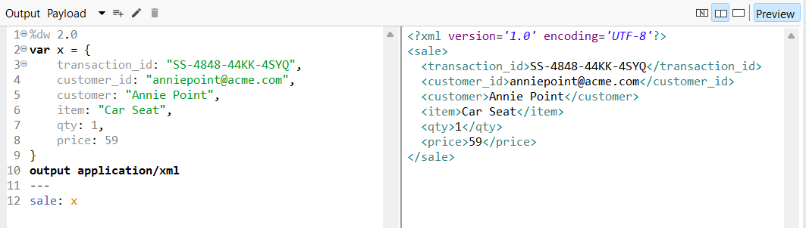

Trick for this is to check if the i/p expression is valide JSON or not. Then look for root element.

Note: for xml to be valide we have to check that when we have two different-different tag then they should be inside a common xml tag otherwise it would be a valide xml. Ex. <uniIqueId></uniqueId> <username></username> above is invalide xml

For above to be vaid xml it should be inside a common <employee> <uniqueId></uniqueId> <username></username> </employee>

**Json to csv:** 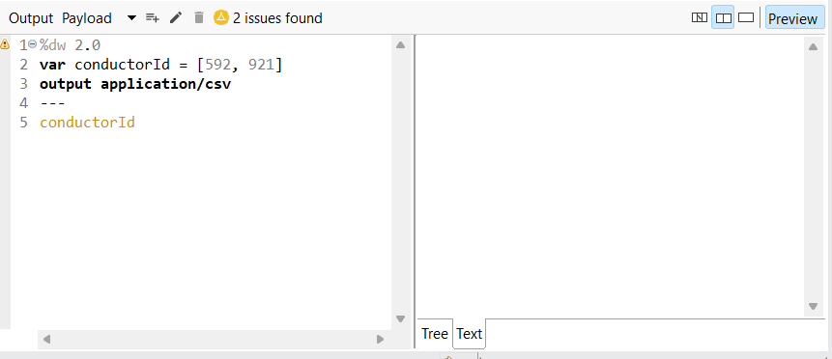 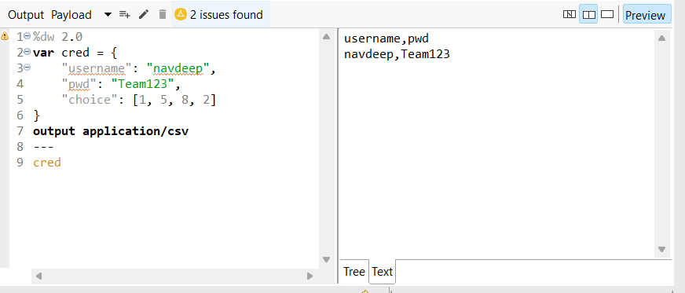 csv wouldn’t accept array, even inside a valid json it wouldn’t accept array. 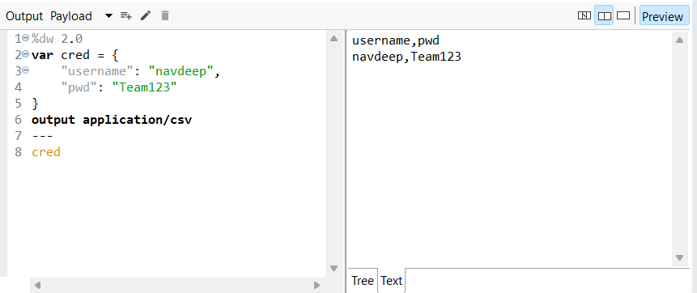

**map & mapObject:** map will take an array & result in array as o/p. **$** - value **$$** - index 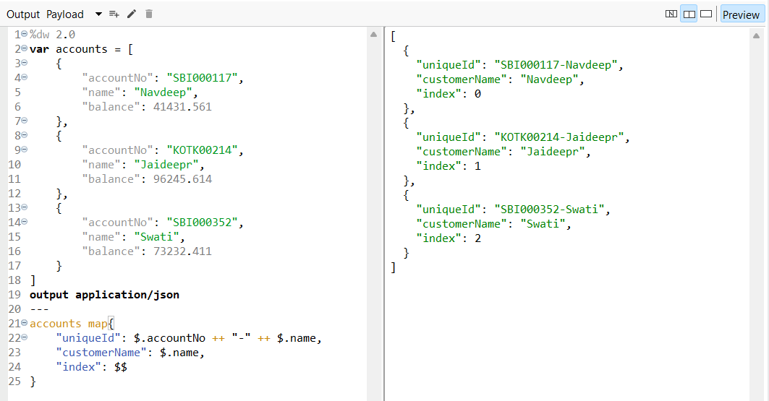 Differ syntex for **map**: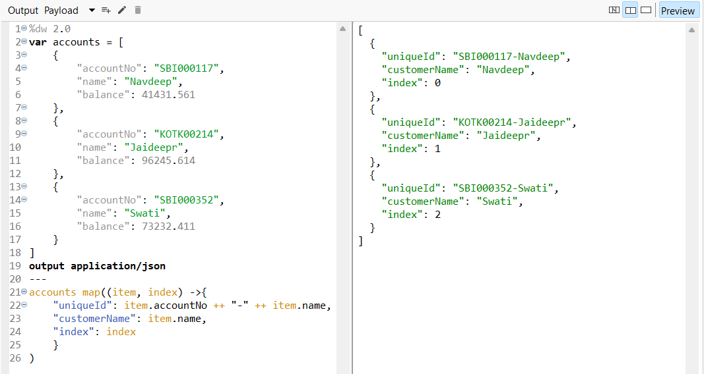

**--------------------------------------------------------------------------------------------------------------------------------------**

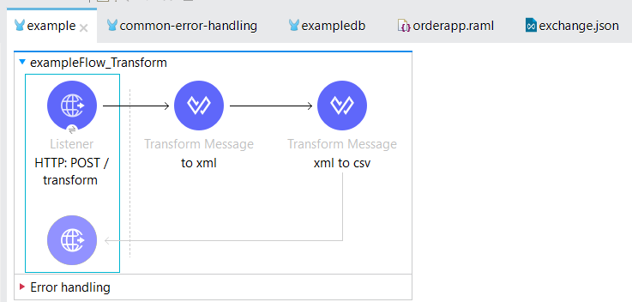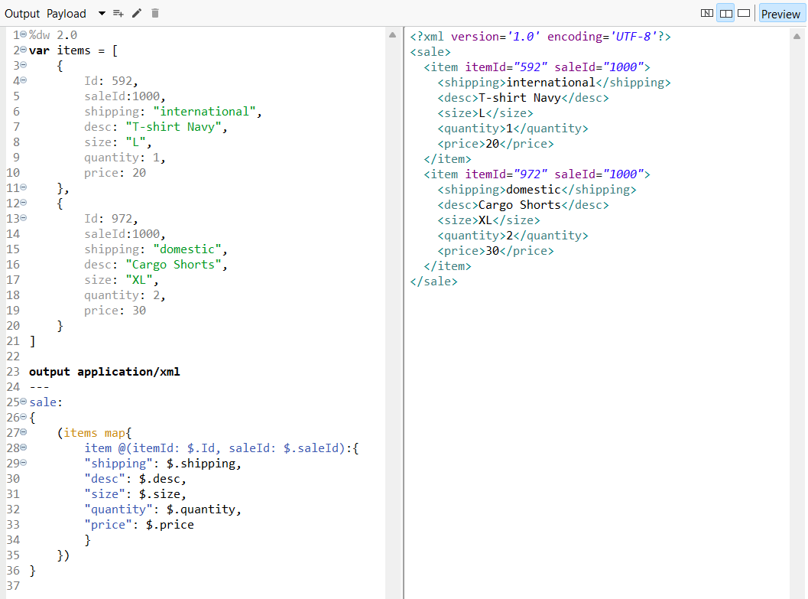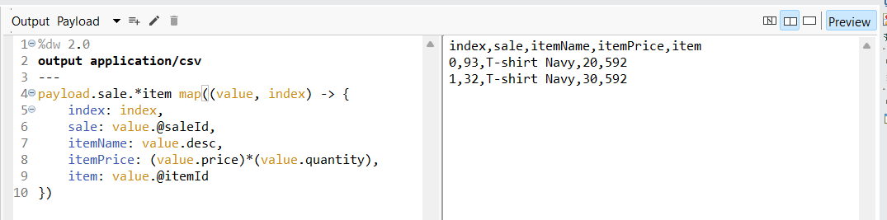

**--------------------------------------------------------------------------------------------------------------------------------------**

405: METHOD_NOT_FOUND 404: RESOURCE_NOT_FOUND

Note: When we get’s the post request at listener then the payload wouldn’t vanish out. **Database uses json.

--------------------------------------------------------------------------------------------------------------------------------------

** **Publish**: async \*\***Publish consume**: sync 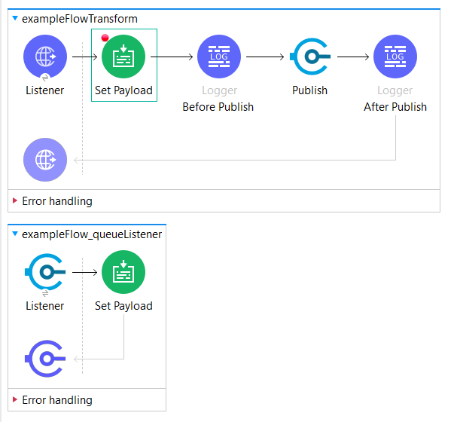 o/p: Initially set payload value is set to 10 and later modified in queue listener Before Publish: 10 After Publish: 10

If the it would have been **Publish consume** then o/p: Before Publish: 10 After Publish: 20

--------------------------------------------------------------------------------------------------------------------------------------

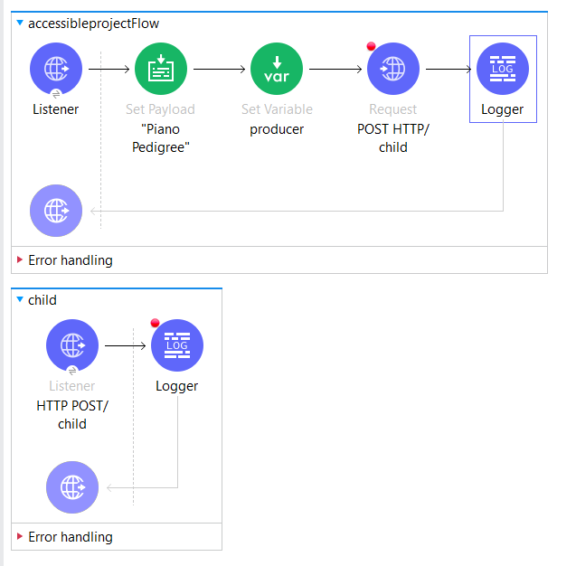 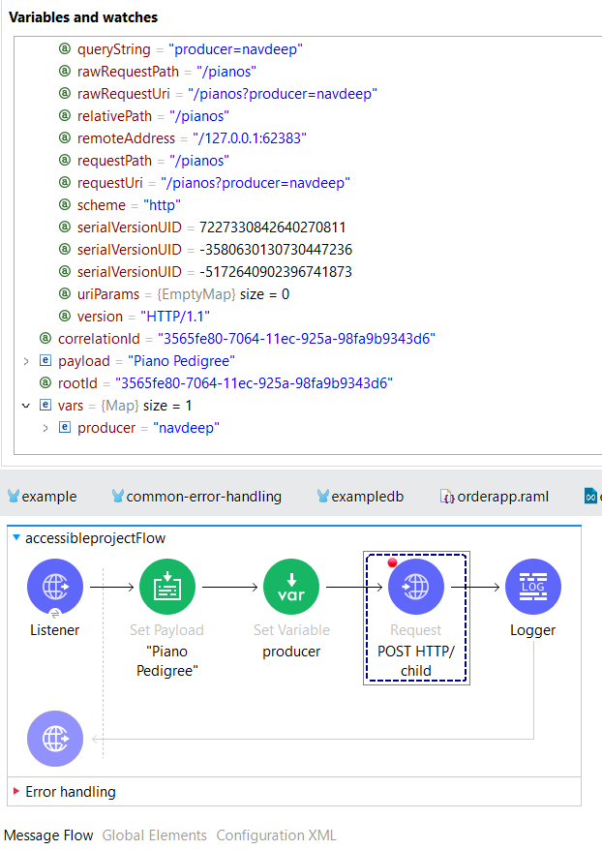 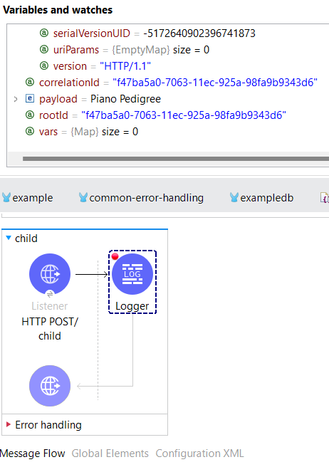 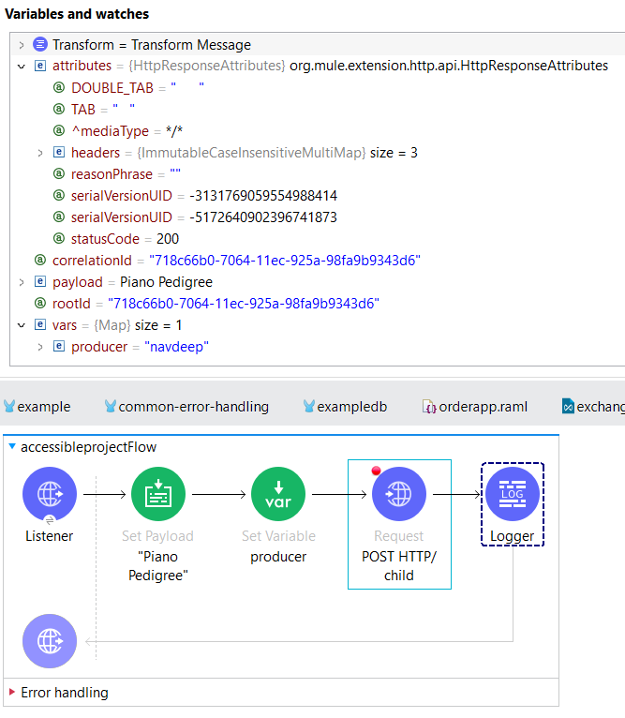

--------------------------------------------------------------------------------------------------------------------------------------

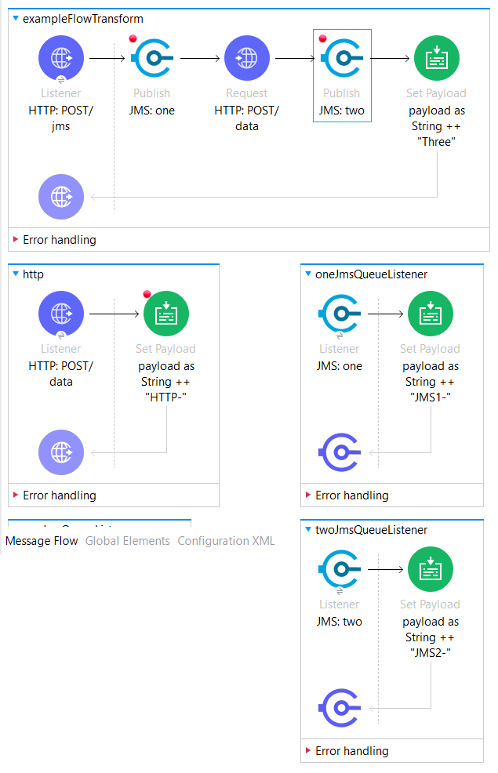 **o/p:** “Hello-HTTP-Three” Note: **Publish** is used thus async.

Think: If the queue would have been **Publish Consume** o/p?.

**--------------------------------------------------------------------------------------------------------------------------------------**

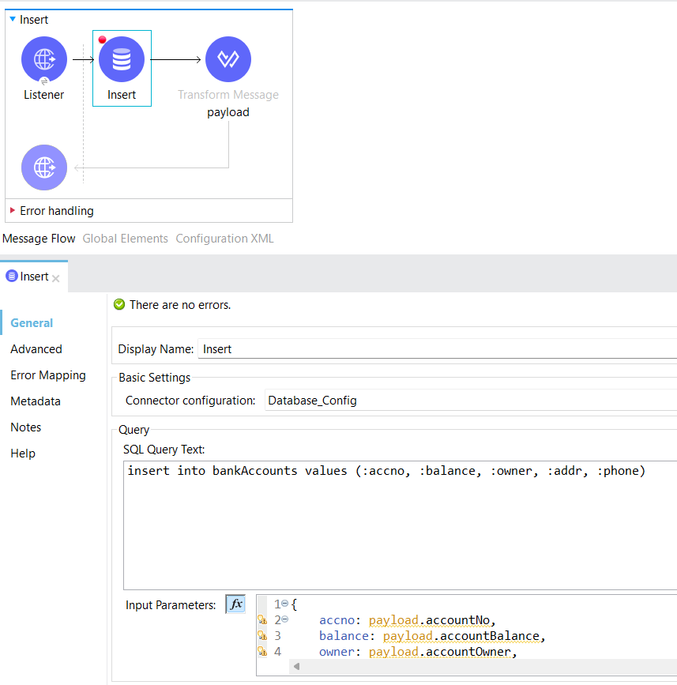

**--------------------------------------------------------------------------------------------------------------------------------------**

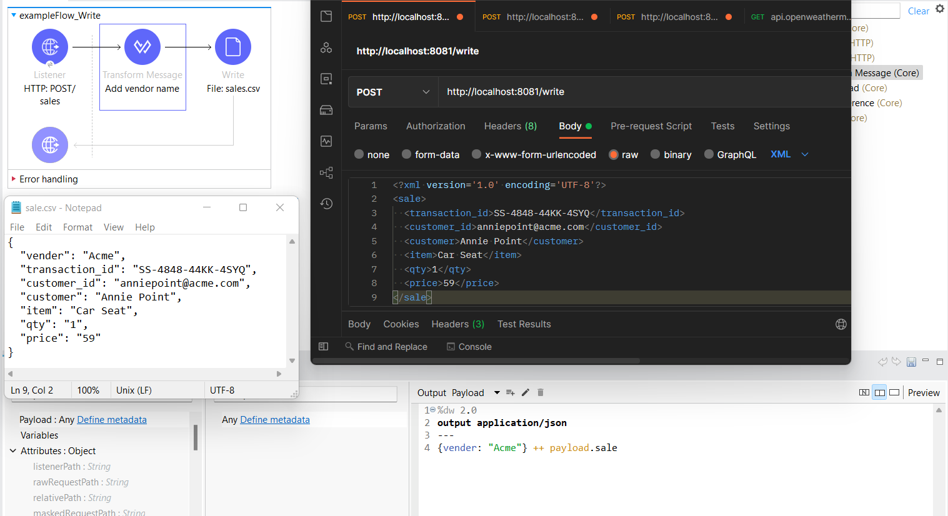

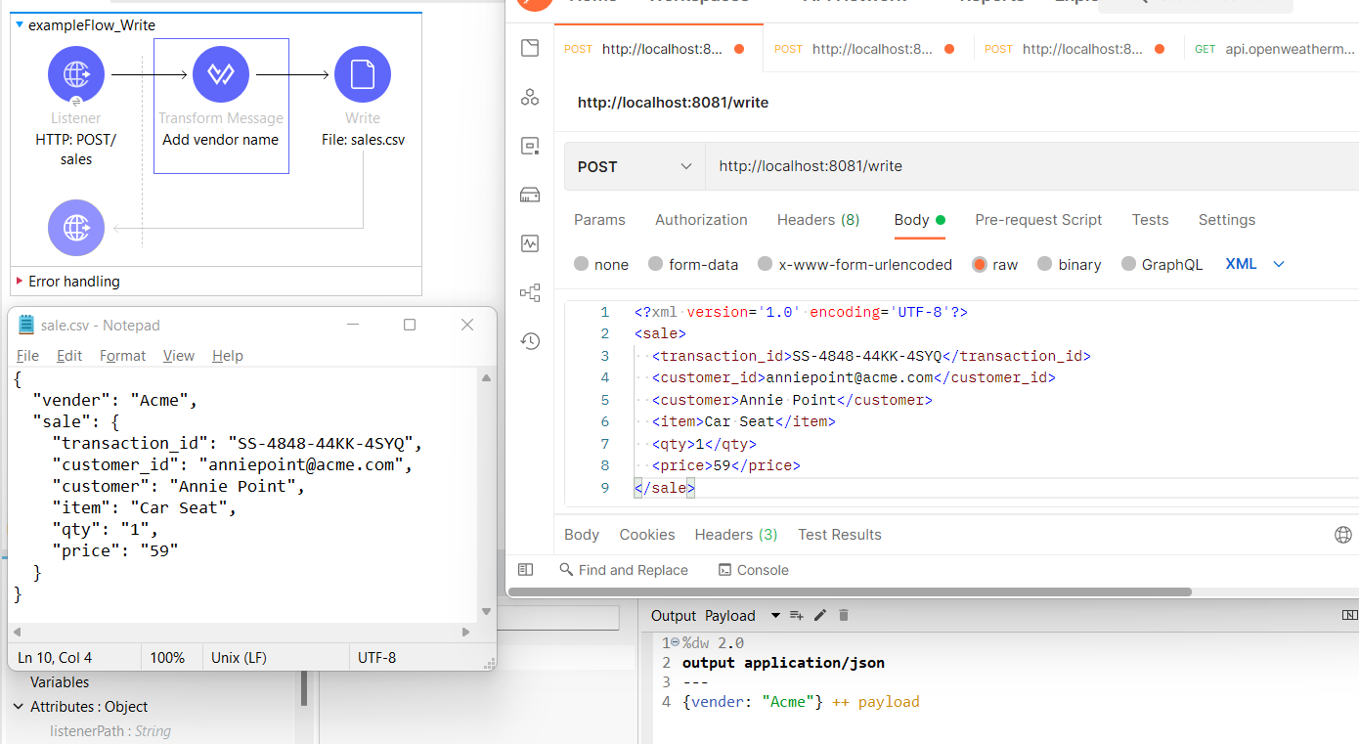

**--------------------------------------------------------------------------------------------------------------------------------------**

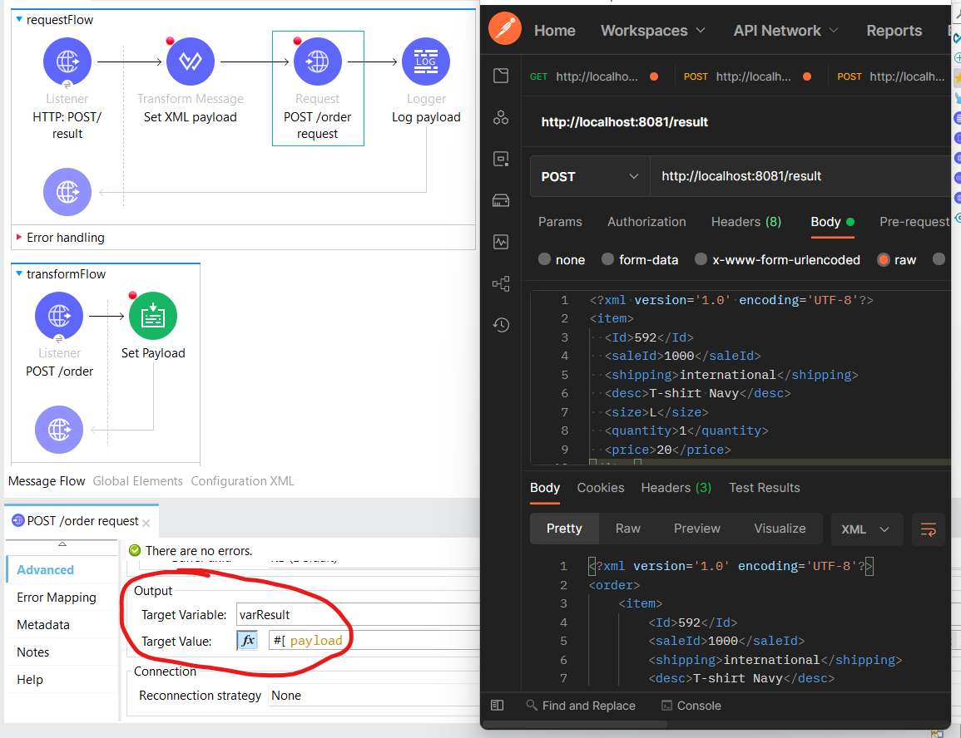

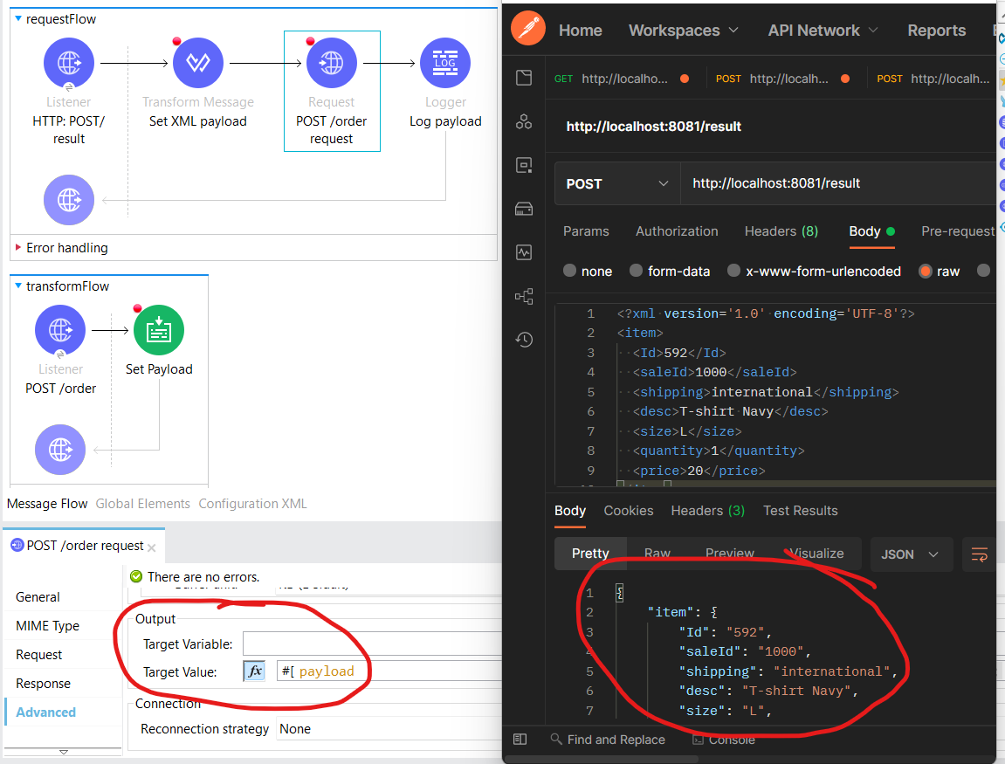

**--------------------------------------------------------------------------------------------------------------------------------------**

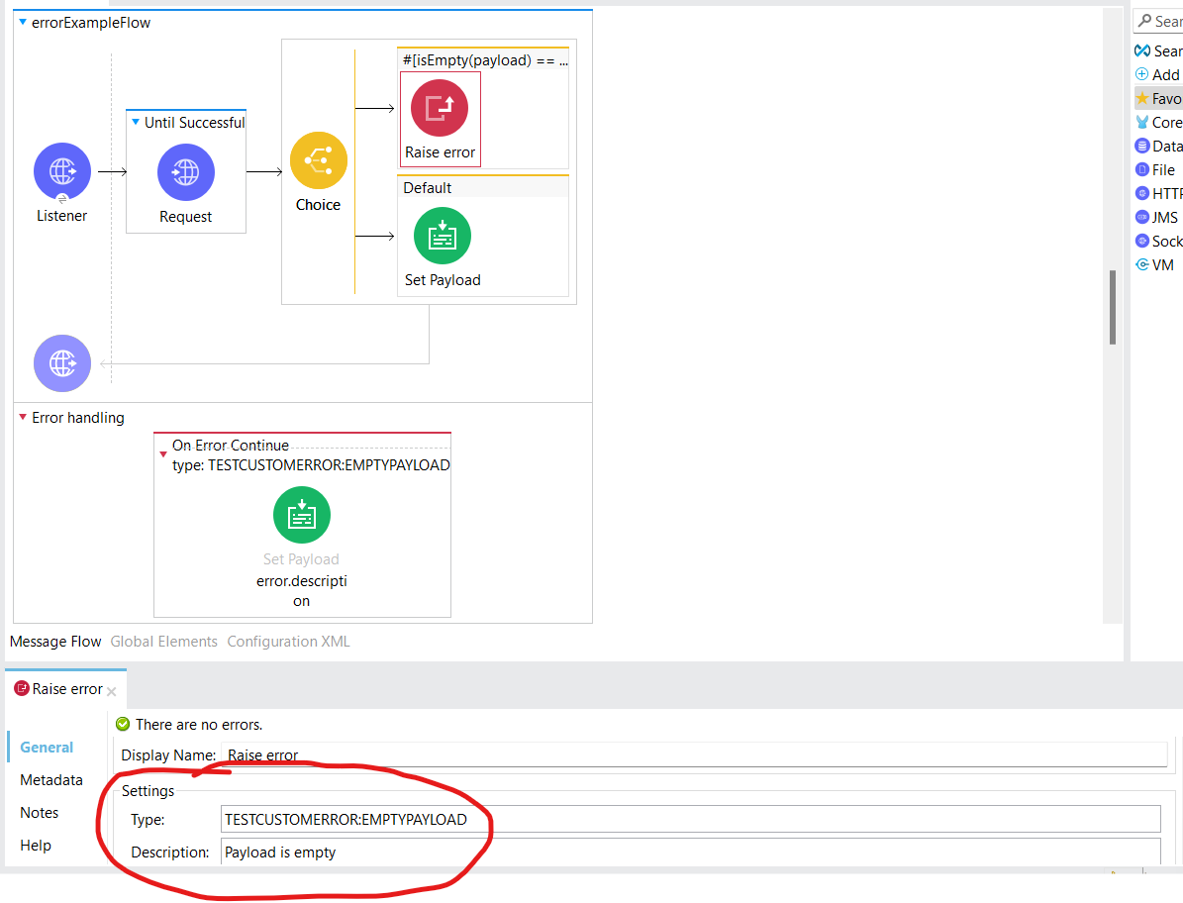

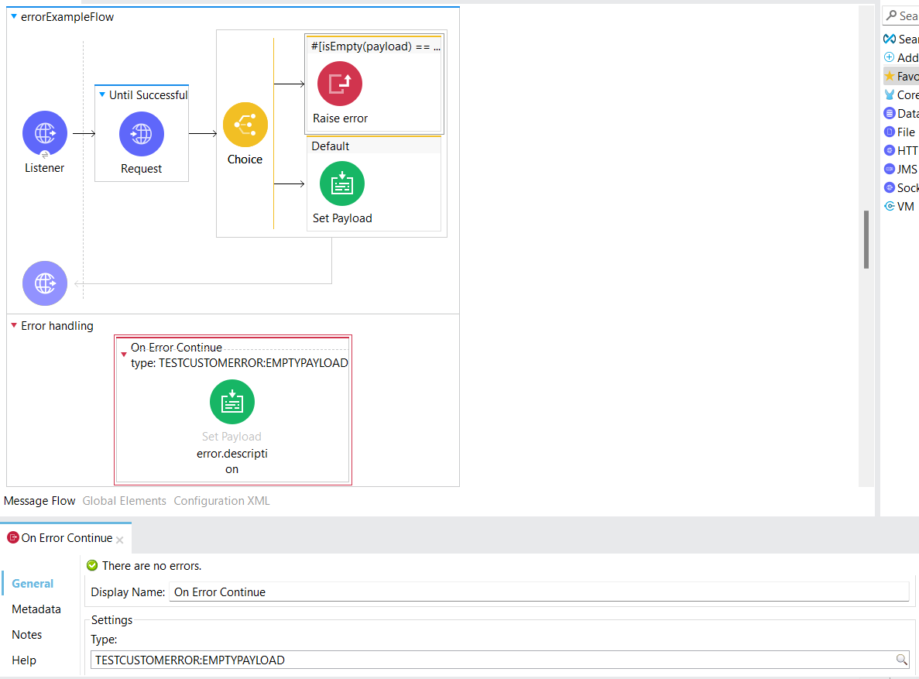

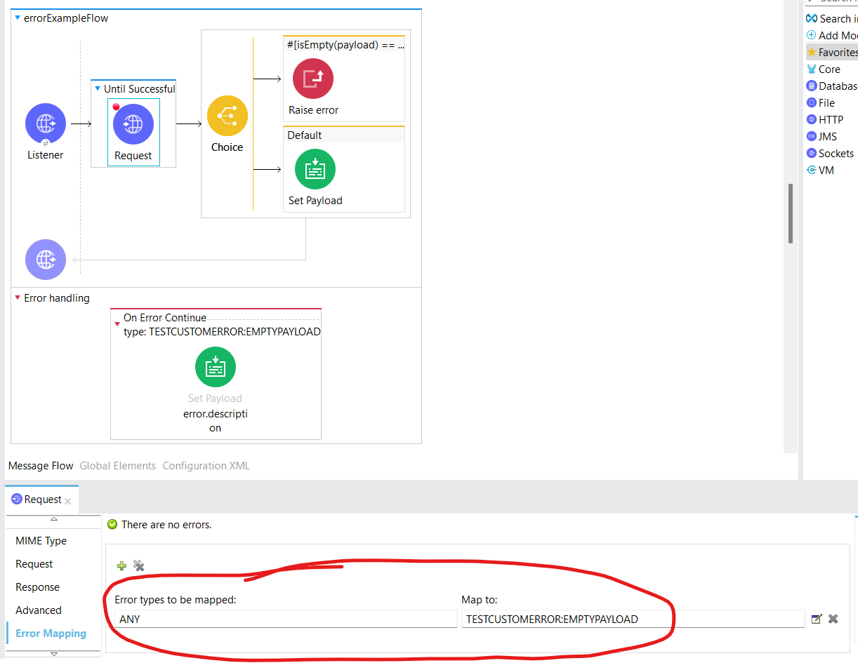**Here in Map to option we can’t map it to default available error type**

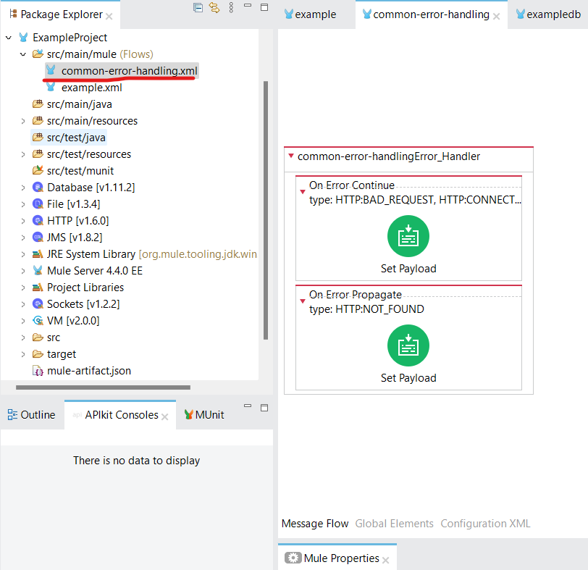

**--------------------------------------------------------------------------------------------------------------------------------------**

**Object store**= key: value | used for persist data across diff. flows

In **Batch Job**, if we have two **batch step** then it will complete first batch step for the complete payload. Then the result of the previous would be send to next batch step.

**Question Asked:** Q. Database query returns result in what format? Array Q. If the http request is sent with POST method, then, the payload would also be transferred with no attribute & no variable but if the method used is GET then nothing would be transferred there.

<https://www.freecram.com/question/MuleSoft.MCD-Level-1.v2020-03-17.q36/refer-to-the-exhibit-the-main-flow-contains-an-http-request-in-the-middle-of-the-flow-the-http-listeners> <https://sanket-m-kangle.medium.com/mulesoft-certified-developer-level-1-questions-answers-quiz-336e2751e01d> <https://www.folkstalk.com/2020/04/mulesoft-certified-developer-level-1.html> <https://www.dumpsbase.com/freedumps/mulesoft-certified-developer-level-1-mule-4-delta-mcd-level-1-delta-dumps.html> <https://www.pass4test.com/MCD-Level-1-exam-questions.html> <https://www.premiumdumps.com/mulesoft/mulesoft-mcd-level-1-dumps> https://vceguide.com/what-is-the-expected-data-that-the-post-accounts-endpoint-expects/ https://howtomule.com/expected-post-account-endpoint/